1. I have installed homebrew on my mac via mac terminal.
2. Then I have installed python3, ansible: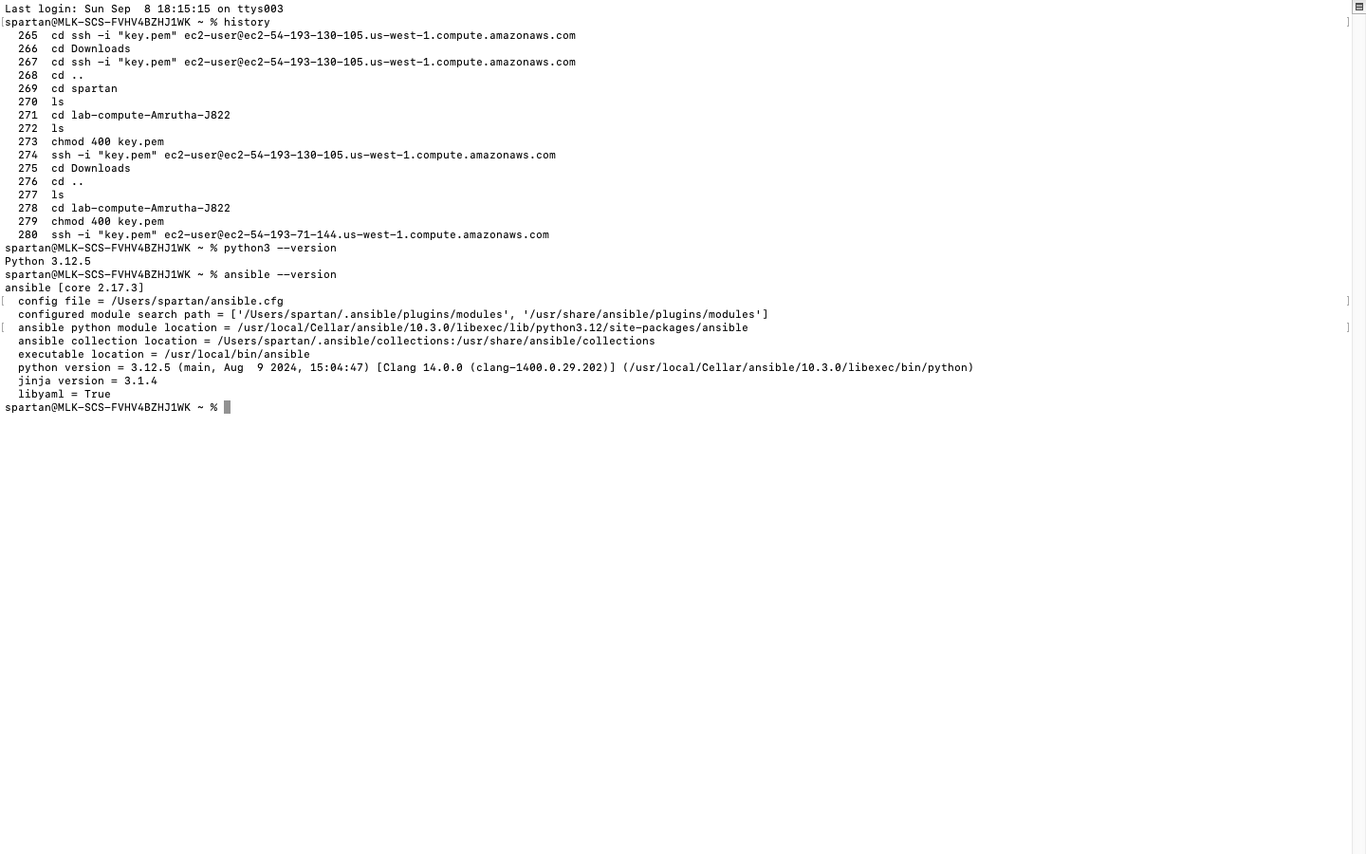
3. Then I have created a git repo name: CMPE_272_Lab02 and cloned it locally
4. I have created 2 EC2 instances named VM1, VM2 on AWS (IAM user: CMPE_272_Ansible_user):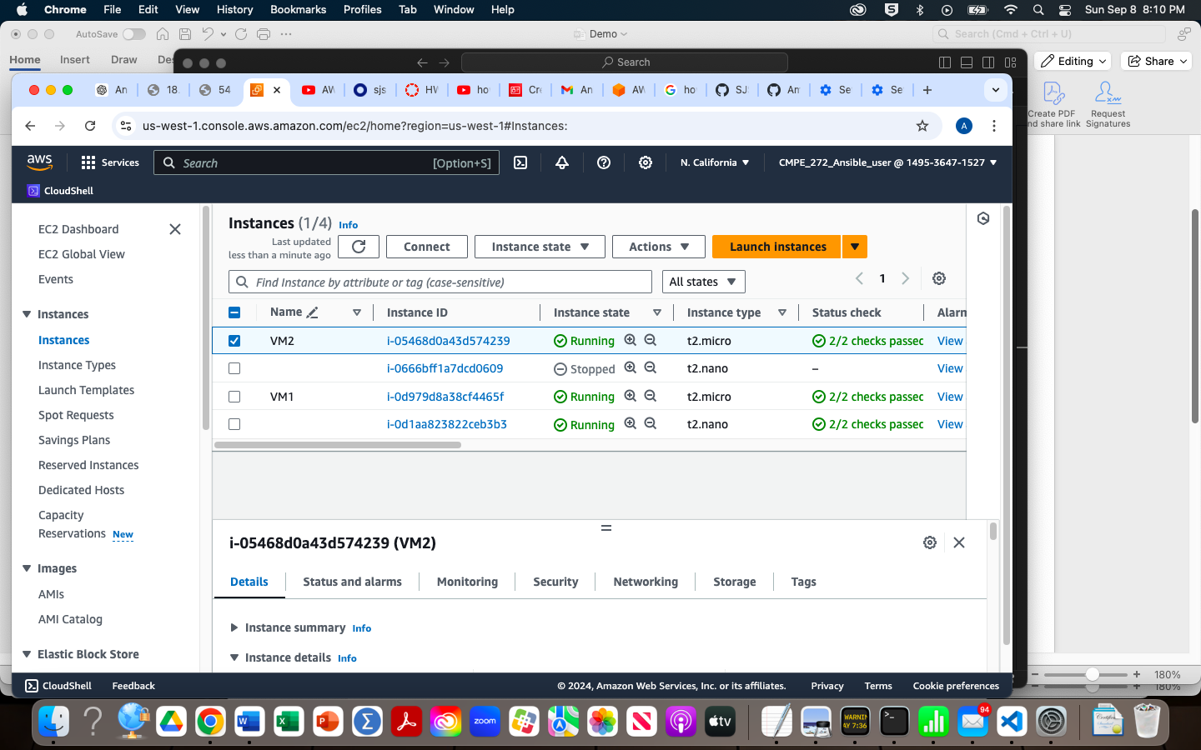
5. I have added port 8080, Custom TCP, invidual key.pem files for both the instances during creation. I have also set the inbound rules to accept port numbers: 80, 22, 8080 for both the instances.
6. Then I have navigated to the SSH Client page by selecting the particular instance and clicking the “Connect ” button, here I have copied the “ssh -i "VM2.pem" [ubuntu@ec2-18-144-3-58.us-west-1.compute.amazonaws.com](mailto:ubuntu@ec2-18-144-3-58.us-west-1.compute.amazonaws.com)” for VM2 and “ssh -i "VM1.pem" [ubuntu@ec2-54-183-228-161.us-west-1.compute.amazonaws.com](mailto:ubuntu@ec2-54-183-228-161.us-west-1.compute.amazonaws.com)” for VM1.
7. I ran the above commands directly on my terminal, which in turn let me logon to unbuntu i.e.,: **ubuntu@ip-172-31-0-217**:**~**$; both for VM1, VM2 (screenshots included in ‘Ansible Assignment’).
8. I opened a new terminal windows, navigated to my locally cloned repo, created a new folder named ‘ansible-webserver’
9. Here I have configured my ansible, inventory files. The commands that I have used for this are: nano inventory.ini (code in ‘inventory.ini’ file in my repo); ansible -i inventory.ini webservers -m ping
10. I have created a playbook file named ‘deploy_webservers’ in YAML, to deploy my VMs. I have entered this command via my terminal: nano deploy_webservers.yml
11. I made sure to enter the element “server_id” in my inventory.ini and added this element in my playbook so that when I deploy via ansible, my VM’s can appear as “Hello World from SJSU-1” and “Hello World from SJSU-2”
12. I have configured the ports, default files via ubuntu OS (which is the OS of my VMS’s) to allow 8080/tcp. For that I ran the below commands (for both of my VMs):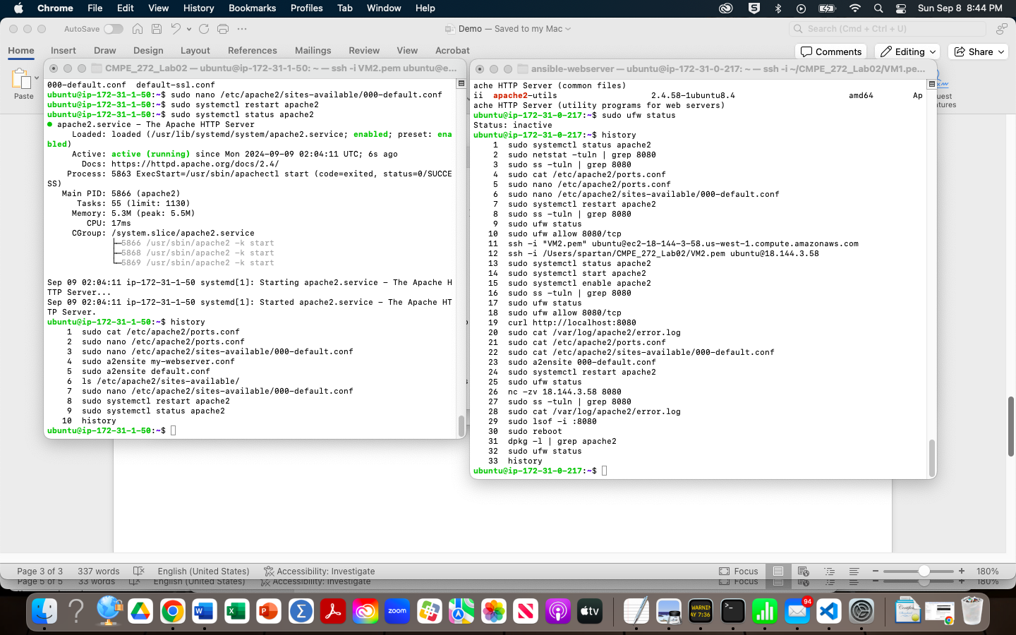
13. And then I ran this command: ansible-playbook -i hosts.ini deploy_webservers.yml
14. After this I have opened my VM’s via chrome:-

VM1: http:// 54.183.228.161:8080

VM2: <http://18.144.3.58:8080>

1. Now that I am done with the deployment part, I will start the next steps to undeploying those VM’s.
2. I have created a new playbook for undeployment: nano undeploy_webservers.yml
3. Then I ran that file via this command: ansible-playbook -i hosts.ini undeploy_webservers.yml
4. I searched for my VMs on my chrome with the links mentioned above and confirmed their undeployment with the following error: