**DAILY ONLINE ACTIVITIES SUMMARY**

|  |  |  |  |  |  |  |  |  |
| --- | --- | --- | --- | --- | --- | --- | --- | --- |
| **Date:** | **03/06/2020** | | | | | **Name:** | **Amrutha M** | |
| **Sem & Sec** | **6th sem & A sec** | | | | | **USN:** | **4AL17CS005** | |
| **Online Test Summary** | | | | | | | | |
| **Subject** | | **PAP assignment test** | | | | | | |
| **Max. Marks** | | **20** | | **Score** | | | **16** | |
| **Certification Course Summary** | | | | | | | | |
| **Course** | **Introduction to Full Stack Development** | | | | | | | |
| **Certificate Provider** | | | **Great Learning** | | **Duration** | | | **1.5 hr(spent by me on that day to learn)** |
| **Coding Challenges** | | | | | | | | |
| **Problem Statement:**   1. Problem statement:   Take a list of length 3 containing integers, find out which is larger, first or last one and set all the elements in the list to be that value. Print the updated list.   1. Python program to print prime numbers in the given range. | | | | | | | | |
| **Status: Completed** | | | | | | | | |
| **Uploaded the report in Github** | | | | | **Yes** | | | |
| **If yes Repository name** | | | | | <https://github.com/Amrutha-M/Online-Coding> | | | |
| **Uploaded the report in slack** | | | | | **Yes** | | | |

**Online Test Details**

PAP assignment test Details:

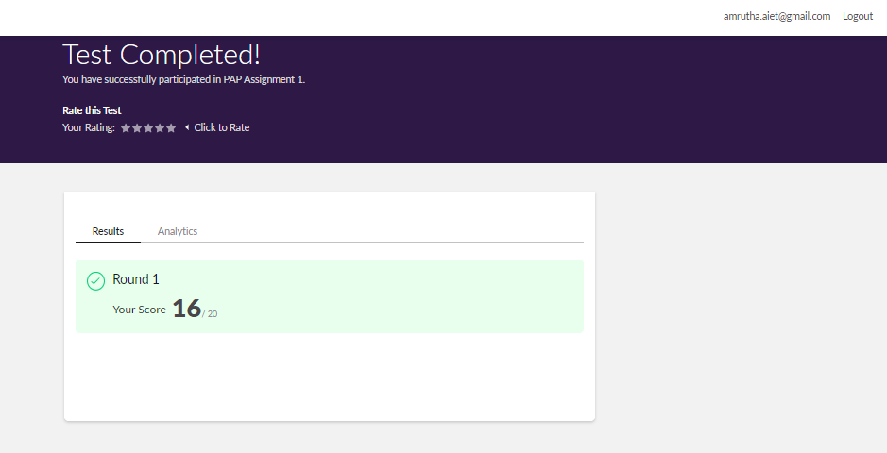

**Online Certification Details**

Lessons completed:

1. Type ID and Class Selector
2. Attribute Selector
3. Attribute + Value Selector
4. Pseucode class Selector
5. Hover Pseudo Class selector

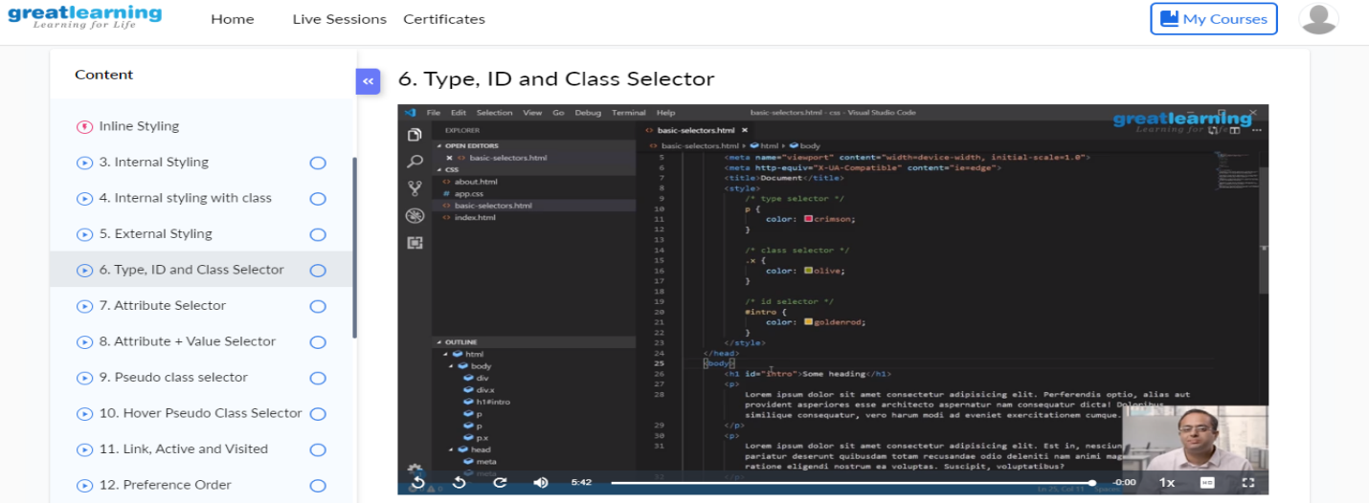

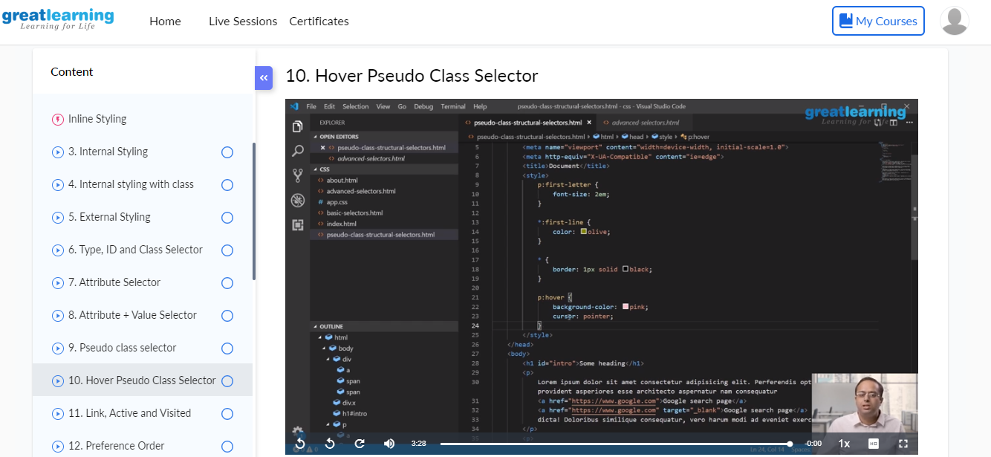

**Coding Challenge Details**

1. Problem statement:

Take a list of length 3 containing integers, find out which is larger, first or last one and set all the elements in the list to be that value. Print the updated list.

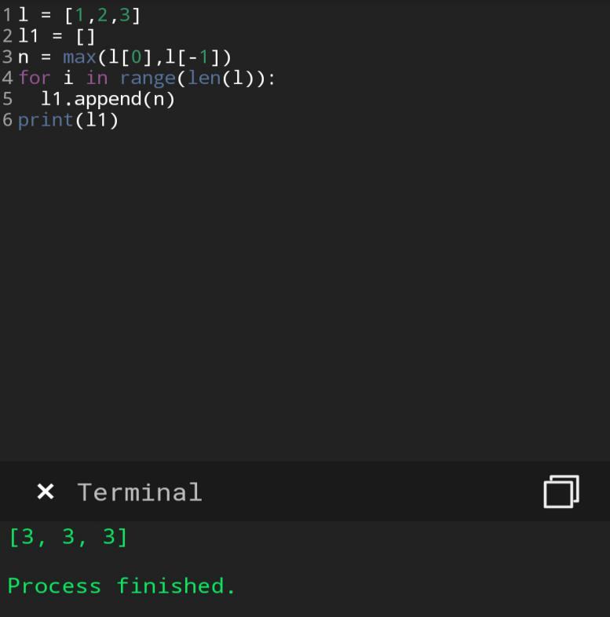

1. Python program to print prime numbers in the given range.

