**DAILY ONLINE ACTIVITIES SUMMARY**

|  |  |  |  |  |  |  |  |  |
| --- | --- | --- | --- | --- | --- | --- | --- | --- |
| **Date:** | **06/06/2020** | | | | | **Name:** | **Amrutha M** | |
| **Sem & Sec** | **6th sem & A sec** | | | | | **USN:** | **4AL17CS005** | |
| **Online Test Summary** | | | | | | | | |
| **Subject** | | **PAP IA Test - 3** | | | | | | |
| **Max. Marks** | | **30** | | **Score** | | | **24** | |
| **Certification Course Summary** | | | | | | | | |
| **Course** | **Introduction to Full Stack Development** | | | | | | | |
| **Certificate Provider** | | | **Great Learning** | | **Duration** | | | **1.5 hr(spent by me on that day to learn)** |
| **Coding Challenges** | | | | | | | | |
| **Problem Statement:**   1. The program takes a string and removes the nth index character from the non-empty string. 2. Python Program to Accept a Hyphen Separated Sequence of Words as Input and Print the Words in a Hyphen-Separated Sequence after Sorting them Alphabetically. | | | | | | | | |
| **Status: Completed** | | | | | | | | |
| **Uploaded the report in Github** | | | | | **Yes** | | | |
| **If yes Repository name** | | | | | <https://github.com/Amrutha-M/Online-Coding> | | | |
| **Uploaded the report in slack** | | | | | **Yes** | | | |

**Online Test Details**

PAP IA Test 3 Details:

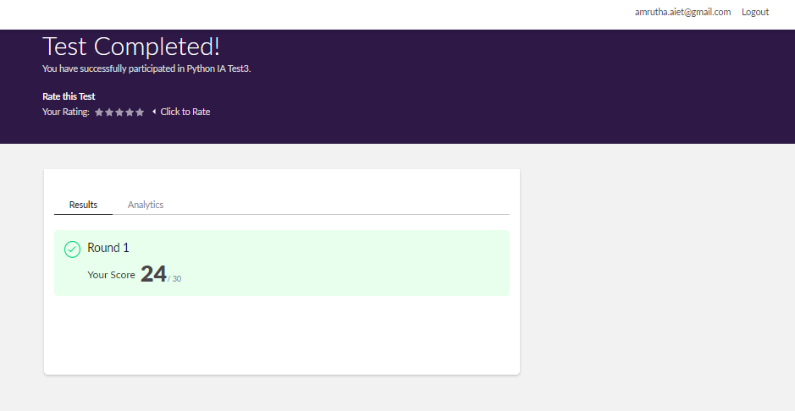

**Online Certification Details**

Lessons completed:

1. CSS Non inherited properties
2. Cascade with embeded styling
3. Cascade with external style sheet
4. Cascade with inline styling
5. Specificity - Type VS Class selector

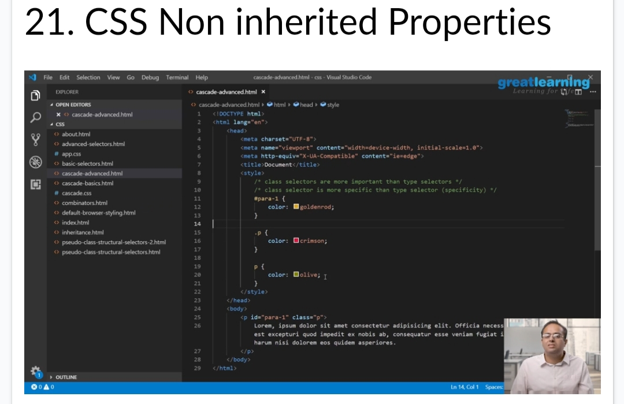

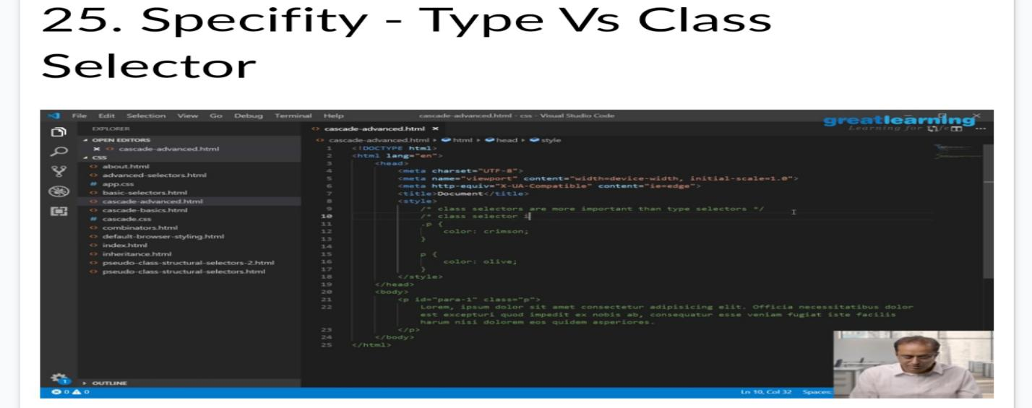

**Coding Challenge Details**

1. The program takes a string and removes the nth index character from the non-empty string.

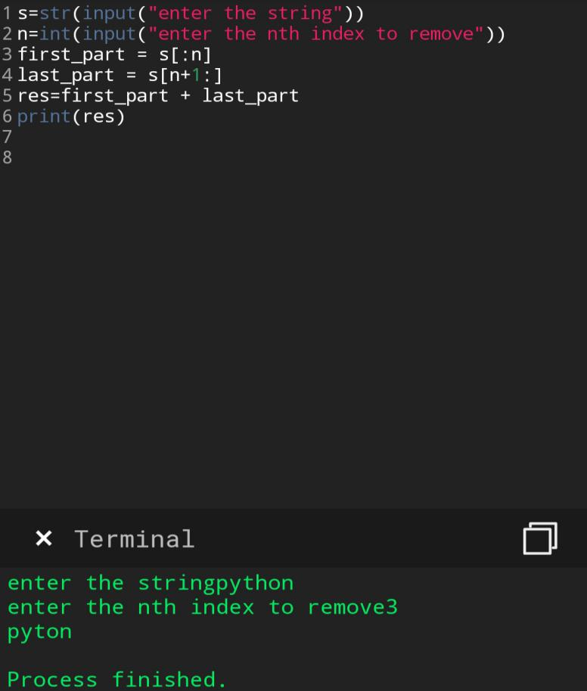

1. Python Program to Accept a Hyphen Separated Sequence of Words as Input and Print the Words in a Hyphen-Separated Sequence after Sorting them Alphabetically

