**DAILY ONLINE ACTIVITIES SUMMARY**

|  |  |  |  |  |  |  |  |  |
| --- | --- | --- | --- | --- | --- | --- | --- | --- |
| **Date:** | **07/06/2020(Sunday)** | | | | | **Name:** | **Amrutha M** | |
| **Sem & Sec** | **6th sem & A sec** | | | | | **USN:** | **4AL17CS005** | |
| **Online Test Summary** | | | | | | | | |
| **Subject** | | **SSCD IA Test - 3** | | | | | | |
| **Max. Marks** | | **30** | | **Score** | | | **23** | |
| **Certification Course Summary** | | | | | | | | |
| **Course** | **Introduction to Full Stack Development** | | | | | | | |
| **Certificate Provider** | | | **Great Learning** | | **Duration** | | | **1.5 hr(spent by me on that day to learn)** |
| **Coding Challenges** | | | | | | | | |
| **Problem Statement:**   1. Python program to count number of strings, program to count the number of strings, provided string length is 2 or more and the first and last character are same from a given list of strings. 2. Python program to square each odd number in the list,take a list of numbers and square each odd number in the list. Print output as comma separated sequence. | | | | | | | | |
| **Status: Completed** | | | | | | | | |
| **Uploaded the report in Github** | | | | | **Yes** | | | |
| **If yes Repository name** | | | | | <https://github.com/Amrutha-M/Online-Coding> | | | |
| **Uploaded the report in slack** | | | | | **Yes** | | | |

**Online Test Details**

SSCD IA Test 3 Details:

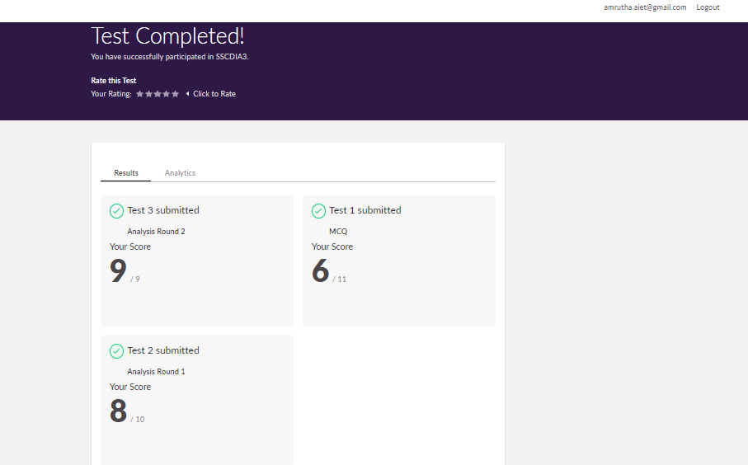

**Online Certification Details**

Lessons completed:

1. Specificity - Type Vs Class Vs ID
2. Combination of selectors
3. Specificity of combination of selectors
4. Specificity values
5. Colors RGB and Hexadecimals

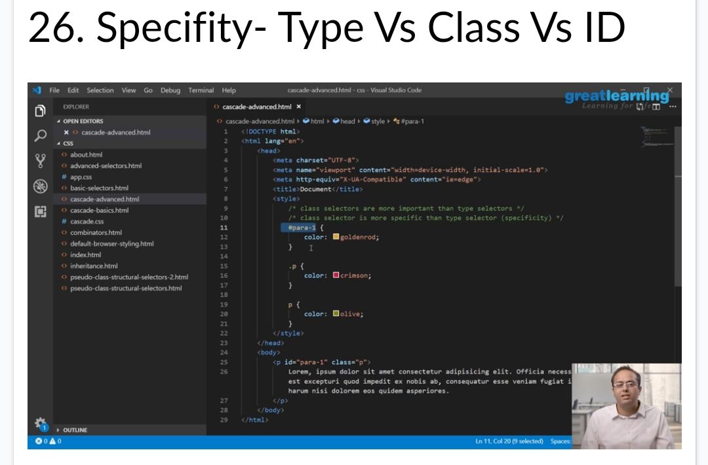

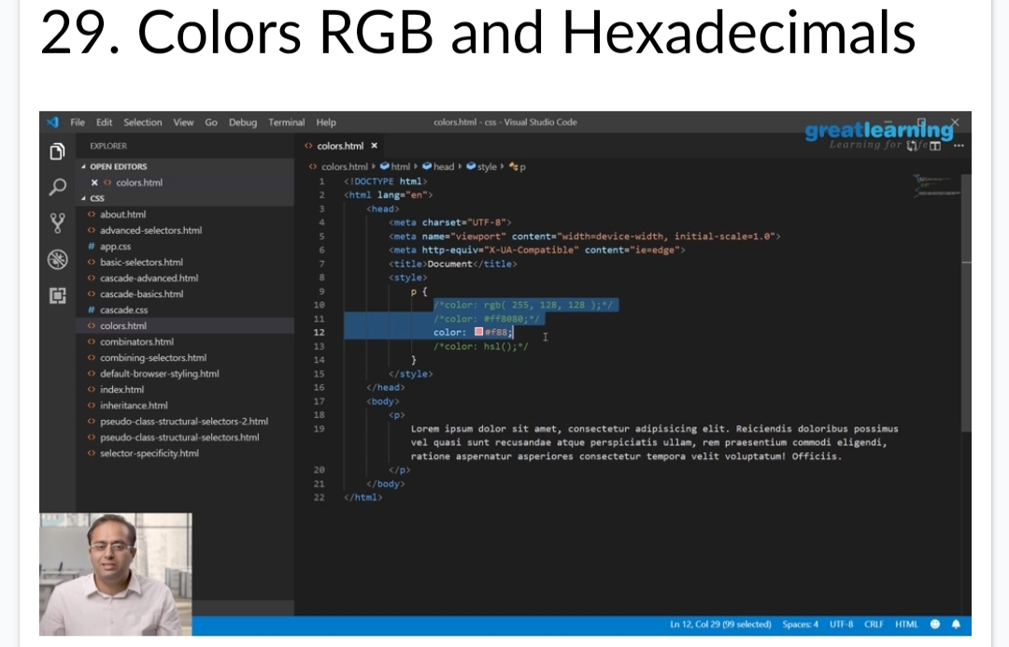

**Coding Challenge Details**

1. Python program to count number of strings, program to count the number of strings, provided string length is 2 or more and the first and last character are same from a given list of strings.

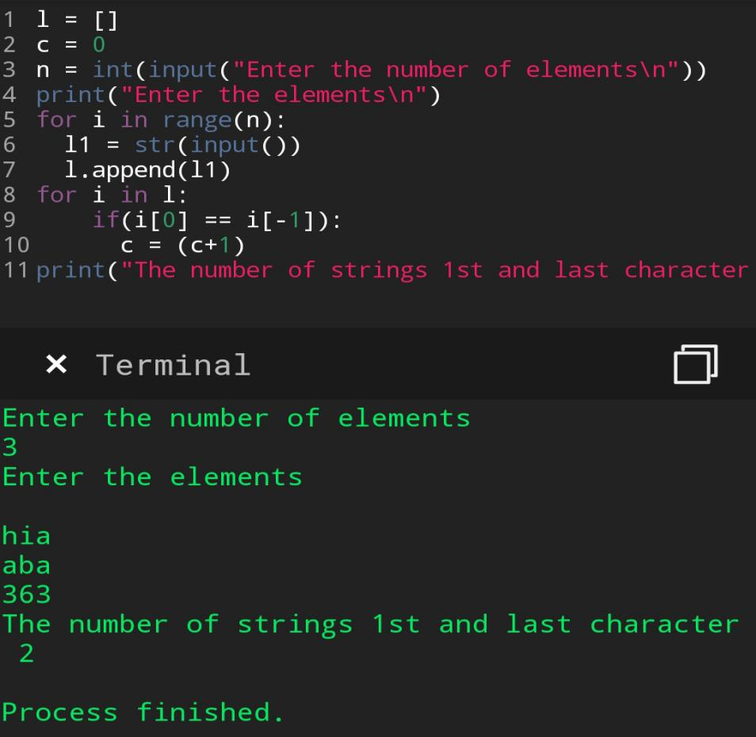

1. Python program to square each odd number in the list,take a list of numbers and square each odd number in the list. Print output as comma separated sequence.

