**DAILY ONLINE ACTIVITIES SUMMARY**

|  |  |  |  |  |  |  |  |  |
| --- | --- | --- | --- | --- | --- | --- | --- | --- |
| **Date:** | **13/06/2020** | | | | | **Name:** | **Amrutha M** | |
| **Sem & Sec** | **6th /A** | | | | | **USN:** | **4AL17CS005** | |
| **Online Test Summary** | | | | | | | | |
| **Subject** | | **PAP IA4** | | | | | | |
| **Max. Marks** | | **30** | | **Score** | | | **28** | |
| **Certification Course Summary** | | | | | | | | |
| **Course** | **Introduction to full stack development** | | | | | | | |
| **Certificate Provider** | | | **Great Learning** | | **Duration** | | | **1.5hr(spent by me per day)** |
| **Coding Challenges** | | | | | | | | |
| **Problem Statement:**   1. Python Program to Take in a String and Replace Every Blank Space with Hyphen 2. Python Program to print the pattern Input: | | | | | | | | |
| **Status: Completed** | | | | | | | | |
| **Uploaded the report in GitHub** | | | | | **Yes** | | | |
| **If yes Repository name** | | | | | [https://github.com/Amrutha-M/Online-Coding](https://github.com/sathvikshetty22/Online-Coding) | | | |
| **Uploaded the report in slack** | | | | | **Yes** | | | |

**Online Test Details**

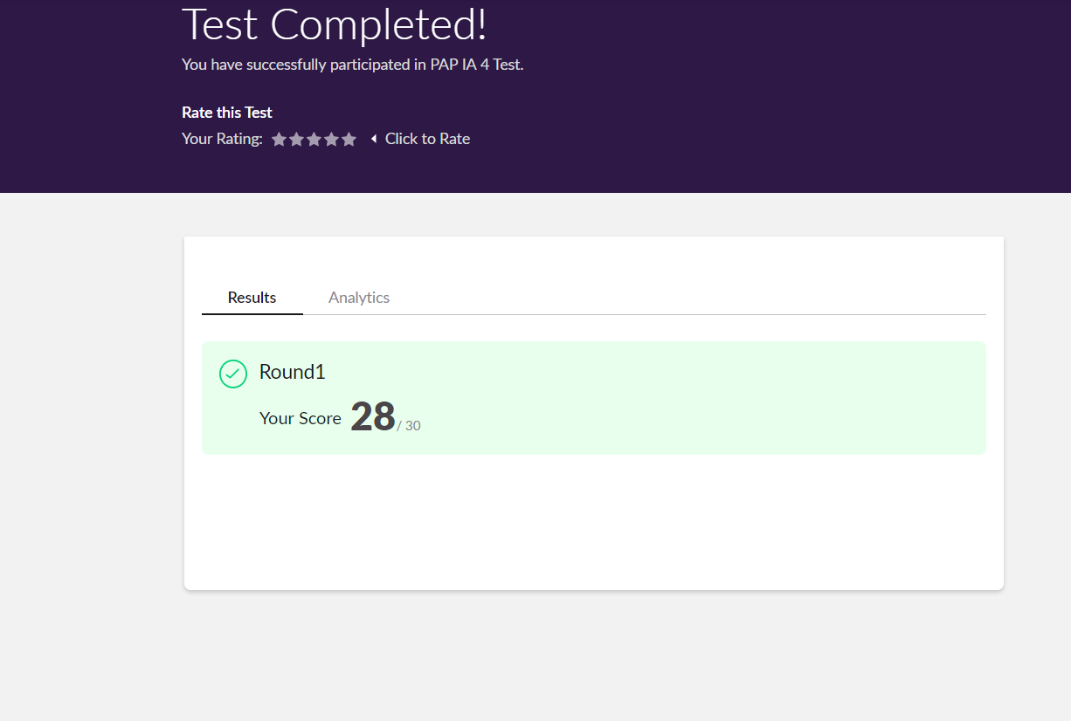

**Online Certification Details**

**HTML and CSS assignment**

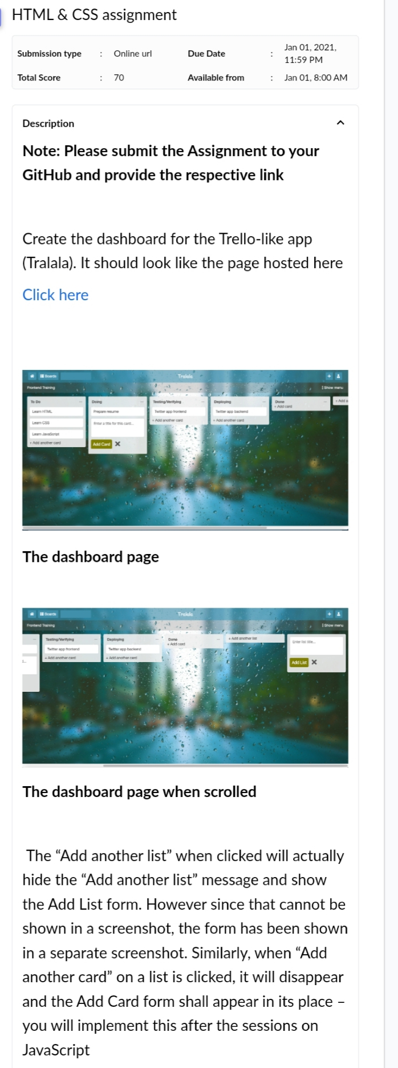

**Coding Challenge Details**

1.Python Program to Take in a String and Replace Every Blank Space with Hyphen

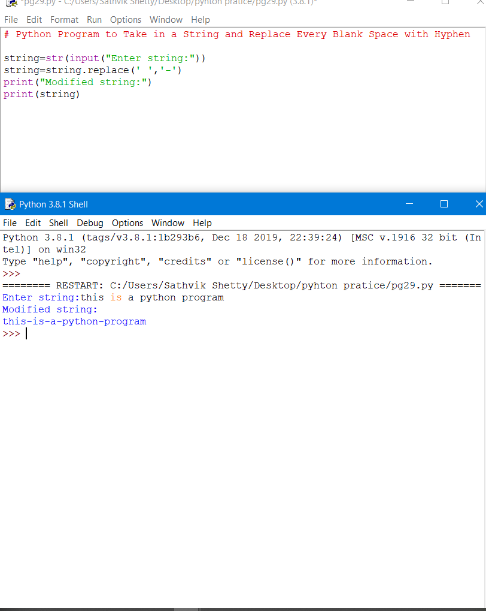

**2.** Python Program to print the pattern Input:

