**DAILY ONLINE ACTIVITIES SUMMARY**

|  |  |  |  |  |  |  |  |  |
| --- | --- | --- | --- | --- | --- | --- | --- | --- |
| **Date:** | **21/05/2020** | | | | | **Name:** | **Amrutha M** | |
| **Sem & Sec** | **6th sem & A sec** | | | | | **USN:** | **4AL17CS005** | |
| **Online Test Summary** | | | | | | | | |
| **Subject** | | **OS IA Test** | | | | | | |
| **Max. Marks** | | **30** | | **Score** | | | **30** | |
| **Certification Course Summary** | | | | | | | | |
| **Course** | **Introduction to Full Stack Development** | | | | | | | |
| **Certificate Provider** | | | **Great Learning** | | **Duration** | | | **1.5 hr(spent by me on that day to learn)** |
| **Coding Challenges** | | | | | | | | |
| **Problem Statement:**  **1.** Write a menu program in Python to find Area-Circle, Circumference-Circle, Area- Square, Circumference-Square using functions with menu choice Create seperate functions for each choice of menu  **2.** Python program to print right angled traingle | | | | | | | | |
| **Status: Completed** | | | | | | | | |
| **Uploaded the report in Github** | | | | | **Yes** | | | |
| **If yes Repository name** | | | | | <https://github.com/Amrutha-M/Online-Coding> | | | |
| **Uploaded the report in slack** | | | | | **Yes** | | | |

**Online Test Details**

OS TEST Details:

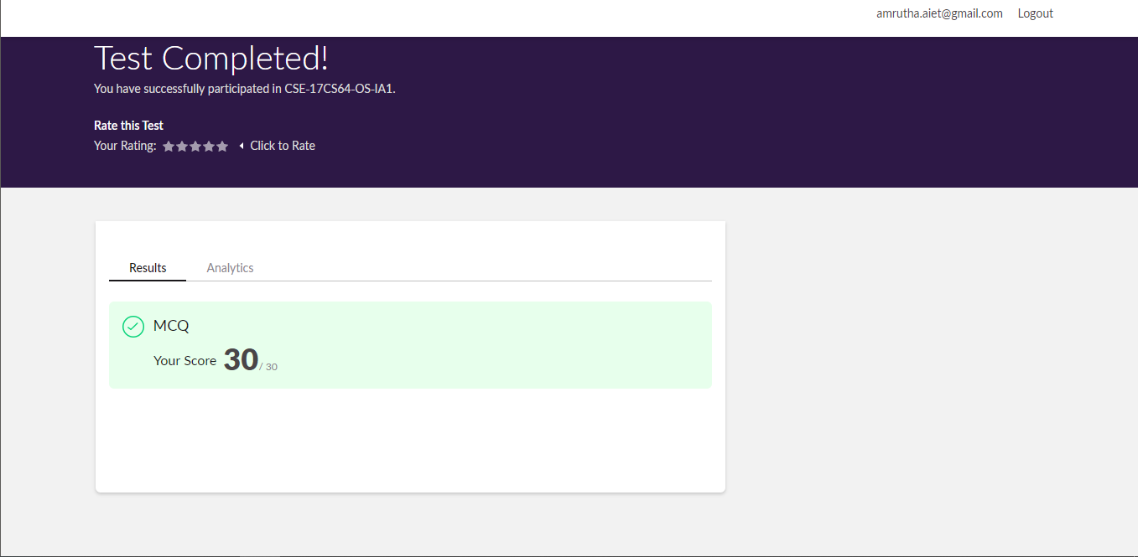

**Online Certification Details**

Lessons completed:

1. Table Tag 1
2. Table Tag 2
3. Introduction to forms
4. Introduction to input elements
5. More on input elements

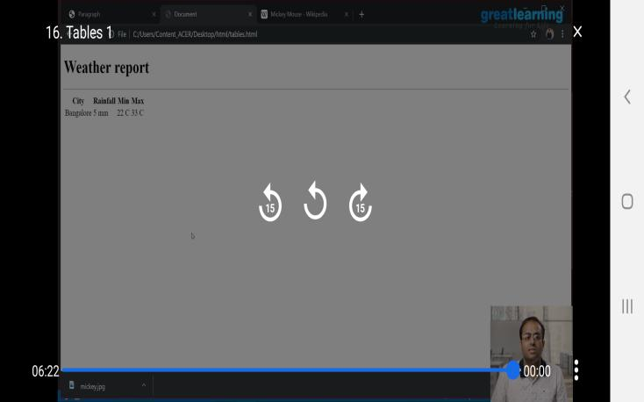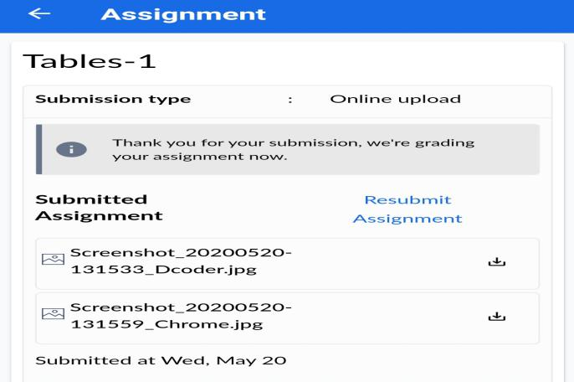

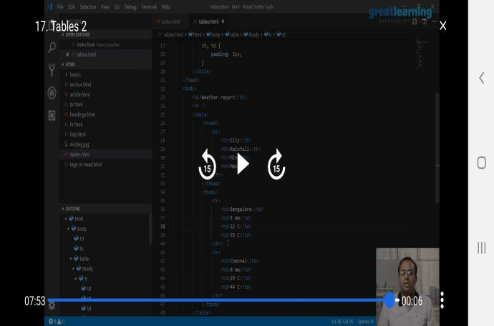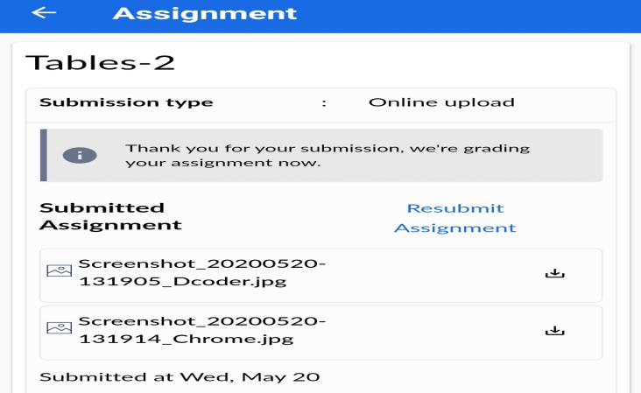

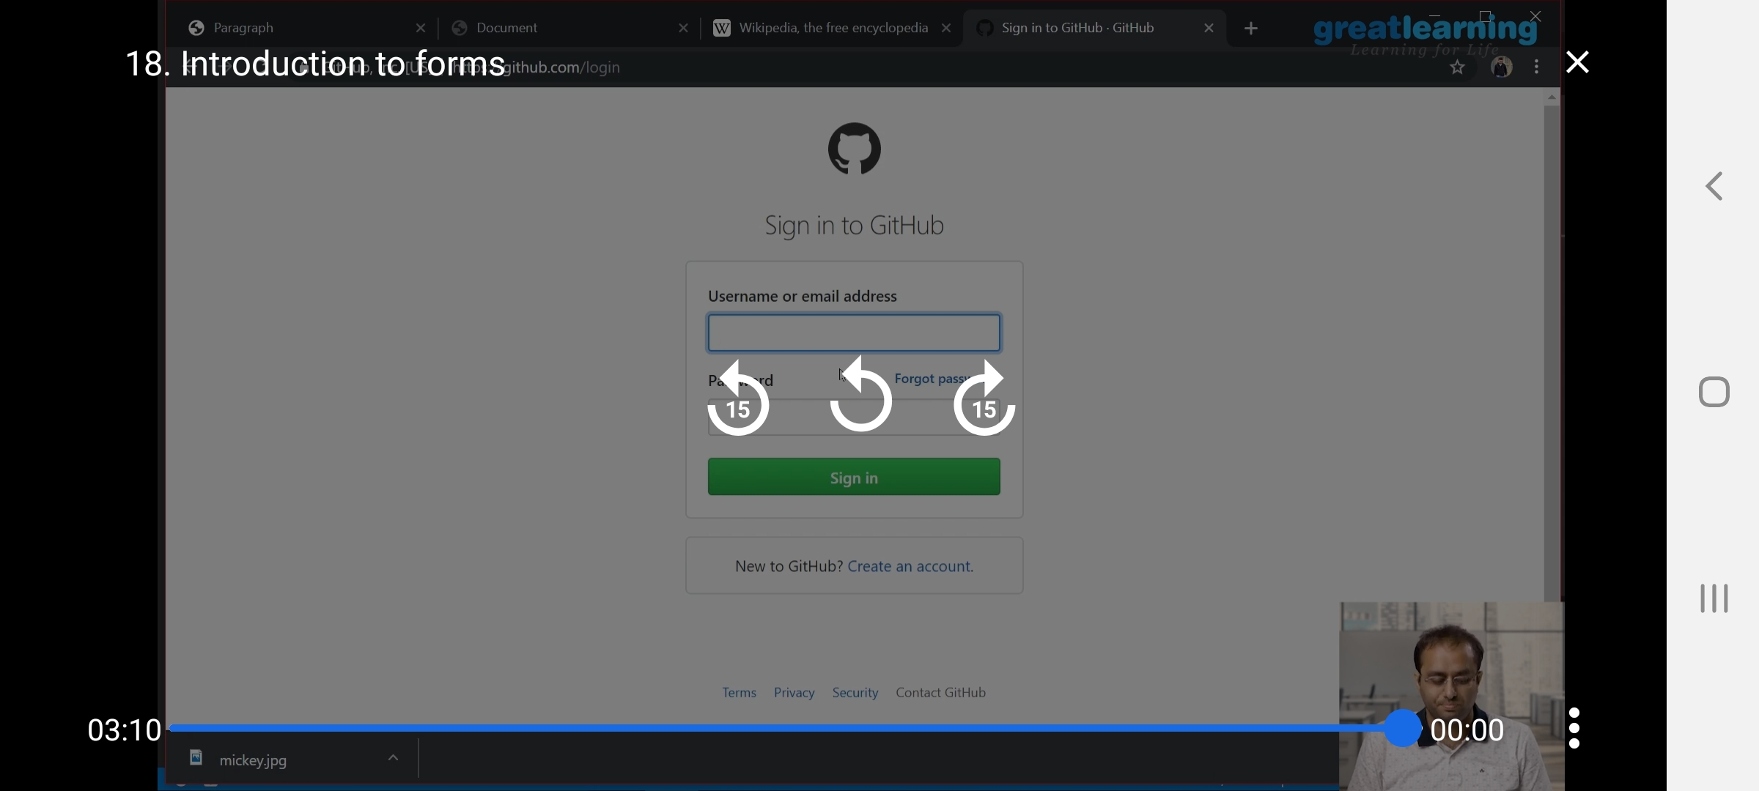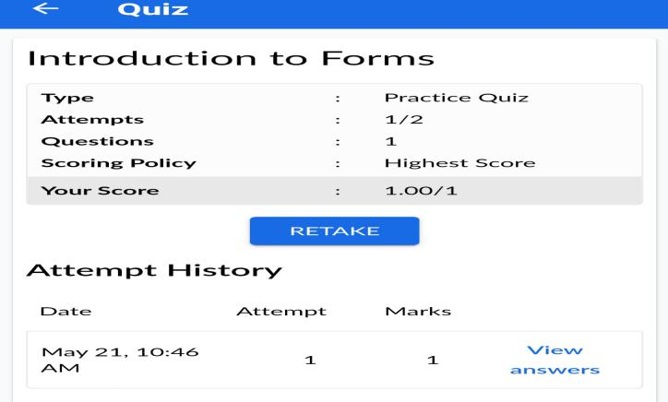

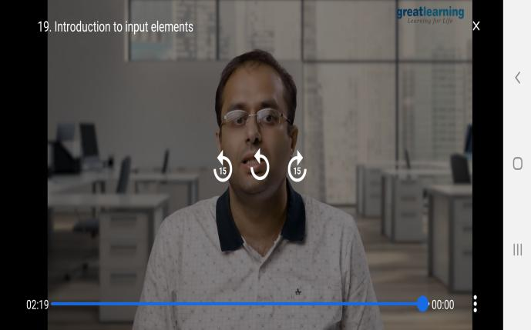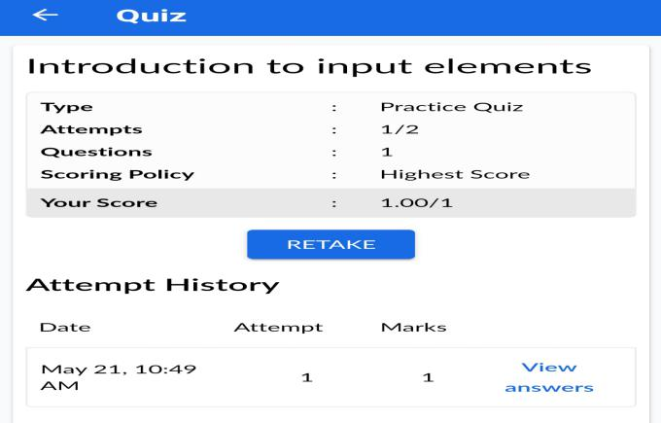

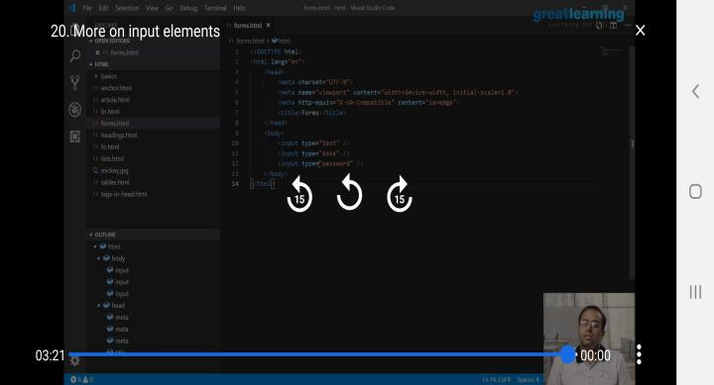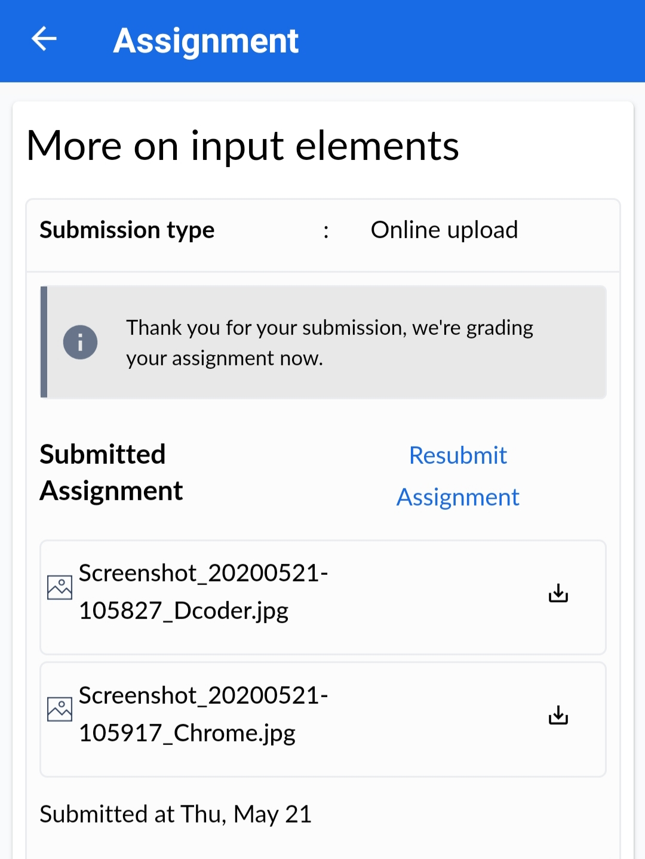

**Coding Challenge Details**

1. Write a menu program in Python to find Area-Circle, Circumference-Circle, Area- Square, Circumference-Square using functions with menu choice  
   Create seperate functions for each choice of menu

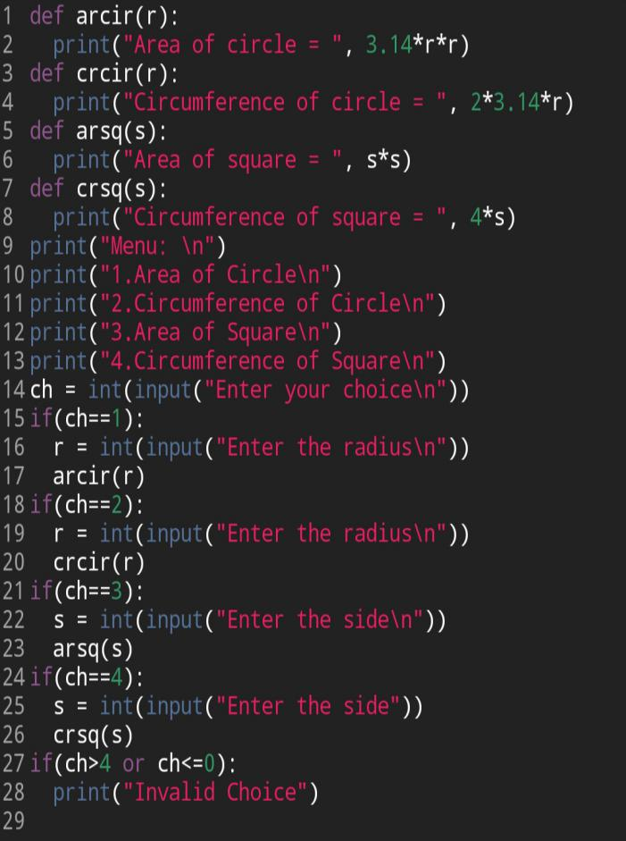

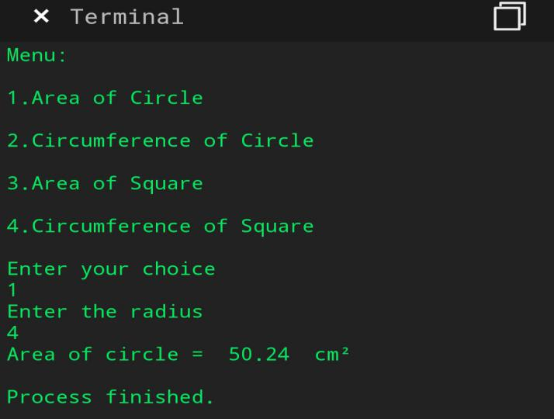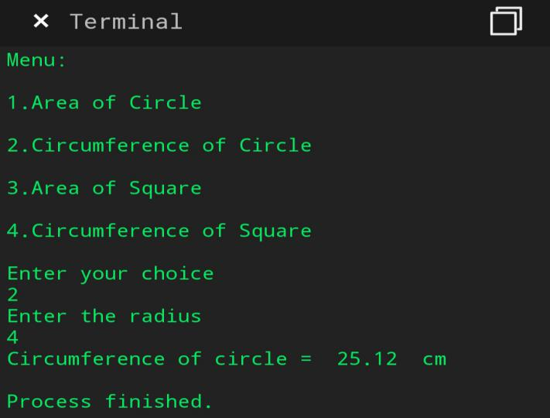

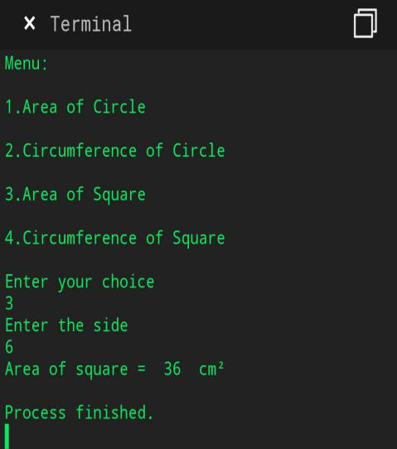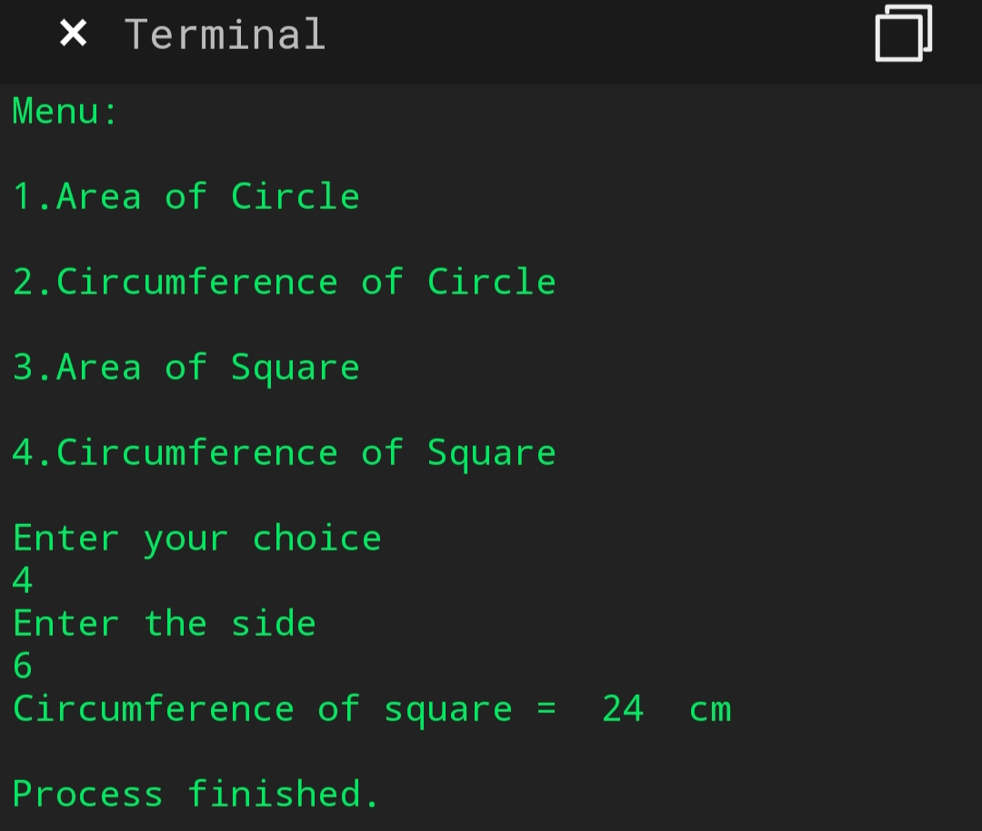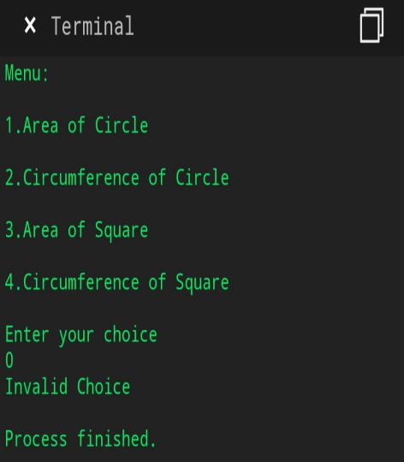

1. Python program to print right angled traingle.

