**DAILY ONLINE ACTIVITIES SUMMARY**

|  |  |  |  |  |  |  |  |  |
| --- | --- | --- | --- | --- | --- | --- | --- | --- |
| **Date:** | **29/05/2020** | | | | | **Name:** | **Amrutha M** | |
| **Sem & Sec** | **6th sem & A sec** | | | | | **USN:** | **4AL17CS005** | |
| **Online Test Summary** | | | | | | | | |
| **Subject** | | **OR IA Test - 2** | | | | | | |
| **Max. Marks** | | **30** | | **Score** | | | **25** | |
| **Certification Course Summary** | | | | | | | | |
| **Course** | **Introduction to Full Stack Development** | | | | | | | |
| **Certificate Provider** | | | **Great Learning** | | **Duration** | | | **1.5 hr(spent by me on that day to learn)** |
| **Coding Challenges** | | | | | | | | |
| **Problem Statement:**   1. Take a string as input and find the #number of uppercase and lower case letters in the string and print the count.   Note: any spaces has to be ignored   1. Python program which takes a string as #an input from user and print only the consonants in the string format. | | | | | | | | |
| **Status: Completed** | | | | | | | | |
| **Uploaded the report in Github** | | | | | **Yes** | | | |
| **If yes Repository name** | | | | | <https://github.com/Amrutha-M/Online-Coding> | | | |
| **Uploaded the report in slack** | | | | | **Yes** | | | |

**Online Test Details**

OR TEST-2 Details:

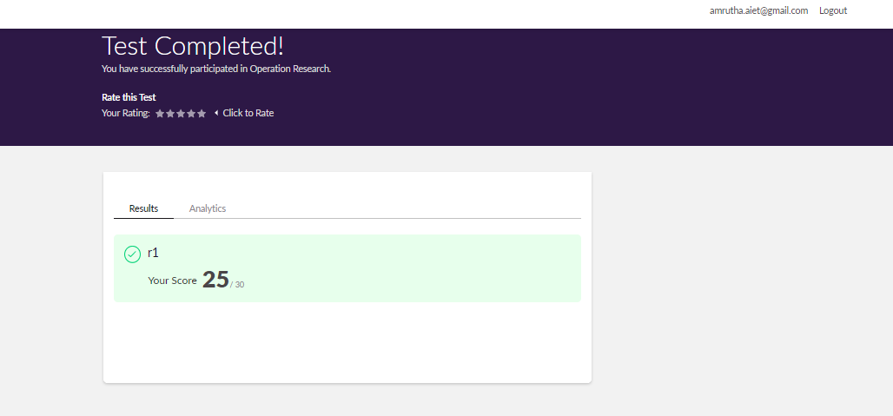

**Online Certification Details**

There was a webinar of 1hr and 30 minutes.

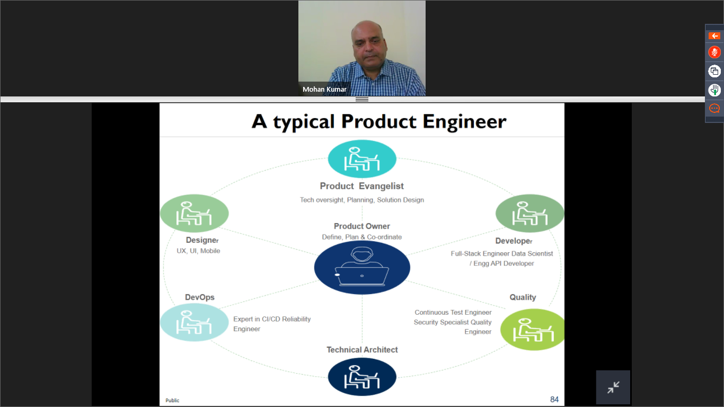

**Coding Challenge Details**

1. Take a string as input and find the #number of uppercase and lower case letters in the string and print the count.

Note: any spaces has to be ignored

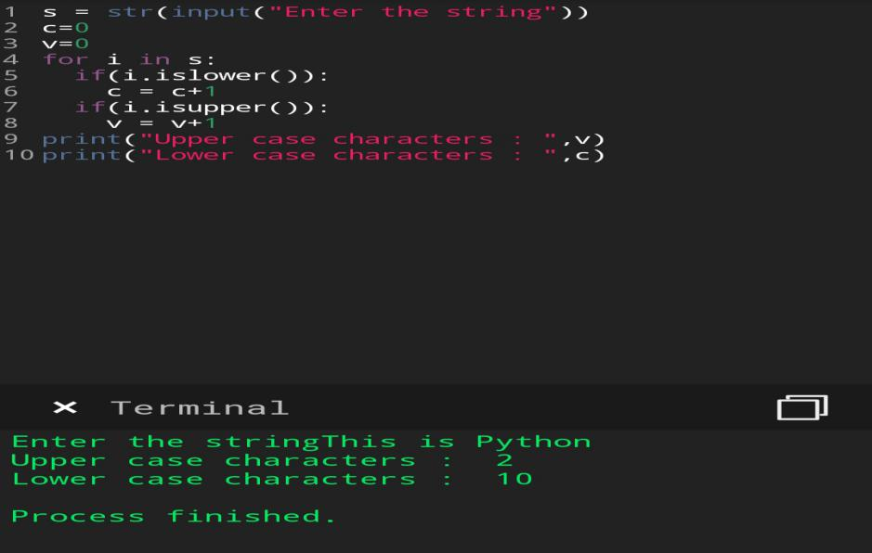

1. Python program which takes a string as #an input from user and print only the consonants in the string format.

