**DAILY ONLINE ACTIVITIES SUMMARY**

|  |  |  |  |  |  |  |  |  |
| --- | --- | --- | --- | --- | --- | --- | --- | --- |
| **Date:** | **31/05/2020** | | | | | **Name:** | **Amrutha M** | |
| **Sem & Sec** | **6th sem & A sec** | | | | | **USN:** | **4AL17CS005** | |
| **Online Test Summary** | | | | | | | | |
| **Subject** | | **-** | | | | | | |
| **Max. Marks** | |  | | * **Score** | | | **-** | |
| **Certification Course Summary** | | | | | | | | |
| **Course** | **Step into Robotic Process Automation** | | | | | | | |
| **Certificate Provider** | | | **Guvi** | | **Duration** | | | **3hr** |
| **Coding Challenges** | | | | | | | | |
| **Problem Statement:** - | | | | | | | | |
| **Status: not solved** | | | | | | | | |
| **Uploaded the report in GitHub** | | | | | **yes** | | | |
| **If yes Repository name** | | | | | <https://github.com/Amrutha-M/Online-Coding> | | | |
| **Uploaded the report in slack** | | | | | **yes** | | | |

CERTIFICATION COURSE

Course completed

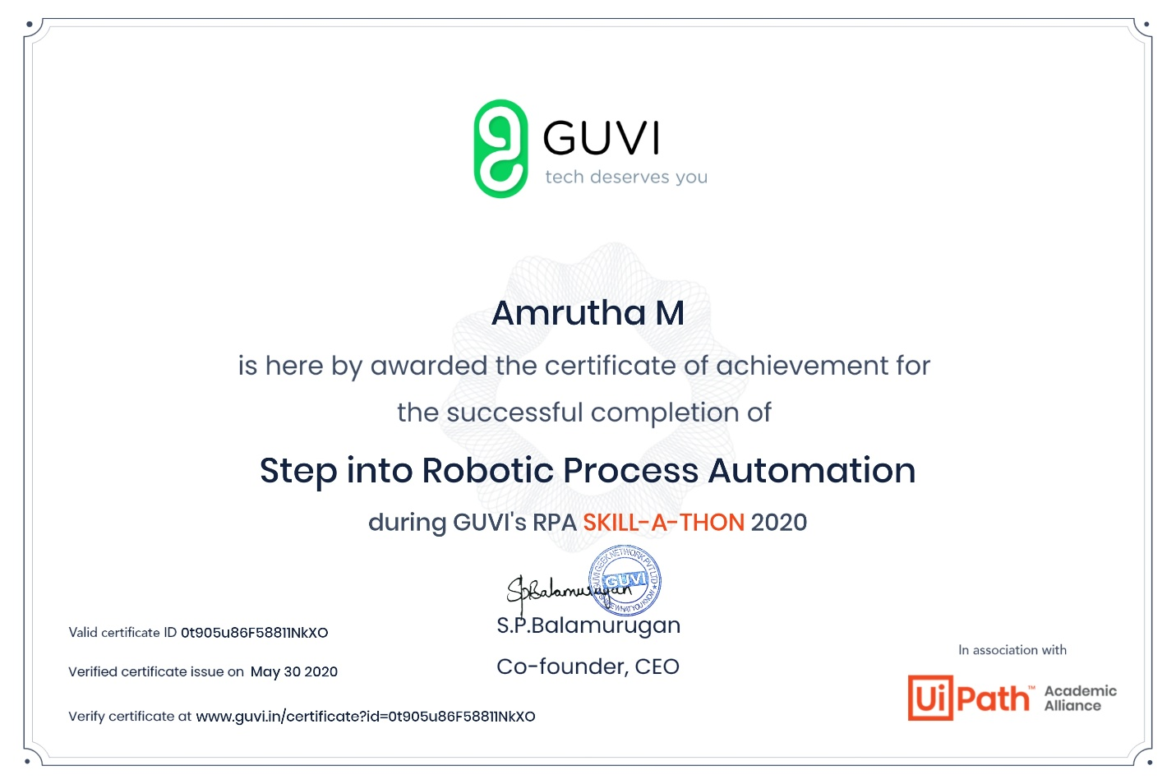Certificate: