Full Stack Development with MERN: Project Documentation
1. Introduction
Project Title: SmartBridge - Customer Care Registry
Developer: Amrutha Varshini Mannem (Sole Developer: Full Stack Development, Database Configuration, and Backend Architecture)

2. Project Overview
Purpose: The Customer Care Registry is a centralized system designed to record and manage customer interactions, issues, and feedback. It enables businesses to streamline support processes, track inquiries, and analyze trends to enhance service quality. By maintaining a comprehensive history of customer interactions, the registry ensures consistency in responses, identifies recurring pain points, and aids in proactive issue resolution.
Features:
Role-Based Access: Dedicated dashboards and workflows for Customers, Agents, and Admins.
Complaint Management: Customers can raise, track, and view the status of complaints. Admins can assign them, and Agents can resolve them.
User Profiles: Customizable fields for customer profile creation and contact management.
Feedback System: Interactive rating and feedback mechanism for resolved issues.
Communication History: Maintains a record of interactions to ensure a consistent customer experience.
3. Architecture
Frontend: Built using React.js with Vite as the build tool. It utilizes React Router for seamless single-page application (SPA) navigation and the Context API for global state management (specifically for User Authentication). The UI features a modern, 3D-textured design with a purple, royal blue, and white color scheme.
Backend: Developed following the Model-View-Controller (MVC) architectural pattern using Node.js and Express.js.
Model Layer: Handles data schemas and database operations using Mongoose.
View (Routing) Layer: Defines RESTful API endpoints and handles HTTP requests.
Controller Layer: Acts as the intermediary, processing requests, validating data, and returning responses.
Database: Utilizes MongoDB, a NoSQL database, managed via Mongoose. The schema is designed around key entities: CUSTOMER, INQUIRY, COMPLAINT, FEEDBACK, REQUEST, AGENT, and ADMIN. Relationships are mapped such that a Customer can submit multiple interactions (1:N), and Agents/Admins manage these interactions.

4. Setup Instructions
Prerequisites:
Node.js (v16 or higher)
MongoDB (Local instance or MongoDB Atlas)
Git
VS Code (Recommended IDE)
Installation:
Clone the repository: git clone [repository-url]
Navigate to the root directory: cd Customer-Care
Backend Setup:
Navigate to the server folder: cd server
Install dependencies: npm install
Create a .env file and add:
Env
PORT=8000
MONGO_URI=mongodb://localhost:27017/customer_care_db
JWT_SECRET=your_super_secret_jwt_key
NODE_ENV=development
Frontend Setup:
Navigate to the client folder: cd ../client
Install dependencies: npm install
5. Folder Structure
Client (Frontend):
Text
client/
├── src/
│ ├── components/ # Reusable UI components (Dashboard, Forms, Cards)
│ ├── context/ # React Context for Auth state management
│ ├── pages/ # Main page components (Login, Register, Landing)
│ ├── App.jsx # Main routing and layout configuration
│ └── main.jsx # React entry point
├── public/
└── package.json

Server (Backend):

Text
server/
├── config/ # Database connection (db.js)
├── controllers/ # Business logic (authController, complaintController)
├── middleware/ # Auth and role-based protection middleware
├── models/ # Mongoose schemas (User, Complaint, etc.)
├── routes/ # API endpoint definitions
├── .env # Environment variables
├── index.js # Express server entry point
└── package.json
6. Running the Application
To run the application locally, open two separate terminal windows:
Frontend: cd client then npm run dev (Runs on http://localhost:5173)
Backend: cd server then npm run dev (Runs on http://localhost:8000)
7. API Documentation
Authentication Routes (/api/auth)
POST /register: Creates a new user (Customer, Agent, or Admin).
POST /login: Authenticates user and returns a JWT token.
GET /me: Retrieves the currently logged-in user's profile (Protected).
Complaint Routes (/api/complaints)
GET /: Retrieves complaints (filtered by role).
POST /: Creates a new complaint (Customer only).
PUT /:id: Updates complaint status or details (Agent/Admin).
DELETE /:id: Deletes a complaint (Admin only).

8. Authentication
Authentication and authorization are handled using JSON Web Tokens (JWT) and bcryptjs.
Registration/Login: Passwords are hashed using bcrypt. Upon successful login, the server generates a signed JWT containing the user's ID and role.
Route Protection: A custom middleware (protect) intercepts incoming requests, verifies the JWT from the Authorization header, and attaches the user object to the request.
Role-Based Access Control (RBAC): An authorize(...roles) middleware ensures only specific roles can access sensitive endpoints.

9. User Interface

Landing Page: Features a hero section, feature highlights, and clear Call-to-Action buttons.
Dashboards: Utilizes a glassmorphism sidebar navigation with role-specific menu items.
Forms: Features 3D-textured inputs, interactive star-rating systems, and real-time validation.
Color Palette: Professional gradient themes using Royal Blue, Purple, and White.

10. Testing
Backend Testing: API endpoints were tested using Postman and custom Node.js scripts to verify CRUD operations, JWT generation, and middleware protection.
Frontend Testing: Manual UI/UX testing was conducted to ensure responsive design, proper routing, state persistence, and seamless integration with backend APIs.
11. Screenshots or Demo
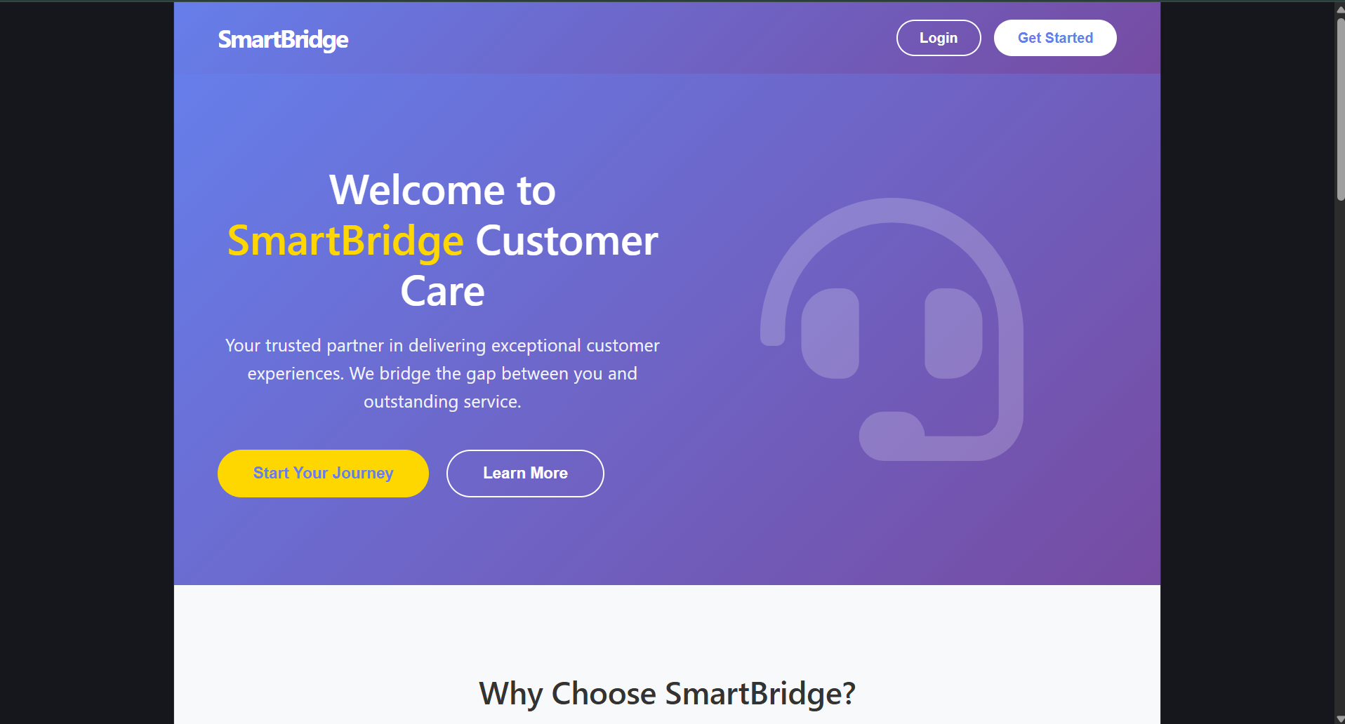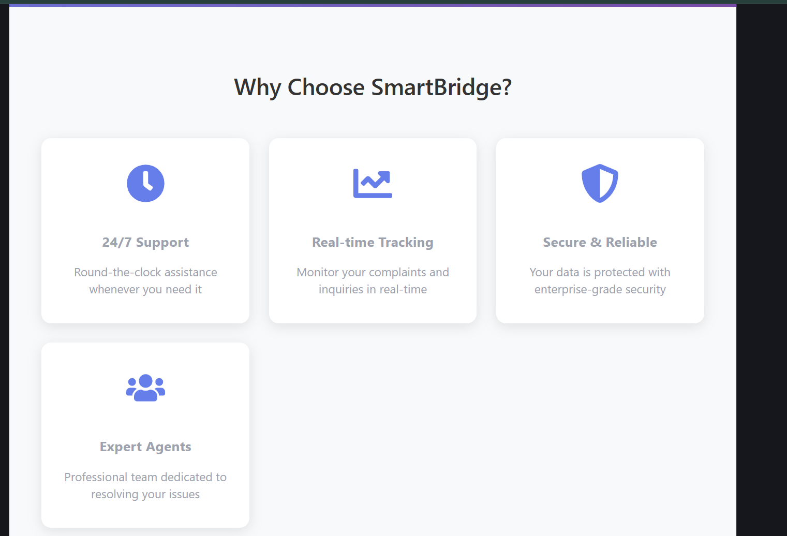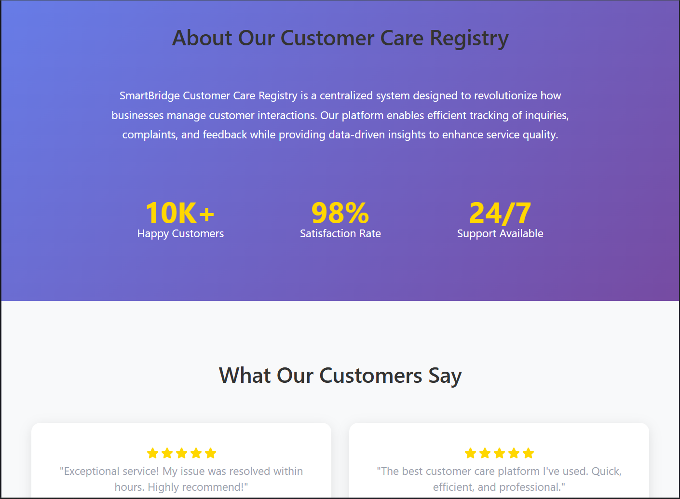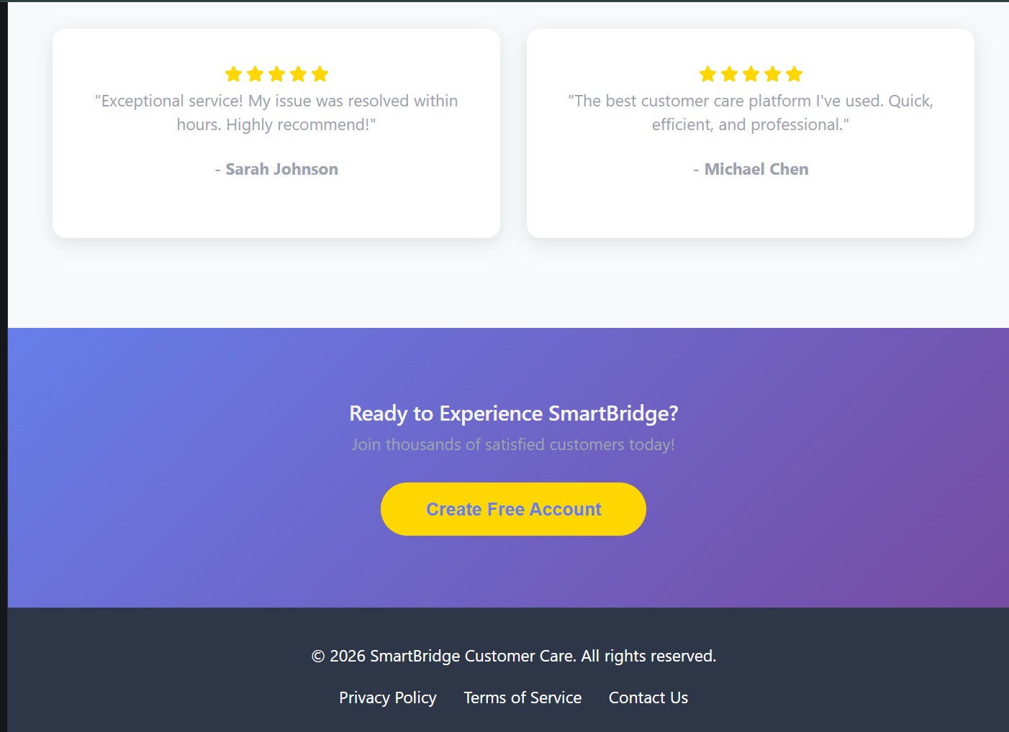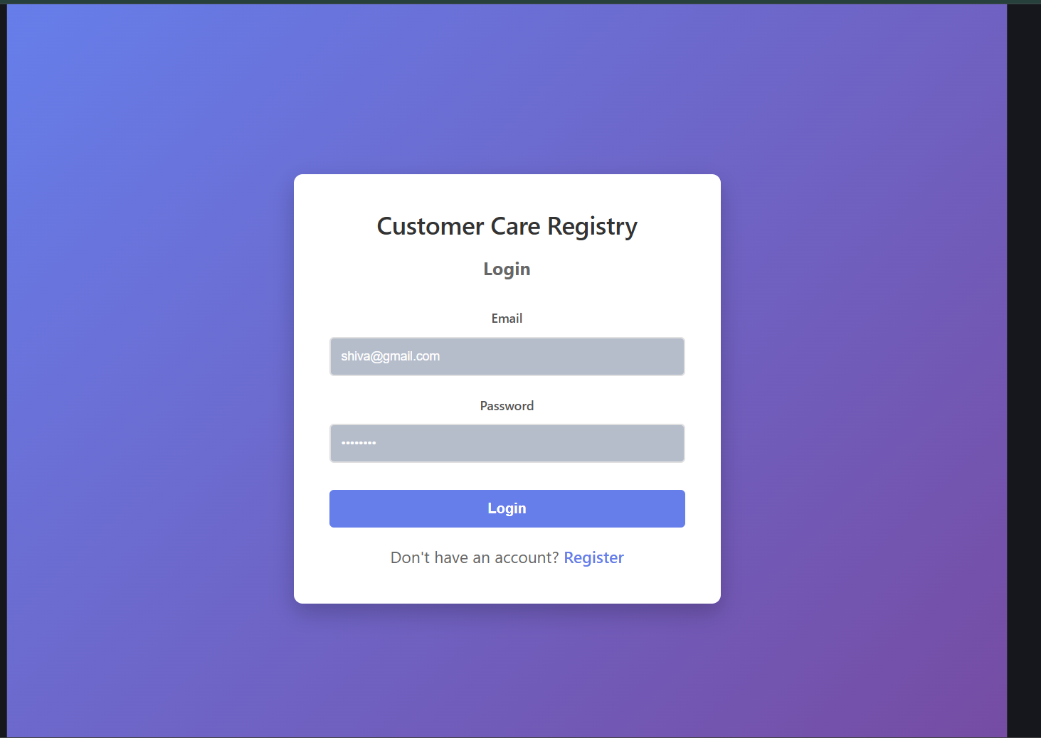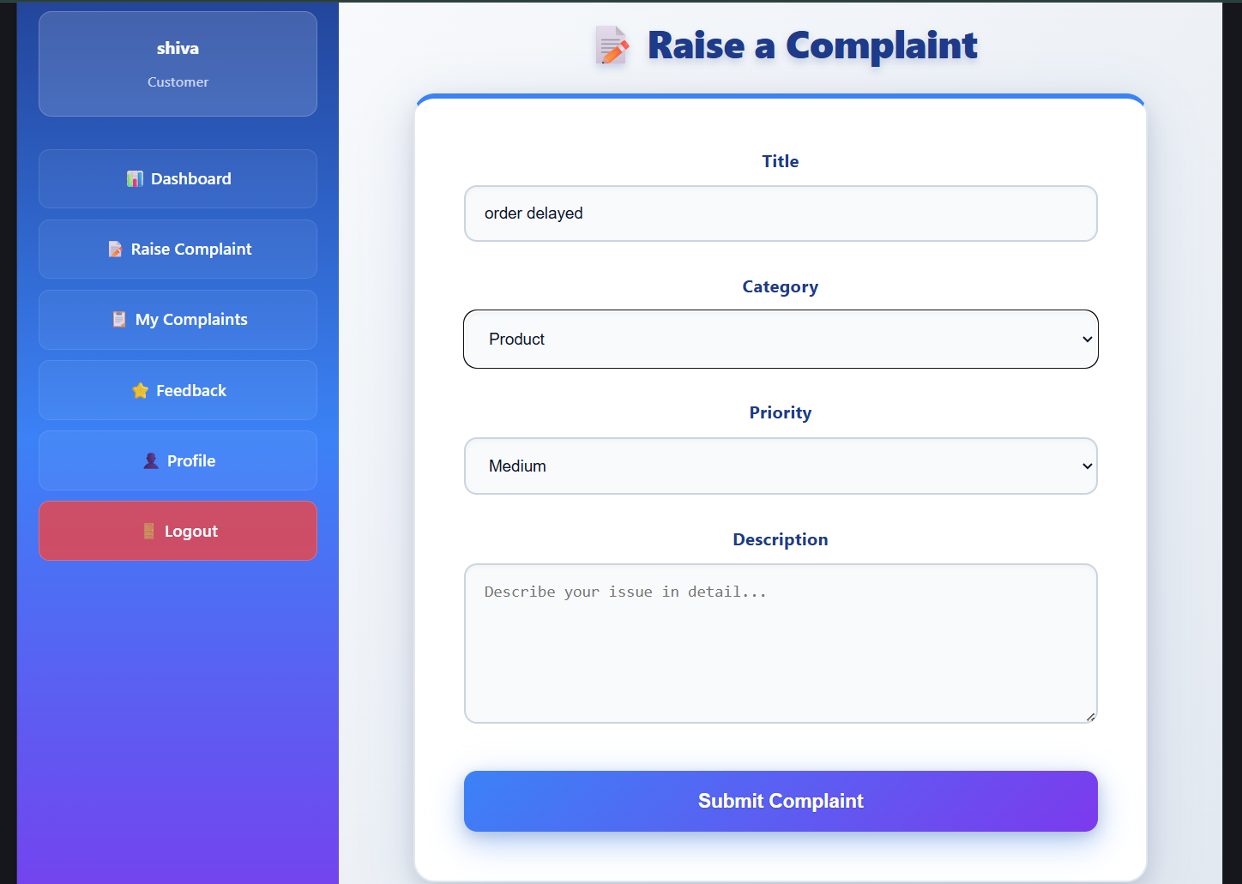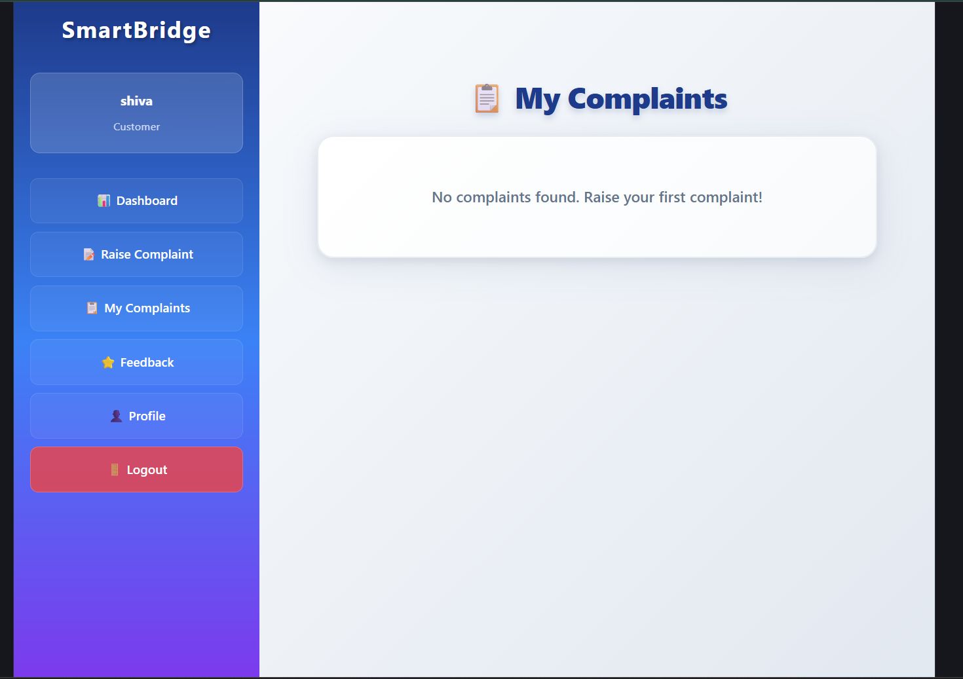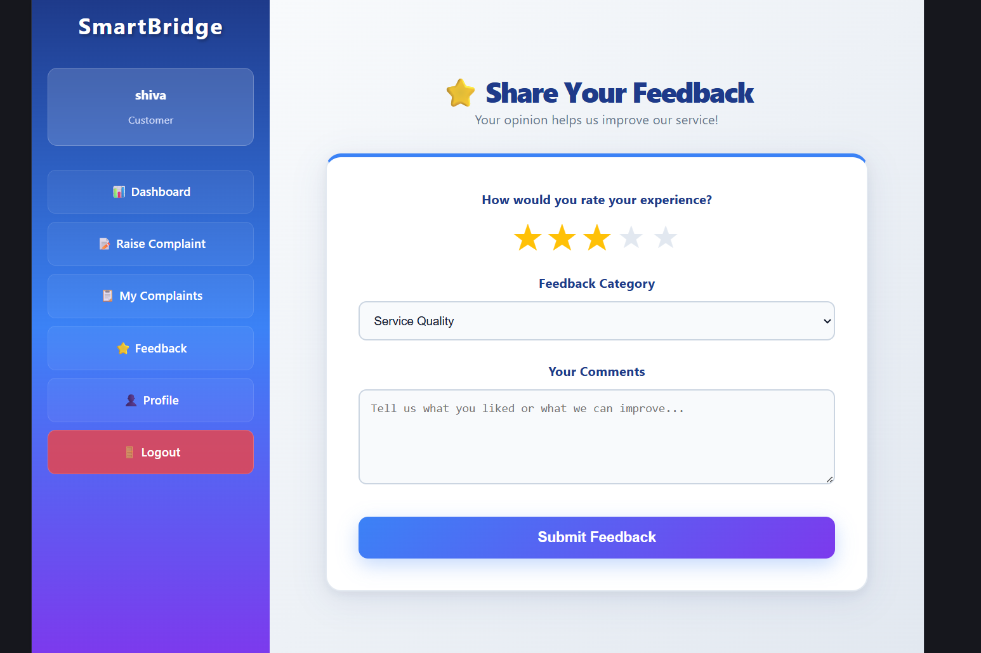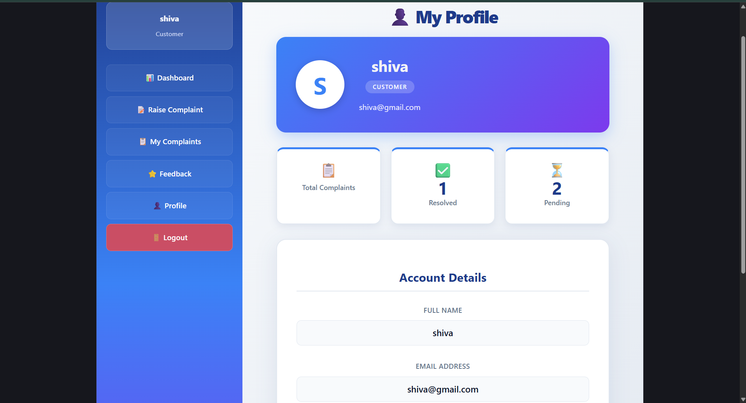
12. Known Issues
File Attachments: The current complaint model supports attachment URLs, but actual file uploading (e.g., to AWS S3 or Cloudinary) is not yet fully integrated into the UI.
Real-time Chat: The communication channel is currently simulated and does not yet use WebSockets for live messaging.
13. Future Enhancements
Real-time Notifications: Integrate Socket.io for live chat and instant notifications.
Email Integration: Use Nodemailer to send automated email alerts for status changes.
Advanced Analytics: Implement charting libraries (like Chart.js) in the Admin Dashboard.
Third-Party SMS: Integrate an SMS gateway (like Twilio) for text message updates.

