1. Install drupal 8.8.5

2. Install admin Tool bar to use admin tool bar and enable the module

3. Install conference lite theme go to settings and add theme slogan and logo

4. To create banner slide show on the front page install views slideshow module and enable it

5. create libraries folder-->jquery.cycle-->jquery.cycle.all (jquery plugin for slideshow)

6. To create responsive slide show install flexslider module and library and enable it

--> How to create responsive slideshow on the front page

1.Install libraries API module

2.Install flexslider module in the modules folder and create libraries folder in the root folder and extract flexslider libraries

3.Create custom content type and add image field--> go to that content type and add images to that field

4.create view

5 In view settings -->add fields of that content type and hide the label (uncheck exclude from display)

6. **In multiple field settings uncheck the same row paragraph(it is in field setting do it while adding fields and in configure field settings)

7. Place the view block in banner block

7. To create responsive menu on the main navigation install superfish module and enable it

---> extract superfish library and jquery easing in libraries folder

---> install superfish module and enable it

----> go to structure and create menu and add respective links

----> Remove the current navigation that it has in the header

----> Place the superfish block(menu name that you created) in the header navigation

8. Webform module

--> Install webform, ctools, views and token modules

1. download webform module

2. enable webform and webform UI

3. go to structure-->webform-->configuration-->libraries(download and install in libraries folder)

4. go to advanced section and uncheck CDN

----------------------------------------------------------

Sending E-mails

1. install maillog module

2. go to configuration and maillog settings uncheck emailto be sent and display image only middle row should be checked

3. go to structure->webform->settings->emails/handler

4. Entity print module is used to download submission form in pdf format

5. To create webform as a page enable webform node.

----------------------------------------------------------

How to Install Full view calendar module

1. Install full view calendar module and enable it.

2. create content types related to your events and add specific fields and start date and end date.

3. create content for the content type.

4. create view select block and pager

5. in filter criteria go to add tab beside that dropdown select add/rearrange and remove event content type

6. click again add tab and search content type select and apply

7.configure filter criteria select (operator) is one of and check created content types and click apply

8. add fields in fields section.

9. in full calendar display settings--> add particular fields and colors and save

Your fullcalendar view is ready.

------------------------------------------------------------------------------------

Simple google map

1. Install simple google map

2. add text plain field to the block type

3. go to manage display and the that text filed settings to map

------------------------------------------------------------------------------------

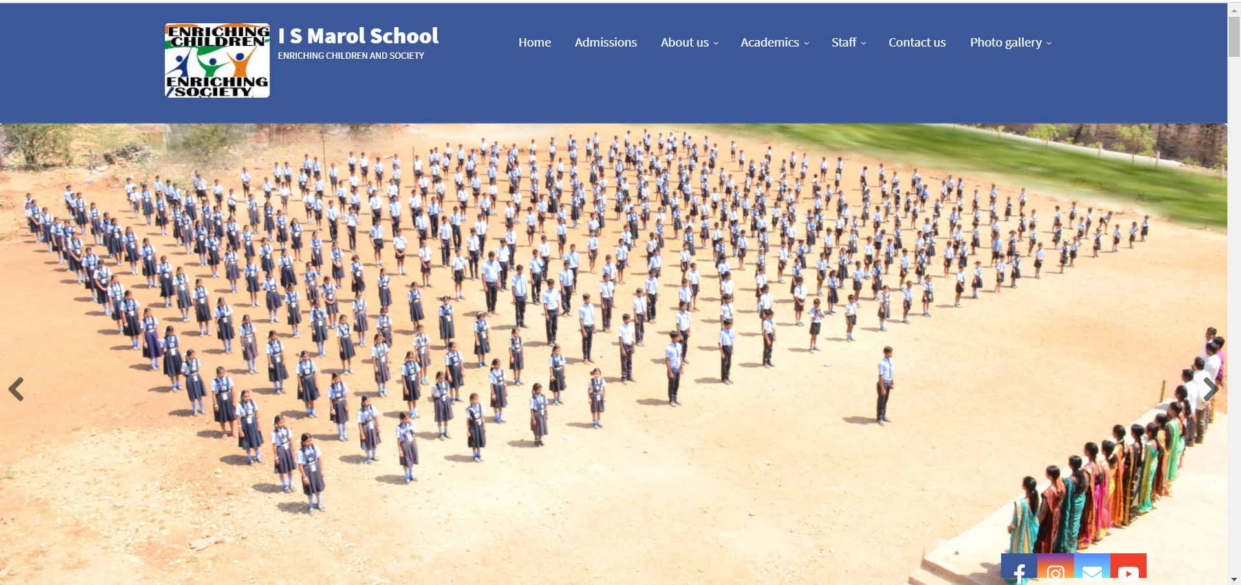

[Live Preview](https://www.ismarol.org)