**Design view:**

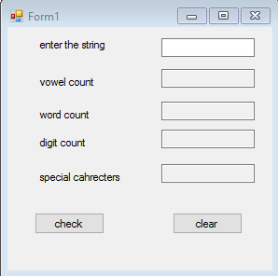

**Controls used:**

|  |  |  |
| --- | --- | --- |
| control | name | properties |
| Label | textinput,textvowel,textdigit,textword,textspecial | text |
| Text box | txtinput,txtsum,txtrev | Text,read only |
| button | Btncal,btnclear | text |

