1. Write a program to find the sum of digit and check palindrome or not and display the results in text box and label.

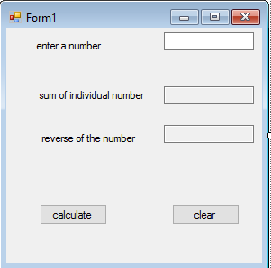**Design view:**

**Controls used:**

|  |  |  |
| --- | --- | --- |
| control | name | properties |
| Label | lblinput,lblsum,lblrev,lblpalin | text |
| Text box | txtinput,txtsum,txtrev | Text,read only |
| button | Btncal,btnclear | text |

**Code for button calculate:**

Private Sub btncal_Click(ByVal sender As System.Object, ByVal e As System.EventArgs) Handles btncal.Click

Dim num, sum, rev, r, temp As Integer

num = Val(txtinput.Text)

temp = num

rev = 0

sum = 0

While (num <> 0)

r = num Mod 10

rev = rev * 10 + r

sum = sum + r

num = num / 10

End While

txtsum.Text = sum

txtrev.Text = rev

If temp = rev Then

lblpalin.Text = "number is pallindrome"

Else

lblpalin.Text = "number is not a pallindrome"

End If

End Sub

**Code of button clear:**

Private Sub btnclear_Click(ByVal sender As System.Object, ByVal e As System.EventArgs) Handles btnclear.Click

txtinput.Text = ""

txtrev.Text = ""

txtsum.Text = ""

lblpalin.Text = ""

End Sub

End Class

**Output:**

