**GSM BASED PASSWORD PROTECTED CIRCUIT BREAKER USING ARDUINO**

A report submitted in partial fulfillment of the requirements

for the award of

**Bachelor of technology**

in

**Electronics and Communication engineering**

By

**B.Tejaswi B.Amrutha**

**(21BQ1A0407) (22BQ5A0403)**

**K.N.V.Durga S.Kavyanjali**

**(22BQ5A0406) (22BQ5A0414)**

**Open-source Hardware Tools for electronics engineers**

**(skill oriented course)**

**DEPARTMENT OF ELECTROICS AND COMMUNICATION ENGINEERING**

**VASIREDDY VENKATADRI INSTITUTE OF TECHNOLOGY**

**(AUTONOMOUS)**

**(Approved by AICTE and permanently affiliated to JNTUK, Accredited by NBA and NAAC)**

**NAMBUR(V), PEDAKAKANI(M), GUNTUR-522508**

**JUNE 2023**

**DEPARTMENT OF ELECTROICS AND COMMUNICATION ENGINEERING**

**VASIREDDY VENKATADRI INSTITUTE OF TECHNOLOGY: NAMBUR**

**(AUTONOMOUS)**



**CERTIFICATE**

This is to certify that the mini project title **“****GSM BASED PASSWORD PROTECTED CIRCUIT BREAKER”** is a bonafide record of work done by **B. Tejaswi(21BQ1A0407), B. Amrutha(22BQ5A0403), K. N. V. Durga(22BQ5A0406), S. Kavyanjali (22BQ5A0414)** as part of the skill-oriented course **Open-Source Hardware Tools for Electronics engineers** in partial fulfillment of the requirement of the degree for bachelor of technology in electronics and communication engineering during the academic year 2022-23

**Mr. N. Durga Rao**

**Course coordinator Head of Department**

**DR. M. Y. BHANU MURTHY**

**DECLARATION**

We**,B.Tejaswi(21BQ1A0407),B.Amrutha(22BQ5A0403),K.N.V.Durga(22BQ5A0406), S.Kavyanjali(22BQ5A0414)** here by declare that the report entitled “**GSM BASED PASSWORD PROTECTED CIRCUIT BREAKER”** is done by us as part of the skill oriented course Open-Source Hardware Tools for Electronics Engineers “ in partial fulfillment of the requirement of the degree for bachelor of technology in electronics and communication Engineering during the academic year 2022-23

DATE:

PLACE: VVIT,Nambur **SIGNATURE OF THE CANDITATES**

**B.Tejaswi(21BQ1A0407)**

**B.Amrutha(22BQ5A0403)**

**K.N.V.Durga(22BQ5A0406)**

**S.Kavyanjali(22BQ5A0414)**

**ACKNOWLEDGEMENT**

We thank Dr. Y. Mallikarjuna Reddy, Principal, Vasireddy Venkatadri Institute of Technology, Nambur for providing us the resources for varying out the project.

Our sincere thanks to Dr. M. Y. Bhanu Murthy, Head of Department of ECE, for his co-operation and guidance which helped us to make our project successful and complete in all aspects.

We also express our sincere thanks and are grateful to our course coordinators Mr. N. Durga Rao, Assistant Professor, of Department of ECE, for motivating us to make our project successful and fully complete, we are grateful for their precious guidance and suggestions.

We also place our floral gratitude to all other teaching staff and lab technicians for their constant support and advices throughout the project.

**NAME OF THE CANDIDATES**

**B.Tejaswi(21BQ1A0407)**

**B.Amrutha(22BQ5A0403)**

**K.N.V.Durga(22BQ5A0406)**

**S.Kavyanjali(22BQ5A0414)**

**TABLE OF CONTENTS**

ABSTRACT

|  |  |  |
| --- | --- | --- |
| **Chapter. No** | **Contents** | **Page. No** |
| 1 | Introduction   * 1. Problem statement   2. Objectives   3. Methodology   4. Project layout | 1  1  1  2  2 |
| 2 | Literature Survey  2.1 Control system  2.2 GSM  2.3 Circuit breaker  2.4 Microcontroller  2.5 Relays | 3  3  5  6  9  11 |
| 3 | Hardware and software descriptions  3.1 Transistor as a switch  3.2 Arduino  3.3 Setting up the LCD  3.4 Interface the keypad to Arduino  3.5GSM module interface with Arduino  3.6 Block diagram  3.7 Wire diagram | 12  12  12  14  15  16  17  18 |
| 4 | System implementation and testing  4.1 System implementation  4.2 Practical circuit | 19  19  22 |

5 Conclusions and recommendations 23

5.1 Conclusions 23

5.2 Recommendations 24 REFERENCES 25

APPENDIX 26

**LIST OF FIGURES**

**Figure No. Title Page No.**

2.1 Uplink and downlink 6

3.1 Single relay channel module 12

3.2 Arduino 13

3.3 LCD with headers soldered on 14

3.4 3×4 Hex keypad 15

3.5 Internal structure and pin notation 15

3.6 SIM900A GSM module 16

3.7 Block diagram 17

3.8 Wire diagram 18

4.1 Upload the code 19

4.2 DC and AC supplies 20

4.3 Entering the password 20

4.4 Appearance of password in LCD 20

4.5 Accept the correct password 21

4.6 Change of password 21

4.7 GSM mode 21

4.8 The practical circuit in normal condition 22

4.9 The practical circuit after detach condition 22

**ABSTRACT**

In our daily lives, security is the primary concern when engaging in any activity. In today's world, the accidental death of a lineman is frequently reported and documented. Looking at the current working style, a safety measure to protect the operator is found to be very necessary in this direction. The electric lineman safety system is intended to control the control panel doors and circuit breaker using a password for safety. Critical electrical accidents involving linemen are on the rise, which may be due to a lack of communication and coordination between maintenance personnel and electric substation personnel. The proposed system provides a solution that ensures the safety of linemen. The lineman is in charge of turning the power to the line on and off. The system is set up so that a password is required to access the control panel and circuit breaker (ON/OFF) doors.

The lineman requests and receives a secure password from the control room for the information on that line. This request is registered, and a password is sent to the lineman's mobile phone and the control panel GSM module for further processing. The password is entered using the matrix keypad that is linked to the Arduino Uno microcontroller. The password entered is compared to the password received by the control panel GSM receiver. If the password is entered correctly, the circuit breaker ON/OFF and door OPEN/CLOSE features are enabled, allowing the lineman to perform the repair. If an introducer tries to operate the mechanism three times with the wrong password, it will display a message on the LCD display and send a message to the control room about unauthorized access to the system for safety reasons.

**CHAPTER 1**

**INTRODUCTION**

In previous years, the problem of lack coordination between the electric power station and the maintenance team that in switch off the circuit breakers during the line men on their work or has not finished yet removing or clearing faults, causing a high damage including injury the team of maintenance with an electric shock may lead to death or combustion at least, also include damages to the equipment’s that use.

So there must be a way to secure and gives a protection to the line man or the maintenance team by not returning the circuit breaker while the maintenance team on a work and that by the line man himself and this insurance is in the form of a password entered by a keypad located in the station, or by a sending a message to the controller include the password.

### Problem Statement

To give an environment to the line man about no one can return the line unless he get finished his work we made a circuit breaker based with password to achieve a safely system to the team that work on maintenance whatever it is.

A circuit breaker is an automatically operated electrical switch designed to protect an electrical circuit from damage caused by overload or short circuit. Its basic function is to detect a fault condition and interrupt current flow. Unlike a fuse, which operates once and then must be reset (either manually or automatically) to resume normal operation. When operate manually we see fatal electrical accidents to the line man are increasing during the electric line repair due to the lack of communication and coordination between the maintenance staff and the electric substation staff.

### Objectives

The main objectives of this study are to:

* Design of Password Based Circuit Breaker circuit.
* Implementation of Password Based Circuit Breaker circuit.
* Simulate of controlling Password Based Circuit Breaker circuit.

1

### 1.3 Methodology

* Study all of previous studies.
* Research about circuit breaker types.
* Research about keypad, LCD and GSM module.
* Drawing the block and wire diagram.
* Starting with the programming logic.
* Design of Password Based Circuit Breaker.

### Project Layout

This project consists of five chapters: Chapter One gives an introduction about the principles of the project, in addition its reasons, motivation and objectives. Chapter Two discusses the theoretical background of Control Systems, global system for mobile (GSM) System, Microcontroller System, circuit breaker Operated. Chapter Three describe the mechanical part of relay, The electrical part, Software and Hardware. Chapter Four shows the System Implementation and the experimental results. Finally, Chapter five provides the conclusion and recommendations.

2

# CHAPTER-2

## LITERATURE REVIEW

#### Control System

There are two major divisions in control theory, namely, classical and modern, which have direct implications over the control engineering applications. The scope of classical control theory is limited to single-input and single-output (SISO) system design, except when analyzing for disturbance rejection using a second input. The system analysis is carried out in the time domain using differential equations, in the complex-s domain with the Laplace transform, or in the frequency domain by transforming from the complex-s domain. Many systems may be assumed to have a second order and single variable system response in the time domain. A controller designed using classical theory often requires on-site tuning due to incorrect design approximations. Yet, due to the easier physical implementation of classical controller designs as compared to systems designed using modern control theory, these controllers are preferred in most industrial applications. The most common controllers designed using classical control theory is Proportional Integral-Derivative controllers (PID).

A less common implementation may include either or both a Lead and Lag filter. The ultimate end goal is to meet requirements set typically provided in the time-domain called the Step response, or at times in the frequency domain called the Open-Loop response. The Step response characteristics applied in a specification are typically percent overshoot, settling time, etc. The Open-Loop response characteristics applied in a specification are typically Gain and Phase margin and bandwidth. These characteristics may be evaluated through simulation including a dynamic model of the system under control coupled with the compensation model. In contrast, modern control theory is carried out in the state space, and can deal with multiple- input and multiple-output (MIMO) systems. This overcomes the limitations of classical control theory in more sophisticated design problems, such as fighter aircraft control, with the limitation that no frequency domain analysis is possible.

3

In modern design, a system is represented to the greatest advantage as a set of decoupled first order differential equations defined using state variables. Nonlinear, multivariable, adaptive and robust control theories come under this division. Matrix methods are significantly limited for MIMO systems where linear independence cannot be assured in the relationship between inputs and outputs.

A control system is a device, or set of devices, that manages, commands, directs or regulates the behavior of other devices or systems. Industrial control systems are used in industrial production for controlling equipment or machines.There are two common classes of control systems, open loop control systems and closed loop control systems. In open loop control systems output is generated based on inputs. In closed loop control systems current output is taken into consideration and corrections are made based on feedback. A closed loop system is also called a feedback control system.

#### 2.1.1 Open-loop control systems

In an open-loop control system, the controller independently calculates exact voltage or current needed by the actuator to do the job and sends it. With this approach, however, the controller never actually knows if the actuator did what it was supposed to because there is no feedback. This system absolutely depends on the controller knowing the operating characteristics of actuator.

Open-loop control systems are appropriate in applications where the actions of the actuator on the process are very repeatable and reliable. Relays and stepper motors are devices with reliable characteristics and are usually open-loop operations. Actuators such as motors or flow valves are sometimes used in open- loop operation, but they must be calibrated and adjusted at regular intervals to ensure proper system operation.

#### 2.1.2 Closed-Loop control systems

In a closed-loop control system, the output of the process (controlled variable) is constantly monitored by a sensor; the sensor samples the system output and converts this measurement into an electric signal that it passes back to the controller. Because the controller knows what the system is actually doing, it can make any adjustment necessary to keep the output where it belongs.

4

The signals from the controller to the actuator are the forward path, and the signal from the sensor to the controller is the feedback. The feedback signal is subtracted from the set point at the comparator.

The self-correcting feature of closed-loop control makes it preferable over open-loop control in many applications, despite the additional hardware required. This is because closed-loop system provides reliable, repeatable performance even when the system components themselves are not absolutely repeatable or precisely known [3].

#### Global System for Mobile Communications (GSM)

GSM is an acronym that stands for Global System for Mobile Communications. The original French acronym stands for Groupe Special Mobile. It was originally developed in 1984 as a standard for a mobile telephone system that could be used across Europe. It’s now an international standard for mobile service. It offers high mobility, subscribers can easily roam worldwide and access any GSM network.

GSM is a digital cellular network. At the time the standard was developed it offered much higher capacity than the current analog systems. It also allowed for a more optimal allocation of the radio spectrum, which therefore allows for a larger number of subscribers.

GSM offers a number of services including voice communications, Short Message Service (SMS), fax, voice mail, and other supplemental services such as call forwarding and caller ID.

Currently there are several bands in use in GSM. 450 MHz, 850 MHZ, 900 MHz, 1800 MHz, and 1900 MHz are the most common ones.

Some bands also have Extended GSM (EGSM) bands added to them, increasing the amount of spectrum available for each band. GSM makes use of Frequency Division Multiple Access (FDMA) and Time Division Multiple Access (TDMA).

GSM allows for use of duplex operation. Each band has a frequency range for the uplink (cell phone to tower) and a separate range for the downlink

5

(tower to the cell phone). The uplink is also known as the Reverse and the downlink shown in figure (2-1) is also known as the Forward. In this tutorial, I will use the terms uplink and downlink.

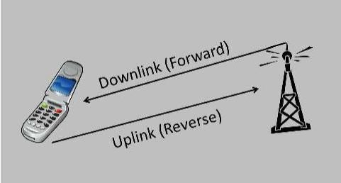

Figure (2-1): Uplink and downlink

**2.3 Circuit Breaker**

As a matter of fact the power system in necessary to control switch on or off whatever it was at normal condition or abnormal condition at various circuits like (transmission lines, distributors, generating plants) In earlier days switches and fuses were used to control , but there are disadvantages for using them , firstly when a fuse blows out it takes a quite sometimes to replace it secondly a fuse cannot interrupt the heavy fault current , we can conclude that the fuses and switches are limited to low voltage and small capacity circuits.

With advancement of power system the lines and equipment operate at very high voltage and carry a large currents this necessitates to employ a more dependable means of control such as it obtained by use of circuit breakers.

A circuit breaker is a piece of equipment which can make or break the circuit either manually or automatically under all conditions no-load, full-load, short- circuit this made circuit breaker very useful in switching or protection of various parts of the power system. As we mentioned that the circuit breaker incorporates manual or remote control .the latter employs relays and operates only under fault conditions.

6

#### 2.3.1 Operating principle

A circuit breaker essentially consists of fixed and moving contacts, called electrodes. These contacts remain closed and will not open automatically until and unless the system becomes faulty. Of course, the contacts can be opened manually or by remote control whenever desired. When a fault occurs on any part of the system, the trip coils of the circuit breaker get energized and the moving contacts are pulled apart by some mechanism, thus opening the circuit.

When the contacts of a circuit breaker are separated under fault conditions, an arc is struck between them. The current is thus able to continue until the discharge ceases. The production of arc not only delays the current interruption process but it also generates enormous heat which may cause damage the system or to the circuit breaker itself. Therefore extinguish the arc within the shortest possible time so that heat generated by it may not reach a dangerous value.

There are two methods of extinguishing the arc in circuit breakers the high resistance method and the low resistance or current zero method.

* High resistance method:

Arc resistance is made to increase with time so that current is reduced to a value insufficient to maintain the arc .the disadvantage of this method is that enormous energy is dissipated in the arc. Therefore, it is employed only in D.C circuit breakers and low-capacity A.C circuit breakers.

* Low resistance or current zero method:

This method is employed for arc extinction in A.C circuits only. It has small dielectric strength and can be easily broken down by the rising contact voltage.

#### There are important terms much used in the circuit breaker analysis

**Arc voltage**

Appears across the contacts of the circuit breaker during the arcing period.

#### Restriking voltage

It is a transient voltage appears across the contact at or near current zero during arc period

#### 7

#### Recovery voltage

It is the normal frequency (50 Hz) R.M.S voltage that appears across the contacts of the circuit breaker after final arc extinction it is approximately equal to the system voltage.

#### Cross-section of arc

The arc resistance increases with the decrease in area of X-section of the arc.

Before discussing the methods of arc extinction, it is necessary to discuss the

principles of arc extinction as

* P.D between the contact
* Ionized particles between the contact
* separate the contacts to such a distance that P.D becomes inadequate to maintain the arc
* The ionized particles between the contacts tend to maintain the arc. If the arc path is deionized the arc extinction will be facilitated. This may be achieved by cooling the arc or by bodily removing the ionized particles from the space between

the contacts.

#### Classification of circuit breaker

The classification of circuit breaker depends on method of extinction used.

Accordingly, circuit breakers may be classified into:

* Oil circuit breakers which employees some insulating oil for arc extinction
* Air-blast circuit breakers which use high pressure air-blast to extinguishing the arc
* Sulphur hexafluoride circuit breakers (SF6) gas is used for arc extinction.
* Vacuum circuit breakers in which vacuum is used for arc extinction.

As we mentioned before all classifications of circuit breakers depend on isolation system but all of above method have advantages and disadvantages. In the following section we can discuss the construction and working of these circuit breakers.

**8**

**2.4 Microcontroller**

A microcontroller is a single-chip computer. Micros suggests that the device is small, and controller suggests that it is used in control applications. Another term for microcontroller is embedded controller, since most of the microcontrollers are built into or embedded in the devices that controlling.

Microcontrollers have traditionally been programmed using the assembly language of the target device. Although the assembly language is fast, it has several disadvantages. An assembly program consists of mnemonics, which makes learning and maintaining a program written using the assembly language difficult. Also, microcontrollers manufactured by different firms have different assembly languages, so the user must learn a new language with every new microcontroller he or she uses. Microcontrollers can also be programmed using a high-level language, such as BASIC, PASCAL, or C. High-level languages are much easier to learn than assembly languages and also facilitate the development of large and Complex programs.

Microcontroller is a highly integrated chip that contains Central Processing Unit (CPU), Random Access Memory (RAM), Read Only Memory (ROM) and Input/output I/O ports. Unlike general-purpose computer, which also includes all of these components, microcontroller is designed for a 9 very specific task to control a particular system. As a result, the parts can be simplified and reduced, which cuts down on production cost.

#### 2.4.1Microcontroller components

A microcontroller basically contains one or more following components:

**Central processing unit**

Central Processing Unit is the brain of a microcontroller. CPU is responsible for fetching the instruction, decodes it, and then finally executed. CPU connects every part of a microcontroller into a single system. The primary function of CPU is fetching and decoding instructions. Instruction fetched from program memory must be decoded by the CPU.

**9**

**Memory**

Memory in a microcontroller is same as microprocessor. It is used to store data and program. A microcontroller usually has a certain amount of RAM and ROM (EEPROM, EPROM, etc.) or flash memories for storing program source codes.

Parallel input/output ports

Parallel input/output ports are mainly used to drive/interface various devices such as LCD’S, LED’S, printers, memories, etc. to a microcontroller.

**Serial interfacing ports**

Serial ports provide various serial interfaces between microcontroller and other peripherals like parallel ports.

**Timers and counter**

This is the one of the useful function of a microcontroller. A microcontroller may have more than one timer and counters. The timers and counters provide all timing and counting functions inside the microcontroller. The major operations of this section are perform clock functions, modulations, pulse generations, frequency measuring, making oscillations, etc. This also can be used for counting external pulses.

**Analog to digital converter**

Analog to Digital Converter (ADC) converters are used for converting the analog signal to digital form. The input signal in this converter should be in analog form (e.g. sensor output) and the output from this unit is in digital form.

The digital output can be used for various digital applications (e.g. measurement devices).

#### Digital to analog converter

Digital to Analog Converter (DAC) perform reversal operation of ADC conversion. DAC convert the digital signal into analog format. It usually used for controlling analog devices like DC motors, various drives, etc.

#### Interrupt control

The interrupt control used for providing interrupt (delay) for a working program. The interrupt may be external (activated by using interrupt pin) or internal (by using interrupt instruction during programming).

10

#### Special functioning block

Some microcontrollers used only for some special applications (e.g. space systems and robotics) these controllers containing additional ports to perform such special operations. This considered as special functioning block [4].

### Relays

Protective relaying is one of the several features of the power system design. Every part of the power system is protected. The factors affecting the choice of protection are type and rating of equipment . In a power system consisting of generators, transformers, transmission and distribution circuits, it is inevitable that sooner or later some failure will occur somewhere in the system when a failure occurs on any part of the system, it must be quickly detected and disconnected from the system. There are two principal reasons for it. Firstly, if the fault is not cleared quickly, it may cause unnecessary interruption of service to the customers. Secondly, rapid disconnection of faulted apparatus limits the amount of damage to it and prevents the effects of fault from spreading into the system.The detection of a fault and disconnection of a faulty section or apparatus can be achieved by using fuses or relays in conjunction with circuit breakers.

A fuse performs both detection and interruption functions automatically but its use is limited for the protection of low-voltage circuits only. For high voltage circuits (say above 3·3 kV), relays and circuit breakers are employed to serve the desired function of automatic protective gear. The relays detect the fault and supply information to the circuit breaker which performs the function of circuit interruption.

#### Protective relays

A protective relay it is a device that detect the fault and initiates the operation of the circuit breaker to isolate the defective element from the reset of the system. The relays detect the abnormal conditions in the electrical circuits by constantly measuring the electrical quantities which are different under normal and fault conditions. The electrical quantities which may change under fault conditions are voltage, current, frequency and phase angle. Through the changes in one or more of these quantities, the faults signal their presence, type and location to the protective relays. Having detected the fault, the relay operates to close the trip circuit of the breaker. This results in the opening of the breaker and disconnection of the faulty circuit. A typical relay circuit is shown in Fig. (2-10). This diagram shows one phase of 3-phase system for simplicity.

11

# CHAPTER-3

**SYSTEM HARDWARE AND SOFTWARE CONSIDERATION**

#### Using transistors as a switch

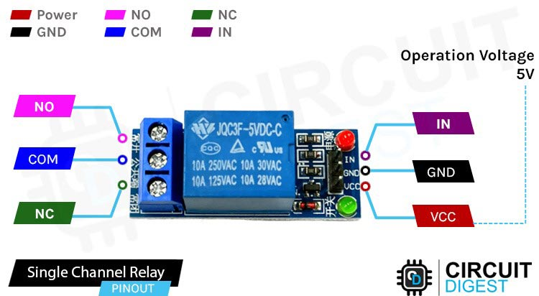

Figure (3-1): Single channel Relay module

**3.2 Arduino**

A simple transistorized circuit is enough to drive the relay. Here NPN transistor works as a switch. Giving a high signal to its base conduct it and energizes the relay coil and connection from COM-NC to COM-NO is done.

Arduino is an open-source electronics platform based on easyto-use hardware and software. Arduino boards are able to read inputs - light on a sensor, a finger on a button, or a Twitter message - and turn it into an output - activating a motor, turning on an LED, publishing something online. You can tell your board what to do by sending a set of instructions to the microcontroller on the board. To do so you use the Arduino programming language (based on Wiring), and the Arduino Software (IDE), based on Processing.

12

Over the years Arduino has been the brain of thousands of projects, from everyday objects to complex scientific instruments. A worldwide community of

makers - students, hobbyists, artists, programmers, and professionals - has gathered around this open-source platform, their contributions have added up to an incredible amount of accessible knowledge that can be of great help to novices and experts alike.

Arduino was born at the Ivrea Interaction Design Institute as an easy tool for fast prototyping, aimed at students without a background in electronics and programming. As soon as it reached a wider community, the Arduino board started changing to adapt to new needs and challenges, differentiating its offer from simple 8-bit boards to products for IoT applications, wearable, 3D printing, and embedded environments. All Arduino boards are completely open-source, empowering users to build them independently and eventually adapt them to their particular needs. The software, too, is open-source, and it is growing through the contributions of users worldwide.

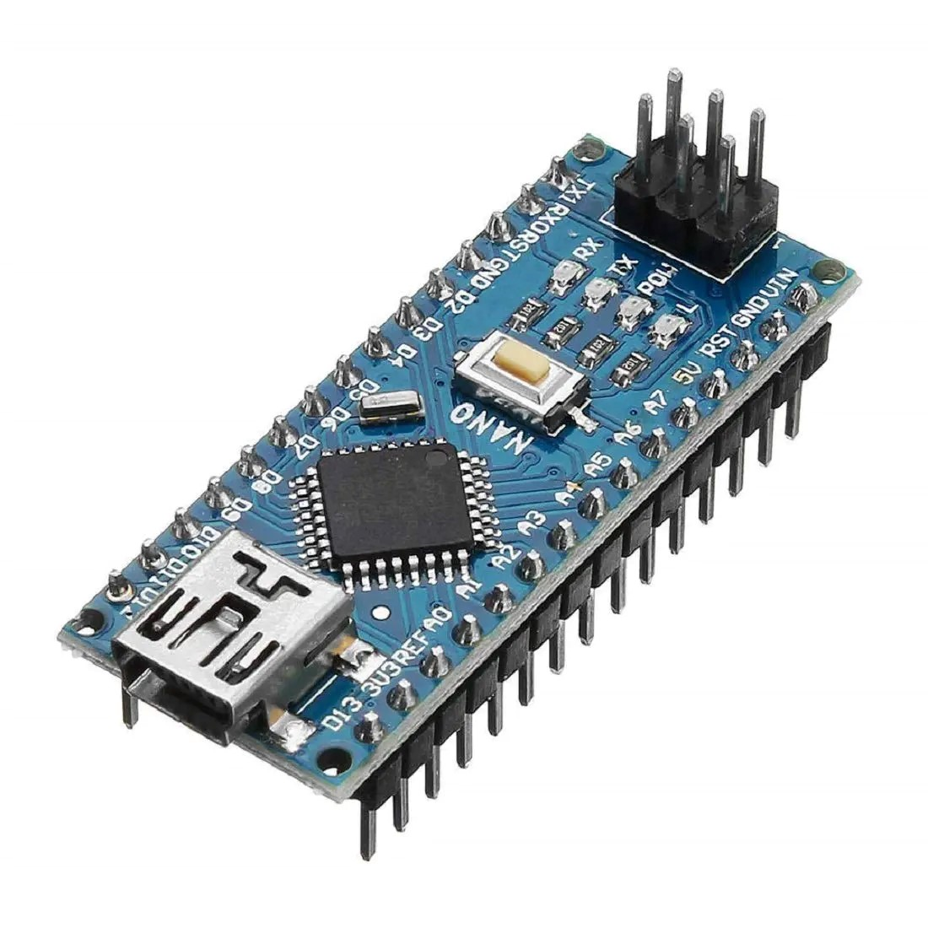

Fig(3-2) Arduino NANO

13

#### 3.3 Setting up the LCD

A parallel LCD screen These are extremely common and come in all kinds of shapes and sizes. The most common is a 16×2 character display with a single row of 16 pins (14 if it does not have a backlight). In this topic, we use a 16-pin LCD display that can show a total of 32 characters (16 columns and 2 rows).

If your display didn’t come with a 16-pin header already soldered on, you need to solder one on so that you can easily install it in your breadboard. With the header successfully soldered on, your LCD should look like the one shown in Figure (3-3).

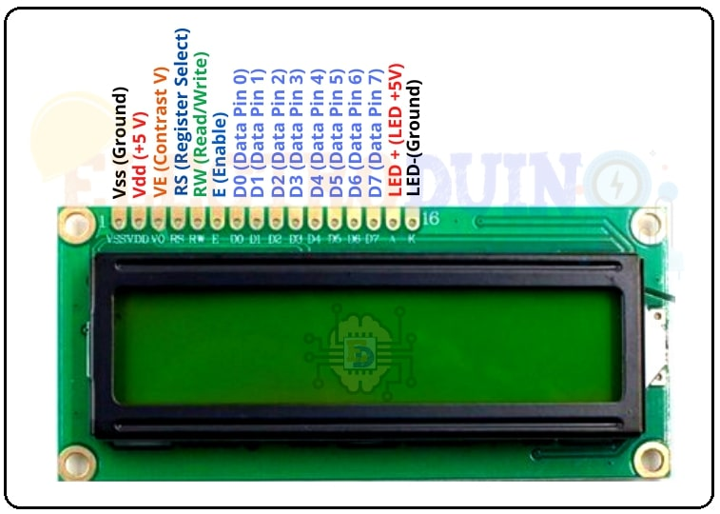

Figure (3-3): LCD with headers soldered on

And you can insert it into your breadboard. Next, you wire up your LCD to a breadboard and to your Arduino. All of these parallel LCD modules have the same pin-out and can be wired in one of two modes: 4-pin or 8-pin mode. You can accomplish everything you might want to do using just 4 pins for communication; that’s how you’ll wire it up. There are also pins for enabling the display, setting the display to command mode or character mode, and for setting it to read/write mode

14

#### 3.4 Interface the keypad to Arduino

A keypad is one of the most commonly used input devices in microprocessor applications shown in figure (3-4). In a standard keypad wired as an X-Y switch matrix, normally-open connect a row to a column when pressed.

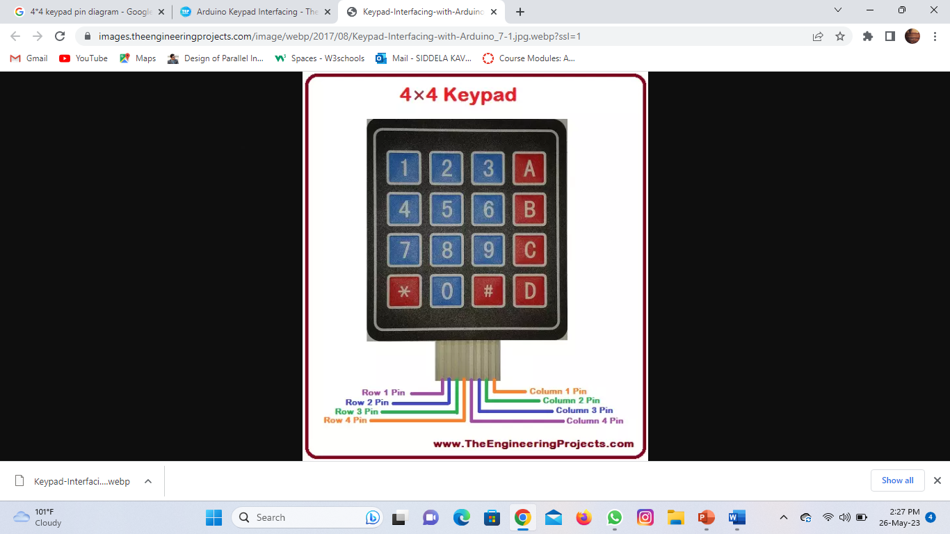

Figure (3-4): 4×4 Hex keypad

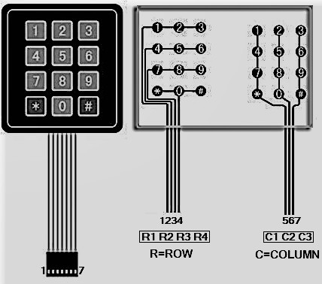

Figure (3-5): Internal structure and pin notation

15

#### 3.5 Gsm module interfacing with Arduino

shown in figure (3-6) There are two ways of connecting GSM module to Arduino. In any case, the communication between Arduino and GSM module is serial. So we are supposed to use serial pins of Arduino (Rx and Tx). You may connect the (**Tx**) pin of GSM module to (**Rx**) pin of Arduino and (**Rx**) pin of GSM module to (**Tx**) pin of Arduino. Also connect the ground pin of Arduino to ground pin of GSM module.

s

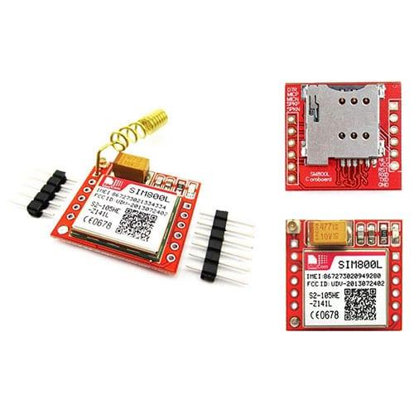

Figure (3-6): SIM900A GSM module

But the problem with this connection is that, while programming Arduino uses serial ports to load program from the Arduino IDE. If these pins are used in wiring, the program will not be loaded successfully to Arduino. So you have to disconnect wiring in Rx and TX each time you burn the program to Arduino. Once the program is loaded successfully, you can reconnect these pins and have the system working, to avoid this difficulty, we must be using an alternate method in which two digital pins of Arduino are used for serial communication.

16

We need to select two PWM enabled pins of Arduino for this method. So we choose pins 2 and 3 (which are PWM enabled pins). This method is made possible with the Software Serial Library of Arduino. Software Serial is a library of Arduino which enables serial data communication through other digital pins of Arduino. The library replicates hardware functions and handles the task of serial communication

#### 3.6 Block diagram

shown in figure (3-7). Describes how to control in relay contacts with a common signal (input) from keypad to the controller and the result appear on LCD screen, the relay does not change it contacts unless a common signal comes from the GSM module that represents on SMS to the controller or signal from keypad. GSM module will activate in case of receiving a signal from keypad.

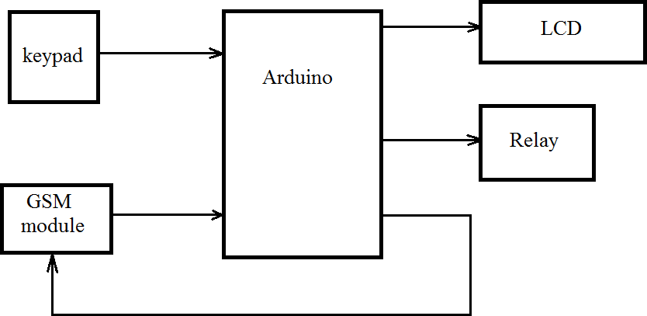

Figure (3-7) Block diagram

#### 17

#### 3.7 Wire diagram

Wire diagram is shown in figure (3-8) is network of wires showing how to connect the circuit components, it explains the signals requirement for the movability and the ON-OFF control, also it declare the power feeding lines for the circuit. Wire diagram describe how all wires connected between the system circuit components. Wire diagram shown below explain (shows) that the connections between the pins of controller and the other components that represent on (LCD screen, keypad, transistor, alarm, GSM module). Also shows the connection of relay contacts.

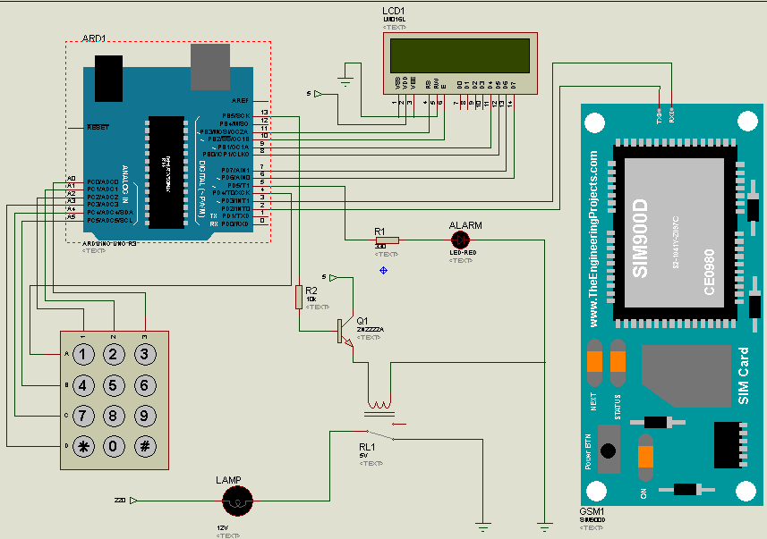

Figure (3-8): Wire diagram

18

# CHAPTER-4

**SYSTEM IMPLEMENTATION AND TESTING**

#### System Implementation

A circuit breaker that based on a password contain of a LCD screen and keypad and a relay with a load also GSM module were collected together and installed as described steps below:

The program of circuit breaker password written on Arduino software and

.hex file created.

The code shown in appendix upload by help of USB cable from Arduino application to Arduino board, and the diagram is connected shown in figure (4-1).

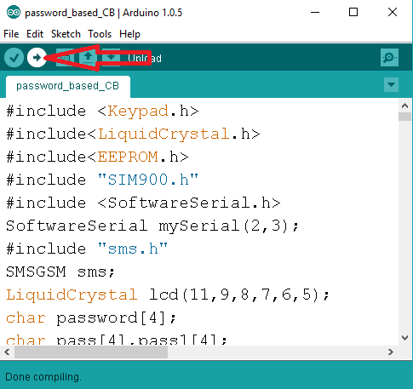

Figure (4-1):upload the code

A 5 volt DC supplies used to the controller. Also DC and AC supplies switched on that means we have about 230 volt on relay output, so do not touch the load shown in figure (4-2).

19

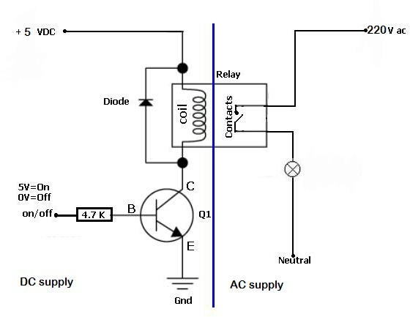

Figure (4-2):DC and AC supplies

LCD displays “Enter the password” that with a help of keypad shown in figure (4-3).

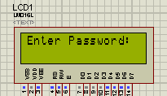

Figure (4-3): Entering the password

You can see on LCD screen the same number that you entered by keypad to get sure about the number that you should show in figure (4-4).

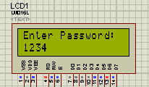

Figure (4-4): Appearance of password in LCD

20

Now, if the password is correct LCD shows that “accepted password” and at same time the pulse make the contacts of relay changes, but if password that you entered is wrong “wrong password” will appear on LCD screen and there is alarm will activate shown in figure (4-5).

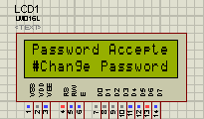

Figure (4-5): Accept the correct password

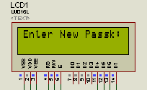It is not a certain password, a user can change the password by entered the bottom ‘#’ the program ask you to enter the old password and seriously the new password that you choose shown in figure (4-6)

Figure (4-6): Change of password

In case of entering the bottom ‘*’ the LCD shows “GSM mode” in this case keypad is not work, there is only on way to control on system and that by sending the write password on SMS message to the number of SD card that used. The same result from a keypad using will occurs in case of correct password or not.

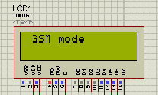

Figure(4-7): GSM mode

#### 21

#### 4.2 The practical circuit

The figures (4-8) and (4-9) shown the practical circuit in normal and after detach condition.

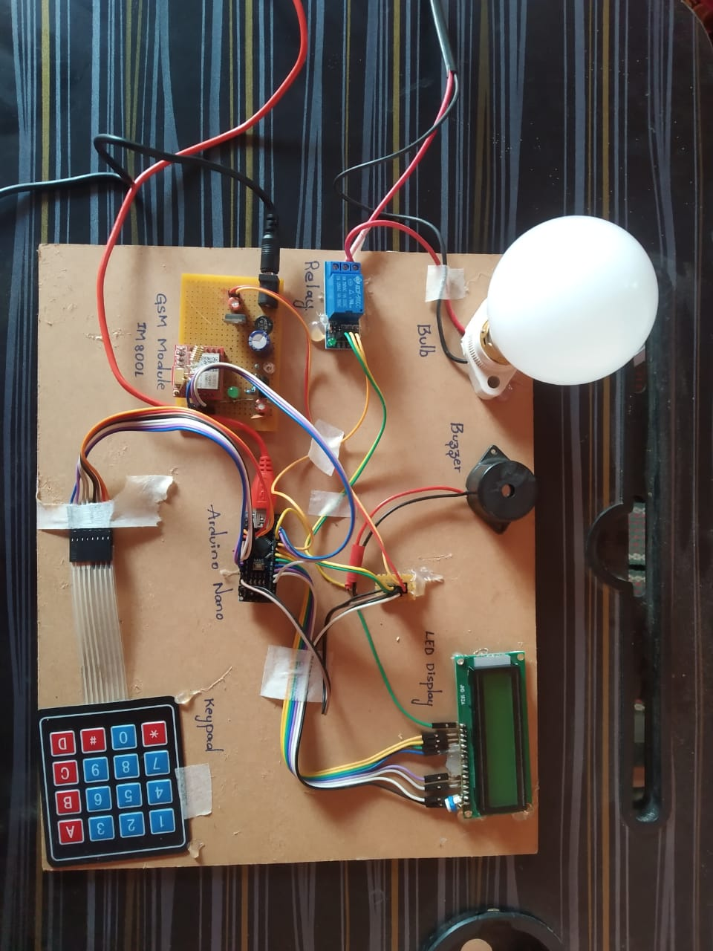

Figure (4-8): The practical circuit in normal condition

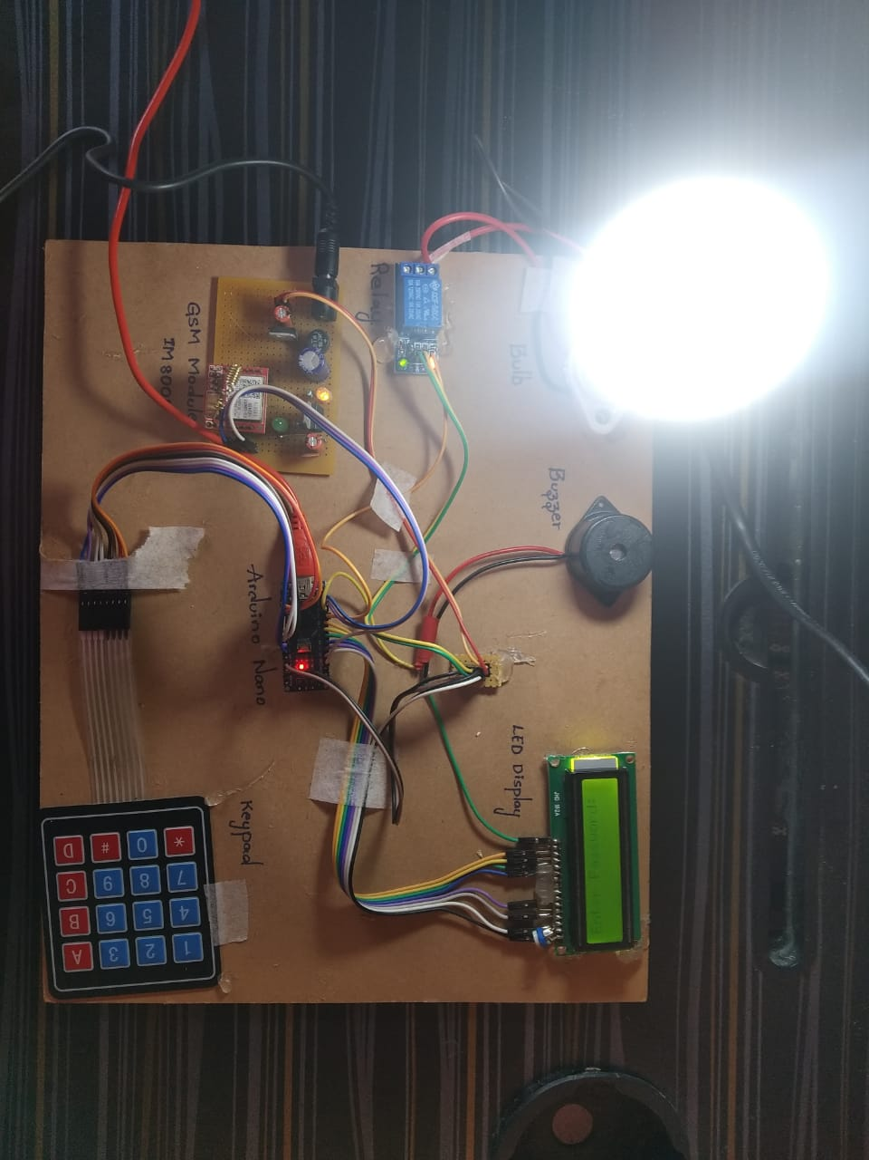

Figure(4-9): The practical circuit after execution condition

22

# CHAPTER-5

# CONCLUSION AND RECOMMENDATIONS

#### 5.1 CONCLUSION

A perfect protection has been achieved to line man, in whilst of increase of line man accident that happens while repairing the electrical lines due to the lack of communication between electrical substation and maintenance staff nowadays. Finally protective system has given to line man protection.

The solve of this problem clarified on using a password to turn ON/OFF circuit breaker. It is not a teaser to turn OFF circuit breaker the issue is that to turn ON circuit breaker whilst line man on a task that may cause a fire , blast , burning

, also we can’t ignore the damage that may cause burning the station this lead to financial losses.

The needle of turn off circuit breaker has represented on adding a buses to station or to treating (lines, transformers, generators … etc.). The manual part is using the keypad to entering password that will appear on LCD screen to be absolute about that you enter the password you preselected. The password will store on Arduino’s EEPROM and the output is to rotate a motor that separate a moving contact and break the circuit. Here a safety has provided to the line man because the moving contact will not move unless we entering the same password that line man select. In addition to alarm that has made in case that someone try to turn ON circuit breaker after he entering a wrong circuit breaker.

By using a global system mobile (GSM) an extra feature has gained represented on gaining time just the line man has to send the same password he selected before in a massage and the breaker will restart the circuit. of the above a multi features have introduced to power system generally and particular electrical protection system is to provide electrical protection from risk, burning, and gain time.

23

#### Recommendations

When we implemented to this project some obstacle appeared most of all solved,

little of it remained, therefor a lot of space for further improvement.

* The controller can receive a message only from a certain number that actually must be saved in the wizard include the password this will give a more security, no one can try to send a random password from any number because the controller does not receive any massage from any number except the number that saved in the wizard.
* Another feature can be added in nameable of reducing cost by use only one controller to control in many relays that depend on adjusting just on code.

24

**REFERENCES**

1. V.K Mehta, **“Principle of power system”,** S. Chand, 2005.
2. Wiley, **“Exploring Arduino”,** Tools and Techniques for Engineering Wizardry, India, 2013.
3. Christopher Kilian**, “Modern control technology”,** Cengage Learning, 2005.
4. Gunther Gridling, Bettina Weiss, **“Introduction to microcontroller”** , in Vienna University of Technology, 2007.

25

#### APPENDIX

*Arduino code:

#include <Keypad.h>

#include <SoftwareSerial.h>

SoftwareSerial mySerial(10, 11);

#include<LiquidCrystal.h>

LiquidCrystal lcd(2,3,4,5,6,7);

#define Password_Length 5

int buzzer = 9;

int relay = 8;

char Data[Password_Length];

char Master[Password_Length] = "1234";

byte data_count = 0, master_count = 0;

bool Pass_is_good;

char customKey;

const byte ROWS = 3;

const byte COLS = 4;

char hexaKeys[ROWS][COLS] = {

26

{'1', '3', '2', '*'},

{'4', '6', '5', '0'},

{'7', '9', '8', '#'}

// {'*', '0', '#', 'A'}

};

byte rowPins[ROWS] = {14, 15, 16};

byte colPins[COLS] = {17, 18, 19 ,20}; //8, 9, 7, 6 //5, 4, 3 ,2

Keypad customKeypad = Keypad(makeKeymap(hexaKeys), rowPins, colPins, ROWS, COLS);

void clearData();

byte flag1=0;

String incomingData; // for storing incoming serial data

String message = ""; // A String for storing the message

void SendSMS();

void send_message(String message);

void buz()

{

for(int k =0;k<2;k++)

{

digitalWrite(buzzer, HIGH);

27

delay(1000);

digitalWrite(buzzer, LOW);

delay(200);

}

}

void setup()

{

pinMode(buzzer, OUTPUT);

pinMode(relay, OUTPUT);

digitalWrite(relay, HIGH);

digitalWrite(buzzer, LOW);

lcd.begin(16, 2);

lcd.clear();

lcd.print("PASSWORD BASED ");

lcd.setCursor(0,1);

lcd.print("CIRCUIT BREAKER"); //

delay(2000);

digitalWrite(relay, LOW); //ON

Serial.begin(9600);

28

mySerial.begin(9600);

delay(1000);

SendSMS();

lcd.clear();

}

void loop()

{

lcd.setCursor(0,0);

lcd.print("Enter Password:");

customKey = customKeypad.getKey();

if (customKey){ // && flag1==1

Data[data_count] = customKey;

lcd.setCursor(data_count,1);

lcd.print(Data[data_count]);

data_count++;

}

if(data_count == Password_Length-1){

lcd.clear();

if(!strcmp(Data, Master)){

flag1=~flag1;

29

lcd.print("Password Correct");

delay(1000);

if(flag1==0x00)

{

digitalWrite(relay, LOW);

lcd.clear();

lcd.print("CIRCUIT BREAKER");

lcd.setCursor(0,1);

lcd.print(" ON ");

delay(2000);

send_message("CIRCUIT BREAKER ON ");

}

if(flag1==0xff)

{

digitalWrite(relay, HIGH);

lcd.clear();

lcd.print("CIRCUIT BREAKER");

lcd.setCursor(0,1);

lcd.print(" OFF ");

delay(2000);

send_message("CIRCUIT BREAKER OFF");

}

clearData();

lcd.clear();

}

30

else{

flag1=0;

lcd.print("Password Incorrect");

buz();

delay(1000);

//send_message("Password Incorrect");

//delay(1000);

clearData();

lcd.clear();

}

}

}

// LOOP END//

void clearData(){

while(data_count !=0){

Data[data_count--] = 0;

}

return;

}

void SendSMS()

31

{

lcd.clear();

lcd.setCursor(0, 0);

lcd.print("MODEM INIT....");

mySerial.println("AT"); //To send SMS in Text Mode

delay(1000);

mySerial.println("AT+CMGF=1"); //To send SMS in Text Mode

delay(1000);

mySerial.println("AT+CNMI=2,2,0,0,0"); //To send SMS in Text Mode

delay(1000);

mySerial.println("AT+CMGS=\"8074218334\"\r"); //Change to destination phone number 9494252144

delay(1000);

mySerial.println("GSM Modem! INIT...");//the content of the message

delay(200);

mySerial.println((char)26); //the stopping character Ctrl+Z

mySerial.write(0x1A);

delay(5000);

lcd.clear();

lcd.setCursor(0, 0);

lcd.print("MSG SENT");

delay(1000);

}

void send_message(String message)

{

32

lcd.clear();

lcd.setCursor(0, 0);

lcd.print("MSG SENDING.....");

mySerial.println("AT"); //To send SMS in Text Mode

delay(1000);

mySerial.println("AT+CMGF=1"); //To send SMS in Text Mode

delay(1000);

mySerial.println("AT+CNMI=2,2,0,0,0"); //To send SMS in Text Mode

delay(1000);

mySerial.println("AT+CMGF=1"); //Set the GSM Module in Text Mode

delay(1000);

mySerial.println("AT+CMGS=\"8074218334\""); // Replace it with your mobile number

delay(1000);

mySerial.println(message); // The SMS text you want to send

delay(1000);

mySerial.println((char)26); //the stopping character Ctrl+Z

mySerial.write(0x1A);

delay(3000);

lcd.clear();

lcd.setCursor(0, 0);

lcd.print("MSG SENT");

delay(1000);

}

33