APARTMENT MAINTENANCE MANAGEMENT SYSTEM
A PROJECT REPORT
Submitted by
AMRUTHAVALLI M
(Register Number: 240701037)
in partial fulfilment of the End Semester Examination for the course
CB23F35 –
LOW-CODE APPLICATION DEVELOPMENT USING ZOHO CREATOR
in
BACHELOR OF ENGINEERING
DEPARTMENT OF COMPUTER SCIENCE AND ENGINEERING

RAJALAKSHMI ENGINEERING COLLEGE
(An Autonomous Institution, Affiliated to Anna University, Chennai)
Rajalakshmi Nagar, Thandalam, Tamil Nadu – 602 105
October 2026

RAJALAKSHMI ENGINEERING COLLEGE
(An Autonomous Institution, Affiliated to Anna University, Chennai)
BONAFIDE CERTIFICATE
Certified that this project report titled “APARTMENT MAINTENANCE MANAGEMENT SYSTEM” is the bonafide work of AMRUTHAVALLI M (Register Number: 240701037), who carried out the individual project work on the Zoho Creator low-code platform for the course CB23F35 – Low-Code Application Development using Zoho Creator.
The report documents the application modules and interface evidence available in the submitted project screenshots. Details not visible in the evidence should be verified against the live application before final submission.
SIGNATURE  Dr. J. Manoranjini  HEAD OF THE DEPARTMENT  Department of Computer Science and Engineering  Rajalakshmi Engineering College  Thandalam – 602 105 | SIGNATURE  S. Kaviya  COURSE FACULTY  Assistant Professor  Department of Computer Science and Engineering  Rajalakshmi Engineering College

Submitted for the End Semester Examination (Individual Project) held on ____________________.
INTERNAL EXAMINER | EXTERNAL EXAMINER
DECLARATION
I, AMRUTHAVALLI M (Register Number: 240701037), hereby declare that the project report titled “APARTMENT MAINTENANCE MANAGEMENT SYSTEM,” submitted for the End Semester Examination of CB23F35 – Low-Code Application Development using Zoho Creator, records the project work carried out by me.
I understand that the descriptions of forms, reports and workflows in this report must match the live Zoho Creator application. Any automation, integration, security configuration or test result not evidenced by the supplied screenshots must be confirmed and updated before submission.
Place: Chennai SIGNATURE OF THE STUDENT
Date: ____________________ AMRUTHAVALLI M
240701037

ACKNOWLEDGEMENT
I express my sincere gratitude to the management of Rajalakshmi Engineering College for providing the learning environment and facilities required to undertake this project.
I thank the Principal and the Head of the Department for their encouragement and support. I am grateful to the course faculty for guidance and feedback during the course CB23F35 – Low-Code Application Development using Zoho Creator.
I also acknowledge Zoho Creator and its learning resources, which provided the low-code platform used to build the Apartment Maintenance Management System. Finally, I thank my family and friends for their encouragement.

AMRUTHAVALLI M

ABSTRACT
Apartment communities must coordinate resident information, maintenance requests, maintenance personnel and payment records. When these activities are handled through disconnected records or informal communication, it can be difficult to locate request details, distinguish pending work from completed work, and maintain a consistent record of service activity.
This mini project, Apartment Maintenance Management System, was developed using Zoho Creator. The submitted application screenshots show resident registration and a resident list, a maintenance request form and request reports, pending maintenance requests, maintenance staff registration and a staff list, a maintenance payment form and payment report, task approval pages, and a dashboard. These components provide a central interface for capturing and viewing apartment maintenance information. The report describes the visible forms and reports and proposes a practical design for managing the lifecycle from request submission to task completion.
The available evidence demonstrates the presence of the listed interfaces; it does not independently establish that email notifications, external integrations, role-specific permissions, payment processing, or automated status transitions have been configured. Those features are therefore treated as unverified rather than claimed as completed. Functional testing should confirm mandatory-field validation, record creation, report filtering, task status handling and access permissions against the live application.
Keywords: Zoho Creator; Apartment Maintenance; Resident Records; Maintenance Requests; Low-Code Application.

PROJECT AT A GLANCE
Attribute | Details
Project Title | Apartment Maintenance Management System
Application Domain | Apartment / residential facility maintenance
Student | Amruthavalli M – 240701037
Platform | Zoho Creator
Visible forms | Resident Form; Maintenance Request Form; Maintenance Staff Form; Maintenance Payment Form
Visible reports/pages | All Residents; All Maintenance Requests; Pending Maintenance Requests; All Maintenance Staffs; Maintenance Payment report; Pending Tasks; Completed Tasks; Maintenance Dashboard
Visible workflow evidence | Workflow/process-stage configuration screen; stage availability message indicates no stages available in the captured state
Integrations / external APIs | Not evidenced in supplied screenshots
Testing / deployment status | To be confirmed on the live application

TABLE OF CONTENTS
ABSTRACT iv
PROJECT AT A GLANCE v
LIST OF TABLES viii
LIST OF FIGURES ix
LIST OF ABBREVIATIONS x
INTRODUCTION 1
1.1 Background 1
1.2 Problem Statement 1
1.3 Objectives 1
1.4 Scope of the Project 2
1.5 Justification for a Low-Code Approach 2
1.6 Organisation of the Report 2
LITERATURE SURVEY AND SYSTEM STUDY 3
2.1 Study of the Existing System 3
2.2 Limitations of the Existing System 3
2.3 Low-Code versus Traditional Development 3
2.4 Literature Survey 4
2.5 Emerging Trends in Low-Code Development 4
2.6 Proposed System 4
REQUIREMENT ANALYSIS 5
3.1 Stakeholders and User Roles 5
3.2 Functional Requirements 5
3.3 Non-Functional Requirements 5
3.4 Hardware and Software Requirements 6
3.5 Use Case Model 6
SYSTEM DESIGN 7
4.1 System Architecture 7
4.2 Data Model 7
4.3 Form Design 7
4.4 Process and Workflow Design 8
4.5 User Interface and Navigation Design 8
4.6 Access Control Design 8
IMPLEMENTATION 9
5.1 Application Setup 9
5.2 Forms and Data Capture 9
5.3 Reports 11
5.4 Pages and Dashboard 13
5.5 Deluge Scripting 14
5.6 Workflows and Automation 14
5.7 Integrations 16
5.8 User Management and Role-Based Access 16
5.9 AI and Analytics Features 16
5.10 Pro-Code Extension 16
5.11 Mobile and Portal Access 16
TESTING AND DEBUGGING 17
6.1 Testing Strategy 17
6.2 Test Cases 17
6.3 Debugging Deluge Scripts 18
6.4 Defect Log 18
6.5 User Acceptance Testing 18
DEPLOYMENT, SECURITY AND GOVERNANCE 19
7.1 Environments and Deployment Strategy 19
7.2 Performance Optimisation 19
7.3 Security Features 19
7.4 Governance and Administration 19
RESULTS AND DISCUSSION 20
8.1 Application Output 20
8.2 Achievement of Objectives 21
8.3 Comparison with the Existing System 21
8.4 Limitations of the Low-Code Approach 22
8.5 No-Code, Low-Code and Pro-Code Reflection 22
CONCLUSION AND FUTURE ENHANCEMENTS 23
9.1 Conclusion 23
9.2 Future Enhancements 23
9.3 Learning Outcomes and Career Relevance 23
REFERENCES 24
APPENDIX A – FEATURE EVIDENCE CHECKLIST 25
APPENDIX B – USER MANUAL 26
B.1 Accessing the Application 26
B.2 Registering a Resident 26
B.3 Submitting a Maintenance Request 26
B.4 Managing Staff and Payments 26
B.5 Viewing Task Status and Dashboard 26

LIST OF TABLES
Table 2.1: Low-Code versus Traditional Development 3
Table 2.2: Summary of Literature Survey 4
Table 3.1: Stakeholders and User Roles 5
Table 3.2: Functional Requirements 5
Table 3.3: Non-Functional Requirements 5
Table 3.4: Hardware and Software Requirements 6
Table 3.5: Use Case Description 6
Table 4.1: Entities and Relationships 7
Table 5.1: Reports and Views 11
Table 6.1: Test Cases 17
Table 6.2: Defect Log 18
Table 7.1: Security Controls 19
Table 8.1: Mapping of Objectives to Outcomes 21
Table 8.2: Existing System versus Proposed Application 21
Table A.1: Feature Evidence Checklist 25

LIST OF FIGURES
Figure 4.1: Apartment Maintenance Management System home screen 8
Figure 5.1: Application home and navigation 9
Figure 5.2: Resident Form 10
Figure 5.3: Maintenance Request Form 10
Figure 5.4: Maintenance Staff Form 11
Figure 5.5: Maintenance Payment Form 11
Figure 5.6: All Residents report 12
Figure 5.7: All Maintenance Requests report 12
Figure 5.8: All Maintenance Staffs report 13
Figure 5.9: Maintenance Payment report 13
Figure 5.10: Maintenance Dashboard 14
Figure 5.11: Pending Tasks page 15
Figure 5.12: Completed Tasks page 15
Figure 5.13: Workflow/process-stage configuration 16
Figure 8.1: Maintenance-related report view 20
Figure 8.2: Empty report state 20
Figure 8.3: Application workflow / configuration view 21

LIST OF ABBREVIATIONS
Abbreviation | Expansion
AI | Artificial Intelligence
API | Application Programming Interface
FR | Functional Requirement
NFR | Non-Functional Requirement
UAT | User Acceptance Testing
UI | User Interface
URL | Uniform Resource Locator

CHAPTER 1

INTRODUCTION

1.1 Background
Apartment maintenance involves the collection of resident details, recording repair or service requests, assigning or coordinating maintenance staff, tracking work status and maintaining payment-related records. A central application can make these records easier to enter, search and review.
The project uses Zoho Creator, a low-code application platform, to organise the maintenance-related records through forms and reports. The supplied screenshots show an application labelled Apartment Maintenance Management System with separate areas for residents, maintenance requests, staff, payments and task pages.

1.2 Problem Statement
The project addresses the need for a single, structured place to record apartment residents and maintenance activity. Without a centralised record system, staff may have difficulty finding resident details, reviewing outstanding requests, identifying completed work and relating payment records to the relevant maintenance activity.
- Resident and maintenance details need consistent data-entry forms.
- Pending and completed work should be distinguishable in the user interface.
- Staff information and payment records should be available as structured reports.
- The application should be tested to ensure records are captured and displayed correctly.

1.3 Objectives
- Create forms for resident, maintenance request, maintenance staff and maintenance payment records.
- Provide reports to view resident, request, staff and payment information.
- Provide separate views for pending tasks and completed tasks.
- Present a dashboard for quick access to maintenance information.
- Evaluate the application through test cases and identify future automation opportunities.

1.4 Scope of the Project
The documented scope covers the visible Zoho Creator forms, reports, task pages and dashboard. The project can support the recording and review of maintenance data. Automated staff assignment, payment-gateway processing, notifications, mobile portal access and advanced analytics are outside the verified scope unless confirmed in the live application.

1.5 Justification for a Low-Code Approach
Zoho Creator provides visual form and report builders that can reduce the amount of code needed for a small record-management application. The platform is suitable for quickly assembling data-entry screens and reports. Deluge scripting and workflow features may be added when business rules require automation, but such features should only be documented as implemented after verification.

1.6 Organisation of the Report
Chapter 2 studies the existing process and proposed solution. Chapter 3 lists stakeholders and requirements. Chapter 4 describes the system design. Chapter 5 documents the visible implementation. Chapters 6–8 cover testing, governance and results. Chapter 9 concludes the report and identifies future enhancements.
CHAPTER 2

LITERATURE SURVEY AND SYSTEM STUDY

2.1 Study of the Existing System
In a typical manual process, a resident reports a maintenance issue, an administrator records the request, maintenance personnel are contacted, the work is completed and payment or service details are recorded. If each stage is recorded separately, the latest status may not be immediately clear.
Resident reports issue → Request is recorded → Staff reviews / performs work → Status is updated → Payment record is maintained

2.2 Limitations of the Existing System
- Information can be spread across separate records or communication channels.
- Outstanding work may be difficult to review without a dedicated pending list.
- Staff and payment details may be harder to connect to a request without consistent identifiers.
- Manual reporting can take additional time and may introduce duplicate or incomplete records.

2.3 Low-Code versus Traditional Development
Table 2.1: Low-Code versus Traditional Development
Criterion | Traditional development | Zoho Creator approach in this project
Forms | Custom UI and data handling must be built | Visual forms are configured in Creator
Reports | Queries and report screens are developed | Built-in report views are configured
Hosting | Application hosting and maintenance are arranged separately | Creator provides the application platform
Custom logic | Full flexibility with programming | Deluge and platform workflows can be used where needed
Maintenance | Requires code and infrastructure expertise | Form/report changes can often be made visually

2.4 Literature Survey
The project is based primarily on the Zoho Creator low-code development environment and its form/report-oriented application model. The following official resources are suitable references for verifying platform capabilities; only capabilities actually used should be claimed in the final report.
Table 2.2: Summary of Literature Survey
S.No. | Source | Relevance
1 | Zoho Creator Help Documentation [1] | Forms, reports and application configuration
2 | Deluge Script Reference [2] | Scripting syntax and supported automation
3 | Zoho Creator Resources [3] | Learning materials and platform examples

2.5 Emerging Trends in Low-Code Development
Low-code platforms increasingly combine visual development, workflow automation, analytics and integration features. For this application, these capabilities could support request assignment, reminders for overdue tasks, dashboard summaries and controlled access. They are future possibilities unless their implementation is visible and verified.

2.6 Proposed System
The proposed system centralises resident details, maintenance requests, staff details and payment records in one Zoho Creator application. Reports provide views of the stored records, while pending and completed task pages offer status-oriented navigation. A dashboard provides an overview of the application. Data relationships and status transitions should be checked in the live app.
CHAPTER 3

REQUIREMENT ANALYSIS

3.1 Stakeholders and User Roles
Table 3.1: Stakeholders and User Roles
Stakeholder | Purpose | Responsibilities
Administrator / app owner | Maintain application data | Manage records and review reports; exact permissions to verify
Resident | Report a maintenance issue | Provide resident and request information if resident access is enabled
Maintenance staff | Carry out maintenance | Use request details to perform work if staff access is enabled
Management / reviewer | Monitor maintenance activity | Review pending/completed work and dashboard

3.2 Functional Requirements
Table 3.2: Functional Requirements
ID | Requirement | Priority
FR-01 | The system shall capture resident information through a resident form. | High
FR-02 | The system shall display resident records in a report. | High
FR-03 | The system shall capture maintenance request details through a form. | High
FR-04 | The system shall provide a report of maintenance requests. | High
FR-05 | The system shall provide a view for pending maintenance requests or tasks. | High
FR-06 | The system shall provide a view for completed tasks. | Medium
FR-07 | The system shall capture maintenance staff details and display staff records. | Medium
FR-08 | The system shall capture and display maintenance payment records. | Medium
FR-09 | The system shall provide a maintenance dashboard. | Medium

3.3 Non-Functional Requirements
Table 3.3: Non-Functional Requirements
ID | Category | Requirement
NFR-01 | Usability | Forms and reports should use clear labels and consistent navigation.
NFR-02 | Data integrity | Mandatory fields and valid field types should be configured where required.
NFR-03 | Security | Only authorised users should view or edit sensitive records.
NFR-04 | Availability | The application should be accessible when the Zoho Creator service and network are available.
NFR-05 | Maintainability | Forms, reports and naming should remain understandable and organised.

3.4 Hardware and Software Requirements
Table 3.4: Hardware and Software Requirements
Category | Specification
Platform | Zoho Creator
Browser | Modern web browser such as Chrome or Edge
Network | Internet connection
Scripting | Deluge, if automation is configured
Client device | Computer or mobile device capable of running a supported browser

3.5 Use Case Model
Primary use cases are to register a resident, submit a maintenance request, review requests, maintain staff records, record a payment and view maintenance status. The exact actors and permissions depend on the access configuration in the live app.
Table 3.5: Use Case Description
Use case | Actor | Main flow | Expected result
Register resident | Administrator / authorised user | Open Resident Form, enter details, submit | Resident record appears in All Residents
Record maintenance request | Authorised user | Open Maintenance Request Form, enter request details, submit | Request record is saved and appears in the request report
Review work status | Administrator / authorised user | Open Pending Tasks or Completed Tasks | Relevant task records are displayed if available

CHAPTER 4

SYSTEM DESIGN

4.1 System Architecture
User / Administrator → Zoho Creator UI → Forms and Reports → Stored application records
The visible architecture consists of a user-facing Zoho Creator application containing forms and reports. The application stores the submitted records and presents them through list views and dashboard pages. No external API or separate database integration is evidenced by the supplied screenshots.

4.2 Data Model
The visible forms suggest four main record groups: residents, maintenance requests, maintenance staff and maintenance payments. The screenshots do not provide enough detail to confirm all field names or lookup relationships. The actual field configuration should be inspected before finalising the entity–relationship model.
Table 4.1: Entities and Relationships
Entity / form | Purpose | Relationship to verify
Resident Form | Stores resident details | Whether maintenance requests look up a resident
Maintenance Request Form | Stores reported maintenance issues | Whether staff, resident and status fields are linked
Maintenance Staff Form | Stores maintenance personnel details | Whether staff are assigned to requests
Maintenance Payment Form | Stores maintenance payment information | Whether payment records link to resident/request

4.3 Form Design
Screenshots show dedicated data-entry screens for residents, maintenance requests, maintenance staff and maintenance payments. Field labels are visible in the screenshots but some are too small to read reliably. The final specification should be completed from the live form builder rather than inferred from the compressed images.

4.4 Process and Workflow Design
Resident / user enters request → Request is stored → Request is reviewed → Work is completed → Payment details are recorded (where applicable)
This is the intended business process, not proof that each transition is automated. A screenshot of the workflow/process-stage builder displays a message that no stages are available in the captured state; therefore a configured Blueprint cannot be confirmed from the evidence.

4.5 User Interface and Navigation Design
The application uses a left-side navigation menu and separate screens for data entry and reports. The menu provides access to residents, maintenance requests, staff, payments, task pages and the dashboard. This separation helps users navigate to the relevant record type.

4.6 Access Control Design
Access-control design should assign least-privilege permissions to administrators, residents and maintenance personnel. The submitted screenshots do not show a role/permission matrix, so the configured roles and record-level restrictions must be verified in Zoho Creator before claiming role-based access control.
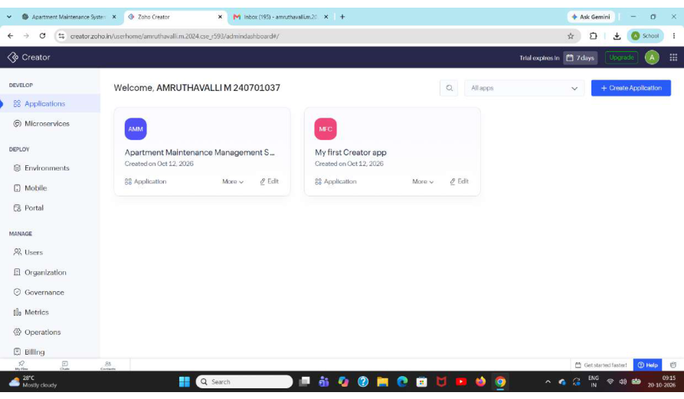
Figure 4.1: Apartment Maintenance Management System home screen
CHAPTER 5

IMPLEMENTATION

5.1 Application Setup
The screenshots show the application named Apartment Maintenance Management System in Zoho Creator. The application uses a navigation menu to organise the main data forms, reports, task views and dashboard.
Figure 5.1: Application home and navigation

5.2 Forms and Data Capture
Four principal forms are visible in the screenshots. These provide structured screens for entering resident, maintenance request, maintenance staff and maintenance payment information.
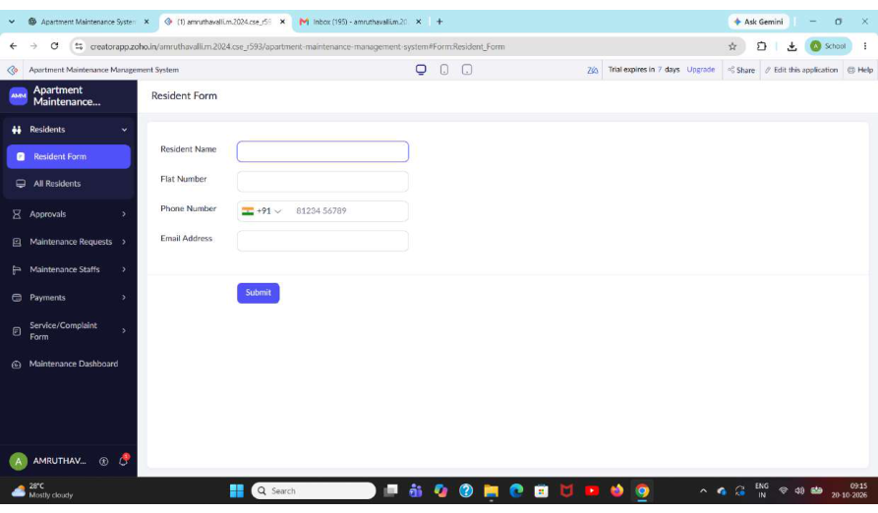
Figure 5.2: Resident Form
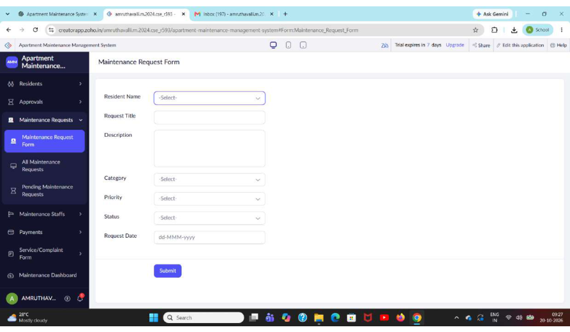
Figure 5.3: Maintenance Request Form
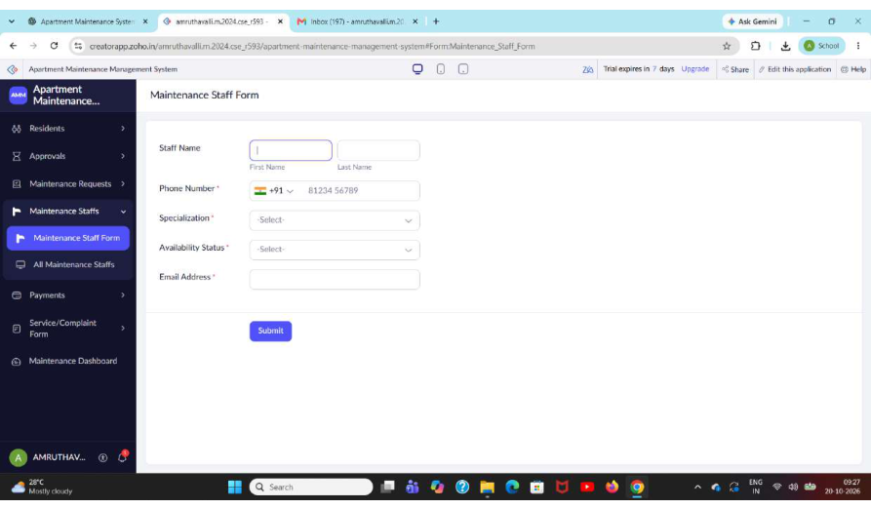
Figure 5.4: Maintenance Staff Form
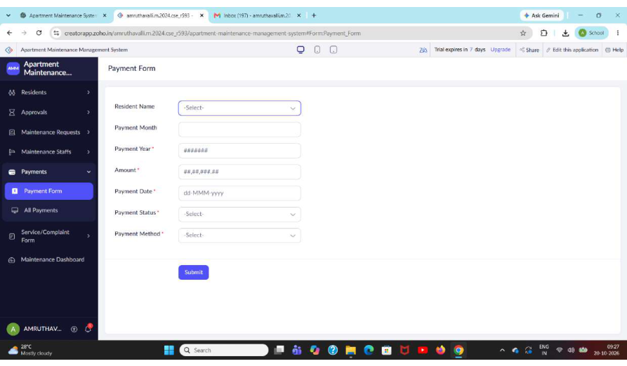
Figure 5.5: Maintenance Payment Form

5.3 Reports
Table 5.1: Reports and Views
Report / view | Purpose | Evidence
All Residents | Review saved resident records | Screenshot page 3
All Maintenance Requests | Review maintenance request records | Screenshot page 7
Pending Maintenance Requests | View requests matching pending criteria | Screenshot page 8; currently shows no matching records
All Maintenance Staffs | Review staff records | Screenshot page 10
Maintenance Payment report | Review payment records | Screenshot page 12; report appears empty in capture
Pending Tasks | View tasks awaiting action | Screenshot page 4
Completed Tasks | View completed/reviewed task entries | Screenshot page 5

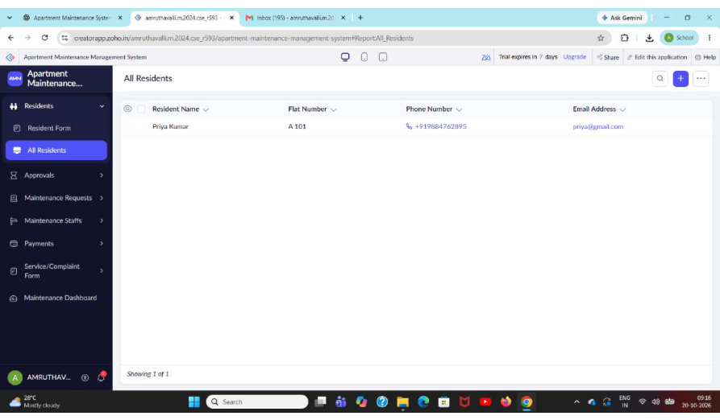
Figure 5.6: All Residents report
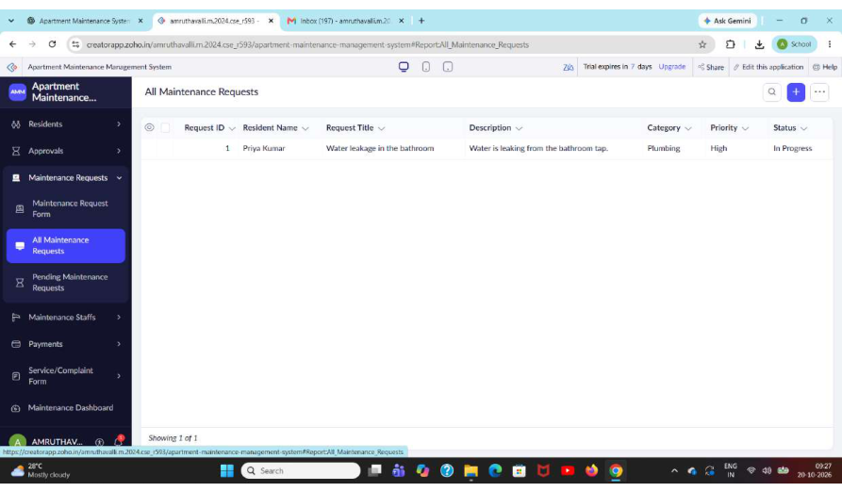
Figure 5.7: All Maintenance Requests report
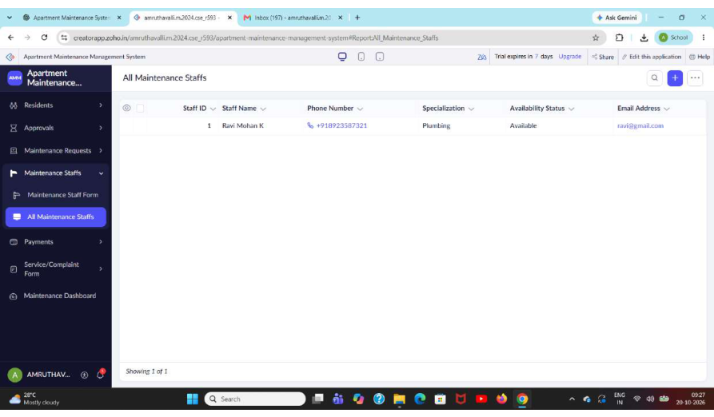
Figure 5.8: All Maintenance Staffs report
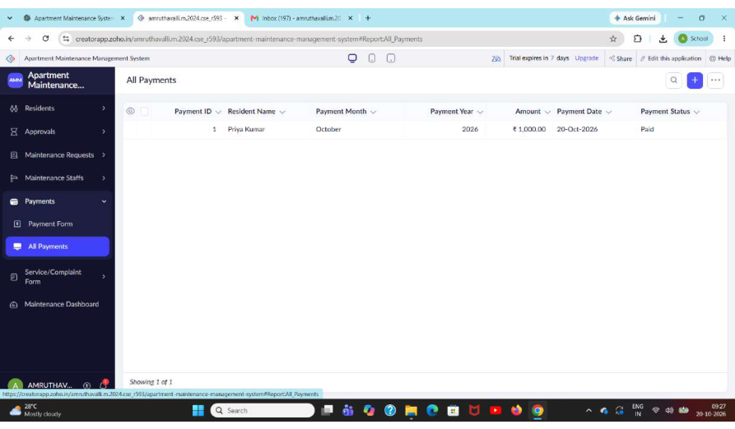
Figure 5.9: Maintenance Payment report

5.4 Pages and Dashboard
A Maintenance Dashboard page is visible and includes summary cards/charts and a form or data-entry area. The captured dashboard indicates a visual summary of maintenance information; exact metric definitions and refresh behaviour should be verified from its configuration.
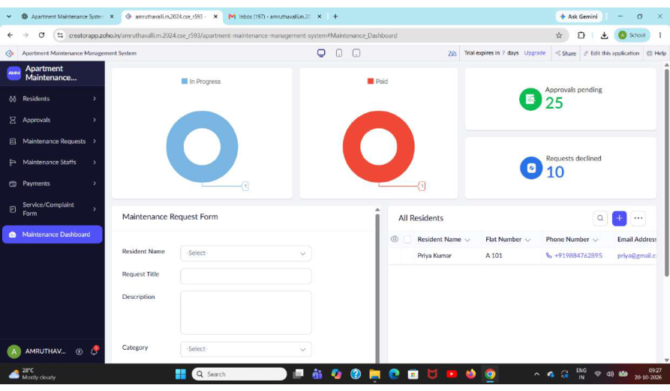
Figure 5.10: Maintenance Dashboard

5.5 Deluge Scripting
No readable Deluge source code is included in the supplied screenshots. Therefore, this report does not claim that custom Deluge functions have been implemented. If scripts are present in the live application, add the script purpose, trigger, source code and test evidence here.

5.6 Workflows and Automation
The screenshots include Pending Tasks and Completed Tasks pages and a workflow/process-stage configuration screen. The latter reports that no stages are available in the captured state. Automated notifications, scheduled workflows and Blueprint transitions are not verified by the supplied evidence.
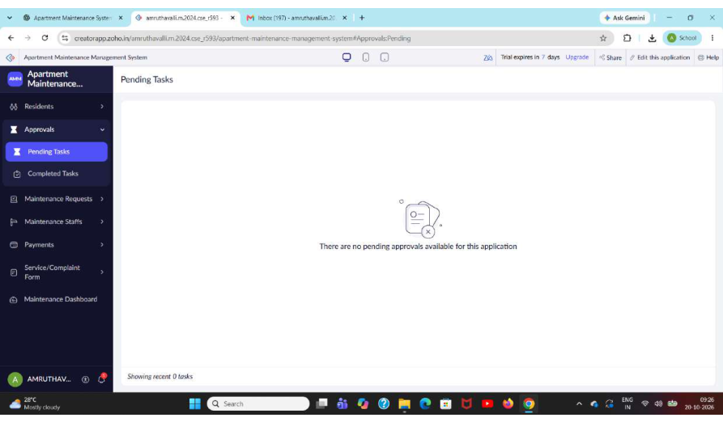
Figure 5.11: Pending Tasks page
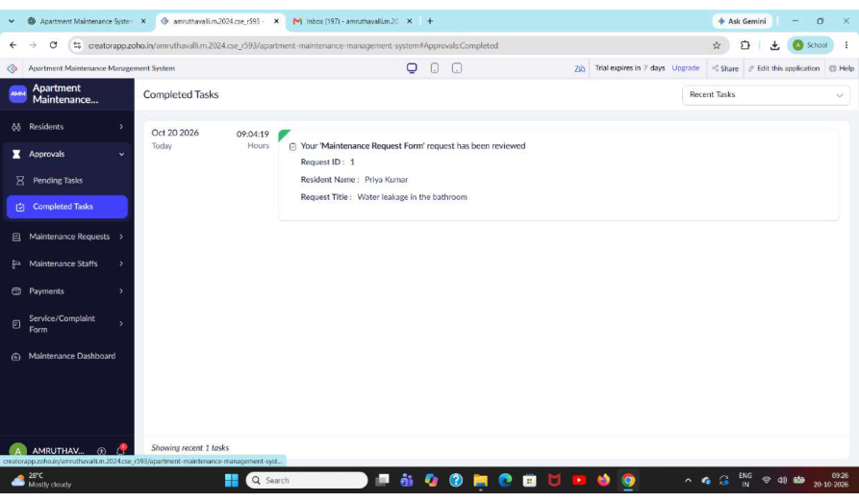
Figure 5.12: Completed Tasks page
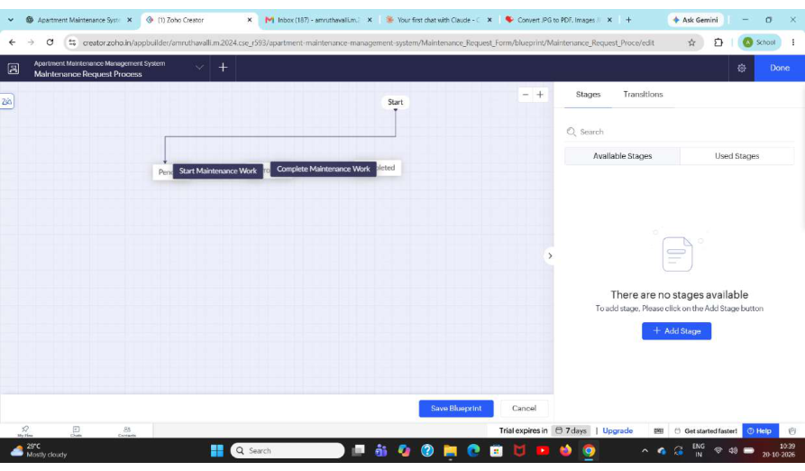
Figure 5.13: Workflow/process-stage configuration

5.7 Integrations
No connection setup, API request/response, webhook or external service integration is visible in the screenshots. This section should remain marked as not implemented unless a working integration can be demonstrated.

5.8 User Management and Role-Based Access
User roles and permission profiles are not evidenced in the submitted images. Before submission, verify which users can add, view, edit and delete records, and whether residents or staff have separate access.

5.9 AI and Analytics Features
The dashboard is the main analytics-related component visible in the screenshots. No Zia or AI-assisted feature is evidenced. Do not describe AI capabilities as implemented unless they can be demonstrated in the live application.

5.10 Pro-Code Extension
No pro-code extension such as Zoho Catalyst, custom JavaScript widget or external service is evidenced. Such extensions are not necessary for the current mini-project scope and may be considered future enhancements.

5.11 Mobile and Portal Access
The supplied evidence consists of browser screenshots. Mobile-specific layouts and customer portal access are not demonstrated and should be treated as unverified.
CHAPTER 6

TESTING AND DEBUGGING

6.1 Testing Strategy
Testing should confirm that each form accepts valid data, rejects missing or invalid mandatory data, saves records, and displays them in the appropriate report. Task views and dashboard summaries should be checked against the saved records. Since the screenshots alone do not prove test execution, the following are proposed test cases to execute and record.

6.2 Test Cases
Table 6.1: Test Cases
Test ID | Test description | Expected result | Status
TC-01 | Open Resident Form | Form opens successfully | To test
TC-02 | Submit resident form with valid data | Record is saved | To test
TC-03 | Submit resident form with a required field blank | Validation prevents invalid submission, if configured | To test
TC-04 | Open All Residents | Resident records are listed | To test
TC-05 | Submit a maintenance request with valid data | Request is saved | To test
TC-06 | Submit a request with required information missing | Validation is applied, if configured | To test
TC-07 | Open All Maintenance Requests | Saved requests are listed | To test
TC-08 | Open Pending Maintenance Requests | Only records matching the pending criteria appear | To test
TC-09 | Open Maintenance Staff Form | Form opens successfully | To test
TC-10 | Save a maintenance staff record | Record is saved and listed | To test
TC-11 | Open Maintenance Payment Form | Form opens successfully | To test
TC-12 | Save a payment record | Payment record is saved and listed | To test
TC-13 | Open Pending Tasks | Pending task view loads | To test
TC-14 | Open Completed Tasks | Completed task view loads | To test
TC-15 | Open Maintenance Dashboard | Dashboard components load and match records | To test
TC-16 | Attempt access using a non-authorised role | Restricted records/actions are blocked if permissions are configured | To test

6.3 Debugging Deluge Scripts
No Deluge editor output or error log is visible in the submitted screenshots. If scripts are used, debugging evidence should include the error message, relevant script section, correction and a successful retest.

6.4 Defect Log
Table 6.2: Defect Log
Bug ID | Description | Resolution | Status
BUG-01 | No defect information supplied | Record defects discovered during the test run and document the fix | Not recorded

6.5 User Acceptance Testing
User acceptance feedback was not included in the evidence. Ask at least two users to try the relevant forms and reports, record their role and feedback, and document any changes made.
CHAPTER 7

DEPLOYMENT, SECURITY AND GOVERNANCE

7.1 Environments and Deployment Strategy
The screenshots show the application open in Zoho Creator but do not establish a development–stage–production deployment sequence or a production release date. Before deployment, test the forms and reports, review permissions, confirm the published URL, and record a version note.

7.2 Performance Optimisation
No benchmark data is provided. For a small application, useful practices include limiting reports to relevant columns, filtering lists where appropriate, avoiding unnecessary scripts and testing report behaviour as record counts increase. Quantitative performance gains should only be reported after measurement.

7.3 Security Features
Table 7.1: Security Controls
Control | Purpose | Evidence status
Role and profile permissions | Limit functions to authorised users | Not shown; verify
Record-level access criteria | Limit users to appropriate records | Not shown; verify
Secure connections for integrations | Avoid exposing credentials | No integration shown
Audit trail / change history | Support accountability | Not shown; verify

7.4 Governance and Administration
Maintain clear form and report names, remove test data before production use, review access permissions periodically, and keep a record of changes. Verify backup/export and audit-history options in the current Creator configuration.
CHAPTER 8

RESULTS AND DISCUSSION

8.1 Application Output
The screenshots demonstrate the presence of resident, maintenance request, staff and payment forms, corresponding report pages, task views and a dashboard. Some reports show no records in the captured state; this may reflect an empty dataset or an active filter and should not be interpreted as a failure without further testing.
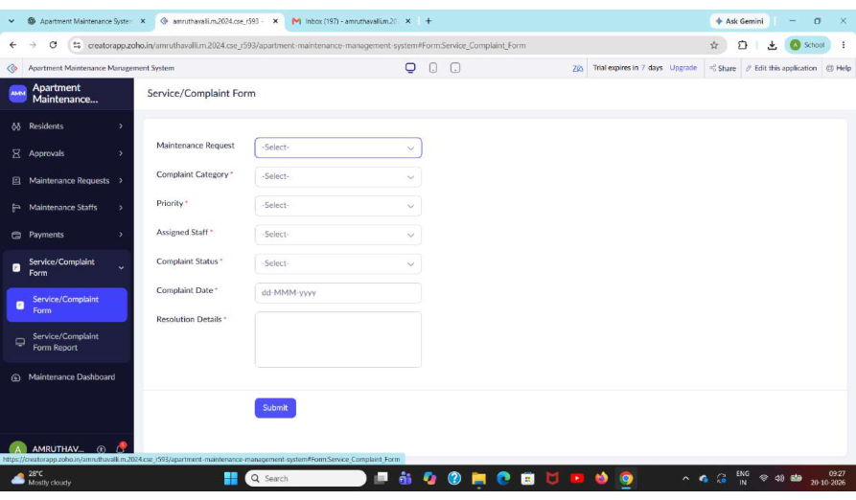
Figure 8.1: Maintenance-related report view
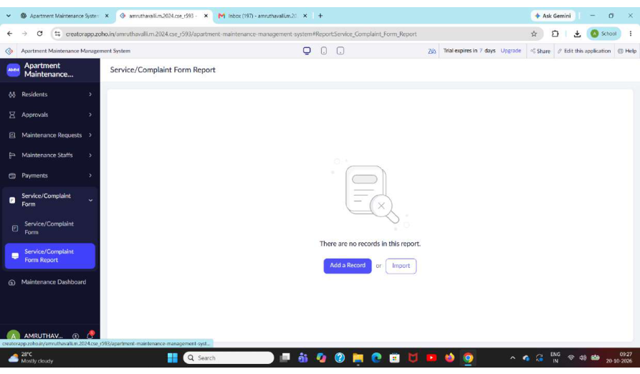
Figure 8.2: Empty report state
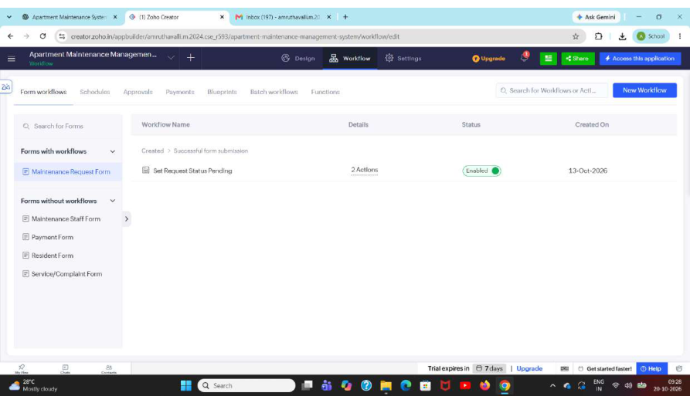
Figure 8.3: Application workflow / configuration view

8.2 Achievement of Objectives
Table 8.1: Mapping of Objectives to Outcomes
Objective | Visible implementation evidence | Assessment
Capture resident data | Resident Form and All Residents report | Interface shown
Capture maintenance requests | Maintenance Request Form and request report | Interface shown
Maintain staff and payment records | Staff form/list and payment form/report | Interface shown
Separate pending and completed work | Pending Tasks and Completed Tasks pages | Pages shown; status logic to verify
Provide dashboard overview | Maintenance Dashboard screenshot | Dashboard shown

8.3 Comparison with the Existing System
Table 8.2: Existing System versus Proposed Application
Parameter | Manual/disconnected approach | Application approach
Data entry | Separate notes or files may be used | Dedicated Creator forms are available
Record lookup | Manual search may be required | Reports provide a central view
Task visibility | Status may need to be checked manually | Pending and completed task pages are available
Performance outcome | Not measured | Not measured in supplied evidence

8.4 Limitations of the Low-Code Approach
The application depends on the Zoho Creator platform and its available features, limits and licensing. Highly specialised interfaces or complex external integrations may require additional scripting or pro-code development. The current evidence does not establish whether such constraints were encountered during implementation.

8.5 No-Code, Low-Code and Pro-Code Reflection
The visible forms, reports and dashboard are consistent with visual low-code configuration. Deluge scripting would represent the low-code extension layer if implemented. External services or custom widgets could represent a pro-code extension, but none is demonstrated in the screenshots.
CHAPTER 9

CONCLUSION AND FUTURE ENHANCEMENTS

9.1 Conclusion
The Apartment Maintenance Management System mini project uses Zoho Creator to organise apartment maintenance information through dedicated resident, maintenance request, maintenance staff and maintenance payment forms. The supplied screenshots also show reports, pending and completed task pages and a dashboard. These components provide a foundation for centralised maintenance record management.
The screenshots verify the visible interface components but do not by themselves confirm data validation, automated status transitions, integrations, security configuration or successful test outcomes. A final live-app test and completion of the evidence checklist are recommended before submission.

9.2 Future Enhancements
- Add and test request assignment to maintenance staff.
- Configure status transitions from submitted to in progress and completed.
- Add email or in-app notifications for new and overdue requests, if supported.
- Link payment records to residents and maintenance requests with clear identifiers.
- Add role-specific permissions and record-level access controls.
- Improve dashboard metrics and test mobile/portal access if required.

9.3 Learning Outcomes and Career Relevance
This project provides practical experience in structuring a small business application using low-code tools. Further work can strengthen skills in data modelling, report design, workflow configuration, application testing, access control and automation. These skills are relevant to low-code development, business process automation and solutions consulting.

REFERENCES
[1] Zoho Corporation, “Zoho Creator Help Documentation.” [Online]. Available: https://www.zoho.com/creator/help/. Accessed: 20 October 2026.
[2] Zoho Corporation, “Deluge Script Reference.” [Online]. Available: https://www.zoho.com/deluge/. Accessed: 20 October 2026.
[3] Zoho Corporation, “Zoho Creator Resources.” [Online]. Available: https://www.zoho.com/creator/resources/. Accessed: 20 October 2026.
Note: These references identify official platform documentation for further verification. Add in-text citations where platform-specific claims are made and include any additional sources actually consulted.

APPENDIX A – FEATURE EVIDENCE CHECKLIST
Table A.1: Feature Evidence Checklist
Feature | Evidence from screenshots | Status
Application and navigation | Application home screen | Shown
Resident form and report | Pages 2–3 | Shown
Maintenance request form and reports | Pages 6–8 | Shown
Maintenance staff form and report | Pages 9–10 | Shown
Maintenance payment form and report | Pages 11–12 | Shown
Pending tasks | Page 4 | Shown
Completed tasks | Page 5 | Shown
Dashboard | Page 15 | Shown
Blueprint / process stages | Page 19 says no stages available | Not confirmed
Deluge scripts | No source code screenshot | Not evidenced
External integration / API | No connection or API screenshot | Not evidenced
Roles and permissions | No configuration screenshot | Not evidenced
Testing logs / UAT | No test evidence supplied | To complete
Deployment environments | No release evidence supplied | To complete

APPENDIX B – USER MANUAL

B.1 Accessing the Application
Open the published Zoho Creator application using the authorised application URL and sign in with an account that has permission to access it. The URL and credentials were not included in the supplied screenshots and should not be placed in a public report.

B.2 Registering a Resident
Use the navigation menu to open Resident Form. Enter the requested details and submit the form. Open All Residents to confirm that the record is listed.

B.3 Submitting a Maintenance Request
Open Maintenance Request Form, enter the issue information requested by the form, and submit it. Open All Maintenance Requests to confirm the record. Use Pending Maintenance Requests or Pending Tasks to review outstanding work, depending on the configured criteria.

B.4 Managing Staff and Payments
Open Maintenance Staff Form to enter staff information and All Maintenance Staffs to review saved records. Open Maintenance Payment Form to enter payment-related details and the Maintenance Payment report to review saved payment records.

B.5 Viewing Task Status and Dashboard
Open Pending Tasks or Completed Tasks to view the relevant task list. Open Maintenance Dashboard to view the summary components. If a report is empty, check whether records exist and whether report filters are active.

