LOW CODE APPLICATION DEVELOPMENT USING ZOHO
CREATOR

M.AMRUTHA VALLI 240701037
EXPERIMENT 2
Setting up a Zoho Creator account and exploring the platform architecture and interface.
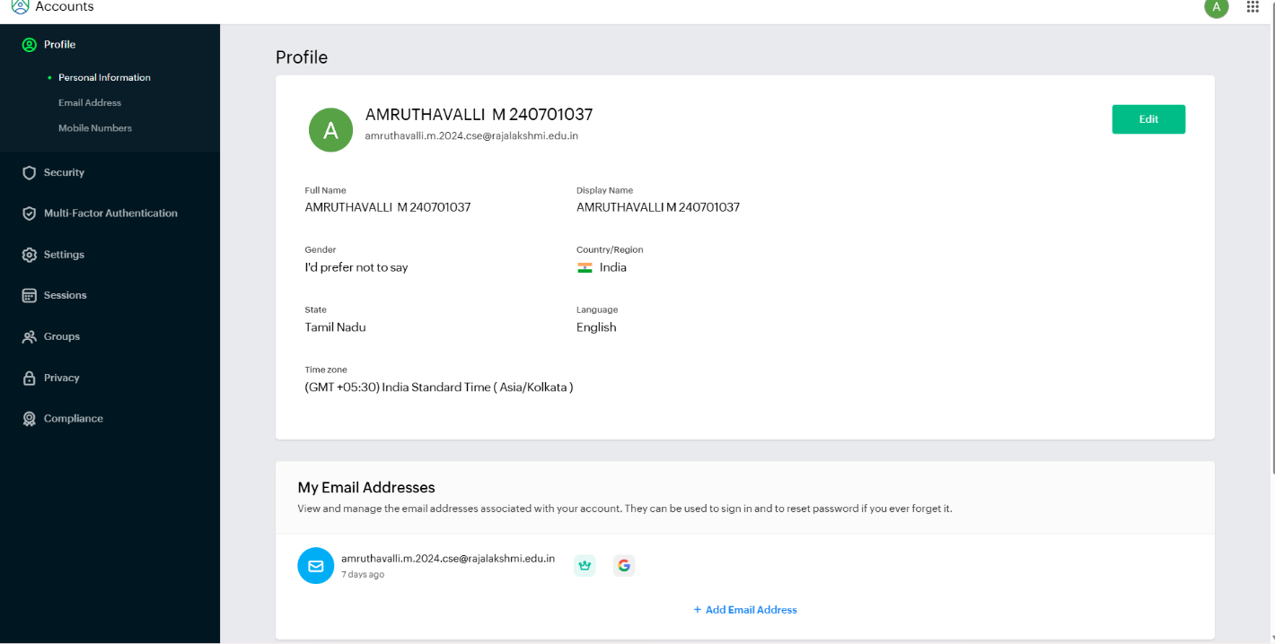
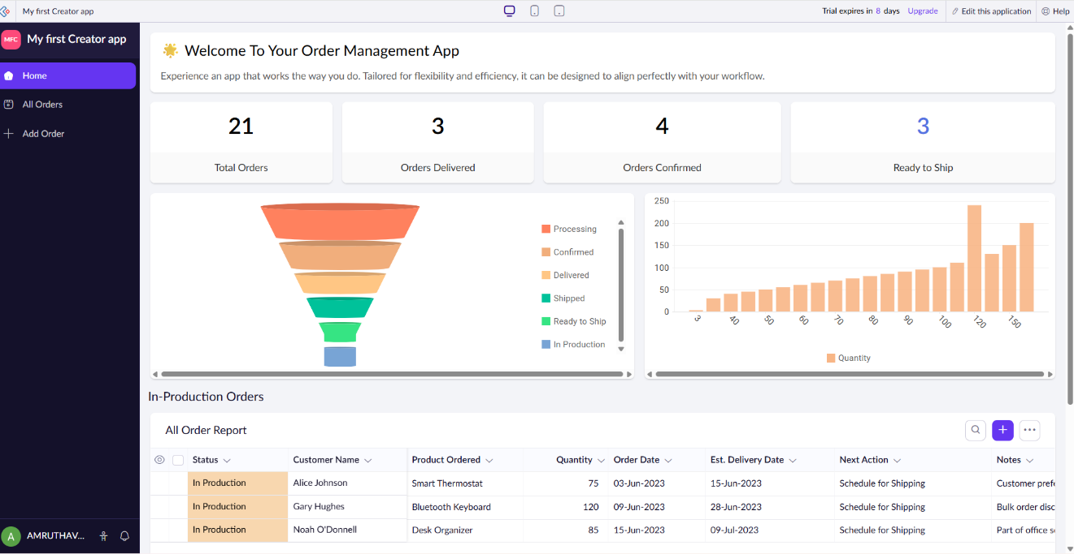

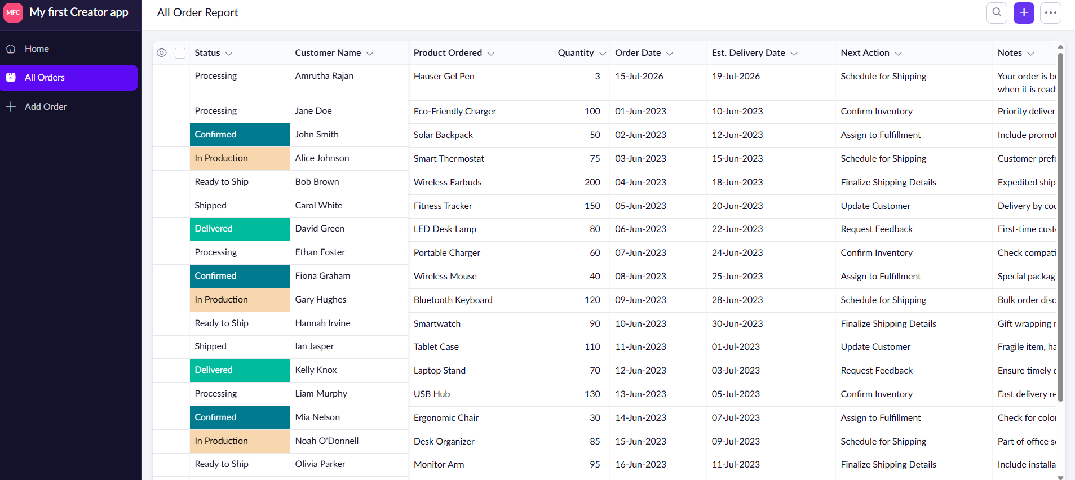

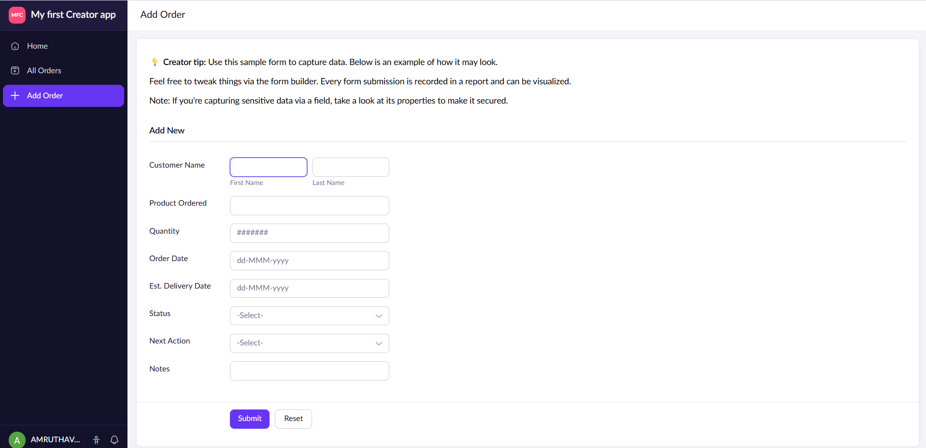
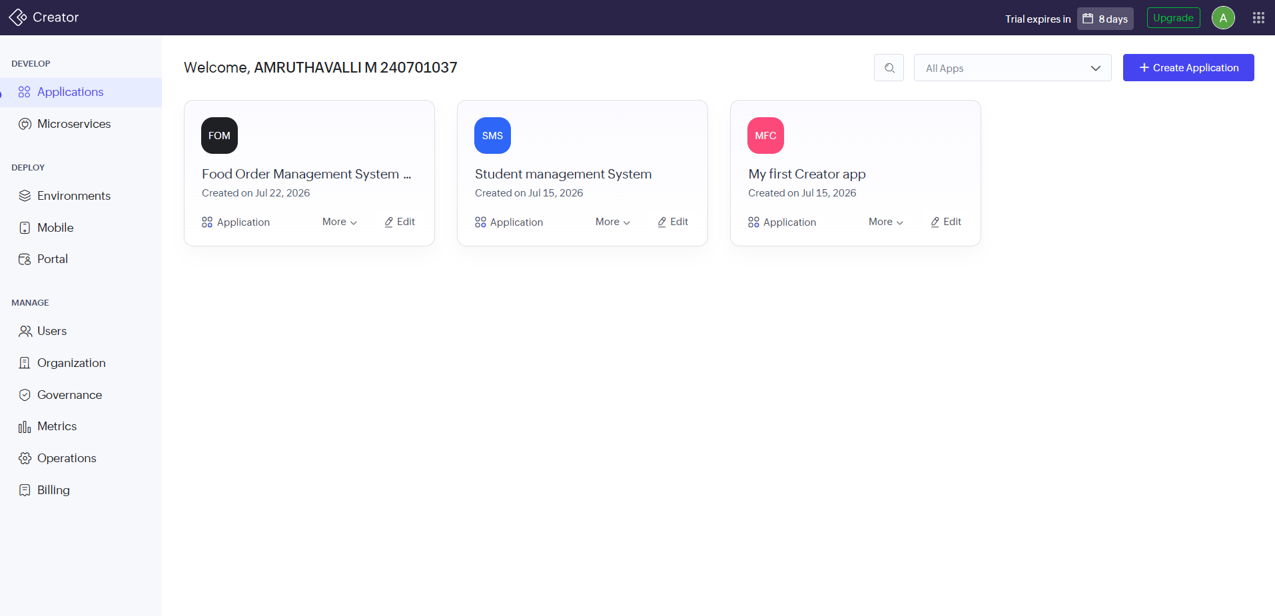

Setting Up Zoho Creator (Create a Sample Application)

Step 1: Create a Zoho Creator Account
- Open a web browser and visit https://creator.zoho.com.
- Click Sign Up.
- Register using an email address or sign in with a Google/Microsoft account.
- Verify the email address (if prompted).
- Log in to Zoho Creator.

Exploring the Zoho Creator Interface

1. Navigation Panel (Left Sidebar)
The left sidebar provides quick access to different parts of the application.
- Home – Displays the application dashboard.
- All Orders – Shows all order records in a report format.
- Add Order – Opens the form to create a new order.

2. Dashboard (Home Page)
The dashboard gives an overview of the application through visual components.
It contains:
- Welcome message
- Summary cards (Total Orders, Orders Delivered, Orders Confirmed, Ready to Ship)
- Charts and graphs
- Order report table

3. Forms
Forms are used to enter and edit data.
Example:
- Add Order form allows users to enter:
  - Customer Name
  - Product Ordered
  - Quantity
  - Order Date
  - Delivery Date
  - Status
  - Notes

4. Reports
Reports display the stored records in table format.
Example:
- All Orders Report
- Allows searching, sorting, filtering, and viewing order details.

5. Charts
Charts provide graphical visualization of data.
Examples in your application:
- Funnel Chart showing order status.
- Bar Chart showing order quantities.

6. Data Table
The data table displays all order information such as:
- Status
- Customer Name
- Product Ordered
- Quantity
- Order Date
- Delivery Date
- Next Action
- Notes

Exploring Zoho Creator Architecture

Overview
Zoho Creator is a low-code application development platform that allows users to build web and mobile applications with minimal coding. Its architecture consists of several interconnected components that handle data storage, user interface design, business logic, automation, and integrations.
1. Forms (Data Collection Layer)
Forms are used to collect and store data from users.
Features
- Drag-and-drop form builder
- Multiple field types:
  - Single Line
  - Multi Line
  - Number
  - Date & Time
  - Email
  - Phone
  - Lookup
  - File Upload
Example
Student Registration Form:
- Student ID
- Name
- Department
- Email
- Mobile Number
Purpose
- Acts as the application's database table.
- Stores records submitted by users.

2. Reports (Data Visualization Layer)
Reports display data stored in forms.
Types of Reports
- List Report
- Summary Report
- Spreadsheet Report
- Calendar Report
- Kanban View
Features
- Filtering
- Sorting
- Searching
- Exporting data
Example
A Student Report showing:
Student ID | Name | Department
101 | Ravi | CSE
102 | Priya | ECE
Purpose
Provides an organized way to view and analyze stored data.

3. Pages (User Interface Layer)
Pages are custom dashboards used to combine different components.
Components Inside Pages
- Reports
- Forms
- Buttons
- Charts
- Panels
- HTML Widgets
Example
College Management Dashboard:
- Student Count
- Attendance Chart
- Fee Collection Summary
Purpose
Creates a professional and interactive user interface.

4. Workflows (Automation Layer)
Workflows automate actions based on events.
Types of Workflows
Form Workflows
Triggered when:
- Form loads
- Field updates
- Form submits
Scheduled Workflows
Triggered:
- Daily
- Weekly
- Monthly
Custom Actions
Triggered manually through buttons.
Example
When a student registers:
- Generate Student ID
- Send Confirmation Email
- Notify Administrator
Purpose
Reduces manual effort and improves efficiency.

5. Deluge Script (Business Logic Layer)
Deluge (Data Enriched Language for Universal Grid Environment) is Zoho's scripting language.
Uses
- Data validation
- Calculations
- Workflow automation
- API integration

Result
The Zoho Creator architecture was successfully explored and analyzed. The study helped in understanding the major components of the platform, including Forms, Reports, Pages, Workflows, Deluge Scripting, Database Management, Integrations, Security, Mobile Access, and Analytics. It was observed that these components work together in a cloud-based low-code environment to enable rapid application development, automation, and efficient data management.

