LOW CODE APPLICATION DEVELOPMENT USING ZOHO CREATOR

M.AMRUTHAVALLI 240701037
EXPERIMENT 1
Comparative study of low-code development versus traditional application development approaches

Aim
To study and compare the low-code development approach with the traditional application development approach based on development process, coding effort, development time, cost, flexibility, and maintenance.

Introduction to Traditional Application Development
Traditional application development is the conventional method of building software where developers write the entire application using programming languages such as Java, Python, C#, or PHP. It requires skilled programmers to design, develop, test, deploy, and maintain the application manually.
This approach provides complete control over the application's functionality, architecture, and customization, making it suitable for large-scale and complex enterprise applications. However, it generally requires more development time, higher costs, and experienced development teams.

Features
- Requires extensive coding.
- High flexibility and customization.
- Longer development lifecycle.
- Suitable for complex applications.
- Requires skilled developers.

Introduction to Low-Code Development
Low-code development is a modern software development approach that enables applications to be built using graphical user interfaces, drag-and-drop components, and minimal hand-written code. Platforms such as Zoho Creator, Mendix, and Microsoft Power Apps allow developers and even non-programmers to create applications quickly.
Low-code platforms automate many development tasks, reducing coding effort and accelerating application delivery. They are ideal for business applications, workflow automation, and rapid application development.

Features
- Minimal manual coding.
- Drag-and-drop interface.
- Faster development.
- Lower development cost.
- Easy maintenance and deployment.

DIAGRAM STAGES OF TRADITIONAL APPROACH:
Stages:
- Requirement Analysis
- System Design
- Coding/Development
- Testing
- Deployment
- Maintenance
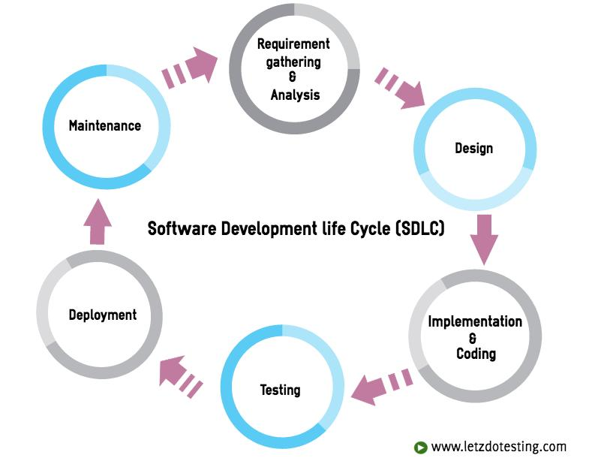

DIAGRAM STAGES OF LOW CODE APPROACH
Stages:
- Gather Requirements
- Visual Application Design
- Configure Business Logic
- Integrate Data Sources
- Testing
- One click Deployment
- Monitor & update

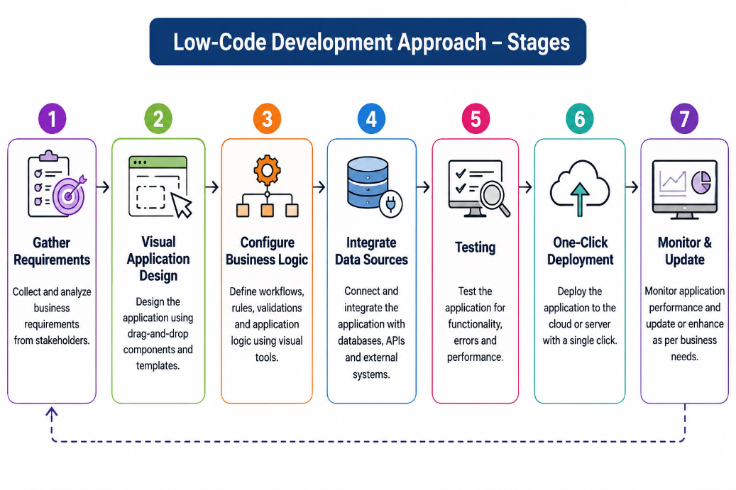

Comparison between Low-Code Development and Traditional Application Development
- Development Speed:
Low-code development enables rapid application development using visual tools, whereas traditional development requires more time due to manual coding.
- Coding Requirement:
Low-code platforms require minimal coding with drag-and-drop components, while traditional development relies entirely on programming languages.
- Cost and Resources:
Low-code reduces development cost and requires fewer skilled developers, whereas traditional development is more expensive and needs experienced programmers.
- Customization and Flexibility:
Traditional development offers complete control and unlimited customization, whereas low-code provides customization within the limitations of the platform.
- Suitable Applications:
Low-code is ideal for business applications, workflow automation, and rapid prototyping, whereas traditional development is better suited for large-scale, complex, and highly customized applications.
CONCLUSION:
Hence we have discussed about the comparative study of low-code development versus traditional application development approaches

