1. **Index Error: list index out of range** - Accessing an index that doesn't exist.

1. **Type Error: list indices must be integers or slices, not str** - Using a string as an index.

1. **Type Error: 'int' object is not subscriptable** - Treating an integer like a list.

1. **Value Error: list.remove(x): x not in list** - Trying to remove an element that doesn't exist in the list.

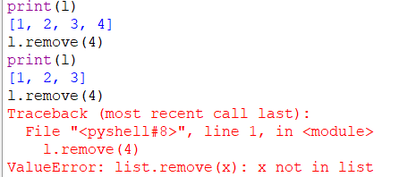

1. **Attribute Error: 'list' object has no attribute 'split'** - Using a string method on a list.

1. **Attribute Error: 'list' object has no attribute 'find'** - Using a string method on a list.

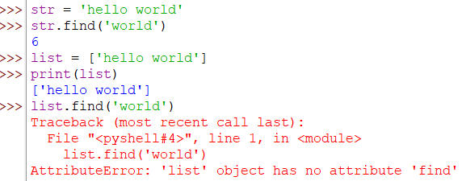

1. **Type Error: can only concatenate list (not "int") to list** - Trying to concatenate an integer to a list.

1. **Type Error: can only concatenate list (not "str") to list** - Trying to concatenate a string to a list.

1. **Type Error: 'int' object is not iterable** - Trying to iterate over an integer.

1. **Type Error: list indices must be integers or slices, not float** - Using a float as an index.

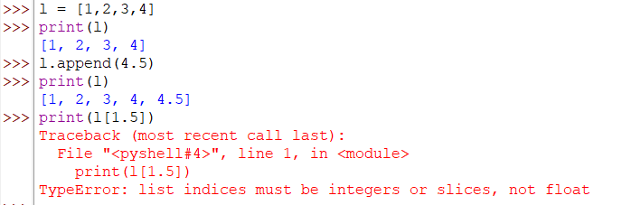

1. **Syntax Error: invalid syntax** - Using incorrect syntax for list comprehensions.

1. **Type Error: '<' not supported between instances of 'str' and 'int'** - Trying to compare incompatible types.

1. **Key Error: 'key'** - Treating a list like a dictionary.

1. **Type Error: 'list' object is not callable** - Trying to call a list like a function.

1. **Type Error: list.append() takes exactly one argument** – Trying to give 2 parameters

1. **Index Error: pop index out of range** - Popping an index that doesn't exist.

1. **Value Error: max (), min () arg is an empty sequence** - Finding the max, min of an empty list.

1. **Type Error: 'builtin_function_or_method' object is not iterable** - Trying to iterate over a method.

1. **Type Error: list indices must be integers or slices, not tuple** - Using a tuple as an index.

1. **Value Error: x not in list** - Using index () to find a non-existent element.

1. **Attribute Error: 'list' object has no attribute 'push'** - Using a method that doesn't exist.

1. **Name Error: name 'lst' is not defined** - Referencing a list before it is defined.

1. **Index Error: list assignment index out of range** - Assigning to an index that doesn't exist.

1. **Type Error: can't multiply sequence by non-int of type 'float'** - Multiplying a list by a float.

1. **Syntax Error: in valid syntax**

1. **Type Error: object of type 'NoneType' has no len() -** Finding the length of None.

1. **Syntax Error: invalid syntax** - Misusing list slicing syntax.

1. **Value Error: invalid literal for int() with base 10** - Converting a list element that isn't a valid integer.

1. **Type Error: unsupported operand type(s) for +: 'list' and 'tuple'** - Adding a list to a tuple.

1. **Type Error: 'int' object is not iterable** - Trying to extend a list using an integer.

1. **Type Error:** **'<' not supported between instances of 'list' and 'str'** -Trying to compare lists using the less than operator.

1. **TypeError: '>' not supported between instances of 'list' and 'int'** - Attempting to compare a list with an integer using the greater than operator.

1. **Type Error: unhashable type: 'list'** - Trying to use a list as a key in a dictionary or as an element in a set.

1. **Type Error: 'range' object does not support item assignment** - Trying to modify a range object by assigning values to its elements.  
   A red text on a white background

   Description automatically generated
2. **Name Error: name 'l2' is not defined** - Referencing a list variable before it's defined.

1. **Value Error: could not convert string to float: 'abc'** - Trying to convert a list of strings to floats where some elements are not valid floats.  
   A screenshot of a computer code

   Description automatically generated
2. **Type Error: 'str' object does not support item assignment** - Attempting to modify a string through item assignment.

1. **Attribute Error: 'list' object has no attribute 'upper'** - Trying to use the upper () method on a list.

1. **Syntax Error: closing parenthesis ')' does not match opening parenthesis '['** Mismatched parentheses when indexing a list.

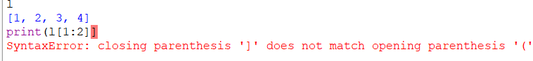

1. **Type Error: 'int' object is not iterable** - Using an integer in a for loop expecting an iterable.  
   A screen shot of a computer code

   Description automatically generated
2. **Value Error: not enough values to unpack (expected 2, got 1)**A red text on a white background

   Description automatically generated
3. **Type Error: sequence item 0: expected str instance, int found – we use join function for strings only.**A screen shot of a computer code

   Description automatically generated
4. **Attribute Error: 'int' object has no attribute 'append'**

1. **UnboundLocal Error: local variable 'variable' referenced before assignment**

1. **Type Error: object of type 'NoneType' has no len()**

1. **ZeroDivision Error: division by zero  
   A red text on a white background

   Description automatically generated**
2. **Value Error: too many values to unpack (expected 2)**

1. **Value Error: invalid literal for int () with base 10**A red text on a white background

   Description automatically generated
2. **Type Error: can only concatenate str (not "int") to str**  
   A computer code with red text

   Description automatically generated
3. **Syntax Error: Expected ‘:’ after function declaration**  
     
   A screen shot of a computer error

   Description automatically generated