OOP L AB CYCLE 3
SUBMITTED BY :
AMRUTHA DINESH
ROLL NO:17
PROGRAM 1

/*
1.Define a class Date. Overload the operator '+' such that it adds a given date with certain number of days.
*/

#include <iostream>
using namespace std;
class dates
{
int day, month, year, last;
int mo[12] = {31, 28, 31, 30, 31, 30, 31, 31, 30, 31, 30, 31};

public:
int key;
dates() {}
dates(int d, int m, int y)
{
day = d;
month = m;
year = y;
}
void outPut();
dates operator+(dates d);

void Month();
void Day();
int valid();
};
void dates::outPut()
{
cout << "Result is = " << day << "/" << month << "/" << year << endl;
}

//validty
void dates::Month()
{
if (month > 0 && month <= 12)
{
if (month == 1 || month == 3 || month == 5 || month == 7 || month == 8 || month == 10 || month == 12)
{
last = 31;
Day();
}
else if (month == 4 || month == 6 || month == 9 || month == 11)
{
last = 30;
Day();
}
else if (month == 2)
{
if ((year % 4 == 0) && (year % 100 != 0) || (year % 400 == 0))
{
last = 29;
Day();
}
else
{
last = 28;
Day();
}
}
}
else
cout << "Invalid Date";
}
//Day
void dates::Day()
{
if (day > 0 && day <= last)
{
valid();
}
else
cout << "Invalid Date";
}

int dates::valid()
{
key = 1;
return key;

}

dates dates::operator+(dates d)
{
dates m;
int i;
m.day = day + d.day;
i = month - 1;
m.month = 0;
m.year = year;
if (i == 1)
{
if ((m.year % 4 == 0) && (m.year % 100 != 0) || (m.year % 400 == 0))
{
mo[1] = 29;
}
}
if ((m.day - mo[i]) > 0)
{
while ((m.day - mo[i]) > 0)
{
if ((m.year % 4 == 0) && (m.year % 100 != 0) || (m.year % 400 == 0))
{
mo[1] = 29;
}
m.day = m.day - mo[i];
month++;
i++;
if ((month - 1) % 12 == 0)
{
i = 0;
m.year++;
}
}
if (month > 12)
{
if (month % 12 == 0)
m.month = 12;
else
m.month = month % 12;
}
else
m.month = month;
i++;
}
else
{
m.month = month;
m.year = year;
}

return m;
}

int main()
{
int d, m, y, n;
cout << "Enter the date\n";
cin >> d >> m >> y;
cout << "Enter the day to be added \n";
cin >> n;
dates d1(d, m, y), d2(n, 0, 0), d3;
d1.Month();
if (d1.key == 1)
{
d3 = d1 + d2;
d3.outPut();
}

return 0;
}

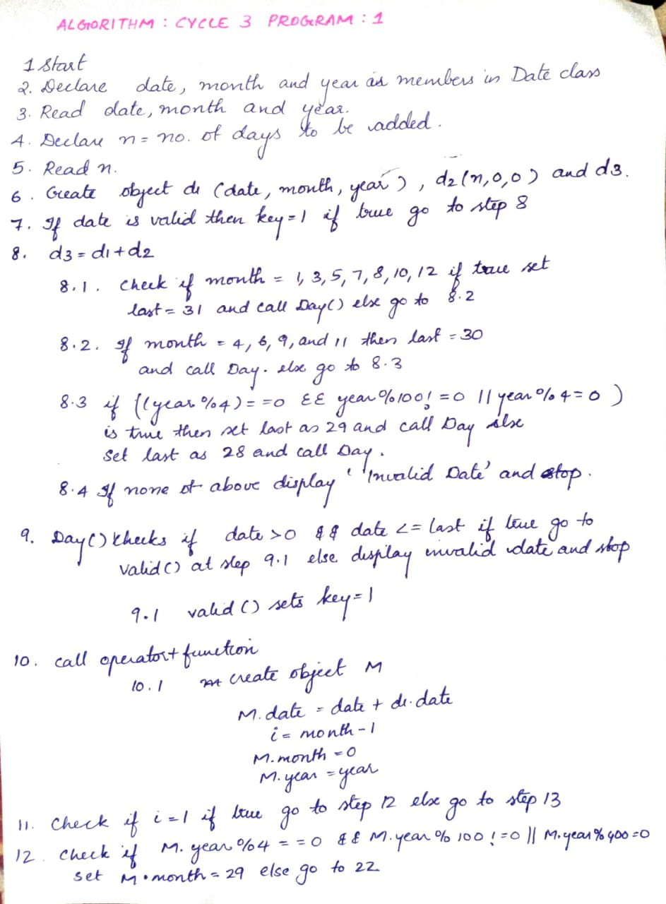

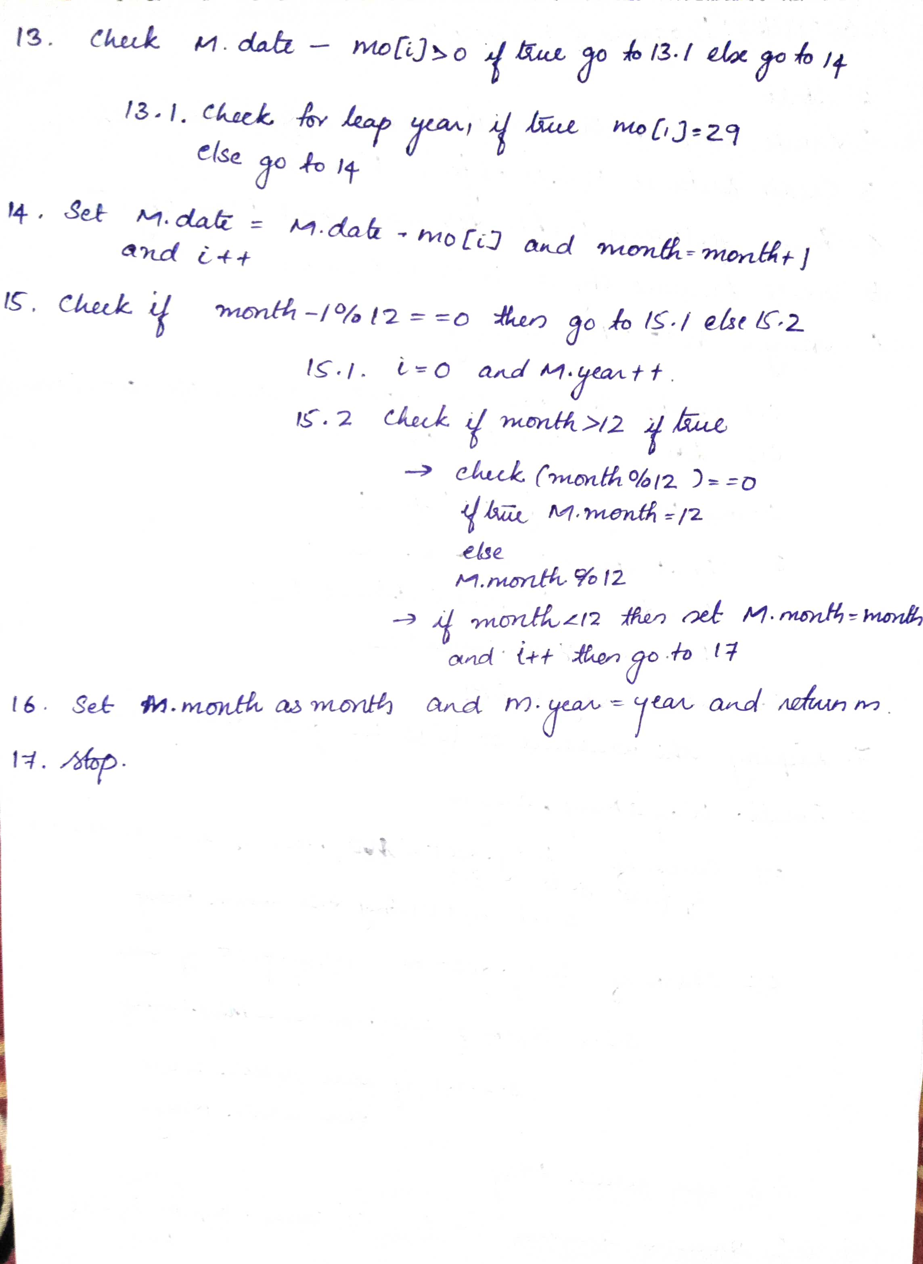

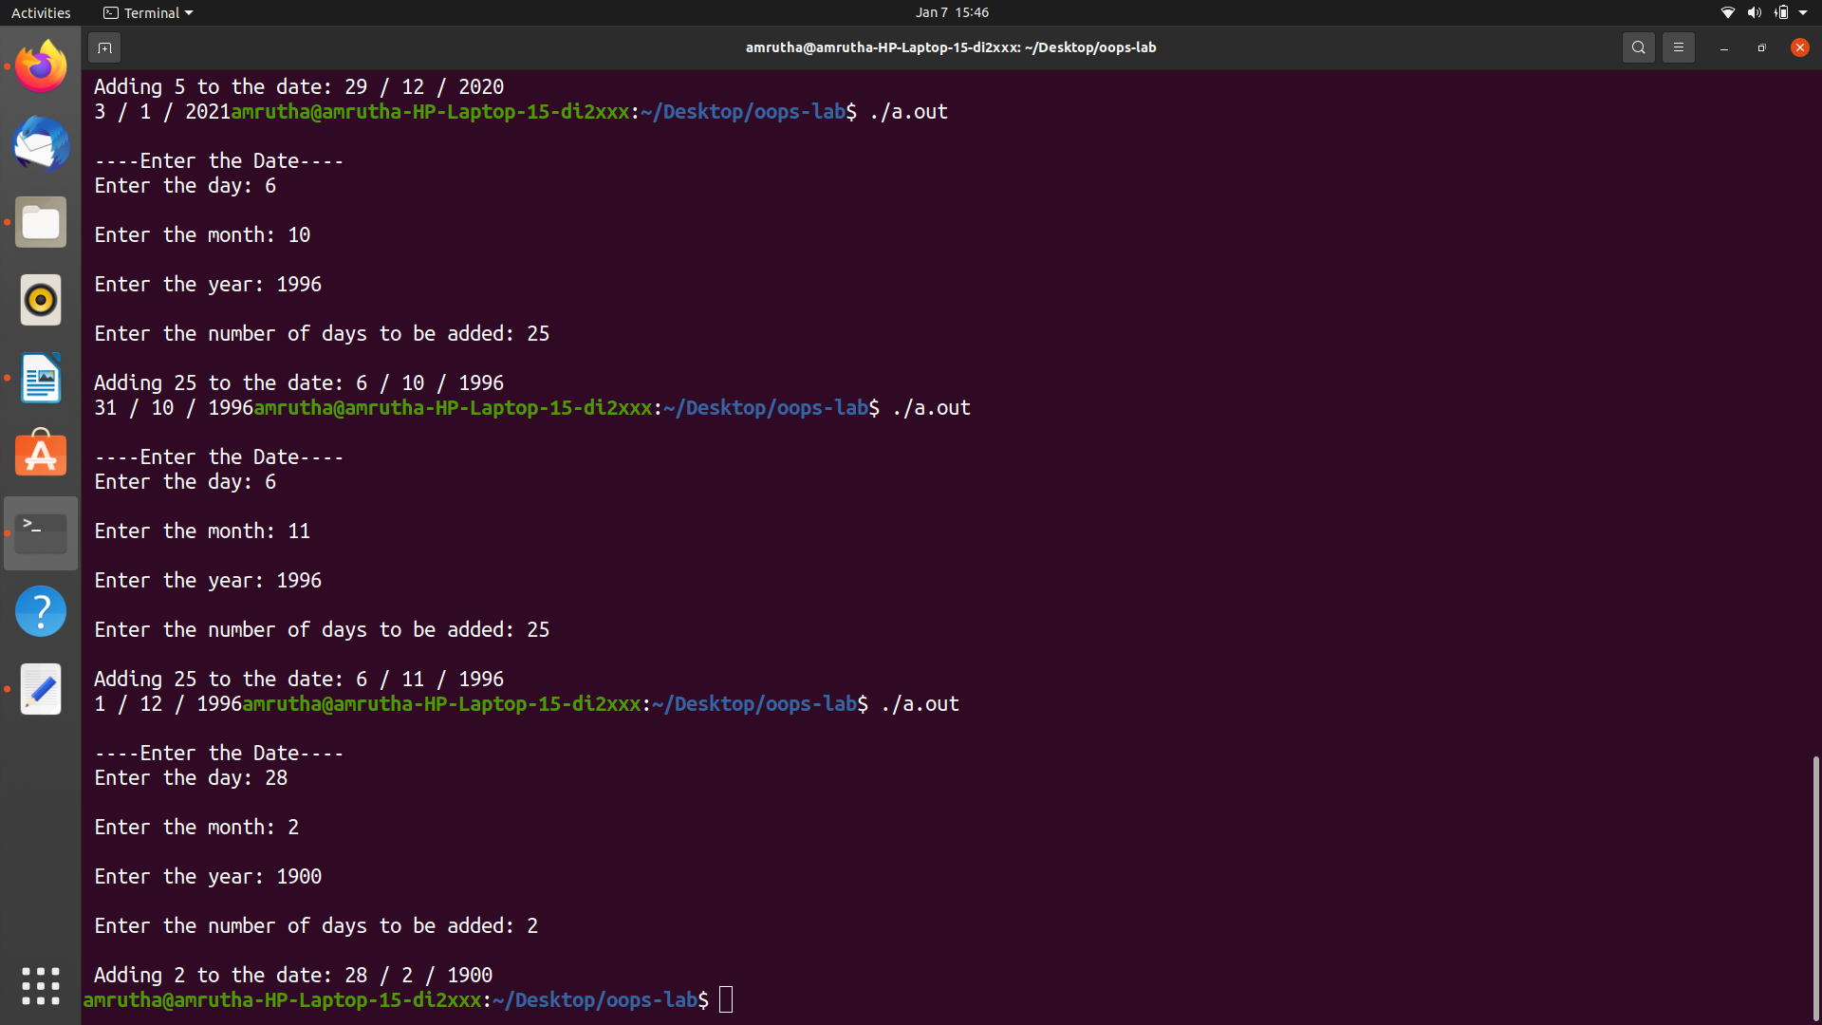

PROGRAM 2

/*Distance is measured in feet and inches unit. Use operator overloading for '+' operator for adding two such distances and '<' for comparing two such distances. (one of the operator function should be implemented as friend function*/

#include<iostream>
using namespace std;

class Distance
{
int foot,inches;
public:
Distance()
{
foot =1;
inches=5;
}
void getdistance()
{
cout<<"Enter the distance in foot :";
cin>>foot;
cout<<"Enter the distance in inches:";
cin>>inches;

}

void display()
{
cout<<"The distance is "<<foot<<"Feet"<<" "<<inches<<"inches";

}

Distance operator + (Distance D);
friend Distance operator < (Distance &D1,Distance &D2);

};

Distance Distance::operator +(Distance D)
{
Distance KM;
KM.foot=foot+D.foot;
KM.inches=inches+D.inches;
KM.foot=KM.foot+KM.inches/12;
KM.inches=KM.inches%12;
return KM;
}

Distance operator <(Distance &D1,Distance &D2)
{
if(D1.foot<D2.foot)
{
return D1;

}
else if(D1.foot==D2.foot)
{
if(D1.inches<D2.inches)
return D1;
else
return D2;
}
else
return D2;
}

int main()
{
Distance Way,May;
Distance Wat,Small;

Way.getdistance();
May.getdistance();
Wat=Way+May;

cout<<"Displaying the added Distance: \n";
Wat.display();

Small=Way<May;
cout<<"Displaying the smaller distance :\n ";
Small.display();

return 0;

}

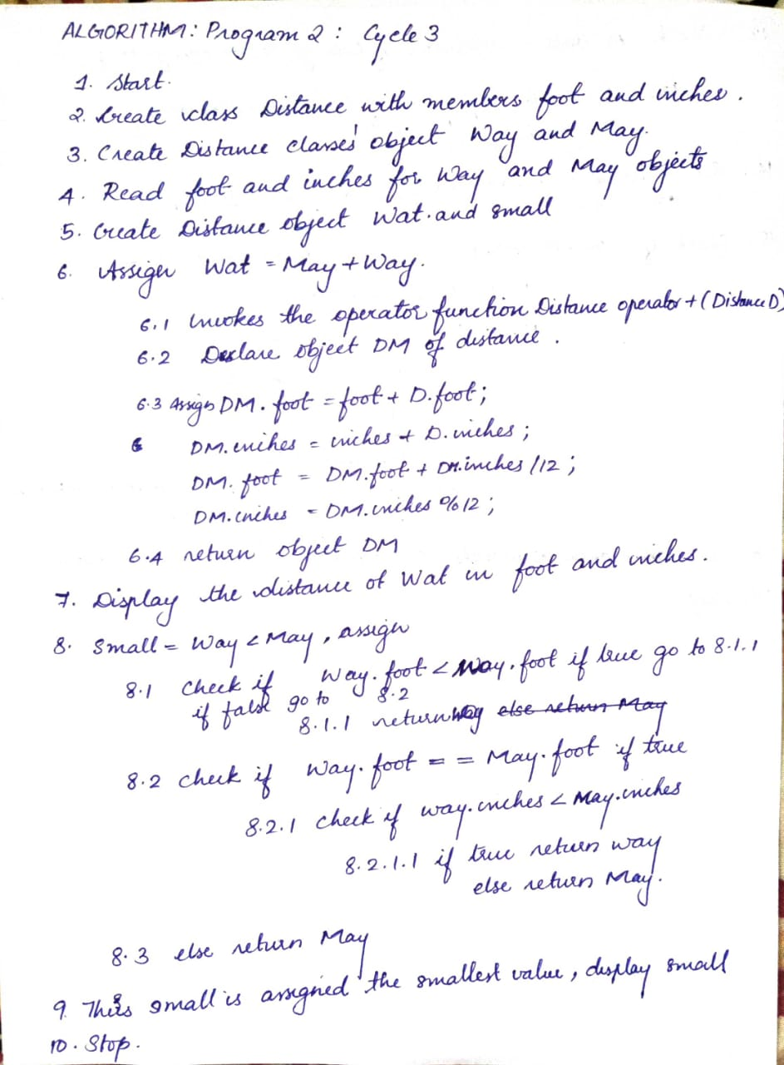

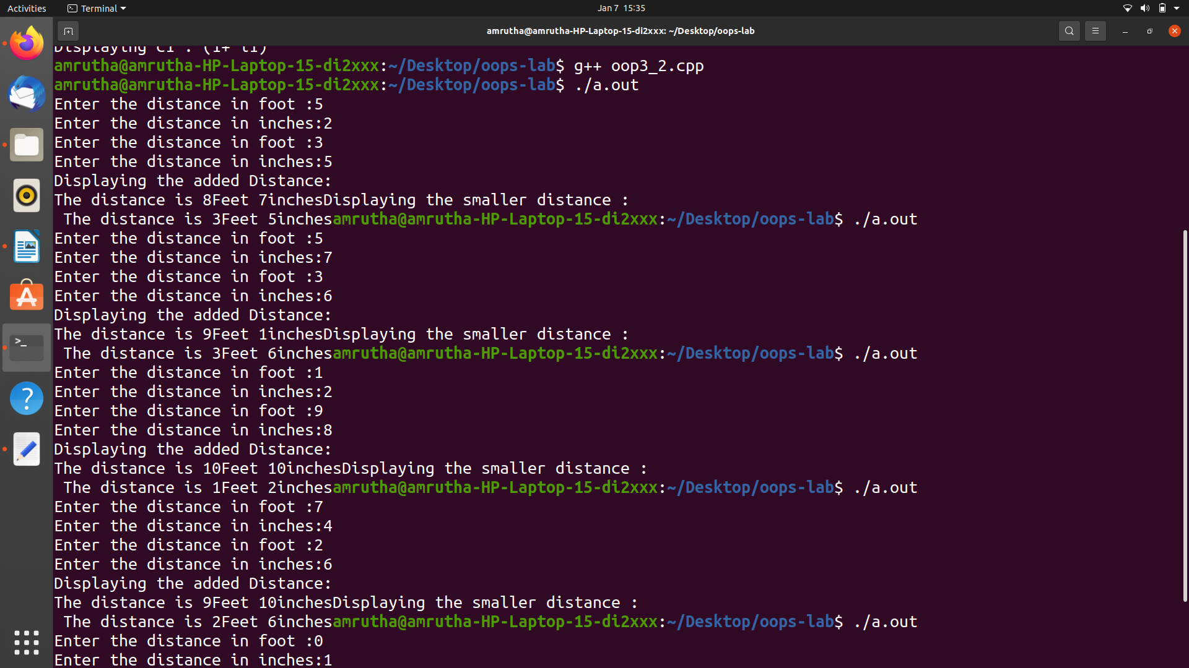
OUTPUT

PROGRAM 3

/*Write a program using operator overloading to overload Stream operators (<< and >>) to read and display the objects of complex class.*/

#include<iostream>
using namespace std;
class complex
{
int a,b;
public:
complex()
{
a=1;
b=1;
}

friend istream & operator >>(istream &pin ,complex &c);
friend ostream & operator <<(ostream &dout ,complex &c);

};

istream & operator >>(istream &pin ,complex &c) //function body of operator function >>
{
cout<<"Enter values of a and b : ";
pin>>c.a>>c.b;
return pin;
}

ostream & operator <<(ostream &dout,complex &c) //function body of operator function <<
{
dout<<"("<<c.a<<"+ i"<<c.b<<")";
return dout;
}

int main()
{
complex C1,C2,C3;
cin>>C3;//invoking the operator function >>
cout<<"Displaying c3 which is overloaded : ";
cout<<C3<<"\n";//invokes the operator function <<
cin>>C2;
cout<<"Displaying c2: ";
cout<<C2<<"\n";
cout<<"Displaying c1 : ";
cout<<C1<<"\n";
return 0;
}

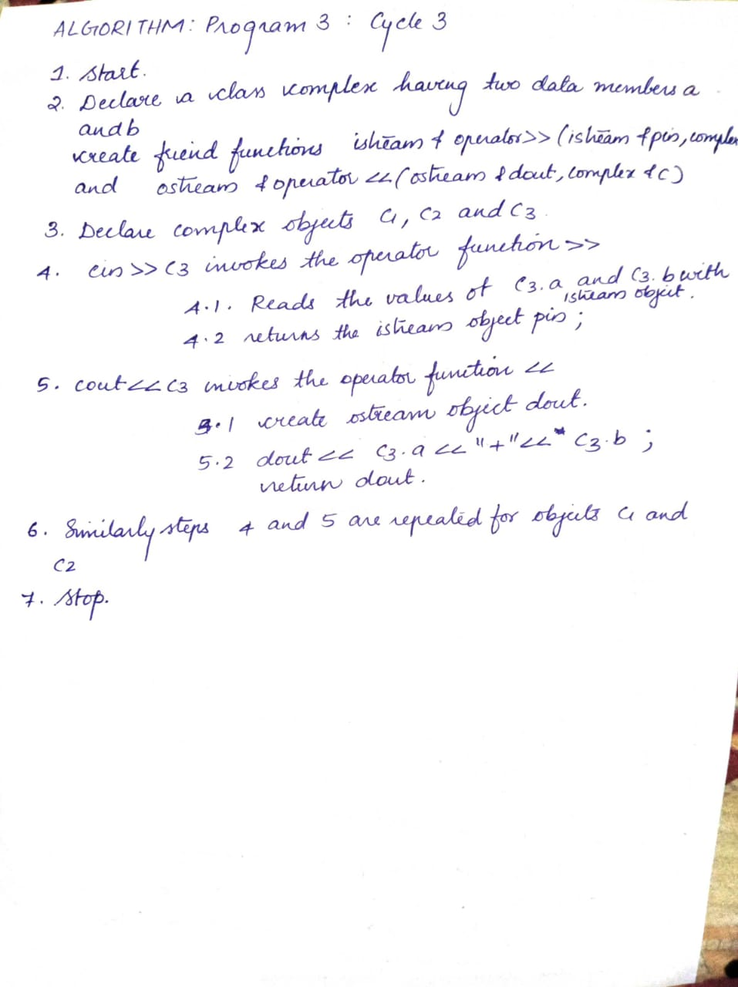

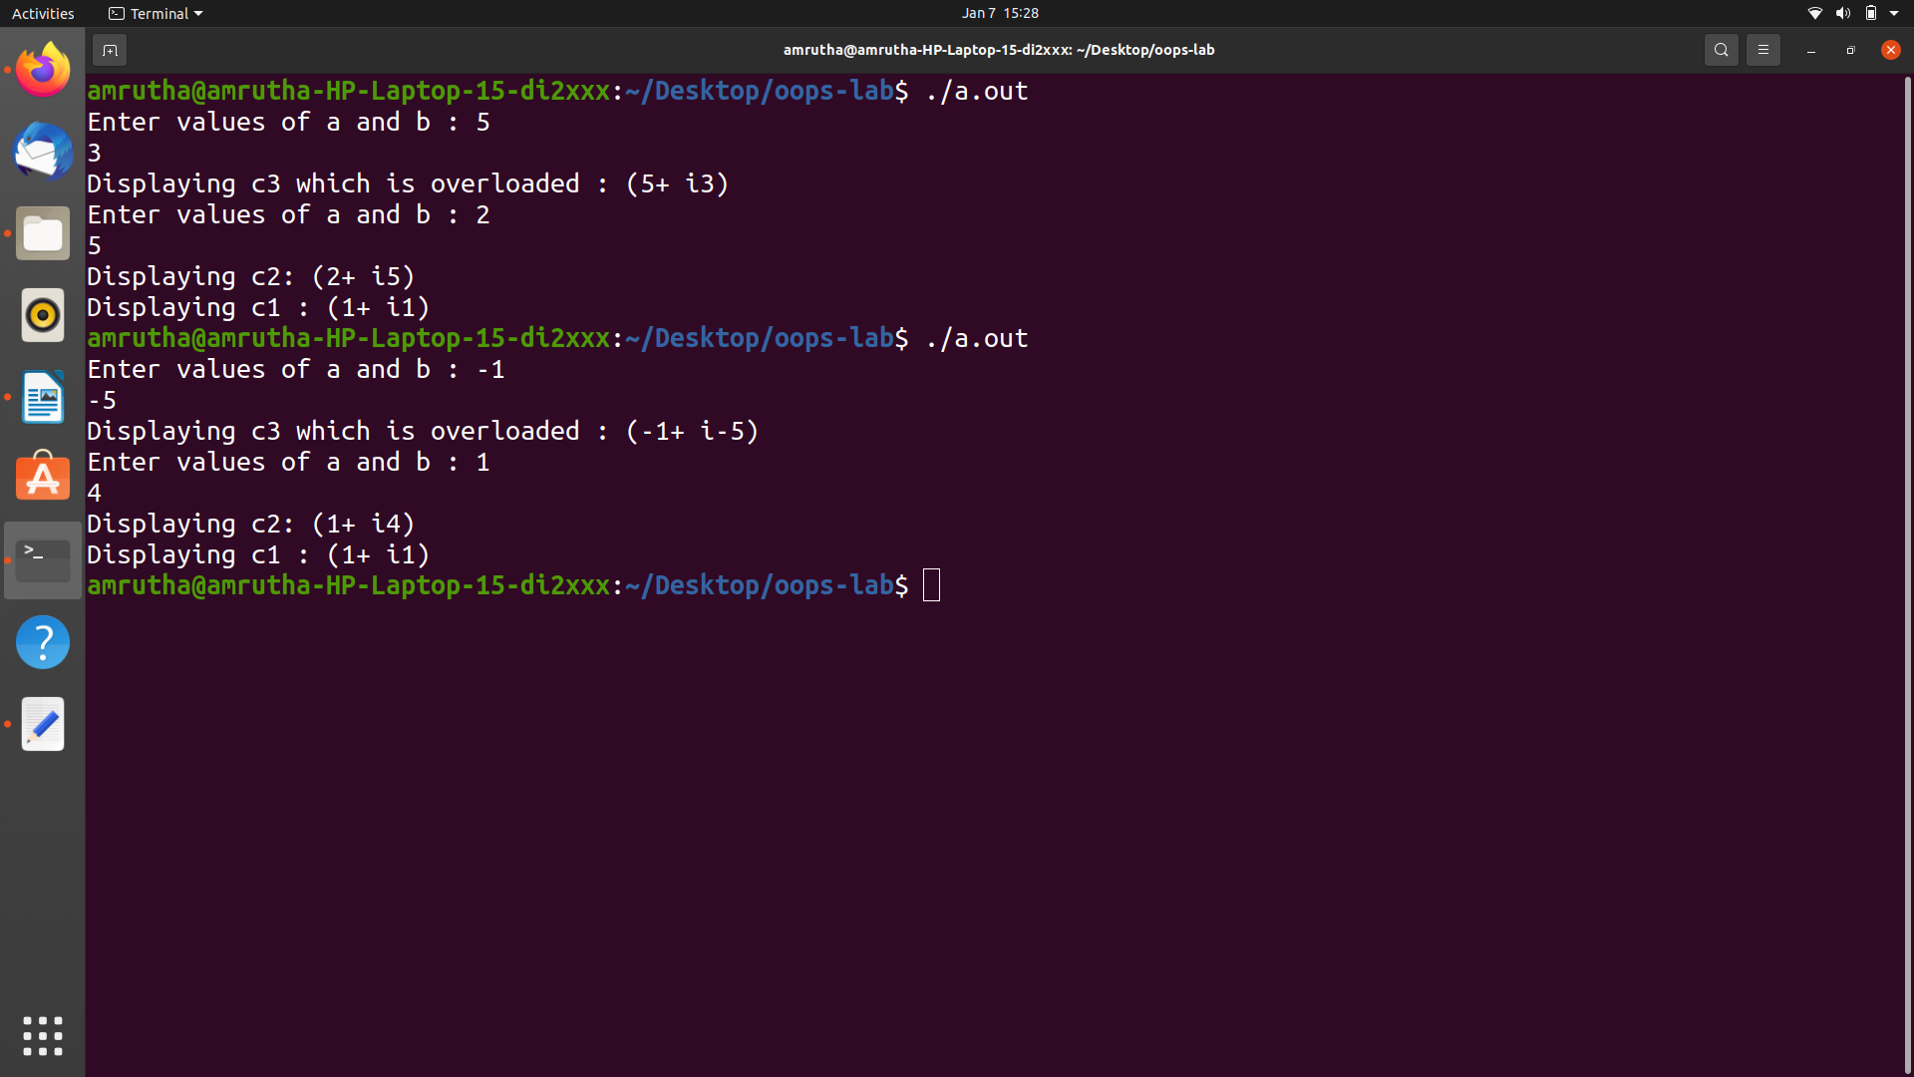
OUTPUT

PROGRAM 4

/*A class representing distance is measured in the unit of feet and inches. Write a program to do conversion from meter unit to objects of class type and objects of class type to meter.*/

#include<iostream>
using namespace std;
class Distance
{
int foot, inches;
public:
Distance()
{
foot=1;
inches=2;

}

Distance(float m)
{
foot=m*3.28;
inches=foot%12;

}
operator float();

void getdist()
{
cout<<"Enter Distance in foot : ";
cin>>foot;
cout<<"Enter Distance in inches : ";
cin>>inches;
}

void display()
{
cout<<"Distance is :\n";
cout<<foot<<" feet"<<inches<<"inches";

}
};

Distance :: operator float ()
{
float m;

m=(foot/3.28)+(inches/39.37);
return m;

}

int main()
{
Distance D;
float m;
cout<<"\nEnter the distance in meters : ";
cin>>m;
D=m;
D.display();
cout<<"\n------conversion succesful------\n";
cout<<"\nEnter the distance in feet and inches :";
D.getdist();
m=D;

cout<<"Displaying distance in metres ";
cout<<"\n"<<m<<" Meters";

cout<<"\n------conversion succesful------\n";

return 0;
}

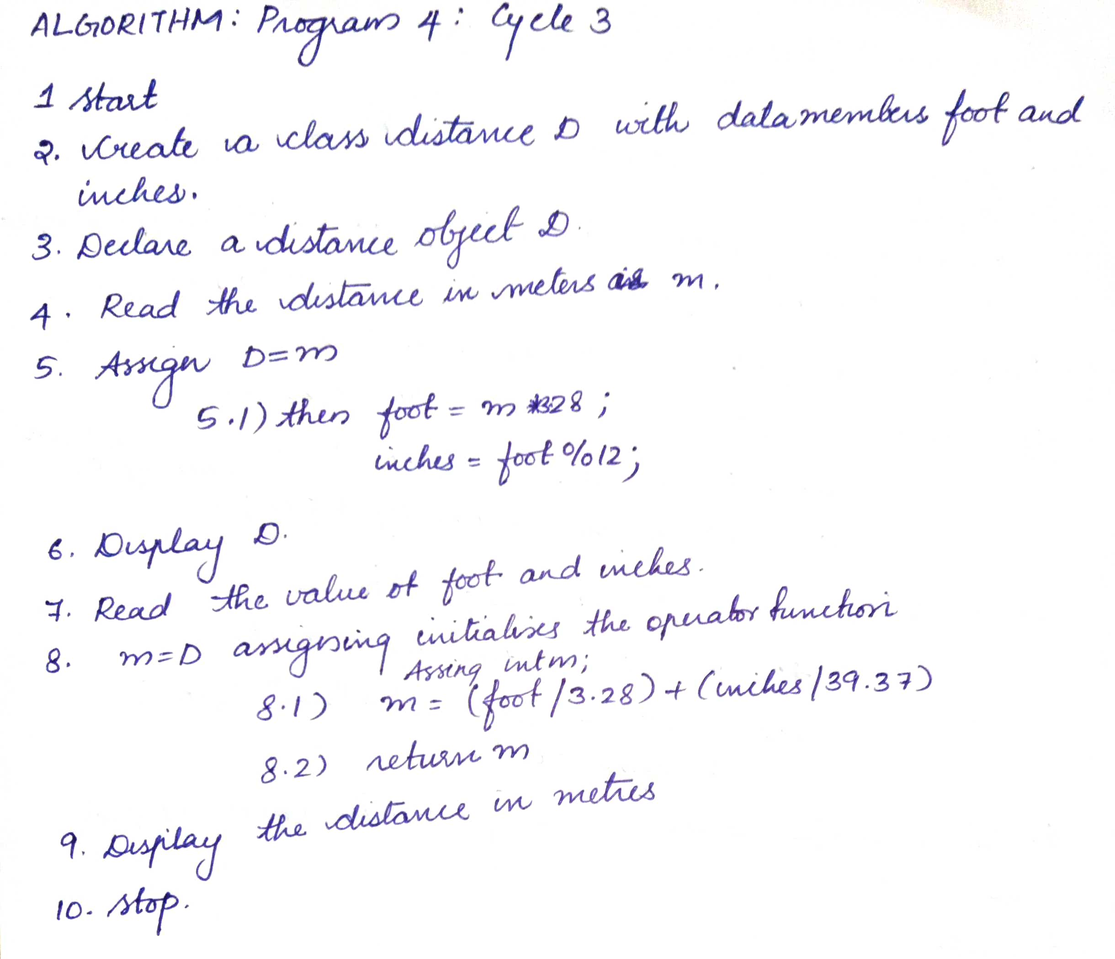

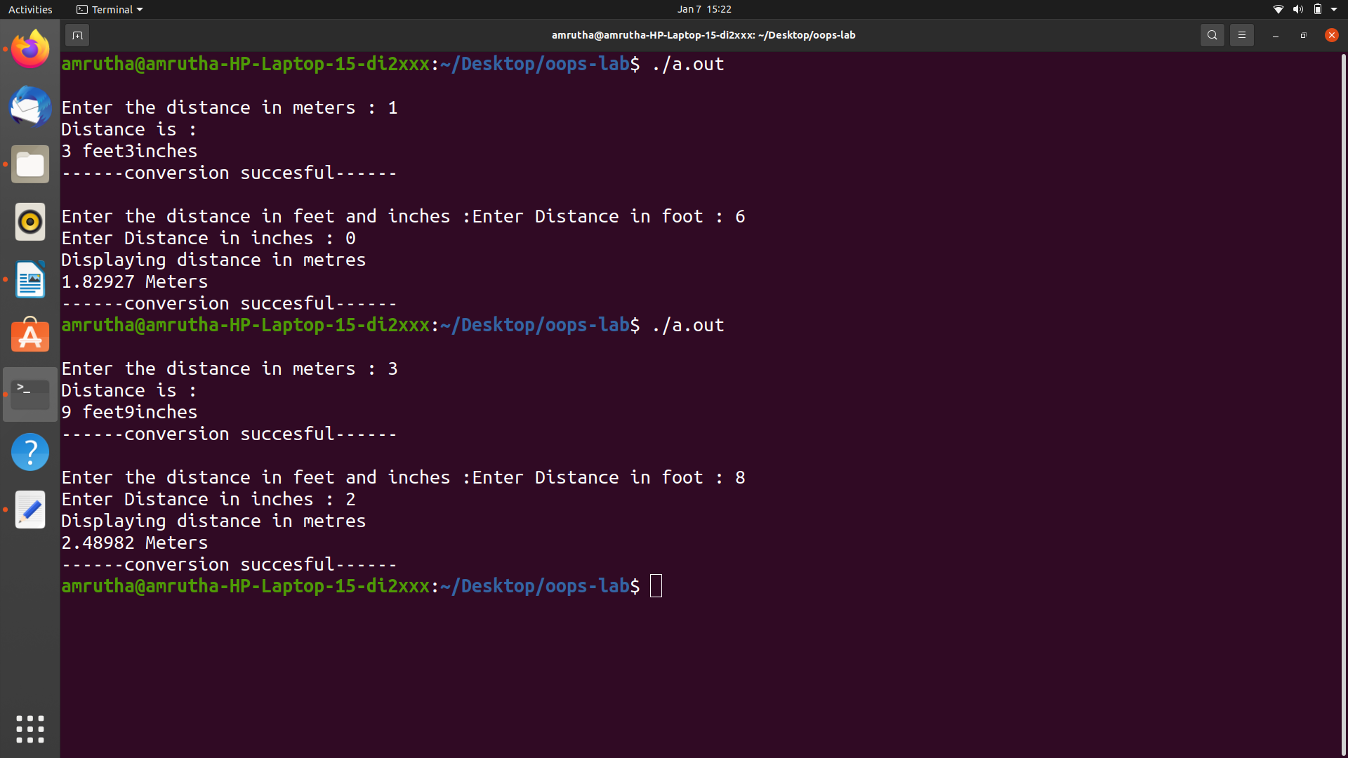
OUTPUT

PROGRAM 5

/*Polar coordinates are represented in angle and radius format while rectangular
coordinates represented as (x,y). Define classes for both types and include member
functions to convert from polar to rectangular coordinates.(conversion from class to class.)*/

#include <iostream>
#include <math.h>
using namespace std;

class Polar
{
float radius, angle;
public:
void input()
{
cout << "Enter the Radius and Angle : ";
cin >> radius >> angle;
}
void output()
{
cout << "\nPolar Form\nradius: " << radius << "m\nangle: " << angle << "°\n";
}
float getRadius()
{
return radius;
}
float getAngle()
{
return angle;
}
};

class Rectangular
{
float x, y;
public:
void operator = (Polar P)
{
x = P.getRadius() * cos((P.getAngle() * M_PI) / 180);
y = P.getRadius() * sin((P.getAngle() * M_PI) / 180);
}
void output()
{
cout << "\nRecatangular form\nx: " << x << "\ny: " << y << endl ;
}
};

int main()
{
Polar pol;
pol.input();
pol.output();
Rectangular rec;
rec = pol;
rec.output();
return 0;
}

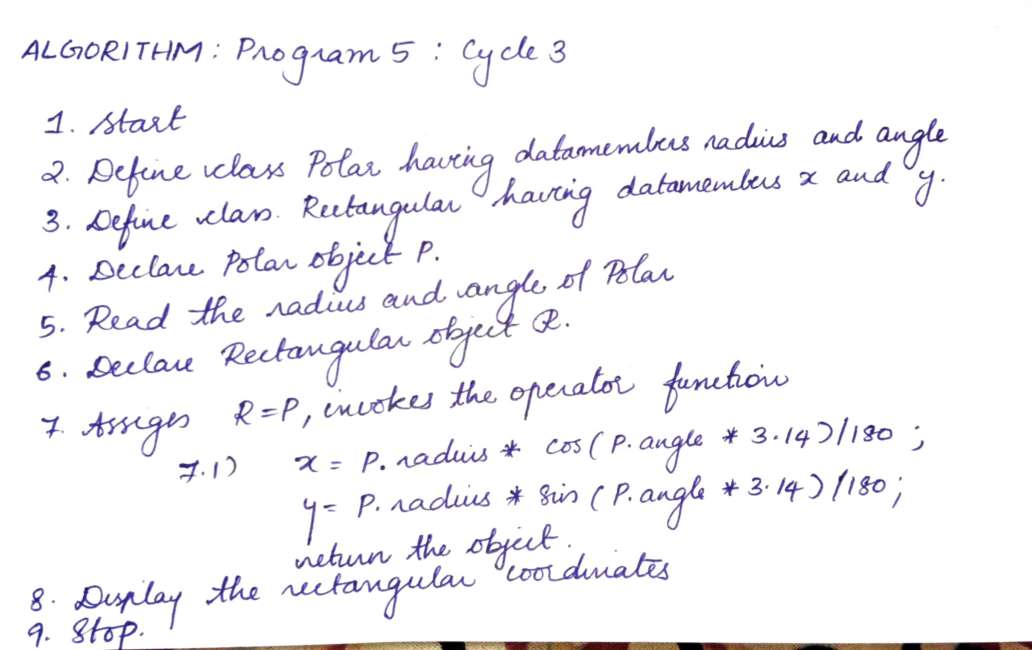
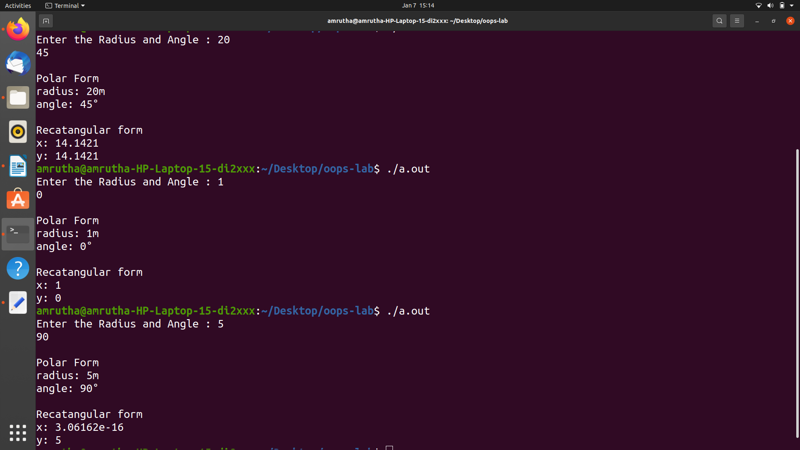

PROGRAM 6

/*. Employee class contain details like name,emp no,pay rate, constructor function and a
pay() function. Manager class inherits from employee and has the option of drawing pay
on hourly basis or salary basis and has an additional data issalaried(bool). Class
Supervisor is derived from employee and has an additional field department and is
always salaried. Base and both derived classes should contain pay() function with same
name.*/

#include<iostream>
#include<string.h>
using namespace std;

class Employee
{
protected:
char name[20];
int emp_no;
float pay_rate;

public:
Employee()
{
strcpy(name,"unknown");
emp_no=1100;
pay_rate=50;

}

virtual float pay()
{

return 0;

}

void getEmp()
{
cout<<"\nEnter the Employee Name :";
cin>>name;
cout<<"\nEnter the Employee Number :";
cin>>emp_no;
cout<<"\nEnter the Em ployee pay rate per hour :";
cin>>pay_rate;

}

void disEmp()
{
cout<<"\nDisplaying the Employee name"<<name<<"\nDisplaying the Employee number "<<emp_no<<"\nEmployee rate per hour : "<<pay_rate;
}

};

class Manager : public Employee
{
int tf;
float amt,h;
public:
bool issalaried()
{
cout<<"\nIs the Manager salaried :(1=yes//0=no)";
cin>>tf;
if(tf==1)
return 1;
else
return 0;
}
float pay()
{
if (issalaried()==1)
{
amt=pay_rate*30*8;
}
else
{
cout<<"Enter the hours worked;";
cin>>h;
amt=pay_rate*h;

}

return amt;
}
void disMan()
{
cout<<"\nDisplaying the Manager pay per month : "<<amt;

}

};

class Supervisor : public Employee
{
char dept[15];
float amt;
public:
Supervisor()
{
strcpy(dept,"unknown");

}
float pay()
{
amt=pay_rate*30*8;
return amt;

}
void getSup();
void disSup();

};

void Supervisor ::getSup()
{

cout<<"\nEnter the department of the Supervisor :";
cin>>dept;

}

void Supervisor ::disSup()
{
cout<<"\nDisplaying Supervisor Department : "<<dept;
cout<<"\nDisplaying the salary :"<<amt;

}

int main()
{

Manager M;
Supervisor S;

cout<<"\nEnter the detauils of the manager :";
M.getEmp();
M.disEmp();

M.pay();
M.disMan();

cout<<"\nEnter the details of the Supervisor : ";
S.getEmp();
S.disEmp();

S.getSup();

S.pay();

S.disSup();

return 0;
}

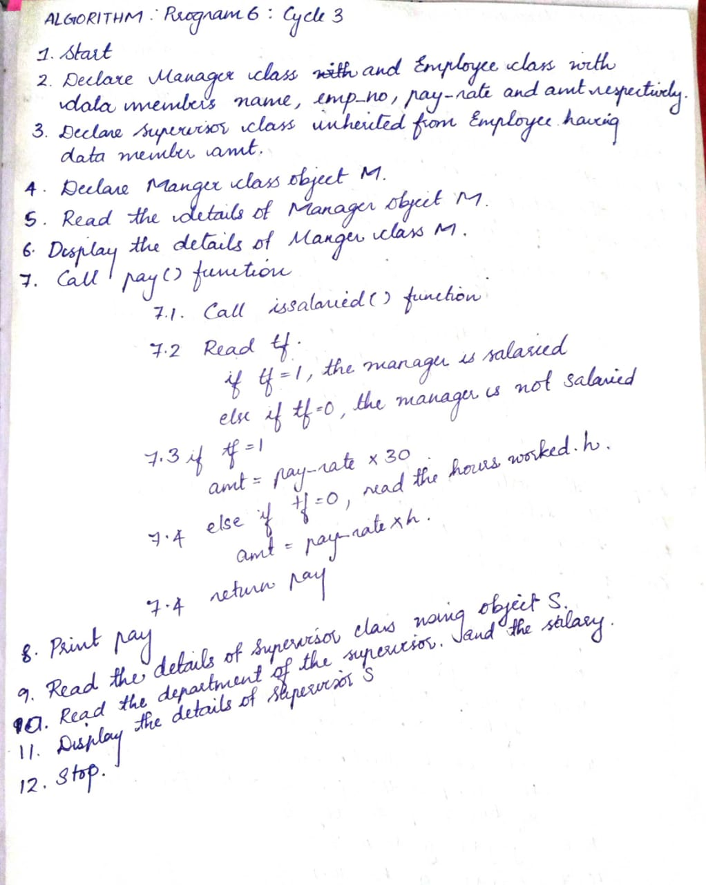
ALGORITHM

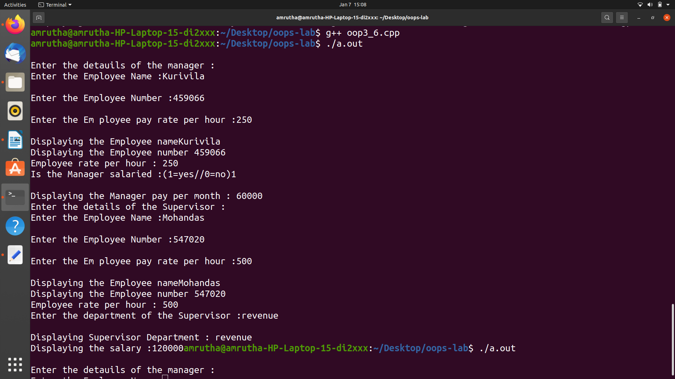
OUTPUT

PROGRAM 7

/*Write a C++ program to create a class STUDENT with age name and register number. Using Inheritance, derive two classes MTech-stud and BTech-stud.List both the category of students in the increasing order of marks( for BTech-stud) and gpa( for MTech-stud). In case of tie, display whichever name comes first. Make sort() function as a virtual function.*/

#include<iostream>
#include<string>
using namespace std;

class STUDENT
{
protected:

int age;
string name;
int reg_no;

public:
STUDENT()
{
age=50;
name.assign("unknown");
reg_no=10000;

}

void getStudnt();
void dispStudnt();
virtual void sort(int n)=0;

};

void STUDENT ::getStudnt()
{
cout<<"\nEnter the student name : ";
cin>>name;
cout<<"\nEnter the student age : ";
cin>>age;
cout<<"\nEnter the student register no : ";
cin>>reg_no;
}
void STUDENT ::dispStudnt()
{
cout<<"\nDisplaying the student name : "<<name<<"\tStudent age : "<<age<<"\tStudent Register number : "<<reg_no<<" ";

}

class BTech_stud:public STUDENT
{
int marks;
public:
BTech_stud()
{
marks=0;
}

void getB()
{
cout<<"\nEnter marks : ";
cin>>marks;
}

void dispB()
{
cout<<"\tMarks = "<<marks;

}

void sort(int n)
{
for (int i = 0; i < n - 1; ++i)
{
for (int j = 0; j < n - i - 1; ++j)
{
if (this[j].marks > this[j + 1].marks)
{
BTech_stud temp = this[j];
this[j] = this[j + 1];
this[j+ 1] = temp;
}
else if (this[j].marks == this[j + 1].marks)
{
if ((this[j].name).compare(this[j + 1].name) >0)
{
BTech_stud temp = this[j];
this[j] = this[j+ 1];
this[j+ 1] = temp;
}
}
}
}
}

};

class MTech_stud:public STUDENT
{
int gpa;
public:
MTech_stud()
{
gpa=5;
}

void getM()
{
cout<<"\nEnter gpa : ";
cin>>gpa;
}

void dispM()
{
cout<<"\tgpa = "<<gpa;

}

void sort(int n)
{
for (int i = 0; i < (n - 1); ++i)
{
for (int j = 0; j < (n - i - 1); ++j)
{
if (this[j].gpa > this[j + 1].gpa)
{
MTech_stud temp = this[j];
this[j] = this[j + 1];
this[j+ 1] = temp;
}
else if (this[j].gpa == this[j + 1].gpa)
{
if ((this[j].name).compare(this[j+ 1].name) >0)
{
MTech_stud temp = this[j];
this[j] = this[j+ 1];
this[j+ 1] = temp;
}
}
}
}
}

};

int main()
{
STUDENT *S;
int Bn,Mn;
cout<<"\nEnter the number of B-Tech Students";
cin>>Bn;

BTech_stud CUSAT[Bn];

for(int i=0;i<Bn;i++)
{
cout<<"\nEnter details of B-Tech student "<<i<<" : \n";
CUSAT[i].getStudnt();
CUSAT[i].getB();

}

cout<<"\nArranging students according to marks : ";
S=CUSAT;
S->sort(Bn);

cout<<"\nDisplaying BTech students details : ";
for(int i=0;i<Bn;i++)
{
CUSAT[i].dispStudnt();
CUSAT[i]. dispB();

}
//for MTech students
cout<<"\nEnter the number of M-Tech Students";
cin>>Mn;

MTech_stud CUCEK[Mn];

for(int i=0;i<Mn;i++)
{
cout<<"\nEnter details of M-Tech student "<<i<<" : \n";
CUCEK[i].getStudnt();
CUCEK[i].getM();
}

cout<<"\nArranging students according to GPA : ";
S=CUCEK;
S->sort(Mn);

cout<<"\nDisplaying MTech student details : ";
for(int i=0;i<Mn;i++)
{
CUCEK[i].dispStudnt();
CUCEK[i]. dispM();

}

return 0;
}

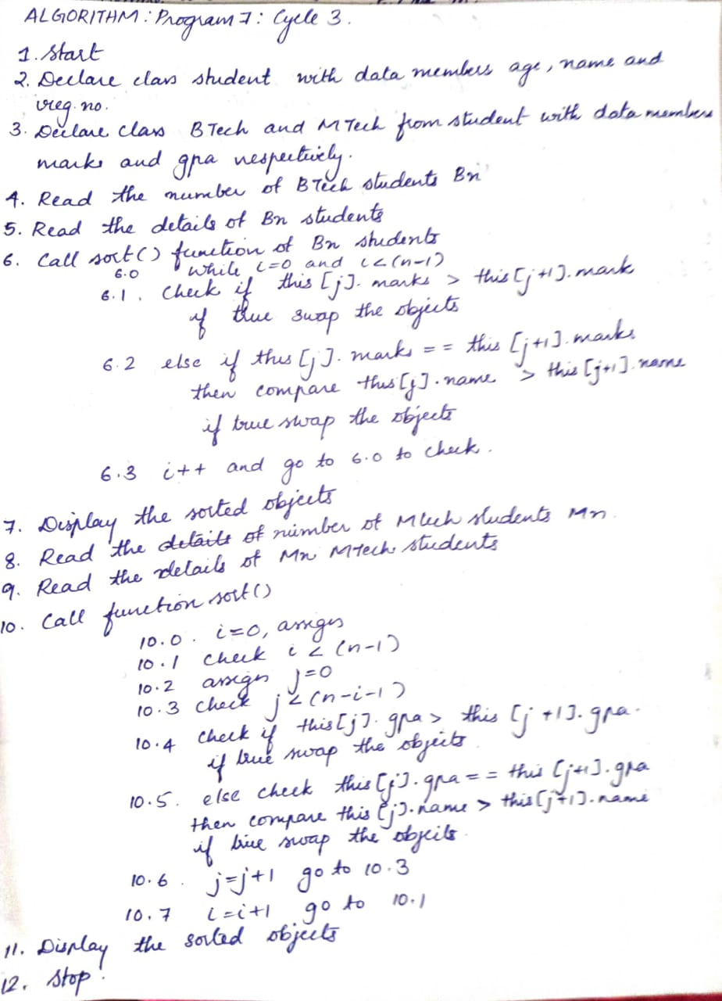
ALGORITHM

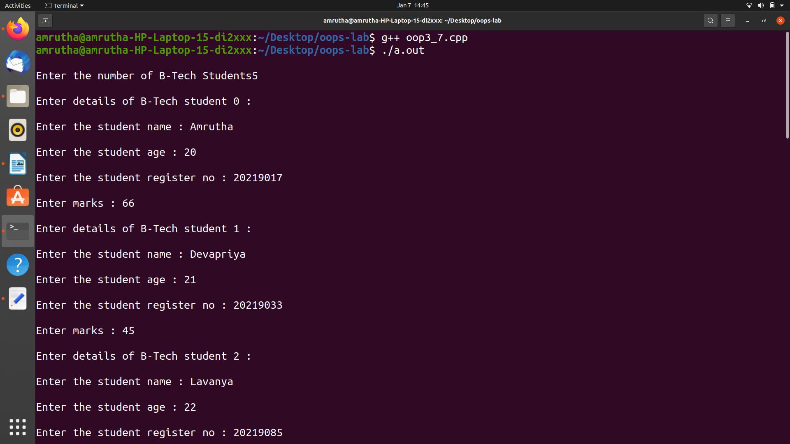
OUTPUT

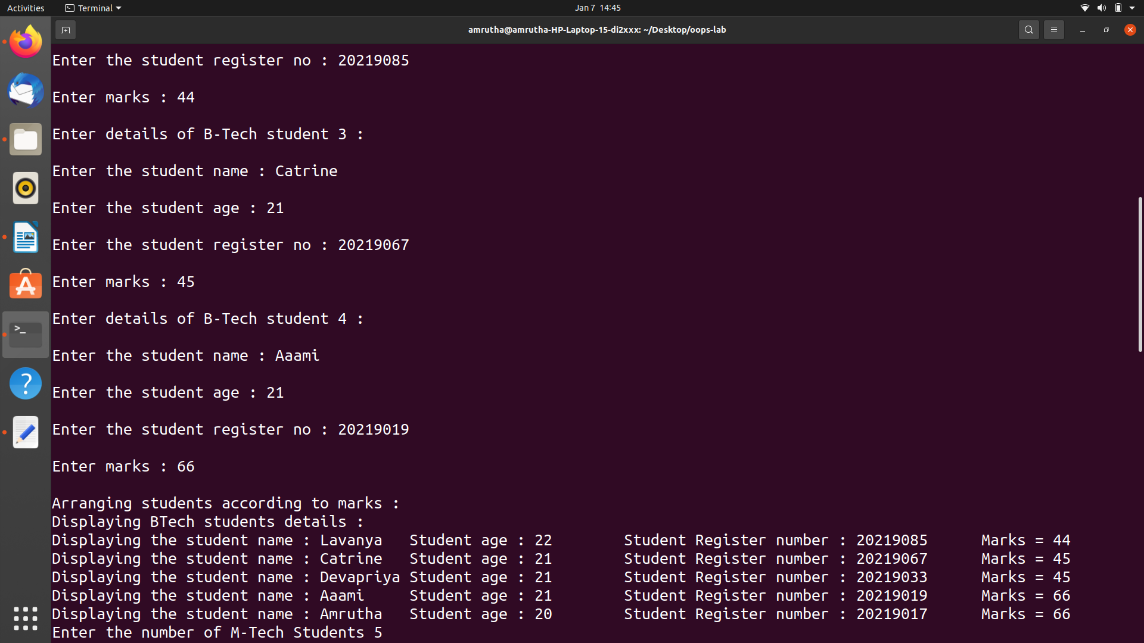

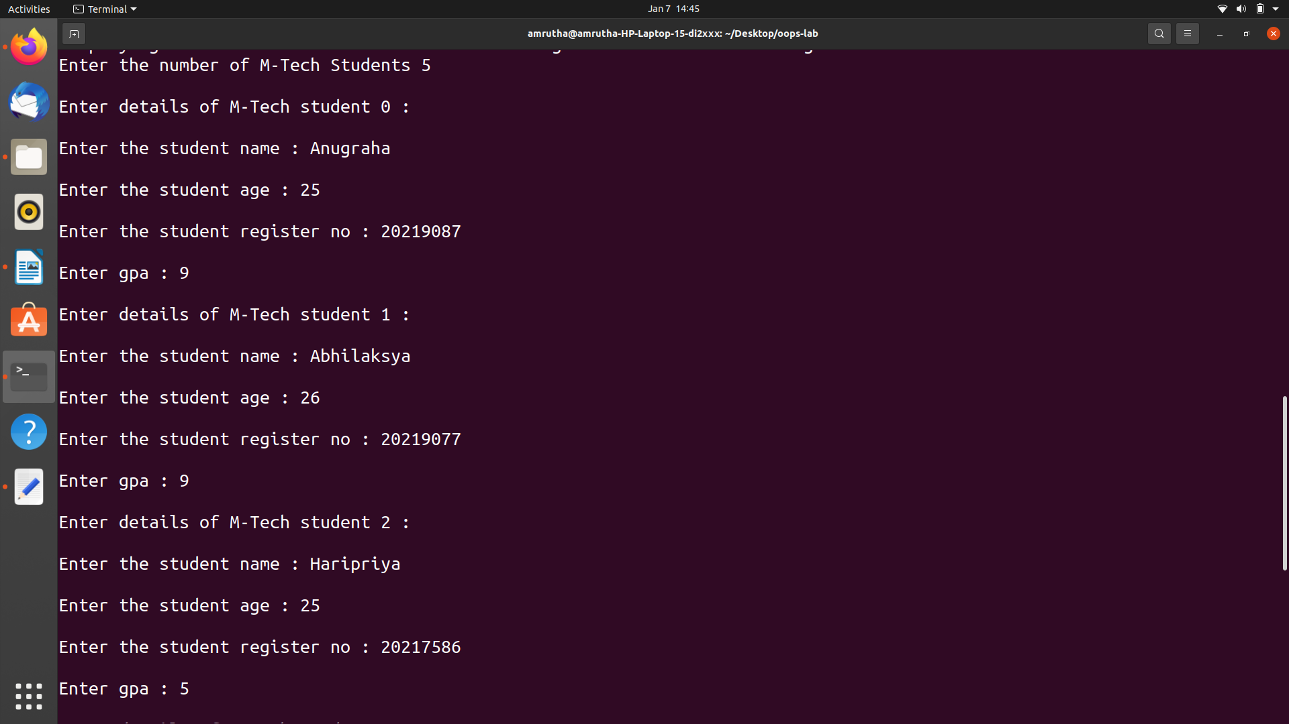

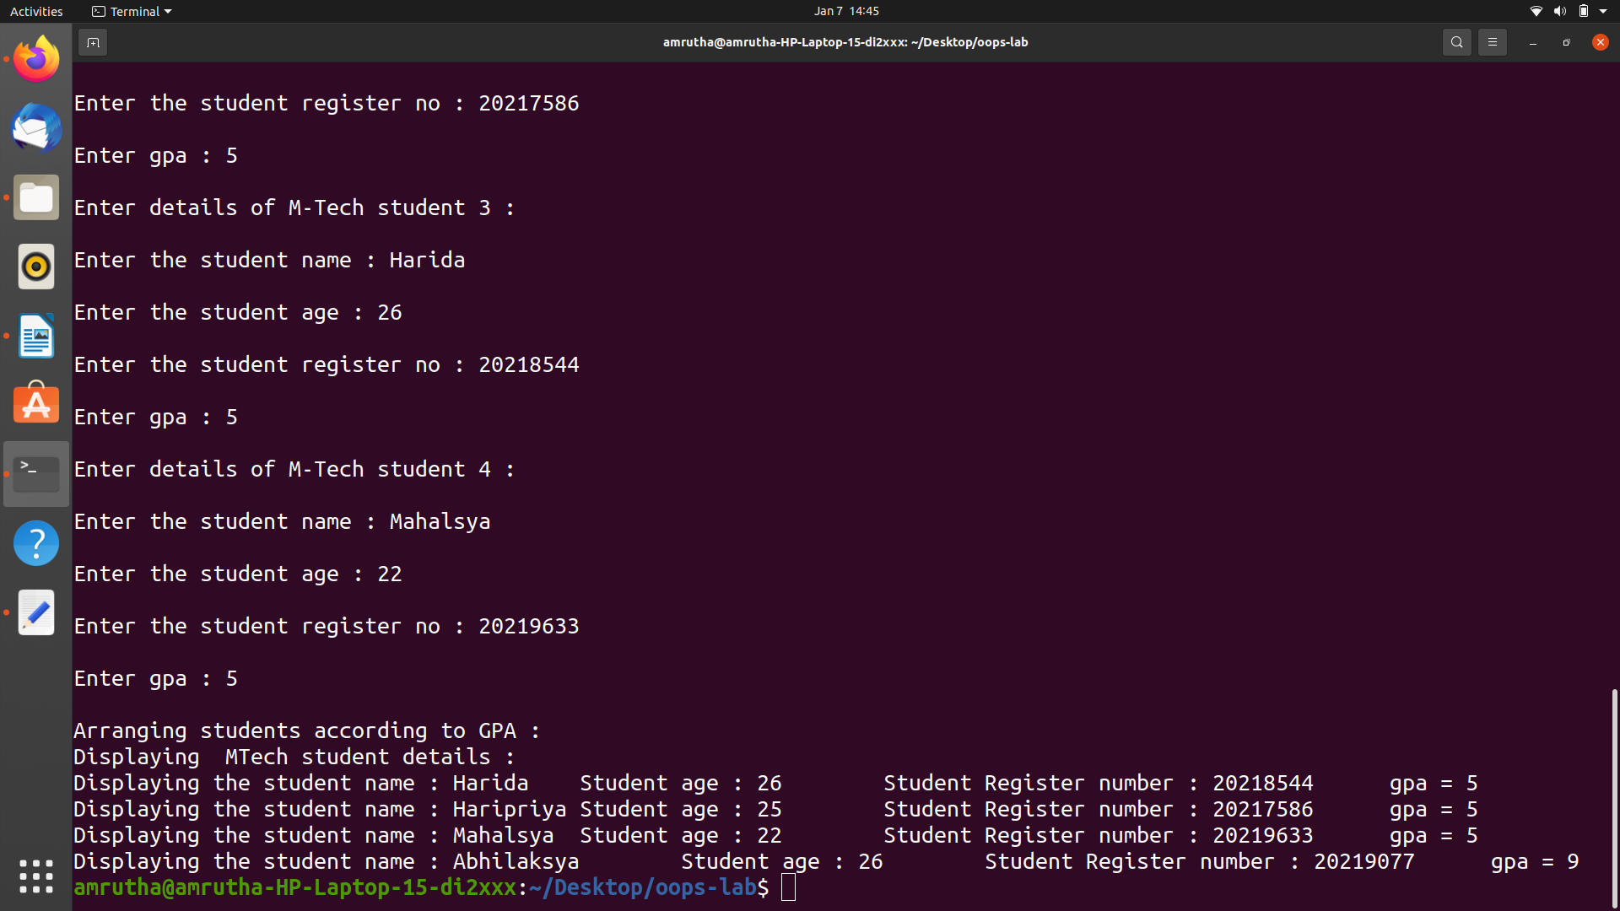

PROGRAM 8

/*Implement the base class Shape and derive triangle,rectangle,circle and square classes
from it. Implement functions to compute the area and perimeter of the polygon. Use the
concept of pure virtual functions.*/

#include <iostream>
#include <cmath>
using namespace std;
int validity(int a,int b,int c);
class shape{
public:
virtual void area()=0;
virtual void perimeter()=0;
};

class triangle:public shape{
protected:
float A,a,s,b,c,P;
public:
triangle(float x,float,float z);
void area();
void perimeter();
};

class square:public shape{
protected:
float x,A,P;
public:
square(float a){
x=a;
}
void area();
void perimeter();
};

class rectangle:public shape{
protected:
float a,b,A,P;
public:
rectangle(float x,float y){
a=x;
b=y;
}
void area();
void perimeter();
};

class circle:public shape{
protected:
float r,A,P;
public:
circle(float a){
r=a;
}
void area();
void perimeter();
};

void circle::area(){
A=3.14*r*r;
cout<<"Area of circle is "<<A<<endl;
}
void circle::perimeter(){
P=2*3.14*r;
cout<<"Perimeter of circle is "<<P<<endl;
}

void rectangle::area(){
A=a*b;
cout<< "Area of rectangle is "<<A<<endl;
}
void rectangle::perimeter(){
P=2*(a+b);
cout<<"Perimeter of rectangle is "<<P<<endl;
}

void square::area(){
A=x*x;
cout << "Area of the Square is "<<A<<endl;
}
void square::perimeter(){
P=4*x;
cout<<"Perimeter of Square is "<<P<<endl;
}

triangle::triangle(float x,float y,float z){
a=x;
b=y;
c=z;
}
void triangle::area(){
s=(a+b+c)/2;
A=sqrt(s*(s-a)*(s-b)*(s-c));
cout<<"Area of Triangle is "<<A<<endl;
}
void triangle::perimeter(){
P=a+b+c;
cout<<"Perimeter of Triangle "<<P<<endl;
}
int validity(int a,int b,int c)
{
if(((a+b)>c)&&((b + c) > a)&&((a + c) > b))
{
cout<<"Triangle is valid.\n";
return 0;
}

else
{
cout<<"\nTriangle is invalid";
return 1;
}

}
int main(){
shape *sptr;
int key=1;
float a,b,c,i=1;
cout<<"------POLYGON AREA CALCULATOR------- \n";
while(key!=0){
cout<<"Choose the Polygon \n 1.Triangle \n 2.Square \n 3.rectangle \n 4.Circle \n 0.exit\n";
cin>>key;

switch(key){
case 1:{
while(i!=0){
cout<<"Enter the sides of triangle \n";
cin>>a>>b>>c;
i=validity(a,b,c);
}

triangle t(a,b,c);
sptr=&t;
sptr->area();
sptr->perimeter();
break;}
case 2:{cout<<"Enter the side of the square \n";
cin>>a;
square s(a);
sptr=&s;
sptr->area();
sptr->perimeter();
break;}
case 3:{
cout<< "Enter the 2 adjacent sides of rectangles \n";
cin>> a>>b;
rectangle r(a,b);
sptr=&r;
sptr->area();
sptr->perimeter();
break;}
case 4:{
cout<< "Enter the radius \n";
cin>> a;
circle c(a);
sptr=&c;
sptr->area();
sptr->perimeter();
break;}

default: cout<<"Error!";

}
}

return 0;

}

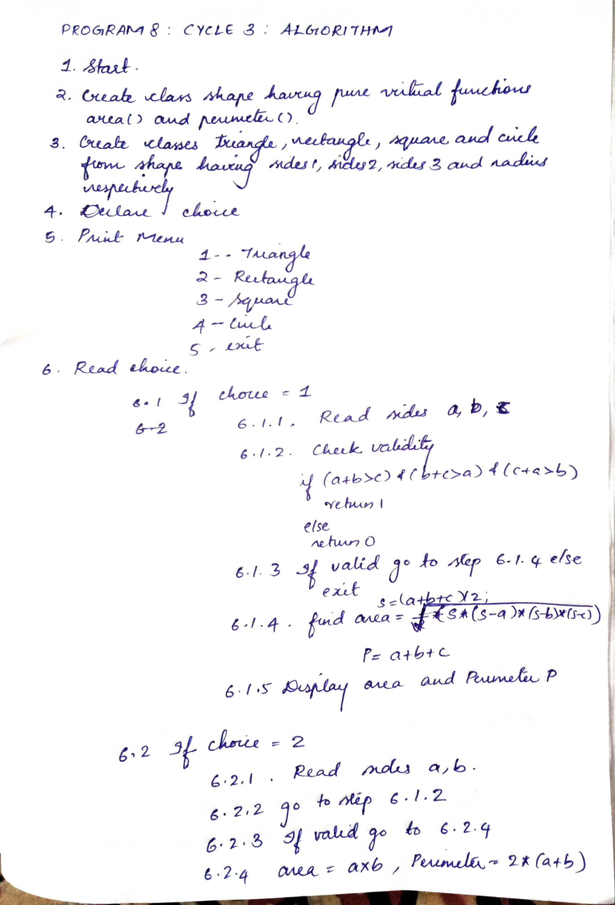

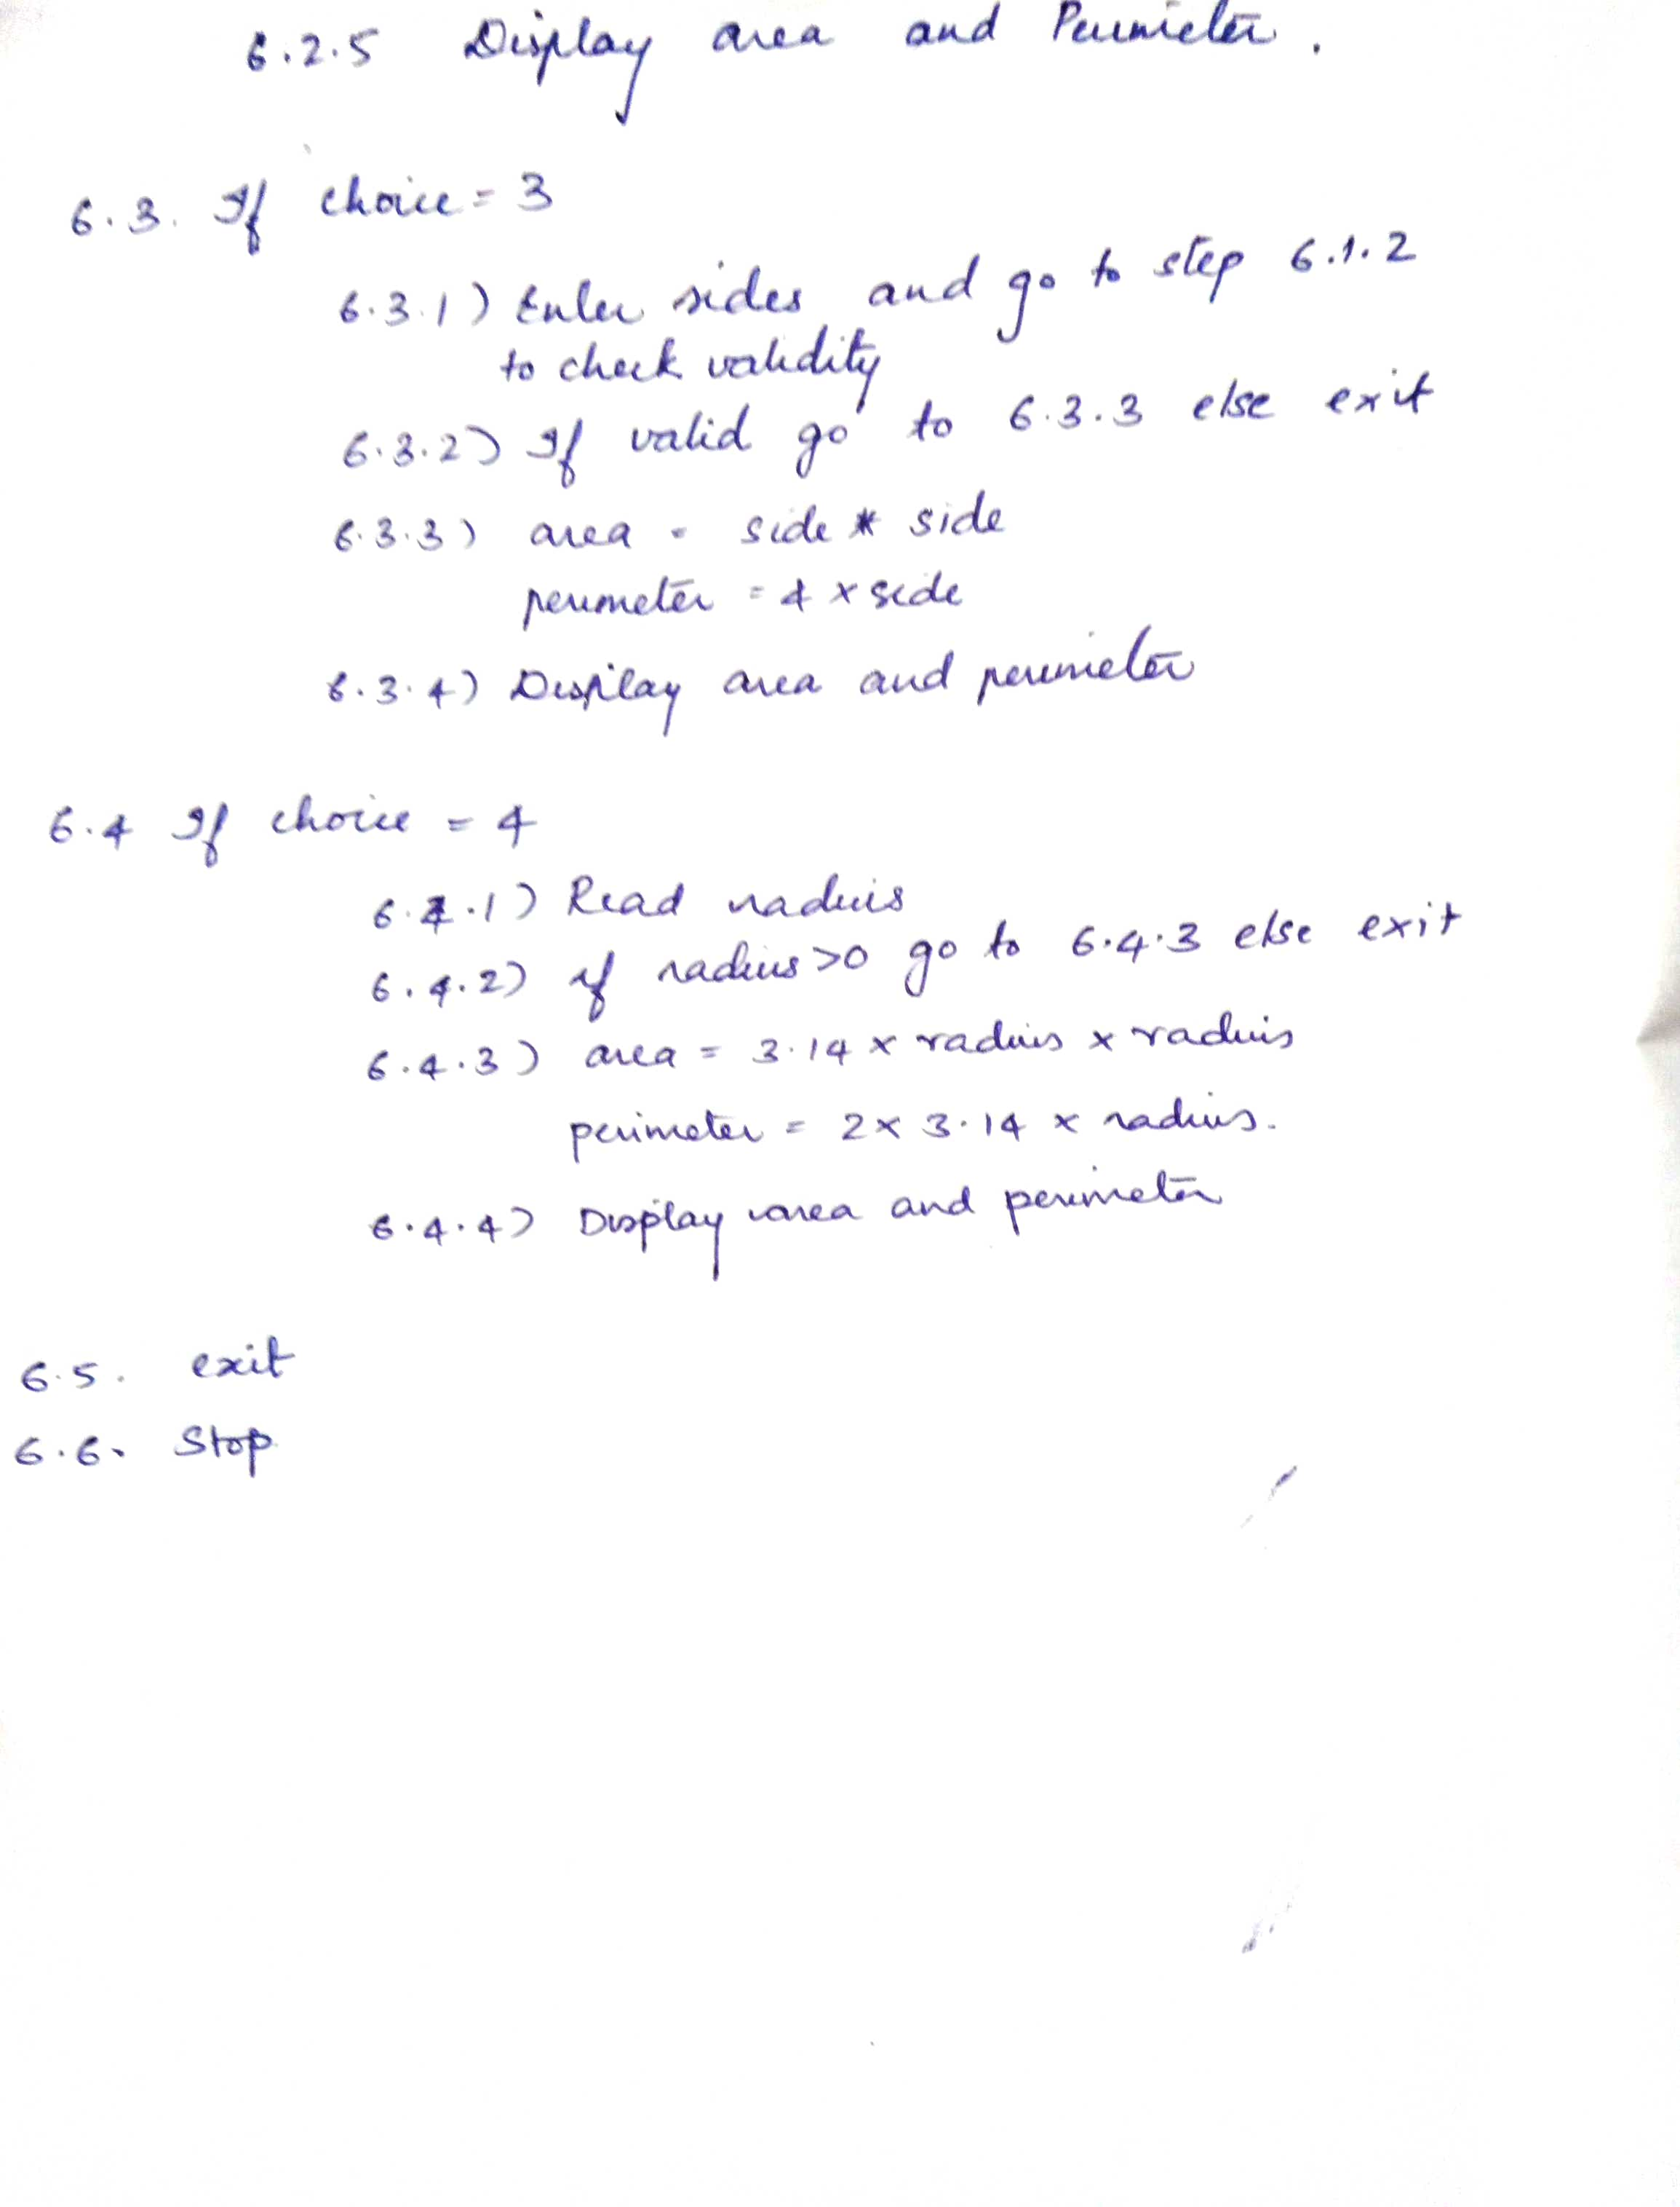

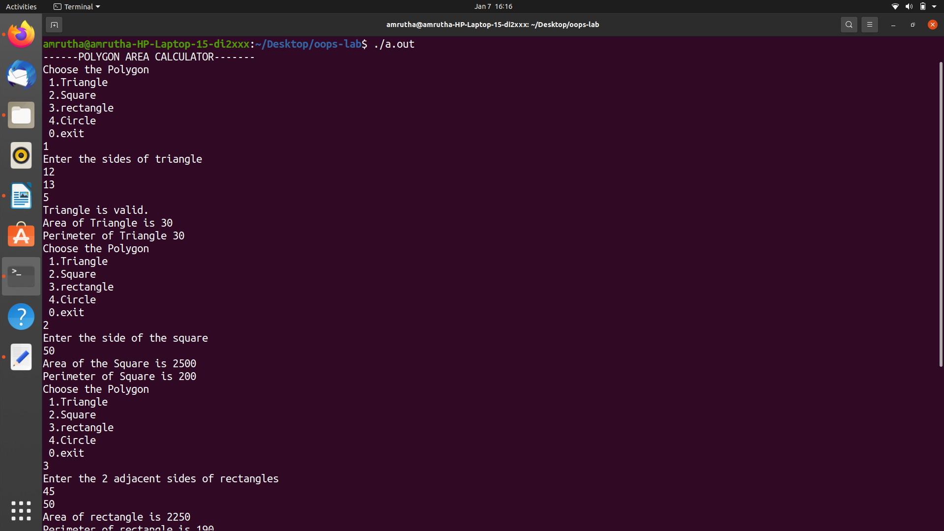
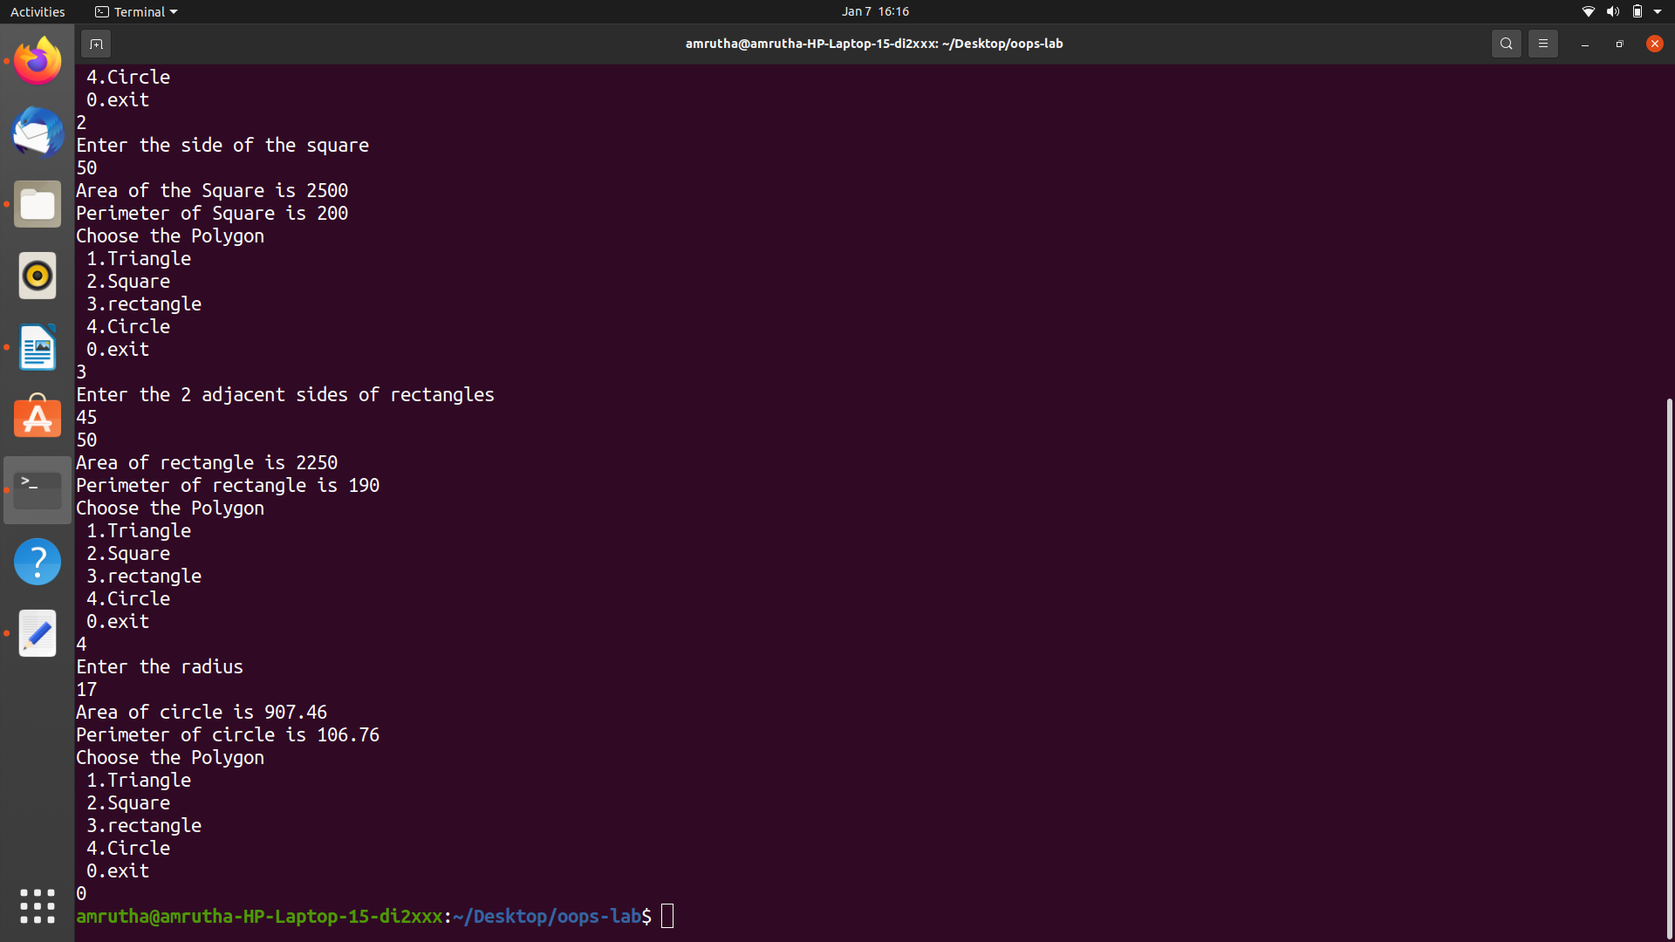
OUTPUT

