#code in postresql

**# Creating the Database**

CREATE DATABASE School

**# Creating Table “Student” under School Database**

CREATE TABLE STUDENT (

Roll_No INT,

Name VARCHAR(255),

Marks INT

Grade CHAR(2)

);

**# insert Multiple values at a time**

INSERT INTO STUDENT (Roll_No, Name, Marks,Grade)

VALUES

(001, 'Meril', 45,'A'),

(002, 'Anendu', 49,'A+'),

(003, 'Febi', 40,'B'),

(004, 'Pinky', 47,'A'),

(005, 'Kashi', 50,'A+'),

(006, 'Ammu', 49,'A+');

**1.Use the select command to display the table.**

select * from School;

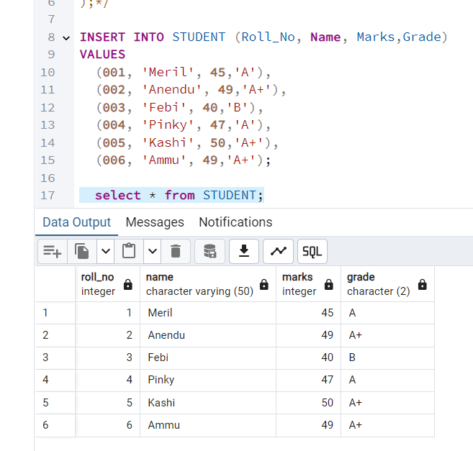

**2.Add a column named Contact to the STUDENT table.**

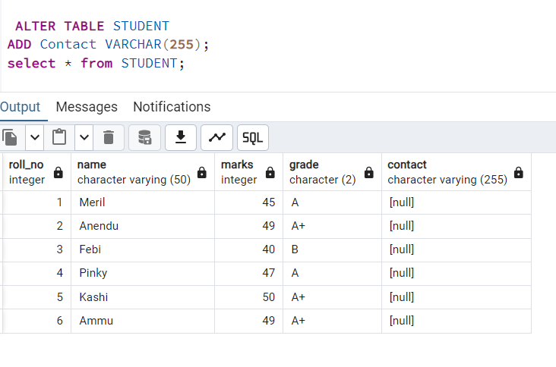

**3.** **Remove the Grade column from the Student table.**

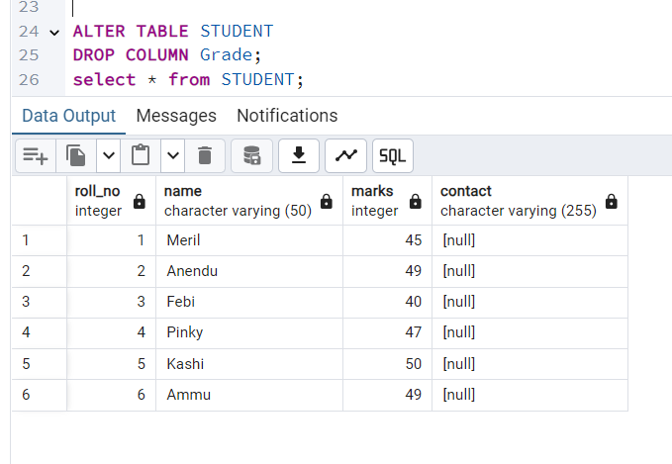

**4.** **Rename the table to CLASSTEN.**

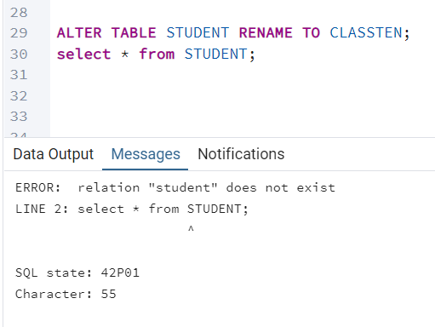

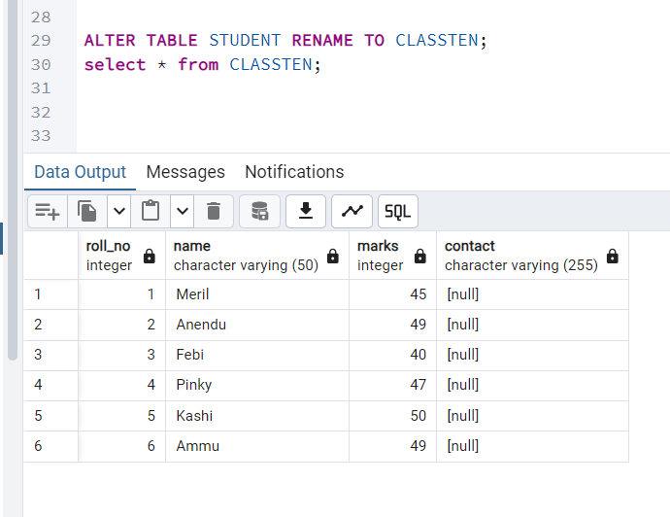

**5. Delete all rows from the table.**

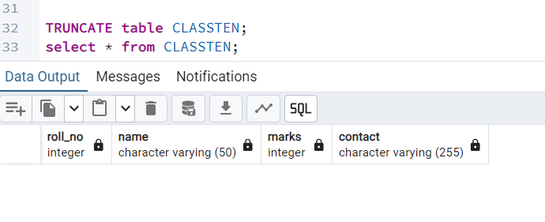

**6.** **Remove the table from the database.**

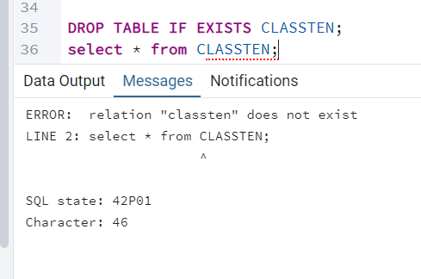

**\*\*\*\*\*\*\*\*\*\*\*\*\*\*\*\*\*\*\*\*\* END \*\*\*\*\*\*\*\*\*\*\*\*\*\*\*\*\*\*\*\*\*\*\*\*\***