## ASSIGNMENT 2 - DDL Constraints

## POSTRESQL DBMS

## Create a database called “Sales”

## CREATE DATABASE Sales;

## create a new table named “Orders” in the Sales database with columns: (Order_Id, Customer_name, Product_Category, Ordered_item, Contact_No)

## 

* **Add a new column named “order_quantity” to the orders table.**

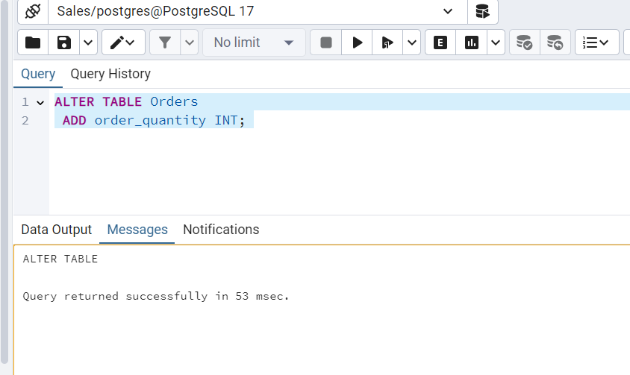

* **Rename the orders table to the sales_orders table.**

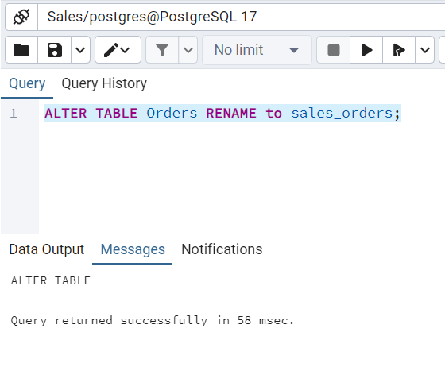

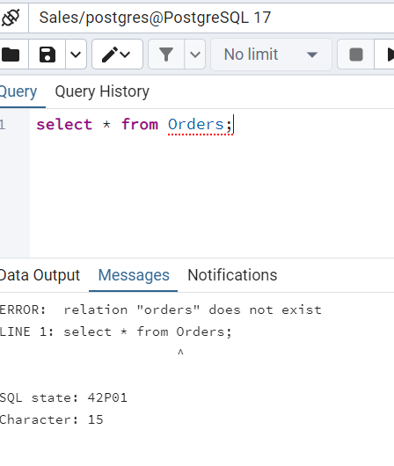

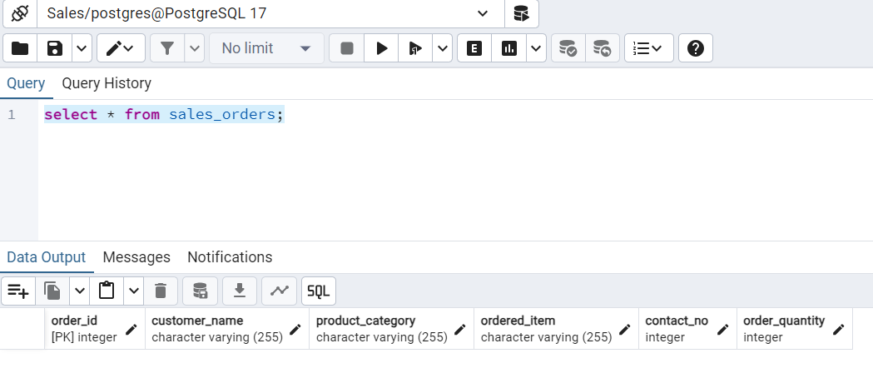

* **Insert 10 rows into the sales_orders table.**

**Please note: I have altered the field contact_no datatype from INT to NUMERIC(10)**

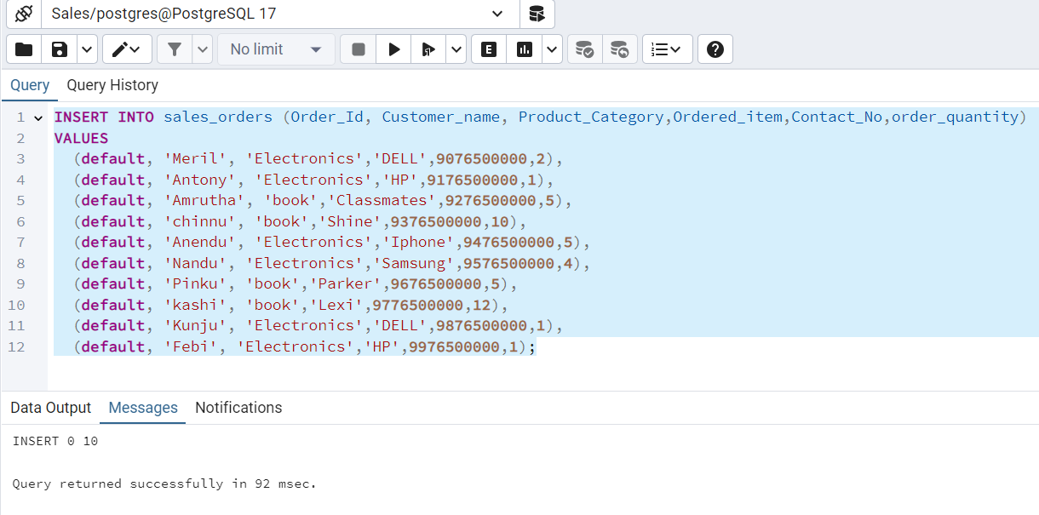

* **Retrieve customer_name and Ordered_Item from the sales_orders table**

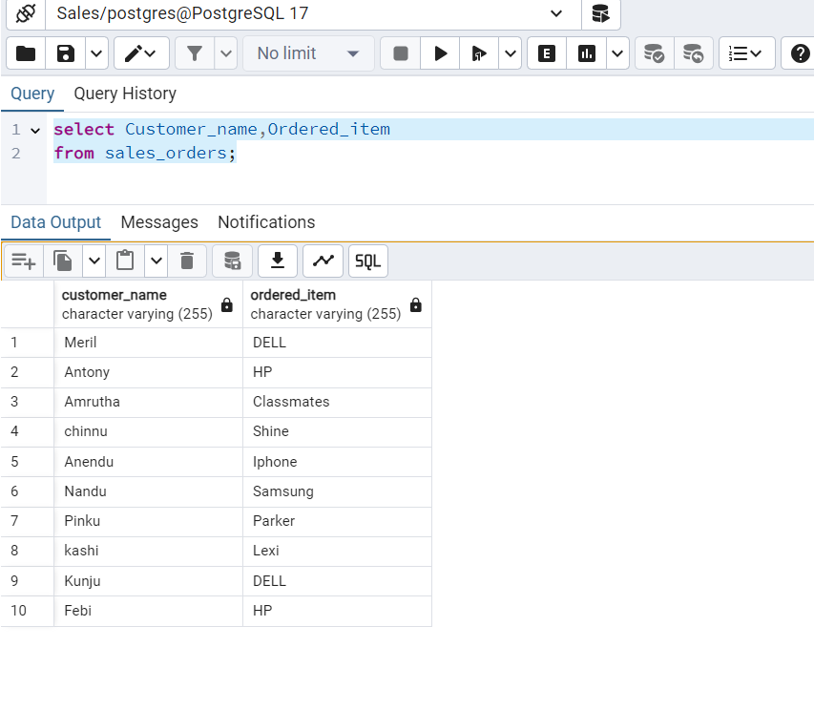

* **Use the update command to change the name of the product for any row(updating the ordered_items of ordered_id 1 & 10)**

**Before updation:**

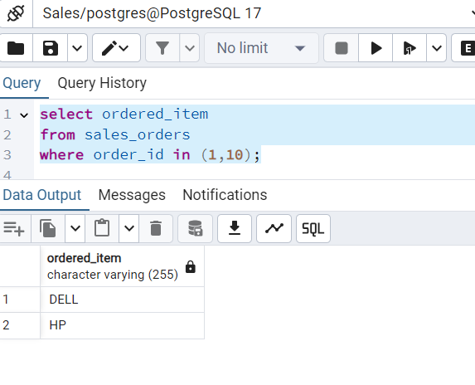

**After Updation:**

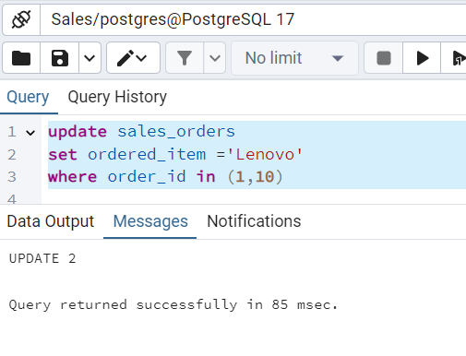

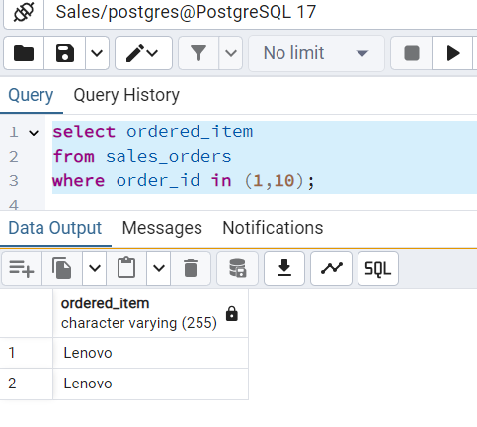

* **Delete the sales_orders table from the database.**

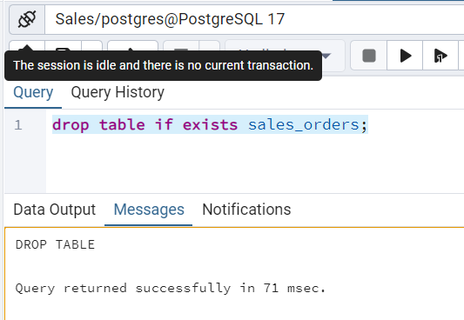

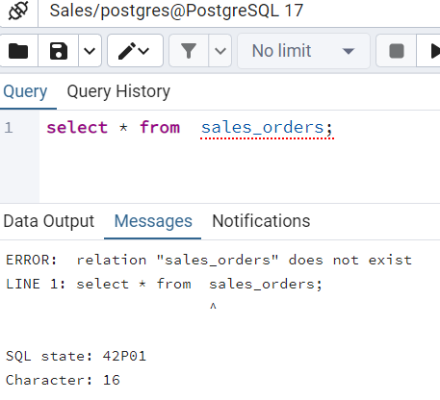

**\*\*\*\*\*\*\*\*\*\*\*\*\*\*\*\*\*\*\*\*\*\*\* END \*\*\*\*\*\*\*\*\*\*\*\*\*\*\*\*\*\*\*\*\*\*\***