**Assignment 3 : DML Commands**

**POSTRESQL Commands :**

* **Create a table named Managers with fields : Manager_Id First_name Last_Name DOB**

**Age ->Use check constraint Last_update Gender Department Salary -> NOT NULL**

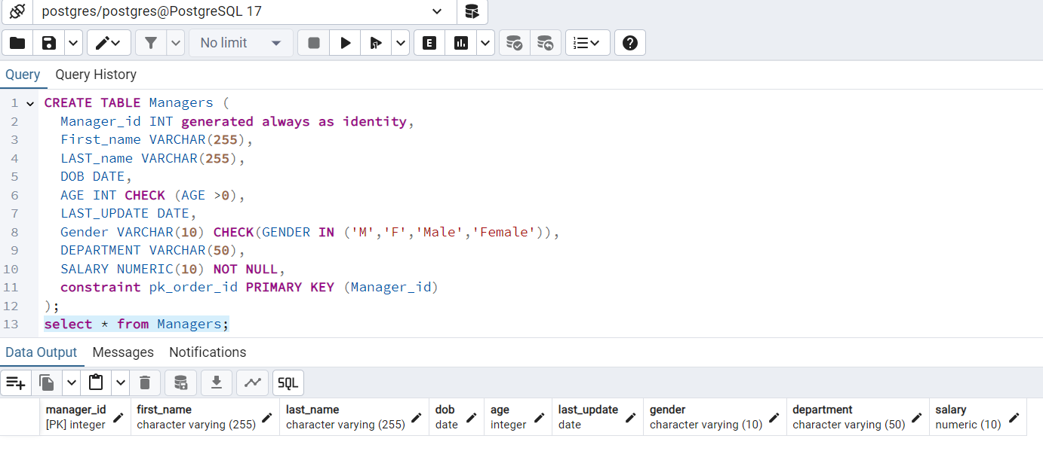

* **Insert 10 rows.**

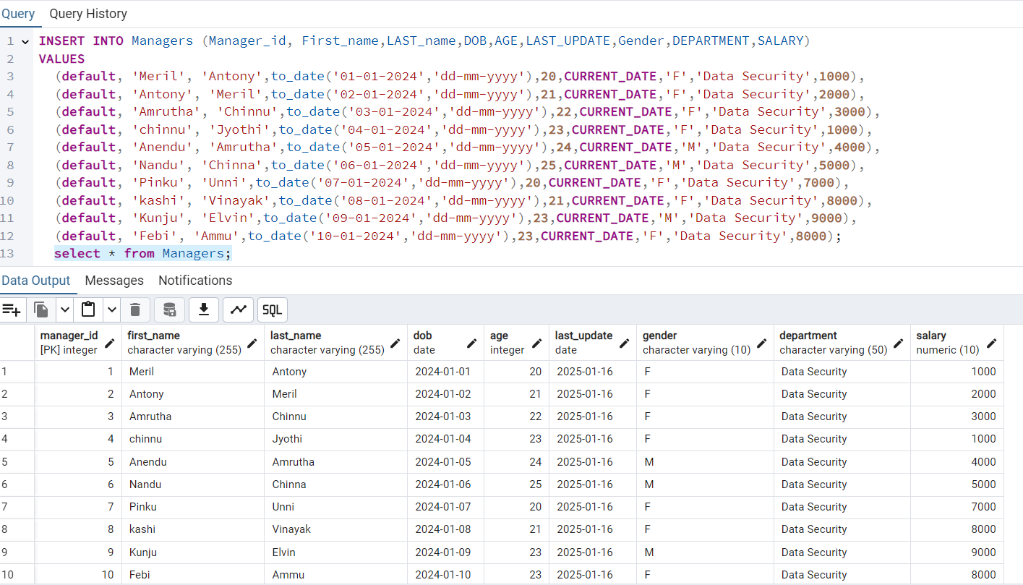

* **Write a query that retrieves the name and date of birth of the manager with Manager_Id**

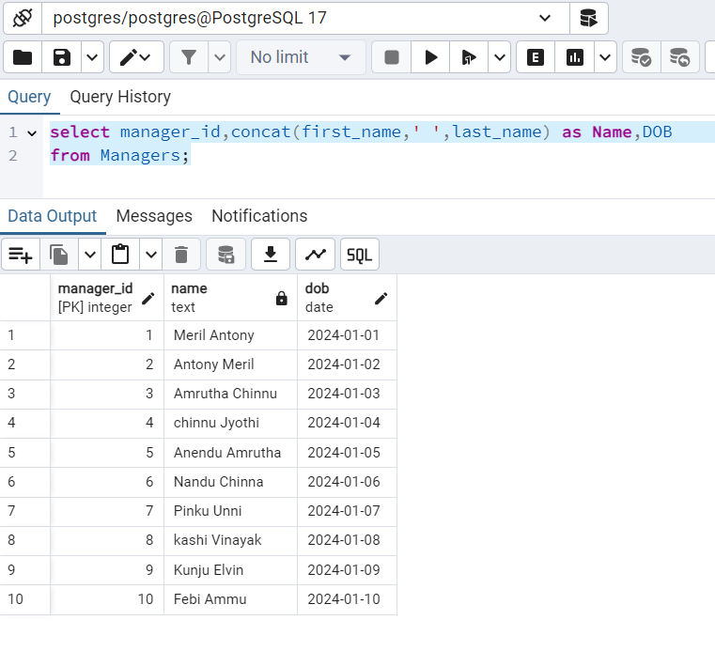

* **Write a query to display the annual income of all managers.**

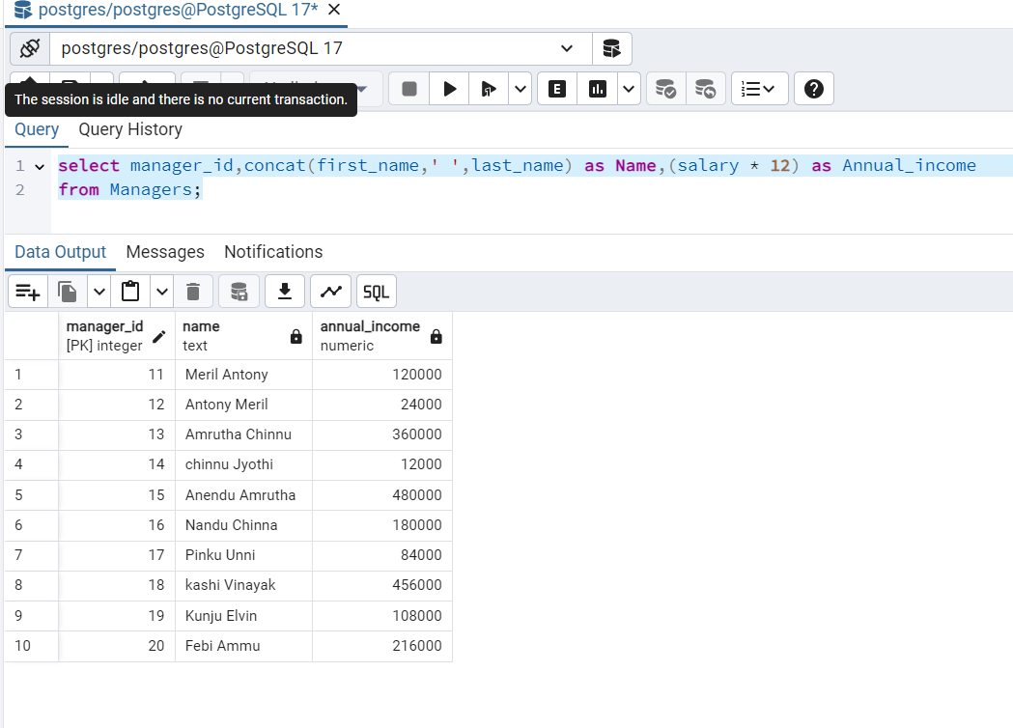

* **Write a query to display records of all managers except ‘Amrutha’**

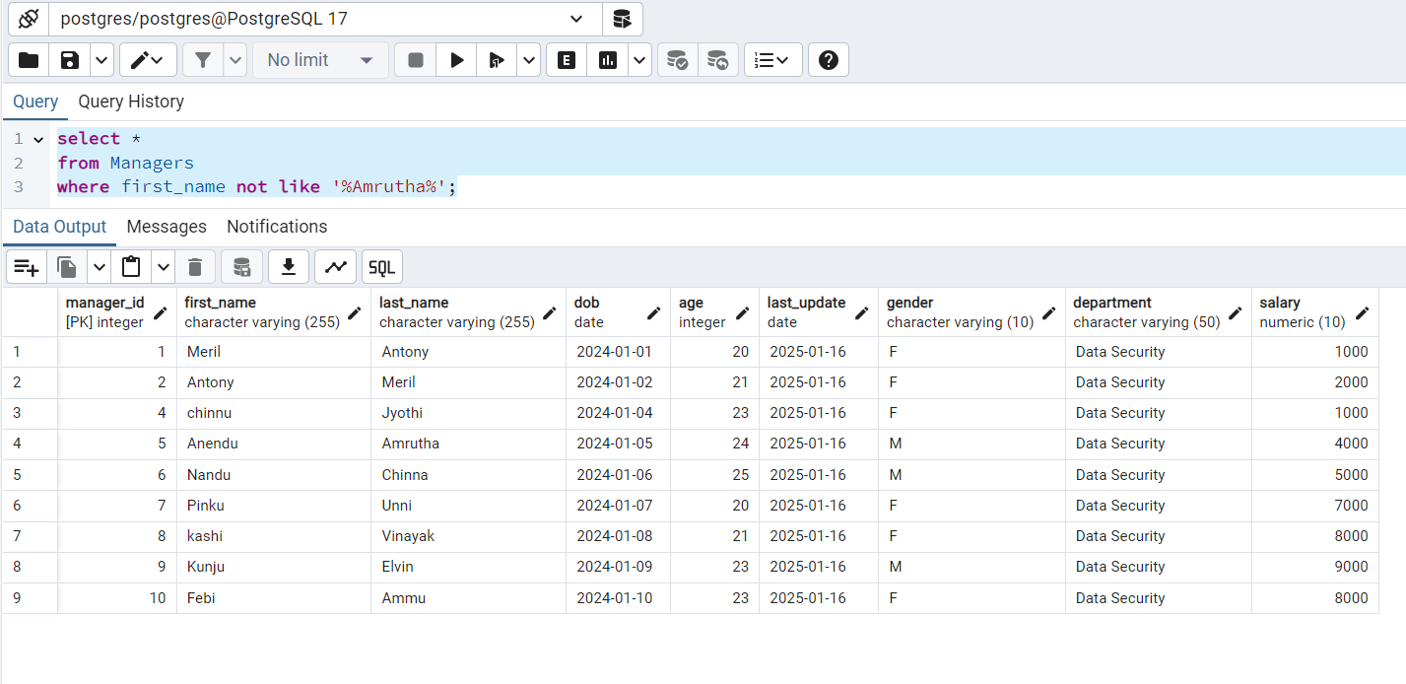

* **Write a query to display details of managers whose department is IT and earns more than 25000 per month.**

**Note:**

**Mam, I need to modify the data to incorporate these requirements. So I changing the data of the table by adding these values into it.**

**Raw Date:**

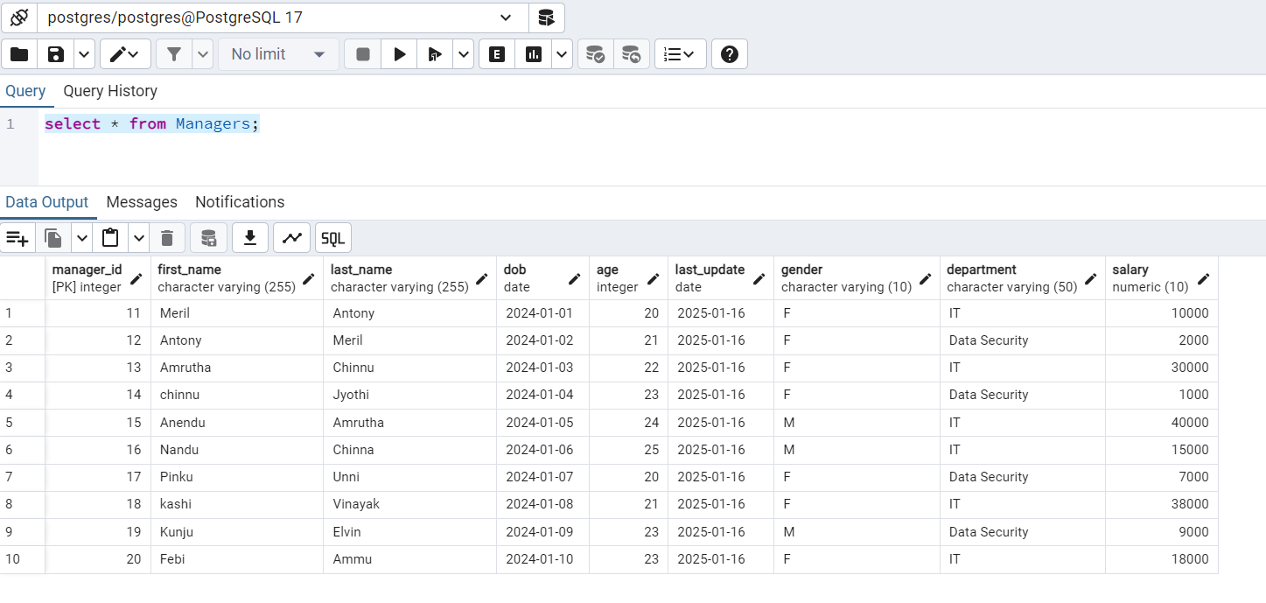

**After query:**

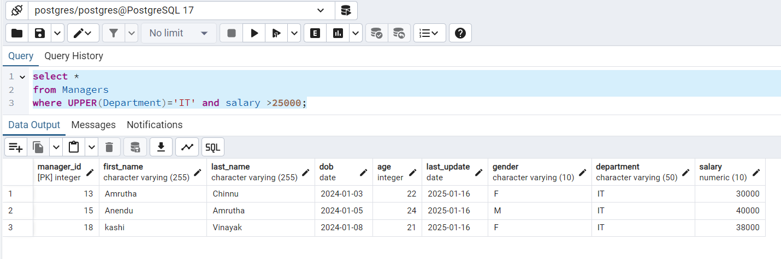

* **Write a query to display details of managers whose salary is between 10000 and 35000**

**Raw Date:**



**After query:**

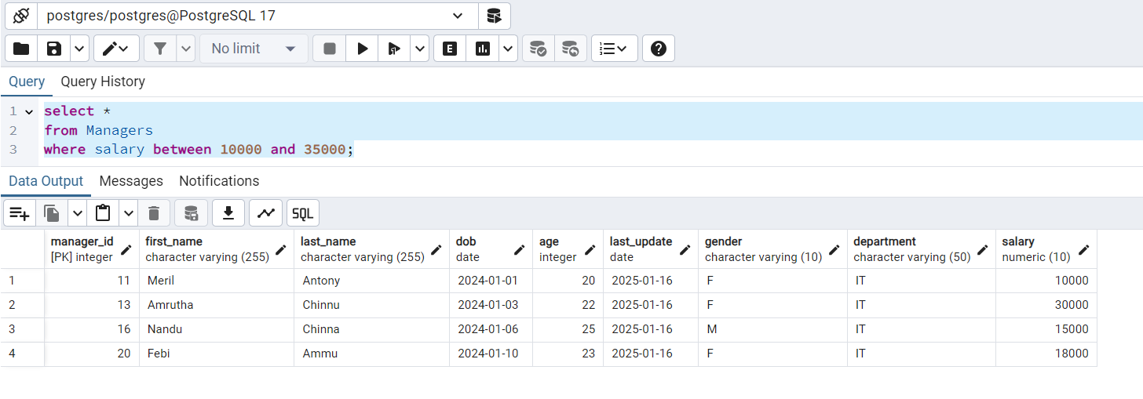

**\*\*\*\*\*\*\*\*\*\*\*\*\*\*\*\*\*\*\*\*\*\*\*\*\*\*\*\*\*\*\*\*\* ****END\*\*\*\*\*\*\*\*\*\*\*\*\*\*\*\*\*\*\*\*\*\*\*\*\*\*\*\*\*\*\*\*\*\*\*\*\*\*\*\*\***