**Assignment 4: Querying Data**

* **Create a table named Country with fields: Id , Country_name ,Population, Area**

CREATE TABLE Country (

Id INT generated always as identity,

Country_name VARCHAR(255),

Population NUMERIC(10),

Area float(10,2)

constraint pk_order_id PRIMARY KEY (Id)

);

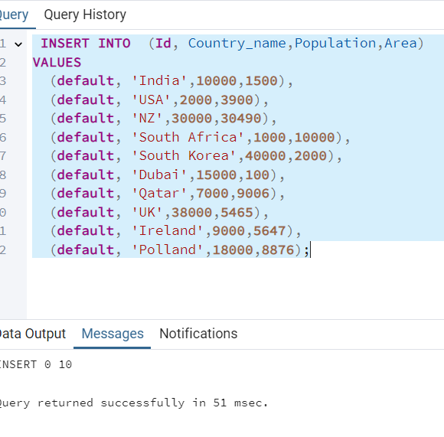

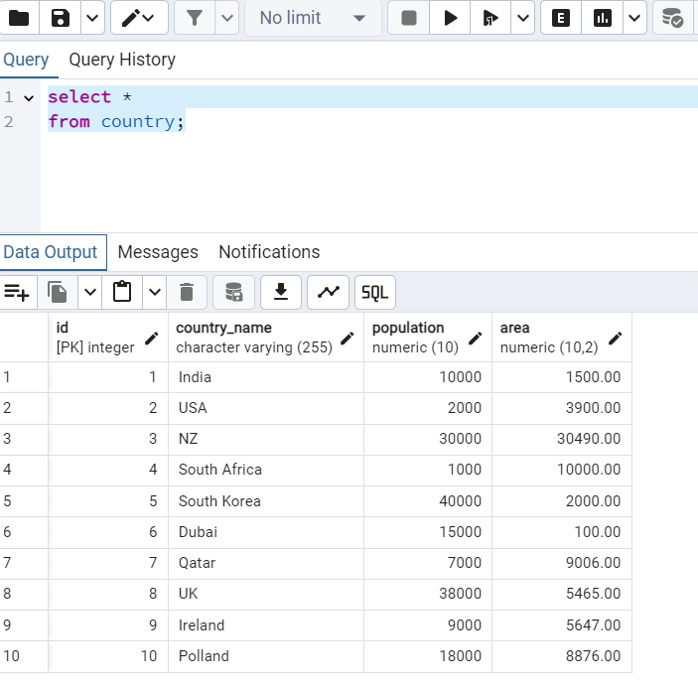

* **Create another table named Persons with fields: Id Fname Lname Population Rating Country_Id Country_name**

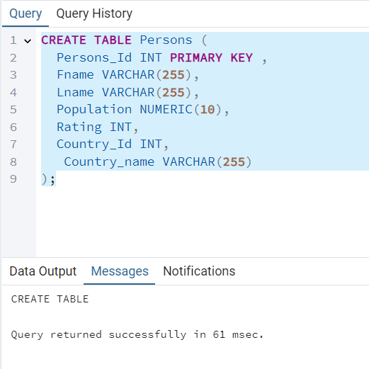

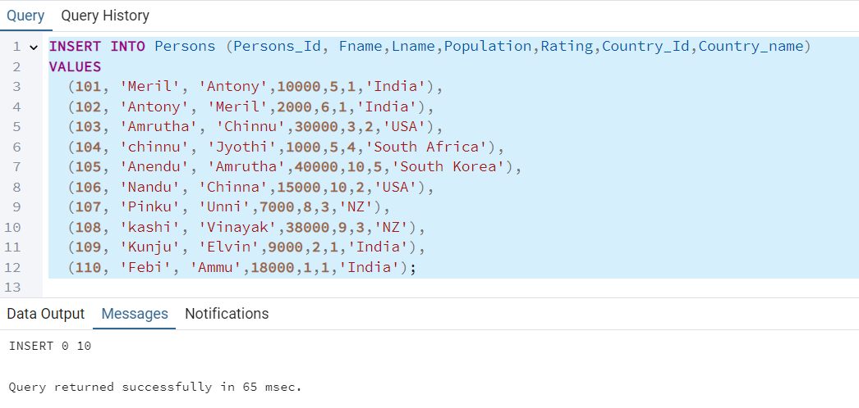

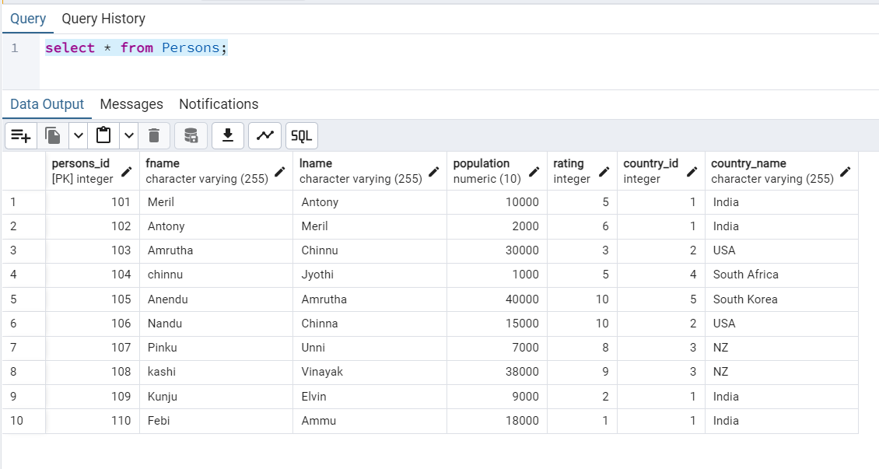

* **List the distinct country names from the Persons table**

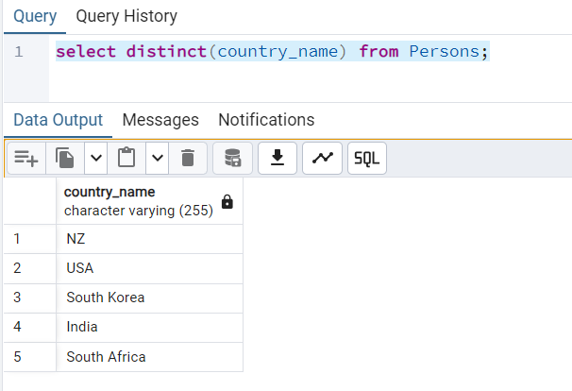

* **Select first names and last names from the Persons table with aliases.**

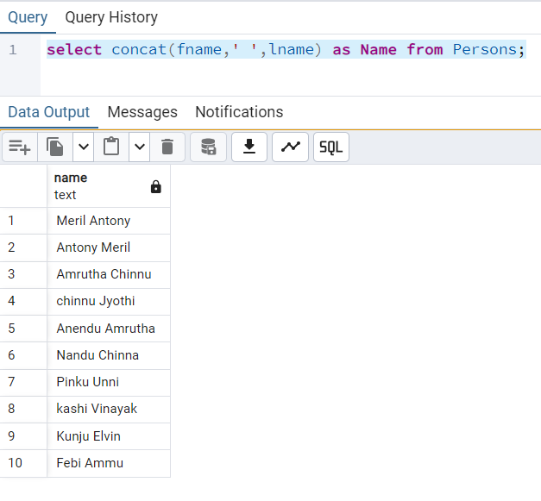

* **Find all persons with a rating greater than 4.0.**

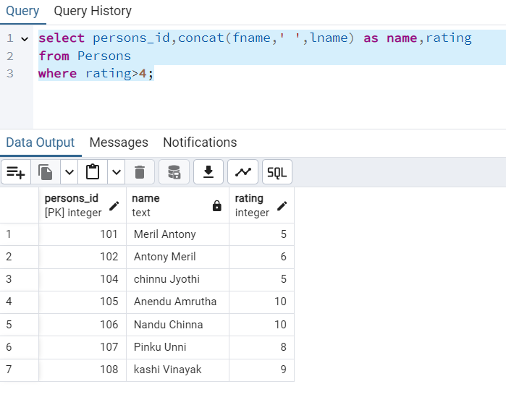

* **Find countries with a population greater than 10 lakhs.**

**Note: I have to modify the data in the table to incorporate this requirement**

**Raw Data:**

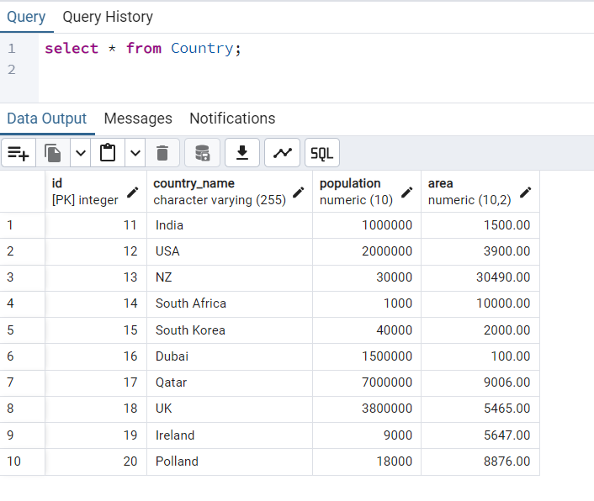

**After Query:**

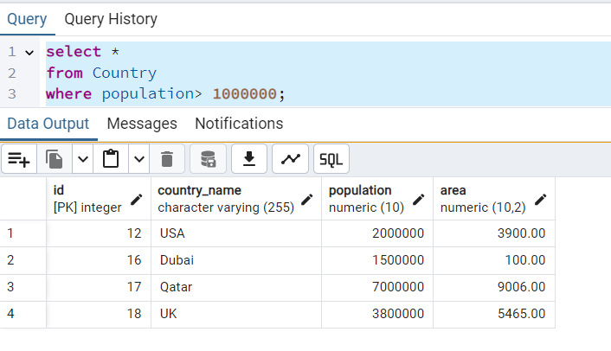

* **Find persons who are from 'USA' or have a rating greater than 4.5**

**Raw data:**

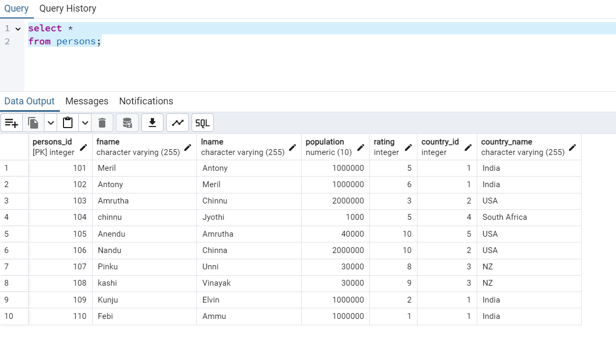

**After query:**

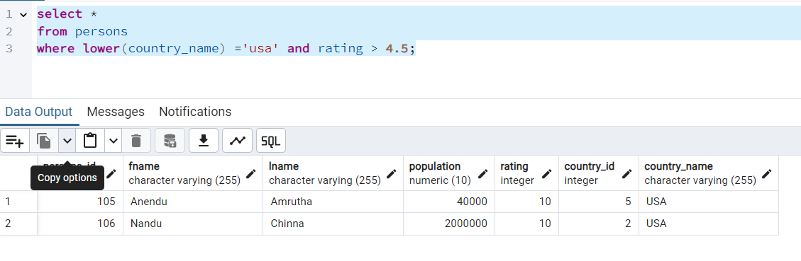

* **Find all persons where the country name is NULL.**

**Raw Data:**

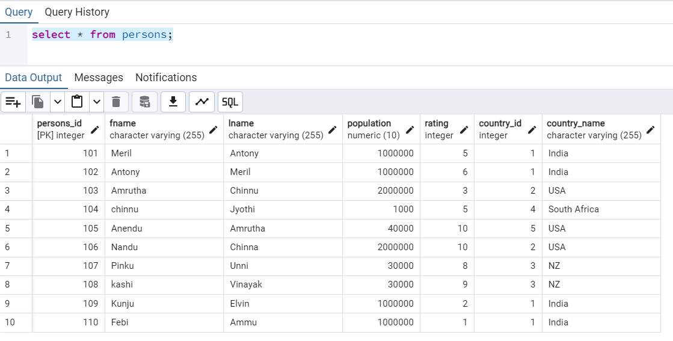

**After query:**

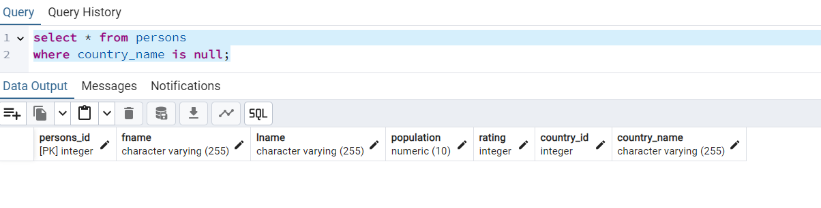

* **Find all persons from the countries 'USA', 'Canada', and 'UK'.**

**Raw Data:**



**After query:**

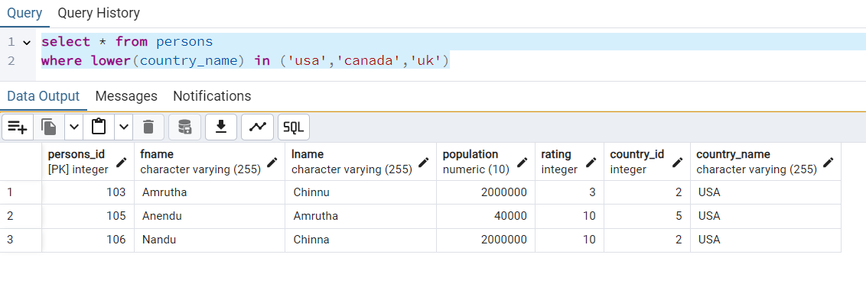

* **Find all persons not from the countries 'India' and 'Australia'.**

**Raw Data:**



**After query:**

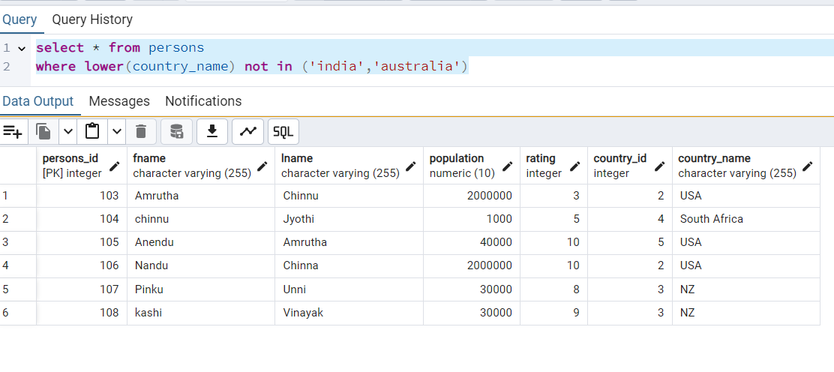

* **Find all countries with a population between 5 lakhs and 20 lakhs.**

**Raw data:**

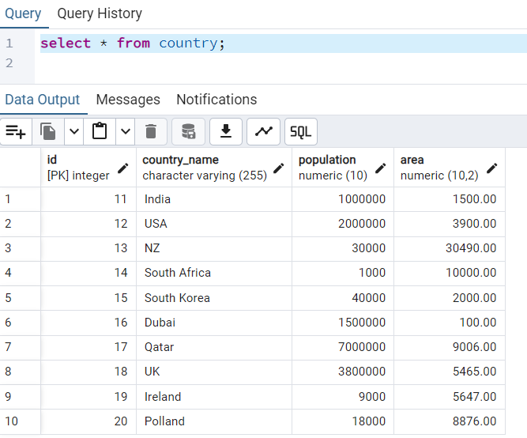

**After Query:**

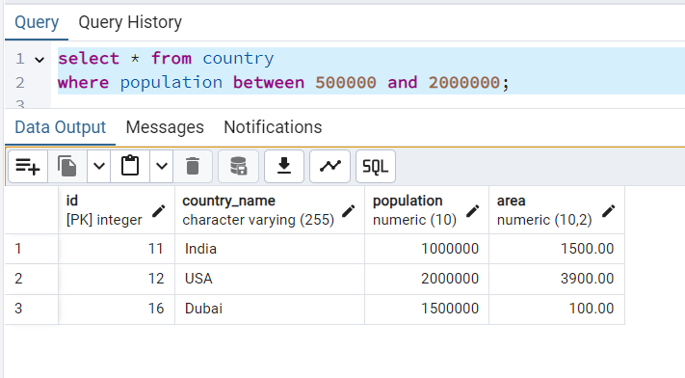

* **Find all countries whose names do not start with 'C'.**

**Raw Data:**



**After Query:**

