## Assignment 5 : Sorting and Grouping data

**Postresql:**

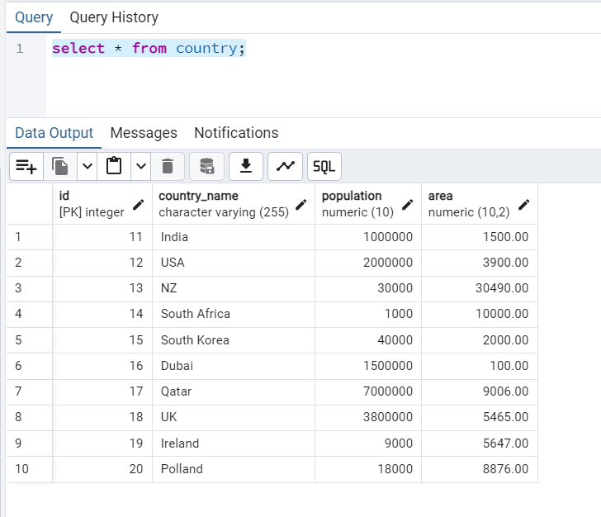

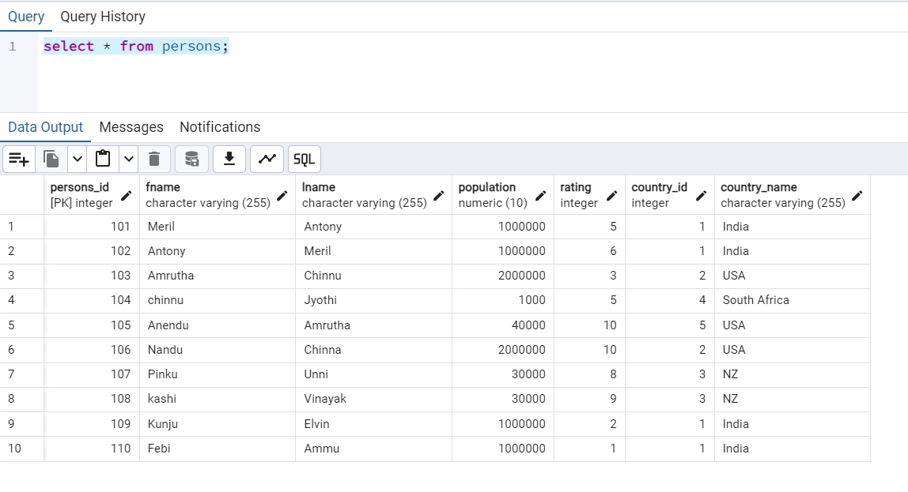

1. **Write an SQL query to print the first three characters of Country_name from the Country table.**

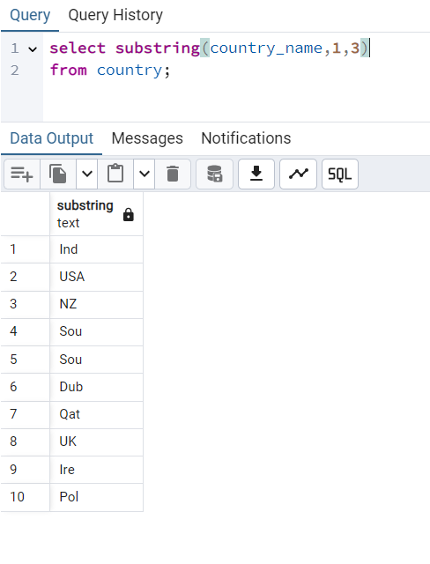

1. **Write an SQL query to concatenate first name and last name from Persons table.**

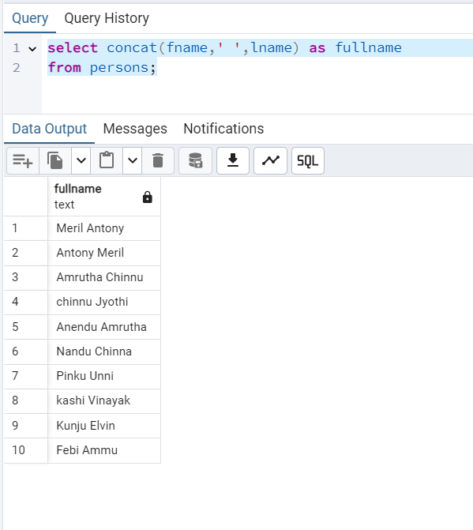

1. **Write an SQL query to count the number of unique country names from Persons table**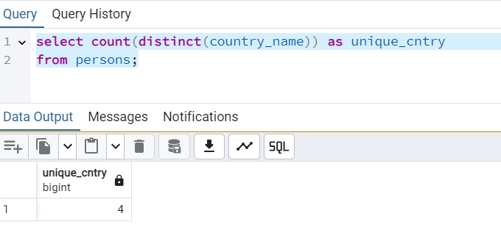
2. **Write a query to print the maximum population from the Country table.**

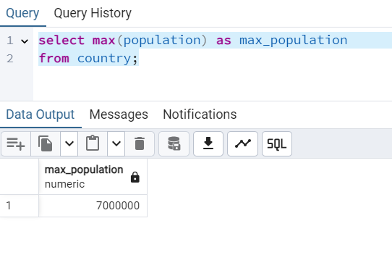

1. **Write a query to print the minimum population from Persons table.**

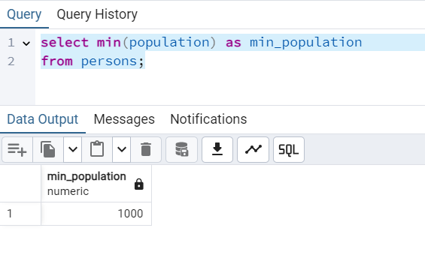

1. **Insert 2 new rows to the Persons table making the Lname NULL. Then write another query to count Lname from Persons table.**

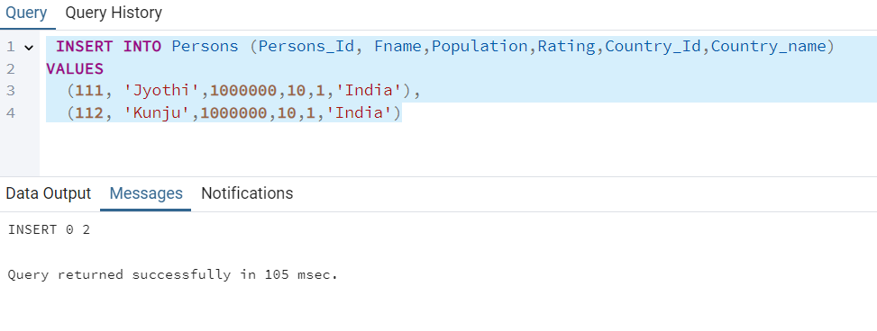

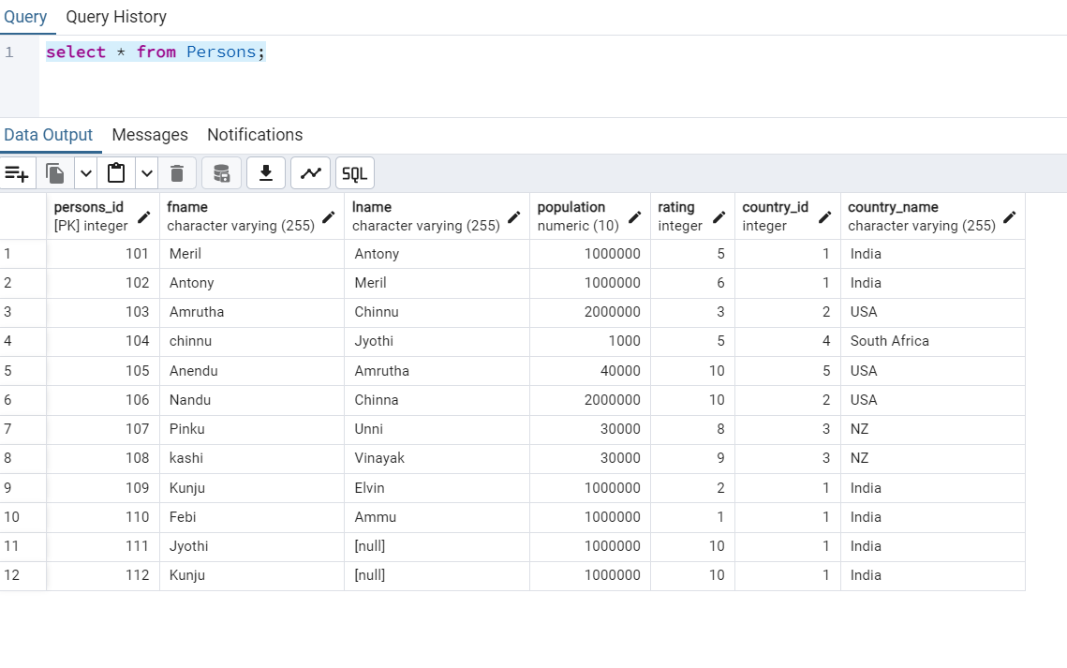

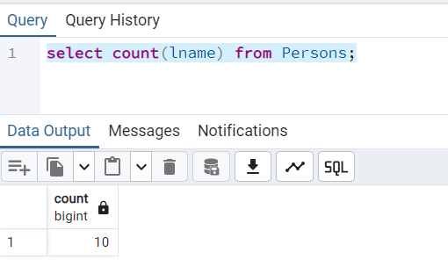

1. **Write a query to find the number of rows in the Persons table.**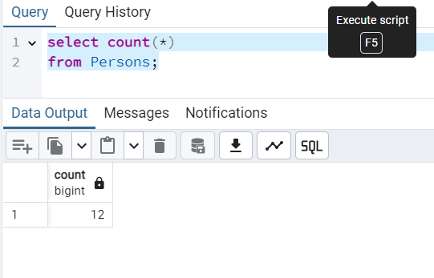
2. **Write an SQL query to show the population of the Country table for the first 3 rows. (Hint: Use LIMIT)**

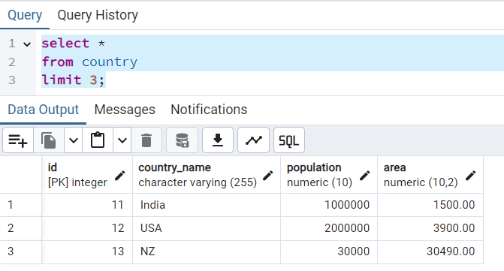

1. **Write a query to print 3 random rows of countries. (Hint: Use rand() function and LIMIT)**

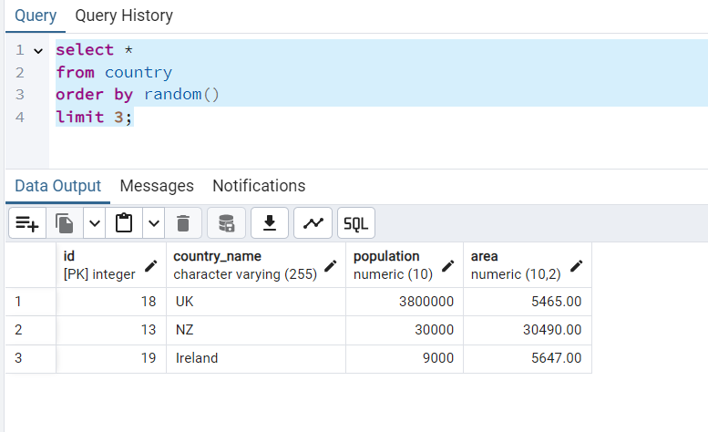

1. **List all persons ordered by their rating in descending order.**

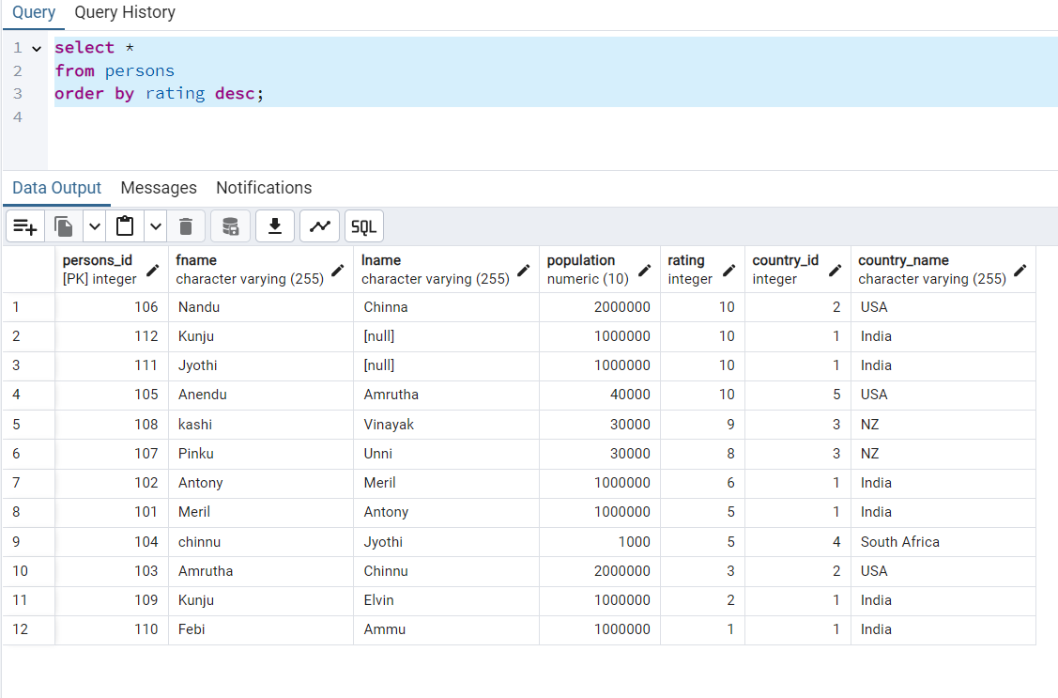

1. **Find the total population for each country in the Persons table.**

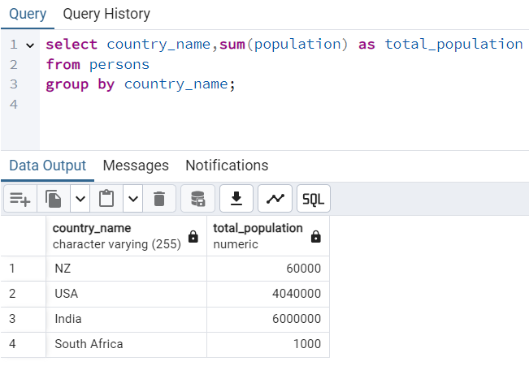

1. **Find countries in the Persons table with a total population greater than 50,000**

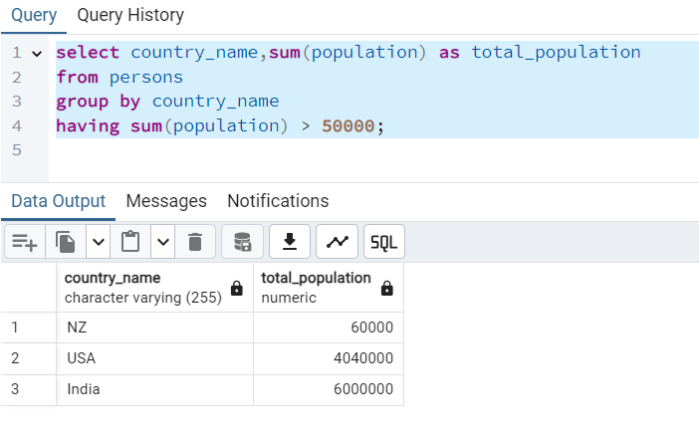

1. **List the total number of persons and average rating for each country, but only for countries with more than 2 persons, ordered by the average rating in ascending order**

