**Assignment6 : Join & Union**

Persons Table:

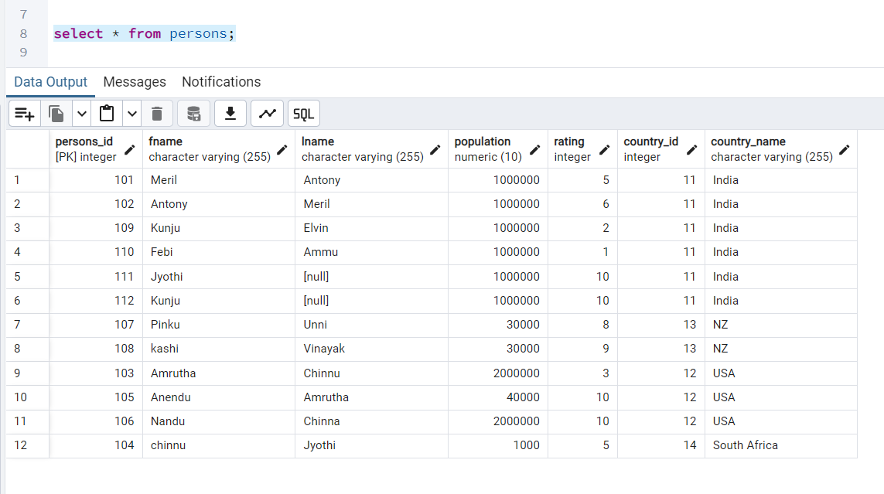

Country Table:

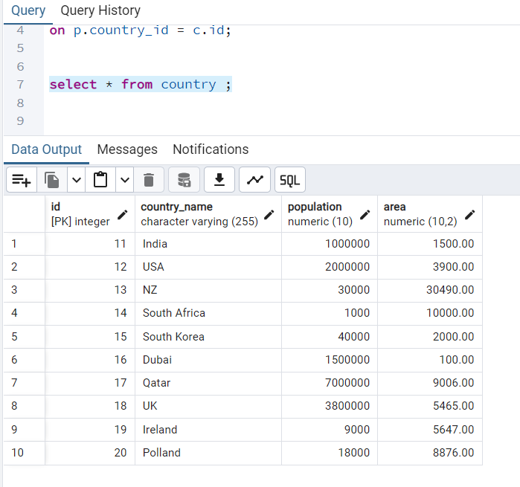

1. **Perform inner join, Left join, and Right join on the tables.**

**Inner Join:**

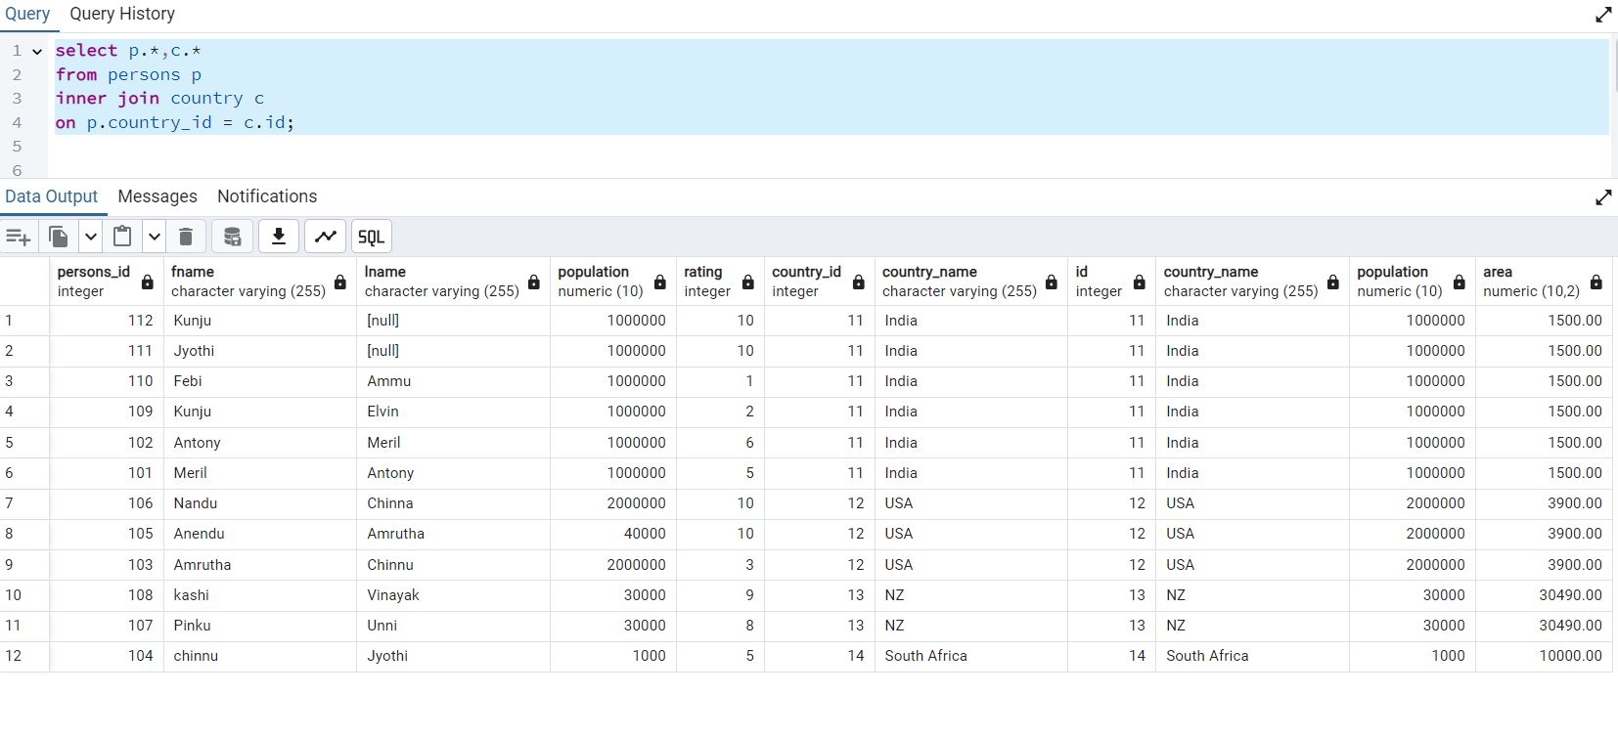

**Left outer Join:**

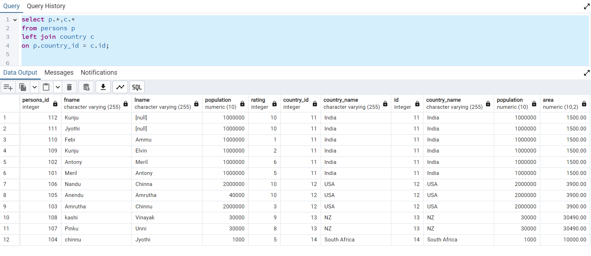

**Right outer Join:**

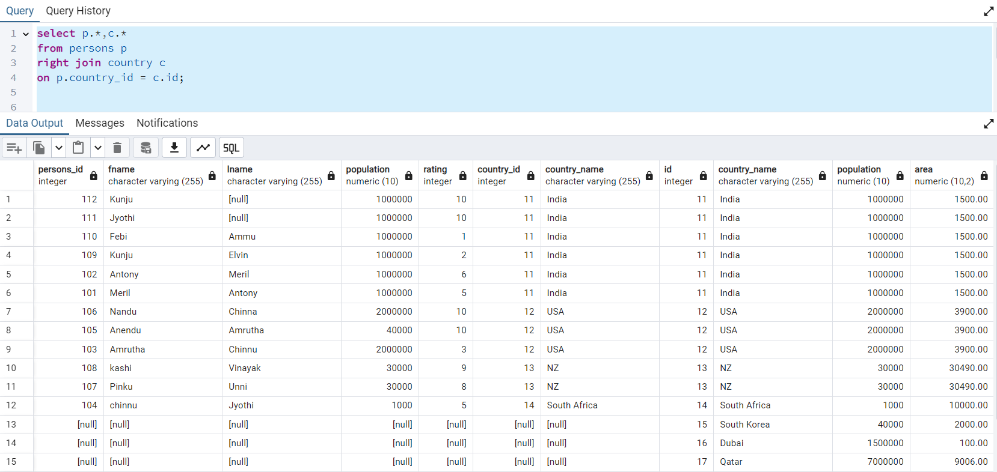

1. **List all distinct country names from both the Country and Persons tables.**

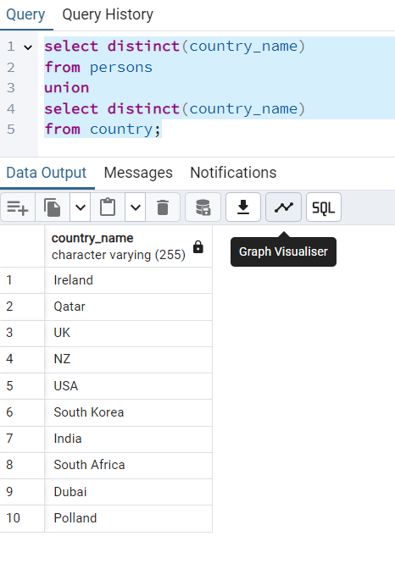

1. **List all country names from both the Country and Persons tables, including duplicates**

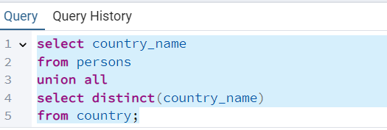

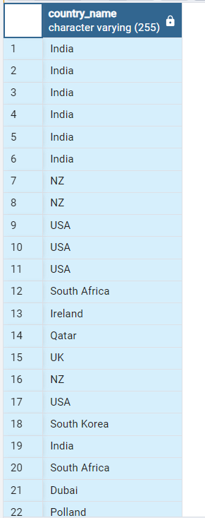

1. **Round the ratings of all persons to the nearest integer in the Persons table.**

