**JSS COLLEGE OF ARTS, COMMERCE & SCIENCE**

(Autonomous)

OOTY ROAD, MYSURU – 570 025

**DEPARTMENT OF COMPUTER SCIENCE**

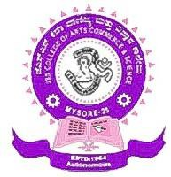

# CERTIFICATE

This is certify that project work entitled **“MENTOR MENTEE MANAGEMENT SYSTEM”** carried out by **Amrutha B M** bearing Register Number – **U01BE22S0066** satisfactorily completed the project work in VI Semester by partial fulfilment for the award of the degree of **Bachelor of Computer Application** by JSS COLLEGE OF ARTS, COMMERCE & SCIENCE (Autonomous) MYSURU during the academic year 2024-2025.

### **Signature of the Guide Signature of the HOD**

Date of the Examination:

**VALUED**

Name & Signature of Examiners

**1.**

**2.**