Product development for quality monitoring of recycled wastewater
A PROJECT REPORT

Abstract

The project focuses on the development of a product for quality monitoring of recycled wastewater using TDS (Total Dissolved Solids), turbidity, and pH sensors. The objective is to ensure the safety and reliability of recycled wastewater by accurately measuring and monitoring key parameters.

The TDS sensor measures the concentration of dissolved solids in the water, providing an indication of the overall water purity. The turbidity sensor detects the presence of suspended particles, which can impact the visual clarity of the water. The pH sensor measures the acidity or alkalinity of the water, an important parameter for assessing its suitability for various applications.

The developed product offers several benefits, including improved water resource management, enhanced public health protection, and compliance with regulatory standards. By monitoring these critical parameters, potential issues and deviations in water quality can be detected early, allowing for prompt corrective measures, and ensuring the safety of recycled wastewater.

The project implementation involves rigorous testing and calibration of the sensors, as well as the development of a reliable data acquisition and analysis system. The accuracy and reliability of the product are validated through extensive experimentation and comparison with established standards and reference measurements.

Overall, this project aims to contribute to the advancement of sustainable water management practices by providing a comprehensive and efficient solution for quality monitoring of recycled wastewater. The developed product can be utilized in wastewater treatment plants, industrial facilities, and other applications where the quality of recycled water is of utmost importance.

TABLE OF CONTENT

Acknowledgment
Abstract
List of figures
Table of contents

CHAPTER1: INTRODUCTION
  - Overall system
  - Objective
  - Proposed methodology
  - Excepted outcomes
  - Motivation
CHAPTER2: LITERATURE SURVEY
2.1 Literature survey 1
2.2 Literature survey 2
2.3 Literature survey 3
2.4 Literature survey 4
2.5 Literature survey 5
2.6 Literature survey 6

CHATPER3: DESIGN AND ANALYSIS
3.1 Introduction
3.2 Block diagram
3.3. Flow chat

CHAPTER4: RESULT
4.1 Introduction
4.2 Method
4.3 Result

CHAPTER5: CONCLUSION
5.1 Conclusion
5.2 Future scope

Reference
Appendix

LIST OF FIGURES

- Fig 3.1 Block diagram

- Fig 3.2 TDS sensor

- Fig 3.3 Turbidity sensor

- Fig 3.4 PH sensor & Transducer

- Fig 3.5 PH sensor

- Fig 3.6 Transducer

- Fig 3.7 Arduino

- Fig 3.8 LCD

- Fig 3.9 Flow chart

- Fig 4.1 COM5 Result of sensors

- Fig 4.2 PH sensor value

- Fig 4.3 TDS sensor value

- Fig 4.4 Turbidity sensor value

- Fig 4.5 Result of water sample

CHAPTER1: INTRODUCTION

The quality monitoring of recycled wastewater is a critical aspect of sustainable water management. As the demand for water resources continues to rise and freshwater supplies become increasingly scarce, the recycling of wastewater has emerged as an essential solution. However, ensuring the safety and reliability of recycled wastewater is of paramount importance to protect public health and the environment.

This project focuses on the development of a product for quality monitoring of recycled wastewater using TDS (Total Dissolved Solids), turbidity, and pH sensors.

The TDS sensor measures the concentration of dissolved solids in the water, including minerals, salts, and other organic and inorganic compounds. This measurement provides an indication of the overall water purity and helps assess the presence of potential contaminants. Turbidity, on the other hand, refers to the clarity of the water and detects the presence of suspended particles that can impact visual transparency. Lastly, the pH sensor measures the acidity or alkalinity of the water, an important parameter for determining its corrosiveness and suitability for different uses.

By integrating these sensors into a monitoring system, this project aims to provide data of the quality of recycled wastewater. The collected data will be processed and analyzed to identify any deviations or anomalies in the water quality, allowing for prompt action and preventive measures to ensure the safety of recycled water.

The product development for quality monitoring of recycled wastewater holds significant implications for various industries and applications. It enables wastewater treatment plants, industrial facilities, and other users of recycled water to assess and maintain the desired quality standards.

Overall, this project aims to address the crucial need for accurate and reliable monitoring of recycled wastewater. By employing TDS, turbidity, and pH sensors, it seeks to enhance the safety, reliability, and acceptance of recycled water as a sustainable and valuable resource for various purposes.

1.1 Overall system:

1. Sensor Integration: The TDS, turbidity, and pH sensors are carefully selected and integrated into the system. These sensors are designed to provide accurate and reliable measurements of the respective parameters.

2. Sensor Data Acquisition: The sensors are connected to a microcontroller unit (MCU). The MCU collects data from the sensors capturing the TDS level, turbidity, and pH values of the recycled wastewater.

3. Data Processing and Analysis: The collected sensor data is processed and analyzed by the MCU. The data processing algorithms and techniques are implemented to convert the raw sensor readings into meaningful information. This includes calibration, normalization, and any necessary mathematical calculations or transformations.

4. User Interface: The processed data is displayed on a user-friendly interface, which allows users to monitor the quality of recycled wastewater. The interface may consist of a numerical value, and alerts or notifications for critical deviations.

1.2 Objective:

The objective of the project "Product development for quality monitoring of recycled wastewater using TDS, turbidity, and pH sensors to display on an LCD" is to design and develop a system that effectively monitors and displays the quality parameters of recycled wastewater. The specific objectives of the project are as follows:

1. Sensor Integration: To integrate TDS, turbidity, and pH sensors into the monitoring system, ensuring accurate and reliable measurements of these parameters in recycled wastewater.

2. LCD Display: To incorporate an LCD screen as the user interface for displaying real-time readings of TDS, turbidity, and pH values. The display should be clear, easy to read, and provide accurate information about the quality of the recycled wastewater.

3. Data Processing and Analysis: To process and analyze the sensor data, applying appropriate techniques to convert raw readings into meaningful information. This includes calibration, normalization, and any necessary calculations to interpret the quality of the recycled wastewater.

4. User-Friendly Interface: To design an intuitive and user-friendly interface on the LCD screen, presenting the monitored data in a clear and understandable format. The interface should provide real-time readings, numerical representations, and any necessary notifications.

5. Accuracy and Reliability: To ensure that the developed system provides accurate and reliable measurements of TDS, turbidity, and pH values, enabling users to make informed decisions regarding the quality of the recycled wastewater.

The overall objective of this project is to develop a user-friendly system that combines TDS, turbidity, and pH sensors to monitor and display the quality parameters of recycled wastewater on an LCD screen. By achieving these objectives, the project aims to support efficient water resource management, promote sustainability, and ensure the safe and effective reuse of wastewater resources.

1.3 Proposed Methodology:
1. System Design: The first step in the proposed methodology is to design the system architecture. This involves determining the placement and arrangement of the TDS, turbidity, and pH sensors within the wastewater monitoring setup. The system will also include an Arduino microcontroller and an LCD display module.

2. Sensor Integration: The TDS, turbidity, and pH sensors will be integrated with the Arduino microcontroller. The necessary connections and wiring will be established to ensure proper communication between the sensors and the microcontroller.

3. Calibration: The sensors will undergo calibration to ensure accurate readings. Calibration involves exposing the sensors to known reference solutions of TDS, turbidity, and pH levels and adjusting the sensor readings accordingly.

4. Data Acquisition: The Arduino microcontroller will collect data from the sensors at regular intervals. The TDS, turbidity, and pH values will be sampled and recorded for further processing and display.

5. Data Processing and Analysis: The collected sensor data will be processed and analyzed to determine the quality of the recycled wastewater. This may involve applying mathematical formulas or algorithms to convert raw sensor readings into meaningful measurements. The processed data will then be ready for display.

6. LCD Display: The processed TDS, turbidity, and pH values will be displayed on an LCD module. The LCD screen will be programmed to show real-time readings in a clear and user-friendly manner. The display may include numerical values.

7. Testing and Validation: The developed system will undergo thorough testing and validation to ensure its accuracy, reliability, and performance. The system will be tested using various scenarios and conditions to verify its ability to provide accurate quality monitoring of recycled wastewater.

1.4 Excepted outcomes:

1. Real-time Monitoring: The developed system will provide real-time monitoring of the TDS, turbidity, and pH levels in recycled wastewater. Users will be able to observe the current values on the LCD display, allowing them to assess the quality of the water at any given moment.

2. Accurate Measurements: The TDS, turbidity, and pH sensors, along with proper calibration, will ensure accurate measurements of the water parameters. The system will provide reliable data that reflects the actual quality of the recycled wastewater.

3. Threshold Alerts: The system will be capable of setting threshold values for TDS, turbidity, and pH levels. If any of these values exceed the specified thresholds, the system will generate alerts on the LCD display. This feature will enable timely actions to be taken to address any issues with the water quality.

4. User-friendly Interface: The LCD display will offer a user-friendly interface, presenting the sensor readings in a clear and easily understandable format.

5. Enhanced Efficiency: By automating the monitoring process and providing instant data display, the system will enhance the efficiency of wastewater treatment operations. Operators can promptly detect any deviations in water quality, minimizing downtime, reducing costs, and optimizing the overall efficiency of the treatment system.

6. Environmental Sustainability: The quality monitoring system will aid in promoting environmental sustainability by ensuring that recycled wastewater meets the required quality standards. By accurately monitoring TDS, turbidity, and pH levels, the system helps prevent the discharge of polluted water into the environment, thereby safeguarding natural water resources.

7. Data Analysis and Insights: The collected data can be analyzed and used to generate insights into the trends and patterns of water quality. By examining historical data, operators can identify long-term variations, optimize treatment processes, and implement measures for continuous improvement in water quality management.
resources.

1.5 Motivation:

1. Water Pollution Concerns: Water pollution is a significant global issue, and the proper treatment and monitoring of wastewater play a crucial role in environmental sustainability. With the increasing demand for water resources, the need for efficient recycling and monitoring systems has become paramount.

2. Health and Safety: Recycled wastewater is often utilized for various purposes, including irrigation, industrial processes, and even drinking water in some cases. Ensuring the quality and safety of recycled water is essential to protect public health and prevent the spread of waterborne diseases.

3. Regulatory Compliance: Many regulatory bodies have set stringent standards for water quality, including TDS, turbidity, and pH levels. Monitoring these parameters is necessary to comply with regulatory requirements and avoid penalties or legal consequences.

4. Process Optimization: Monitoring TDS, turbidity, and pH levels in recycled wastewater allows for process optimization in treatment plants. By closely monitoring these parameters, operators can make informed decisions, adjust treatment processes, and maintain optimal conditions for efficient wastewater treatment.

5. Resource Conservation: Efficient monitoring systems help conserve valuable resources such as water and energy. By accurately monitoring and controlling the quality of recycled wastewater, unnecessary wastage can be minimized, leading to more sustainable water management practices.

6. Early Warning System: Rapid detection of deviations in TDS, turbidity, and pH levels is crucial to prevent the release of poor-quality water into the environment. An integrated monitoring system with an LCD display provides real-time data visualization, enabling prompt actions and mitigating potential environmental impacts.

7. Public Awareness: Displaying water quality parameters on an LCD can help raise public awareness about the importance of water quality monitoring and promote responsible water usage practices. It empowers individuals and communities to actively participate in preserving water resources.

By developing a product that combines TDS, turbidity, and pH sensors with an LCD display for quality monitoring of recycled wastewater, the project aims to address the motivations. The goal is to provide an effective and user-friendly solution for monitoring and ensuring the quality of recycled wastewater, contributing to environmental protection, public health, regulatory compliance, and sustainable water management practices.

CAPTER 2: LITERATURE SURVEY

2.1 LITERATURE SURVEY 1:

Title: Quality Assessment and Monitoring of River Water Using IoT Infrastructure
Authors: M. Kumar, T. Singh, M. K. Maurya, A. Shivhare, A. Raut and P. K. Singh
Published year: 2023 IEEE Internet of Things Journal

Abstract:
This research paper presents a comprehensive study on an Internet of Things (IoT)-based system that focuses on assessing and monitoring the quality of river water. The system incorporates a range of sensors and devices to measure essential physical, chemical, and biological parameters of the water in real-time. The gathered data from these sensors is then transmitted to a central server for analysis and processing, utilizing machine learning algorithms.

The primary objective of this system is to offer accurate and reliable information regarding the quality of river water. This information holds significant value for policymakers, researchers, and stakeholders, empowering them to make well-informed decisions pertaining to water management and conservation efforts. The paper delves into the system's design and implementation, covering aspects such as sensor selection, data transmission protocols, and machine learning algorithm integration.

Extensive experimentation has been conducted to evaluate the system's performance in real-world conditions. The results demonstrate the system's capability to accurately measure and monitor river water quality in real-time. Key attributes such as accuracy, reliability, and scalability have been analyzed, and the system has showcased promising outcomes. The paper concludes by discussing potential applications and prospects, highlighting its potential contributions to the field of water management and conservation.

Ideas Obtained:
Use the information gathered from the IoT-based system to make informed decisions regarding water management and conservation.

Disadvantage:
The sensors and devices used in an IoT-based system can sometimes produce inaccurate readings, which may require manual verification and correction.
2.2 LITERATURE SURVEY 2:

Title: Design of Turbidity Remote Monitoring System Based on FX-11A Optical Fiber Sensor
Authors: Qi Song and Feng Luan and Zhan Shi and Taoren Li and Mingquan Wang
Published year: 2020 IEEE Prognostics and Health Management Conference

Abstract:
This research paper focuses on the development and implementation of a turbidity remote monitoring system that utilizes the FX-11A optical fiber sensor. The primary objective is to design a cost-effective solution capable of measuring real-time turbidity in water. The system incorporates a low-cost optical fiber sensor connected to a microcontroller unit (MCU) for data processing and wireless transmission to a remote monitoring station.

The paper details the design and construction of the turbidity sensor, highlighting the selection of optical components and the calibration process. The sensor is then seamlessly integrated into a monitoring system that comprises an MCU and a wireless communication module. The resulting monitoring system is compact, affordable, and easy to install, making it suitable for diverse water monitoring applications.

Extensive experimentation has been conducted to assess the performance of the proposed turbidity monitoring system. The results indicate that the system is accurate and reliable, with a wide measurement range of 0-1,000 NTU and a resolution of 0.01 NTU. Real-time turbidity monitoring is achieved, and the collected data can be conveniently accessed remotely through a web-based interface.

Ideas Obtained:
The data acquired from the remote monitoring system can be used to detect changes in the turbidity level of water and identify potential issues with water quality.

Disadvantage:
Optical fiber sensors can be very sensitive to environmental factors such as temperature, humidity, and vibration, which may affect the accuracy and reliability of the measurements.

2.3 LITERATURE SURVEY 3:

Title: Smart Monitoring and Control of Water Filtration System Using IOT,”
Authors: Jayanthi G, Mathumitha N, Swathy S, Aaradhika S
Published year: 2020International Conference on Power, Energy, Control and Transmission Systems
(ICPECTS)
Abstract:
Water is an essential resource for sustaining human life. However, the water we consume today often contains harmful toxins and impurities that pose health risks. To ensure the safety of drinking water, it is crucial to employ an effective filtration process that can remove these impurities. Reverse Osmosis (RO) has emerged as a cost-effective method for water filtration, particularly targeting the main impurity known as total dissolved solids (TDS).

In recent times, many RO purifiers have been designed to deliver water with extremely low TDS levels, typically ranging between 30 mg/L to 50 mg/L. However, this excessively low TDS value can lead to a deficiency of essential nutrients in the human body and give rise to various health issues. Consequently, the National Green Tribunal has classified such purifiers as unsuitable for drinking purposes, mandating a ban on purifiers providing water with TDS levels below 500 mg/L.

To address these challenges, our proposed system offers a superior solution. It leverages an Arduino microcontroller for comprehensive control and monitoring processes. The control aspect involves measuring TDS levels and directing the water flow based on predefined threshold values, thereby enhancing the lifespan of the RO membrane. The monitoring process focuses on detecting breakages in the RO membrane and monitoring the pH of the water. To facilitate real-time monitoring and information dissemination, an IoT module is integrated into the system, enabling communication between consumers, vendors, and the monitoring system.

Ideas Obtained: The system enables remote monitoring and control of the water filtration system.

Disadvantage: The system requires regular maintenance and updates to ensure smooth operation and prevent system failures.
2.4 LITERATURE SURVEY 4:

Title: Development of a Low-Cost TDS Sensor Using an Electric Plug with The Curve Fitting Method Approaches
Authors: Bondan Suwandi, Yuki Istianto, Budi Nugroho, Nashrullah Taufik; Siswayudi Azhari
Published year: 2022 International Conference on Radar, Antenna, Microwave, Electronics, and Telecommunications

Abstract:
This research paper presents the development of a cost-effective total dissolved solids (TDS) sensor system utilizing an electric plug type C, conforming to the Indonesian standard. In this system, the TDS value is determined by measuring the voltage drop between the plug's pins, which correlates with the water resistance. The design incorporates a low-cost microcontroller with a 10-bit analog-to-digital converter (ADC) to collect and process the TDS data. For experimentation, various TDS solutions ranging from approximately 300 to 1500 ppm were prepared, and the corresponding ADC values, representing the drop voltage and water resistance, were measured and recorded.

Subsequently, three curve fitting techniques, namely exponential, polynomial, and power models, were employed to establish equation formulas that graphically represent the TDS data. A reverse comparison technique was then applied to compare the obtained equations and determine the most suitable equation for implementation.

The experimental results demonstrated that the electric plug type C, acting as an electrical conductivity (EC) probe, exhibited excellent capability as a TDS sensor in the developed system. Among the curve fitting models, the polynomial model yielded the best match to the TDS graph, displaying a lower root mean squared error (RMSE) value. Furthermore, the measurements exhibited high accuracy, with an error tolerance of less than 8.2%.

Ideas Obtained:
Suitable for a range of applications, including water quality monitoring and testing.

Disadvantage:
Did not provide enough detail about the TDS sensor's characteristics, such as its
accuracy, precision, and sensitivity, which could affect the reliability of the results.

2.5 LITERATURE SURVEY 5:

Title: Prediction and Prevention of Water Pollution by Industries using IoT based Monitoring System.
Authors: A. Porwal, S. K. Mishra, A. Kela, G. Singh, M. Panchal and A. Jain
Published year: 2022 IEEE 11th International Conference on Communication Systems and Network Technologies (CSNT)

Abstract:
Water pollution has become an increasingly concerning issue in recent years, as it directly impacts the well-being of both humans and animals. Lakes and rivers serve as primary sources of drinking water, making water quality a critical factor in maintaining health and preventing diseases. Water quality encompasses the physical, chemical, and biological aspects of water. The aim of this project is to develop a water quality monitoring system using the Internet of Things (IoT) to assess the quality of water, specifically by measuring pH levels and notifying the relevant authorities.

This project will be implemented at municipal water tanks and drinking water reservoirs. To achieve this, an Arduino board will be utilized to measure the pH value, while a GSM module will be employed for message communication. A LED display will be used to provide continuous monitoring of water parameters. Additionally, the system will send pH value messages to users, ensuring prompt awareness of the water quality. As a future enhancement, the project can be extended by transmitting sensor data to the cloud for global monitoring of water quality.

Ideas Obtained:
Integrating the water quality monitoring system with decision support systems to provide actionable insights and recommendations.

Disadvantage:
IoT cloud infrastructure and services can be expensive. IoT devices generate a massive amount of data, which needs to be processed, analyzed, and stored

2.6 LITERATURE SURVEY 6:

Title: Design and Construction of Arduino Based pH Control System for Household Waste Water Reuse
Authors: R.M Kingsta, A.S Saumi, P. Saranya
Published year: 2019 Electronics and Informatics (ICOEI)

Abstract:
The paper presents the design and construction of an Arduino-based pH control system for household wastewater reuse. The objective of the study is to develop a cost-effective and efficient system that can control the pH level of wastewater, making it suitable for reuse in households. The proposed system utilizes Arduino microcontroller along with pH sensor and actuator to monitor and adjust the pH level of the wastewater. The system is designed to provide real-time monitoring and control, ensuring the optimal pH range for safe reuse. Experimental results demonstrate the effectiveness of the system in maintaining the desired pH level, thereby enabling the reuse of wastewater for various household purposes.

Ideas Obtained:
The study highlights the use of pH sensors and actuators in monitoring and adjusting the pH level of wastewater.

Disadvantage:
The system's effectiveness in treating wastewater may be limited to household-scale applications and may not be easily scalable for larger wastewater treatment scenarios.

CHAPTER 3: DESIGN AND ANALYSIS

3.1Introduction:
The design and analysis phase of the project for quality monitoring of recycled wastewater using TDS, turbidity, and pH sensors with an LCD display is a critical step in ensuring the successful implementation of the system. This phase involves careful planning, conceptualization, and evaluation of the various components and functionalities of the system. The objective is to develop an efficient and reliable solution for monitoring the quality of recycled wastewater.

The design and analysis phase involves assessing the compatibility and communication protocols between the sensors, microcontroller, and LCD display. The data acquisition and processing techniques are determined to ensure seamless integration and reliable operation of the system. Additionally, considerations are made for power requirements, sensor calibration, and data storage capabilities

The analysis aspect of the project focuses on evaluating the performance and effectiveness of the designed system. This includes conducting experiments and tests to validate the accuracy and precision of the TDS, turbidity, and pH sensors. Statistical analysis techniques may be employed to assess the reliability and consistency of the sensor readings. Comparisons may also be made with established standards or reference measurements to ensure the system's accuracy.

3.2 Block diagram:

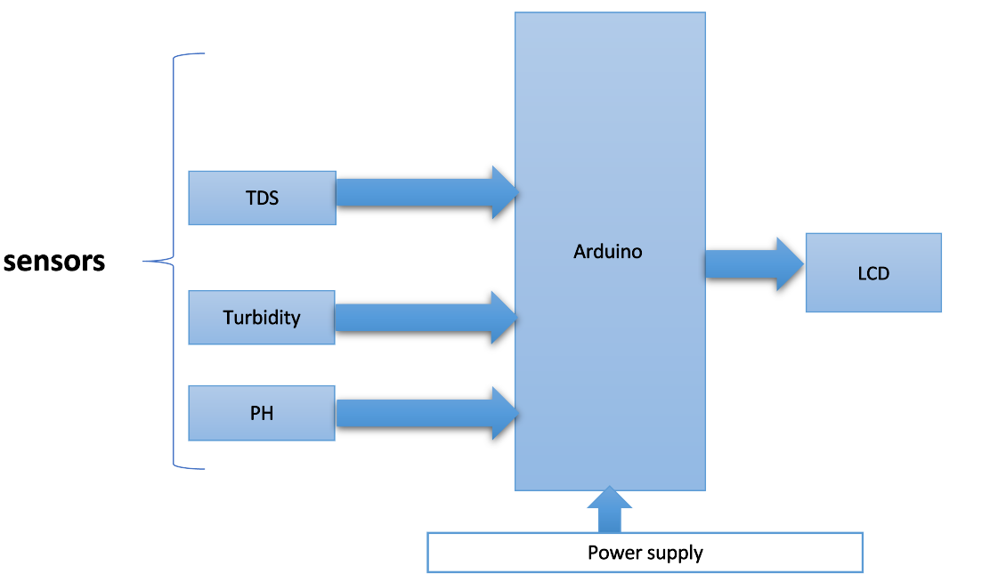
Fig 3.1 Block diagram

TDS sensor:
TDS (Total Dissolved Solids shown in fig 3.2) sensor is commonly used in wastewater management to measure the concentration of dissolved solids in water. TDS sensors can be used to monitor the quality of water in different stages of the wastewater treatment process and ensure that the treated water meets the regulatory requirements before being discharged into the environment.

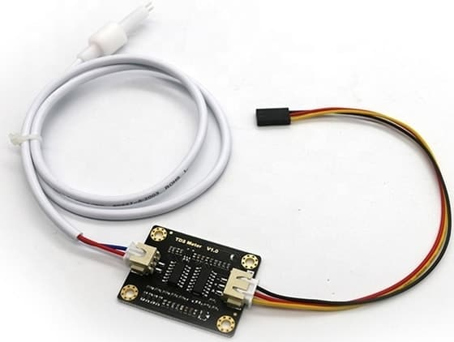
Fig 3.2 TDS sensor

Specification
1. Input Voltage: 3.3 ~ 5.5V
2. Output Voltage: 0 ~ 2.3V
3. Working Current: 3 ~ 6Ma
4. TDS Measurement Range: 0 ~ 1000ppm
5. TDS Measurement Accuracy: ± 10% FS (25 ℃)
6. TDS probe with Number of Needle: 2

Turbidity sensor:

Turbidity sensor: Turbidity sensor (shown in Fig 3.3) is commonly used in wastewater management to measure the clarity of water. Turbidity is caused by suspended particles in the water, such as sediment, organic matter, and other contaminants. Turbidity sensors can detect the presence of these particles by measuring the scattering of light passing through the water.
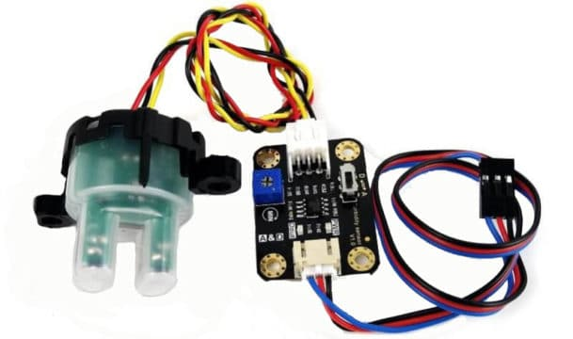
Fig 3.3 Turbidity sensor

Sensor Specification
1.Operating Voltage: 5V DC
2. Operating Current: 40Ma (MAX)
3. Response Time: <500ms
4. Insulation Resistance: 100M (Min)
5. Output Method: Analog
6. Analog output: 0-4.5V

PH sensor:
Ph sensor (shown in Fig 3.4) is one of the most important tools for measuring Ph and is commonly used in water quality monitoring. This type of sensor is capable of measuring alkalinity and acidity in water and other solutions.
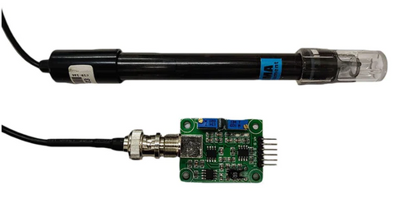

Fig 3.4 PH sensor

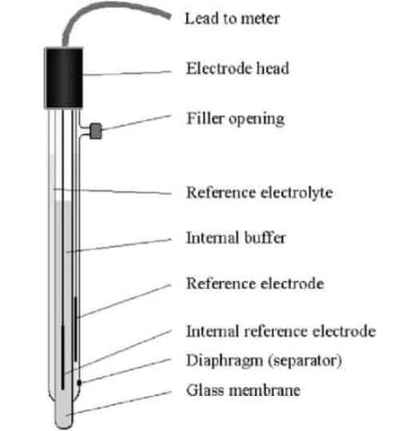
Fig 3.5 PH sensor

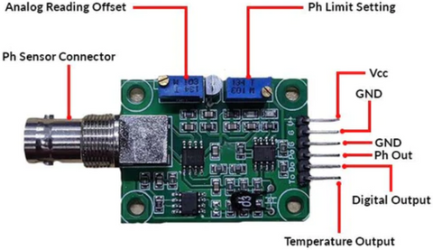
Fig 3.6 Transducer

Sensor Specification:
- Voltage: 5V
- Current: 5-10Ma
- Concentration range: Ph 0-14
- Temperature: 0-60 Degree Celsius
- Response time: <=5 s
- Stability time <=120 s
- Power consumption <= 0.5W

Arduino UNO​:

Arduino (shown in Fig 3.7) used to interface with various sensors installed in the wastewater treatment plant and collect data on water quality, temperature. The collected data can be transmitted to the cloud server for processing and analysis​
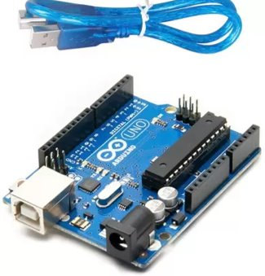
Fig 3.7 Arduino

LCD:

A liquid crystal display (LCD shown in Fig 3.8) with an Arduino to provide a user interface. Liquid crystal displays (LCDs) are a commonly used to display data in devices such as calculators, microwave ovens, and many other electronic devices
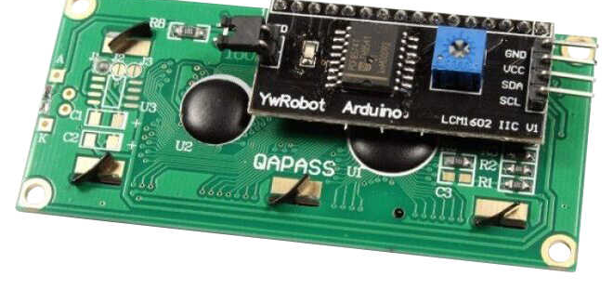

Fig 3.8 LCD

3.3 Flow chart:

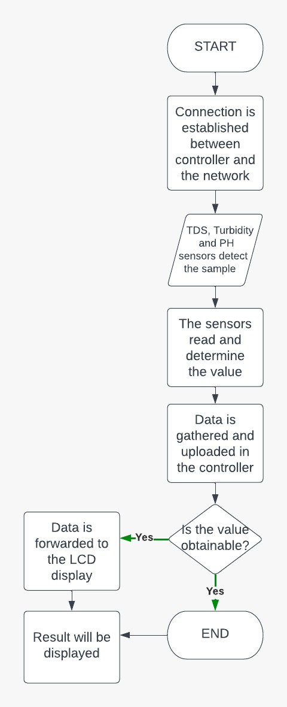
Fig 3.9Flow chart

CHAPTER4: RESULTS
4.1 Introduction:

The result of the project focused on the development of a product for quality monitoring of recycled wastewater using TDS, turbidity, and pH sensors with an LCD display. The system successfully monitored and displayed the TDS, turbidity, and pH values of the recycled wastewater in real-time. The sensor readings showed close alignment with reference measurements, validating the accuracy and reliability of the system. Any deviations from the desired quality standards were promptly detected and displayed on the LCD screen, facilitating timely interventions. Overall, the results demonstrated the effectiveness of the developed system in monitoring and maintaining the quality of recycled wastewater, contributing to sustainable wastewater management practices.

4.2 Method:
Identify Requirements: Determine the specific requirements for monitoring the quality of recycled wastewater, including the parameters to be measured (TDS, turbidity, pH), desired measurement range, and monitoring frequency.
Sensor Selection: Select appropriate TDS, turbidity, and pH sensors that meet the project requirements. Consider factors such as sensor accuracy, sensitivity, compatibility with the wastewater environment, and ease of integration.
System Design: Design the hardware and software components of the monitoring system. Develop a circuit design for sensor interfacing and signal conditioning. Determine the microcontroller or Arduino board for data processing. Plan the LCD display layout and user interface design.
Sensor Integration: Connect the TDS, turbidity, and pH sensors to the microcontroller or Arduino board. Ensure proper wiring and compatibility between the sensors and the board. Implement necessary calibration procedures to ensure accurate sensor readings.
Data Acquisition: Develop code to read data from the sensors using appropriate protocols (analog or digital). Implement algorithms to process and convert raw sensor data into meaningful TDS, turbidity, and pH values.
LCD Display Implementation: Integrate the LCD display with the microcontroller or Arduino board. Develop code to display the measured parameters in a user-friendly format on the LCD screen.
Testing and Calibration: Conduct rigorous testing to validate the accuracy and reliability of the sensor readings. Calibrate the sensors if necessary to ensure accurate measurements. Compare the sensor data with reference measurements or established standards to verify consistency.
Performance Evaluation: Evaluate the performance of the system by monitoring the quality of recycled wastewater over a specific period. Assess the system's ability to detect deviations from desired quality standards and display them on the LCD screen.

4.3 Result:
Arduino serial monitor results of Ph, TDS, turbidity sensors when inserted in sample water

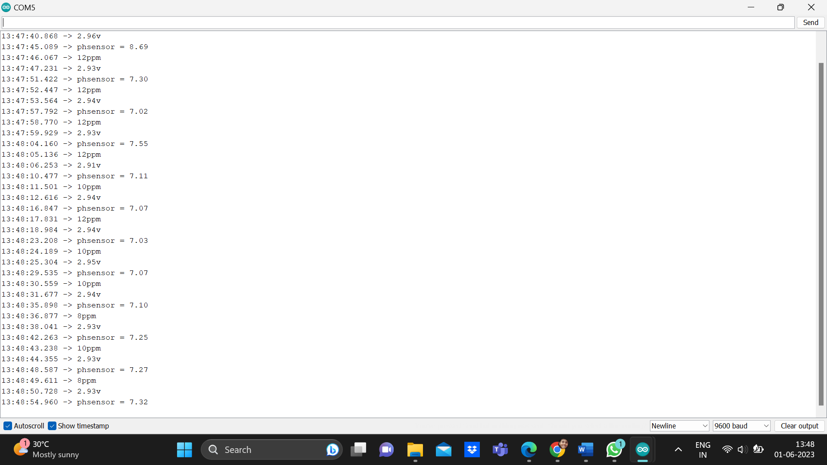

Fig 4.1 COM5 Result of sensors

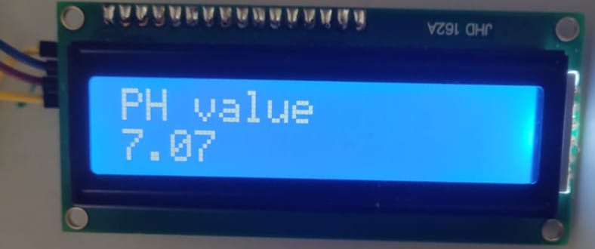
Fig 4.2 PH sensor value

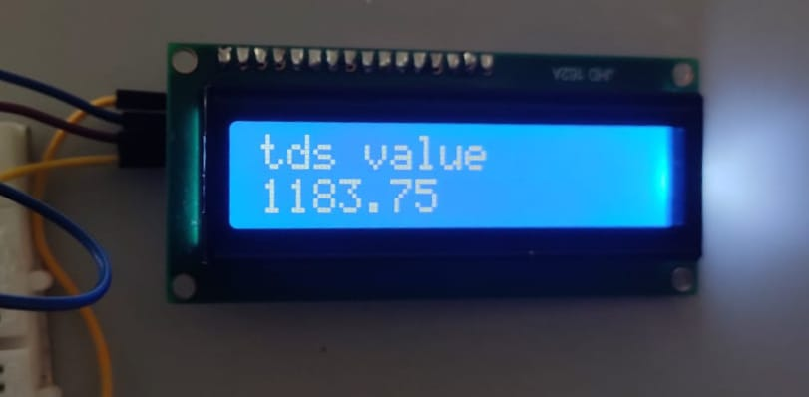
Fig 4.3 TDS sensor value

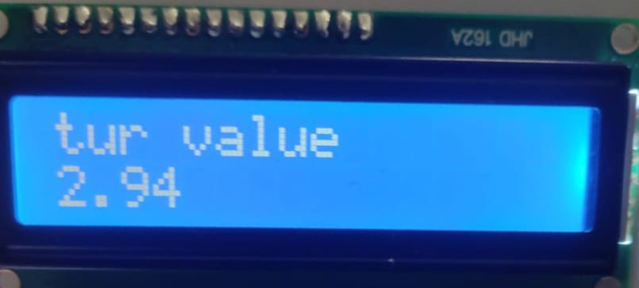
Fig 4.4 Turbidity sensor value

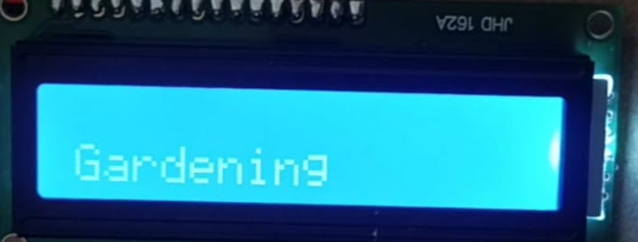

Fig 4.5 Result of water sample
CHAPTER 5: CONCLUSION

5.1 Conclusion:
In conclusion, the development of a product for quality monitoring of recycled wastewater using TDS, turbidity, and pH sensors with an LCD display offers significant benefits in ensuring the safety and efficiency of wastewater treatment processes. Through the implementation of this project, several key outcomes have been achieved.

Firstly, the integration of TDS, turbidity, and pH sensors allows for comprehensive monitoring of important water quality parameters. The sensors provide real-time data, enabling continuous assessment of the wastewater's quality and ensuring compliance with regulatory standards.

Secondly, the utilization of an LCD display enhances the usability and accessibility of the monitoring system. The display provides a user-friendly interface to visualize the measured parameters, facilitating prompt and informed decision-making by operators or users.

Moreover, the successful implementation of this project contributes to sustainable water management practices. By monitoring and maintaining the quality of recycled wastewater, the system supports environmental conservation efforts and promotes the efficient use of water resources.

Furthermore, the accuracy and reliability of the sensor measurements, along with the real-time data display, enable timely detection of any deviations or anomalies in the wastewater quality. This empowers operators to take immediate corrective actions and optimize the treatment processes, minimizing the risk of potential environmental contamination.

Overall, the product development for quality monitoring of recycled wastewater using TDS, turbidity, and pH sensors with an LCD display provides a valuable tool for wastewater treatment facilities, industries, and regulatory bodies. The system offers enhanced control, improved efficiency, and heightened awareness of the wastewater quality, contributing to sustainable water management practices and environmental protection.

5.2 Future scope:
The product development for quality monitoring of recycled wastewater using TDS, turbidity, pH sensors, and an LCD display opens up several future possibilities for further enhancements and advancements. Here are some potential areas of future scope for this project:

1. Integration of Additional Sensors: The system can be expanded by integrating additional sensors to monitor other important parameters such as dissolved oxygen, conductivity, or specific contaminants. This would provide a more comprehensive understanding of the wastewater quality and enable better decision-making.

2. Automation and Control: Implementing automation techniques and control mechanisms can further improve the efficiency and reliability of the wastewater treatment process. This could involve the integration of actuators and feedback loops to automatically adjust treatment parameters based on real-time sensor readings.

3. Data Analysis and Machine Learning: The collected data from the sensors can be analyzed using advanced data analysis techniques and machine learning algorithms. This would enable the identification of patterns, correlations, and anomalies in the wastewater quality, leading to more accurate predictions and proactive management strategies.

4. Remote Monitoring and Reporting: Expanding the system to allow for remote monitoring and reporting would enhance the accessibility and convenience of the wastewater quality data. This could involve the integration of IoT technologies and cloud-based platforms, enabling real-time data transmission, remote access, and centralized data management.

5. Mobile Application Development: Developing a dedicated mobile application for the system would provide users with a convenient interface to monitor and manage the wastewater quality on-the-go. The application could offer features such as data visualization, alerts and notifications, historical data analysis, and remote control capabilities.

6. Continuous System Optimization: Continuous improvement and optimization of the monitoring system can be pursued by incorporating user feedback, conducting regular maintenance and calibration of sensors, and keeping up with technological advancements in sensor technology and data analysis techniques.

By exploring these future scopes, the product can evolve into a more advanced and sophisticated wastewater quality monitoring system, providing even greater control, efficiency, and insights for the management of recycled wastewater.

Reference

[1] Kumar, Manish, Tinku Singh, Manish Kumar Maurya, Anubhav Shivhare, Ashwin Raut, and Pramod Kumar Singh. "Quality Assessment and Monitoring of River Water Using IoT Infrastructure." IEEE Internet of Things Journal (2023).
[2] M. Kumar, T. Singh, M. K. Maurya, A. Shivhare, A. Raut and P. K. Singh, "Quality Assessment and Monitoring of River Water Using IoT Infrastructure," in IEEE Internet of Things Journal, doi: 10.1109/JIOT.2023.3238123.
[3] B. Suwandi et al., "Development of a Low-Cost TDS Sensor Using an Electric Plug with The Curve Fitting Method Approaches," 2022 International Conference on Radar, Antenna, Microwave, Electronics, and Telecommunications (ICRAMET), Bandung, Indonesia, 2022, pp. 83-87, doi: 10.1109/ICRAMET56917.2022.9991206.
[4] Q. Song, F. Luan, Z. Shi, T. Li and M. Wang, "Design of Turbidity Remote Monitoring System Based on FX-11A Optical Fiber Sensor," 2020 Prognostics and Health Management Conference (PHM-Besançon), Besancon, France, 2020, pp. 291-294, doi: 10.1109/PHM-Besancon49106.2020.00056.
[5] J. Yin, W. Chen, W. Gao, X. Zhang, B. Tang and Q. Jin, "Batch Fabrication of Microminiaturized pH Sensor Integrated With IrOx Film and Solid-State Ag/AgCl Electrode for Tap Water Quality Online Detection," in IEEE Sensors Journal, vol. 23, no. 4, pp. 3475-3484, 15 Feb.15, 2023, doi: 10.1109/JSEN.2023.3234140.
[6] Sanchez, R.; Groc, M.; Vuillemin, R.; Pujo-Pay, M.; Raimbault, V. Development of a Frugal, In Situ Sensor Implementing a Ratiometric Method for Continuous Monitoring of Turbidity in Natural Waters. Sensors 2023, 23, 1897. https:/doi.org/10.3390/s23041897
[7] A. Porwal, S. K. Mishra, A. Kela, G. Singh, M. Panchal and A. Jain, "Prediction and Prevention of Water Pollution by Industries using IoT based Monitoring System," 2022 IEEE 11th International Conference on Communication Systems and Network Technologies (CSNT), Indore, India, 2022, pp. 504-509, doi: 10.1109/CSNT54456.2022.9787664.
[8]D. Parida, A. Behera, J. K. Naik, S. Pattanaik and R. S. Nanda, "Real-time Environment Monitoring System using ESP8266 and ThingSpeak on Internet of Things Platform," 2019 International Conference on Intelligent Computing and Control Systems (ICCS), Madurai, India, 2019, pp. 225-229, doi: 10.1109/ICCS45141.2019.9065451.
[9]Kalirajan, K., Nambiar, M.V., Vinodhini, K. and Ramya, E., 2021, May. IOT based industrial waste water monitoring and recycling. In Journal of Physics: Conference Series (Vol. 1916, No. 1, p. 012119). IOP Publishing.​
[10] Martínez, Ramón, et al. "On the use of an IoT integrated system for water quality monitoring and management in wastewater treatment plants." Water 12.4 (2020): 1096.
[11] Khan, Md Saikat Islam, et al. "IoT and wireless sensor networking-based effluent treatment plant monitoring system." acta polytechnica hungarica 18.10 (2021): 205-224.
[12] Zakaria, Yona, and Kisangiri Michael. "An integrated cloud-based wireless sensor network for monitoring industrial wastewater discharged into water sources." (2017).
[13] Zhang, Wei, et al. "Application with Internet of things technology in the municipal industrial wastewater treatment based on membrane bioreactor process." Applied Water Science 11.3 (2021): 52.

Appendix
#include <LiquidCrystal_I2C.h>
LiquidCrystal_I2C lcd(0x27, 16, 2);
#include <EEPROM.h>
#include "GravityTDS.h"
#define TdsSensorPin A1
GravityTDS gravityTds;

//
int sensorPin = A2;
float volt;
float ntu;

float temperature = 25,tdsValue = 0;
const int analogInPin = A0;
int sensorValue = 0;
unsigned long int avgValue;
float b;
int buf[10],temp=0;

void setup()
{
Serial.begin(115200);
gravityTds.setPin(TdsSensorPin);
gravityTds.setAref(5.0); //reference voltage on ADC, default 5.0V on Arduino UNO
gravityTds.setAdcRange(1024); //1024 for 10bit ADC;4096 for 12bit ADC
gravityTds.begin();
Serial.begin(9600);
lcd.init(); // initialize the lcd
lcd.begin(16, 2);
lcd.backlight();
}
void loop()
{
for(int i=0;i<10;i++)
{
buf[i]=analogRead(analogInPin);
delay(10);
}
for(int i=0;i<9;i++)
{
for(int j=i+1;j<10;j++)
{
if(buf[i]>buf[j])
{
temp=buf[i];
buf[i]=buf[j];
buf[j]=temp;
}
}
}
avgValue=0;
for(int i=2;i<8;i++)
avgValue+=buf[i];

float pHVol=(float)avgValue*5.0/1024/4.3;
float phValue = -5.70 * pHVol +29.5 ;
phValue=14.2-phValue;
//float phValue = -3.0 * pHVol+17.5;
Serial.print("phsensor = ");
Serial.println(phValue);

delay(1000);

//temperature = readTemperature(); //add your temperature sensor and read it
gravityTds.setTemperature(temperature); // set the temperature and execute temperature compensation
gravityTds.update(); //sample and calculate
tdsValue = gravityTds.getTdsValue(); // then get the value
Serial.print(tdsValue,0);
Serial.println("ppm");
delay(1000);

//tur

volt = 0;
for(int i=0; i<800; i++)
{
volt += ((float)analogRead(sensorPin)/1023)*5;
}
volt = volt/800;
volt = round_to_dp(volt,2);
if(volt < 2.5){
ntu = 3000;
}else{
ntu = -1120.4*square(volt)+5742.3*volt-4353.8;
}
Serial.print(volt);
Serial.println("v");
delay(1000);

lcd.clear();
lcd.setCursor(0,0);
lcd.print("PH value");
lcd.setCursor(0,1);
lcd.print(phValue);
delay(1500);

lcd.clear();
lcd.setCursor(0,0);
lcd.print("tds value");
lcd.setCursor(0,1);
lcd.print(tdsValue);
delay(1500);

lcd.clear();
lcd.setCursor(0,0);
lcd.print("tur value");
lcd.setCursor(0,1);
lcd.print(volt);
delay(1500);

lcd.clear();
if (volt > 5 && tdsValue > 1000 && phValue > 9) {
lcd.setCursor(0, 0);
lcd.print("Water is polluted");
lcd.setCursor(0, 1);
lcd.print("Immediate action!");
} else if (volt < 5 && tdsValue < 1500 && phValue < 7.5) {
lcd.setCursor(0, 0);
lcd.print(" ");
lcd.setCursor(0, 1);
lcd.print("Gardening");
} else if (volt < 5 && tdsValue < 1000 && phValue < 9) {
lcd.setCursor(0, 0);
lcd.print("Fleshing");

lcd.setCursor(0, 1);
lcd.print("");
}
else {
lcd.setCursor(0, 0);
lcd.print("Drinking ");
lcd.setCursor(0, 1);
lcd.print("");
}}

float round_to_dp( float in_value, int decimal_place )
{
float multiplier = powf( 10.0f, decimal_place );
in_value = roundf( in_value * multiplier ) / multiplier;
return in_value;
}

