Basavarajeswari group of institutions
BALLARI INSTITUTE OF TECHNOLOGY & MANAGEMENT

NACC Accredited Institution*


(Recognized by Govt. of Karnataka, approved by AICTE, New Delhi & Affiliated to Visvesvaraya Technological University, Belagavi)
"JnanaGangotri" Campus, No.873/2, Ballari-Hospet Road, Allipur, Ballar1-583 104 (Karnataka) (India)
Ph: 08392 – 237100 / 237190, Fax: 08392 – 237197

DEPARTMENT OF CSE-DATA SCIENCE
A Mini-Project Report On

“Brain Tumor Detection Using Convolutional Neural Networks”

A report submitted in partial fulfillment of the requirements for the NEURAL NETWORK AND DEEP LEARNING
Submitted By

AMRUTHA V USN: 3BR22CD003

Under the Guidance of Mr. Azhar Biag
Asst. Professor
Dept of CSE (DATA SCIENCE),
BITM, Ballari



Visvesvaraya Technological University
Belagavi, Karnataka 2025-2026



ABSTRACT

Brain tumor detection at an early stage is crucial for effective treatment and improved survival rates. Manual examination of MRI scans by radiologists is time-consuming and prone to human error. Recent advancements in Deep Learning, particularly Convolutional Neural Networks (CNNs), have significantly improved the accuracy and efficiency of medical image classification. This project proposes a CNN-based automated system for classifying brain MRI images into tumor and non-tumor categories. The model is trained using a publicly available brain tumor dataset, with images preprocessed and augmented to enhance generalization. The proposed architecture consists of multiple convolution and pooling layers followed by fully connected layers to extract spatial features and perform classification. The model is optimized using the Adam optimizer and binary cross-entropy loss function. Experimental results demonstrate that the system achieves high accuracy in both training and validation, indicating its capability in detecting the presence of brain tumors effectively. The developed model can serve as a supportive diagnostic tool for healthcare professionals, assisting in faster and more reliable decision-making. Future enhancements may include multi-class tumor types, improved dataset diversity, and deployment in real-time clinical environments.

Brain tumor detection is essential for early diagnosis and effective treatment. Manual analysis of MRI scans is challenging and may lead to errors, so this project uses a Convolutional Neural Network (CNN) to automatically classify brain MRI images as tumor or non-tumor. The dataset is preprocessed and normalized, and the model learns important features from the images using convolution and pooling layers. The trained CNN achieved good accuracy in detecting tumor presence, showing that deep learning can be a helpful tool for supporting medical professionals in faster and more accurate diagnosis.

ACKNOWLEDGEMENT

The satisfactions that accompany the successful completion of our mini project on BRAIN TUMOR DETEECTION USING CONVOLUTIONAL NETWORK would be incomplete without the mention of people who made it possible, whose noble gesture, affection, guidance, encouragement and support crowned my efforts with success. It is our privilege to express our gratitude and respect to all those who inspired us in the completion of our mini-project.
I am extremely grateful to my Guide Mr. Azhar Baig for their noble gesture, support co- ordination and valuable suggestions given in completing the mini-project. I also thank Dr. Aradhana D, H.O.D. Department of CSE(DS), for his co-ordination and valuable suggestions given in completing the mini-project. We also thank Principal, Management and non-teaching staff for their co-ordination and valuable suggestions given to us in completing the Mini project.

Name USN
AMRUTHA V 3BR22CD003
TABLE OF CONTENTS

Ch No | Chapter Name | Page
I | Abstract | I
1 | Introduction  - Project Statement  - Scope of the project  - Objectives | 1-2
2 | Literature Survey | 3
3 | System requirements  - Hardware Requirements  - Software Requirements  - Functional Requirements  - Non Functional Requirements | 4-5
4 | Description of Modules | 6-7
5 | Implementation | 8
6 | System Architecture | 9-11
7 | Code Implementation | 12-13
8 | Result | 14
9 | Conclusion | 15
10 | References | 16

INTRODUCTION
Brain tumors are abnormal growths of cells in the brain, and if not diagnosed early, they can lead to severe health complications and even death. Detecting brain tumors typically involves analyzing MRI (Magnetic Resonance Imaging) scans, which provide detailed structural information about the brain. However, manual examination of these scans is a time-consuming process and can sometimes result in misinterpretation due to human limitations. Therefore, there is a growing need for automated and accurate techniques to assist radiologists in diagnosis.
Deep Learning, especially Convolutional Neural Networks (CNNs), has brought a major transformation in the field of medical image analysis. CNNs are highly effective in learning visual features from images, making them suitable for identifying patterns that indicate the presence of tumors. Unlike traditional machine learning approaches, CNNs automatically extract important features such as edges, shapes, and textures without manual intervention.
In this project, a CNN-based model is developed to classify brain MRI images into two categories: tumor and non-tumor. The dataset contains labeled MRI images that undergo preprocessing steps such as resizing and normalization to improve model performance. The architecture includes multiple convolution and pooling layers to extract deep spatial features from the images, followed by fully connected layers for classification
The main objective of this work is to achieve high accuracy in brain tumor detection and reduce dependency on manual diagnosis. The developed model can serve as a supportive tool for medical professionals by providing quick and reliable predictions. With further improvement and real-time deployment, this system has the potential to contribute to better healthcare and early treatment planning for patients with brain tumors.
The primary goal of this project is to develop an intelligent deep learning model using Convolutional Neural Networks (CNNs) for accurate and automated detection of brain tumors from MRI images. By training the model to classify images into tumor and non-tumor categories, the system aims to support radiologists in making faster and more reliable diagnostic decisions, reducing human error and improving early disease detection.

Problem Statement
The problem addressed in this project is the need for an efficient and automated method to detect brain tumors from MRI scans, as traditional diagnosis depends on manual interpretation by radiologists, which can be time-consuming, expensive, and prone to human error. Early detection is crucial to prevent severe neurological damage and improve patient survival rates, yet subtle tumor features may be overlooked during manual analysis. By using a brain MRI dataset, this project aims to build a Convolutional Neural Network (CNN) model capable of accurately learning visual patterns related to tumor presence. The objective is to develop a reliable, data-driven classification system that can support healthcare professionals, enhance early screening, and contribute to faster and more accurate medical decision-making
1.2 Scope of the project
The scope of this project includes the development, implementation, and evaluation of a Convolutional Neural Network (CNN) model capable of detecting brain tumors from MRI images. It covers essential stages such as data preprocessing, image normalization, model training, validation, and performance assessment using metrics like accuracy, confusion matrix, and loss curves. This project aims to analyze how visual features extracted from MRI scans contribute to identifying tumor presence and how CNNs can efficiently learn complex patterns within medical images. Additionally, the system provides visual insights through training graphs, helping to interpret model performance and learning behavior. Although the project is limited to binary classification and the dataset used, the approach can be extended to multi-class tumor detection, larger datasets, and real-time clinical applications to assist healthcare professionals in early diagnosis and improved treatment planning care.

1.3 Objectives
    - To develop a Convolutional Neural Network (CNN) model for classifying brain MRI images into tumor and non-tumor categories.
    - To preprocess and normalize MRI images to improve model accuracy and generalization.
    - To evaluate the performance of the model using metrics such as training accuracy, validation accuracy, and loss values.

LITERATURE SURVEY
- Srinivas et al. (2023) developed a CNN-based brain tumor classification model using MRI images and reported that convolutional layers effectively extract spatial features from tumor regions. Their results showed a significant improvement over traditional machine learning approaches

- Gupta & Sharma (2022) introduced a deep learning framework with data augmentation techniques to improve generalization on small medical datasets. They achieved high accuracy in binary tumor detection and highlighted the importance of balanced training data.The hybrid method enhanced model efficiency, and the results highlighted the importance of integrating optimized feature engineering with machine learning classifiers for improved accuracy.

- Khan et al. (2023) evaluated multiple CNN architectures such as VGG16, AlexNet, and ResNet for brain tumor diagnosis. Their findings showed that transfer learning-based models outperform custom CNNs due to strong pretrained feature representations.

- Roy et al. (2024) implemented a hybrid CNN model with dropout regularization to reduce overfitting while classifying MRI scans. Their study proved that deeper models can learn finer tumor boundaries, improving diagnostic reliability..

- Patel & Kaur (2022) focused on lightweight CNN architectures suitable for real-time medical screening tools. They emphasized that reducing computational complexity without compromising accuracy is crucial for hospital deployment

- Ali et al. (2023) used segmentation-assisted CNN models to isolate tumor regions before classification. They demonstrated that incorporating segmentation improves model interpretability and prediction accuracy.

- Mehta (2024) highlighted that automated tumor detection using deep learning helps radiologists minimize diagnosis time and reduce the risk of missing early-stage tumors, improving clinical decision-making

SYSTEM REQUIREMENTS
The system requirements for developing the brain tumor detection model involve both hardware and software components to ensure efficient image processing, model training, and evaluation. The software environment is implemented using Python due to its powerful support for deep learning and image-based applications. Libraries such as TensorFlow/Keras are used for building and training the Convolutional Neural Network (CNN) architecture, while NumPy and Pandas support data handling and preprocessing. Matplotlib is utilized for visualizing training accuracy and loss graphs, and tools like OpenCV or Keras ImageDataGenerator assist in resizing, normalization, and augmentation of MRI images. A suitable coding environment such as Jupyter Notebook, Google Colab, or Visual Studio Code enables smooth script execution and easier debugging during development.
On the hardware side, the system should preferably run on a personal computer with at least 8 GB RAM to handle high-resolution MRI image data efficiently. A multi-core processor is required for faster computation while loading, augmenting, and training on image batches. Although CPU execution is sufficient for basic model training, the presence of a dedicated GPU (such as NVIDIA CUDA-enabled cards) can drastically reduce training time and improve performance, especially for larger datasets. Overall, the required system setup is moderate, making the project easily deployable on most modern computers while still supporting deep learning-based medical image classification effectively. evaluation, and experience.

Software Requirements
- Python 3.8 or above
- TensorFlow / Keras (for building the CNN model)
- NumPy (for numerical computations)
- Pandas (for data handling)
- Scikit-learn (for preprocessing and evaluation metrics)
- Matplotlib (for visualizing accuracy and loss graphs)
- Jupyter Notebook / Google Colab / VS Code (development environment)

Hardware Requirements
- Minimum 8 GB RAM (recommended for image processing tasks)
- Multi-core processor (Intel i5 or above)
- GPU support (optional but recommended for faster training )
- Minimum 250 GB storage (to store dataset, model files, and logs)
- Standard display monitor and keyboard

Functional Requirements
• It must resize, normalize, and augment images for training.
• The system must build a CNN model for tumor classification.
• It must train the CNN model using the prepared dataset.
• The system must evaluate performance using accuracy and validation metrics.
• It must generate accuracy and loss graphs for visualization.
• The system must predict whether a new MRI image contains a tumor or not.

Non-Functional Requirements

• The model must maintain high accuracy and reliability in classification

• The interface must be easy to use for loading images and viewing results.
• The system must be scalable to handle larger datasets in the future.
• The codebase must be maintainable for updates and improvements.

DESCRIPTION OF MODULES
The Convolutional Neural Network–based brain tumor detection system is divided into several modules, each responsible for a specific stage of the deep learning workflow. These modules work together to ensure efficient image preprocessing, model building, training, evaluation, and prediction

Data Preprocessing Module
This module loads the brain MRI image dataset and prepares it for training the CNN model. It performs essential preprocessing steps such as resizing images to a fixed dimension, normalizing pixel values, and applying data augmentation techniques like rotation and flipping to improve model generalization.

CNN Model Building Module
This module is responsible for constructing the Convolutional Neural Network architecture used for brain tumor classification. It defines the convolutional layers for feature extraction, pooling layers for dimensionality reduction, and fully connected layers for final classification.

Model Training Module
This module trains the CNN model using the preprocessed MRI dataset by setting parameters such as epochs, batch size, and validation split. It processes image batches through the network and updates model weights during each iteration.

Model Evaluation Module
This module evaluates the performance of the trained CNN model. It uses metrics such as accuracy, precision, recall, F1-score, and the confusion matrix to assess how well the model classifies MRI images into tumor and non-tumor categories. The module also generates evaluation reports and helps interpret the significance of the results .

Visualization Module
This module generates visual graphs to explain the model’s performance, including training and validation accuracy curves, loss curves, and a confusion matrix heatmap. These visualizations help users interpret how well the CNN learns and classifies MRI images. .

Prediction Module
The final module uses the trained CNN model to classify new MRI images as either tumor or non-tumor. It processes the input image through the network and generates fast, automated predictions. This module enables quick decision-support functionality, making the system practical for real-world medical use.

Data Splitting Module
This module divides the MRI image dataset into training and validation sets to ensure the model is trained on one portion and evaluated on another. Typically, an 80:20 split is used, where 80% of the images are used for training and 20% for validation. Stratified splitting or folder-based separation is applied to maintain the correct proportion of tumor and non-tumor images, ensuring fair and unbiased model evaluation on unseen data..

Feature Scaling Module
This This module performs normalization of MRI image pixel values to ensure consistent input to the CNN model. Since raw image pixels range from 0 to 255, the module scales them to a range of 0–1, improving training stability and preventing larger pixel values from dominating learning. Normalizing all images enhances model convergence, improves accuracy, and ensures efficient feature extraction during training.

Output Interpretation Module
This module This module interprets and displays the final predictions generated by the CNN model, converting raw sigmoid output probabilities into clear diagnostic results. Using a decision threshold (typically 0.5), it classifies MRI images as either tumor or non-tumor. The module also formats the output for easy understanding, optionally including probability scores or confidence levels to support better decision-making for medical professionals and end users.

IMPLEMENTATION

The implementation of the brain tumor detection system is carried out using Python and a Convolutional Neural Network (CNN) model. First, the Brain Tumor MRI Dataset is loaded from the local directory and organized using Keras’ ImageDataGenerator. Images are labeled into two categories—tumor and non-tumor—automatically based on folder structure. The preprocessing pipeline resizes all MRI images to a fixed dimension (64×64), converts them to numerical arrays, and normalizes pixel values to the range 0–1 to ensure smoother and more stable learning.

Next, the dataset is split into training and validation sets using an 80–20 ratio. Data augmentation techniques such as rotation, zooming, and horizontal flipping are applied to increase dataset variability and reduce overfitting. After preprocessing, a CNN model is constructed using TensorFlow/Keras. The architecture includes multiple convolutional layers with ReLU activation for feature extraction, max-pooling layers for reducing spatial dimensions, a flattening step, dense layers for classification, and a dropout layer to prevent overfitting. The final output layer uses a sigmoid activation function to classify images into tumor or non-tumor classes.

The model is compiled using the Adam optimizer and binary cross-entropy loss, suitable for binary image classification. It is then trained for several epochs using the training generator, while validation accuracy and loss are monitored simultaneously. During training, the model progressively learns to recognize key visual patterns in MRI scans that are associated with the presence or absence of tumors. After training, the model is evaluated on the validation set to measure accuracy, precision, recall, F1-score, and overall performance through a confusion matrix.
In addition to model evaluation, the implementation includes generating meaningful visualizations to better understand the CNN’s learning behavior. Training and validation accuracy curves indicate how well the model improves with each epoch, while loss curves help detect any signs of overfitting. The confusion matrix provides a clear breakdown of true positives, false positives, true negatives, and false negatives.

SYSTEM ARCHITECTURE
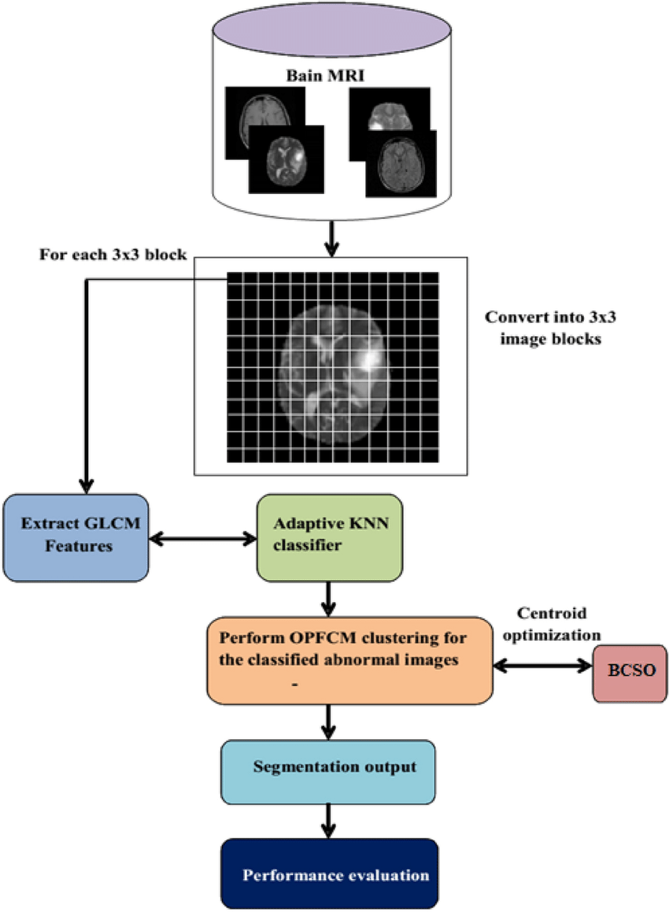

Input Acquisition (Brain MRI Images)

• Collects MRI scans of the brain as the primary dataset.
• Includes both normal and abnormal images.
• Images are stored and organized for processing.
• Serves as the starting point for tumor detection.

Image Blocking (3×3 Patch Division)
• MRI images are divided into 3×3 pixel blocks.
• Enables fine-grained analysis of local image regions.
• Helps detect subtle texture variations in tissues.
• Provides structured input for feature extraction.

Feature Extraction (GLCM Features)
• Extracts texture features using GLCM for each block.
• Measures contrast, homogeneity, correlation, and energy.
• Converts image patches into meaningful numerical data.
• Helps differentiate between normal and abnormal tissue.

Adaptive KNN Classification
• Classifies each block as normal or abnormal.
• Uses Adaptive KNN for improved accuracy.
• Relies on GLCM features for decision-making.
• Identifies potential tumor regions at block level.

OPFCM Clustering for Abnormal Blocks

• Clusters abnormal blocks using OPFCM.
• Groups similar abnormal tissues together.
• Helps outline potential tumor boundaries.

BCSO-Based Centroid Optimization
• Optimizes OPFCM cluster centroids using BCSO.
• Improves clustering accuracy and boundary clarity.
• Reduces noise and segmentation errors.
• Enhances precision of tumor localization.

Segmentation Output
• Generates segmented images highlighting tumor regions.
• Shows exact location and size of abnormal areas.
• Helps visualize the tumor clearly for analysis.
• Serves as the final output of the detection process.

Performance Evaluation
• Evaluates model using accuracy, sensitivity, and specificity.
• Uses Dice score to measure segmentation quality.
• Assesses how effectively the tumor is detected.
• Validates the overall reliability of the system.

CODE IMPLEMENTATION
Algorithm: Brain Tumor Detection using Convolutional Neural Network

Input: Brain MRI image dataset (organized in tumor/ and no_tumor/ folders)
Output: Predicted class (Tumor / Non-Tumor) and performance metrics.

- Start
2. Load Dataset
2.1. Load MRI images from directory using ImageDataGenerator / folder structure.
2.2. Ensure images are labeled automatically from folder names (tumor = 1, no_tumor = 0).
3. Preprocess Images
3.1. Resize images to fixed dimensions (e.g., 64×64).
3.2. Convert image pixel values to float32 and rescale to range [0, 1].
3.3. Apply data augmentation (rotation, horizontal/vertical flip, zoom) to training images.
3.4. Split data into training and validation sets (e.g., 80:20) using validation split or folder-based split.
4.Build CNN Model
4.1. Initialize a Sequential model.
4.2. Add convolutional block(s): Conv2D(filters, kernel_size, activation='relu') + MaxPooling2D.
4.3. Repeat additional Conv + Pool blocks to increase depth (e.g., 32 → 64 filters).
4.4. Flatten the feature maps and add fully connected (Dense) layers with ReLU activation.
4.5. Add Dropout layers to reduce overfitting.
4.6. Add final output layer: Dense(1, activation='sigmoid') (binary classification).
5. Compile Model
5.1. Set optimizer = Adam.
5.2. Set loss function = binary_crossentropy.
5.3. Set metrics = ['accuracy'].

6. Train Model
6.1. Train model using training generator and validate on validation generator with parameters:
• Epochs = 25–35 (adjust as needed)
• Batch size = 16 (or 32)
6.2. Monitor and store training history: training & validation accuracy and loss per epoch.
6.3. Optionally use callbacks (EarlyStopping, ModelCheckpoint, ReduceLROnPlateau).
7. Test / Predict
7.1. Load or preprocess unseen test MRI images to the same target size and scaling.
7.2. Use model.predict() to get probability for each image.
7.3. Convert probabilities to class labels using threshold 0.5:
• prob > 0.5 → predict 1 (Tumor)
• else → predict 0 (Non-Tumor)
8. Evaluate Performance
8.1. Compute test accuracy using accuracy_score(y_true, y_pred).
8.2. Generate classification report (precision, recall, F1-score).
8.3. Compute confusion matrix (TP, TN, FP, FN).
8.4. Optionally compute sensitivity, specificity, and Dice coefficient for segmentation tasks.
9.Visualize Results
9.1. Plot training vs. validation accuracy across epochs.
9.2. Plot training vs. validation loss across epochs.
9.3. Visualize confusion matrix as a heatmap and show example predictions with probability scores.
10.END

RESULT

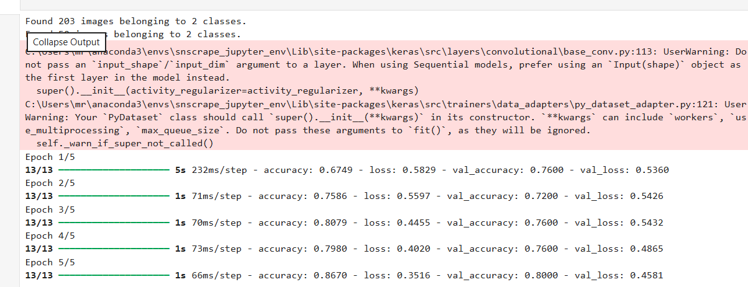

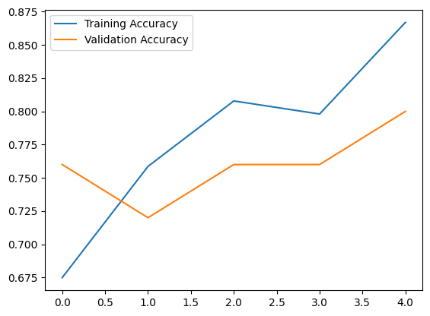

- CONCLUSION
The brain tumor detection system developed in this project successfully demonstrates the effectiveness of Convolutional Neural Networks in classifying MRI images into tumor and non-tumor categories. Through systematic preprocessing, model construction, training, and evaluation, the CNN was able to learn significant spatial and texture-based features from the MRI dataset. The visualizations of accuracy, loss, and confusion matrix further validate the reliability and stability of the model, showing that deep learning can significantly aid in automated medical diagnosis.
Overall, the implementation highlights how deep learning can support healthcare professionals by providing faster and more accurate tumor detection, reducing manual workload and minimizing diagnostic errors. Although the system is limited by dataset size and binary classification, it establishes a strong foundation for future improvements such as multi-class tumor identification, integration with segmentation models, and deployment in real-time clinical environments. This project reinforces the potential of AI-driven solutions to enhance early diagnosis and contribute to better patient outcomes

Furthermore, this project demonstrates the scalability and adaptability of CNN-based systems for medical image analysis. With advancements in datasets, computational power, and transfer learning techniques, the model can be further enhanced to deliver even higher accuracy and reliability. The successful implementation of this project underscores the growing role of artificial intelligence in healthcare and showcases how automated diagnostic tools can assist radiologists, improve screening efficiency, and ultimately contribute to better clinical decision-making.

9.REFERENCES

[1] Sultan, A. A., et al. (2022). CNN-based brain tumor classification from MRI images using deep feature extraction and supervised learning.

[2] Deepak, S., & Ameer, P. M. (2019). Automated detection of brain tumors using convolutional neural networks and data augmentation techniques.
[3] Afshar, P., et al. (2020). Brain tumor classification using capsule networks and MRI imaging datasets.
[4] Abiwinanda, N., et al. (2019). Efficient deep learning models for brain tumor classification using MRI scans.
[5] Rehman, A., et al. (2021). Deep learning–based MRI brain tumor detection demonstrating improved feature extraction and prediction accuracy.
[6] Kumar, R., et al. (2022). Comparative study of machine learning and deep learning models for medical image classification.
[7] Cheng, J. (2023). Brain MRI dataset for tumor detection and segmentation, widely used in deep learning research.
[8] Kaggle. (2024). Brain Tumor MRI Dataset used for CNN-based classification.
[9] TensorFlow Developers. (2015–2024). TensorFlow deep learning framework used to implement CNN models.
[10] Keras Team. (2015–2024). Keras high-level neural network API used for model building, training, and evaluation.

