1) Write a program that takes number as input, print the sum of odd digits in the given number

var num=prompt("enter a number :")

var sum=0

for(i=0;i<num.length;i++){

    if(Number(num[i])%2==1){

        sum=sum+Number(num[i])

    }

}

console.log(sum)

2) Write a program to print the sum of even digits in the given numbers

var num=prompt("enter a number :")

var sum=0

for(i=0;i<num.length;i++){

    if(Number(num[i])%2==0){

        sum=sum+Number(num[i])

    }

}

console.log(sum)

3) Write a program to print the difference between even sum and odd sum in the given number.

var num=prompt("enter a number :")

var sum=0

count=0

for(i=0;i<num.length;i++){

    if(Number(num[i])%2==0){

        sum=sum+Number(num[i])

    }

    else if(Number(num[i])%2==1){

        count=count+Number(num[i])

}

}

console.log(sum)

console.log(count)

if(sum>count){

    console.log(sum-count);

}

else{

    console.log(count-sum)

}

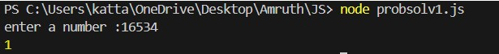

4) Write a program to print the largest sum between odd sum and even sum.

var num=prompt("enter a number :")

var sum=0

count=0

for(i=0;i<num.length;i++){

    if(Number(num[i])%2==0){

        sum=sum+Number(num[i])

    }

    else if(Number(num[i])%2==1){

        count=count+Number(num[i])

}

}

console.log(sum)

console.log(count)

if(sum>count){

    console.log("Even sum is bigger");

}

else{

    console.log("Odd sum is bigger")

