NorthStar Marketing Analytics Dashboard
Release Notes — v1.0
NorthStar Residential Group
April 2026
Table of Contents

About These Notes
This document describes every visual that ships in v1.0 of the NorthStar Marketing Analytics Dashboard. It is written for end users who need to read the dashboard correctly — what each visual is for, how it’s calculated, what it means, and where it can mislead.
Each visual entry follows the same structure:
- Purpose — what question it answers
- Inputs — fact tables and dimensions involved
- DAX / Measure — the measure(s) behind it (named, with formula or pattern)
- How to read it — what to look for first, second, third
- Edge cases — when the number can mislead and how to spot it
Numbers shown in screenshots are illustrative, taken from the v1.0 demo data covering April 2025 – April 2026 across 120 properties, 11 vendors, and 12 markets.

What’s in v1.0
Page | Type | Audience | Refresh
Executive Summary | Primary | Executives, Directors | Daily
Operations Monitor | Primary | Ops Leadership, Regional Mgrs | Daily
Marketing Funnel | Primary | Marketing, Vendor Managers | Daily
Geography Page | Primary | Marketing, Regional Leadership | Daily
Operations Detail | Drill-through | Property/Asset Managers | Daily
Funnel Detail | Drill-through | Vendor Managers, Marketing Ops | Daily
Geography Detail | Drill-through | Regional Marketing, Property Mgmt | Daily
Data foundation: Star schema with 4 dimensions (dim_property, dim_vendor, dim_market/dim_region, dim_date plus role-playing dim_lease_date) feeding 4 fact tables: fact_property_ops_daily (99K rows), fact_leasing_daily (99K rows), fact_marketing_spend_daily (1.09M rows), and fact_prospect_journey (multi-touch attribution).
Three composite indices drive every score in the dashboard. Read these first — every visual that shows a tier, badge, or ranked list is built on one of them.

VPI — Vendor Performance Index
Evaluates each marketing vendor across the full leasing funnel. Conversion-heavy weighting:
Stage | Weight | Components
Awareness | 15% | Impressions, CTR, CPC, Click-to-Visit (25% each)
Consideration | 20% | Visits, CPV, Visit-to-Lead (33/34/33)
Evaluation | 25% | Leads, CPL, Lead-to-Lease (33/33/34)
Conversion | 40% | New Leases, CP-Lease, Imp-to-Lease, Sell Rate (25% each)
Every component is a portfolio percentile (0–100) — the vendor is ranked against all other vendors on that metric. Tier thresholds: Elite ≥75, Strong 60–74, Moderate 48–59, Underperforming 35–47, Critical <35.

GPI — Geographic Performance Index
Two-pillar score for property/market/region marketing health:
- Pillar 1 — Absolute (60%): portfolio percentile across CPL, Cost-per-Lease, Sell Rate, Vacancy Fill %, Vacant Ready %, SLA Compliance %
- Pillar 2 — Trend (40%): period-over-period scaled deltas, capped at ±15%, on New Leases, Cost-per-Lease, Cost-per-Lead, Net Absorption, and Lease Velocity
Tiers: Excellent · High Performing · Below Average · At Risk · Critical. Pillar Balance flag: Absolute-Led / Momentum-Led / Balanced (within 5 pts).

Ops Index Score
Property-level operational health blending occupancy, leasing velocity, absorption, vacancy fill, and pipeline coverage (scheduled move-ins ÷ lease expirations next 60 days). Tiers: Optimized · Optimizing · At Risk · Critical.

The 30-Day Minimum Window Rule
This is the most important rule to internalize. Every base measure that feeds a percentile or score enforces a 30-day minimum scoring window. If the filter context resolves to fewer than 30 days, the window automatically expands backward 30 days from the latest date in filter:
_Base_<Metric> =
VAR DaysInFilter = [_DaysInFilter]
VAR MaxDate = [_MaxDateInFilter]
RETURN
IF(
DaysInFilter < 30,
CALCULATE([Metric], DATESINPERIOD(dim_date[Date], MaxDate, -30, DAY)),
[Metric]
)
Why: percentile rankings on thin data (a single week, a single day) are statistically unreliable and produce wild rank swings. The 30-day floor keeps scores stable.
Consequence to know: if you select “This Week” in a date slicer, the percentile-based scores you see were calculated against the last 30 days, not the week — but the volume KPIs (Spend, Leases, Impressions) reflect the week as selected. This is intentional but can surprise users who expect everything to follow the slicer.

Page 1 — Executive Summary
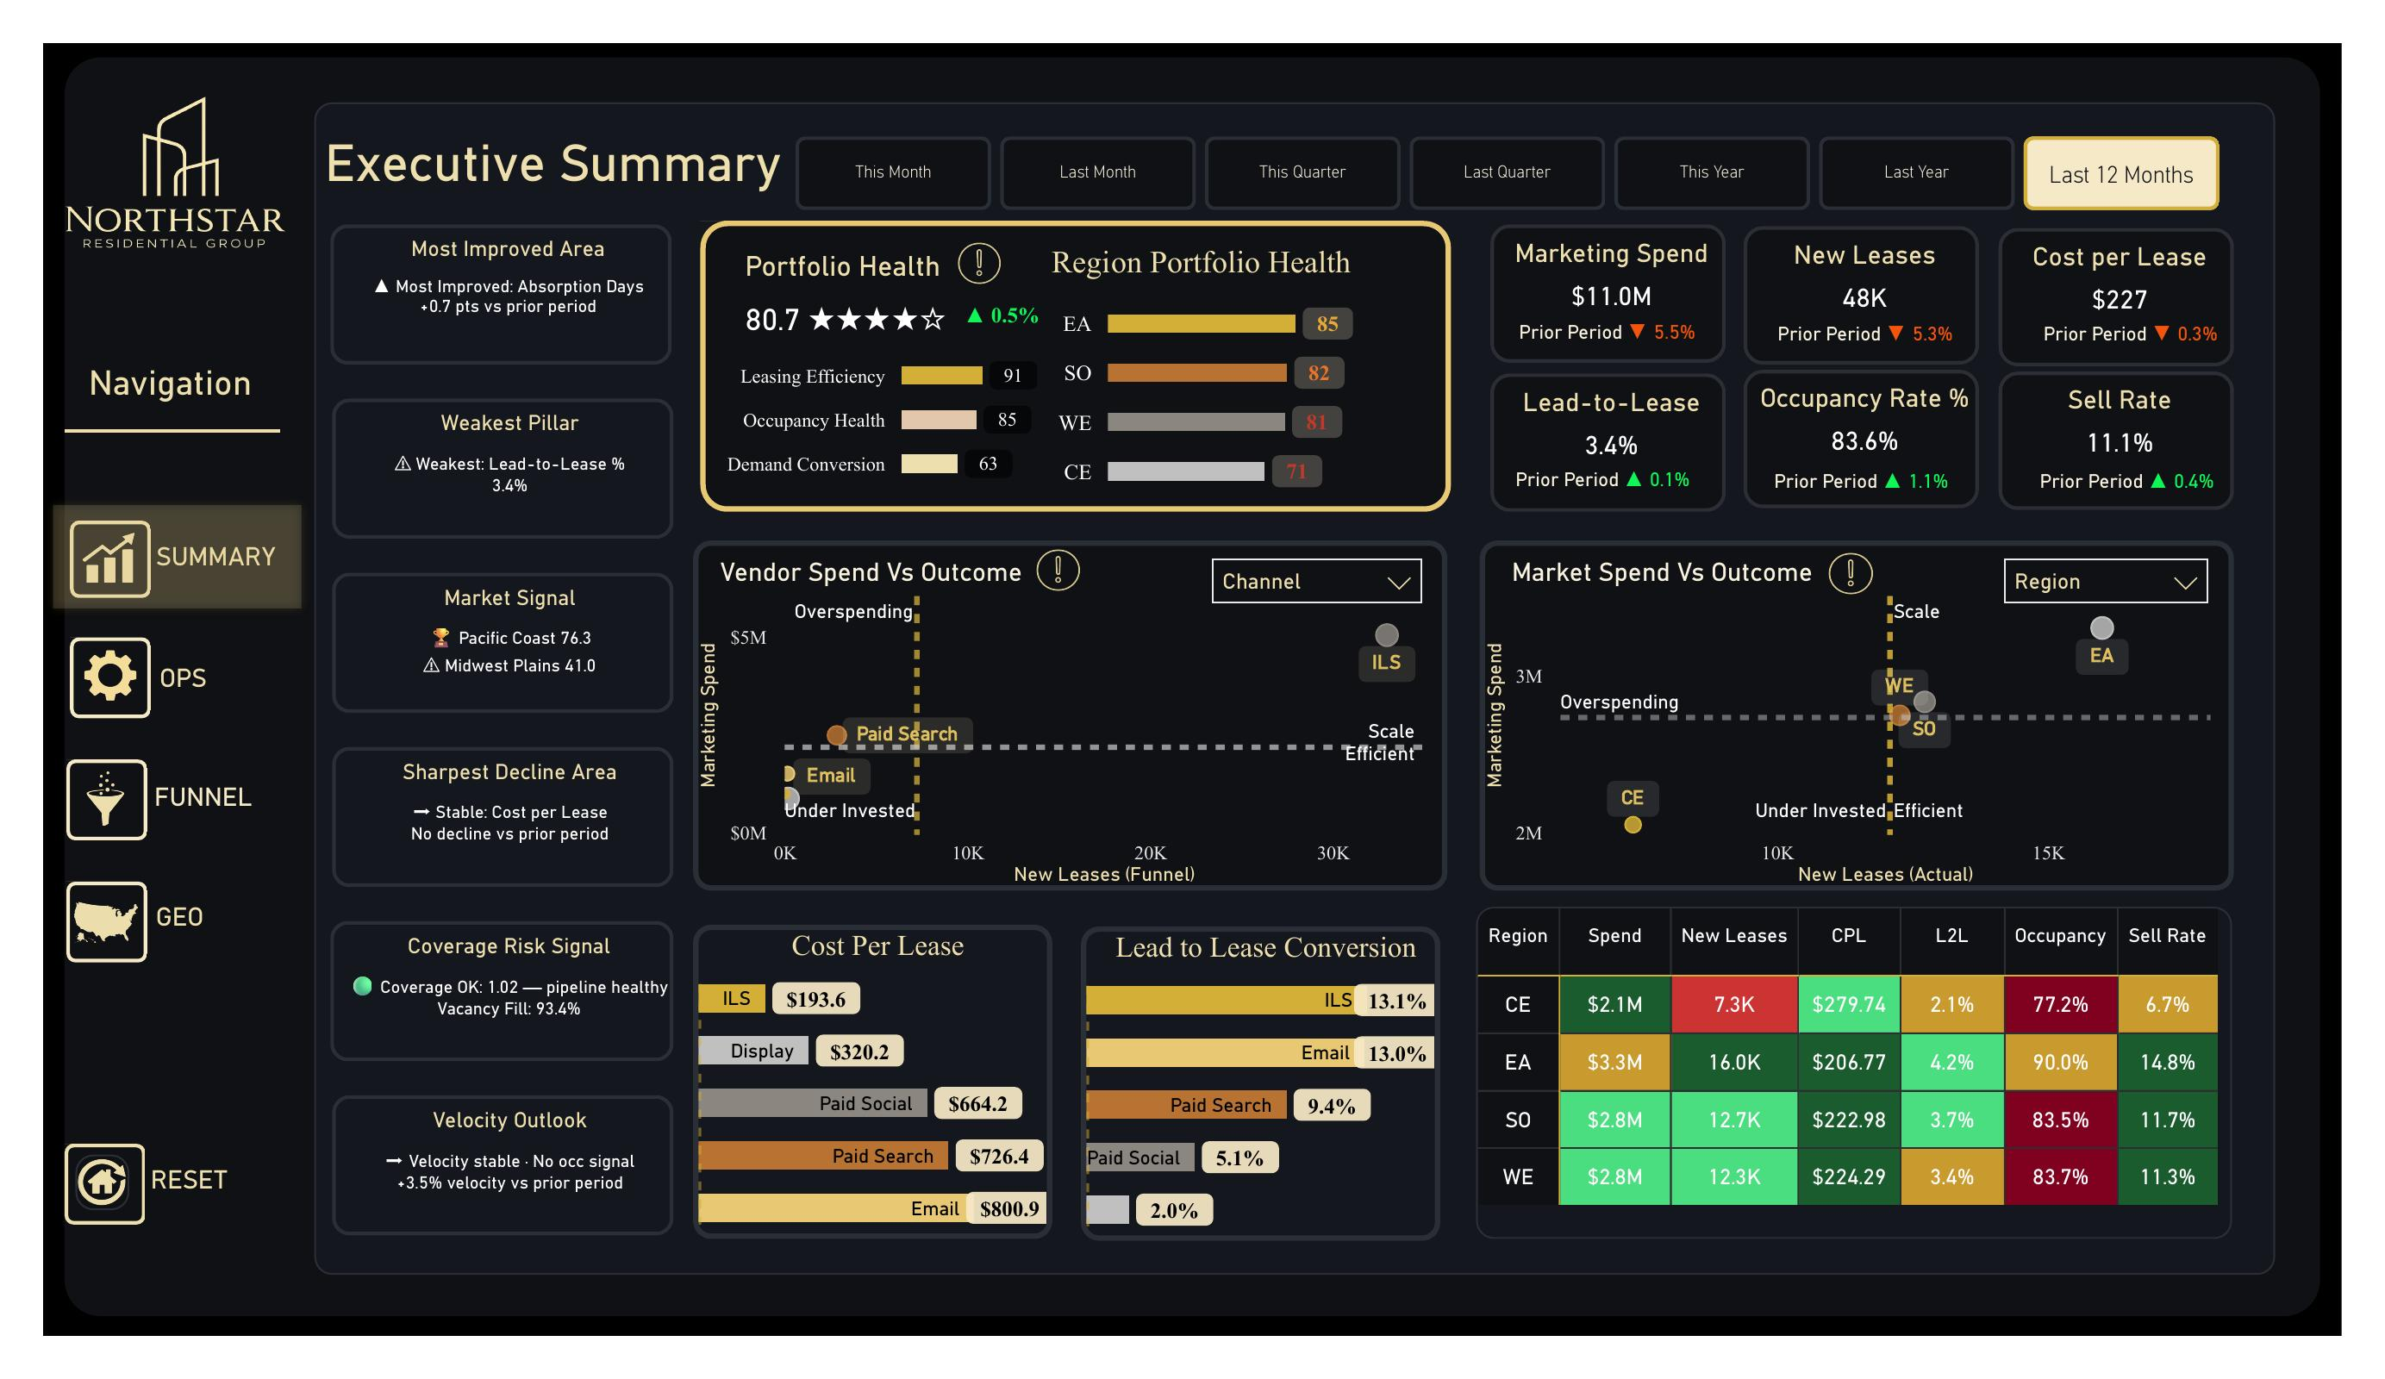
Purpose: Top-of-house view for executives. Answers “How is the portfolio performing this period, and where is the biggest signal?”
Default period: Last 12 Months. Period toggle along the top: This Month · Last Month · This Quarter · Last Quarter · This Year · Last Year · Last 12 Months.

1.1 Portfolio Health Composite
Purpose: Single 0–100 score for the entire portfolio’s marketing + operations health, with a star rating and prior-period delta arrow.
Inputs: Three pillar measures derived from fact_property_ops_daily and fact_leasing_daily:
- Portfolio_Health_Pillar1_Occupancy — occupancy + vacancy + absorption components
- Portfolio_Health_Pillar2_Leasing — leasing efficiency (cost + velocity)
- Portfolio_Health_Pillar3_Demand — demand conversion (top-of-funnel → lease)
DAX: Portfolio_Pillar_Value switches the displayed pillar by the slicer; the composite is the average of the three pillar scores. Bar color is driven by Portfolio_Pillar_Bar_Color which thresholds at 85 / 70 / 55.
How to read it:
- Headline number (80.7) is the composite. Star rating is a visual shortcut for the same number.
- Three rows below break the composite into its pillars. The lowest pillar is the bottleneck — in this screenshot, Demand Conversion at 63 is dragging Leasing Efficiency (91) and Occupancy Health (85) down.
- Green arrow + percentage is the change vs. the prior equal-length period.
Edge case: Star rating thresholds (75 / 60 / 48 / 35) and tier thresholds in the rest of the dashboard are slightly different — don’t expect a 4-star rating to align perfectly with “Strong” tier elsewhere.

1.2 Region Portfolio Health
Purpose: Side-by-side region comparison of the same composite.
Inputs: Portfolio_Pillar_Value calculated per dim_region[RegionName].
How to read it: Bars are sorted by score descending. The numerical badge at the right edge is the integer score. Color gradient is gold-on-dark — darker bars are weaker scores.
Edge case: Only 4 regions exist (CE, EA, SO, WE). If a region’s data is incomplete (e.g., a market has no spend), the score will still calculate but on a smaller component count. Hover for the tooltip to confirm.

1.3 KPI Card Cluster (top-right)
Purpose: Six volume + efficiency KPIs with prior-period arrows.
Card | Measure | Direction Indicator
Marketing Spend | Marketing Spend (sum of fact_marketing_spend_daily.Spend) | ▼ = lower spend (could be good or bad — read with leases)
New Leases | New Leases (from fact_leasing_daily.NewLeases) | ▲ = more leases
Cost per Lease | Cost per Lease (Actual) = Spend ÷ New Leases | ▼ = cheaper per lease
Lead-to-Lease % | Lead-to-Lease Conversion % | ▲ = better conversion
Occupancy Rate % | Occupancy Rate % (latest snapshot, not period avg) | ▲ = better
Sell Rate | Sell Rate = New Leases ÷ Available Units | ▲ = better
How to read it: Always read Spend and New Leases together — a falling spend with rising leases is great, but a falling spend with falling leases is just a slowdown.
Edge case: Occupancy Rate is a snapshot metric (latest available date in filter), not a period average. The prior-period arrow compares snapshot-to-snapshot.

1.4 Vendor Spend vs Outcome (Quadrant)
Purpose: Identify which vendors/channels are scaling efficiently vs. overspending vs. under-invested.
Inputs: Scatter of Marketing Spend (Y) vs New Leases (Funnel) (X), sliced by Channel or Vendor (dropdown top-right).
How to read it (quadrants):
- Scale & Invest (top-right): high spend, high leases — keep funding
- Efficient (bottom-right): low spend, high leases — increase budget here
- Overspending (top-left): high spend, low leases — cut or fix
- Under-Invested (bottom-left): low spend, low leases — investigate before scaling
Quadrant cutoffs are the median spend and median leases across the items in scope (not fixed thresholds), so the chart is always relative to the current selection.
Edge case: With only 2–3 channels visible, “median” is defined by very few points and one mover can flip a quadrant. Switch to Vendor view for a denser plot before drawing conclusions.

1.5 Market Spend vs Outcome (Quadrant)
Purpose: Same logic as 1.4, but at the geographic level (Region or Market dropdown).
How to read it: Identical four-quadrant logic. EA in the top-right means it has the highest spend AND highest leases — that’s the workhorse region. CE in the bottom-left means low spend AND low leases — investigate whether that’s deliberate (smaller portfolio) or a missed opportunity.

1.6 Region Performance Table
Purpose: Tabular view of the same six KPIs broken out by region.
How to read it: Conditional formatting on CPL, L2L, Occupancy, Sell Rate columns — green = good, red = needs attention. Thresholds are portfolio percentile based (CF_Region_* measures).

1.7 Cost Per Lease & Lead to Lease Conversion (Channel Bars)
Purpose: Two horizontal bar charts ranking channels.
- Cost Per Lease — sorted ascending (cheapest first). ILS at $193 is the cheapest channel; Email at $800 is the most expensive on a per-lease basis.
- Lead to Lease Conversion — sorted descending (best conversion first). ILS at 13.1% converts best.
Edge case: Email shows high CPL and low conversion — looks bad. But Email also has low total spend, so it’s not the biggest dollar problem. Always cross-reference with the Vendor quadrant in 1.4.

1.8 Signal Callout Cards (left rail)
Six narrative cards that name the top signal in each category. Driven by their own measures:
- Most Improved Area — highest period-over-period delta among GPI components
- Weakest Pillar — lowest of the three Portfolio Health pillars
- Market Signal — top + bottom GPI markets by name
- Sharpest Decline Area — largest negative delta vs prior period
- Coverage Risk Signal — coverage ratio (scheduled move-ins ÷ expirations next 60D); ≥1.0 is healthy
- Velocity Outlook — period-over-period change in lease velocity
How to read it: These are the executive’s “what to look at first” cards. They’re text strings generated by DAX, so they’re always specific (e.g. “Pacific Coast 76.3”) — not generic.

Page 2 — Operations Monitor
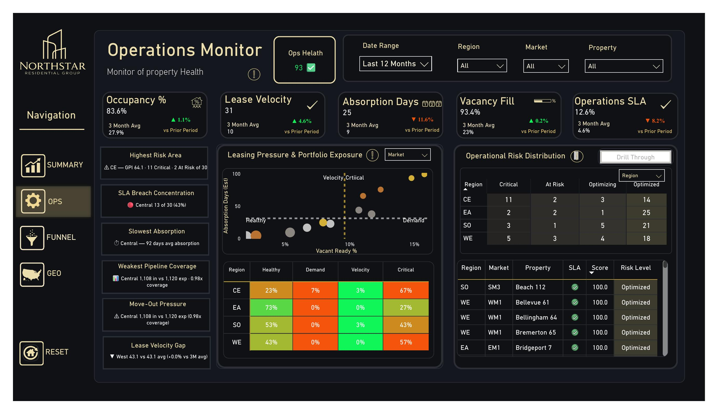
Purpose: Property-health monitor for operations leadership. Answers “Which properties are at risk, why, and how concentrated is the risk?”

2.1 Ops Health Tile (header)
Purpose: Single 0–100 score for portfolio-wide ops health, color-coded badge.
DAX: Average of Operations Index Score across all properties in scope. Green checkmark when ≥85; warning icon below.

2.2 Five-KPI Header Strip
Card | Measure | What “good” looks like
Occupancy % | Latest snapshot of Occupancy Rate % | ▲ trending up; ≥90% is strong
Lease Velocity | Lease Velocity — leases ÷ units in period | ▲ trending up
Absorption Days | Vacant Unit Absorption Days (Est) | ▼ trending down (faster fill)
Vacancy Fill | Vacancy Fill % (30D) | ▲ trending up
Operations SLA | % Properties Within SLA | ▲ trending up
Each card shows a 3-month average for context and the prior-period arrow.
Edge case: Absorption Days is an estimate derived from vacant ready units and recent move-in pace — not a direct measurement. Treat it as a directional indicator, not an absolute.

2.3 Highest Risk / Slowest / Weakest Callouts (left rail)
Six narrative signal cards, each pointing to the single worst case in its category:
- Highest Risk Area — region with lowest GPI + count of Critical/At Risk properties
- SLA Breach Concentration — region with highest % of properties out of SLA
- Slowest Absorption — region with highest avg absorption days
- Weakest Pipeline Coverage — region with lowest scheduled move-ins ÷ expirations ratio
- Move-Out Pressure — same coverage ratio framed as a count
- Lease Velocity Gap — region underperforming its own 3-month average
How to read it: These cards are deliberately repetitive across categories so you can spot a region appearing in multiple cards — that’s a concentration signal. In the screenshot, “Central” appears in 4 of 6 cards.

2.4 Leasing Pressure & Portfolio Exposure (Scatter)
Purpose: Vacant Ready % (X) vs Absorption Days (Y) per market — exposes properties simultaneously high on supply and slow on absorption.
Quadrants:
- Healthy (bottom-left): low vacancy, fast absorption — best
- Demand (bottom-right): high vacancy, fast absorption — supply pressure but moving
- Velocity Critical (top-left): low vacancy, slow absorption — small problem but slow
- Critical (top-right): high vacancy, slow absorption — biggest problem
How to read it: Bubble color reflects GPI tier. A red bubble in the top-right is the most urgent intervention.

2.5 Operational Risk Distribution Matrix
Purpose: Per-region count of properties by risk tier (Critical, At Risk, Optimizing, Optimized).
DAX: Property Count Matrix — counts properties per region × per status, where status is derived from Operations Index Score thresholds (≥85 Optimized, 65–84 Optimizing, etc.).
How to read it: Read each row across — a region with most weight in “Optimized” and “Optimizing” is healthy. A region with weight in “Critical” needs intervention. The screenshot shows CE with 11 Critical properties (most concentrated risk).
Edge case: Counts are absolute, not percentages. CE having 11 critical and EA having 2 critical doesn’t mean CE is 5× worse — it means CE has 5× more critical properties out of its 30 total. Use the Operational Region Heatmap (page 4) for a normalized view.

2.6 Region × Status Percentage Heatmap
Purpose: Per-region split of properties across Healthy / Demand / Velocity / Critical buckets, as percentages.
How to read it: Reads the same way as 2.5 but normalized by region. CE at 67% Critical is concerning; EA at 73% Healthy is healthy. The color gradient (green→red) is the visual shortcut.

2.7 Operations Property Drill List
Purpose: Sortable property table — Region, Market, Property, SLA badge, Score, Risk Level. Click-through to Operations Detail page (drill-through).
How to read it: Default sort is by score descending. The SLA column shows a green checkmark when within SLA, red when not. The Risk Level column maps to the same tiers as the matrix above.

Page 3 — Marketing Funnel
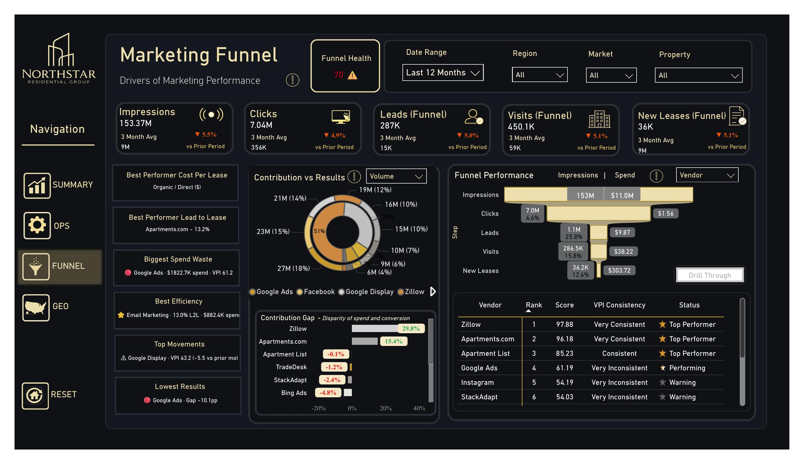
Purpose: Vendor performance scoreboard with funnel conversion, contribution gaps, and VPI rankings. Answers “Which vendors are paying off, where in the funnel are we losing prospects, and where is spend misallocated?”

3.1 Funnel Health Tile (header)
Purpose: Single 0–70-something composite for funnel health.
DAX: Average funnel-stage score weighted by stage. The yellow warning icon at 70 indicates the score is in the “Performing” tier but not “Top Performer” — a single click on the tile shows the breakdown.

3.2 Five-Stage Funnel Header
Five cards: Impressions · Clicks · Leads (Funnel) · Visits (Funnel) · New Leases (Funnel)
Each card shows total volume in period, the 3-month average, and the prior-period delta arrow. The “(Funnel)” suffix distinguishes funnel measures (fact_marketing_funnel_daily) from operational measures (fact_leasing_daily).
Edge case: Leads (Funnel) and Leads (Actual) can differ. Funnel leads count touchpoints tagged as leads in the marketing funnel; Actual leads count CRM lead records. Reconciliation between the two is part of the ETL pipeline (pipeline_flags table); some divergence is normal.

3.3 Best/Worst Performance Callouts (left rail)
Six narrative cards:
- Best Performer Cost Per Lease — vendor with lowest CPLease
- Best Performer Lead to Lease — vendor with highest L2L %
- Biggest Spend Waste — vendor with high spend AND low VPI
- Best Efficiency — vendor with best L2L given spend
- Top Movements — vendor with biggest period-over-period VPI change
- Lowest Results — vendor with worst funnel gap
How to read it: These are the marketing leader’s “where to focus this week” cards.

3.4 Contribution vs Results (Donut)
Purpose: Vendor’s share of impressions (or leads/spend, by toggle).
How to read it: Each segment is one vendor; outer ring shows % of total volume. Pair this with 3.6 — a vendor with a big slice here AND a positive Contribution Gap is healthy; big slice here AND negative gap is overspending.

3.5 Funnel Performance Visual
Purpose: Stage-by-stage waterfall — Impressions → Clicks → Leads → Visits → New Leases — with conversion % at each step and spend bars overlaid.
How to read it:
- The width of each bar is volume
- The percentage label is the conversion rate from the prior stage
- The right-side gold bars are the cost-per-step ($1.56 per click, $9.87 per lead, etc.)
The biggest drop-off in the screenshot is Clicks → Leads at 25.8% — that’s the stage to fix first.

3.6 Contribution Gap Bar Chart
Purpose: Disparity between a vendor’s share of spend and share of conversion.
DAX: (Vendor's % of Conversions) − (Vendor's % of Spend). Positive = converting more than its spend share (efficient); negative = overspending relative to results.
How to read it: Vendors are sorted descending by gap.
- Green positive bars at top — these vendors are over-delivering. Apartments.com at +15.4% means it converts 15.4 percentage points more than its spend share would predict.
- Red negative bars at bottom — these vendors are over-paid relative to results. Bing Ads at -4.8% is the largest underperformer.
This is the most actionable single visual for budget reallocation conversations.

3.7 VPI Vendor Ranking Table
Purpose: Definitive ranked list of vendors by VPI score.
Column | Source
Vendor | dim_vendor[VendorName]
Rank | VPI Portfolio Rank
Score | Vendor Performance Index
VPI Consistency | VPI Consistency (range across 4 stage scores)
Status | VPI_Status_Icon (Top Performer / Performing / Warning / At Risk)
How to read it:
- Score is the headline.
- Consistency tells you whether to trust the score. “Very Consistent” means the vendor is balanced across all 4 funnel stages. “Very Inconsistent” means the vendor is great at 1–2 stages and terrible at others — its top-line VPI may hide a serious weakness.
- Status icon is a quick visual tier marker.
In the screenshot, Google Ads ranks #4 with 61.2 (Performing) — but is “Very Inconsistent.” That’s a yellow flag: the score is propped up by one or two stages.
Edge case: Rank ties get the same number (competition rank). Two vendors tied at 65.0 will both show #3, and the next vendor will show #5 — not #4.

Page 4 — Geography Page
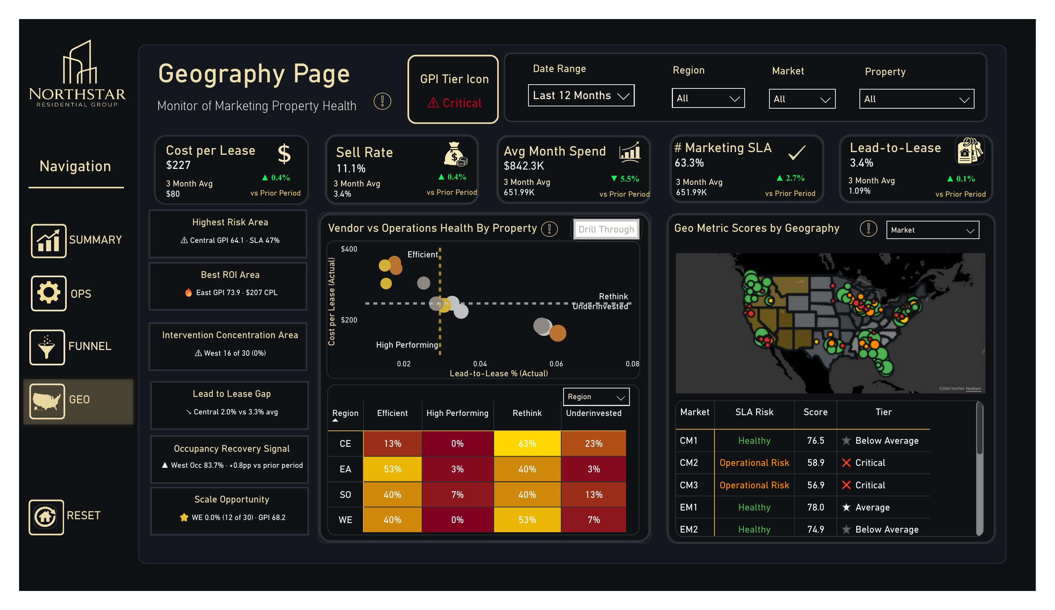
Purpose: GPI-driven view of marketing property health across regions, markets, and properties. Answers “Where geographically is marketing performing, where is it failing, and where should we intervene?”

4.1 GPI Tier Icon (header)
Purpose: Tier badge for the current selection (portfolio, region, market, or property depending on filter context).
DAX: GPI Tier based on GPI Score. Tiers: Excellent (≥80), High Performing (65–79), Below Average (50–64), At Risk (35–49), Critical (<35).

4.2 Five-KPI Header Strip
Card | Measure
Cost per Lease | Cost per Lease (Actual)
Sell Rate | Sell Rate
Avg Month Spend | Marketing Spend ÷ months in period
% Marketing SLA | % Properties Within SLA
Lead-to-Lease | Lead-to-Lease Conversion %

4.3 Geographic Signal Callouts (left rail)
Six cards naming the top signal in each category:
- Highest Risk Area — region with lowest GPI + worst SLA
- Best ROI Area — region with highest GPI + lowest CPL
- Intervention Concentration Area — region with most properties needing intervention
- Lead to Lease Gap — region where L2L lags portfolio average most
- Occupancy Recovery Signal — region trending up most in occupancy
- Scale Opportunity — region with capacity to absorb more spend efficiently

4.4 Vendor vs Operations Health Matrix (Scatter)
Purpose: Lead-to-Lease % (X) vs Cost-per-Lease (Y), per property — surfaces marketing efficiency vs. yield combinations.
Quadrants:
- High Performing (low CPL, high L2L) — best
- Efficient (low CPL, low L2L) — cheap but not converting
- Underinvested (high CPL, high L2L) — converting but expensive
- Rethink (high CPL, low L2L) — worst, intervention needed
Bubble size = property scale; color = GPI tier.

4.5 Geo Score Map
Purpose: Choropleth-style U.S. map with property pins colored by GPI tier (green = Excellent, red = Critical, gray = no data).
How to read it: Cluster of green pins = healthy region; cluster of red = problem region. Click a pin or region to drill the rest of the page; click through to Geography Detail for a single property deep dive.

4.6 Region × Tier Distribution Matrix
Purpose: Per-region count of properties by Marketing Tier (Efficient, High Performing, Rethink, Underinvested).
How to read it: Same logic as the Ops matrix on page 2 — read each row across; concentrations of “Rethink” or “Underinvested” are the targets.

4.7 Geo Metric Scores by Geography (Right Table)
Purpose: Sortable table — Market, SLA Risk, Score, Tier — for the geographic level selected (Region or Market dropdown).
How to read it: Default sort is alphabetical. Sort by Score descending to find the worst markets first. The SLA Risk column has its own threshold (“Healthy” vs “Operational Risk”) independent of GPI tier — a market can be Healthy on SLA but still Below Average on GPI.

Page 5 — Operations Detail (Drill-Through)
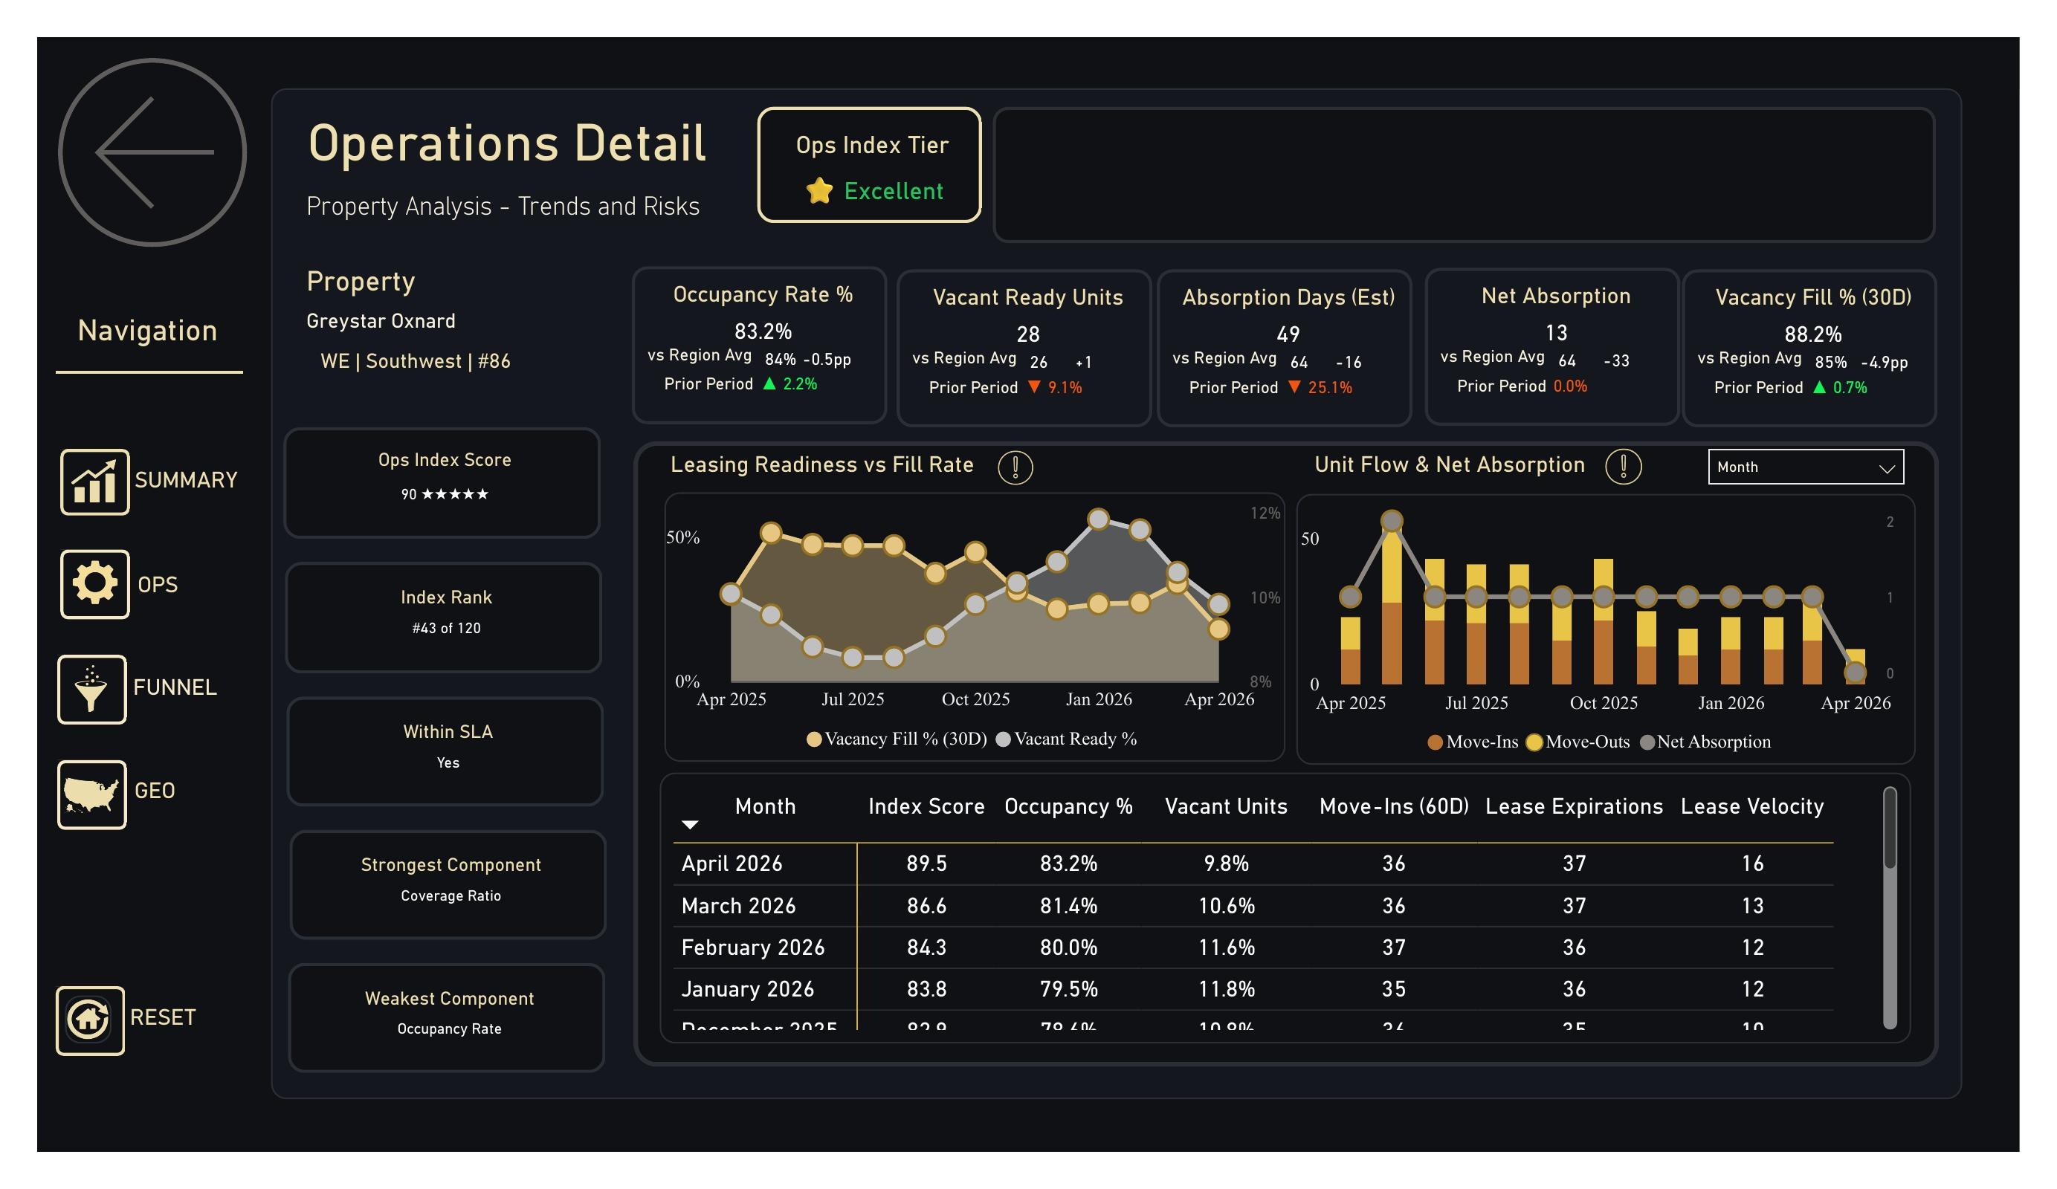
Purpose: Single-property deep dive. Reached via drill-through from page 2 (Operations Monitor). Answers “Why is this specific property scoring what it scores, and how is it trending?”
Header: Property name (Greystar Oxnard), Region | Market | property number, and Ops Index Tier badge (Excellent in the screenshot).

5.1 Five-KPI Strip with Region Benchmarks
Each KPI card shows three things:
- Current value for the property in the selected period
- vs Region Avg — property minus region average, in absolute or percentage points
- Prior Period — property’s own period-over-period change
Card | Measure
Occupancy Rate % | Occupancy Rate %
Vacant Ready Units | Vacant Ready Units (Est)
Absorption Days (Est) | Vacant Unit Absorption Days (Est)
Net Absorption | Move-Ins − Move-Outs in period
Vacancy Fill % (30D) | Vacancy Fill % (30D)
How to read it: Two arrows per card — prior period (the property’s trend) and vs region (the benchmark gap). Both green = strong on both; both red = serious problem; mixed = need to read carefully.
DAX pattern (region avg comparison):
<Metric> - vs Region Avg =
VAR PropVal = [<Metric>]
VAR RegionAvg = CALCULATE([<Metric>],
ALLEXCEPT(dim_property, dim_property[RegionKey]))
RETURN PropVal - RegionAvg
Edge case: Region averages are unweighted property averages, not weighted by units. A 10-unit boutique property and a 400-unit complex contribute equally to the average.

5.2 Index Score / Rank / SLA Cards (left rail)
- Ops Index Score — property’s score with star rating
- Index Rank — #43 of 120 ranking format (Ops_Index_Property_Rank_Display)
- Within SLA — Yes/No badge based on coverage ratio + score thresholds
- Strongest Component / Weakest Component — component name driving up / pulling down the score
How to read it: Strongest/Weakest is the most actionable pair on this page. If the property scores 90 but its weakest component is “Occupancy Rate,” that’s where to focus the next ops review.

5.3 Leasing Readiness vs Fill Rate (Combo Chart)
Purpose: 12-month combo chart with Vacancy Fill % (30D) line and Vacant Ready % area.
How to read it: Falling Vacant Ready paired with rising Vacancy Fill = the property is processing units faster than it’s accumulating vacancies. The opposite (rising Vacant Ready, falling Vacancy Fill) is a backlog warning.

5.4 Unit Flow & Net Absorption (Bar + Line)
Purpose: Move-Ins (yellow bars) and Move-Outs (orange bars) with Net Absorption (line) over 12 months.
How to read it: Bars above zero are inflow, below are outflow; the line tracks the net. Sustained negative net absorption is a red flag regardless of headline occupancy.

5.5 Trend Table
Purpose: Month-by-month detail — Index Score, Occupancy %, Vacant Units, Move-Ins (60D), Lease Expirations, Lease Velocity.
How to read it: Default sort is descending by month. Look for trend reversals (e.g., Occupancy was rising then started falling) before isolated bad months.

Page 6 — Funnel Detail (Drill-Through)
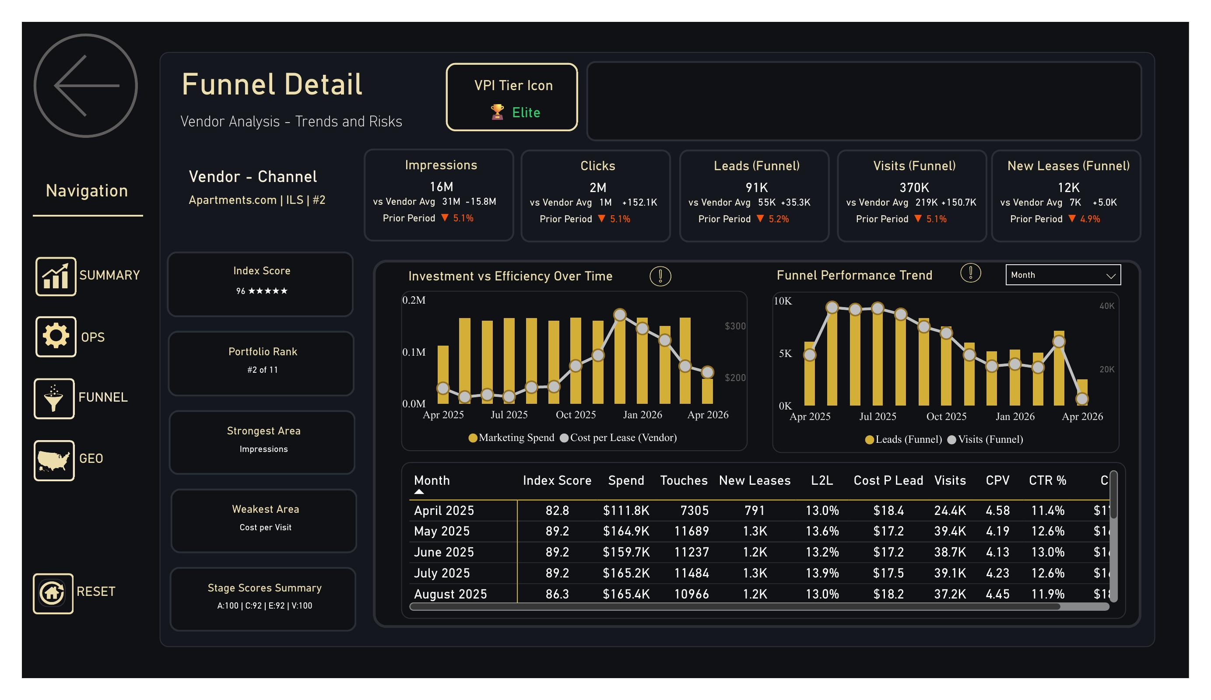
Purpose: Single-vendor deep dive. Reached via drill-through from page 3 (Marketing Funnel). Answers “Why is this specific vendor scoring what it scores, and where in the funnel is it strong or weak?”
Header: Vendor — Channel — rank format (Apartments.com | ILS | #2), with VPI Tier Icon ([Elite] in the screenshot).

6.1 Five-Stage KPI Strip with Vendor-Avg Benchmarks
Same five funnel stages as page 3, but each card now shows:
- Current value for this vendor
- vs Vendor Avg — vendor minus cross-vendor average
- Prior Period — vendor’s own period-over-period change
The Vendor Avg comparison is the analog of the Region Avg comparison on page 5 — same pattern, different dimension.

6.2 Index Score / Portfolio Rank Cards (left rail)
- Index Score — VPI score with star rating
- Portfolio Rank — #2 of 11 ranking format (VPI Portfolio Rank)
- Strongest Area — name of the strongest funnel stage component
- Weakest Area — name of the weakest funnel stage component
- Stage Scores Summary — compact A:## | C:## | E:## | V:## ribbon
The Stage Scores Summary is the single best diagnostic on this page. The screenshot shows A:100 | C:92 | E:92 | V:100 — Apartments.com is essentially perfect across all four stages. A vendor showing A:95 | C:88 | E:45 | V:30 would have a strong front-end but a fatal weakness at lead conversion.
DAX:
VPI Stage Scores Summary =
"A:" & FORMAT([Awareness_Score], "0") &
" | C:" & FORMAT([Consideration_Score], "0") &
" | E:" & FORMAT([Evaluation_Score], "0") &
" | V:" & FORMAT([Conversion_Score], "0")

6.3 Investment vs Efficiency Over Time (Combo Chart)
Purpose: 12-month combo — Marketing Spend bars + Cost-per-Lease line.
How to read it: Rising spend with falling CPL is the ideal pattern (you’re scaling efficiently). Rising spend with rising CPL means diminishing returns — the vendor is saturated. Falling spend with rising CPL means you’re losing scale efficiency.

6.4 Funnel Performance Trend (Combo Chart)
Purpose: 12-month combo — Leads (Funnel) and Visits (Funnel) over time.
How to read it: The two lines should trend roughly together. Divergence signals a conversion-rate change at the visit-to-lead step — worth investigating.

6.5 Trend Table
Purpose: Month-by-month — Index Score, Spend, Touches, New Leases, L2L, Cost per Lead, Visits, CPV, CTR %, etc.
How to read it: Use this to validate the headline VPI score against the underlying inputs. If the score moves but no individual metric changed dramatically, the cause is usually a percentile shift — the vendor’s competitors moved.

Page 7 — Geography Detail (Drill-Through)
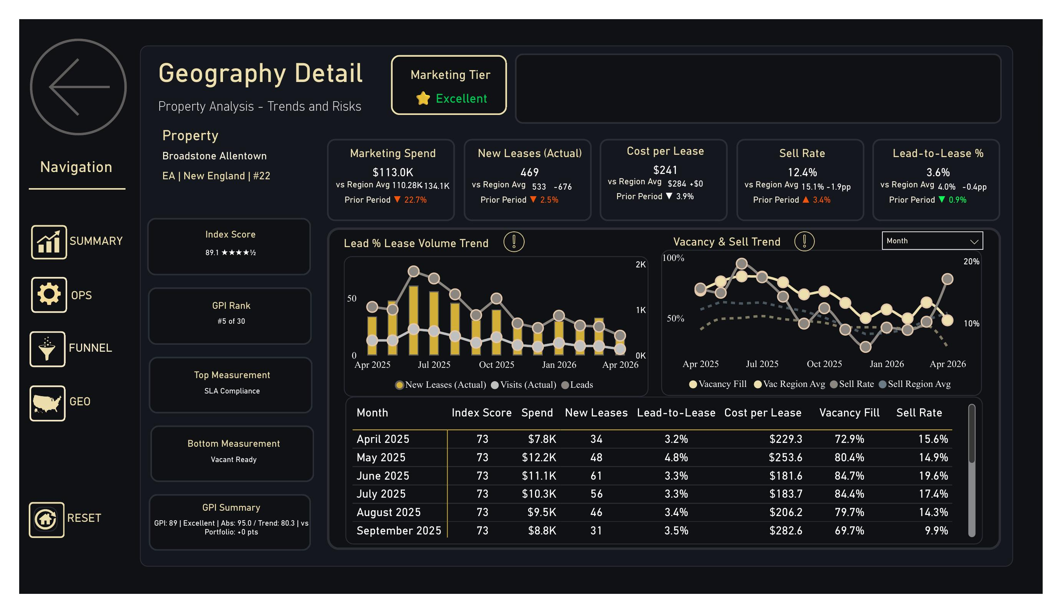
Purpose: Single-property GPI deep dive. Reached via drill-through from page 4 (Geography Page). Answers “Why is this specific property scoring what it scores on marketing, and how is it trending?”
Header: Property name (Broadstone Allentown), Region | Market | property number, with Marketing Tier badge ([Excellent]).

7.1 Five-KPI Strip with Region Benchmarks
Same pattern as page 5 (vs Region Avg + Prior Period), but with marketing-flavored KPIs:
Card | Measure
Marketing Spend | Marketing Spend
New Leases (Actual) | New Leases
Cost per Lease | Cost per Lease (Actual)
Sell Rate | Sell Rate
Lead-to-Lease % | Lead-to-Lease Conversion %

7.2 Index Score / GPI Rank Cards (left rail)
- Index Score — GPI score with star rating
- GPI Rank — #5 of 30 (rank within region)
- Top Measurement — name of the strongest GPI component
- Bottom Measurement — name of the weakest GPI component
- GPI Summary — formatted string e.g. GPI: 89 | Excellent | Abs: 95.0 / Trend: 80.3 | vs Portfolio: +0 pts
The GPI Summary string is the single most informative element on this page. It shows: headline score, tier, both pillar scores, and the gap to portfolio in one line.
DAX:
GPI Summary =
"GPI: " & FORMAT([GPI Score], "0") &
" | " & [GPI Tier] &
" | Abs: " & FORMAT([GPI Pillar 1 (Absolute)], "0.0") &
" / Trend: " & FORMAT([GPI Pillar 2 (Trend)], "0.0") &
" | vs Portfolio: " &
IF([GPI vs Portfolio] >= 0, "+", "") &
FORMAT([GPI vs Portfolio], "0") & " pts"
How to read it: If Abs and Trend are within 5 points of each other, the property is “Balanced” — score is reliable. If one pillar is much higher than the other (e.g., Abs 90 / Trend 40), the property is being held up by either current performance or recent improvement, not both.

7.3 Lead % Lease Volume Trend (Combo)
Purpose: 12-month combo — New Leases (Actual) bars, Visits (Actual) line, Leads line.
How to read it: Watch for the three lines to move together. Diverging lines indicate a conversion-rate shift somewhere in the funnel.

7.4 Vacancy & Sell Trend (Multi-Line)
Purpose: 12-month chart — Vacancy Fill (property) vs Vacancy Region Avg (dashed), Sell Rate (property) vs Sell Region Avg (dashed).
How to read it: Solid lines should sit above the dashed lines for the property to outperform its region. Where solid drops below dashed, the property is lagging.

7.5 Trend Table
Purpose: Month-by-month — Index Score, Spend, New Leases, L2L, Cost per Lease, Vacancy Fill, Sell Rate.

Cross-Cutting Behaviors

Date Slicer Interaction
The date slicer at the top of pages 2, 3, and 4 controls all visuals on that page. Two important behaviors:
- Score measures (VPI, GPI, Ops Index) apply the 30-day minimum window rule. Selecting “Last 7 Days” still scores against 30 days.
- Volume measures (Spend, Leases, Impressions) follow the slicer exactly. They reflect what’s selected.
This means a 7-day selection will show: real 7-day volumes, but 30-day-windowed scores. This is intentional and prevents misleading rankings on thin data.

Drill-Through Filter Carry
When you drill from a portfolio page into a detail page (e.g., Geography → Geography Detail), only the Property filter carries forward. Date Range, Region, Market are reset to “All”. You can re-apply them on the detail page if needed.

Period-over-Period Calculations
The “Prior Period” arrow on every KPI card uses an equal-length, immediately-preceding window. If the current period is “This Quarter” (Jan–Mar), the prior period is the prior quarter (Oct–Dec). If the current period is a custom 47-day range, the prior is the immediately-preceding 47 days.
Edge case: When the prior window resolves to a date before your data starts (e.g., comparing the first month of available data), the delta will be blank rather than misleadingly large.

Tie Handling in Ranks
Rank measures use competition ranking: tied scores receive the same rank, and the next score skips ranks accordingly. Two vendors tied at #3 = both show #3, next is #5 (not #4).
Some legacy rank measures use DENSE rank (no skipping); these are tagged _Fixed in the measure name. Where both exist, the non-Fixed version is the production measure.

Coverage Ratio (Operations Risk)
Coverage ratio = ScheduledMoveIns_Next60D ÷ LeaseExpirations_Next60D.
- ≥1.10 — Healthy, surplus pipeline
- 0.95–1.09 — OK, balanced
- <0.95 — Risk, expirations exceed scheduled move-ins
This drives the “Coverage Risk” callout on page 1, the “Within SLA” badge on page 5, and the “Pipeline Coverage” callout on page 2.

Known Limitations in v1.0
- Funnel vs Actual reconciliation: Some divergence between Funnel-stage measures (from fact_marketing_funnel_daily and fact_prospect_journey) and Actual measures (from fact_leasing_daily) is normal and reflects timing + multi-touch attribution differences. A reconciliation report is on the v1.1 roadmap.
- Region averages unweighted: Property-vs-region comparisons treat all properties equally regardless of unit count. A unit-weighted version is on the v1.1 roadmap.
- Channel rollup uses spend-weighted VPI: When viewing a Channel rather than a single Vendor, the displayed VPI is a spend-weighted average of vendor VPIs in that channel. This means a single high-spending vendor can dominate the channel score.
- 30-day window minimum applies to scores only: Volume KPIs follow the date slicer literally, which can confuse users selecting tight date ranges. A future version will surface a “Scoring Window: – ” subtitle when the minimum kicks in.
- No mobile layout in v1.0: Dashboard is built for desktop / tablet (1920×1080). Mobile view is planned for v1.2.

Glossary
Term | Definition
Attributed Lease | A new lease where the prospect’s journey can be traced to one or more vendor touches
Coverage Ratio | Scheduled move-ins ÷ lease expirations over the next 60 days
CPL | Cost per Lead = Marketing Spend ÷ Leads
Cost per Lease | Marketing Spend ÷ New Leases
Dense Rank | Ranking method where ties get the same rank and the next rank is consecutive (1, 2, 2, 3)
Competition Rank | Ranking method where ties get the same rank but next rank skips (1, 2, 2, 4)
Funnel Stage | One of: Awareness, Consideration, Evaluation, Conversion
GPI | Geographic Performance Index (0–100)
L2L | Lead-to-Lease conversion percentage
Pillar Balance | Whether a GPI score is led by Absolute pillar, Trend pillar, or Balanced (within 5 pts)
Ops Index | Property-level operational health score (0–100)
SLA | Service Level Agreement — operational threshold a property must meet
Sell Rate | New Leases ÷ Available Units
Vacancy Fill % (30D) | Percentage of vacant units filled in the trailing 30-day window
Vacant Ready % | Vacant units ready to lease ÷ total vacant units
VPI | Vendor Performance Index (0–100)

Support
For data discrepancies, raise a ticket in the Analytics queue with the page name, visual name, screenshot, and your filter selections. For DAX-level questions, see the full measure documentation in VPI_Documentation_v2.docx and the MAA_All_Measures_Current.tsv measure inventory in the project repository.

NorthStar Residential Group · Marketing Analytics · v1.0 · April 2026

