Executive MBA | IT Strategy Course

The Impact of Information Technology
on Professions in the Banking Sector
A Quantitative and Qualitative Analysis of Job Displacement and Job Creation
Group Assignment
Prepared by
Ahmed Awad | Tariq Salama | Ahmed Sabri
Course Instructor: Dr. Ghada
Submission Date: 03-06-2026

1. Introduction
Banking has long been one of the most information-intensive industries in the world, and for that reason it has also been one of the most deeply transformed by information technology (IT). From the first automated teller machines (ATMs) to today's mobile applications, artificial intelligence (AI), and robotic process automation (RPA), technology has continuously reshaped how banks operate and, with that, what banking professionals actually do.
This report answers a single guiding research question: How did IT impact professions in the banking sector? It examines both the quantitative impact, measured in jobs, branches, and transactions, and the qualitative impact, measured in the changing nature of banking work. It then identifies the roles that have declined or disappeared and the new roles that technology has created. Finally, it responds directly to the popular claim that technology simply destroys jobs.
The analysis draws on global data, with selected examples from Egypt, where a rapid wave of digital banking and financial inclusion offers a clear, recent illustration of the same forces at work.

2. The Quantitative Impact
The clearest quantitative signal of IT's impact is the steady decline of the bank teller role and the physical branch network that supports it. In the United States, teller employment has fallen by nearly 30 percent since 2010, and the US Bureau of Labor Statistics projects a further 13 percent decline between 2024 and 2034. The branch network that once required large teller workforces has contracted just as sharply, from roughly 100,000 branches in 2009 to about 77,500 at the start of 2024 and fewer than 65,000 by mid-2025, as Figure 1 shows.
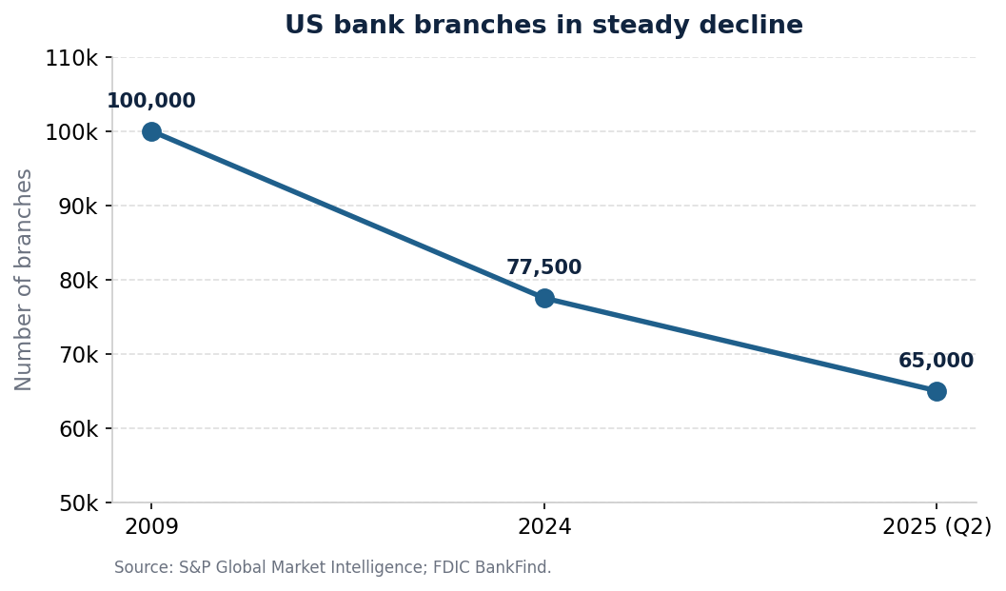
Figure 1. The long decline of the US physical branch network, a key driver of teller job losses.
Behind this decline is a simple substitution: routine transactions that once required a human teller are now handled by machines and software. AI chatbots and virtual agents already handle up to 65 percent of routine banking interactions globally. Yet the same technology that displaces routine roles also creates new ones. The World Economic Forum estimates that technology and broader economic change will create about 170 million jobs worldwide between 2025 and 2030 while displacing about 92 million, a net gain of roughly 78 million jobs, as Figure 2 illustrates.
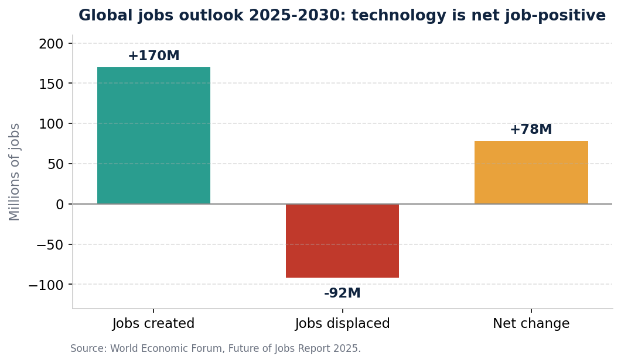
Figure 2. Globally, technology is projected to be net job-positive over 2025 to 2030.
The table below summarizes the headline quantitative indicators referenced throughout this report.
Indicator | Figure | Source
US bank teller employment since 2010 | Down nearly 30% | Burning Glass Institute
US teller employment, 2024 to 2034 (projected) | Down 13% | US Bureau of Labor Statistics
US bank branches, 2009 to 2025 | 100,000 to below 65,000 | S&P Global; FDIC
Routine transactions handled by AI or virtual agents | Up to 65% | CoinLaw
Global jobs, 2025 to 2030 (net of displacement) | +78 million | World Economic Forum
Worker skills transformed or outdated by 2030 | 39% | World Economic Forum

3. The Qualitative Impact
Numbers alone understate the change. Technology has not only reduced certain jobs, it has fundamentally altered the nature of banking work. The teller who once spent the day counting cash and processing deposits is increasingly expected to act as a universal banker: an advisor who sells products, resolves complex problems, and guides customers through digital channels. Routine processing has moved to machines, while uniquely human skills such as advice, judgment, relationship management, and trust have become the core of the front-line role.
This shift demands new skills from existing staff. The World Economic Forum estimates that 39 percent of workers' current skill sets will be transformed or become outdated between 2025 and 2030. Banking work is now data-driven, available around the clock, and centered on customer self-service, which means that even traditional roles increasingly require digital literacy, comfort with analytics, and an understanding of cybersecurity and compliance.

4. Roles That Declined or Disappeared
The professions most exposed to automation share a common feature: they are built on routine, rule-based, and repetitive tasks that software performs faster and at lower cost. The clearest examples include:
- Bank tellers and branch cashiers, displaced by ATMs, mobile apps, and self-service banking.
- Data-entry and cheque-processing clerks, replaced by digital capture, imaging, and straight-through processing.
- Back-office reconciliation and settlement clerks, automated through RPA and modern core banking systems.
- Manual bookkeepers and filing staff, made redundant by integrated digital records.
- Routine call-center agents, increasingly replaced by chatbots and virtual assistants for first-line queries.

5. Roles Created or in Growing Demand
At the same time, technology has created entire categories of work that did not exist, or barely existed, a generation ago. According to the World Economic Forum, fintech engineers, big-data specialists, and AI and machine-learning specialists are among the fastest-growing occupations of the decade. The banking sector is now a major employer of technology talent. The table below contrasts the roles in decline with those in demand.
Roles that declined or disappeared | Roles created or in growing demand
Bank tellers and branch cashiers | Data scientists and data engineers
Data-entry and cheque-processing clerks | AI and machine-learning specialists
Back-office reconciliation clerks | Fintech and mobile-application engineers
Manual bookkeepers and filing staff | Cybersecurity analysts and ethical hackers
Routine call-center agents (now chatbots) | Cloud engineers and DevOps specialists
Physical-branch support roles | RPA developers, regtech and AML-tech specialists

The pattern is consistent: demand is shifting away from manual transaction processing and toward roles that build, secure, analyze, and govern the technology that now runs the bank.

6. The Egypt Lens
Egypt offers a vivid, recent example of these global forces. A national push for digital banking and financial inclusion has rapidly expanded access to financial services while reshaping the sector's workforce. As Figure 3 shows, financial inclusion among adults rose from about 27 percent in 2016 to 74.8 percent by the end of 2024 and 76.3 percent by June 2025, driven almost entirely by digital channels rather than new branches.
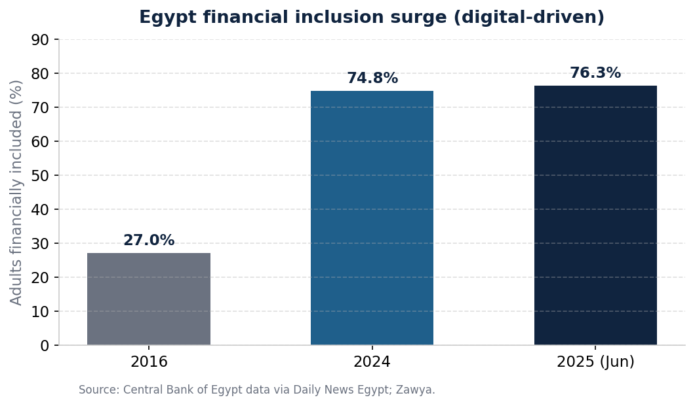
Figure 3. Egypt's digital-driven surge in financial inclusion, 2016 to 2025.
The supporting infrastructure is striking. By June 2025, the InstaPay instant-payment service had surpassed 16 million users and 1.1 billion transactions worth EGP 2.4 trillion, the national Meeza card had exceeded 43.5 million cards, and mobile wallets had reached 55.5 million. Leading banks such as the National Bank of Egypt have invested heavily in mobile apps, internet banking, and fintech subsidiaries. The result mirrors the global story: routine, branch-based roles are under pressure, while demand grows for software engineers, data analysts, cybersecurity professionals, and fintech specialists who build and run this digital ecosystem.

7. Responding to the Claim That Technology Destroys Jobs
A common claim holds that IT and automation simply destroy jobs. The evidence from banking tells a more nuanced and ultimately more hopeful story. The classic case is the ATM. When ATMs spread in the 1990s and 2000s, many predicted the end of the bank teller. Instead, by making each branch cheaper to operate, ATMs allowed banks to open more branches, and the total number of tellers initially held steady even as their work shifted toward sales and customer relationships (American Enterprise Institute, n.d.). Technology changed the job before it reduced the headcount.
The aggregate numbers reinforce this point. The roughly 92 million jobs that technology is expected to displace worldwide by 2030 are more than offset by the roughly 170 million it is expected to create, a net gain of about 78 million jobs. The honest conclusion is that technology transforms work far more than it destroys it. Routine roles decline, but new, often higher-value and better-paid roles emerge, provided that workers and institutions invest in reskilling.
The real risk, therefore, is not mass unemployment but a skills gap. The banks and the workers who thrive are those who treat technology as a tool that augments human capability, freeing people from repetitive tasks so they can focus on advice, innovation, and trust, the things customers still value most.

8. Conclusion
Information technology has reshaped the banking profession more profoundly than almost any other force in the industry's history. Quantitatively, it has reduced the number of tellers and branches and automated much of the back office. Qualitatively, it has redefined the remaining roles around advice, analytics, and digital service. It has retired some occupations entirely while creating high-demand new ones in data, AI, cybersecurity, and fintech. The Egyptian experience confirms that this is a global pattern now unfolding in emerging markets at remarkable speed. The clear lesson for banks, and for the professionals who work in them, is that technology does not end careers in banking. It changes them, and rewards those who are ready to learn.

References
American Enterprise Institute. (n.d.). What ATMs and bank tellers reveal about the rise of the robots and jobs. https://www.aei.org/economics/what-atms-bank-tellers-rise-robots-and-jobs/
Burning Glass Institute. (n.d.). The case of the vanishing teller: How banking's entry-level jobs are transforming. https://www.burningglassinstitute.org/bginsights/the-case-of-the-vanishing-teller-how-bankings-entry-level-jobs-are-transforming
CoinLaw. (2026). Bank branch closure statistics 2026: Global closures now. https://coinlaw.io/bank-branch-closure-statistics/
Daily News Egypt. (2025, November 17). CBE's digital transformation push lifts financial inclusion to 76.3% in June 2025. https://www.dailynewsegypt.com/2025/11/17/cbes-digital-transformation-push-lifts-financial-inclusion-to-76-3-in-june-2025/
Federal Deposit Insurance Corporation. (n.d.). BankFind suite: Bank structure changes. https://banks.data.fdic.gov/bankfind-suite/oscr/branch_office_closings
S&P Global Market Intelligence. (2025, May). Pace of US bank branch closures picks up in Q1 2025. https://www.spglobal.com/market-intelligence/en/news-insights/articles/2025/5/pace-of-us-bank-branch-closures-picks-up-in-q1-2025-88699893
U.S. Bureau of Labor Statistics. (n.d.). Tellers: Occupational outlook handbook. https://www.bls.gov/ooh/office-and-administrative-support/tellers.htm
World Economic Forum. (2025, January). The future of jobs report 2025. https://www.weforum.org/publications/the-future-of-jobs-report-2025/
Zawya. (2025). Central Bank of Egypt's digital transformation push lifts financial inclusion to 76.3% in June 2025. https://www.zawya.com/en/business/banking-and-insurance/central-bank-of-egypts-digital-transformation-push-lifts-financial-inclusion-to-763-in-june-2025-o9ytdkh8

