HARPY AEROSPACE

INTERNSHIP

AIOT Project: RECOMMENDATION SYSTEM

By

AMSAPRIYA K 2022506021

B.Tech Information Technology Madras Institute of Technology

Recommendation System 1: SVD (Singular Value Decomposition)

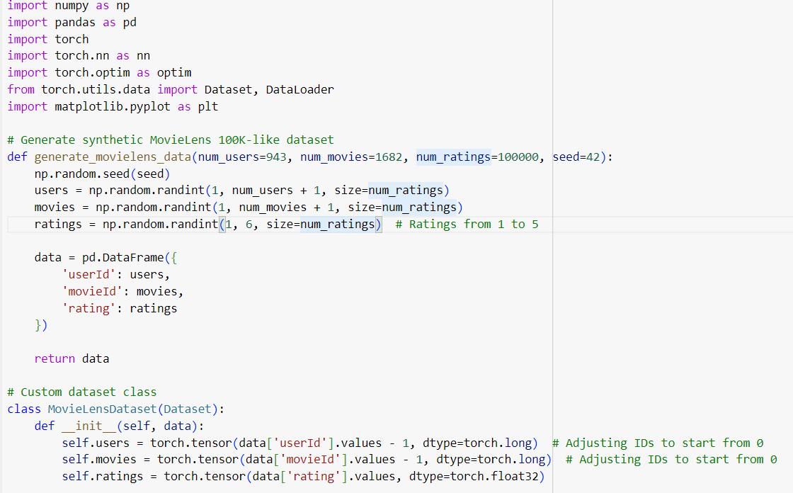

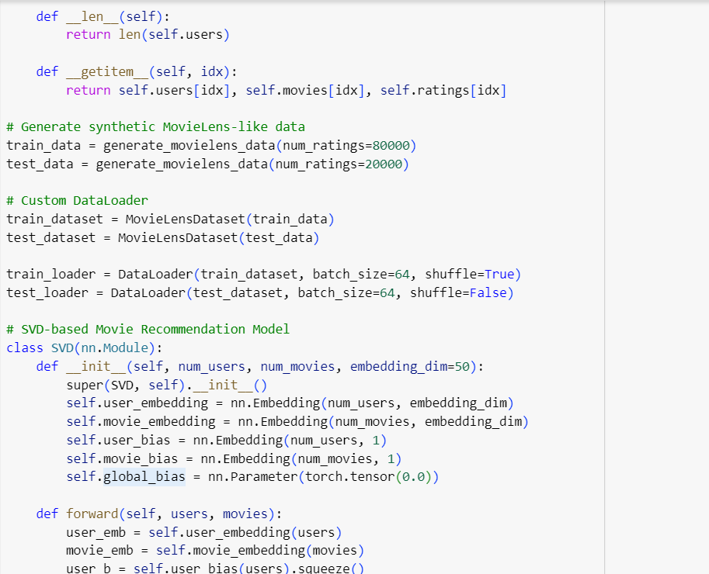

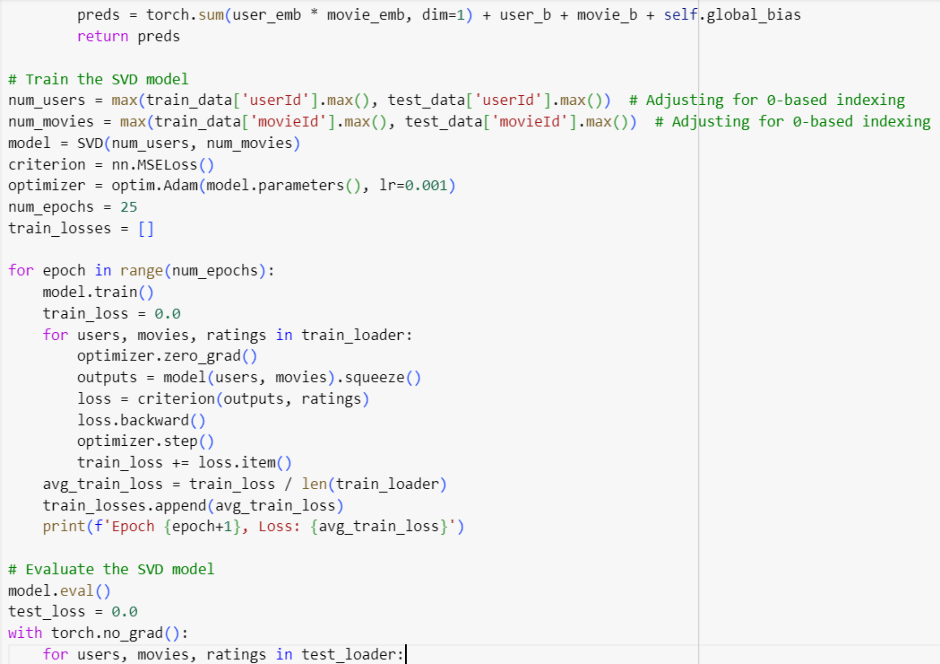

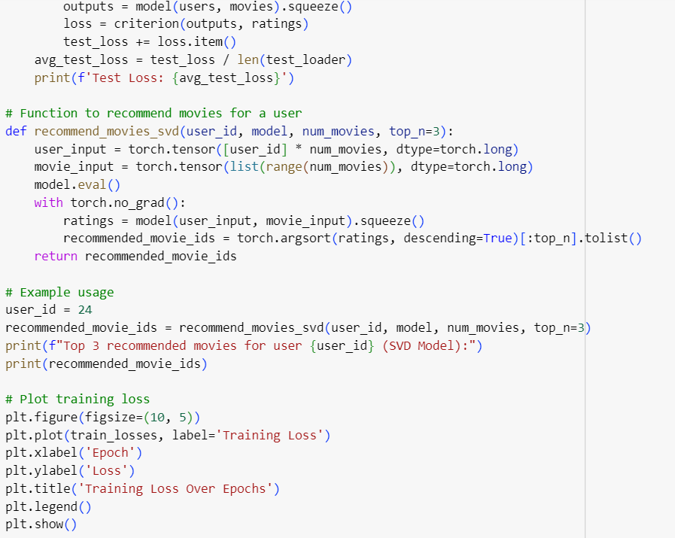

OUTPUT:

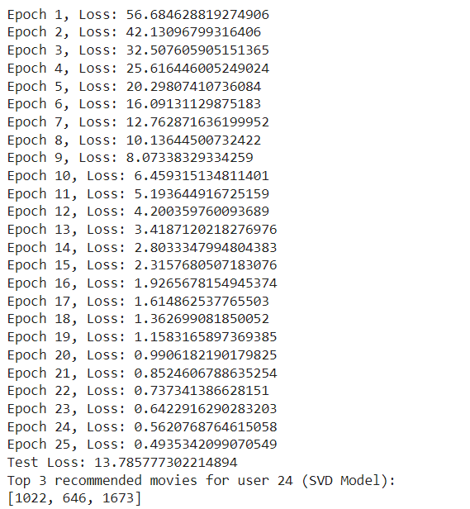

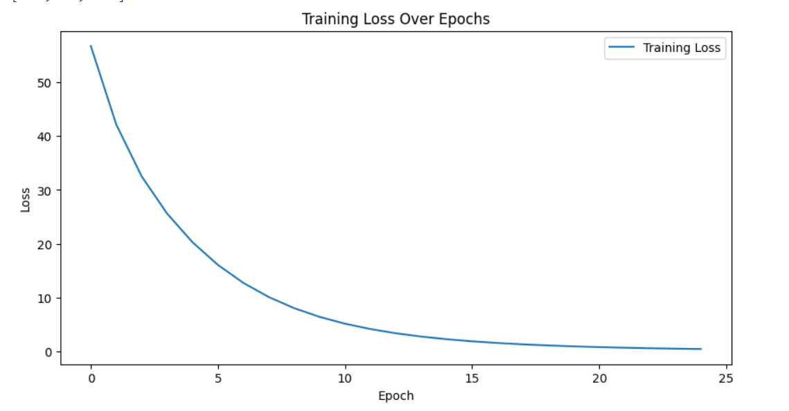

Recommendation System 2: Enhanced Movie Lens Model

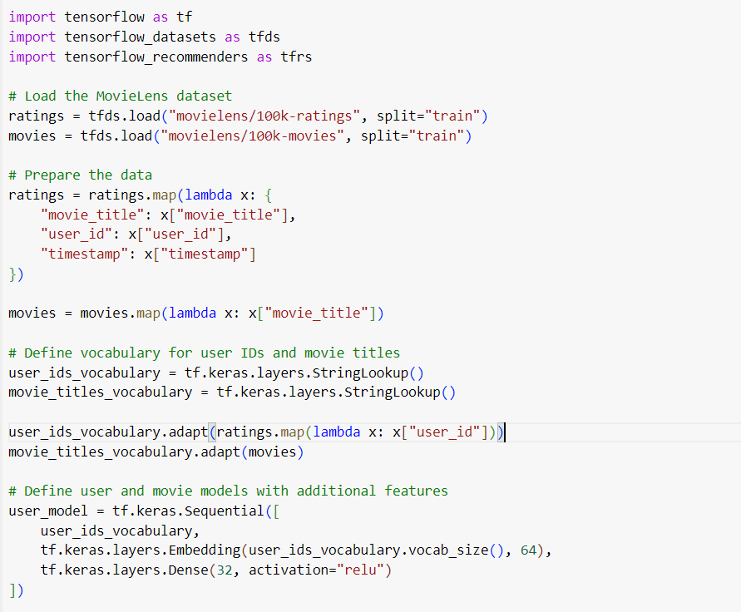

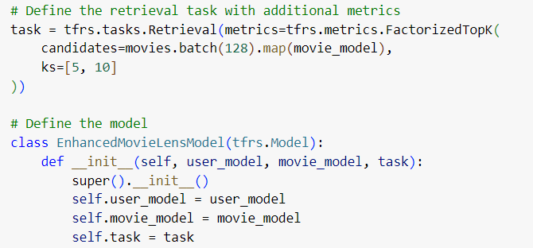

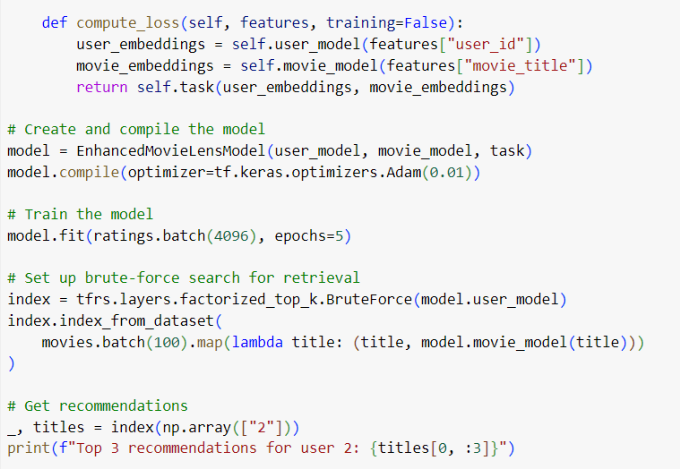

OUTPUT:

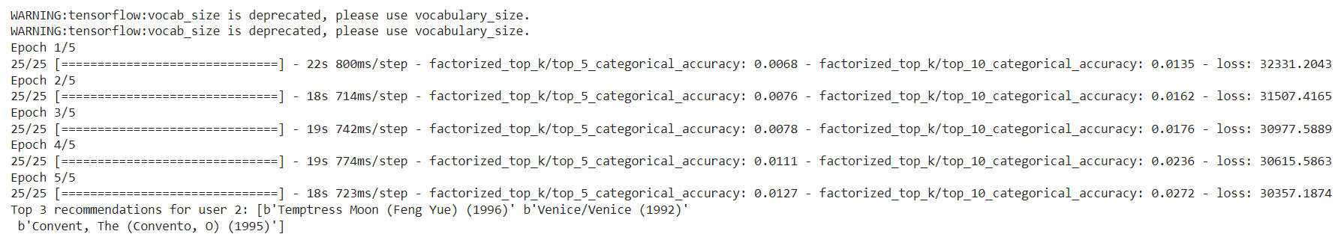

Recommendation System 3: Genre-based Movie Recommendation Model

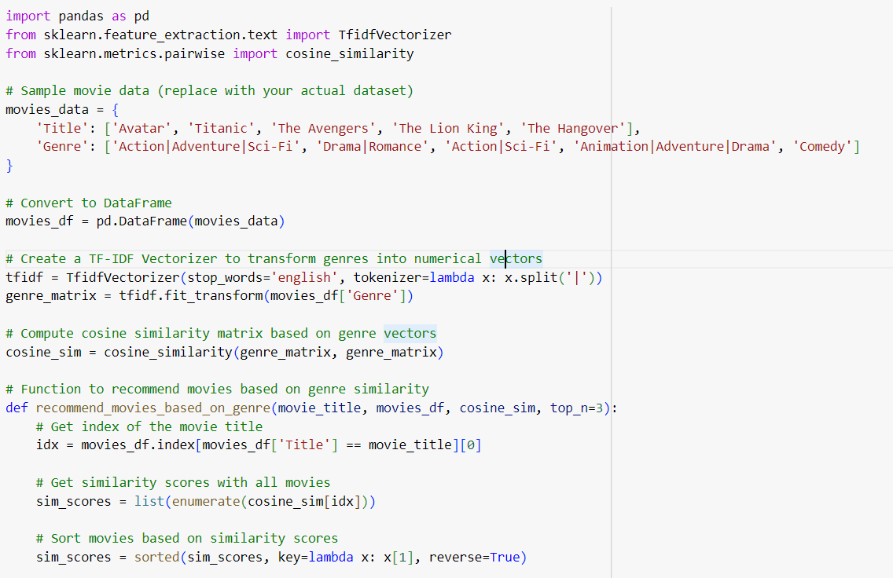

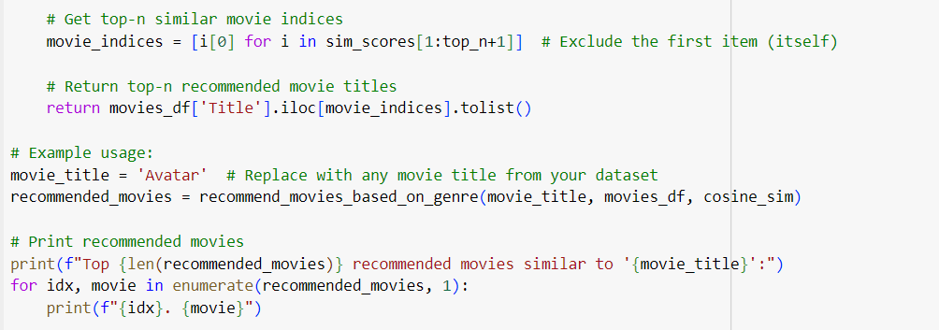

OUTPUT:

