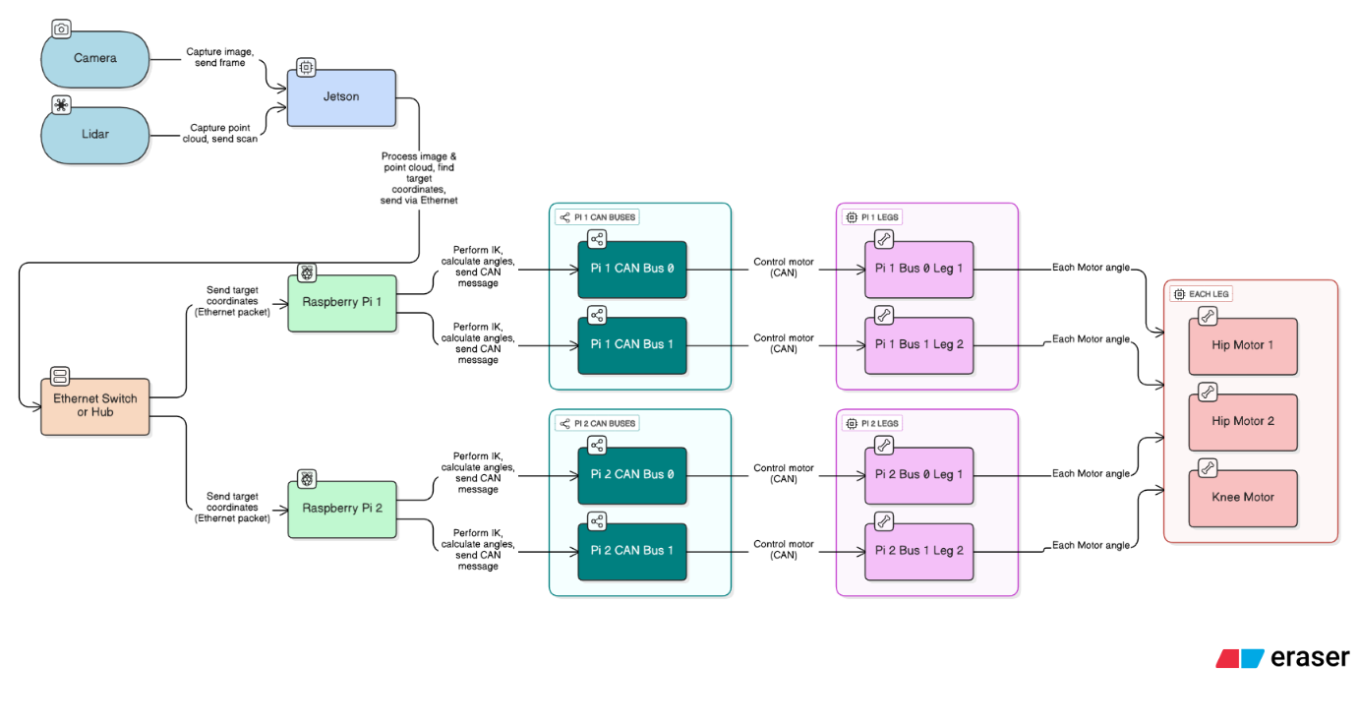
1. Sensors (Input Stage)
- Camera:
  - Captures images.
  - Sends image frames to the Jetson for processing.
- LiDAR:
  - Captures 2D point clouds (environment scan).
  - Sends scan data to the Jetson.

2. Jetson (Processing Unit)
- Receives data from Camera and LiDAR.
- Processes the image and point cloud to identify the target coordinates.
- Sends the target coordinates as an Ethernet packet to Raspberry Pi 1 and Raspberry Pi 2 via the Ethernet Switch.

3. Ethernet Communication
- Ethernet Switch / Hub distributes the Ethernet packets (containing target coordinates).
- Both Raspberry Pi 1 and Raspberry Pi 2 receive the same target coordinates simultaneously.

4. Raspberry Pis (Local Control Units)
- Raspberry Pi 1:
  - Receives target coordinates.
  - Performs Inverse Kinematics (IK) to calculate required joint angles.
  - Sends CAN bus messages to motors of Leg 1 and Leg 2.
- Raspberry Pi 2:
  - Receives target coordinates.
  - Performs Inverse Kinematics (IK) to calculate required joint angles.
  - Sends CAN bus messages to motors of Leg 3 and Leg 4.

5. CAN Buses (Motor Communication Layer)
- Each Raspberry Pi has two CAN buses:
  - Pi 1 CAN Bus 0 → controls motors for Leg 1.
  - Pi 1 CAN Bus 1 → controls motors for Leg 2.
  - Pi 2 CAN Bus 0 → controls motors for Leg 3.
  - Pi 2 CAN Bus 1 → controls motors for Leg 4.
- Each CAN bus sends motor control commands (angles, torque) to the respective motors.

6. Leg Modules (Actuators)
- Each leg receives motor angle commands from the CAN bus.
- Each Leg contains:
  - Hip Motor 1
  - Hip Motor 2
  - Knee Motor
- These motors execute the calculated angles to move the leg accordingly.

Workflow Summary:
- Camera + LiDAR → provide environment data.
- Jetson → processes data, finds target coordinates.
- Ethernet → distributes target info to Raspberry Pis.
- Raspberry Pis → perform IK, compute motor angles.
- CAN Buses → transmit commands to motors.
- Legs → execute movement with Hip + Knee motors.

