* 3 different user groups created and share screen shot for all 3 groups with permissions.

Connection EC2 :

Ping Ip

Create Nginx

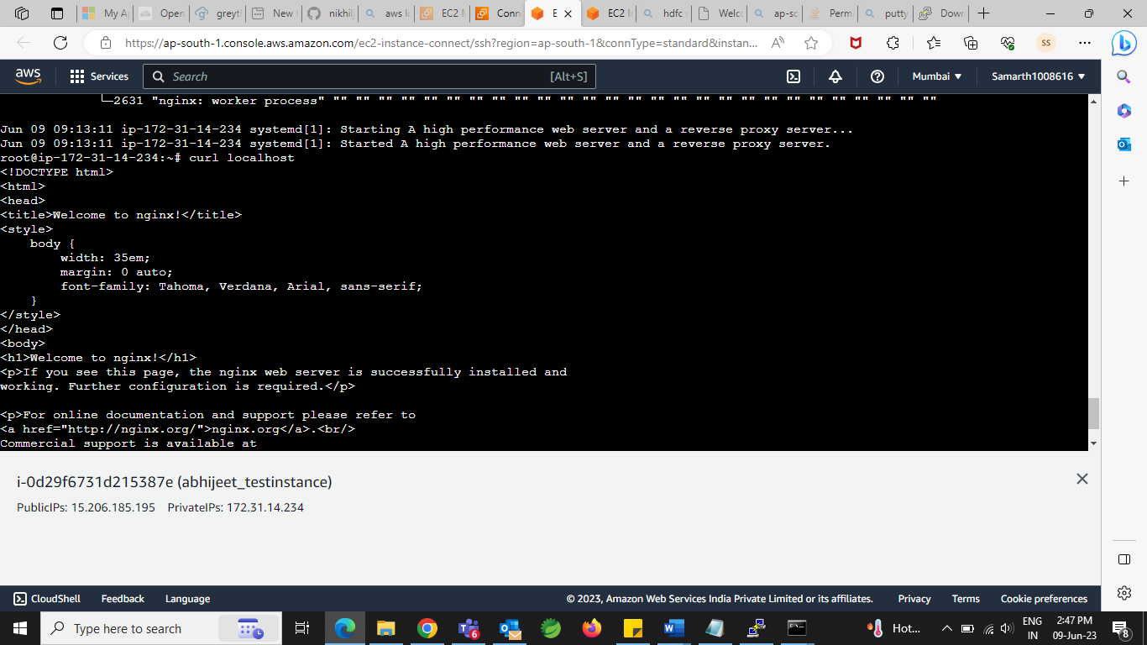

S3 bucket File Upload:

Create S3 Bucket :

