| Name :Ross Paolo Villavicencio | Section : BSIT 3A |
| --- | --- |
| Assignment No : 3 | Submission Date : Mar. 16, 2024 |
| Assignment Title: Guessing Number Game | |

**Code :**

<!DOCTYPE html>

<html lang="en">

<head>

<meta charset="UTF-8">

<meta name="viewport" content="width=device-width, initial-scale=1.0">

<title>Calculator</title>

<link rel="stylesheet" href="styles.css">

</head>

<body>

<div class="calculator">

<input type="text" id="display" readonly>

<div class="buttons">

<div class="row">

<button class="operator" onclick="Button('+')">+</button>

<button class="number" onclick="Button('1')">1</button>

<button class="number" onclick="Button('2')">2</button>

<button class="number" onclick="Button('3')">3</button>

</div>

<div class="row">

<button class="operator" onclick="Button('-')">-</button>

<button class="number" onclick="Button('4')">4</button>

<button class="number" onclick="Button('5')">5</button>

<button class="number" onclick="Button('6')">6</button>

</div>

<div class="row">

<button class="operator" onclick="Button('*')">*</button>

<button class="number" onclick="Button('7')">7</button>

<button class="number" onclick="Button('8')">8</button>

<button class="number" onclick="Button('9')">9</button>

</div>

<div class="row">

<button class="operator" onclick="Button('/')">/</button>

<button class="number" onclick="Button('0')">0</button>

<button class="number" onclick="Button('.')">.</button>

<button class="number" onclick="calculate()">=</button>

</div>

<div class="row">

<button class="operator" onclick="clearEntry()">CE</button>

<button class="number" onclick="backspace()">←</button>

</div>

</div>

</div>

<script src="script.js"></script>

<script>

document.addEventListener('DOMContentLoaded', function() {

document.getElementById('display').value = '0'; // display with '0'

});

</script>

</body>

</html>

**JS FILE**

let currentInput = '';

let ans = '';

function Button (value) {

if (ans && currentInput === ans) {

updateDisplay(ans + value);

return;

}

if (value === '=') {

if (currentInput !== '') {

calculate();

}

return;

}

updateDisplay(currentInput + value);

}

function updateDisplay(value) {

if (value === '') {

document.getElementById('display').value = '0';

} else {

document.getElementById('display').value = value;

}

currentInput = value;

}

function clearEntry() {

updateDisplay('');

}

function backspace() {

updateDisplay(currentInput.slice(0, -1));

}

function calculate() {

var displayValue = document.getElementById('display').value;

displayValue = displayValue.replace('ans', ans);

if (!isValidInput(displayValue)) {

clearEntry();

alert('Invalid input');

return;

}

try {

var result = eval(displayValue);

if (!isFinite(result)) {

throw new Error('Invalid expression');

}

updateDisplay(result);

ans = result;

} catch (error) {

clearEntry();

alert('Error: ' + error.message);

}

}

function isValidInput(input) {

if (/[\+\-\*\/]{2,}/.test(input)) {

return false;

}

if (/[0-9]+\.[0-9]+\./.test(input)) {

return false;

}

if (/^[\+\-\*\/]/.test(input)) {

return false;

}

return true;

}

**CSS FILE**

body{

margin: 0;

display: flex;

justify-items: left;

align-items: center;

height: 100vh;

background-color: hsl(0, 0%, 95%);

}

.calculator {

width: 200px;

margin: 100px auto;

text-align: center;

background-color: #1C1C1C;

color: #D4D4D2;

border-radius: 3%;

}

#display {

width: 93%;

margin-bottom: 10px;

padding: 5px;

font-size: 20px;

background-color: black;

color: white;

border: none;

outline: none;

}

.buttons {

display: flex;

flex-direction: column;

}

.row {

display: flex;

justify-content: space-between;

}

.buttons button {

width: calc(25% - 10px);

height: 40px;

margin: 5px;

font-size: 18px;

border-radius: 50%;

border: none;

outline: none;

}

.operator {

background-color: #FF9500;

}

.number {

background-color: #D4D4D2;

}

**SCREENSHOT**

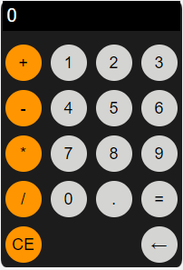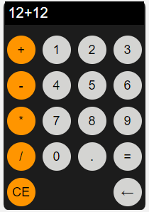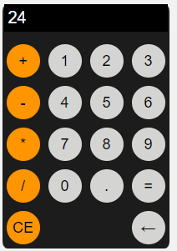

**Dictionary:**

*// List keywords, tags, or methods that are new to you and explain how they are used in the code.*

*// atleast 5 tag, methods or keyword  
  
Example :*

* **eval** - method evaluates the expression or computes the computation.

*Ex. ( insert the example : syntax / code / process )*

**Syntax** : eval(string)

**Parameter** : string (hold an expression, variable, statement, or sequence of statements.

console.log(eval(123+1+5))

Output : 129