Clare Hall Secondary School · Mathematics Department

FORM 3 MATHEMATICS · UNIT 1
Sets & Set Notation
Self-Paced Learning Pack
Name: ______________________________________ Class: ___________
Time in class: 2 weeks School year: 2026–2027 Next topic: Algebra – Introduction

What's inside
Section | What you will do
Before You Start | Warm up with the number facts you need
Lesson 1 | What Is a Set?
Lesson 2 | Comparing Sets: Equal, Equivalent, Empty and Subsets
Lesson 3 | Universal Set, Complement, Union, Intersection and Venn Diagrams
Lesson 4 | Venn Diagrams with Three Sets
Lesson 5 | Solving Problems with Venn Diagrams
Exam Practice | CSEC-style questions that use all five lessons
Self-Check Quiz | 12 questions that show whether you are ready to move on
Answers | Check your work (at the back of the pack)

How to Use This Pack
- This pack lets you learn at your own pace. You can work ahead of the class or go back over anything you missed.
- Work through the lessons in order. Each lesson builds on the one before it.
- For each lesson: Read the key ideas → Watch the videos → Study the worked examples → Practise.
- Before you read the solution to a worked example, cover it and try the example yourself first. Then check each step.
- Practice has three levels. Level 1 (Foundation) checks the basics. Level 2 (Developing) makes you apply them. Level 3 (Think Deeper) asks you to explain, find mistakes and create your own examples.
- Check your answers at the back of the pack. If you get an answer wrong, find your mistake before you move on. A mistake you understand teaches you more than a correct guess.
- When you finish all five lessons, try the CSEC-Style Exam Practice, then the Self-Check Quiz. Your quiz score tells you whether you are ready for the next topic.

The learning route for every lesson
① Read the key ideas → ② Watch the videos → ③ Try the worked examples, then check each step → ④ Practise Level 1 → 2 → 3 → ⑤ Check your answers → ⑥ Tick your checklist

My Progress Checklist
Tick one box for each statement before you start and again after you finish. Be honest. This checklist is for you.
I can… | Not yet | Getting there | Got it!
Tell the difference between finite and infinite sets (Lesson 1) | ☐ | ☐ | ☐
Use correct notation to list finite and infinite sets (Lesson 1) | ☐ | ☐ | ☐
Identify equal sets (Lesson 2) | ☐ | ☐ | ☐
Identify and give examples of equivalent sets (Lesson 2) | ☐ | ☐ | ☐
Explain why the empty set is a subset of every set (Lesson 2) | ☐ | ☐ | ☐
Identify and list the subsets of a given set (Lesson 2) | ☐ | ☐ | ☐
Read and use set notation: element, union, intersection, empty set, complement, subset, universal set (Lessons 1–3) | ☐ | ☐ | ☐
Use a Venn diagram to list the elements of a set and to show one set as a subset of another (Lesson 3) | ☐ | ☐ | ☐
Draw Venn diagrams with three sets (Lesson 4) | ☐ | ☐ | ☐
Describe how sets are related using notation, and solve problems with Venn diagrams (Lessons 3–5) | ☐ | ☐ | ☐

Symbols You Will Use
Symbol | Meaning | Example
{ } | braces – the elements of a set go inside | A = {2, 4, 6}
∈ | is an element of | 4 ∈ A
∉ | is not an element of | 5 ∉ A
n(A) | number of elements in set A | n(A) = 3
U | universal set (some books write ℰ or ξ) | U = {1, 2, …, 10}
∅ or { } | the empty (null) set | {months with 32 days} = ∅
⊂ | is a subset of | {2, 4} ⊂ A
⊄ | is not a subset of | {1, 2} ⊄ A
∪ | union (in A or B or both) | A ∪ B
∩ | intersection (in both A and B) | A ∩ B
A′ | complement of A (in U but not in A) | A′
… | ellipsis – the pattern continues | {1, 3, 5, …}

Before You Start: Warm-Up
Sets use the number words you already know. Do these questions to check you remember them. If any of them are hard, ask your teacher or look them up before you start Lesson 1.
1. List the even numbers between 1 and 11.
2. List all the factors of 12.
3. List the prime numbers less than 20.
4. Write down the first five multiples of 4.
5. Which of these are integers? −3, 0.5, 7, 0, ⅔
6. Is 1 a prime number? Explain your answer.

Lesson 1: What Is a Set?
Building on: Number facts: factors, multiples, primes, odd and even numbers (the warm-up).
Goal: By the end of this lesson I can describe and list a set, use ∈ and ∉, find n(A), and say whether a set is finite or infinite.

① Key Ideas
- A set is a well-defined collection of objects. Well-defined means we can always decide whether an object belongs to the set or not. {tall students} is not well-defined, because people will disagree about who is tall. {students taller than 160 cm} is well-defined.
- The objects in a set are called its elements (or members). We name sets with capital letters and write the elements inside braces { }, separated by commas.
- ∈ means "is an element of" and ∉ means "is not an element of". If A = {2, 4, 6}, then 4 ∈ A and 5 ∉ A.
- There are three ways to describe a set. In words: A = {even numbers less than 8}. By listing: A = {2, 4, 6}. In set-builder notation: A = {x : x is an even number, x < 8}. The colon ":" is read as "such that".
- Order does not matter, and each element is listed only once: {a, b, c} = {c, a, b}. The letters of the word BANANA form the set {B, A, N}.
- n(A) means the number of elements in A. If A = {2, 4, 6}, then n(A) = 3.
- A finite set has a number of elements that we can count, and the counting ends. An infinite set goes on forever. We use an ellipsis (…) to show that a pattern continues: {2, 4, 6, 8, …} is infinite. {1, 2, 3, …, 100} is finite, because the list stops at 100.

② Watch
Watch these videos after you have read the key ideas. Pause the video and try each example before it is solved. Online, click the link. On paper, type the short address into YouTube.
Video | What it covers | Link
Introduction to Sets and Set Notation  Mathispower4u | Elements, listing and set-builder notation | Watch on YouTube  youtu.be/82vEUReURYw
Finite and Infinite Sets  Knowledge Platform | Finite vs infinite sets | Watch on YouTube  youtu.be/qupC613eivM

③ Worked Examples
Cover the solution and try the example first. Then uncover one step at a time and compare it with your own working.
Example 1.1 · Listing a set
List the elements of A = {days of the week beginning with T}. Find n(A).
Solution
1. Go through the days one at a time: Monday, Tuesday, Wednesday, Thursday, Friday, Saturday, Sunday.
2. Keep only the days that start with T: Tuesday and Thursday.
Answer: A = {Tuesday, Thursday}, so n(A) = 2.

Example 1.2 · Repeated elements
List the set of letters in the word ANTIGUA and find its number of elements.
Solution
1. The letters in order are A, N, T, I, G, U, A.
2. The letter A appears twice, but a set lists each element only once.
Answer: {A, N, T, I, G, U}, so n = 6 (not 7).
💭 Think: Why do you think a set does not count repeats? What question does a set answer: "how many times?" or "which ones?"

Example 1.3 · Describing a set in words
Describe B = {2, 3, 5, 7} in words.
Solution
1. Look for what the elements have in common. 2, 3, 5 and 7 each have exactly two factors, so they are all prime.
2. Check for any primes that are missing: 2, 3, 5 and 7 are all the primes less than 10.
Answer: B = {prime numbers less than 10}
💭 Think: {prime numbers less than 11} is also correct. Can one set have more than one correct description in words?

Example 1.4 · Using ∈ and ∉
P = {factors of 18}. Say whether each statement is true or false: (a) 6 ∈ P (b) 4 ∈ P (c) 18 ∉ P
Solution
1. First list P: 18 = 1 × 18 = 2 × 9 = 3 × 6, so P = {1, 2, 3, 6, 9, 18}.
2. (a) 6 is in the list, so the statement is true.
3. (b) 4 is not in the list, so the statement is false.
4. (c) 18 is in the list, so "18 is not an element" is false.
Answer: (a) True (b) False (c) False

Example 1.5 · Finite or infinite?
State whether each set is finite or infinite: (a) {multiples of 5} (b) {grains of sand on Dickenson Bay beach} (c) {1, 2, 3, …, 500} (d) {fractions between 0 and 1}
Solution
1. (a) 5, 10, 15, 20, … never ends, so the set is infinite.
2. (b) There are a huge number of grains, but the number is not endless. In theory they could be counted, so the set is finite.
3. (c) The ellipsis is followed by a last element (500), so the set is finite.
4. (d) Between any two fractions there is always another one (for example, halfway between them), so the set is infinite.
Answer: (a) infinite (b) finite (c) finite (d) infinite
💭 Think: Part (b) shows that "very large" is not the same as "infinite".

Example 1.6 · Set-builder notation
List the elements of C = {x : x is an integer, −2 ≤ x < 3}.
Solution
1. Read it as: "C is the set of all x such that x is an integer and x is between −2 and 3".
2. −2 ≤ x means −2 IS included. x < 3 means 3 is NOT included.
3. The integers from −2 up to (but not including) 3 are −2, −1, 0, 1, 2.
Answer: C = {−2, −1, 0, 1, 2} and n(C) = 5

⚠ Common mistakes
- Listing an element more than once, e.g. {C, O, C, O, N, U, T}.
- Thinking that a very large set must be infinite.
- Forgetting to check whether the ends of an inequality are included (≤) or not included (<).

④ Practice
Write your answers in your exercise book. Start at Level 1. If you get most of a level right, move on to the next one. The answers are at the back of the pack.

Level 1 · Foundation
1. List the elements of each set.
(a) {vowels in the English alphabet}
(b) {odd numbers between 10 and 20}
(c) {months of the year that have exactly 30 days}
2. C = {3, 6, 9, 12, 15}. Write true or false for each statement.
(a) 9 ∈ C
(b) 10 ∈ C
(c) 15 ∉ C
(d) n(C) = 5
3. State whether each set is finite or infinite.
(a) {even numbers}
(b) {students in your class}
(c) {whole numbers less than 1 000 000}
(d) {points on a straight line}

Level 2 · Developing
4. List the set of letters in the word MISSISSIPPI and find its number of elements.
5. Describe each set in words.
(a) {1, 4, 9, 16, 25}
(b) {Antigua, Barbuda, Redonda}
(c) {5, 10, 15, 20, …}
6. List the elements of each set.
(a) {x : x is a factor of 24}
(b) {x : x is an integer, −3 < x ≤ 2}
(c) {x : x is a prime number, 20 < x < 40}
7. Use an ellipsis (…) to write each set. Then state whether it is finite or infinite.
(a) {multiples of 3}
(b) {whole numbers from 1 to 50}

Level 3 · Think Deeper
8. Think about it. Which of these collections are sets (well-defined)? Explain each answer.
(a) {the best cricketers in the West Indies}
(b) {students in Form 3 who are 14 years old}
(c) {delicious fruits}
(d) {parishes of Antigua}
9. Spot the error. Keisha wrote the set of letters in the word COCONUT as {C, O, C, O, N, U, T} and said n = 7. Explain her mistake and correct it.
10. Always, sometimes or never? "A set written with an ellipsis (…) is infinite." Give an example to support your answer.
11. Create. Write a set A with n(A) = 4 whose elements are all even numbers AND all factors of 40. What is the largest possible value of n(A)? Explain.

Before you move on, say or write in one or two sentences: "I can explain the difference between {1, 2, 3, …} and {1, 2, 3, …, 10}."
How confident do I feel? ☐ Not yet ☐ Getting there ☐ Got it!

Lesson 2: Comparing Sets: Equal, Equivalent, Empty and Subsets
Building on: Lesson 1: listing sets and finding n(A).
Goal: By the end of this lesson I can decide whether two sets are equal or equivalent, recognise the empty set, and list all the subsets of a set.

① Key Ideas
- Equal sets have exactly the same elements (order does not matter). {1, 2, 3} = {3, 1, 2}.
- Equivalent sets have the same number of elements: n(A) = n(B). {a, b, c} and {1, 2, 3} are equivalent but not equal. Every pair of equal sets is also equivalent, but equivalent sets are not always equal.
- The empty set (or null set) has no elements. We write it as ∅ or { }. For example, {months with 32 days} = ∅. Note that {0} is not empty. It has one element, the number 0.
- A is a subset of B, written A ⊂ B, if every element of A is also an element of B. {2, 4} ⊂ {1, 2, 3, 4}. If A is not a subset of B, we write A ⊄ B.
- Every set is a subset of itself, and the empty set is a subset of every set. Why? To show A ⊄ B, you must find an element of A that is not in B. The empty set has no elements, so you can never find one. The rule is never broken.
- A set with n elements has 2ⁿ subsets. Each element can either be in a subset or not, so there are 2 choices for each element. A proper subset is any subset except the set itself, so there are 2ⁿ − 1 proper subsets.
- Be careful with ∈ and ⊂. If A = {2, 4, 6}, then 2 ∈ A (2 is an element), but {2} ⊂ A ({2} is a set).

② Watch
Watch these videos after you have read the key ideas. Pause the video and try each example before it is solved. Online, click the link. On paper, type the short address into YouTube.
Video | What it covers | Link
Set theory lesson 2 – subset, empty set, finite/infinite set, equal/equivalent set, cardinality  Magic Monk | Equal, equivalent and empty sets, and subsets | Watch on YouTube  youtu.be/EVxj74MRyis

③ Worked Examples
Cover the solution and try the example first. Then uncover one step at a time and compare it with your own working.
Example 2.1 · Equal or equivalent?
A = {1, 2, 3}, B = {3, 1, 2}, C = {x, y, z}. Compare the sets.
Solution
1. A and B have exactly the same elements in a different order, so A = B.
2. A and C each have 3 elements, but the elements are different. So A and C are equivalent but not equal.
Answer: A = B. A and C are equivalent (n(A) = n(C) = 3).

Example 2.2 · Recognising the empty set
Which of these sets are empty? (a) {even prime numbers greater than 2} (b) {0} (c) {months with 32 days} (d) {x : x is an integer, 3 < x < 4}
Solution
1. (a) The only even prime is 2, so there are none greater than 2. The set is empty.
2. (b) This set contains the number 0. It has 1 element, so it is not empty.
3. (c) No month has 32 days, so the set is empty.
4. (d) There is no integer between 3 and 4, so the set is empty.
Answer: (a), (c) and (d) are empty. (b) is not.

Example 2.3 · Listing subsets systematically
List all the subsets of S = {a, b, c}.
Solution
1. Work by size so that you do not miss any.
2. 0 elements: ∅
3. 1 element: {a}, {b}, {c}
4. 2 elements: {a, b}, {a, c}, {b, c}
5. 3 elements: {a, b, c}
Answer: There are 8 subsets. 8 = 2³, which matches the rule 2ⁿ.
💭 Think: Look at the pattern: a set with 0 elements has 1 subset, 1 element gives 2, 2 elements give 4, and 3 elements give 8. Why does the number double each time you add an element?

Example 2.4 · Subsets and elements
A = {2, 4, 6, 8}, B = {even numbers less than 10}, C = {4, 8}. True or false? (a) C ⊂ A (b) A = B (c) {2} ∈ A
Solution
1. (a) 4 and 8 are both in A, so C ⊂ A is True.
2. (b) B = {2, 4, 6, 8}, which has the same elements as A. True.
3. (c) The elements of A are numbers, not sets. The number 2 is an element, so 2 ∈ A. But {2} is a set, so the correct statement is {2} ⊂ A. The statement is False.
Answer: (a) True (b) True (c) False

Example 2.5 · Counting subsets
How many subsets and how many proper subsets does a set with 5 elements have?
Solution
1. The number of subsets is 2⁵ = 2 × 2 × 2 × 2 × 2 = 32.
2. The proper subsets are all of these except the set itself: 32 − 1 = 31.
Answer: 32 subsets, 31 proper subsets

⚠ Common mistakes
- Thinking {0} is the empty set.
- Forgetting ∅ and the set itself when listing subsets.
- Mixing up ∈ (for an element) and ⊂ (for a set).

④ Practice
Write your answers in your exercise book. Start at Level 1. If you get most of a level right, move on to the next one. The answers are at the back of the pack.

Level 1 · Foundation
1. Are the sets in each pair equal, equivalent (but not equal), or neither?
(a) {1, 3, 5} and {5, 1, 3}
(b) {a, b, c, d} and {1, 2, 3, 4}
(c) {2, 4} and {2, 4, 6}
(d) {letters in STOP} and {letters in POTS}
2. Which of these sets are empty?
(a) {odd numbers that are divisible by 2}
(b) {0}
(c) {months beginning with Q}
(d) {whole numbers less than 1}
3. List all the subsets of {x, y}.

Level 2 · Developing
4. A = {1, 2, 3, 4, 5, 6}, B = {2, 4, 6}, C = {1, 4, 9}, D = {6, 4, 2}. True or false?
(a) B ⊂ A
(b) C ⊂ A
(c) B = D
(d) B and C are equivalent
(e) ∅ ⊂ C
5. List all 8 subsets of {1, 2, 3}.
6. Find the number of subsets of a set with (a) 4 elements (b) 6 elements. (c) How many proper subsets does a set with 4 elements have?
7. A set has 32 subsets. How many elements does it have? Explain.

Level 3 · Think Deeper
8. Spot the error. Marcus says: "{0} is the empty set because 0 means nothing." Explain why Marcus is wrong.
9. Always, sometimes or never? Explain each answer.
(a) If A = B, then A and B are equivalent.
(b) If A and B are equivalent, then A = B.
(c) ∅ is a subset of every set.
(d) A set with 3 elements has exactly 6 subsets.
10. Explain. Why does the number of subsets double each time you add one element to a set? Use {a, b} and {a, b, c} in your explanation.
11. Challenge. T = {p, q, r, s}. (a) How many subsets of T contain the element p? (b) How many subsets of T have exactly 2 elements?

Before you move on, say or write in one or two sentences: "I can explain why ∅ ⊂ A for every set A."
How confident do I feel? ☐ Not yet ☐ Getting there ☐ Got it!

Lesson 3: Universal Set, Complement, Union, Intersection and Venn Diagrams
Building on: Lesson 2: subsets and the empty set.
Goal: By the end of this lesson I can find A ∪ B, A ∩ B and A′, draw a Venn diagram for two sets, and describe shaded regions using set notation.

① Key Ideas
- The universal set U contains all the elements being considered in a question. In a Venn diagram, U is drawn as a rectangle, and the other sets are circles inside it.
- The complement of A, written A′, is the set of elements in U that are not in A. This means n(A) + n(A′) = n(U).
- The intersection A ∩ B is the set of elements that are in A and in B (in both). It is where the circles overlap.
- The union A ∪ B is the set of elements that are in A or B or both. Each element is listed only once.
- If A ∩ B = ∅, then A and B are disjoint: they have no elements in common, so their circles do not overlap.
- If A ⊂ B, then circle A is drawn completely inside circle B.
- A two-set Venn diagram has four regions: A only (A ∩ B′), both (A ∩ B), B only (A′ ∩ B) and neither ((A ∪ B)′).
- How to draw a Venn diagram: (1) fill in the intersection first, (2) then the "only" regions, (3) then the elements outside both circles. Check that every element of U appears exactly once.

② Watch
Watch these videos after you have read the key ideas. Pause the video and try each example before it is solved. Online, click the link. On paper, type the short address into YouTube.
Video | What it covers | Link
Venn Diagrams  Corbettmaths | Drawing Venn diagrams and set notation | Watch on YouTube  youtu.be/xwK--rNDI9E
Venn Diagrams: Shading Regions for Two Sets  Patrick J (PatrickJMT) | Shading union, intersection and complement | Watch on YouTube  youtu.be/b6t0994ZZDA

③ Worked Examples
Cover the solution and try the example first. Then uncover one step at a time and compare it with your own working.
Example 3.1 · Union, intersection and complement
U = {1, 2, 3, …, 10}, A = {even numbers}, B = {multiples of 3}. Find A ∩ B, A ∪ B, A′ and (A ∪ B)′. Then draw a Venn diagram.
Solution
1. List the sets: A = {2, 4, 6, 8, 10} and B = {3, 6, 9}.
2. In both: A ∩ B = {6}.
3. In either or both (list each once): A ∪ B = {2, 3, 4, 6, 8, 9, 10}.
4. Not in A: A′ = {1, 3, 5, 7, 9}.
5. Not in A ∪ B: (A ∪ B)′ = {1, 5, 7}.
6. Draw the Venn diagram: put 6 in the overlap first, then 2, 4, 8, 10 in A only, then 3, 9 in B only, then 1, 5, 7 outside the circles.
Answer: A ∩ B = {6}, A ∪ B = {2, 3, 4, 6, 8, 9, 10}, A′ = {1, 3, 5, 7, 9}, (A ∪ B)′ = {1, 5, 7}
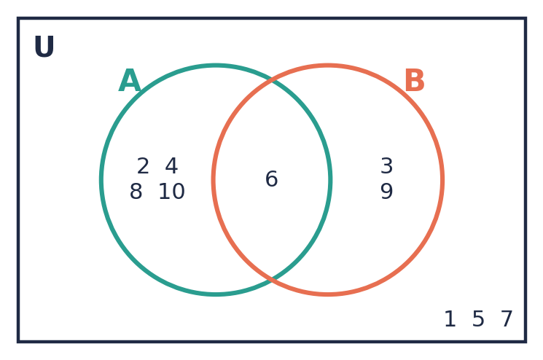
💭 Think: Check: n(A) + n(A′) = 5 + 5 = 10 = n(U). Why must this always be true?

Example 3.2 · Disjoint sets and subsets
U = {1, 2, …, 12}, P = {prime numbers}, Q = {4, 8, 12}, R = {2, 3}. Describe how P and Q are related, and how R and P are related. Show both in Venn diagrams.
Solution
1. P = {2, 3, 5, 7, 11}. P and Q have no elements in common, so P ∩ Q = ∅. They are disjoint: draw two circles that do not touch.
2. Every element of R is in P, so R ⊂ P. Draw circle R inside circle P.
Answer: P ∩ Q = ∅ (disjoint sets). R ⊂ P (R is inside P).
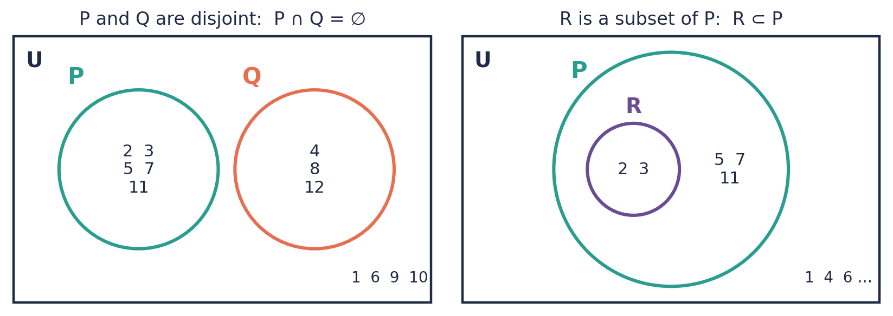

Example 3.3 · Reading a Venn diagram
Use the Venn diagram to list: A, B, A ∪ B, A′, A ∩ B′ and (A ∩ B)′.
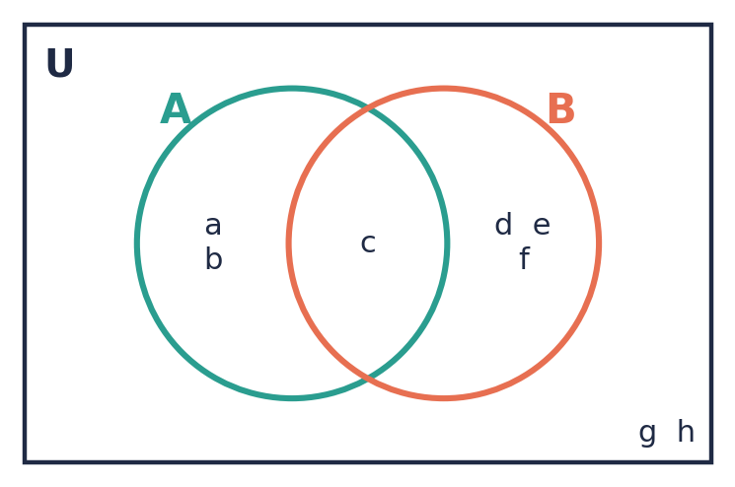
Solution
1. A = everything inside circle A = {a, b, c}.
2. B = everything inside circle B = {c, d, e, f}.
3. A ∪ B = everything inside either circle = {a, b, c, d, e, f}.
4. A′ = everything outside circle A = {d, e, f, g, h}.
5. A ∩ B′ = in A and not in B = A only = {a, b}.
6. (A ∩ B)′ = everything except the overlap = {a, b, d, e, f, g, h}.
Answer: A = {a, b, c}, B = {c, d, e, f}, A ∪ B = {a, b, c, d, e, f}, A′ = {d, e, f, g, h}, A ∩ B′ = {a, b}, (A ∩ B)′ = {a, b, d, e, f, g, h}

Example 3.4 · Shading regions
Shade each region on a Venn diagram: A ∩ B, A ∪ B, A′, A ∩ B′.
Solution
1. A ∩ B: shade only the overlap.
2. A ∪ B: shade both circles completely.
3. A′: shade everything outside circle A, including the part of B that is not in A.
4. A ∩ B′: shade the part of A that is not in B (the crescent shape).
Answer: See the four diagrams.
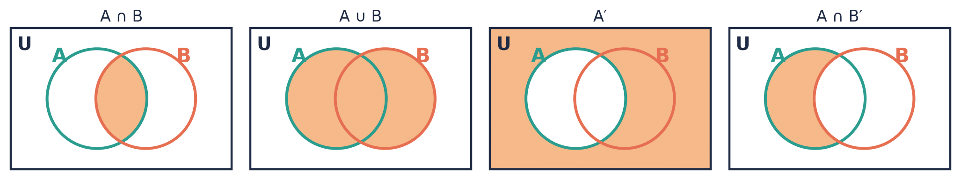
💭 Think: A useful strategy: shade the first set with vertical lines and the second set with horizontal lines. For ∩, keep the region where the lines cross. For ∪, keep every region that has any lines.

⚠ Common mistakes
- Listing an element twice in a union, e.g. {1, 2, 3, 3, 4}.
- Writing A ∩ B = 3 instead of A ∩ B = {3}. An intersection is always a set.
- Forgetting the elements outside the circles when finding a complement.

④ Practice
Write your answers in your exercise book. Start at Level 1. If you get most of a level right, move on to the next one. The answers are at the back of the pack.

Level 1 · Foundation
1. U = {1, 2, 3, …, 12}, A = {1, 2, 3, 4, 5, 6}, B = {2, 4, 6, 8, 10, 12}. List:
(a) A ∩ B
(b) A ∪ B
(c) A′
(d) B′
2. Draw a Venn diagram to show U, A and B from Question 1.
3. Write each statement using set notation.
(a) the elements in both P and Q
(b) the elements not in P
(c) the elements in P or Q or both
(d) P and Q have no elements in common

Level 2 · Developing
4. Use the Venn diagram to list or find:
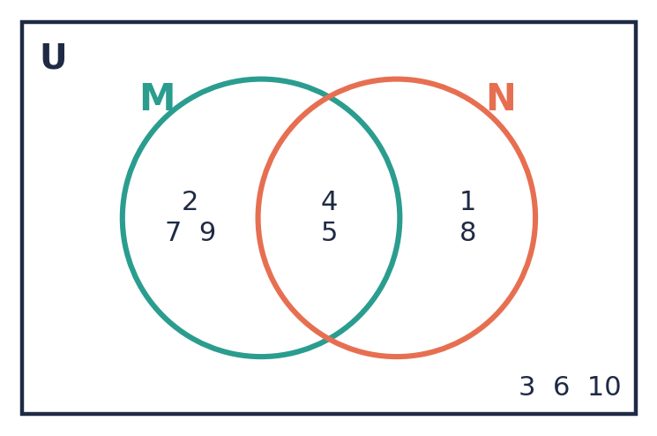
(a) M
(b) N
(c) M ∪ N
(d) (M ∪ N)′
(e) M ∩ N′
(f) n(N′)
(g) n(U)
5. Use set notation to describe the shaded region in each diagram.
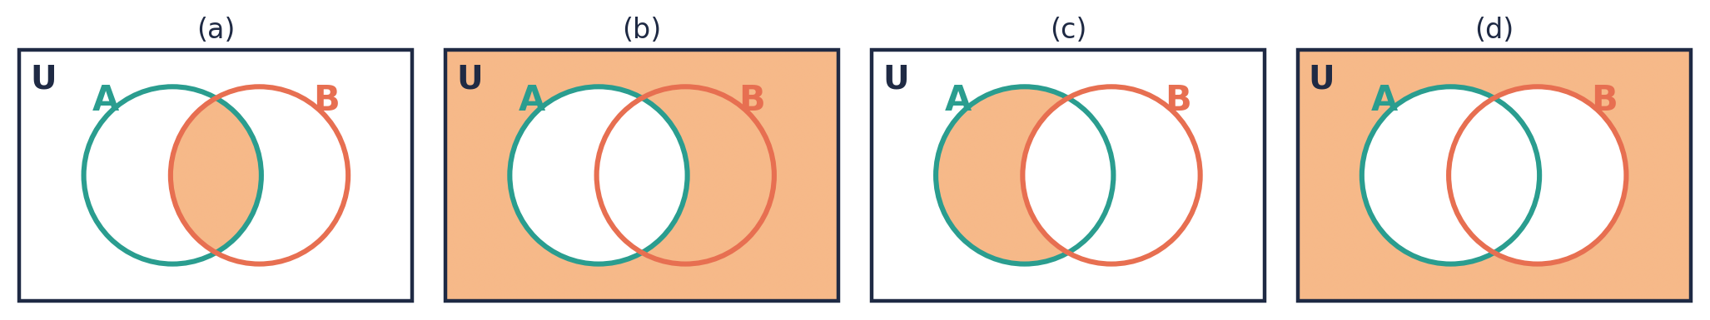
6. U = {whole numbers from 1 to 20}, E = {even numbers}, F = {multiples of 5}.
(a) List E ∩ F.
(b) Find n(E ∪ F).
(c) Draw a Venn diagram.
(d) List (E ∪ F)′.

Level 3 · Think Deeper
7. Spot the error. A = {1, 2, 3} and B = {3, 4}. Jada wrote A ∪ B = {1, 2, 3, 3, 4} and A ∩ B = 3. Find her TWO mistakes and correct them.
8. Investigate. Using U, A and B from Level 1 Question 1, find (A ∪ B)′, A′ ∪ B′ and A′ ∩ B′. Is (A ∪ B)′ the same as A′ ∪ B′? Which one is it equal to?
9. Always, sometimes or never? Explain each answer.
(a) A ∩ B ⊂ A ∪ B
(b) n(A ∪ B) = n(A) + n(B)
(c) A ∩ A′ = ∅
(d) A ∪ A′ = U
10. Create. U = {1, 2, …, 10}. Choose sets A and B so that A ⊂ B, n(A) = 3 and n(B′) = 4. Draw your Venn diagram.

Before you move on, say or write in one or two sentences: "I can explain the difference between A ∪ B and A ∩ B using the words "or" and "and"."
How confident do I feel? ☐ Not yet ☐ Getting there ☐ Got it!

Lesson 4: Venn Diagrams with Three Sets
Building on: Lesson 3: two-set Venn diagrams and the order of filling them in.
Goal: By the end of this lesson I can draw a three-set Venn diagram and describe any of its regions using set notation.

① Key Ideas
- Three overlapping circles make 8 regions: the centre (all three sets), three "two sets only" regions, three "one set only" regions, and the region outside all the circles.
- Fill from the centre outwards: (1) A ∩ B ∩ C, (2) each pair only, e.g. A ∩ B ∩ C′, (3) each single set only, e.g. A ∩ B′ ∩ C′, (4) outside, (A ∪ B ∪ C)′.
- Before placing each element, ask three questions: Is it in A? Is it in B? Is it in C? The three answers tell you exactly which region it goes in.
- Some region names: "A and B but not C" = A ∩ B ∩ C′. "A only" = A ∩ B′ ∩ C′. "In none of the sets" = (A ∪ B ∪ C)′.
- Check your diagram. Every element of U must appear exactly once, and the numbers in all 8 regions must add up to n(U).

② Watch
Watch these videos after you have read the key ideas. Pause the video and try each example before it is solved. Online, click the link. On paper, type the short address into YouTube.
Video | What it covers | Link
Venn Diagrams with 3 sets – Lesson  Jeremy Klassen | Placing elements in a three-set diagram | Watch on YouTube  youtu.be/RjvLjyHgCmI
Shading a Venn Diagram with 3 Sets: Unions, Intersections, and Complements  Kratzmeyer's Math | Shading regions for three sets | Watch on YouTube  youtu.be/ZpNlhDNxcL0

③ Worked Examples
Cover the solution and try the example first. Then uncover one step at a time and compare it with your own working.
Example 4.1 · Filling a three-set diagram
U = {1, 2, …, 15}, A = {factors of 12}, B = {even numbers}, C = {multiples of 3}. Draw the Venn diagram.
Solution
1. List the sets: A = {1, 2, 3, 4, 6, 12}, B = {2, 4, 6, 8, 10, 12, 14}, C = {3, 6, 9, 12, 15}.
2. Centre (in A, B and C): 6 and 12.
3. A and B only (not in C): 2 and 4.
4. A and C only (not in B): 3.
5. B and C only (not in A): the even multiples of 3 are 6 and 12, and both are already in the centre. So this region is empty.
6. A only: 1. B only: 8, 10, 14. C only: 9, 15.
7. Outside: 5, 7, 11, 13.
8. Check: 2 + 2 + 1 + 0 + 1 + 3 + 2 + 4 = 15 = n(U).
Answer: See the completed diagram.
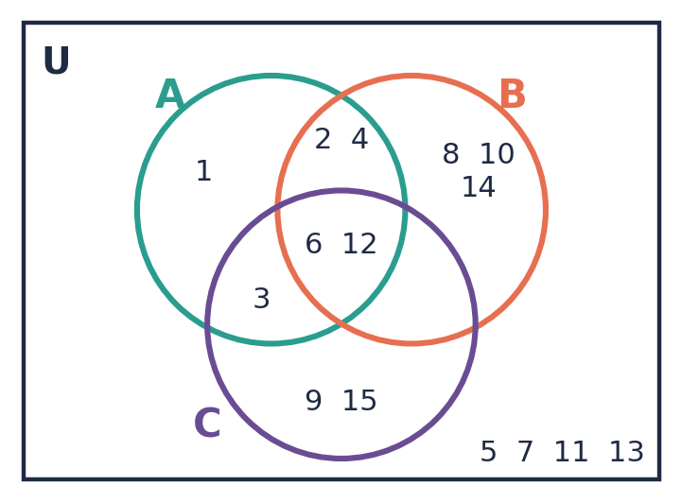
💭 Think: A region can be empty. Leave it blank (or write 0 when counting). Do not force an element into it.

Example 4.2 · Naming regions
Use the example above to list: (a) A ∩ B ∩ C (b) A ∩ B ∩ C′ (c) (A ∪ B ∪ C)′ (d) B ∩ (A ∪ C)′
Solution
1. (a) Centre: {6, 12}.
2. (b) A and B but not C: {2, 4}.
3. (c) Outside every circle: {5, 7, 11, 13}.
4. (d) (A ∪ C)′ means not in A and not in C. Combined with B, this is "B only": {8, 10, 14}.
Answer: (a) {6, 12} (b) {2, 4} (c) {5, 7, 11, 13} (d) {8, 10, 14}

Example 4.3 · Shading with three sets
Shade: A ∩ B ∩ C, A ∩ B ∩ C′, A ∩ (B ∪ C), (A ∪ B ∪ C)′.
Solution
1. A ∩ B ∩ C: only the centre.
2. A ∩ B ∩ C′: the overlap of A and B, but not the centre.
3. A ∩ (B ∪ C): first find B ∪ C (both circles). Then keep only the part that is also in A.
4. (A ∪ B ∪ C)′: only the region outside all three circles.
Answer: See the four diagrams.
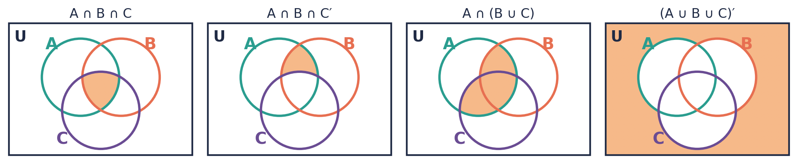

⚠ Common mistakes
- Putting an element in a "two sets only" region when it belongs in the centre. Always fill the centre first.
- Placing an element in more than one region.
- Forgetting that a region can be empty.

④ Practice
Write your answers in your exercise book. Start at Level 1. If you get most of a level right, move on to the next one. The answers are at the back of the pack.

Level 1 · Foundation
1. U = {1, 2, …, 12}, P = {1, 2, 3, 4, 5, 6}, Q = {2, 4, 6, 8, 10, 12}, R = {3, 6, 9, 12}. Draw a three-set Venn diagram.
2. Use your diagram from Question 1 to list:
(a) P ∩ Q ∩ R
(b) P ∪ Q ∪ R
(c) (P ∪ Q ∪ R)′
(d) P ∩ R

Level 2 · Developing
3. Use the Venn diagram to list or find:
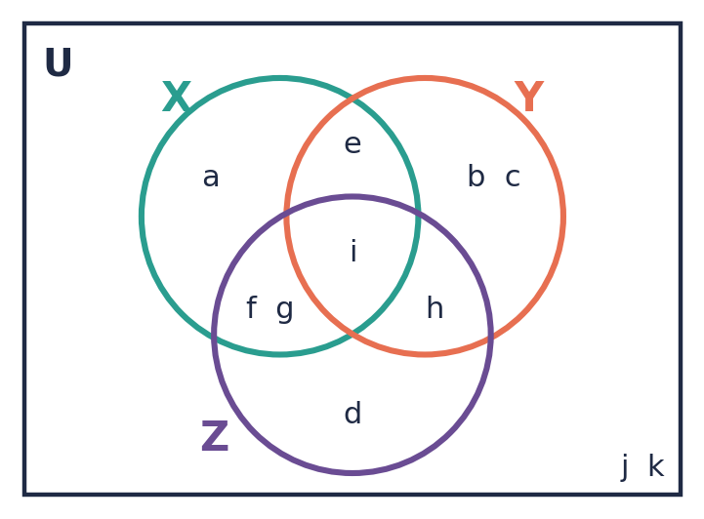
(a) X ∩ Y
(b) X ∩ Y ∩ Z′
(c) Z′
(d) n(X ∪ Y)
4. The regions of a three-set Venn diagram are numbered 1 to 8. Write the region number(s) for each set.
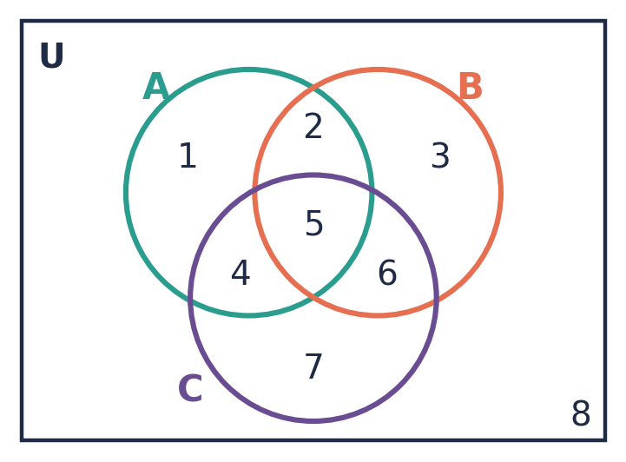
(a) A ∩ B ∩ C
(b) A only
(c) (A ∪ B ∪ C)′
(d) B ∩ C ∩ A′
(e) A ∪ B
5. U = {whole numbers from 1 to 20}, A = {multiples of 2}, B = {multiples of 3}, C = {multiples of 5}.
(a) List A ∩ B, B ∩ C and A ∩ C.
(b) Find A ∩ B ∩ C. Explain your answer.
(c) Draw the Venn diagram.
(d) How many elements of U are in none of the sets?

Level 3 · Think Deeper
6. Always, sometimes or never? "A ∩ B ∩ C ⊂ A ∩ B". Explain.
7. Spot the error. U = {1, …, 12}, A = {even numbers}, B = {multiples of 3}, C = {factors of 12}. Ravi placed 6 in the region "A and B only". Explain his mistake and how he could have avoided it.
8. Explain. Which is larger, or can they be equal: n(A ∩ B) or n(A ∩ B ∩ C)? Give an example where they are equal.
9. Create. Sketch a Venn diagram of three sets where C ⊂ A, B and C are disjoint, and A and B overlap. Then write all three facts using set notation.

Before you move on, say or write in one or two sentences: "I can explain why I fill in the centre of a three-set Venn diagram first."
How confident do I feel? ☐ Not yet ☐ Getting there ☐ Got it!

Lesson 5: Solving Problems with Venn Diagrams
Building on: Lessons 3 and 4: Venn diagrams and n(A). This lesson also uses algebra: forming and solving a simple equation.
Goal: By the end of this lesson I can use n(A ∪ B) = n(A) + n(B) − n(A ∩ B), and use x and an equation to solve Venn diagram word problems.

① Key Ideas
- n(A ∪ B) = n(A) + n(B) − n(A ∩ B). We subtract n(A ∩ B) because the elements in the overlap were counted twice: once in n(A) and once in n(B).
- In word problems we often put numbers in the regions instead of listing elements.
- When the overlap is unknown, call it x. Then A only = n(A) − x and B only = n(B) − x.
- All the regions together make up the universal set. So the sum of all regions = n(U). This gives an equation that you can solve for x.
- In three-set problems, start with the centre, then work outwards. Subtract as you go.
- Useful words: "only" means one region. "Both" usually means the whole overlap. "Neither" or "none" means outside the circles. "At least one" means the union.

② Watch
Watch these videos after you have read the key ideas. Pause the video and try each example before it is solved. Online, click the link. On paper, type the short address into YouTube.
Video | What it covers | Link
Solving Word Problems With Venn Diagrams Two Sets  Steve Crow | Two-set word problems | Watch on YouTube  youtu.be/oSLitQKUPiY
Problem Solving with Venn diagrams  Kawthar Ali (Ms K Ali) | Using x to solve Venn diagram problems | Watch on YouTube  youtu.be/0h8a3POgKxU
Problem solving Venn Diagrams – 3 sets  ExamRevision | Three-set word problems | Watch on YouTube  youtu.be/OG045QBuUrg

③ Worked Examples
Cover the solution and try the example first. Then uncover one step at a time and compare it with your own working.
Example 5.1 · Using the formula
n(A) = 18, n(B) = 15 and n(A ∩ B) = 7. Find n(A ∪ B).
Solution
1. n(A ∪ B) = n(A) + n(B) − n(A ∩ B)
2. = 18 + 15 − 7
3. = 26
Answer: n(A ∪ B) = 26

Example 5.2 · Finding x (CSEC style)
In a Form 3 class of 35 students, 20 play cricket (C), 18 play football (F) and 4 play neither sport. x students play both. (a) Draw a Venn diagram. (b) Write an equation and solve it for x. (c) How many students play cricket only?
Solution
1. (a) Put x in the overlap. Cricket only = 20 − x. Football only = 18 − x. Neither = 4.
2. (b) All the regions add up to the class size: (20 − x) + x + (18 − x) + 4 = 35.
3. Simplify: 42 − x = 35, so x = 7.
4. (c) Cricket only = 20 − 7 = 13.
5. Check: 13 + 7 + 11 + 4 = 35 ✓
Answer: x = 7. 13 students play cricket only.
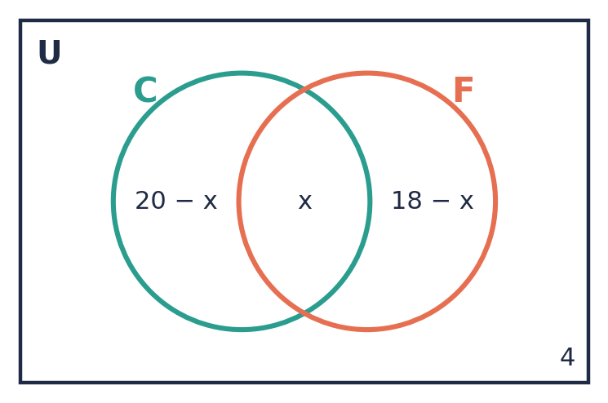
💭 Think: Why is it (20 − x) and not just 20 in the "cricket only" region?

Example 5.3 · Expressions in the regions
The Venn diagram shows the number of elements in each region, and n(U) = 45. Find x, and then find n(P).
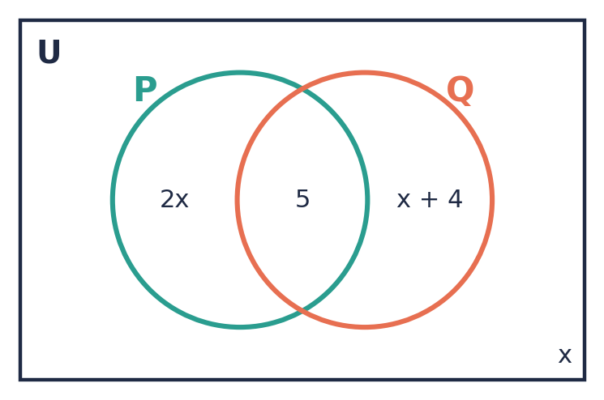
Solution
1. Add all the regions: 2x + 5 + (x + 4) + x = 45.
2. Collect like terms: 4x + 9 = 45.
3. 4x = 36, so x = 9.
4. n(P) = P only + both = 2x + 5 = 18 + 5 = 23.
Answer: x = 9 and n(P) = 23

Example 5.4 · Three-set word problem
50 students were asked about three clubs: Maths (M), English (E) and Science (S). 20 are in M, 22 in E and 18 in S. 8 are in M and E, 6 in M and S, 7 in E and S, and 3 are in all three. How many students are in: (a) none of the clubs? (b) exactly one club? (c) exactly two clubs?
Solution
1. Centre: 3.
2. Pairs only (subtract the centre): M∩E only = 8 − 3 = 5. M∩S only = 6 − 3 = 3. E∩S only = 7 − 3 = 4.
3. Singles only: M only = 20 − 5 − 3 − 3 = 9. E only = 22 − 5 − 4 − 3 = 10. S only = 18 − 3 − 4 − 3 = 8.
4. In at least one club: 3 + 5 + 3 + 4 + 9 + 10 + 8 = 42. So none = 50 − 42 = 8.
5. Exactly one: 9 + 10 + 8 = 27. Exactly two: 5 + 3 + 4 = 12.
Answer: (a) 8 (b) 27 (c) 12
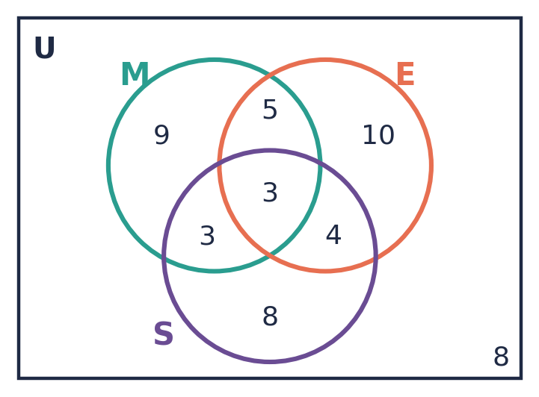
💭 Think: Why do we subtract the centre from each pair total before working out the "only" regions?

⚠ Common mistakes
- Putting n(A) in the "A only" region. You must subtract the overlap first.
- Forgetting the "neither" group when forming the equation.
- In three-set problems, forgetting to subtract the centre from each pair total.

④ Practice
Write your answers in your exercise book. Start at Level 1. If you get most of a level right, move on to the next one. The answers are at the back of the pack.

Level 1 · Foundation
1. n(A) = 12, n(B) = 9 and n(A ∩ B) = 4. Find n(A ∪ B).
2. n(P ∪ Q) = 30, n(P) = 18 and n(Q) = 20. Find n(P ∩ Q).
3. A Venn diagram has 7 in A only, 3 in A ∩ B, 5 in B only and 6 outside. Find:
(a) n(U)
(b) n(A)
(c) n(B′)
(d) n(A ∪ B)

Level 2 · Developing
4. In a group of 40 students, 25 like mango (M), 22 like guava (G) and 3 like neither. Let x be the number who like both.
(a) Draw a Venn diagram showing x.
(b) Write an equation in x and solve it.
(c) How many like mango only?
5. The Venn diagram shows the number of elements in each region, and n(U) = 46.
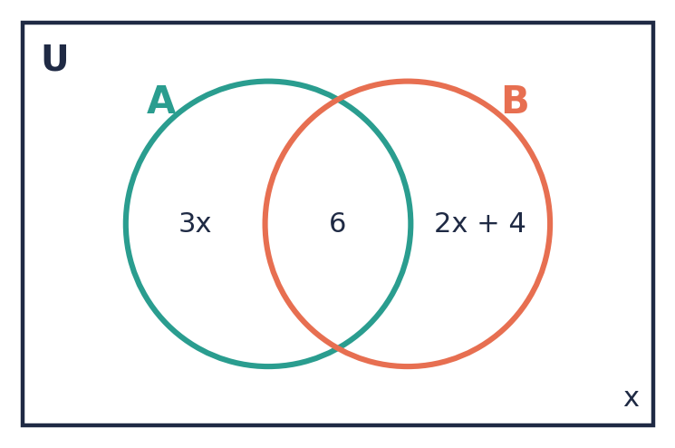
(a) Write an equation in x.
(b) Solve for x.
(c) Find n(A) and n(B).
6. In a class of 30 students, 17 study French, 14 study Spanish and 5 study neither. How many study both? How many study exactly one language?
7. 60 Form 3 students were asked which sports they play: cricket (C), football (F), netball (N). 25 play C, 28 play F, 20 play N. 10 play C and F, 7 play C and N, 9 play F and N, and 4 play all three.
(a) Draw the Venn diagram.
(b) How many play cricket only?
(c) How many play exactly two sports?
(d) How many play none of these sports?

Level 3 · Think Deeper
8. Spot the error. n(A) = 15, n(B) = 12 and n(A ∩ B) = 5. Deon says n(A ∪ B) = 27. Explain his mistake and give the correct answer.
9. Think deeper. In a class of 30, 20 play cricket and 18 play football. (a) What is the SMALLEST possible number who play both? (b) What is the LARGEST? Explain your reasoning.
10. Create. Write your own Venn diagram word problem (with a "neither" group) whose equation gives x = 5. Solve it to show it works.

Before you move on, say or write in one or two sentences: "I can explain why we subtract n(A ∩ B) in the formula for n(A ∪ B)."
How confident do I feel? ☐ Not yet ☐ Getting there ☐ Got it!

CSEC-Style Exam Practice
These questions are like the ones on CSEC Paper 2, and they use all five lessons. Try them under test conditions: no notes, and about 30 minutes. Show all your working.
1. U = {x : x is an integer, 1 ≤ x ≤ 15}, A = {prime numbers}, B = {odd numbers}.
(a) List the elements of A and of B. [2 marks]
(b) Draw a Venn diagram to show U, A and B. [3 marks]
(c) List the elements of (A ∪ B)′. [1 mark]
(d) Find n(A′ ∩ B). [1 mark]
2. The Venn diagram shows the number of students in a Form 3 class who play steelpan (S) and guitar (G). There are 38 students in the class.
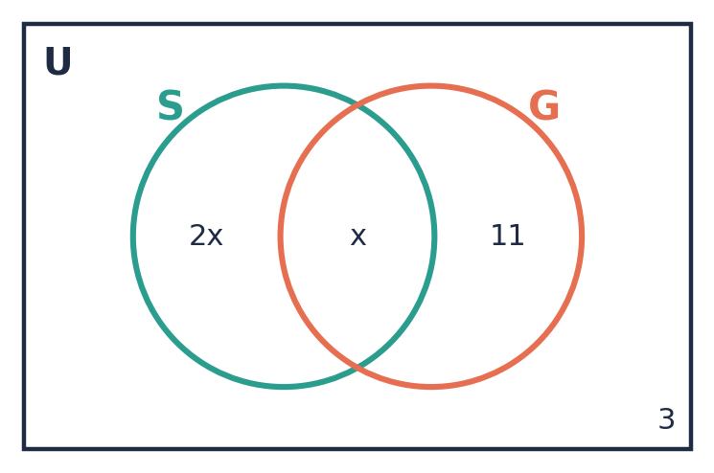
(a) Write an expression in x for the number of students who play steelpan. [1 mark]
(b) Write an equation in x and solve it. [2 marks]
(c) How many students play only one instrument? [2 marks]
3. 50 CSEC students were surveyed. 26 take Physics (P), 23 take Chemistry (C) and 21 take Biology (B). 10 take P and C, 8 take C and B, 9 take P and B, and 4 take all three.
(a) Draw a Venn diagram showing the number of students in each region. [4 marks]
(b) How many students take none of these subjects? [1 mark]
(c) How many take exactly one of these subjects? [1 mark]
(d) How many take at least two of these subjects? [1 mark]
4. (a) Copy the Venn diagram and shade the region A′ ∩ B. [1 mark] (b) n(U) = 30, n(A) = 14, n(B) = 12 and n((A ∪ B)′) = 9. Find n(A ∩ B). [3 marks]
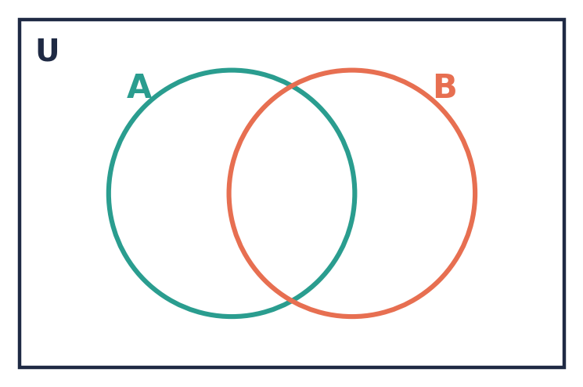

Self-Check Quiz: Am I Ready?
Answer all 12 questions without looking back at the lessons. Then check your answers and write your score in the box. The lesson number after each question tells you where to go back if you get it wrong.
1. Which of these sets is infinite? (Lesson 1)
A {days of the week} B {multiples of 7} C {1, 2, 3, …, 1000} D {students in Antigua}
2. What is n({letters in the word CARIBBEAN})? (Lesson 1)
A 9 B 8 C 7 D 6
3. Which of these is the empty set? (Lesson 2)
A {0} B {x : x is an even number, 2 < x < 4} C {1} D {months of the year}
4. How many subsets does {p, q, r, s} have? (Lesson 2)
A 4 B 8 C 16 D 15
5. {a, b, c} and {1, 2, 3} are… (Lesson 2)
A equal B equivalent C disjoint subsets D empty
6. A = {2, 4, 6}, B = {4, 6, 8}. What is A ∪ B? (Lesson 3)
A {4, 6} B {2, 4, 6, 8} C {2, 4, 4, 6, 6, 8} D {2, 8}
7. A = {2, 4, 6}, B = {4, 6, 8}. What is A ∩ B? (Lesson 3)
A {4, 6} B {2, 4, 6, 8} C {2, 8} D ∅
8. U = {1, 2, …, 8}, A = {1, 3, 5, 7}. What is A′? (Lesson 3)
A {1, 3, 5, 7} B {2, 4, 6, 8} C ∅ D {8}
9. Which notation means "in A but not in B"? (Lesson 3)
A A ∪ B B A′ ∩ B C A ∩ B′ D (A ∩ B)′
10. In a three-set Venn diagram, the region "in A and B but not C" is… (Lesson 4)
A A ∩ B ∩ C B A ∩ B ∩ C′ C A ∪ B ∪ C′ D (A ∩ B)′ ∩ C
11. n(A) = 10, n(B) = 8 and n(A ∪ B) = 15. What is n(A ∩ B)? (Lesson 5)
A 2 B 3 C 5 D 18
12. In a class of 32, 18 like Maths, 20 like Science and 2 like neither. How many like both? (Lesson 5)
A 6 B 8 C 10 D 4

My score | What it means
11–12 | Ready! You are ready for the next topic: Algebra – Introduction.
8–10 | Nearly there. Look at the lesson number next to each question you missed. Redo the Level 2 practice for those lessons.
0–7 | Go back over the lessons for the questions you missed. Redo the Level 1 and Level 2 practice, watch the videos again, then retake this quiz.
My score: ______ / 12

Answers
Use these to check your work. If your answer is different, look for your mistake before you ask for help. Your teacher has the full worked solutions.

Warm-Up
1. 2, 4, 6, 8, 10
2. 1, 2, 3, 4, 6, 12
3. 2, 3, 5, 7, 11, 13, 17, 19
4. 4, 8, 12, 16, 20
5. −3, 7 and 0
6. No. A prime number has exactly two factors (1 and itself). The number 1 has only one factor.

Lesson 1: What Is a Set?
Level 1 · Foundation
1. (a) {a, e, i, o, u} (b) {11, 13, 15, 17, 19} (c) {April, June, September, November}
2. (a) True (b) False (c) False (d) True
3. (a) infinite (b) finite (c) finite (d) infinite
Level 2 · Developing
4. {M, I, S, P}, n = 4
5. (a) {square numbers from 1 to 25} (b) {islands of the state of Antigua and Barbuda} (c) {multiples of 5}
6. (a) {1, 2, 3, 4, 6, 8, 12, 24} (b) {−2, −1, 0, 1, 2} (c) {23, 29, 31, 37}
7. (a) {3, 6, 9, 12, …}, infinite (b) {1, 2, 3, …, 50}, finite
Level 3 · Think Deeper
8. (a) Not a set, it is a matter of opinion (b) Set (c) Not a set, it is a matter of opinion (d) Set
9. She listed repeated letters. The correct set is {C, O, N, U, T} and n = 5.
10. Sometimes. {1, 2, 3, …} is infinite, but {1, 2, 3, …, 50} is finite.
11. Many answers are possible, e.g. {2, 4, 8, 10}. The largest possible n(A) is 6.

Lesson 2: Comparing Sets: Equal, Equivalent, Empty and Subsets
Level 1 · Foundation
1. (a) equal (b) equivalent (c) neither (d) equal
2. (a) empty (b) not empty (c) empty (d) not empty, it is {0}
3. ∅, {x}, {y}, {x, y}
Level 2 · Developing
4. (a) True (b) False (c) True (d) True (e) True
5. ∅, {1}, {2}, {3}, {1, 2}, {1, 3}, {2, 3}, {1, 2, 3}
6. (a) 16 (b) 64 (c) 15
7. 5 elements
Level 3 · Think Deeper
8. {0} has one element (the number 0), so n({0}) = 1. The empty set has no elements.
9. (a) Always (b) Sometimes (c) Always (d) Never
10. Each old subset gives two new ones: one without c and one with c added.
11. (a) 8 (b) 6

Lesson 3: Universal Set, Complement, Union, Intersection and Venn Diagrams
Level 1 · Foundation
1. (a) {2, 4, 6} (b) {1, 2, 3, 4, 5, 6, 8, 10, 12} (c) {7, 8, 9, 10, 11, 12} (d) {1, 3, 5, 7, 9, 11}
2. Overlap: 2, 4, 6. A only: 1, 3, 5. B only: 8, 10, 12. Outside: 7, 9, 11.
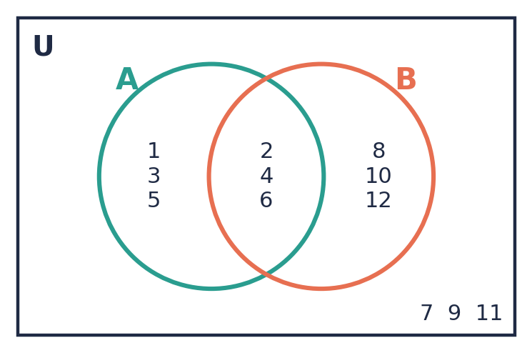
3. (a) P ∩ Q (b) P′ (c) P ∪ Q (d) P ∩ Q = ∅
Level 2 · Developing
4. (a) {2, 4, 5, 7, 9} (b) {1, 4, 5, 8} (c) {1, 2, 4, 5, 7, 8, 9} (d) {3, 6, 10} (e) {2, 7, 9} (f) 6 (g) 10
5. (a) A ∩ B (b) A′ (c) A ∩ B′ (d) (A ∪ B)′
6. (a) {10, 20} (b) 12 (c) see the answer diagram in the teacher key (d) {1, 3, 7, 9, 11, 13, 17, 19}
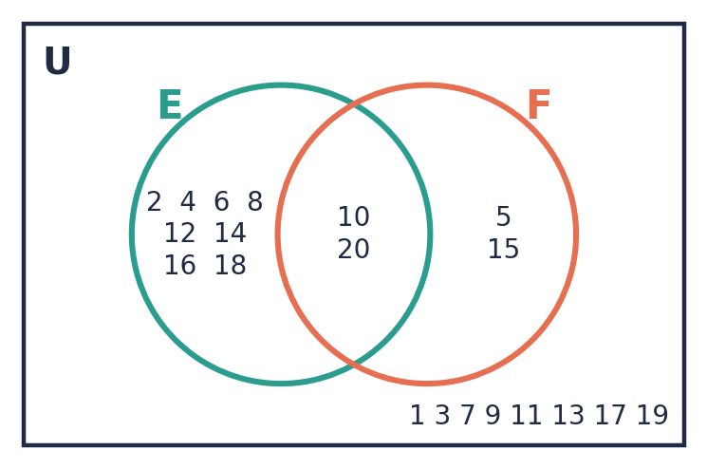
Level 3 · Think Deeper
7. A ∪ B = {1, 2, 3, 4} (list 3 once); A ∩ B = {3} (an intersection is a set, so it needs braces).
8. (A ∪ B)′ = {7, 9, 11}; A′ ∪ B′ = {1, 3, 5, 7, 8, 9, 10, 11, 12}; A′ ∩ B′ = {7, 9, 11}. So (A ∪ B)′ = A′ ∩ B′, not A′ ∪ B′.
9. (a) Always (b) Sometimes (only when A and B are disjoint) (c) Always (d) Always
10. Many answers are possible. B must have 6 elements, and A must be 3 of them. For example B = {1, 2, 3, 4, 5, 6}, A = {1, 2, 3}.

Lesson 4: Venn Diagrams with Three Sets
Level 1 · Foundation
1. Centre: 6. P∩Q only: 2, 4. P∩R only: 3. Q∩R only: 12. P only: 1, 5. Q only: 8, 10. R only: 9. Outside: 7, 11.
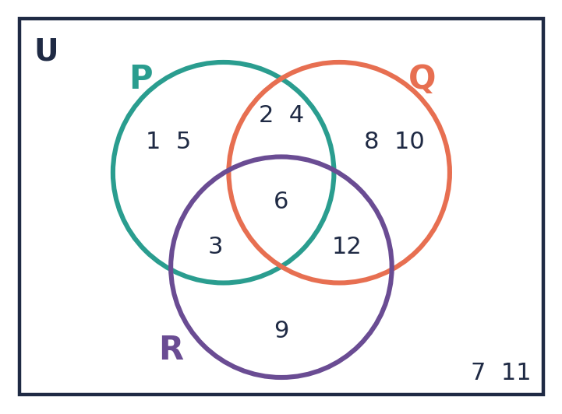
2. (a) {6} (b) {1, 2, 3, 4, 5, 6, 8, 9, 10, 12} (c) {7, 11} (d) {3, 6}
Level 2 · Developing
3. (a) {e, i} (b) {e} (c) {a, b, c, e, j, k} (d) 8
4. (a) 5 (b) 1 (c) 8 (d) 6 (e) 1, 2, 3, 4, 5, 6
5. (a) A∩B = {6, 12, 18}, B∩C = {15}, A∩C = {10, 20} (b) ∅ (c) see the answer diagram in the teacher key (d) 6
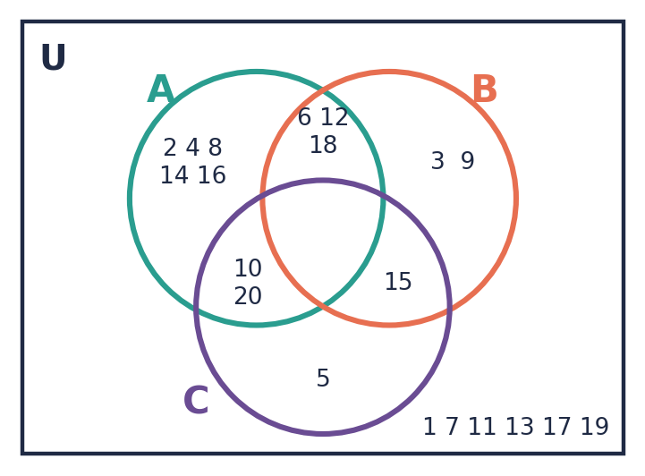
Level 3 · Think Deeper
6. Always. Anything in all three sets is certainly in A and B.
7. 6 is also a factor of 12, so it belongs in the centre (A ∩ B ∩ C). Filling the centre first avoids this.
8. n(A ∩ B) ≥ n(A ∩ B ∩ C). They are equal when every element of A ∩ B is also in C.
9. C is drawn inside A, away from B, and A overlaps B. C ⊂ A, B ∩ C = ∅, A ∩ B ≠ ∅.

Lesson 5: Solving Problems with Venn Diagrams
Level 1 · Foundation
1. 17
2. 8
3. (a) 21 (b) 10 (c) 13 (d) 15
Level 2 · Developing
4. (b) (25 − x) + x + (22 − x) + 3 = 40, so x = 10 (c) 15
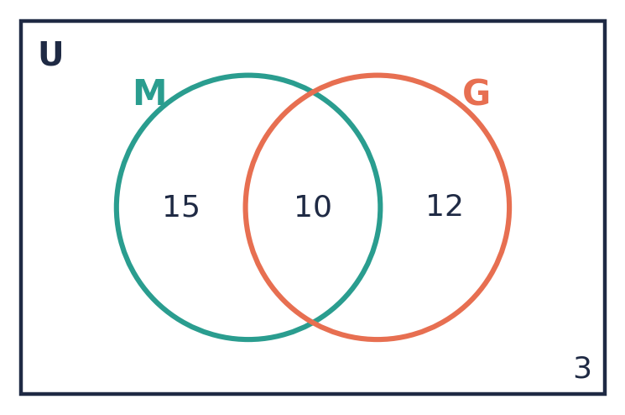
5. (a) 3x + 6 + (2x + 4) + x = 46 (b) x = 6 (c) n(A) = 24, n(B) = 22
6. 6 study both; 19 study exactly one.
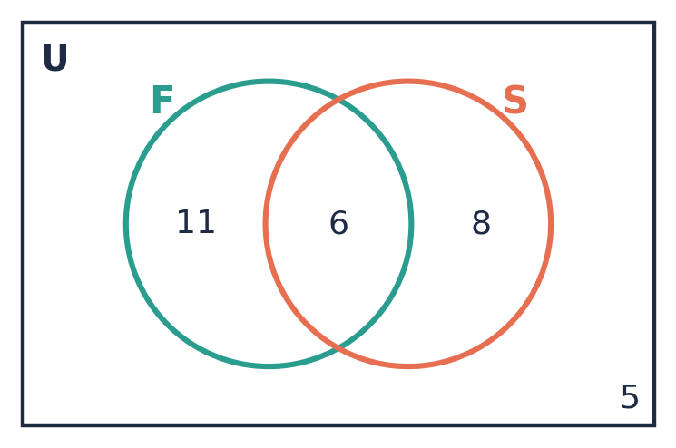
7. (b) 12 (c) 14 (d) 9
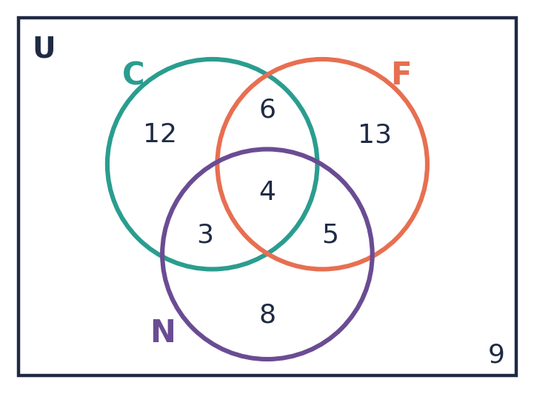
Level 3 · Think Deeper
8. He did not subtract the overlap. n(A ∪ B) = 15 + 12 − 5 = 22.
9. (a) 8 (b) 18
10. Many answers are possible, e.g. 30 students, 18 like A, 15 like B, 2 like neither: (18 − x) + x + (15 − x) + 2 = 30 gives x = 5.

CSEC-Style Exam Practice
1. (a) A = {2, 3, 5, 7, 11, 13}, B = {1, 3, 5, 7, 9, 11, 13, 15} (c) {4, 6, 8, 10, 12, 14} (d) 3
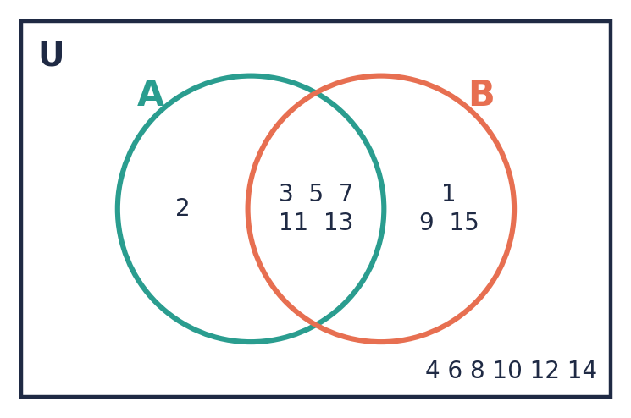
2. (a) 3x (b) 2x + x + 11 + 3 = 38, x = 8 (c) 27
3. (b) 3 (c) 28 (d) 19
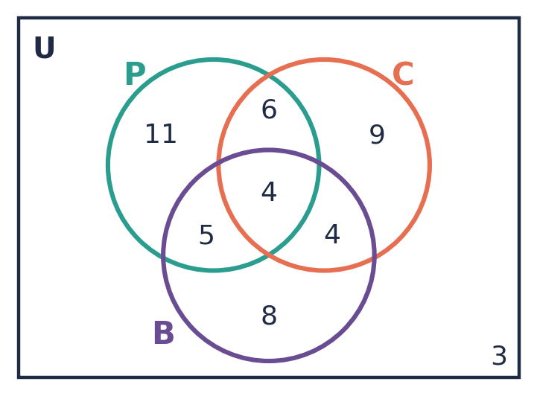
4. (a) Shade B only (b) 5
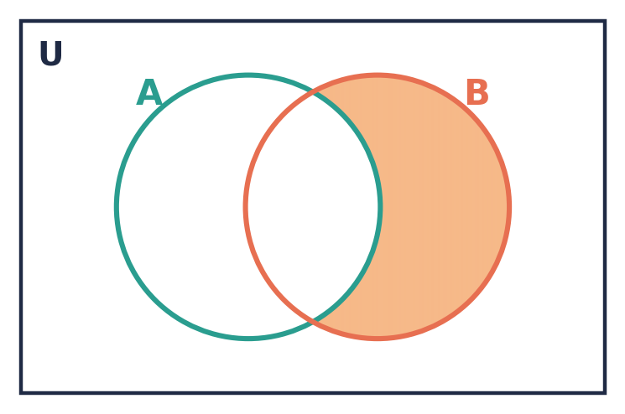

Self-Check Quiz
Q | Answer | Why
1 | B | The multiples of 7 (7, 14, 21, …) never end. The other sets can be counted and the counting stops.
2 | C | The different letters are C, A, R, I, B, E, N. A and B repeat, so n = 7.
3 | B | There is no even number strictly between 2 and 4. Note that {0} has one element, so it is not empty.
4 | C | 2⁴ = 16. (15 is the number of proper subsets.)
5 | B | They have the same number of elements (3) but different elements, so they are equivalent.
6 | B | The union contains everything in either set, with each element listed once.
7 | A | 4 and 6 are the only elements in both sets.
8 | B | A′ is everything in U that is not in A.
9 | C | "In A" is A, and "not in B" is B′. Both must be true, so we use ∩: A ∩ B′.
10 | B | In A (A), in B (B) and not in C (C′), joined by ∩.
11 | B | 15 = 10 + 8 − n(A ∩ B), so n(A ∩ B) = 18 − 15 = 3.
12 | B | The union is 32 − 2 = 30. So both = 18 + 20 − 30 = 8.

