Clare Hall Secondary School · Mathematics Department

FORM 3 MATHEMATICS · UNIT 7
Completing the Square
Self-Paced Learning Pack
Name: ______________________________________ Class: ___________
Time in class: 1 week School year: 2026–2027 Next topic: Form 4 Mathematics

What's inside
Section | What you will do
Before You Start | Warm up with the number facts you need
Lesson 1 | What Completing the Square Means
Lesson 2 | Completing the Square for x² + bx + c
Lesson 3 | Using Completed-Square Form to Find the Minimum Value
Lesson 4 | Solving Quadratic Equations by Completing the Square
Exam Practice | CSEC-style questions that use all four lessons
Self-Check Quiz | 10 questions that show whether you are ready to move on
Answers | Check your work (at the back of the pack)

How to Use This Pack
- This pack lets you learn at your own pace. You can work ahead of the class or go back over anything you missed.
- Work through the lessons in order. Each lesson builds on the one before it.
- For each lesson: Read the key ideas → Watch the videos → Study the worked examples → Practise.
- Before you read the solution to a worked example, cover it and try the example yourself first. Then check each step.
- Practice has three levels. Level 1 (Foundation) checks the basics. Level 2 (Developing) makes you apply them. Level 3 (Think Deeper) asks you to explain, find mistakes and create your own examples.
- Check your answers at the back of the pack. If you get an answer wrong, find your mistake before you move on. A mistake you understand teaches you more than a correct guess.
- When you finish all the lessons, try the CSEC-Style Exam Practice, then the Self-Check Quiz. Your quiz score tells you whether you are ready for the next topic.

The learning route for every lesson
① Read the key ideas → ② Watch the videos → ③ Try the worked examples, then check each step → ④ Practise Level 1 → 2 → 3 → ⑤ Check your answers → ⑥ Tick your checklist

My Progress Checklist
Tick one box for each statement before you start and again after you finish. Be honest. This checklist is for you.
I can… | Not yet | Getting there | Got it!
Rewrite a quadratic expression x² + bx + c in completed-square form, (x + h)² + k (Lessons 1–2) | ☐ | ☐ | ☐
Understand the relationship between x² + bx + c and (x + h)² + k using an area (geometric) model (Lesson 1) | ☐ | ☐ | ☐
Use completed-square form to find the minimum or maximum value of a quadratic and its axis of symmetry (Lesson 3) | ☐ | ☐ | ☐
Solve quadratic equations by completing the square (Lesson 4) | ☐ | ☐ | ☐

Key Words
Symbol | Meaning | Example
quadratic expression | an expression whose highest power of x is x² | x² + 6x + 5
monic | a quadratic where the coefficient of x² is 1 | x² + 6x + 5 is monic; 2x² + 6x + 5 is not
completed-square form | a quadratic written as (x + h)² + k | x² + 6x + 11 = (x + 3)² + 2
turning point / vertex | the single minimum or maximum point on a parabola | (x + 3)² + 2 has turning point (−3, 2)
axis of symmetry | the vertical line through the turning point that the curve is a mirror image about | for (x + 3)² + 2, the axis of symmetry is x = −3
perfect square | an expression of the form (x + h)² | (x + 3)² = x² + 6x + 9

Before You Start: Warm-Up
This unit uses skills from earlier units: expanding brackets, substitution, factorizing perfect square trinomials, and solving equations with square roots. Check you still have them.
1. Expand (x + 5)².
2. Expand (x − 4)².
3. Factorize x² + 8x + 16.
4. Find half of 10, then square your answer.
5. Solve x² = 49.
6. Evaluate (−3)².

Lesson 1: What Completing the Square Means
Building on: Unit 2: expanding brackets. Unit 4: perfect square trinomials, (x + h)² = x² + 2hx + h².
Goal: By the end of this lesson I can explain, using an area diagram, why x² + bx needs the term (b/2)² added to become a perfect square.

① Key Ideas
- In Unit 4 you learned to factorize a perfect square trinomial like x² + 6x + 9 into (x + 3)². Completing the square asks the opposite question: given x² + 6x (which is NOT a perfect square), what must be added to make it one?
- Picture it as area. x² + bx is a square of side x, plus two matching rectangles of width b/2 — together they form an L-shape (a gnomon) with a small square-shaped corner missing.
- The missing corner has side b/2, so its area is (b/2)². Adding this completes the big square, of side (x + b/2).
- This gives the key identity: x² + bx = (x + b/2)² − (b/2)². We add (b/2)² to complete the square, and subtract the same amount so the value of the expression does not change.
- Completed-square form is (x + h)² + k. It looks different from x² + bx + c, but for the same values of x, it gives exactly the same output — the two forms are equivalent.
- Once b is a fraction (for example, b = 5, so b/2 = 2.5), the method is exactly the same — just work with the fraction or decimal carefully.

② Watch
Watch these videos after you have read the key ideas. Pause the video and try each example before it is solved. Online, click the link. On paper, type the short address into YouTube.
Video | What it covers | Link
Completing the Square  Corbettmaths | What completing the square means and how to do it | Watch on YouTube  youtu.be/VS6apvTv2Rc

③ Worked Examples
Cover the solution and try the example first. Then uncover one step at a time and compare it with your own working.
Example 1.1 · Reading the area diagram
The diagram shows x² + 6x as an L-shape with a missing corner. What is the side length of the missing corner, and its area? What perfect square does adding it complete?
Solution
1. The two rectangles each have width 3 (half of 6), so the missing corner is a 3 by 3 square.
2. Its area is 3² = 9.
3. Adding it completes the square (x + 3)², which has area x² + 6x + 9.
Answer: Side 3, area 9; completes (x + 3)²
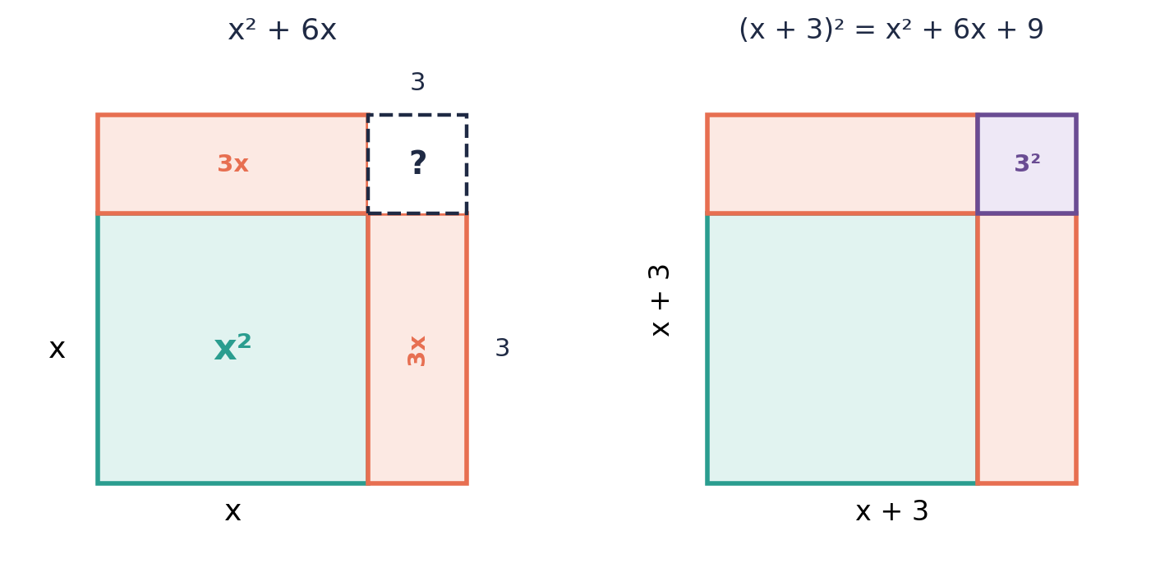

Example 1.2 · Checking the identity by expanding
Show that x² + 6x + 9 = (x + 3)² by expanding the right-hand side.
Solution
1. (x + 3)² = (x + 3)(x + 3).
2. = x² + 3x + 3x + 9 = x² + 6x + 9.
3. This matches the left-hand side.
Answer: Confirmed: (x + 3)² = x² + 6x + 9

Example 1.3 · Finding what completes the square
What must be added to x² + 10x to make it a perfect square trinomial? Write the trinomial and its factorized form.
Solution
1. Half of 10 is 5.
2. Square it: 5² = 25.
3. x² + 10x + 25 is a perfect square: (x + 5)².
Answer: Add 25; x² + 10x + 25 = (x + 5)²
💭 Think: Compare this to Unit 4, where you factorized perfect square trinomials that were already given to you. Here, you are building one from scratch.

Example 1.4 · A missing corner with a fraction
What must be added to x² + 5x to make it a perfect square? Write the completed square.
Solution
1. Half of 5 is 2.5.
2. Square it: 2.5² = 6.25.
3. x² + 5x + 6.25 = (x + 2.5)².
Answer: Add 6.25; (x + 2.5)²
💭 Think: The picture still works even though the missing corner is not a whole number. Can you sketch what side length 2.5 would look like compared to side length 3 in the earlier example?

⚠ Common mistakes
- Adding b instead of (b/2)² — for x² + 6x, adding 9 is correct, not 6 or 3.
- Forgetting to halve b before squaring — (b/2)² is not the same as b²/2 for most values.
- Thinking the missing corner's side is b, when it is actually b/2 (there are two rectangles sharing the b between them).

④ Practice
Write your answers in your exercise book. Start at Level 1. If you get most of a level right, move on to the next one. The answers are at the back of the pack.

Level 1 · Foundation
1. Find half of each number, then square your answer.
(a) 8
(b) 12
(c) 20
(d) 7
2. What must be added to each expression to complete the square?
(a) x² + 4x
(b) x² + 14x
(c) x² + 2x
3. Write x² + 4x + 4 as a perfect square.

Level 2 · Developing
4. The diagram shows x² + 8x as an L-shape with a missing corner.
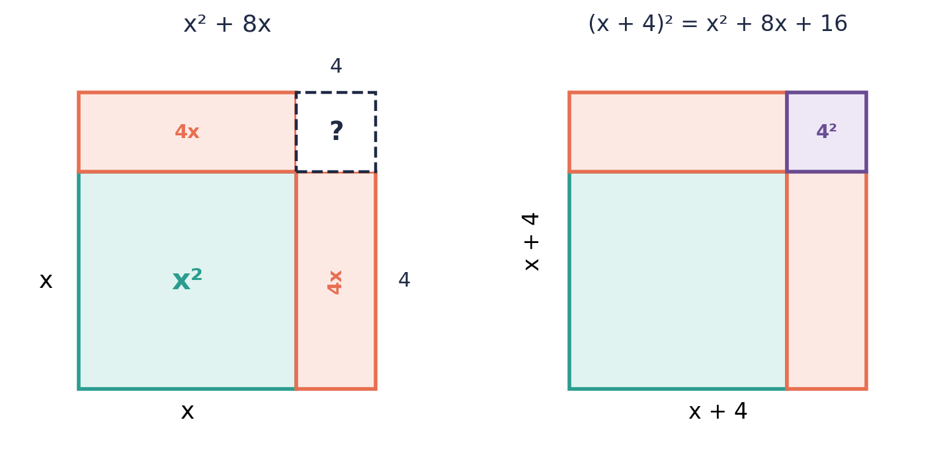
(a) State the side length of the missing corner.
(b) State its area.
(c) Write the completed square.
5. What must be added to each expression to complete the square? Then write the completed square.
(a) x² + 16x
(b) x² + 9x
(c) x² + 3x
6. Show, by expanding, that x² + 12x + 36 = (x + 6)².
7. Draw and label an area diagram (like the worked examples) for x² + 20x. What is the area of the missing corner?

Level 3 · Think Deeper
8. Spot the error. To complete the square for x² + 10x, Anaya added 10² = 100. Find her mistake and the correct value.
9. Explain. Using the area diagram, explain why the amount needed to complete the square is (b/2)² and not b² or b/2.
10. Always, sometimes or never? "x² + bx + c is already a perfect square trinomial." Use x² + 6x + 9 and x² + 6x + 11 in your answer.
11. Create. Write an expression of the form x² + bx that is NOT yet a perfect square. State what must be added to complete the square, and write the result in completed-square form.

Before you move on, say or write in one or two sentences: "I can explain, using the area diagram, why we add (b/2)² and not b² to complete the square."
How confident do I feel? ☐ Not yet ☐ Getting there ☐ Got it!

Lesson 2: Completing the Square for x² + bx + c
Building on: Lesson 1, and collecting like terms (Unit 2).
Goal: By the end of this lesson I can rewrite any monic quadratic x² + bx + c in completed-square form (x + h)² + k.

① Key Ideas
- The rule: x² + bx + c = (x + b/2)² − (b/2)² + c. The h in (x + h)² is always half of b.
- Method: (1) Halve b to get h. (2) Write (x + h)². (3) Subtract h² (to "cancel out" the extra amount you introduced). (4) Combine the subtracted h² with c to get the final k.
- So the completed-square form is (x + h)² + k, where h = b/2 and k = c − h².
- Check your answer by expanding (x + h)² + k and confirming you get back x² + bx + c.
- This works whether b is positive or negative. If b is negative, h is negative too — for example, x² − 8x has h = −4, giving (x − 4)².
- Extension (ax² + bx + c, a ≠ 1). If the coefficient of x² is not 1, first factor a out of the x² and x terms only, then complete the square inside the brackets.

② Watch
Watch these videos after you have read the key ideas. Pause the video and try each example before it is solved. Online, click the link. On paper, type the short address into YouTube.
Video | What it covers | Link

③ Worked Examples
Cover the solution and try the example first. Then uncover one step at a time and compare it with your own working.
Example 2.1 · Positive b, simple case
Write x² + 6x + 11 in completed-square form.
Solution
1. b = 6, so h = 6 ÷ 2 = 3.
2. Write (x + 3)², which expands to x² + 6x + 9 — that is 9 = 3² too many.
3. Subtract 9 and add the original 11: (x + 3)² − 9 + 11 = (x + 3)² + 2.
Answer: (x + 3)² + 2

Example 2.2 · Negative b
Write x² − 8x + 5 in completed-square form.
Solution
1. b = −8, so h = −8 ÷ 2 = −4.
2. Write (x − 4)², which expands to x² − 8x + 16.
3. Subtract 16 and add the original 5: (x − 4)² − 16 + 5 = (x − 4)² − 11.
Answer: (x − 4)² − 11

Example 2.3 · Checking by expanding
Check the previous example by expanding (x − 4)² − 11.
Solution
1. (x − 4)² = x² − 8x + 16.
2. (x − 4)² − 11 = x² − 8x + 16 − 11 = x² − 8x + 5.
3. This matches the original expression.
Answer: Confirmed

Example 2.4 · Odd b (a fraction appears)
Write x² + 5x + 1 in completed-square form.
Solution
1. b = 5, so h = 5 ÷ 2 = 2.5.
2. (x + 2.5)² expands to x² + 5x + 6.25.
3. Subtract 6.25 and add 1: (x + 2.5)² − 6.25 + 1 = (x + 2.5)² − 5.25.
Answer: (x + 2.5)² − 5.25
💭 Think: Fractions and decimals are common in completing the square. Would it be easier for you to work with 2½ and 5¼, or with 2.5 and 5.25?

Example 2.5 · When c is already the right amount
Write x² + 12x + 36 in completed-square form.
Solution
1. b = 12, so h = 6.
2. (x + 6)² expands to x² + 12x + 36 exactly.
3. There is nothing left over: k = 36 − 36 = 0.
4. So x² + 12x + 36 = (x + 6)² + 0 = (x + 6)².
Answer: (x + 6)²
💭 Think: This is a perfect square trinomial, like the ones you factorized in Unit 4. Completing the square and factorizing a perfect square trinomial give the same result here.

⚠ Common mistakes
- Forgetting to add the original constant c back in after subtracting h².
- Sign errors with negative b, such as writing (x + 4)² instead of (x − 4)² for x² − 8x + 5.
- Leaving the answer as (x + h)² − h² + c instead of simplifying to (x + h)² + k.

④ Practice
Write your answers in your exercise book. Start at Level 1. If you get most of a level right, move on to the next one. The answers are at the back of the pack.

Level 1 · Foundation
1. Write each expression in completed-square form.
(a) x² + 2x + 5
(b) x² + 4x + 1
(c) x² + 10x + 3
2. Write x² − 4x + 7 in completed-square form.
3. Check that (x + 4)² − 9 expands to x² + 8x + 7.

Level 2 · Developing
4. Write each expression in completed-square form.
(a) x² + 6x − 1
(b) x² − 10x + 30
(c) x² + 8x + 20
(d) x² − 2x − 5
5. Write x² + 7x + 2 in completed-square form.
6. Write x² − 3x in completed-square form (there is no constant term to add on).
7. A student completed the square for x² + 6x + 4 and got (x + 3)² − 5. Verify this is correct by expanding.

Level 3 · Think Deeper
8. Spot the error. For x² − 8x + 5, Cody wrote h = 8 and got (x + 8)² − 59. Find both of his mistakes and give the correct answer.
9. Explain. Why must k always equal c − h², and not simply equal c?
10. Challenge (extension, a ≠ 1). Write 2x² + 12x + 5 in completed-square form. (Hint: factor 2 out of the first two terms first.)
11. Create. Write your own quadratic x² + bx + c with a negative value of b, and rewrite it in completed-square form. Check your answer by expanding.

Before you move on, say or write in one or two sentences: "I can explain how to find h and k when completing the square for x² + bx + c."
How confident do I feel? ☐ Not yet ☐ Getting there ☐ Got it!

Lesson 3: Using Completed-Square Form to Find the Minimum Value
Building on: Lesson 2, and plotting coordinates (earlier units).
Goal: By the end of this lesson I can use completed-square form to state the minimum value of a quadratic, its turning point, and its axis of symmetry, without drawing the graph.

① Key Ideas
- For y = x² + bx + c, the graph is a parabola (a U-shaped curve) that opens upward, because the coefficient of x² is positive.
- In completed-square form, y = (x + h)² + k. Since (x + h)² is a squared term, it can never be negative — its smallest possible value is 0, which happens when x = −h.
- So the minimum value of y is k, and it occurs when x = −h. The turning point (vertex) of the graph is the point (−h, k).
- Watch the sign carefully: if the completed-square form is (x + 3)² + 2, the turning point is (−3, 2), not (3, 2) — the x-coordinate is the opposite sign of the number inside the bracket.
- The axis of symmetry is the vertical line through the turning point: x = −h. The curve is a mirror image of itself on either side of this line.
- This method finds the exact minimum value without plotting a single point — a powerful shortcut compared with drawing a table of values and a graph.

② Watch
Watch these videos after you have read the key ideas. Pause the video and try each example before it is solved. Online, click the link. On paper, type the short address into YouTube.
Video | What it covers | Link
Minimum Values using Completing the Square  Corbettmaths | Reading the minimum value and turning point from completed-square form | Watch on YouTube  youtu.be/QNu7geF0RaE

③ Worked Examples
Cover the solution and try the example first. Then uncover one step at a time and compare it with your own working.
Example 3.1 · Finding the minimum value and turning point
y = x² − 6x + 11. Write this in completed-square form, then state the minimum value of y, the turning point, and the axis of symmetry.
Solution
1. Complete the square: h = −3, h² = 9, k = 11 − 9 = 2. So y = (x − 3)² + 2.
2. The minimum value of y is 2, occurring when x = 3.
3. The turning point is (3, 2).
4. The axis of symmetry is x = 3.
Answer: Minimum value 2 at x = 3; turning point (3, 2); axis of symmetry x = 3
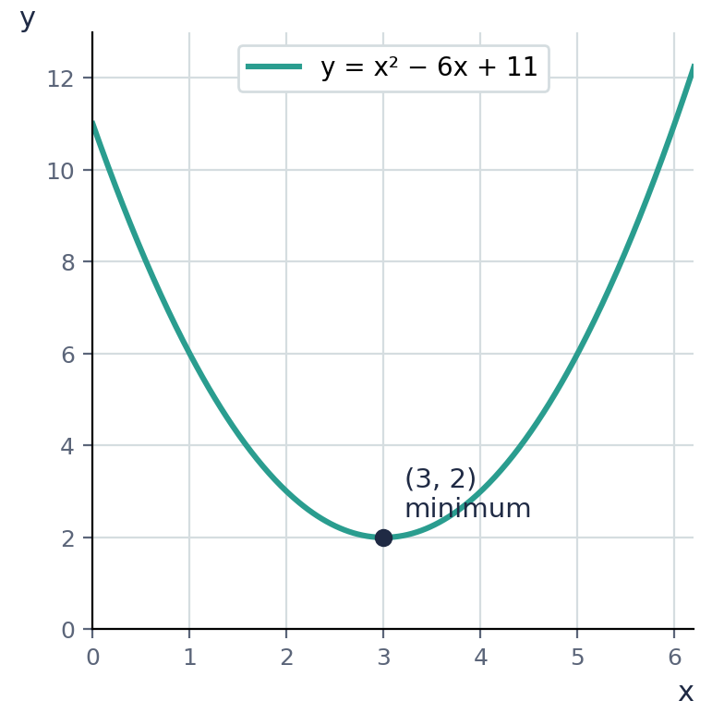

Example 3.2 · Reading the graph to confirm
The graph shows y = x² − 6x + 11. Confirm that the graph matches the answer from the previous example.
Solution
1. The lowest point on the curve is at (3, 2), matching our turning point.
2. The curve is symmetric about the vertical line x = 3.
3. For every x-value, the point directly opposite across x = 3 gives the same y-value — for example, y(2) = 3 and y(4) = 3.
Answer: Confirmed

Example 3.3 · A different sign of h
y = x² + 4x + 9. Find the minimum value, the turning point, and the axis of symmetry.
Solution
1. Complete the square: h = 2, h² = 4, k = 9 − 4 = 5. So y = (x + 2)² + 5.
2. The minimum value is 5, when x = −2 (the opposite sign of the +2 in the bracket).
3. The turning point is (−2, 5). The axis of symmetry is x = −2.
Answer: Minimum value 5 at x = −2; turning point (−2, 5)

Example 3.4 · Using the minimum value in context
The height, in metres, of a cable above a valley floor is modelled by h(x) = x² − 10x + 34, where x is the horizontal distance in metres. Find the lowest point of the cable.
Solution
1. Complete the square: half of −10 is −5, (−5)² = 25. k = 34 − 25 = 9.
2. h(x) = (x − 5)² + 9.
3. The minimum value of h is 9, when x = 5.
4. The lowest point of the cable is 9 m above the valley floor, at x = 5 m.
Answer: 9 m above the valley floor, at x = 5 m
💭 Think: Why is knowing the minimum value useful here, compared with just knowing the equation?

⚠ Common mistakes
- Writing the turning point as (h, k) instead of (−h, k) — the x-coordinate changes sign.
- Confusing the axis of symmetry (a whole line, x = a number) with just a single point.
- Trying to find the minimum value from x² + bx + c directly, without completing the square first.

④ Practice
Write your answers in your exercise book. Start at Level 1. If you get most of a level right, move on to the next one. The answers are at the back of the pack.

Level 1 · Foundation
1. Each expression is already in completed-square form. State the minimum value of y and the value of x where it occurs.
(a) y = (x + 2)² + 6
(b) y = (x − 5)² + 1
(c) y = (x + 1)² − 3
2. State the turning point and axis of symmetry for y = (x − 4)² + 7.
3. y = x² + 6x + 2 = (x + 3)² − 7 (already completed for you). State the minimum value and where it occurs.

Level 2 · Developing
4. Complete the square for each, then state the minimum value and the turning point.
(a) y = x² + 8x + 20
(b) y = x² − 4x − 1
(c) y = x² + 2x + 8
5. Find the minimum value of y = x² − 12x + 40 and state the axis of symmetry.
6. The profit, in dollars, of a small business is modelled by P(x) = x² − 20x + 75, where x is the number of items sold beyond a certain point. Find the minimum value of P and the value of x where it occurs. What does this tell the business?
7. A rectangle has perimeter 40 m. If one side is x m, the area is A = x(20 − x) = −x² + 20x. Rewrite −A = x² − 20x in completed-square form to find the maximum possible area.

Level 3 · Think Deeper
8. Spot the error. For y = (x + 5)² − 2, Rashida said the turning point is (5, −2). Find her mistake and the correct turning point.
9. Explain. Why is (x + h)² always greater than or equal to zero, whatever value x takes? Why does this guarantee that y = (x + h)² + k has a minimum value of exactly k?
10. Always, sometimes or never? "A quadratic y = x² + bx + c has a minimum value that is negative." Use y = x² + 6x + 9 and y = x² + 6x + 20 in your answer.
11. Investigate. For y = x² + bx (with c = 0), show that the minimum value is always −(b/2)², and is never positive. Test it with b = 6 and b = 10.

Before you move on, say or write in one or two sentences: "I can explain how to read the minimum value and turning point straight from completed-square form."
How confident do I feel? ☐ Not yet ☐ Getting there ☐ Got it!

Lesson 4: Solving Quadratic Equations by Completing the Square
Building on: Lessons 2–3. Unit 4: solving quadratics by factorizing.
Goal: By the end of this lesson I can solve a quadratic equation by completing the square, including when the answers are not whole numbers.

① Key Ideas
- In Unit 4, you solved quadratic equations that factorize neatly. Completing the square gives a method that works for every quadratic equation, even ones that do not factorize with whole numbers.
- Method: (1) Complete the square to write the equation as (x + h)² + k = 0. (2) Rearrange to (x + h)² = −k. (3) Take the square root of both sides, remembering both the positive and negative root: x + h = ±√(−k). (4) Solve for x.
- ± means "plus or minus" — a quadratic equation usually has two solutions, one from each sign.
- If −k is negative (that is, k is positive), there is no real solution, because you cannot take the square root of a negative number. This matches a minimum value that never reaches zero.
- Always check your solutions by substituting them back into the original equation.
- This method connects directly to Lesson 3: the equation x² + bx + c = 0 asks "where does the graph cross the x-axis?", while the minimum value from Lesson 3 tells you whether it crosses at all.

② Watch
Watch these videos after you have read the key ideas. Pause the video and try each example before it is solved. Online, click the link. On paper, type the short address into YouTube.
Video | What it covers | Link
Solving Quadratic Equations By Completing The Square  The Organic Chemistry Tutor | Solving equations using the ± square root method | Watch on YouTube  youtu.be/2MKigAgPZMQ

③ Worked Examples
Cover the solution and try the example first. Then uncover one step at a time and compare it with your own working.
Example 4.1 · A simple case
Solve x² − 2x − 3 = 0 by completing the square.
Solution
1. Complete the square: h = −1, h² = 1, k = −3 − 1 = −4. So (x − 1)² − 4 = 0.
2. Rearrange: (x − 1)² = 4.
3. Square root both sides: x − 1 = ±2.
4. So x = 1 + 2 = 3, or x = 1 − 2 = −1.
Answer: x = 3 or x = −1
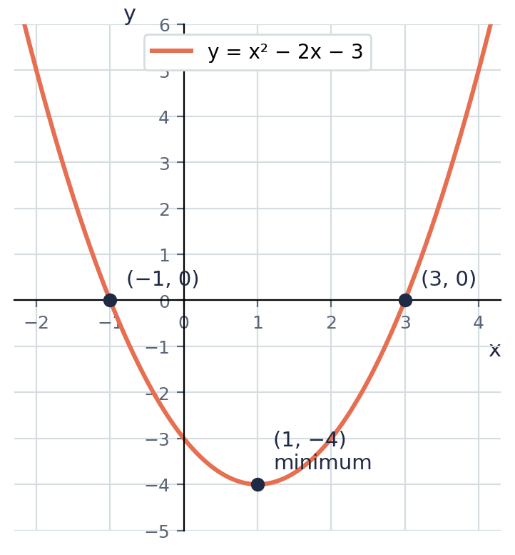

Example 4.2 · Checking against the graph
The graph shows y = x² − 2x − 3. Use it to confirm the solutions to x² − 2x − 3 = 0 from the previous example.
Solution
1. The solutions of x² − 2x − 3 = 0 are the x-values where the curve crosses the x-axis (where y = 0).
2. The graph crosses the x-axis at x = −1 and x = 3, matching the algebraic answer.
3. The turning point (1, −4) is below the x-axis, which is why the curve crosses twice.
Answer: Confirmed

Example 4.3 · Checking against factorizing (Unit 4)
Solve x² − 2x − 3 = 0 by factorizing, and compare with the completing-the-square answer.
Solution
1. x² − 2x − 3 = (x − 3)(x + 1).
2. (x − 3)(x + 1) = 0 gives x = 3 or x = −1.
3. This matches the answer from completing the square exactly.
Answer: x = 3 or x = −1 (same answer, different method)
💭 Think: Completing the square and factorizing gave the same answer here because this equation happens to factorize neatly. When would you need completing the square instead of factorizing?

Example 4.4 · An equation that does not factorize neatly
Solve x² + 4x − 2 = 0 by completing the square, giving your answers to 2 decimal places.
Solution
1. Complete the square: h = 2, h² = 4, k = −2 − 4 = −6. So (x + 2)² − 6 = 0.
2. (x + 2)² = 6.
3. x + 2 = ±√6 ≈ ±2.449.
4. x ≈ −2 + 2.449 = 0.45, or x ≈ −2 − 2.449 = −4.45.
Answer: x ≈ 0.45 or x ≈ −4.45
💭 Think: Try to factorize x² + 4x − 2 using whole numbers. Why does it not work? This is exactly when completing the square is essential.

Example 4.5 · No real solution
Solve x² + 4x + 9 = 0 by completing the square. What happens?
Solution
1. Complete the square: h = 2, h² = 4, k = 9 − 4 = 5. So (x + 2)² + 5 = 0.
2. (x + 2)² = −5.
3. There is no real number whose square is negative, so there is no real solution.
Answer: No real solution
💭 Think: Look back at Lesson 3: the minimum value of x² + 4x + 9 is 5, which is positive. What does that tell you about whether the graph ever crosses the x-axis?

⚠ Common mistakes
- Forgetting the ± sign, and giving only one solution instead of two.
- Trying to take the square root of a negative number without recognising there is no real solution.
- Sign errors when moving from (x + h)² = m to x = −h ± √m.

④ Practice
Write your answers in your exercise book. Start at Level 1. If you get most of a level right, move on to the next one. The answers are at the back of the pack.

Level 1 · Foundation
1. Solve by taking square roots.
(a) (x − 2)² = 9
(b) (x + 1)² = 16
(c) (x − 5)² = 1
2. Solve x² + 2x + 1 = 0 by completing the square.
3. Solve x² − 6x + 5 = 0 by completing the square, then check by factorizing.

Level 2 · Developing
4. Solve each equation by completing the square.
(a) x² + 6x + 5 = 0
(b) x² − 4x − 12 = 0
(c) x² + 8x + 7 = 0
5. Solve x² − 2x − 5 = 0 by completing the square, giving your answers to 2 decimal places.
6. Solve x² + 4x − 1 = 0 by completing the square, giving exact answers involving a square root.
7. Show that x² + 2x + 5 = 0 has no real solution, using completing the square.

Level 3 · Think Deeper
8. Spot the error. Solving (x + 3)² = 25, Tariq wrote x + 3 = 5, so x = 2, and stopped. What did he miss? Give the full solution.
9. Explain. How does the sign of k in (x + h)² + k = 0 tell you, before doing any more work, whether the equation has a real solution?
10. Connect to Lesson 3. For y = x² + 4x + 9, you found in Lesson 3 that the minimum value is 5, which is positive. Without completing the square again, explain what this tells you about the solutions of x² + 4x + 9 = 0.
11. Create. Write a quadratic equation x² + bx + c = 0 that has no real solution, and one that has two real solutions. Justify each using the minimum value from Lesson 3.

Before you move on, say or write in one or two sentences: "I can explain why a quadratic equation sometimes has no real solution, using the idea of a minimum value."
How confident do I feel? ☐ Not yet ☐ Getting there ☐ Got it!

CSEC-Style Exam Practice
These questions are like the ones on CSEC Paper 2, and they use all four lessons. Try them under test conditions: no notes, and about 30 minutes. Show all your working.
1. Write x² + 10x + 3 in completed-square form.
2. y = x² − 8x + 19.
(a) Write y in completed-square form. [2 marks]
(b) State the minimum value of y and the value of x at which it occurs. [2 marks]
(c) State the equation of the axis of symmetry. [1 mark]
3. Solve x² + 6x − 7 = 0 by completing the square. Show all your working. [4 marks]
4. Solve x² − 4x − 3 = 0 by completing the square, giving your answers to 2 decimal places. [4 marks]
5. A ball is thrown, and its height in metres is modelled by h(t) = −t² + 6t + 1, so −h(t) = t² − 6t − 1, where t is the time in seconds.
(a) Rewrite t² − 6t − 1 in completed-square form. [2 marks]
(b) Hence state the maximum height reached by the ball and the time at which it occurs. [2 marks]

Self-Check Quiz: Am I Ready?
Answer all 10 questions without looking back at the lessons. Then check your answers and write your score in the box. The lesson number after each question tells you where to go back if you get it wrong.
1. What must be added to x² + 8x to complete the square? (Lesson 1)
A 64 B 16 C 4 D 8
2. x² + 6x + 9 in factorized form is… (Lesson 1)
A (x + 3)(x − 3) B (x + 6)(x + 3) C (x + 9)² D (x + 3)²
3. The completed-square form of x² + 4x + 9 is… (Lesson 2)
A (x + 2)² + 5 B (x + 4)² + 9 C (x + 2)² + 9 D (x + 2)² − 5
4. For x² − 6x + 1, the value of h in (x + h)² is… (Lesson 2)
A −6 B 3 C −3 D 6
5. y = (x + 4)² − 3. The minimum value of y is… (Lesson 3)
A 4 B −4 C −3 D 3
6. y = (x − 5)² + 2. The turning point is… (Lesson 3)
A (5, 2) B (5, −2) C (2, 5) D (−5, 2)
7. The axis of symmetry of y = (x + 1)² + 6 is… (Lesson 3)
A x = 6 B y = 6 C x = 1 D x = −1
8. To solve (x − 2)² = 25, the next correct step is… (Lesson 4)
A x = 25 + 2 B x − 2 = ±5 C x − 2 = 5 D x² = 27
9. Solving x² + 2x − 8 = 0 by completing the square gives (x + 1)² = 9, so x =… (Lesson 4)
A 2 or −4 B 3 or −1 C 9 or −9 D 8 or −8
10. For (x + 2)² + 7 = 0, we get (x + 2)² = −7. What does this mean? (Lesson 4)
A x = −2 B x = 7 C there is no real solution D x = ±7

My score | What it means
9–10 | Ready! You are ready for the next topic: Form 4 Mathematics.
6–8 | Nearly there. Look at the lesson number next to each question you missed. Redo the Level 2 practice for those lessons.
0–5 | Go back over the lessons for the questions you missed. Redo the Level 1 and Level 2 practice, watch the videos again, then retake this quiz.
My score: ______ / 10

Answers
Use these to check your work. If your answer is different, look for your mistake before you ask for help. Your teacher has the full worked solutions.

Warm-Up
1. x² + 10x + 25
2. x² − 8x + 16
3. (x + 4)²
4. 5, then 25
5. x = 7 or x = −7
6. 9

Lesson 1: What Completing the Square Means
Level 1 · Foundation
1. (a) 4, 16 (b) 6, 36 (c) 10, 100 (d) 3.5, 12.25
2. (a) 4 (b) 49 (c) 1
3. (x + 2)²
Level 2 · Developing
4. Side 4, area 16; completes (x + 4)²
5. (a) 64, (x + 8)² (b) 20.25, (x + 4.5)² (c) 2.25, (x + 1.5)²
6. Confirmed
7. 100
Level 3 · Think Deeper
8. She squared b instead of half of b. The correct value is (10/2)² = 25.
9. The gnomon is made of two rectangles, each of width b/2 (since together they use up the full b). The missing corner square has this same side length, b/2, so its area is (b/2)², not b² or b/2.
10. Sometimes. x² + 6x + 9 is a perfect square, (x + 3)², because 9 = (6/2)². x² + 6x + 11 is not, because 11 ≠ 9.
11. e.g. x² + 18x needs + 81 added, giving (x + 9)².

Lesson 2: Completing the Square for x² + bx + c
Level 1 · Foundation
1. (a) (x + 1)² + 4 (b) (x + 2)² − 3 (c) (x + 5)² − 22
2. (x − 2)² + 3
3. Confirmed
Level 2 · Developing
4. (a) (x + 3)² − 10 (b) (x − 5)² + 5 (c) (x + 4)² + 4 (d) (x − 1)² − 6
5. (x + 3.5)² − 10.25
6. (x − 1.5)² − 2.25
7. Confirmed
Level 3 · Think Deeper
8. He used h = 8 instead of h = −4 (half of −8, not 8), so the bracket sign is wrong. Correct: (x − 4)² − 11.
9. Writing (x + h)² already introduces an extra h² compared with x² + bx alone, so h² must be subtracted before adding the original constant c, giving k = c − h².
10. 2(x + 3)² − 13
11. e.g. x² − 6x + 2 → (x − 3)² − 7

Lesson 3: Using Completed-Square Form to Find the Minimum Value
Level 1 · Foundation
1. (a) min 6 at x = −2 (b) min 1 at x = 5 (c) min −3 at x = −1
2. Turning point (4, 7); axis of symmetry x = 4
3. Minimum value −7 at x = −3
Level 2 · Developing
4. (a) (x + 4)² + 4; min 4 at (−4, 4) (b) (x − 2)² − 5; min −5 at (2, −5) (c) (x + 1)² + 7; min 7 at (−1, 7)
5. Minimum value 4; axis of symmetry x = 6
6. Minimum P = −25 at x = 10; a negative minimum means the model predicts a loss of $25 at that number of items.
7. Maximum area 100 m², when x = 10 m
Level 3 · Think Deeper
8. She used the same sign as in the bracket. The bracket is zero when x = −5, so the turning point is (−5, −2).
9. A squared real number can never be negative, so (x + h)² ≥ 0 always. Its smallest possible value is 0, giving y = 0 + k = k as the smallest possible value of y.
10. Sometimes. y = x² + 6x + 9 = (x + 3)² has minimum value 0 (not negative). y = x² + 6x + 20 = (x + 3)² + 11 has minimum value 11 (positive). Whether it is negative depends on c compared with h².
11. Minimum value is always −(b/2)², which is 0 or negative for every b. For b = 6: −9. For b = 10: −25.

Lesson 4: Solving Quadratic Equations by Completing the Square
Level 1 · Foundation
1. (a) x = 5 or x = −1 (b) x = 3 or x = −5 (c) x = 6 or x = 4
2. x = −1 (a repeated solution)
3. x = 5 or x = 1
Level 2 · Developing
4. (a) x = −1 or x = −5 (b) x = 6 or x = −2 (c) x = −1 or x = −7
5. x ≈ 3.45 or x ≈ −1.45
6. x = −2 + √5 or x = −2 − √5
7. No real solution
Level 3 · Think Deeper
8. He forgot the negative square root. x + 3 = ±5, so x = 2 or x = −8.
9. Rearranging gives (x + h)² = −k. Since a square cannot be negative, this only has a solution when −k ≥ 0, i.e. when k ≤ 0.
10. Since the minimum value of y is 5 (always positive), y = x² + 4x + 9 is never equal to 0, so the equation x² + 4x + 9 = 0 has no real solution.
11. e.g. No real solution: x² + 2x + 10 = 0 (minimum value 9, positive). Two real solutions: x² + 2x − 10 = 0 (minimum value −11, negative).

CSEC-Style Exam Practice
1. (x + 5)² − 22
2. (a) (x − 4)² + 3 (b) minimum 3 at x = 4 (c) x = 4
3. x = 1 or x = −7
4. x ≈ 4.65 or x ≈ −0.65
5. (a) (t − 3)² − 10 (b) Maximum height 10 m at t = 3 s

Self-Check Quiz
Q | Answer | Why
1 | B | Half of 8 is 4, and 4² = 16.
2 | D | Half of 6 is 3, and 3² = 9 matches the constant term.
3 | A | h = 2, h² = 4, k = 9 − 4 = 5.
4 | C | h = half of b = half of −6 = −3.
5 | C | The bracket is smallest (zero) when x = −4, leaving y = −3.
6 | A | The bracket is zero when x = 5, giving the point (5, 2).
7 | D | The axis of symmetry passes through the turning point, x = −1.
8 | B | Taking the square root of both sides gives two possible values, +5 and −5.
9 | A | x + 1 = ±3, so x = 2 or x = −4.
10 | C | No real number squares to a negative number.

