Clare Hall Secondary School · Mathematics Department

FORM 3 MATHEMATICS · UNIT 3
Inequalities
Self-Paced Learning Pack
Name: ______________________________________ Class: ___________
Time in class: 1 week School year: 2026–2027 Next topic: Unit 4: Changing the Subject of the Formula

What's inside
Section | What you will do
Before You Start | Warm up with the number facts you need
Lesson 1 | Inequality Symbols, Number Lines and Solution Sets
Lesson 2 | Solving Linear Inequalities
Lesson 3 | Compound Inequalities: ‘Between’ and ‘Or’
Lesson 4 | Graphing Linear Inequalities in Two Variables
Lesson 5 | Regions: Several Inequalities at Once
Exam Practice | CSEC-style questions that use all five lessons
Self-Check Quiz | 12 questions that show whether you are ready to move on
Answers | Check your work (at the back of the pack)

How to Use This Pack
- This pack lets you learn at your own pace. You can work ahead of the class or go back over anything you missed.
- Work through the lessons in order. Each lesson builds on the one before it.
- For each lesson: Read the key ideas → Watch the videos → Study the worked examples → Practise.
- Before you read the solution to a worked example, cover it and try the example yourself first. Then check each step.
- Practice has three levels. Level 1 (Foundation) checks the basics. Level 2 (Developing) makes you apply them. Level 3 (Think Deeper) asks you to explain, find mistakes and create your own examples.
- Check your answers at the back of the pack. If you get an answer wrong, find your mistake before you move on. A mistake you understand teaches you more than a correct guess.
- When you finish all the lessons, try the CSEC-Style Exam Practice, then the Self-Check Quiz. Your quiz score tells you whether you are ready for the next topic.

The learning route for every lesson
① Read the key ideas → ② Watch the videos → ③ Try the worked examples, then check each step → ④ Practise Level 1 → 2 → 3 → ⑤ Check your answers → ⑥ Tick your checklist

My Progress Checklist
Tick one box for each statement before you start and again after you finish. Be honest. This checklist is for you.
I can… | Not yet | Getting there | Got it!
Read and write inequalities using <, >, ≤ and ≥, and show them on a number line (Lesson 1) | ☐ | ☐ | ☐
Write solution sets in words, in set-builder notation and as lists of integers (Lesson 1) | ☐ | ☐ | ☐
Solve linear inequalities, including when the sign must be reversed (Lesson 2) | ☐ | ☐ | ☐
Solve compound (double) inequalities and 'or' inequalities, and show the answers on a number line (Lesson 3) | ☐ | ☐ | ☐
Graph linear inequalities in two variables and shade the solution region (Lesson 4) | ☐ | ☐ | ☐
Find and describe the region that satisfies several inequalities, and use it to solve word problems (Lesson 5) | ☐ | ☐ | ☐

Key Words
Symbol | Meaning | Example
inequality | a statement comparing two quantities that are not necessarily equal | 3x + 1 > 7
< > ≤ ≥ | less than; greater than; less than or equal to; greater than or equal to | x ≥ 2 means x is 2 or bigger
solution set | all the values that make an inequality true | {x : x > 2}
open circle ○ / closed circle ● | on a number line: open means the number is NOT included (< or >); closed means it IS included (≤ or ≥) | x ≤ 4 has a closed circle at 4
integer solutions | the whole-number solutions (positive, negative or zero) | −2 ≤ x < 2 gives −2, −1, 0, 1
compound (double) inequality | two inequalities joined together, such as a ‘between’ statement | −3 < x ≤ 5
boundary line | the line (from replacing the inequality sign with =) that separates the region from the rest of the graph | for y > x + 1 the boundary is y = x + 1
region (R) | the part of the graph where all the inequalities are true | shaded and labelled R

Before You Start: Warm-Up
This unit builds on solving equations from Unit 2, and on number lines, sets and graphs from earlier. Check you still have these skills.
1. Which is greater, −3 or −7?
2. Solve 2x + 5 = 17.
3. Solve 3x − 4 = 5x + 6.
4. List the whole numbers between −3 and 2 (not including −3 or 2).
5. Expand 3(x − 2).
6. Is the point (1, 3) on the line y = x + 2?
7. Where does the line y = 2x − 1 cross the y-axis?
8. Using U = {1, 2, 3, 4, 5, 6}, A = {1, 2, 3, 4} and B = {3, 4, 5, 6}, find A ∩ B.

Lesson 1: Inequality Symbols, Number Lines and Solution Sets
Building on: Unit 1: sets and set-builder notation. Earlier work on the number line and negative numbers.
Goal: By the end of this lesson I can read and write inequalities, show them on a number line, and describe a solution set in words, in set-builder notation and as a list of integers.

① Key Ideas
- An inequality compares two quantities that may not be equal. > means greater than, < means less than. The open end of the symbol always faces the bigger number.
- ≥ means greater than or equal to and ≤ means less than or equal to. These include the number itself: x ≥ 2 means x can be 2, 2.5, 7, and so on.
- Words to symbols: at least means ≥. At most and no more than mean ≤. More than means >. Fewer than and less than mean <.
- On a number line: use an open circle ○ when the number is NOT included (< or >) and a closed circle ● when it IS included (≤ or ≥). Draw a line from the circle in the direction of the solutions, with an arrow if it carries on forever.
- The solution set is all the values that make the inequality true. It can be written as an inequality (x > 2), in set-builder notation {x : x > 2} (read the set of all x such that x is greater than 2), or shown on a number line.
- The solution set depends on which numbers we are allowed to use. If U = {integers}, then {x : −2 ≤ x < 2} = {−2, −1, 0, 1}. If x can be any number, the set cannot be listed because it has infinitely many members.
- Negative numbers: the further left a number is on the number line, the smaller it is. So −5 < −2.

② Watch
Watch these videos after you have read the key ideas. Pause the video and try each example before it is solved. Online, click the link. On paper, type the short address into YouTube.
Video | What it covers | Link
Inequalities  Corbettmaths | What the symbols mean and how to write inequalities | Watch on YouTube  youtu.be/OjgdLu0JaZo
Inequalities on a number line  Corbettmaths | Open and closed circles and reading a number line | Watch on YouTube  youtu.be/3UUDyPOyKyc

③ Worked Examples
Cover the solution and try the example first. Then uncover one step at a time and compare it with your own working.
Example 1.1 · Words to symbols
Write each statement as an inequality. (a) x is greater than 4 (b) y is at most 10 (c) n is at least −3 (d) k is less than 0
Solution
1. (a) ‘greater than’ is >, so x > 4.
2. (b) ‘at most’ means 10 is the largest allowed, so y ≤ 10.
3. (c) ‘at least’ means −3 is the smallest allowed, so n ≥ −3.
4. (d) ‘less than’ is <, so k < 0.
Answer: (a) x > 4 (b) y ≤ 10 (c) n ≥ −3 (d) k < 0

Example 1.2 · Showing x > 2 on a number line
Show x > 2 on a number line.
Solution
1. 2 itself is not included, so draw an open circle at 2.
2. The solutions are bigger than 2, so draw the line to the right.
3. Add an arrow at the end because the solutions never stop.
Answer: Open circle at 2, line and arrow pointing right
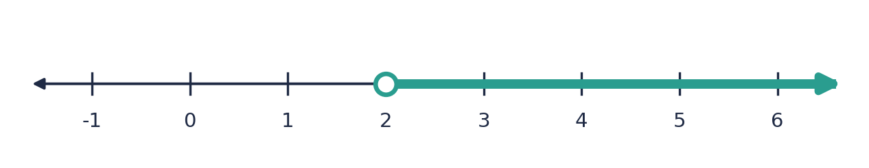

Example 1.3 · A closed circle
Show x ≤ −1 on a number line.
Solution
1. −1 is included (≤), so draw a closed circle at −1.
2. The solutions are smaller than −1, so the line goes to the left.
3. Add an arrow.
Answer: Closed circle at −1, line and arrow pointing left
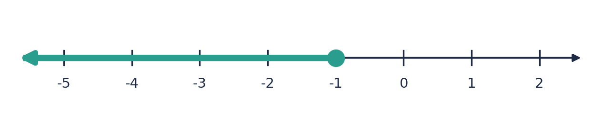

Example 1.4 · Between two numbers
Show −2 ≤ x < 3 on a number line.
Solution
1. Read it as ‘x is at least −2 and less than 3’.
2. −2 is included: closed circle at −2.
3. 3 is not included: open circle at 3.
4. Draw a line between the circles. There are no arrows, because the solutions stop at both ends.
Answer: Closed circle at −2, open circle at 3, line joining them
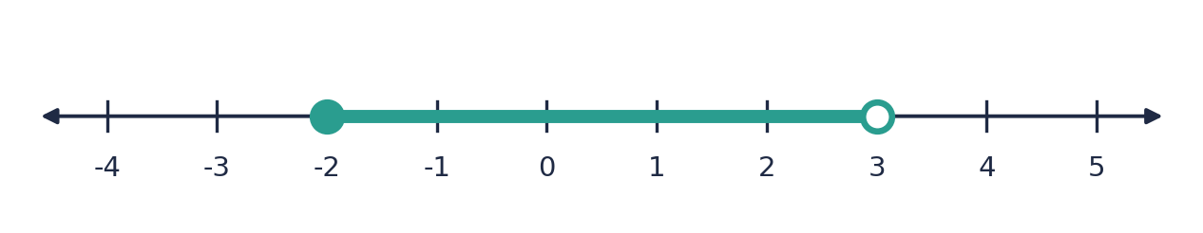

Example 1.5 · Reading a number line
Write the inequality shown on the number line.
Solution
1. The left circle is open at −1, so x is greater than −1.
2. The right circle is closed at 4, so x is less than or equal to 4.
3. Join them: −1 < x ≤ 4.
Answer: −1 < x ≤ 4
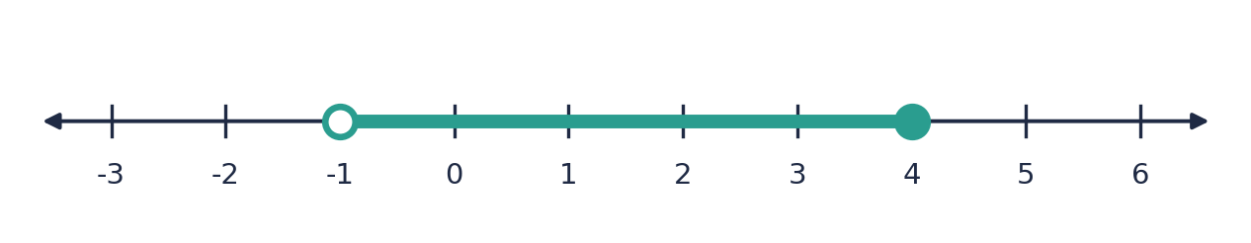
💭 Think: What would change in the answer if the circle at 4 were open instead?

Example 1.6 · Integer solutions
U = {integers}. List the solution set of −3 < x ≤ 2.
Solution
1. −3 is not included, so the smallest integer is −2.
2. 2 is included, so the largest integer is 2.
3. List every integer from −2 to 2.
Answer: {−2, −1, 0, 1, 2}

Example 1.7 · Set-builder notation
(a) Write {x : x ≥ 5} in words. (b) Which of 5, 4.9, 0 and 12 belong to {x : x < 4}?
Solution
1. (a) ‘The set of all x such that x is greater than or equal to 5’.
2. (b) Test each number against x < 4: 5 is not less than 4, 4.9 is not, 0 is, 12 is not.
Answer: (a) all numbers that are 5 or more (b) only 0

⚠ Common mistakes
- Using a closed circle for < or > (or an open circle for ≤ or ≥).
- Pointing the arrow the wrong way. x < 3 goes to the left, towards the smaller numbers.
- Thinking −5 is bigger than −2 because 5 is bigger than 2. On the number line, −5 is further left, so it is smaller.

④ Practice
Write your answers in your exercise book. Start at Level 1. If you get most of a level right, move on to the next one. The answers are at the back of the pack.

Level 1 · Foundation
1. Write each statement as an inequality.
(a) x is less than 7
(b) y is at least 12
(c) n is at most −2
(d) t is greater than or equal to 0
2. True or false?
(a) 5 > −8
(b) −3 ≥ −3
(c) −6 < −9
(d) 0.5 ≤ 0.05
3. Describe how you would show each inequality on a number line.
(a) x > 3
(b) x ≤ −2
(c) x < 0
4. Write the inequality shown by each number line.
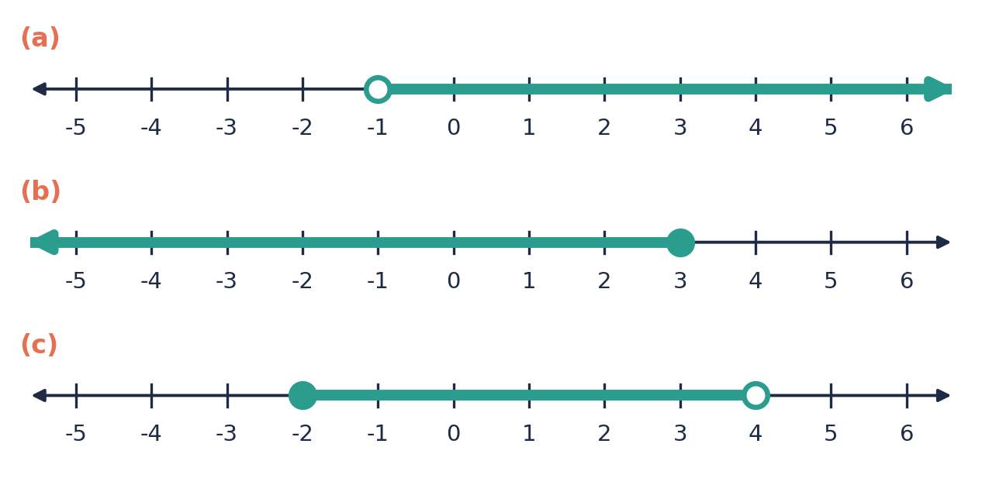

Level 2 · Developing
5. U = {integers}. List the solution set of each inequality.
(a) −2 ≤ x < 4
(b) 1 < x ≤ 5
(c) −4 < x < −1
6. Describe how you would show −1 < x ≤ 3 on a number line.
7. Write each set in set-builder notation.
(a) all numbers greater than 4
(b) all integers from −3 to 3, including both −3 and 3
8. A lift can carry at most 8 people. Write an inequality for p, the number of people, and say what values p can take.
9. U = {integers}. A = {x : −3 ≤ x < 2} and B = {x : x > −1, x ≤ 3}. List A, B and A ∩ B.

Level 3 · Think Deeper
10. Spot the error. Dana drew an open circle at 4 to show x ≥ 4. What is wrong, and what should she draw?
11. Explain. Why can we list the solutions of −2 < x < 3 if x is an integer, but not if x can be any number?
12. Always, sometimes or never? ‘If a > b, then −a > −b.’ Test it with a = 5, b = 2 and with a = −1, b = −4.
13. Create. Write an inequality whose integer solutions are exactly 2, 3, 4 and 5. Find a second, different inequality that gives the same integer solutions.
14. Investigate. How many integers satisfy −5 < x ≤ 5? How many satisfy −5 ≤ x ≤ 5? What do you notice, and how many integers satisfy a < x ≤ b if a and b are integers?

Before you move on, say or write in one or two sentences: "I can explain when to use an open circle and when to use a closed circle."
How confident do I feel? ☐ Not yet ☐ Getting there ☐ Got it!

Lesson 2: Solving Linear Inequalities
Building on: Lesson 1, and solving equations from Unit 2 (including brackets, fractions and unknowns on both sides).
Goal: By the end of this lesson I can solve a linear inequality, remember to reverse the sign when I multiply or divide by a negative number, and show my answer on a number line.

① Key Ideas
- Solve an inequality like an equation: do the same thing to both sides to get x on its own. The only change is the inequality sign instead of the = sign.
- Adding or subtracting any number, or multiplying or dividing by a positive number, keeps the sign the same.
- Multiplying or dividing by a negative number reverses the sign. < becomes >, ≤ becomes ≥, and so on. Reason: 2 < 5, but if we multiply by −1 we get −2 > −5.
- An alternative: move the x terms to the side where the coefficient of x is positive. Then you never divide by a negative. For 3 − 2x > 9, add 2x to both sides to get 3 > 9 + 2x, and carry on.
- Write the answer with x on the left: x > 3, not 3 < x (they mean the same thing, but x > 3 is clearer).
- Always check. Test a number from your solution (it should make the original true), a number outside it (it should make it false), and the boundary number (it should make the two sides equal).
- Problems may ask for the greatest or least integer that works. Solve first, then pick the integer carefully. The boundary is only a solution if the sign is ≤ or ≥.

② Watch
Watch these videos after you have read the key ideas. Pause the video and try each example before it is solved. Online, click the link. On paper, type the short address into YouTube.
Video | What it covers | Link
Solving inequalities  Corbettmaths | Solving linear inequalities, including reversing the sign | Watch on YouTube  youtu.be/-YcE_D78fGE

③ Worked Examples
Cover the solution and try the example first. Then uncover one step at a time and compare it with your own working.
Example 2.1 · One step
Solve x − 4 > 7.
Solution
1. Add 4 to both sides: x > 11.
2. Check with x = 12: 12 − 4 = 8 > 7 ✓
Answer: x > 11

Example 2.2 · Two steps
Solve 3x − 4 > 5 and show the answer on a number line.
Solution
1. Add 4 to both sides: 3x > 9.
2. Divide both sides by 3 (positive, so the sign stays): x > 3.
3. Check: x = 4 gives 12 − 4 = 8 > 5 ✓. x = 3 gives 5 > 5, which is false, so 3 is not included: open circle.
Answer: x > 3
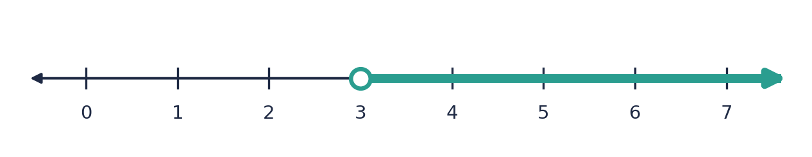

Example 2.3 · Dividing by a negative
Solve −2x ≥ 6 and show the answer on a number line.
Solution
1. Divide both sides by −2.
2. Dividing by a negative reverses the sign: ≥ becomes ≤.
3. x ≤ −3.
4. Check: x = −4 gives −2(−4) = 8 ≥ 6 ✓. x = 0 gives 0 ≥ 6 ✗.
Answer: x ≤ −3
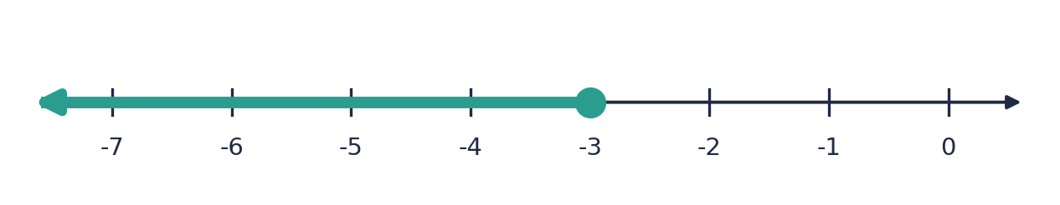
💭 Think: Why is the circle at −3 closed?

Example 2.4 · A negative coefficient and a constant
Solve 1 − 2x < 9.
Solution
1. Subtract 1 from both sides: −2x < 8.
2. Divide by −2 and reverse the sign: x > −4.
3. Check: x = 0 gives 1 − 0 = 1 < 9 ✓. x = −5 gives 1 + 10 = 11 < 9 ✗.
Answer: x > −4
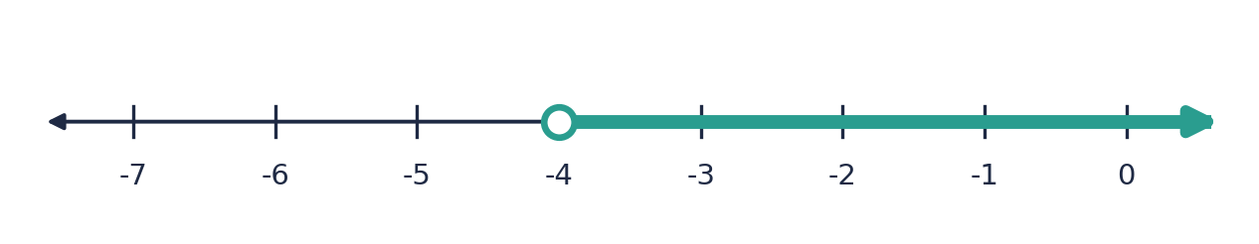

Example 2.5 · The alternative method
Solve 1 − 2x < 9 again without dividing by a negative.
Solution
1. Add 2x to both sides: 1 < 9 + 2x.
2. Subtract 9: −8 < 2x.
3. Divide by 2: −4 < x, which is the same as x > −4.
Answer: x > −4 (same answer, no reversing needed)
💭 Think: Which method do you prefer? Why might the second one be safer?

Example 2.6 · x on both sides
Solve 5x − 3 ≤ 2x + 9.
Solution
1. Subtract 2x from both sides: 3x − 3 ≤ 9.
2. Add 3: 3x ≤ 12.
3. Divide by 3: x ≤ 4.
Answer: x ≤ 4

Example 2.7 · Brackets
Solve 2(3x − 1) ≥ 4x + 6.
Solution
1. Expand: 6x − 2 ≥ 4x + 6.
2. Subtract 4x: 2x − 2 ≥ 6.
3. Add 2: 2x ≥ 8.
4. Divide by 2: x ≥ 4.
Answer: x ≥ 4

Example 2.8 · Fractions
Solve (2x − 1)/3 > 3.
Solution
1. Multiply both sides by 3 (positive): 2x − 1 > 9.
2. Add 1: 2x > 10.
3. Divide by 2: x > 5.
Answer: x > 5

Example 2.9 · Greatest integer
Find the greatest integer x that satisfies 4x + 3 < 30.
Solution
1. Subtract 3: 4x < 27.
2. Divide by 4: x < 6.75.
3. The integers less than 6.75 are …, 5, 6. The greatest is 6.
Answer: 6
💭 Think: What would the answer be if the question said 4x + 3 ≤ 27?

Example 2.10 · A word problem
A taxi charges $5 plus $2.50 per kilometre. Sam has $30. What distances can Sam travel?
Solution
1. Let d be the distance in km. The cost is 5 + 2.5d.
2. Sam can spend at most $30, so 5 + 2.5d ≤ 30.
3. Subtract 5: 2.5d ≤ 25.
4. Divide by 2.5: d ≤ 10.
Answer: Sam can travel up to 10 km (0 ≤ d ≤ 10)

⚠ Common mistakes
- Not reversing the sign when multiplying or dividing by a negative number. This is the most common mistake in the unit.
- Reversing the sign when it is not needed, for example when dividing by a positive number.
- Forgetting that −x > 3 means x < −3: the −x must become +x, which means multiplying by −1.
- Writing the boundary with the wrong circle. The boundary is only included when the sign is ≤ or ≥.

④ Practice
Write your answers in your exercise book. Start at Level 1. If you get most of a level right, move on to the next one. The answers are at the back of the pack.

Level 1 · Foundation
1. Solve each inequality.
(a) x + 3 > 7
(b) x − 5 ≤ 2
(c) 4x < 20
(d) x/2 ≥ 3
2. Solve each inequality.
(a) 2x + 1 > 9
(b) 3x − 2 ≤ 10
(c) 5x + 4 < 24
3. Solve 3x − 1 ≥ 8. Which of the numbers 0, 2 and 5 are solutions?

Level 2 · Developing
4. Solve each inequality.
(a) 4x − 7 ≥ 13
(b) 7 − x > 3
(c) 2 − 3x ≤ 11
(d) 5 − 2x > 1
5. Solve each inequality.
(a) 5x + 2 > 3x + 10
(b) 4x − 1 ≤ 7x + 8
(c) 3x + 7 < 5x − 1
6. Solve each inequality.
(a) 2(x + 3) < 14
(b) 3(2x − 1) ≥ 15
(c) 5(x − 2) > 2(x + 4)
7. Solve 3x − 5 < 10 and list the positive integer solutions.
8. Solve each inequality.
(a) (2x + 1)/3 ≤ 5
(b) (x − 2)/4 > 1
9. A bus hire costs $120 plus $8 for each student. The school can spend at most $400. Write an inequality and find the greatest number of students.

Level 3 · Think Deeper
10. Spot the error. To solve 5 − 2x > 11, Kemi wrote −2x > 6, so x > −3. Find her mistake and give the correct answer.
11. Explain. Use the numbers 2 and 5 to explain why the sign reverses when you multiply both sides by a negative number.
12. Two methods. Alex solves 3 − 2x ≥ 7 by dividing by −2. Bea adds 2x to both sides first. Do both methods and show they agree.
13. Always, sometimes or never? ‘The solution of ax + b > c is x > (c − b) ÷ a.’ Test with 2x + 1 > 7 and −2x + 1 > 7.
14. Create. Write an inequality with x on both sides, where the x term must be divided by a negative number, whose solution is x < 2.
15. Challenge. (a) Find the least integer n such that 6 − 4n < −20. (b) Find the greatest integer x such that 3x + 4 ≥ 8x − 12.

Before you move on, say or write in one or two sentences: "I can explain why the inequality sign reverses when I divide by a negative number."
How confident do I feel? ☐ Not yet ☐ Getting there ☐ Got it!

Lesson 3: Compound Inequalities: ‘Between’ and ‘Or’
Building on: Lessons 1–2, and Unit 1: intersection (∩) and union (∪) of sets.
Goal: By the end of this lesson I can solve a compound (double) inequality, solve an ‘or’ inequality, list integer solutions, and show the answers on a number line.

① Key Ideas
- A compound (double) inequality such as −3 < 2x + 1 ≤ 9 says that 2x + 1 is between two numbers. It means both −3 < 2x + 1 and 2x + 1 ≤ 9.
- Solve it by doing the same thing to all three parts. Subtract 1 from every part: −4 < 2x ≤ 8. Divide every part by 2: −2 < x ≤ 4.
- If you multiply or divide all three parts by a negative number, reverse both signs. Then rewrite so the smaller number is on the left.
- If x appears in more than one part, split it into two inequalities, solve each, and combine them with ‘and’.
- ‘And’ means the solution must satisfy both inequalities (the intersection ∩). ‘Or’ means it can satisfy either one (the union ∪).
- An ‘or’ inequality gives two separate pieces on the number line. It cannot be written as one chain, such as x < 2 or x ≥ 6.
- Sometimes ‘and’ gives no solution: x > 5 and x < 2 cannot both be true, so the solution set is empty (∅).

② Watch
Watch these videos after you have read the key ideas. Pause the video and try each example before it is solved. Online, click the link. On paper, type the short address into YouTube.
Video | What it covers | Link
Solving Inequalities with Two Signs  Corbettmaths | Solving a double inequality | Watch on YouTube  youtu.be/zTXiZ6SiiUs
How To Solve Compound Inequalities  The Organic Chemistry Tutor | ‘And’ and ‘or’ compound inequalities | Watch on YouTube  youtu.be/msiceXvwriE

③ Worked Examples
Cover the solution and try the example first. Then uncover one step at a time and compare it with your own working.
Example 3.1 · A double inequality
Solve −3 < 2x + 1 ≤ 9 and show the answer on a number line.
Solution
1. Subtract 1 from all three parts: −4 < 2x ≤ 8.
2. Divide all three parts by 2: −2 < x ≤ 4.
3. −2 is not included (open circle); 4 is included (closed circle).
Answer: −2 < x ≤ 4
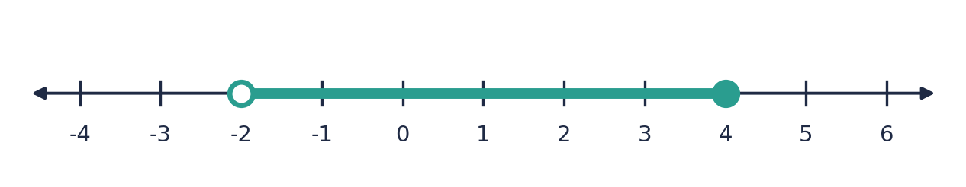

Example 3.2 · Integer solutions
Solve 4 ≤ 3x − 2 < 13 and list the integer solutions.
Solution
1. Add 2 to all parts: 6 ≤ 3x < 15.
2. Divide all parts by 3: 2 ≤ x < 5.
3. The integers from 2 (included) to 5 (excluded) are 2, 3, 4.
Answer: 2 ≤ x < 5; integers 2, 3, 4

Example 3.3 · Dividing by a negative
Solve −6 < −2x ≤ 4.
Solution
1. Divide all three parts by −2.
2. Reverse both signs: 3 > x ≥ −2.
3. Rewrite with the smaller number on the left: −2 ≤ x < 3.
4. Check x = 0: −2(0) = 0, which is between −6 and 4 ✓.
Answer: −2 ≤ x < 3
💭 Think: Why did the 3 end up with the open circle even though 4 had ≤ in the original?

Example 3.4 · x in two places
Solve 2x − 1 < x + 7 ≤ 3x + 1.
Solution
1. Split into two: 2x − 1 < x + 7 and x + 7 ≤ 3x + 1.
2. First: subtract x, then add 1: x < 8.
3. Second: subtract x and 1: 6 ≤ 2x, so x ≥ 3.
4. Both must be true (and): 3 ≤ x < 8.
Answer: 3 ≤ x < 8

Example 3.5 · An ‘or’ inequality
Solve 2x − 1 < 3 or x + 4 ≥ 10 and show the answer on a number line.
Solution
1. First: 2x < 4, so x < 2.
2. Second: x ≥ 6.
3. ‘Or’ means either: x < 2 or x ≥ 6.
4. Two separate pieces on the number line: an arrow left from an open circle at 2, and an arrow right from a closed circle at 6.
Answer: x < 2 or x ≥ 6
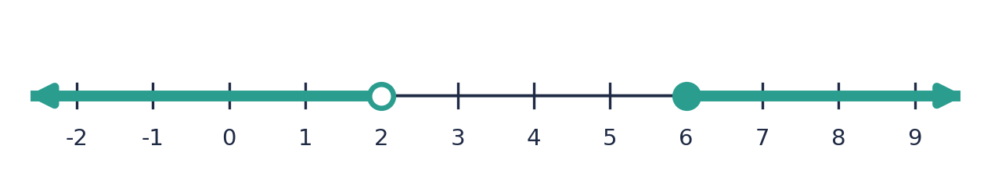

Example 3.6 · Inequalities and sets
U = {x : x is an integer, −4 ≤ x ≤ 5}, A = {x : x < 3} and B = {x : x ≥ −1}, both within U. List A, B, A ∩ B and A ∪ B.
Solution
1. A: integers in U that are less than 3: {−4, −3, −2, −1, 0, 1, 2}.
2. B: integers in U that are at least −1: {−1, 0, 1, 2, 3, 4, 5}.
3. A ∩ B (in both): {−1, 0, 1, 2}. This is the ‘and’ answer: −1 ≤ x < 3.
4. A ∪ B (in either): every element of U, since A and B together cover U.
Answer: A ∩ B = {−1, 0, 1, 2}; A ∪ B = U

Example 3.7 · No solution
Solve x > 5 and x < 2.
Solution
1. A number bigger than 5 cannot also be smaller than 2.
2. No number satisfies both, so the solution set is empty: ∅.
Answer: No solution (∅)
💭 Think: Compare with x > 5 or x < 2. What is the solution to that?

⚠ Common mistakes
- Doing the operation to the middle only. In 4 ≤ 3x − 2 < 13, the 4 and the 13 must also change.
- Not reversing both signs when dividing by a negative.
- Writing an impossible chain such as 5 < x < 2. If the numbers are the wrong way round, the answer is probably ‘or’, or there is no solution.
- Mixing up ‘and’ and ‘or’. ‘And’ gives one connected piece; ‘or’ usually gives two separate pieces.

④ Practice
Write your answers in your exercise book. Start at Level 1. If you get most of a level right, move on to the next one. The answers are at the back of the pack.

Level 1 · Foundation
1. Write each statement as one inequality.
(a) x is greater than −2 and less than 5
(b) x is at least 3 and less than 8
(c) x is more than 0 and at most 10
2. Solve each inequality.
(a) 3 < x + 2 < 8
(b) 2 ≤ x − 1 ≤ 6
(c) −4 < x + 3 ≤ 1
3. U = {integers}. List the integer solutions.
(a) 1 < x ≤ 5
(b) −3 ≤ x < 1
(c) −5 < x < −2

Level 2 · Developing
4. Solve each inequality.
(a) 5 < 2x + 1 < 13
(b) −2 ≤ 3x − 5 ≤ 7
(c) 0 < 4x + 8 ≤ 20
(d) 1 < (x + 1)/2 ≤ 4
5. Solve −7 < 3x − 1 ≤ 8 and list the integer solutions.
6. Solve each inequality.
(a) −4 < −2x ≤ 6
(b) 3 ≥ 5 − x > −1
7. Solve each ‘or’ inequality.
(a) 3x + 1 < 7 or 2x − 3 ≥ 9
(b) x − 4 ≤ −3 or 2x > 10
8. U = {x : x is an integer, 1 ≤ x ≤ 10}, A = {x : x > 3} and B = {x : x ≤ 7}. List A, B, A ∩ B and A ∪ B.

Level 3 · Think Deeper
9. Spot the error. Leon solved −8 < −4x ≤ 12 and wrote 2 < x ≤ −3. Explain why this cannot be right and give the correct answer.
10. Explain. What is the difference between ‘x > 2 and x < 5’ and ‘x < 2 or x > 5’? Show each on a number line.
11. Always, sometimes or never? ‘The compound inequality a < x < b (with a < b) has at least one integer solution.’
12. Create. Write a double inequality of the form p < 2x + 3 < q whose only integer solutions are 1, 2, 3 and 4.
13. Challenge. x is a prime number that satisfies 5 < 3x − 1 < 20. Find all possible values of x.
14. Investigate. How many integers satisfy k < x ≤ k + 3 when k = 1.5? When k = 2.5? Try other values. What do you notice?

Before you move on, say or write in one or two sentences: "I can explain the difference between ‘and’ and ‘or’ in a compound inequality."
How confident do I feel? ☐ Not yet ☐ Getting there ☐ Got it!

Lesson 4: Graphing Linear Inequalities in Two Variables
Building on: Lessons 1–2, and drawing straight-line graphs (Form 2 and Unit 2).
Goal: By the end of this lesson I can draw the boundary line of an inequality, decide whether it is solid or dashed, and shade the region that satisfies it.

① Key Ideas
- An inequality in x and y, such as y > 2x − 1, is satisfied by many points (x, y). Together they form a region of the graph, not just a single line.
- Step 1: draw the boundary line. Replace the inequality sign with = and draw that line. Use the intercepts (set x = 0, then y = 0) or the gradient and y-intercept.
- Solid or dashed? Points on the line are solutions only for ≤ and ≥, so draw a solid line. For < and >, draw a dashed line.
- Step 2: choose a test point that is not on the line. (0, 0) is easiest. Put it in the inequality: if it is true, shade the side with the test point. If it is false, shade the other side.
- Step 3: shade the required region (and label it R). Check with one more point from the shaded region.
- Vertical and horizontal lines: x > 2 is the region to the right of the vertical line x = 2. y ≤ 3 is the region below the horizontal line y = 3.
- Shortcut: when y is on its own on the left, y > … is the region above the line, and y < … is below. Be careful: if you divide by a negative number, the sign reverses (Lesson 2).
- Exam convention: in this pack we shade the region we want. Some exam questions ask you to shade the unwanted region instead, so that R is left clear. Always read the question.

② Watch
Watch these videos after you have read the key ideas. Pause the video and try each example before it is solved. Online, click the link. On paper, type the short address into YouTube.
Video | What it covers | Link
Graphical Inequalities part 1  Corbettmaths | Drawing the boundary line and shading the region | Watch on YouTube  youtu.be/39tsiUFCd4c
Graphical Inequalities part 2  Corbettmaths | More graphical inequalities | Watch on YouTube  youtu.be/DCQY8Dyce4k

③ Worked Examples
Cover the solution and try the example first. Then uncover one step at a time and compare it with your own working.
Example 4.1 · y ≥ x + 1 (solid line)
Show the region y ≥ x + 1 on a graph.
Solution
1. Boundary: y = x + 1, passing through (0, 1) and (−1, 0).
2. The sign is ≥, so draw a solid line.
3. Test (0, 0): 0 ≥ 0 + 1 is false, so (0, 0) is not in the region.
4. Shade the other side of the line, which is above it.
Answer: A solid line y = x + 1, with the region above it shaded
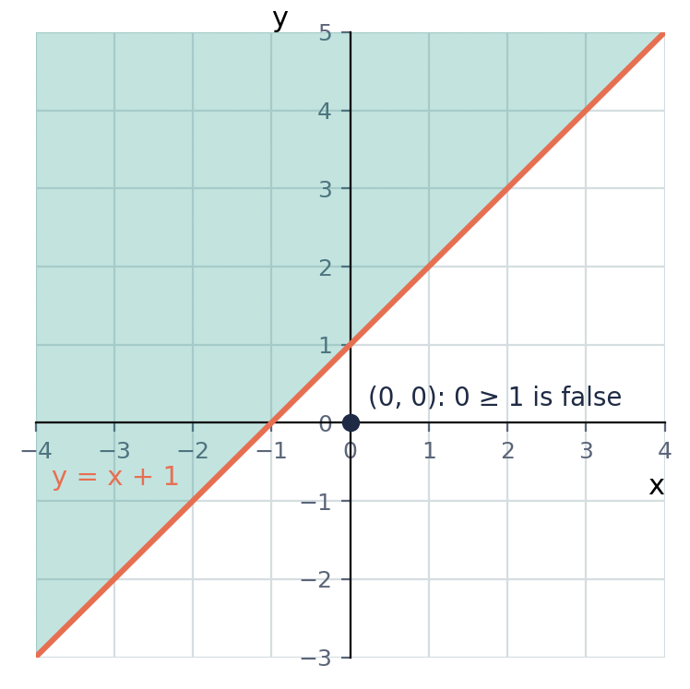

Example 4.2 · y < −x + 3 (dashed line)
Show the region x + y < 3 on a graph.
Solution
1. Boundary: x + y = 3, passing through (3, 0) and (0, 3).
2. The sign is <, so draw a dashed line.
3. Test (0, 0): 0 + 0 < 3 is true, so shade the side that contains (0, 0).
4. That is the side below and to the left of the line.
Answer: A dashed line x + y = 3, with the region containing (0, 0) shaded
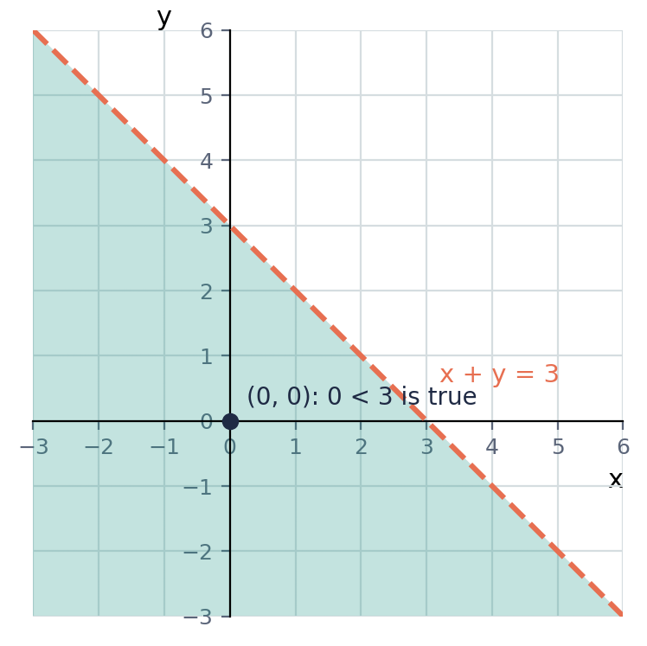

Example 4.3 · A vertical boundary
Show the region x > 2 on a graph.
Solution
1. The boundary is the vertical line x = 2.
2. The sign is >, so the line is dashed.
3. x > 2 means the x-coordinates are bigger than 2, so shade the right-hand side.
Answer: A dashed vertical line x = 2, with the region to the right shaded
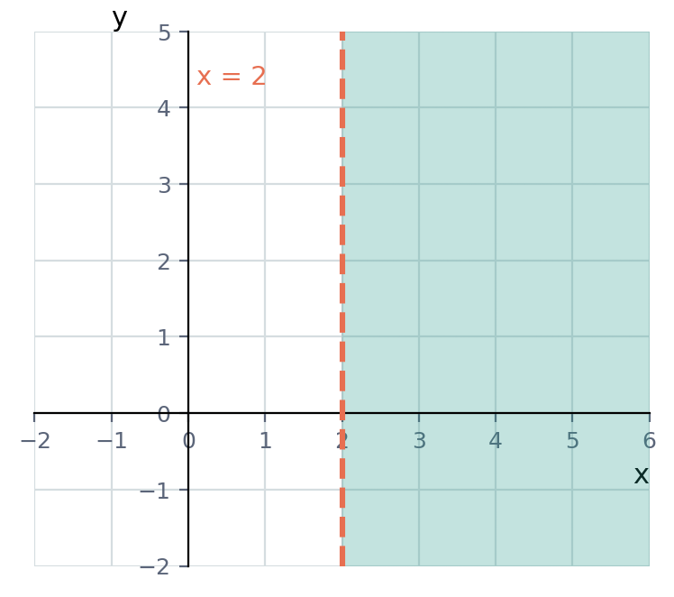

Example 4.4 · Using intercepts
Show the region 2x + 3y ≤ 12 on a graph.
Solution
1. Find the intercepts of 2x + 3y = 12. When x = 0, y = 4. When y = 0, x = 6.
2. Draw a solid line through (0, 4) and (6, 0), because the sign is ≤.
3. Test (0, 0): 0 ≤ 12 is true, so shade the side containing the origin.
Answer: A solid line through (0, 4) and (6, 0), with the origin side shaded
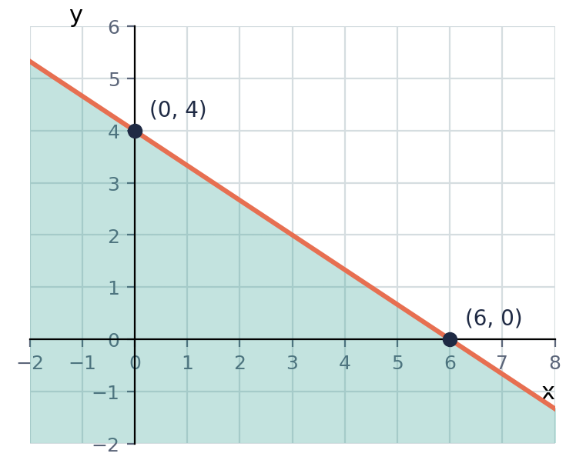

Example 4.5 · Checking points
Which of (3, 4), (1, 1) and (0, 3) satisfy y > 2x − 1?
Solution
1. (3, 4): 2(3) − 1 = 5, and 4 > 5 is false.
2. (1, 1): 2(1) − 1 = 1, and 1 > 1 is false. The point is on the dashed line, so it is not included.
3. (0, 3): 2(0) − 1 = −1, and 3 > −1 is true.
Answer: Only (0, 3)
💭 Think: (1, 1) would be a solution if the inequality were y ≥ 2x − 1. Why?

Example 4.6 · When y has a negative coefficient
Show the region x − 2y > 4 on a graph.
Solution
1. Boundary: x − 2y = 4. When x = 0, y = −2. When y = 0, x = 4.
2. The sign is >, so draw a dashed line through (0, −2) and (4, 0).
3. Test (0, 0): 0 − 0 > 4 is false, so shade the side that does not contain the origin.
4. That is the region below the line. (Rearranging gives y < ½x − 2: dividing by −2 reversed the sign.)
Answer: A dashed line through (0, −2) and (4, 0), with the region below it shaded
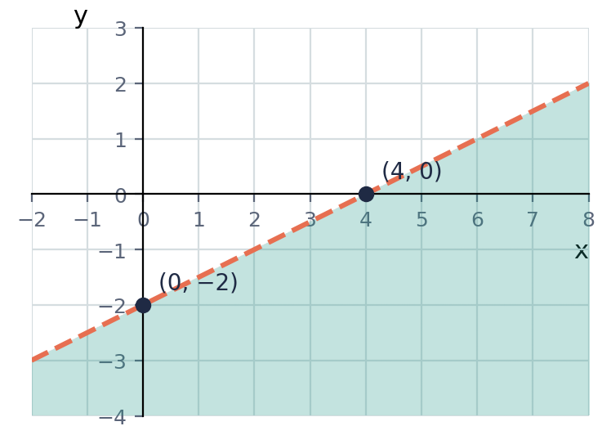
💭 Think: A test point avoids having to remember to reverse the sign. Does it give the same answer as rearranging?

⚠ Common mistakes
- Using a solid line for < or > (or a dashed line for ≤ or ≥).
- Shading the wrong side. Always check with a test point.
- Using (0, 0) as the test point when the line passes through the origin. Choose another point, such as (1, 0) or (0, 1).
- Shading ‘above’ automatically. After rearranging, a negative coefficient of y reverses the sign.

④ Practice
Write your answers in your exercise book. Start at Level 1. If you get most of a level right, move on to the next one. The answers are at the back of the pack.

Level 1 · Foundation
1. Say whether the boundary line is solid or dashed.
(a) y > 3x
(b) y ≤ x − 2
(c) x + y ≥ 5
(d) 2x − y < 4
2. Is each point a solution of y ≥ 2x + 1?
(a) (0, 3)
(b) (2, 4)
(c) (1, 3)
(d) (−1, −1)
3. Without drawing, describe which side is shaded.
(a) y > x + 2
(b) y ≤ x + 2
(c) x > 3
(d) y < 1

Level 2 · Developing
4. Draw a graph and shade the region for each inequality.
(a) y > x − 1
(b) y ≤ 2x + 1
(c) x + y < 4
5. Show the region 3x + 2y ≥ 12 on a graph. State the intercepts, the type of line and the side you shade.
6. Write the inequality for the shaded region.
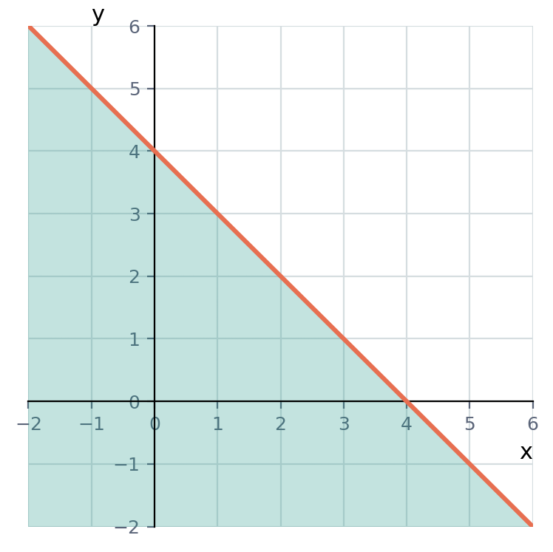
7. Write each statement as an inequality in x and y.
(a) the sum of x and y is more than 6
(b) y is less than 3 more than x
(c) y is at least twice x
8. Rearrange each inequality to make y the subject, then say which side of the boundary is shaded.
(a) 2y > 6x − 4
(b) 2x + y ≤ 5
(c) y − 3x ≥ 1

Level 3 · Think Deeper
9. Spot the error. Mia graphed y < x + 1 with a solid line and shaded above the line. Find two mistakes.
10. Explain. Why can you not use (0, 0) as the test point for y ≥ 2x? Show how to find the correct side.
11. Always, sometimes or never? ‘The region ax + by ≥ c always lies above the line ax + by = c.’ Test with x + y ≥ 4 and x − y ≥ 1.
12. Create. Write two different inequalities that the point (1, 2) satisfies, where (1, 2) lies on the boundary line of one of them.
13. Challenge. The point (a, 3) satisfies 2x + y < 9. Find the possible values of a.
14. Investigate. How many points with integer coordinates satisfy x ≥ 1, y ≥ 1 and x + y ≤ 4? List them.

Before you move on, say or write in one or two sentences: "I can explain how a test point tells me which side of the line to shade."
How confident do I feel? ☐ Not yet ☐ Getting there ☐ Got it!

Lesson 5: Regions: Several Inequalities at Once
Building on: Lessons 1–4, and Unit 1: intersection of sets.
Goal: By the end of this lesson I can find the region that satisfies several inequalities, write inequalities for a given region, list integer points in it, and use it to solve word problems.

① Key Ideas
- When there are several inequalities, the solution is the region where all of them are true at the same time: the overlap (intersection ∩) of the individual regions.
- Method: (1) Draw each boundary line, solid or dashed. (2) For each one, decide which side is wanted using a test point. (3) The required region R is where all the wanted sides overlap. Label it R.
- Corners (vertices) of R are where two boundary lines meet. Find them by solving the two boundary equations together, or read them off when one line is horizontal or vertical.
- Writing inequalities from a region: find the equation of each boundary line, decide solid or dashed, then test a point inside R to choose the correct sign.
- In real-life problems, quantities cannot be negative, so we often need x ≥ 0 and y ≥ 0. If x and y count whole objects, only the integer points inside R are possible answers.
- ‘At most’ and ‘no more than’ give ≤. ‘At least’ gives ≥. These are the same words as in Lesson 1.
- A region might be empty: if the conditions contradict each other, there are no points that satisfy all of them.

② Watch
Watch these videos after you have read the key ideas. Pause the video and try each example before it is solved. Online, click the link. On paper, type the short address into YouTube.
Video | What it covers | Link
Inequalities and Regions on Graphs  Corbettmaths | Finding the region that satisfies several inequalities | Watch on YouTube  youtu.be/aexvnpH-jhI

③ Worked Examples
Cover the solution and try the example first. Then uncover one step at a time and compare it with your own working.
Example 5.1 · Finding region R
Show the region R that satisfies x ≥ 1, y ≥ 1 and x + y ≤ 6, and label its vertices.
Solution
1. Draw x = 1 (solid vertical), y = 1 (solid horizontal) and x + y = 6 (solid, through (6, 0) and (0, 6)).
2. x ≥ 1: to the right of x = 1. y ≥ 1: above y = 1. x + y ≤ 6: the origin side (0 ≤ 6 is true).
3. R is the triangle where all three overlap.
4. Vertices: (1, 1) where x = 1 meets y = 1; (1, 5) where x = 1 meets x + y = 6; (5, 1) where y = 1 meets x + y = 6.
Answer: A triangle R with vertices (1, 1), (1, 5) and (5, 1)
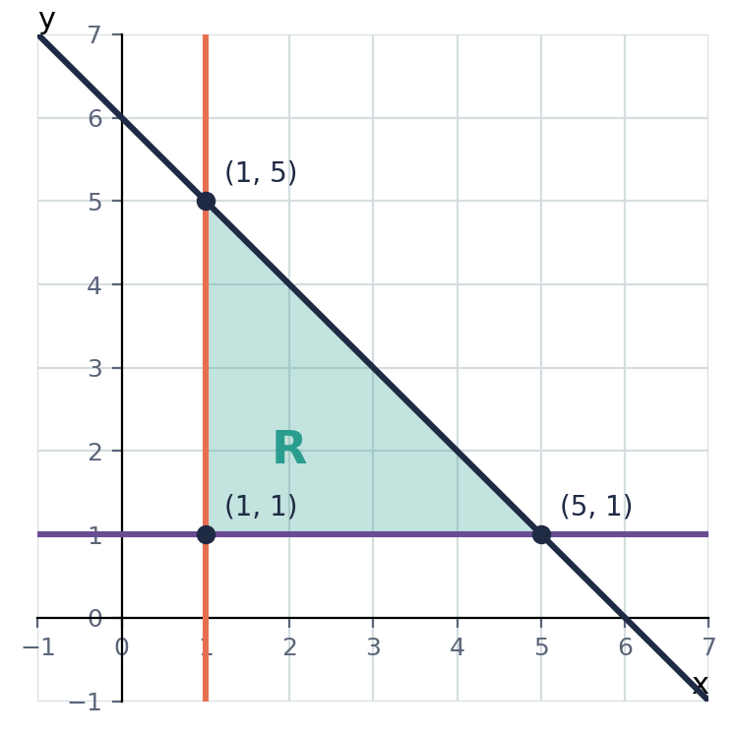

Example 5.2 · Is the point in R?
Using the region in the previous example, decide whether (2, 3) and (4, 3) are in R.
Solution
1. (2, 3): 2 ≥ 1 ✓, 3 ≥ 1 ✓, 2 + 3 = 5 ≤ 6 ✓. All three are true, so (2, 3) is in R.
2. (4, 3): 4 ≥ 1 ✓, 3 ≥ 1 ✓, 4 + 3 = 7 ≤ 6 ✗. One fails, so (4, 3) is not in R.
Answer: (2, 3) is in R; (4, 3) is not

Example 5.3 · Integer points in R
How many points with integer coordinates are in R (including the boundary)?
Solution
1. x = 1: y = 1, 2, 3, 4, 5 (5 points).
2. x = 2: y = 1 to 4 (4 points).
3. x = 3: 3 points. x = 4: 2 points. x = 5: 1 point.
4. Total: 5 + 4 + 3 + 2 + 1 = 15.
Answer: 15 points
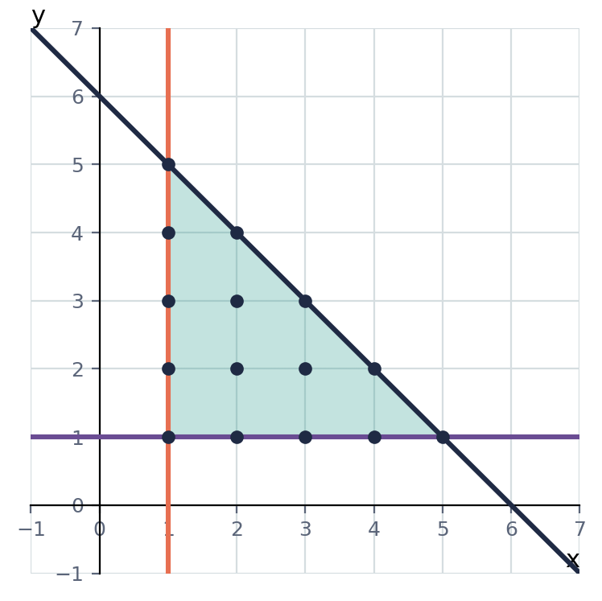

Example 5.4 · Writing inequalities from a region
Write three inequalities that define the region R shown.
Solution
1. The top boundary is the solid horizontal line y = 4. R is below it: y ≤ 4.
2. The left boundary is the solid y-axis, x = 0. R is to the right: x ≥ 0.
3. The diagonal boundary is the dashed line y = x. A point inside R, such as (1, 3), has y > x.
4. Dashed means strict: y > x.
Answer: x ≥ 0, y ≤ 4, y > x
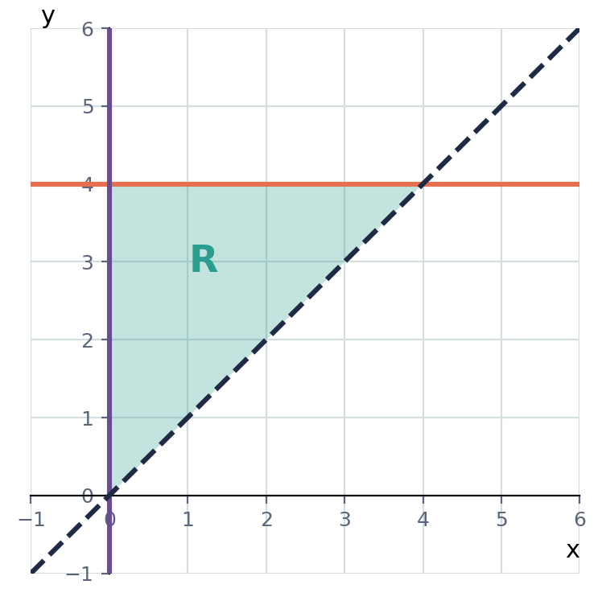
💭 Think: How do you know the diagonal boundary has to be dashed?

Example 5.5 · A word problem
Maria buys x notebooks at $2 each and y pens at $1 each. She spends at most $10, buys at least 1 notebook and at least 2 pens. Write the inequalities. List all the possible (x, y) when she buys 2 notebooks, and say how many combinations there are in total.
Solution
1. Spending: 2x + y ≤ 10. At least 1 notebook: x ≥ 1. At least 2 pens: y ≥ 2.
2. If x = 2: 4 + y ≤ 10, so y ≤ 6. With y ≥ 2, y = 2, 3, 4, 5, 6.
3. Count all the integer points in R: x = 1: y = 2 to 8 (7); x = 2: y = 2 to 6 (5); x = 3: y = 2 to 4 (3); x = 4: y = 2 (1).
4. Total: 7 + 5 + 3 + 1 = 16.
Answer: 2x + y ≤ 10, x ≥ 1, y ≥ 2. With 2 notebooks she can buy 2 to 6 pens. There are 16 combinations in total.
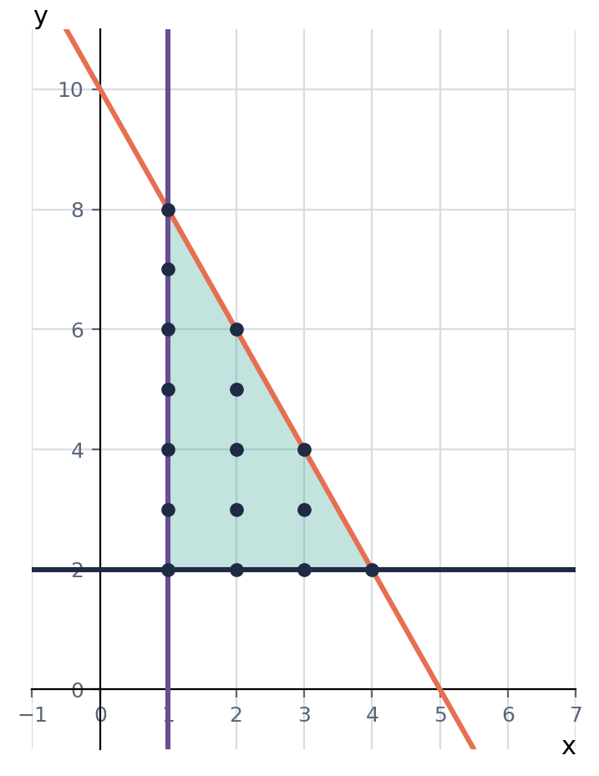
💭 Think: Why are only the dots in the shaded region valid answers, and not every point?

Example 5.6 · An empty region
Show that no point satisfies x ≥ 4, y ≥ 4 and x + y ≤ 6.
Solution
1. If x ≥ 4 and y ≥ 4, then x + y ≥ 8.
2. But x + y ≤ 6, which is less than 8.
3. These conditions contradict each other, so R is empty.
Answer: There are no points that satisfy all three

⚠ Common mistakes
- Shading or considering only one inequality. R must satisfy all of them.
- Using a solid line for a strict inequality, and counting points on a dashed line as solutions.
- Forgetting x ≥ 0 and y ≥ 0 in real-life problems.
- Counting points that are not whole numbers when the problem is about whole objects.

④ Practice
Write your answers in your exercise book. Start at Level 1. If you get most of a level right, move on to the next one. The answers are at the back of the pack.

Level 1 · Foundation
1. Is each point in the region defined by x ≥ 0, y ≥ 0 and x + y ≤ 5?
(a) (2, 1)
(b) (4, 2)
(c) (0, 5)
(d) (−1, 3)
2. Write each statement as an inequality.
(a) x is at least 2
(b) y is at most 5
(c) x + y is less than 7
3. For each pair of inequalities, state whether each boundary line is solid or dashed.
(a) x > 1 and y ≤ 4
(b) y ≥ 0 and x + y < 8

Level 2 · Developing
4. Draw and label the region R defined by x ≥ 0, y ≥ 0 and x + y ≤ 4. State the vertices.
5. Draw and label the region R defined by y ≥ x, y ≤ 5 and x ≥ 0. State the vertices.
6. List all the integer points in the region x ≥ 1, y ≥ 1 and x + y ≤ 4.
7. Write three inequalities that define the region R shown.
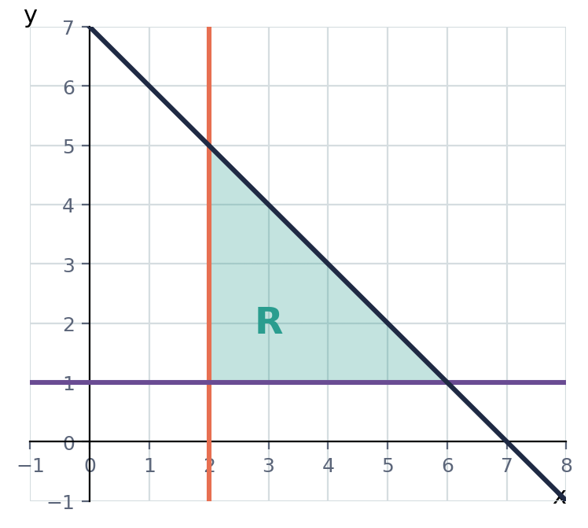
8. A coach buys x footballs at $6 each and y netballs at $5 each. She spends at most $60, and buys at least 3 footballs and at least 2 netballs. Write three inequalities, and check that (4, 5) is a possible purchase.
9. Find the vertices of the region defined by y ≥ 1, y ≤ x and x ≤ 4.

Level 3 · Think Deeper
10. Spot the error. Chen says the region x ≥ 4, y ≥ 4, x + y ≤ 6 is a small triangle. Explain what is wrong.
11. Explain. In a real-life problem about buying items, why do we usually include x ≥ 0 and y ≥ 0, and why do only integer points count?
12. Always, sometimes or never? ‘A pair of linear inequalities has a region where both are true.’ Give examples.
13. Create. Write three inequalities whose region is the triangle with vertices (0, 0), (4, 0) and (0, 3).
14. Challenge. For the region x ≥ 1, y ≥ 1 and x + y ≤ 6 from Example 5.1, find the greatest value of (a) 2x + y and (b) x + 3y at a vertex. Which vertex gives each?

Before you move on, say or write in one or two sentences: "I can explain why the answer to a word problem must lie inside the shaded region."
How confident do I feel? ☐ Not yet ☐ Getting there ☐ Got it!

CSEC-Style Exam Practice
These questions are like the ones on CSEC Paper 2, and they use all five lessons. Try them under test conditions: no notes, and about 30 minutes. Show all your working.
1. (a) Solve 3x − 7 ≤ 8. [2 marks] (b) Show your answer to (a) on a number line. [2 marks] (c) Solve 5 − 2x < 11. List the integers that satisfy both inequalities (a) and (c). [4 marks]
2. Solve −5 < 2x − 3 ≤ 7. List the integer values of x that satisfy the inequality. [4 marks]
3. (a) Solve 3(x + 2) > 5x − 4. [3 marks] (b) Write down the greatest integer that satisfies this inequality. [1 mark] (c) Solve the inequality 2x − 1 < 3 or x + 4 ≥ 10. [3 marks]
4. The diagram shows the region R.
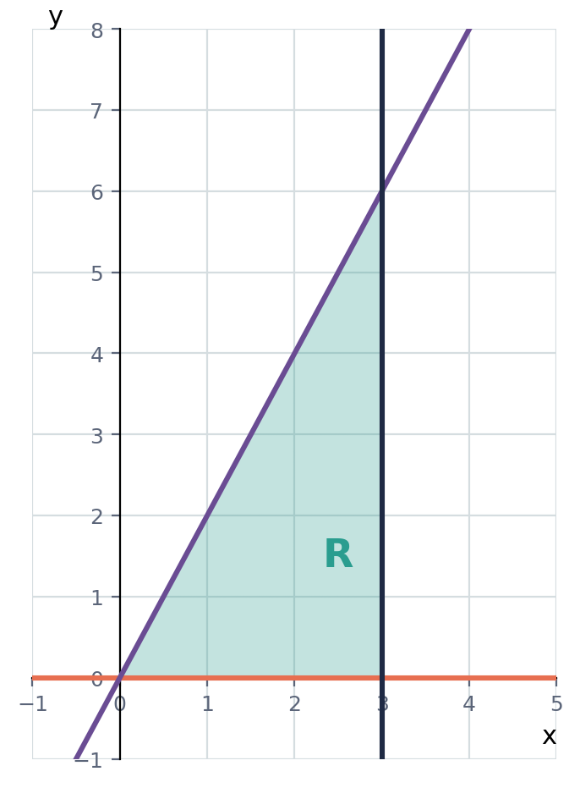
(a) Write down three inequalities that define R. [4 marks]
(b) Find the greatest value of x + y for points in R. [2 marks]
5. A school trip buys x adult tickets at $8 each and y student tickets at $5 each. The total cost is at most $120. There must be at least 2 adults and at least 10 students.
(a) Write three inequalities in x and y. [3 marks]
(b) Show that 4 adults and 15 students is possible. [2 marks]
(c) If 5 adults go, find the greatest number of students. [3 marks]

Self-Check Quiz: Am I Ready?
Answer all 12 questions without looking back at the lessons. Then check your answers and write your score in the box. The lesson number after each question tells you where to go back if you get it wrong.
1. Which inequality means ‘n is at least 7’? (Lesson 1)
A n ≤ 7 B n ≥ 7 C n < 7 D n > 7
2. On a number line, x < 3 is shown with… (Lesson 1)
A a closed circle at 3 and an arrow pointing right B an open circle at 3 and an arrow pointing right C a closed circle at 3 and an arrow pointing left D an open circle at 3 and an arrow pointing left
3. U = {integers}. The solution set of −2 < x ≤ 2 is… (Lesson 1)
A {−1, 0, 1, 2} B {−2, −1, 0, 1, 2} C {−2, −1, 0, 1} D {−1, 0, 1}
4. Solve 3x + 2 > 14. (Lesson 2)
A x > 12 B x > 16 C x > 4 D x < 4
5. Solve 5 − 2x ≥ 11. (Lesson 2)
A x ≤ 3 B x ≥ 3 C x ≤ −3 D x ≥ −3
6. What is the greatest integer satisfying 4x − 3 < 15? (Lesson 2)
A 4 B 4.5 C 5 D 3
7. Solve −1 < 2x + 3 ≤ 9. (Lesson 3)
A −2 ≤ x < 3 B −1 < x ≤ 3 C −4 < x ≤ 6 D −2 < x ≤ 3
8. The solution of x < −1 or x ≥ 4 on a number line is… (Lesson 3)
A no numbers at all B two separate pieces going outwards C one line between −1 and 4 D the whole number line
9. The boundary line for y ≥ 2x − 1 is… (Lesson 4)
A solid B dashed C horizontal D vertical
10. For x + y < 5, testing (0, 0) gives 0 < 5, which is true. So you should… (Lesson 4)
A draw a solid line and shade the side containing (0, 0) B draw a solid line and shade the side not containing (0, 0) C draw a dashed line and shade the side containing (0, 0) D draw a dashed line and shade the side not containing (0, 0)
11. When several inequalities are graphed, the required region is… (Lesson 5)
A where any one of the regions is shaded B where all the shaded regions overlap C the region above all the lines D the region outside all the lines
12. Which point is in the region x ≥ 1, y ≥ 1, x + y ≤ 6? (Lesson 5)
A (5, 3) B (0, 2) C (1, 0) D (2, 3)

My score | What it means
11–12 | Ready! You are ready for the next topic: Unit 4: Changing the Subject of the Formula.
8–10 | Nearly there. Look at the lesson number next to each question you missed. Redo the Level 2 practice for those lessons.
0–7 | Go back over the lessons for the questions you missed. Redo the Level 1 and Level 2 practice, watch the videos again, then retake this quiz.
My score: ______ / 12

Answers
Use these to check your work. If your answer is different, look for your mistake before you ask for help. Your teacher has the full worked solutions.

Warm-Up
1. −3
2. x = 6
3. x = −5
4. −2, −1, 0, 1
5. 3x − 6
6. Yes, because 3 = 1 + 2
7. (0, −1)
8. {3, 4}

Lesson 1: Inequality Symbols, Number Lines and Solution Sets
Level 1 · Foundation
1. (a) x < 7 (b) y ≥ 12 (c) n ≤ −2 (d) t ≥ 0
2. (a) True (b) True (c) False (d) False
3. (a) open circle at 3, arrow right (b) closed circle at −2, arrow left (c) open circle at 0, arrow left
4. (a) x > −1 (b) x ≤ 3 (c) −2 ≤ x < 4
Level 2 · Developing
5. (a) {−2, −1, 0, 1, 2, 3} (b) {2, 3, 4, 5} (c) {−3, −2}
6. Open circle at −1, closed circle at 3, line joining them
7. (a) {x : x > 4} (b) {x : x is an integer, −3 ≤ x ≤ 3}
8. p ≤ 8. Because p is a number of people, p = 0, 1, 2, …, 8
9. A = {−3, −2, −1, 0, 1}; B = {0, 1, 2, 3}; A ∩ B = {0, 1}
Level 3 · Think Deeper
10. The inequality includes 4, so the circle must be closed (●) at 4, with the arrow pointing right.
11. Between −2 and 3 there are only four integers (−1, 0, 1, 2), so they can be listed. If x can be any number, there are infinitely many, such as 0.5, 0.51 and 0.511.
12. Never. 5 > 2 but −5 < −2, and −1 > −4 but 1 < 4. Changing both signs reverses the order.
13. e.g. 1 < x ≤ 5 and 2 ≤ x < 6
14. 10 integers (−4 to 5) and 11 integers (−5 to 5). Including the left end adds one more. For a < x ≤ b there are b − a integers.

Lesson 2: Solving Linear Inequalities
Level 1 · Foundation
1. (a) x > 4 (b) x ≤ 7 (c) x < 5 (d) x ≥ 6
2. (a) x > 4 (b) x ≤ 4 (c) x < 4
3. x ≥ 3; only 5 is a solution
Level 2 · Developing
4. (a) x ≥ 5 (b) x < 4 (c) x ≥ −3 (d) x < 2
5. (a) x > 4 (b) x ≥ −3 (c) x > 4
6. (a) x < 4 (b) x ≥ 3 (c) x > 6
7. x < 5; the positive integers are 1, 2, 3, 4
8. (a) x ≤ 7 (b) x > 6
9. 120 + 8n ≤ 400, so n ≤ 35. The greatest number is 35 students.
Level 3 · Think Deeper
10. She divided by −2 but did not reverse the sign. The correct answer is x < −3.
11. 2 < 5. Multiplying both by −1 gives −2 and −5, and −2 > −5, because −2 is to the right of −5 on the number line. Multiplying by a negative flips numbers to the opposite side of zero and reverses their order.
12. Both give x ≤ −2.
13. Sometimes. It is true when a is positive (2x + 1 > 7 gives x > 3), but when a is negative the sign reverses (−2x + 1 > 7 gives x < −3).
14. e.g. 7 − 3x > 1
15. (a) 7 (b) 3

Lesson 3: Compound Inequalities: ‘Between’ and ‘Or’
Level 1 · Foundation
1. (a) −2 < x < 5 (b) 3 ≤ x < 8 (c) 0 < x ≤ 10
2. (a) 1 < x < 6 (b) 3 ≤ x ≤ 7 (c) −7 < x ≤ −2
3. (a) 2, 3, 4, 5 (b) −3, −2, −1, 0 (c) −4, −3
Level 2 · Developing
4. (a) 2 < x < 6 (b) 1 ≤ x ≤ 4 (c) −2 < x ≤ 3 (d) 1 < x ≤ 7
5. −2 < x ≤ 3; integers −1, 0, 1, 2, 3
6. (a) −3 ≤ x < 2 (b) 2 ≤ x < 6
7. (a) x < 2 or x ≥ 6 (b) x ≤ 1 or x > 5
8. A = {4, …, 10}; B = {1, …, 7}; A ∩ B = {4, 5, 6, 7}; A ∪ B = {1, …, 10} = U
Level 3 · Think Deeper
9. 2 < x ≤ −3 is impossible (no number is bigger than 2 and at most −3). Dividing by −4 reverses both signs: 2 > x ≥ −3, so −3 ≤ x < 2.
10. The first is one connected piece between 2 and 5 (2 < x < 5). The second is two separate pieces: left of 2 and right of 5. They describe opposite regions of the number line.
11. Sometimes. 1 < x < 3 has the integer 2. 1.2 < x < 1.8 has no integers.
12. e.g. 3 < 2x + 3 < 13 (which gives 0 < x < 5)
13. x = 3 or x = 5
14. k = 1.5 gives 2, 3, 4 (three integers). k = 2.5 gives 3, 4, 5 (three integers). It is always three, because the interval has length 3 and includes only one end.

Lesson 4: Graphing Linear Inequalities in Two Variables
Level 1 · Foundation
1. (a) dashed (b) solid (c) solid (d) dashed
2. (a) Yes (b) No (c) Yes (d) Yes
3. (a) above the line (b) below the line (and on it) (c) to the right of x = 3 (d) below y = 1
Level 2 · Developing
4. (a) dashed line through (0, −1) and (1, 0), shade above (b) solid line through (0, 1) and (1, 3), shade below (c) dashed line through (4, 0) and (0, 4), shade the side containing the origin
5. Intercepts (4, 0) and (0, 6); solid line; shade the side that does not contain the origin
6. x + y ≤ 4
7. (a) x + y > 6 (b) y < x + 3 (c) y ≥ 2x
8. (a) y > 3x − 2, above (b) y ≤ −2x + 5, below (c) y ≥ 3x + 1, above
Level 3 · Think Deeper
9. The line should be dashed (the sign is <), and the shading should be below the line (test (0, 0): 0 < 1 is true, and the origin is below the line).
10. (0, 0) lies on the line y = 2x, so it does not tell you which side to shade. Choose another point such as (1, 0): 0 ≥ 2 is false, so shade the other side, which is above the line.
11. Sometimes. x + y ≥ 4 is above the line y = −x + 4. But x − y ≥ 1 rearranges to y ≤ x − 1, which is below the line.
12. e.g. y ≥ 2x (2 ≥ 2, on the boundary) and y > x (2 > 1)
13. a < 3
14. 6 points: (1, 1), (1, 2), (1, 3), (2, 1), (2, 2), (3, 1)

Lesson 5: Regions: Several Inequalities at Once
Level 1 · Foundation
1. (a) Yes (b) No (c) Yes (d) No
2. (a) x ≥ 2 (b) y ≤ 5 (c) x + y < 7
3. (a) x = 1 dashed; y = 4 solid (b) y = 0 solid; x + y = 8 dashed
Level 2 · Developing
4. R is a triangle with vertices (0, 0), (4, 0) and (0, 4)
5. R is a triangle with vertices (0, 0), (0, 5) and (5, 5)
6. (1, 1), (1, 2), (1, 3), (2, 1), (2, 2), (3, 1)
7. x ≥ 2, y ≥ 1, x + y ≤ 7
8. 6x + 5y ≤ 60, x ≥ 3, y ≥ 2. For (4, 5): 24 + 25 = 49 ≤ 60 ✓, 4 ≥ 3 ✓, 5 ≥ 2 ✓.
9. (1, 1), (4, 1) and (4, 4)
Level 3 · Think Deeper
10. If x ≥ 4 and y ≥ 4 then x + y ≥ 8, which is bigger than 6. The conditions contradict, so there is no region.
11. You cannot buy a negative number of items, so x and y cannot be negative. You also cannot buy part of an item, so only whole-number points inside R give possible answers.
12. Sometimes. x > 1 and x < 3 have the region 1 < x < 3. But x > 3 and x < 1 have no region.
13. x ≥ 0, y ≥ 0, 3x + 4y ≤ 12
14. (a) 11 at (5, 1) (b) 16 at (1, 5)

CSEC-Style Exam Practice
1. (a) x ≤ 5 (b) closed circle at 5, arrow pointing left (c) x > −3; integers −2, −1, 0, 1, 2, 3, 4, 5
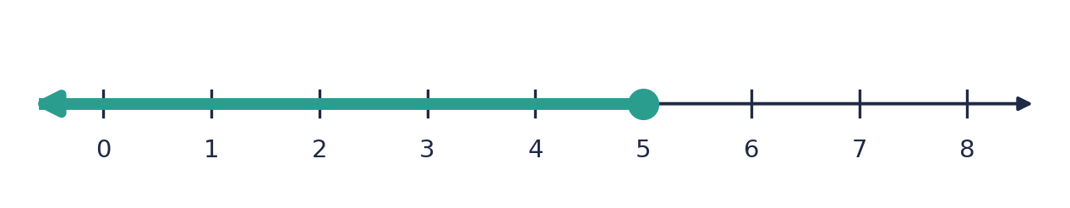
2. −1 < x ≤ 5; integers 0, 1, 2, 3, 4, 5
3. (a) x < 5 (b) 4 (c) x < 2 or x ≥ 6
4. (a) y ≥ 0, y ≤ 2x, x ≤ 3 (b) 9 at (3, 6)
5. (a) 8x + 5y ≤ 120, x ≥ 2, y ≥ 10 (b) 32 + 75 = 107 ≤ 120 (c) 16 students

Self-Check Quiz
Q | Answer | Why
1 | B | ‘At least’ includes 7 and everything bigger, so n ≥ 7.
2 | D | 3 is not included (open), and smaller numbers are to the left.
3 | A | −2 is excluded and 2 is included.
4 | C | 3x > 12, so x > 4.
5 | C | −2x ≥ 6. Dividing by −2 reverses the sign: x ≤ −3.
6 | A | 4x < 18, so x < 4.5. The greatest integer is 4.
7 | D | Subtract 3 from every part: −4 < 2x ≤ 6. Divide by 2: −2 < x ≤ 3.
8 | B | ‘Or’ gives two pieces: left of −1, and 4 and above.
9 | A | ≥ includes the line itself, so the line is solid.
10 | C | The sign is < (dashed), and (0, 0) satisfies it, so shade its side.
11 | B | A point must satisfy every inequality, so it must be in the overlap.
12 | D | (2, 3): 2 ≥ 1, 3 ≥ 1, 5 ≤ 6. The other points each fail one condition.

