Clare Hall Secondary School · Mathematics Department

FORM 3 MATHEMATICS · UNIT 4
Changing the Subject of the Formula
Self-Paced Learning Pack
Name: ______________________________________ Class: ___________
Time in class: 1 week School year: 2026–2027 Next topic: Factorization

What's inside
Section | What you will do
Before You Start | Warm up with the number facts you need
Lesson 1 | Formulae and the Subject
Lesson 2 | Two-Step Rearranging with Function Machines
Lesson 3 | Formulae with Brackets and Fractions
Lesson 4 | Formulae with Powers and Roots
Exam Practice | CSEC-style questions that use all four lessons
Self-Check Quiz | 12 questions that show whether you are ready to move on
Answers | Check your work (at the back of the pack)

How to Use This Pack
- This pack lets you learn at your own pace. You can work ahead of the class or go back over anything you missed.
- Work through the lessons in order. Each lesson builds on the one before it.
- For each lesson: Read the key ideas → Watch the videos → Study the worked examples → Practise.
- Before you read the solution to a worked example, cover it and try the example yourself first. Then check each step.
- Practice has three levels. Level 1 (Foundation) checks the basics. Level 2 (Developing) makes you apply them. Level 3 (Think Deeper) asks you to explain, find mistakes and create your own examples.
- Check your answers at the back of the pack. If you get an answer wrong, find your mistake before you move on. A mistake you understand teaches you more than a correct guess.
- When you finish all the lessons, try the CSEC-Style Exam Practice, then the Self-Check Quiz. Your quiz score tells you whether you are ready for the next topic.

The learning route for every lesson
① Read the key ideas → ② Watch the videos → ③ Try the worked examples, then check each step → ④ Practise Level 1 → 2 → 3 → ⑤ Check your answers → ⑥ Tick your checklist

My Progress Checklist
Tick one box for each statement before you start and again after you finish. Be honest. This checklist is for you.
I can… | Not yet | Getting there | Got it!
Explain what the subject of a formula is (Lesson 1) | ☐ | ☐ | ☐
Change the subject of a formula in one step (Lesson 1) | ☐ | ☐ | ☐
Use a function machine and inverse operations to change the subject in two or more steps (Lesson 2) | ☐ | ☐ | ☐
Change the subject of formulae with brackets and fractions (Lesson 3) | ☐ | ☐ | ☐
Change the subject of formulae that involve powers and roots (Lesson 4) | ☐ | ☐ | ☐
Rearrange a formula and then substitute to find an unknown value (Lessons 1–4) | ☐ | ☐ | ☐

Key Words and Symbols
Symbol | Meaning | Example
formula | a rule that connects two or more quantities | A = lw
subject | the letter on its own on one side of the formula | A is the subject of A = lw
inverse | the operation that undoes another one | − undoes +, and ÷ undoes ×
x² | x squared. Undo it with a square root √ | √(x²) = x for x ≥ 0
√x | the square root of x. Undo it by squaring | (√x)² = x
x³, ∛x | x cubed and the cube root of x. Each one undoes the other | ∛64 = 4
(a + b)/c | the whole of a + b is divided by c | (10 + 2)/4 = 3

Before You Start: Warm-Up
Changing the subject uses the same skills as solving equations in Unit 2. Check that you can still do these.
1. Solve 4x = 28.
2. Solve 3x + 5 = 20.
3. Solve (x − 2)/4 = 3.
4. Write the inverse of each operation: (a) × 5 (b) − 8 (c) squaring (d) square root
5. Find (a) √49 (b) 6² (c) ∛27
6. A = lw. Find A when l = 9 and w = 4.

Lesson 1: Formulae and the Subject
Building on: Unit 2, Lesson 5: solving equations with inverse operations.
Goal: By the end of this lesson I can explain what the subject of a formula is, and change the subject in one step.

① Key Ideas
- A formula connects quantities. For example, A = lw gives the area of a rectangle.
- The subject is the letter on its own on one side of the formula. In A = lw, A is the subject.
- Changing the subject means rearranging the formula so that a different letter is on its own. For example, A = lw becomes w = A/l.
- It works exactly like solving an equation. The only difference is that the answer contains letters instead of a number. Do the same thing to both sides, using inverse operations.
- + and − undo each other, and × and ÷ undo each other.
- Once you have rearranged a formula, you can substitute numbers to find the new subject.

② Watch
Watch these videos after you have read the key ideas. Pause the video and try each example before it is solved. Online, click the link. On paper, type the short address into YouTube.
Video | What it covers | Link
Introduction to Rearranging Formulae | GCSE Maths  AJMaths | What the subject is and why we rearrange | Watch on YouTube  youtu.be/WJ9UiImhAuo
Changing the Subject  Corbettmaths | One-step and two-step rearranging | Watch on YouTube  youtu.be/8U9u_itcs7k

③ Worked Examples
Cover the solution and try the example first. Then uncover one step at a time and compare it with your own working.
Example 1.1 · An equation and a formula side by side
(a) Solve 12 = x + 5. (b) Make x the subject of y = x + 5.
Solution
1. (a) To undo + 5, subtract 5 from both sides: 12 − 5 = x, so x = 7.
2. (b) Do exactly the same: y − 5 = x.
3. Write the subject on the left: x = y − 5.
Answer: (a) x = 7 (b) x = y − 5
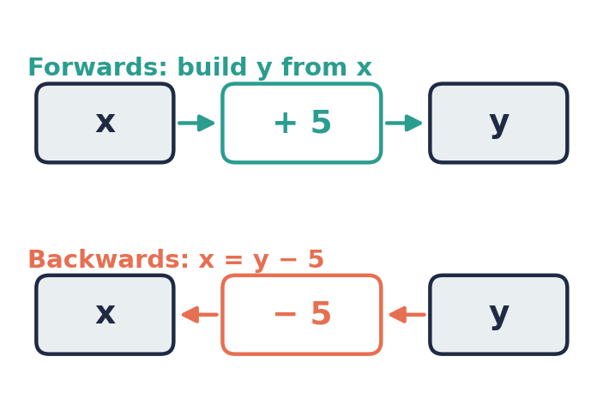
💭 Think: Substitute y = 12 into your answer to (b). Do you get the answer to (a)? Why?

Example 1.2 · Undoing multiplication
Make I the subject of V = IR.
Solution
1. IR means I × R. To leave I on its own, undo × R.
2. Divide both sides by R: V/R = I.
Answer: I = V/R

Example 1.3 · Rearrange, then substitute
The circumference of a circle is C = πd. (a) Make d the subject. (b) Find d when C = 44 cm. Use π = 22/7.
Solution
1. (a) Divide both sides by π: d = C/π.
2. (b) d = 44 ÷ 22/7 = 44 × 7/22 = 14.
Answer: (a) d = C/π (b) d = 14 cm

Example 1.4 · Undoing division
Make n the subject of m = n/4.
Solution
1. n is divided by 4. To undo ÷ 4, multiply both sides by 4.
2. 4m = n.
Answer: n = 4m

Example 1.5 · When the new subject is subtracted
a = b − c. Make (a) b the subject (b) c the subject.
Solution
1. (a) Add c to both sides: a + c = b. So b = a + c.
2. (b) c is being taken away, so first add c to both sides to make it positive: a + c = b.
3. Then subtract a from both sides: c = b − a.
Answer: (a) b = a + c (b) c = b − a
💭 Think: Check with numbers: 7 = 10 − 3. Does c = b − a give 3?

⚠ Common mistakes
- Doing an operation to only one side of the formula.
- Using the operation instead of its inverse, e.g. writing I = VR from V = IR.
- Leaving a minus sign in front of the subject, e.g. −c = a − b. Make the subject positive.

④ Practice
Write your answers in your exercise book. Start at Level 1. If you get most of a level right, move on to the next one. The answers are at the back of the pack.

Level 1 · Foundation
1. Make x the subject of each formula.
(a) y = x + 3
(b) y = x − 8
(c) y = 5x
(d) y = x/6
(e) p = x + q
2. Distance = speed × time: D = ST.
(a) Make S the subject.
(b) Make T the subject.
3. The perimeter of a triangle is P = a + b + c. Make b the subject.

Level 2 · Developing
4. Make the letter in square brackets the subject.
(a) A = lw [w]
(b) V = Ah [h]
(c) m = k/n [k]
(d) C = 2πr [r]
5. Make x the subject of y = 10 − x.
6. A bus travels D = 150 km at an average speed of S = 60 km/h. Make T the subject of D = ST, then find T.
7. The cost of n bottles of water at $p each is C = np. Make p the subject. Find p when C = 42 and n = 12.

Level 3 · Think Deeper
8. Spot the error. From V = IR, Jamal wrote I = R/V. Use V = 12 and R = 3 to show that he is wrong, then correct his formula.
9. Explain. Solve 20 = 4x. Then make x the subject of y = 4x. How are the two tasks the same?
10. True or false? If y = k − x, then x = y − k. Test with numbers, then give the correct formula.
11. Create. Write one formula in which you would divide by 3 to make x the subject, and one in which you would multiply by 3.

Before you move on, say or write in one or two sentences: "I can explain how changing the subject is like solving an equation."
How confident do I feel? ☐ Not yet ☐ Getting there ☐ Got it!

Lesson 2: Two-Step Rearranging with Function Machines
Building on: Lesson 1 and Unit 2, Lesson 5: the function machine for two-step equations.
Goal: By the end of this lesson I can use a function machine or inverse operations to change the subject in two steps.

① Key Ideas
- Build a function machine for the new subject. Write down what happens to it, in order, to make the other side of the formula.
- To reverse the machine, start from the other end. Use the inverse of each operation, in reverse order.
- For y = 3x + 5: x is × 3, then + 5. Going back: − 5, then ÷ 3. So x = (y − 5)/3.
- Use brackets when you divide a whole expression: (y − 5)/3 is not the same as y − 5/3.
- You can also use the balance method: do the same operation to both sides, one step at a time. Both methods give the same answer.
- If the subject has a negative coefficient, as in y = 5 − 2x, add the x term to both sides first to make it positive.

② Watch
Watch these videos after you have read the key ideas. Pause the video and try each example before it is solved. Online, click the link. On paper, type the short address into YouTube.
Video | What it covers | Link
Rearranging Formulae | Using Function Machines  Deanna McKercher | The function machine method | Watch on YouTube  youtu.be/fYjSMpxlA6o
Rearranging Equations Flow Chart Method  A Star Learning | Flow charts for rearranging | Watch on YouTube  youtu.be/vwi3t5vg8sU

③ Worked Examples
Cover the solution and try the example first. Then uncover one step at a time and compare it with your own working.
Example 2.1 · Using a function machine
Make x the subject of y = 3x + 5.
Solution
1. Forwards: x is multiplied by 3, then 5 is added, to give y.
2. Backwards: start with y. Undo + 5 first: y − 5.
3. Then undo × 3: (y − 5)/3.
4. Check with x = 5: y = 20, and (20 − 5)/3 = 5 ✓
Answer: x = (y − 5)/3
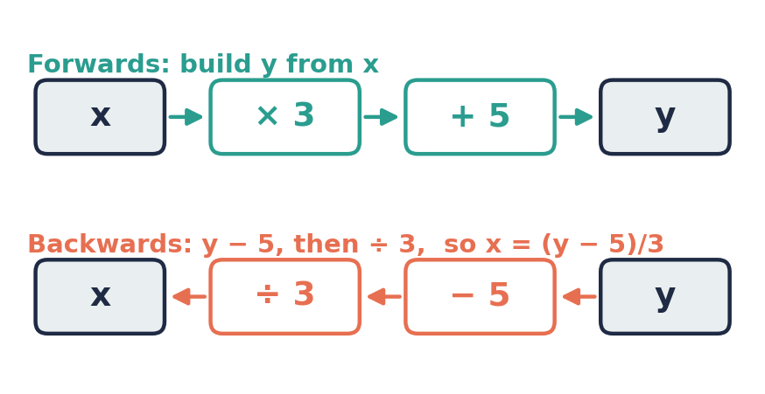

Example 2.2 · A physics formula
Make t the subject of v = u + at.
Solution
1. What happens to t? It is multiplied by a, then u is added.
2. Backwards: subtract u from both sides: v − u = at.
3. Divide both sides by a: t = (v − u)/a.
Answer: t = (v − u)/a
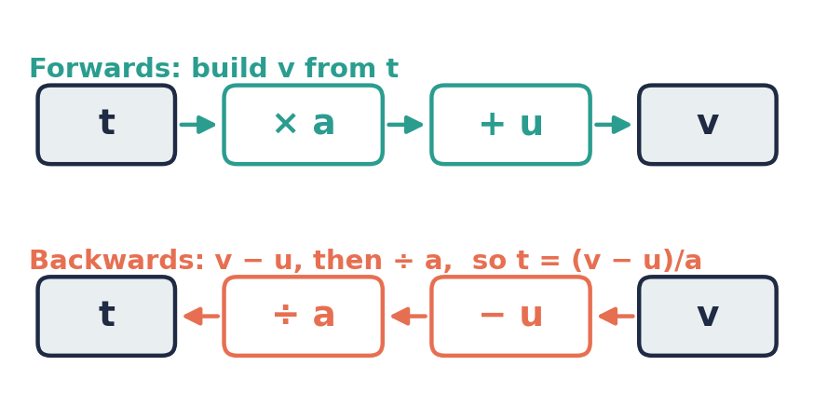

Example 2.3 · Perimeter of a rectangle
Make l the subject of P = 2l + 2w.
Solution
1. Subtract 2w from both sides: P − 2w = 2l.
2. Divide both sides by 2: l = (P − 2w)/2.
Answer: l = (P − 2w)/2
💭 Think: This can also be written l = P/2 − w. Why are these the same?

Example 2.4 · A negative coefficient
Make x the subject of y = 5 − 2x.
Solution
1. Add 2x to both sides to make the x term positive: y + 2x = 5.
2. Subtract y from both sides: 2x = 5 − y.
3. Divide by 2: x = (5 − y)/2.
4. Check with x = 1: y = 3, and (5 − 3)/2 = 1 ✓
Answer: x = (5 − y)/2

Example 2.5 · Rearrange and use
The area of a triangle is A = ½bh. (a) Make h the subject. (b) Find h when A = 24 cm² and b = 8 cm.
Solution
1. (a) ½bh means b × h ÷ 2. Undo ÷ 2 first: 2A = bh.
2. Then undo × b: h = 2A/b.
3. (b) h = 2 × 24 ÷ 8 = 6.
Answer: (a) h = 2A/b (b) h = 6 cm

⚠ Common mistakes
- Undoing the operations in the wrong order, e.g. x = y/3 − 5 for y = 3x + 5.
- Forgetting brackets: writing y − 5/3 when you mean (y − 5)/3.
- Sign errors when the subject has a negative coefficient.

④ Practice
Write your answers in your exercise book. Start at Level 1. If you get most of a level right, move on to the next one. The answers are at the back of the pack.

Level 1 · Foundation
1. Make x the subject of each formula.
(a) y = 2x + 7
(b) y = 4x − 1
(c) y = x/3 + 2
(d) y = x/5 − 4
2. Make u the subject of v = u + at.
3. Make x the subject of y = mx + c.

Level 2 · Developing
4. Make the letter in square brackets the subject.
(a) P = 2l + 2w [w]
(b) A = ½bh [b]
(c) y = 7 − 3x [x]
(d) Q = 4R − 3S [R]
5. v = u + at.
(a) Make a the subject.
(b) Find a when v = 30, u = 10 and t = 4.
6. A taxi charges C = 15 + 2.5d dollars for d km. Make d the subject. How far can you travel for $40?
7. The perimeter of a rectangle is P = 2l + 2w. Find l when P = 30 cm and w = 4 cm.

Level 3 · Think Deeper
8. Spot the error. Kemar made x the subject of y = 3x + 5 and wrote x = y/3 − 5. Test his formula with y = 20, then correct it.
9. Spot the error. Shanice made x the subject of y = 5 − 2x and wrote x = (y − 5)/2. Test with x = 2, then correct it.
10. Explain. Show that x = (y − c)/m and x = y/m − c/m are the same formula.
11. Create. The reverse machine for a formula is "− 4, then ÷ 7". Write the original formula y = … and explain how you found it.

Before you move on, say or write in one or two sentences: "I can explain why x = (y − 5)/3 needs brackets."
How confident do I feel? ☐ Not yet ☐ Getting there ☐ Got it!

Lesson 3: Formulae with Brackets and Fractions
Building on: Lesson 2: two-step rearranging. Unit 2, Lesson 2: expanding brackets.
Goal: By the end of this lesson I can change the subject of a formula that contains brackets or fractions.

① Key Ideas
- Brackets: you can either divide by the number outside the bracket first, or expand the bracket first. Both methods work.
- Fractions: multiply both sides by the denominator first to clear the fraction. For y = (x + 3)/4, multiply by 4 to get 4y = x + 3, so x = 4y − 3.
- Work step by step, and write each new line underneath the one before.
- Subject in the denominator: in y = 12/x, multiply both sides by x to get xy = 12, then divide by y to get x = 12/y.
- Check your new formula by substituting simple numbers into both versions.

② Watch
Watch these videos after you have read the key ideas. Pause the video and try each example before it is solved. Online, click the link. On paper, type the short address into YouTube.
Video | What it covers | Link
Rearranging Equations Flow Chart Method  A Star Learning | Flow charts with fractions and brackets | Watch on YouTube  youtu.be/vwi3t5vg8sU
Changing the Subject  Corbettmaths | Worked examples with brackets | Watch on YouTube  youtu.be/8U9u_itcs7k

③ Worked Examples
Cover the solution and try the example first. Then uncover one step at a time and compare it with your own working.
Example 3.1 · A formula with a bracket
Make l the subject of P = 2(l + w).
Solution
1. Method 1: divide both sides by 2: P/2 = l + w. Subtract w: l = P/2 − w.
2. Method 2: expand: P = 2l + 2w. Subtract 2w: P − 2w = 2l. Divide by 2: l = (P − 2w)/2.
3. Both answers are the same formula.
Answer: l = P/2 − w (or l = (P − 2w)/2)

Example 3.2 · Clearing a fraction
Make x the subject of y = (x + 3)/4.
Solution
1. Multiply both sides by 4: 4y = x + 3.
2. Subtract 3: x = 4y − 3.
3. Check with x = 5: y = 8/4 = 2, and 4 × 2 − 3 = 5 ✓
Answer: x = 4y − 3

Example 3.3 · Fahrenheit and Celsius
F = 9C/5 + 32 converts °C to °F. (a) Make C the subject. (b) A hot day in St John's is 86°F. Convert this to °C.
Solution
1. (a) Subtract 32: F − 32 = 9C/5.
2. Multiply by 5: 5(F − 32) = 9C.
3. Divide by 9: C = 5(F − 32)/9.
4. (b) C = 5 × (86 − 32)/9 = 5 × 54/9 = 5 × 6 = 30.
Answer: (a) C = 5(F − 32)/9 (b) 30°C
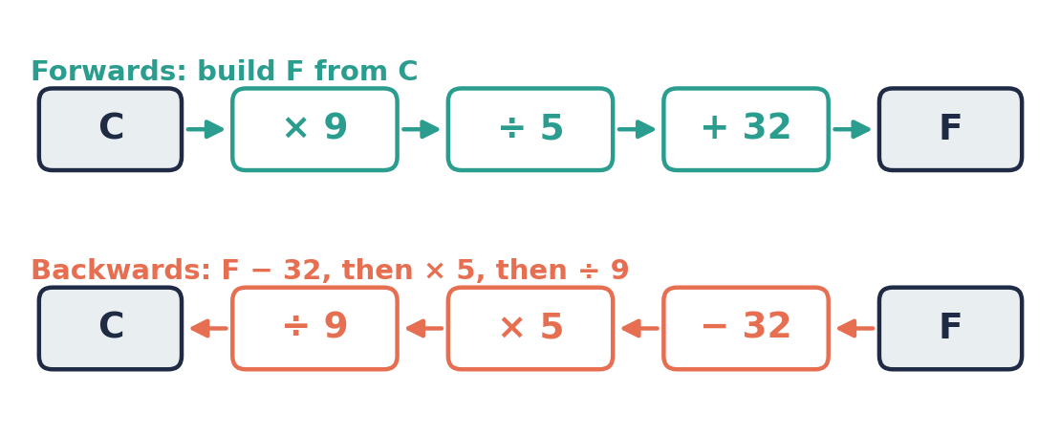

Example 3.4 · Area of a trapezium
Make a the subject of A = ½(a + b)h.
Solution
1. Multiply by 2: 2A = (a + b)h.
2. Divide by h: 2A/h = a + b.
3. Subtract b: a = 2A/h − b.
Answer: a = 2A/h − b

Example 3.5 · Subject in the denominator
A 60 km journey at a speed of n km/h takes T = 60/n hours. Make n the subject.
Solution
1. Multiply both sides by n: Tn = 60.
2. Divide both sides by T: n = 60/T.
Answer: n = 60/T
💭 Think: Notice that T and n swap places. Does this always happen with formulae like y = k/x?

⚠ Common mistakes
- Only multiplying one term by the denominator.
- Expanding a bracket incorrectly, e.g. 2(l + w) = 2l + w.
- Forgetting that 9C/5 means 9 × C ÷ 5, so both the × 9 and the ÷ 5 must be undone.

④ Practice
Write your answers in your exercise book. Start at Level 1. If you get most of a level right, move on to the next one. The answers are at the back of the pack.

Level 1 · Foundation
1. Make x the subject of each formula.
(a) y = 3(x + 2)
(b) y = (x − 1)/5
(c) y = 2(x − 4)
(d) y = (x + 7)/2
2. P = 2(l + w).
(a) Make w the subject.
(b) Find w when P = 26 and l = 8.
3. Make x the subject of y = 20/x.

Level 2 · Developing
4. Make the letter in square brackets the subject.
(a) y = (2x + 1)/3 [x]
(b) a = (b − c)/d [b]
(c) m = (p + q)/2 [q]
(d) y = 5(x − 3)/2 [x]
5. C = 5(F − 32)/9.
(a) Make F the subject.
(b) Find F when C = 25.
6. A = ½(a + b)h.
(a) Make h the subject.
(b) Find h when A = 45 cm², a = 7 cm and b = 11 cm.
7. The mean of three test scores is m = (a + b + c)/3. Make c the subject. Kerry scored 70 and 82 on her first two tests. What must she score on the third test to get a mean of 80?

Level 3 · Think Deeper
8. Spot the error. From y = (x + 3)/4, Tevin wrote x = y/4 − 3. Test his answer with x = 17, then correct it.
9. Explain. Show that l = P/2 − w and l = (P − 2w)/2 are the same formula.
10. Always, sometimes or never? Explain each answer.
(a) If y = 12/x, then x = 12/y (x and y not zero).
(b) (a + b)/c = a/c + b/c (c not zero)
11. Challenge. Make x the subject of y = 3/(x − 2).

Before you move on, say or write in one or two sentences: "I can explain why I multiply by the denominator first when the formula has a fraction."
How confident do I feel? ☐ Not yet ☐ Getting there ☐ Got it!

Lesson 4: Formulae with Powers and Roots
Building on: Lessons 2 and 3, and square numbers and square roots from the warm-up.
Goal: By the end of this lesson I can change the subject of a formula that contains squares, cubes or roots.

① Key Ideas
- Squaring and square-rooting undo each other. Cubing and cube-rooting undo each other.
- If the new subject is squared, get the squared term on its own first, then take the square root of both sides. For A = πr², r² = A/π, so r = √(A/π).
- If the new subject is under a square root, get the root on its own first, then square both sides. For y = √(x + 5), y² = x + 5, so x = y² − 5.
- A function machine still works. Square and √ are just operations like × and +.
- Strictly, x² = 9 gives x = 3 or x = −3 (written x = ±3). For lengths, times and other quantities that must be positive, use the positive root.

② Watch
Watch these videos after you have read the key ideas. Pause the video and try each example before it is solved. Online, click the link. On paper, type the short address into YouTube.
Video | What it covers | Link
Change the subject of the formula part 2 powers and roots  Mrs McTaggart Maths | Formulae with squares and roots | Watch on YouTube  youtu.be/vxjTxLEnkVQ
National 5 – Changing the Subject of a Formula 2 – Powers & Roots  Larbert Mathematics | More examples with powers and roots | Watch on YouTube  youtu.be/FdB_q42PBt4

③ Worked Examples
Cover the solution and try the example first. Then uncover one step at a time and compare it with your own working.
Example 4.1 · Area of a circle
A = πr². (a) Make r the subject. (b) Find r when A = 154 cm². Use π = 22/7.
Solution
1. (a) r is squared, then multiplied by π. Undo × π: r² = A/π.
2. Undo the square with a square root: r = √(A/π).
3. (b) r² = 154 ÷ 22/7 = 154 × 7/22 = 49, so r = √49 = 7.
Answer: (a) r = √(A/π) (b) r = 7 cm
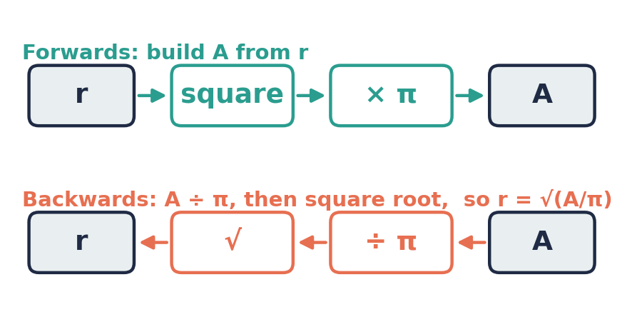

Example 4.2 · The subject under a root
Make x the subject of (a) y = √x (b) y = √(x + 5).
Solution
1. (a) Square both sides: y² = x.
2. (b) Square both sides: y² = x + 5. Subtract 5: x = y² − 5.
Answer: (a) x = y² (b) x = y² − 5

Example 4.3 · Pythagoras' theorem
c² = a² + b². (a) Make a the subject. (b) Find a when c = 13 and b = 5.
Solution
1. (a) Subtract b²: a² = c² − b². Square root: a = √(c² − b²).
2. (b) a = √(169 − 25) = √144 = 12.
Answer: (a) a = √(c² − b²) (b) a = 12
💭 Think: Why is √(c² − b²) not the same as c − b? Test with c = 13 and b = 5.

Example 4.4 · Two subjects from one formula
v² = u² + 2as. Make (a) s the subject (b) u the subject.
Solution
1. (a) Subtract u²: v² − u² = 2as. Divide by 2a: s = (v² − u²)/(2a).
2. (b) Subtract 2as: u² = v² − 2as. Square root: u = √(v² − 2as).
Answer: (a) s = (v² − u²)/(2a) (b) u = √(v² − 2as)

Example 4.5 · The pendulum formula
The time for one swing of a pendulum is T = 2π√(L/g). Make L the subject.
Solution
1. Forwards: L is ÷ g, then square-rooted, then × 2π.
2. Backwards: divide by 2π: T/(2π) = √(L/g).
3. Square both sides: T²/(4π²) = L/g.
4. Multiply by g: L = gT²/(4π²).
Answer: L = gT²/(4π²)
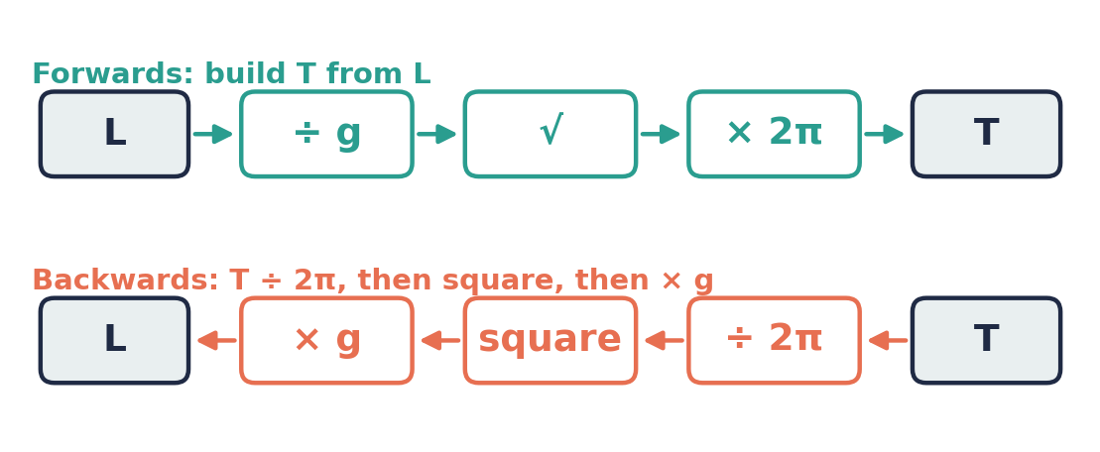

Example 4.6 · Cube roots
The volume of a cube is V = x³. Make x the subject, and find x when V = 64 cm³.
Solution
1. Take the cube root of both sides: x = ∛V.
2. x = ∛64 = 4, because 4 × 4 × 4 = 64.
Answer: x = ∛V; x = 4 cm

⚠ Common mistakes
- Taking the square root too early, e.g. y = x² + 4 → x = √y + 4 ✗. First subtract 4: x = √(y − 4).
- Writing √(c² − b²) = c − b ✗.
- Square-rooting only part of an expression: √(A/π) is not √A/π.

④ Practice
Write your answers in your exercise book. Start at Level 1. If you get most of a level right, move on to the next one. The answers are at the back of the pack.

Level 1 · Foundation
1. Make x the subject of each formula.
(a) y = x²
(b) y = 3x²
(c) y = √x
(d) y = x³
2. A = πr². Find r when A = 616 cm². Use π = 22/7.
3. Make x the subject of y = x² + 4.

Level 2 · Developing
4. Make the letter in square brackets the subject.
(a) E = mc² [c]
(b) y = √(x − 2) [x]
(c) V = x²h [x]
(d) y = 2√x [x]
(e) y = √(x/3) [x]
5. c² = a² + b². Make b the subject, then find b when c = 10 and a = 6.
6. v² = u² + 2as. Find s when v = 20, u = 10 and a = 5.
7. The volume of a cube is V = x³. Make x the subject, and find the side length of a cube with volume 125 cm³.

Level 3 · Think Deeper
8. Spot the error. From A = πr², Nadia wrote r = √A/π (the square root of A, then divided by π). Test her formula with A = 154 and π = 22/7, then correct it.
9. Spot the error. From y = √(x + 3), Leon wrote x = y² + 3. Test with x = 6, then correct it.
10. Explain. x² = 9 has two solutions, but we say that the length of a square with area 9 cm² is 3 cm. Why?
11. Challenge. T = 2π√(L/g). A clock's pendulum takes T = 2 seconds for one swing, and g = 9.8 m/s². Find the length L, correct to 2 decimal places.
12. Create. Write a formula y = … in which making x the subject needs these steps in order: subtract 1, take the square root, divide by 2.

Before you move on, say or write in one or two sentences: "I can explain when to square and when to square-root while rearranging."
How confident do I feel? ☐ Not yet ☐ Getting there ☐ Got it!

CSEC-Style Exam Practice
These questions are like the ones on CSEC Paper 2, and they use all four lessons. Try them under test conditions: no notes, and about 30 minutes. Show all your working.
1. The formula v = u + at is used in physics.
(a) Make t the subject of the formula. [2 marks]
(b) Hence find t when v = 25, u = 5 and a = 4. [1 mark]
2. The volume of a cone is V = ⅓πr²h.
(a) Make r the subject of the formula. [3 marks]
(b) Find r when V = 132 cm³ and h = 3.5 cm. Use π = 22/7. [2 marks]
3. The formula F = 9C/5 + 32 converts a temperature in °C to °F.
(a) Make C the subject of the formula. [2 marks]
(b) The temperature in Barbuda at noon is 95°F. Find the temperature in °C. [1 mark]
4. Make the letter in square brackets the subject of each formula.
(a) y = (3x − 2)/5 [x] [2 marks]
(b) A = 2πr² + 2πrh [h] [2 marks]
(c) p = √(a/b) [a] [2 marks]

Self-Check Quiz: Am I Ready?
Answer all 12 questions without looking back at the lessons. Then check your answers and write your score in the box. The lesson number after each question tells you where to go back if you get it wrong.
1. Make x the subject of y = x + 9. (Lesson 1)
A x = 9 − y B x = y − 9 C x = y + 9 D x = 9y
2. Make I the subject of V = IR. (Lesson 1)
A I = R/V B I = VR C I = V − R D I = V/R
3. Make n the subject of m = n/4. (Lesson 1)
A n = 4m B n = m/4 C n = 4/m D n = m − 4
4. D = ST. Find T when D = 150 and S = 60. (Lesson 1)
A 0.4 B 90 C 2.5 D 9000
5. Make x the subject of y = 3x − 2. (Lesson 2)
A x = y/3 + 2 B x = (y − 2)/3 C x = (y + 2)/3 D x = 3y + 2
6. Make t the subject of v = u + at. (Lesson 2)
A t = (v − u)/a B t = a(v − u) C t = v − u/a D t = (v + u)/a
7. Make x the subject of y = 8 − 2x. (Lesson 2)
A x = 8 − y/2 B x = (y − 8)/2 C x = (y + 8)/2 D x = (8 − y)/2
8. Make l the subject of P = 2(l + w). (Lesson 3)
A l = 2P − w B l = P/2 − w C l = P − 2w D l = P/2 + w
9. Make x the subject of y = (x + 1)/3. (Lesson 3)
A x = 3y − 1 B x = 3y + 1 C x = y/3 − 1 D x = (y − 1)/3
10. Make r the subject of A = πr². (Lesson 4)
A r = (A/π)² B r = A/π² C r = √(A/π) D r = √A ÷ π
11. Make x the subject of y = √x. (Lesson 4)
A x = √y B x = y² C x = 2y D x = y/2
12. Make a the subject of c² = a² + b². (Lesson 4)
A a = c² − b² B a = √c − √b C a = c − b D a = √(c² − b²)

My score | What it means
11–12 | Ready! You are ready for the next topic: Factorization.
8–10 | Nearly there. Look at the lesson number next to each question you missed. Redo the Level 2 practice for those lessons.
0–7 | Go back over the lessons for the questions you missed. Redo the Level 1 and Level 2 practice, watch the videos again, then retake this quiz.
My score: ______ / 12

Answers
Use these to check your work. If your answer is different, look for your mistake before you ask for help. Your teacher has the full worked solutions.

Warm-Up
1. x = 7
2. x = 5
3. x = 14
4. (a) ÷ 5 (b) + 8 (c) square root (d) squaring
5. (a) 7 (b) 36 (c) 3
6. 36

Lesson 1: Formulae and the Subject
Level 1 · Foundation
1. (a) x = y − 3 (b) x = y + 8 (c) x = y/5 (d) x = 6y (e) x = p − q
2. (a) S = D/T (b) T = D/S
3. b = P − a − c
Level 2 · Developing
4. (a) w = A/l (b) h = V/A (c) k = mn (d) r = C/(2π)
5. x = 10 − y
6. T = D/S = 2.5 hours
7. p = C/n = $3.50
Level 3 · Think Deeper
8. When V = 12 and R = 3, I = 4 (since 12 = 4 × 3). Jamal's formula gives 3/12 = 0.25. Correct: I = V/R.
9. x = 5 and x = y/4. Both divide both sides by 4. The only difference is a number or a letter on the other side.
10. False in general (e.g. k = 10, x = 3 gives y = 7, but y − k = −3). The correct formula is x = k − y.
11. e.g. y = 3x (divide by 3) and y = x/3 (multiply by 3)

Lesson 2: Two-Step Rearranging with Function Machines
Level 1 · Foundation
1. (a) x = (y − 7)/2 (b) x = (y + 1)/4 (c) x = 3(y − 2) (d) x = 5(y + 4)
2. u = v − at
3. x = (y − c)/m
Level 2 · Developing
4. (a) w = (P − 2l)/2 (b) b = 2A/h (c) x = (7 − y)/3 (d) R = (Q + 3S)/4
5. (a) a = (v − u)/t (b) a = 5
6. d = (C − 15)/2.5; 10 km
7. l = 11 cm
Level 3 · Think Deeper
8. When y = 20, x should be 5, but Kemar's formula gives 20/3 − 5 ≈ 1.67. Correct: x = (y − 5)/3.
9. x = 2 gives y = 1, but (1 − 5)/2 = −2. Correct: x = (5 − y)/2.
10. Dividing a subtraction by m is the same as dividing each term by m.
11. y = 7x + 4

Lesson 3: Formulae with Brackets and Fractions
Level 1 · Foundation
1. (a) x = y/3 − 2 (b) x = 5y + 1 (c) x = y/2 + 4 (d) x = 2y − 7
2. (a) w = P/2 − l (b) w = 5
3. x = 20/y
Level 2 · Developing
4. (a) x = (3y − 1)/2 (b) b = ad + c (c) q = 2m − p (d) x = 2y/5 + 3
5. (a) F = 9C/5 + 32 (b) F = 77
6. (a) h = 2A/(a + b) (b) h = 5 cm
7. c = 3m − a − b; 88
Level 3 · Think Deeper
8. x = 17 gives y = 5, but 5/4 − 3 = −1.75. Correct: x = 4y − 3.
9. (P − 2w)/2 = P/2 − 2w/2 = P/2 − w.
10. (a) Always (b) Always
11. x = 3/y + 2

Lesson 4: Formulae with Powers and Roots
Level 1 · Foundation
1. (a) x = √y (b) x = √(y/3) (c) x = y² (d) x = ∛y
2. r = 14 cm
3. x = √(y − 4)
Level 2 · Developing
4. (a) c = √(E/m) (b) x = y² + 2 (c) x = √(V/h) (d) x = y²/4 (e) x = 3y²
5. b = √(c² − a²) = 8
6. s = 30
7. x = ∛V; 5 cm
Level 3 · Think Deeper
8. r should be 7, but √154 ÷ π ≈ 3.95. Correct: r = √(A/π).
9. x = 6 gives y = 3, but 3² + 3 = 12. Correct: x = y² − 3.
10. x = 3 or x = −3, but a length cannot be negative, so we use 3.
11. L ≈ 0.99 m
12. e.g. y = (2x)² + 1, which gives x = √(y − 1)/2

CSEC-Style Exam Practice
1. (a) t = (v − u)/a (b) t = 5
2. (a) r = √(3V/(πh)) (b) r = 6 cm
3. (a) C = 5(F − 32)/9 (b) 35°C
4. (a) x = (5y + 2)/3 (b) h = (A − 2πr²)/(2πr) (c) a = bp²

Self-Check Quiz
Q | Answer | Why
1 | B | Subtract 9 from both sides.
2 | D | I is multiplied by R, so divide both sides by R.
3 | A | n is divided by 4, so multiply both sides by 4.
4 | C | T = D/S = 150/60 = 2.5.
5 | C | Undo − 2 first (add 2), then ÷ 3.
6 | A | Subtract u, then divide by a. Brackets show that all of v − u is divided.
7 | D | Add 2x: y + 2x = 8. Subtract y: 2x = 8 − y. Divide by 2.
8 | B | Divide by 2: P/2 = l + w. Subtract w.
9 | A | Multiply by 3: 3y = x + 1. Subtract 1.
10 | C | Divide by π, then take the square root of the whole of A/π.
11 | B | Square both sides.
12 | D | a² = c² − b². Then take the square root of the whole expression.

