Clare Hall Secondary School · Mathematics Department

FORM 3 MATHEMATICS · UNIT 5
Factorization
Self-Paced Learning Pack
Name: ______________________________________ Class: ___________
Time in class: 2 weeks School year: 2026–2027 Next topic: Simultaneous Equations

What's inside
Section | What you will do
Before You Start | Warm up with the number facts you need
Lesson 1 | Taking Out a Common Factor
Lesson 2 | Factorizing by Grouping
Lesson 3 | The Difference of Two Squares
Lesson 4 | Perfect Square Trinomials
Lesson 5 | Factorizing Quadratics x² + bx + c
Lesson 6 | Factorizing ax² + bx + c and Choosing a Method
Exam Practice | CSEC-style questions that use all six lessons
Self-Check Quiz | 12 questions that show whether you are ready to move on
Answers | Check your work (at the back of the pack)

How to Use This Pack
- This pack lets you learn at your own pace. You can work ahead of the class or go back over anything you missed.
- Work through the lessons in order. Each lesson builds on the one before it.
- For each lesson: Read the key ideas → Watch the videos → Study the worked examples → Practise.
- Before you read the solution to a worked example, cover it and try the example yourself first. Then check each step.
- Practice has three levels. Level 1 (Foundation) checks the basics. Level 2 (Developing) makes you apply them. Level 3 (Think Deeper) asks you to explain, find mistakes and create your own examples.
- Check your answers at the back of the pack. If you get an answer wrong, find your mistake before you move on. A mistake you understand teaches you more than a correct guess.
- When you finish all the lessons, try the CSEC-Style Exam Practice, then the Self-Check Quiz. Your quiz score tells you whether you are ready for the next topic.

The learning route for every lesson
① Read the key ideas → ② Watch the videos → ③ Try the worked examples, then check each step → ④ Practise Level 1 → 2 → 3 → ⑤ Check your answers → ⑥ Tick your checklist

My Progress Checklist
Tick one box for each statement before you start and again after you finish. Be honest. This checklist is for you.
I can… | Not yet | Getting there | Got it!
Factorize by taking out the highest common factor (Lesson 1) | ☐ | ☐ | ☐
Factorize four-term expressions by grouping, e.g. ax + bx + ay + by (Lesson 2) | ☐ | ☐ | ☐
Factorize a difference of two squares, a² − b² (Lesson 3) | ☐ | ☐ | ☐
Recognise and factorize perfect squares, a² ± 2ab + b² (Lesson 4) | ☐ | ☐ | ☐
Factorize quadratics of the form x² + bx + c (Lesson 5) | ☐ | ☐ | ☐
Factorize quadratics of the form ax² + bx + c by inspection or the AC method (Lesson 6) | ☐ | ☐ | ☐
Choose the right method and factorize an expression completely (Lesson 6) | ☐ | ☐ | ☐

Key Words and Patterns
Symbol | Meaning | Example
factor | something that divides exactly into a number or term | 3 and x are factors of 3x
HCF | highest common factor: the biggest factor shared by all the terms | HCF of 6x² and 9x is 3x
factorize | write an expression as a product (the reverse of expanding) | 6x + 12 = 6(x + 2)
a² − b² | difference of two squares = (a − b)(a + b) | x² − 9 = (x − 3)(x + 3)
a² + 2ab + b² | perfect square = (a + b)² | x² + 8x + 16 = (x + 4)²
a² − 2ab + b² | perfect square = (a − b)² | x² − 10x + 25 = (x − 5)²
ax² + bx + c | a quadratic trinomial; a, b and c are numbers | 3x² + 22x + 24

Before You Start: Warm-Up
Factorizing is expanding in reverse, so you need Unit 2, Lesson 2 and your times tables. Check these first.
1. Find the highest common factor (HCF) of (a) 12 and 18 (b) 24 and 36.
2. List all the factor pairs of 24.
3. Expand 3(2x − 5).
4. Expand x(x + 7).
5. Find two numbers that multiply to 12 and add to 7.
6. Find two numbers that multiply to −10 and add to 3.

Lesson 1: Taking Out a Common Factor
Building on: Unit 2, Lesson 2: expanding brackets. Factorizing is the reverse.
Goal: By the end of this lesson I can factorize an expression completely by taking out the highest common factor.

① Key Ideas
- Factorizing means writing an expression as a product of factors. It is the reverse of expanding: expanding 6(x + 2) gives 6x + 12, so factorizing 6x + 12 gives 6(x + 2).
- Find the highest common factor (HCF) of all the terms, including numbers and letters. Write it outside the bracket. Inside the bracket, write what each term becomes after dividing by the HCF.
- Always take out a common factor first. It is the first step for every factorizing question in this unit.
- "Factorize completely" (or "fully") means take out the highest common factor. 2x² + 4x = 2(x² + 2x) is not complete. 2x(x + 2) is.
- Check by expanding your answer. You should get back to the original expression.
- The common factor can be a whole bracket: a(x + 2) + 5(x + 2) = (x + 2)(a + 5). This idea is used in Lesson 2.

② Watch
Watch these videos after you have read the key ideas. Pause the video and try each example before it is solved. Online, click the link. On paper, type the short address into YouTube.
Video | What it covers | Link
Factorisation  Corbettmaths | Taking out common factors | Watch on YouTube  youtu.be/UrOJrsRv9iI

③ Worked Examples
Cover the solution and try the example first. Then uncover one step at a time and compare it with your own working.
Example 1.1 · A number as the common factor
Factorize 12x + 18.
Solution
1. The HCF of 12 and 18 is 6.
2. 12x ÷ 6 = 2x and 18 ÷ 6 = 3.
3. So 12x + 18 = 6(2x + 3).
4. Check: 6 × 2x + 6 × 3 = 12x + 18 ✓
Answer: 6(2x + 3)

Example 1.2 · A letter as the common factor
Factorize x² + 3x.
Solution
1. Both terms contain x, so x is a common factor.
2. x² ÷ x = x and 3x ÷ x = 3.
3. So x² + 3x = x(x + 3). The tile diagram shows a rectangle x by (x + 3).
Answer: x(x + 3)
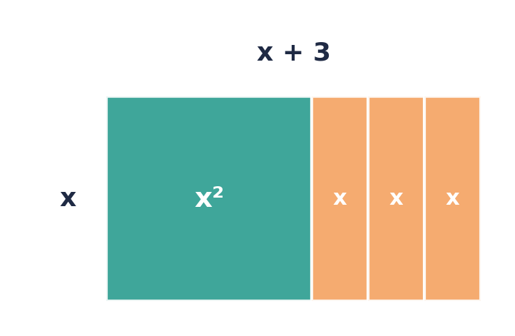

Example 1.3 · Factorizing completely
Factorize completely: (a) 2x² + 4x (b) 3x² + 6
Solution
1. (a) The numbers have HCF 2 and both terms contain x, so the HCF is 2x.
2. 2x² ÷ 2x = x and 4x ÷ 2x = 2, so 2x² + 4x = 2x(x + 2).
3. (b) The HCF of 3 and 6 is 3, but 6 has no x, so x is not common. 3x² + 6 = 3(x² + 2).
Answer: (a) 2x(x + 2) (b) 3(x² + 2)
💭 Think: 2(x² + 2x) is correct but not complete. How can you tell that a bracket still has a common factor inside it?

Example 1.4 · More than one letter
Factorize completely 6a²b − 9ab².
Solution
1. Numbers: HCF of 6 and 9 is 3.
2. Letters: both terms have at least one a and at least one b, so ab is common.
3. HCF = 3ab.
4. 6a²b ÷ 3ab = 2a and 9ab² ÷ 3ab = 3b.
5. Answer: 3ab(2a − 3b).
Answer: 3ab(2a − 3b)

Example 1.5 · A bracket as the common factor
Factorize a(x + 2) + 5(x + 2).
Solution
1. The bracket (x + 2) appears in both terms, so it is a common factor.
2. Take it out: (x + 2)(a + 5).
Answer: (x + 2)(a + 5)
💭 Think: Expand (x + 2)(a + 5) to check. You will use this step in every question in Lesson 2.

⚠ Common mistakes
- Not taking out the highest common factor: 6x² + 9x = 3(2x² + 3x) is not complete.
- Forgetting the 1: 5x + 5 = 5(x + 1), not 5x.
- Losing a sign inside the bracket. Check by expanding.

④ Practice
Write your answers in your exercise book. Start at Level 1. If you get most of a level right, move on to the next one. The answers are at the back of the pack.

Level 1 · Foundation
1. Factorize.
(a) 5x + 10
(b) 12y − 8
(c) 7a + 21b
(d) 9 − 6p
2. Factorize.
(a) x² + 5x
(b) y² − 7y
(c) ab + ac
(d) 3m² + m
3. Copy and complete.
(a) 4x + 12 = 4(x + ☐)
(b) 6y² + 9y = 3y(☐ + 3)

Level 2 · Developing
4. Factorize completely.
(a) 4x² + 8x
(b) 10p² − 15p
(c) 6a²b − 9ab²
(d) 12x³ + 18x²
(e) 3x² + 6
5. Factorize completely.
(a) 2x + 4y − 6z
(b) πr² + 2πrh
(c) 5a²b³ + 10ab²
6. Factorize by taking out a common bracket.
(a) x(y + 3) + 4(y + 3)
(b) 2a(b − 1) − 3(b − 1)
7. The surface area of a cylinder is A = 2πr² + 2πrh.
(a) Factorize the right-hand side completely.
(b) Use your answer to find A when r = 7 and h = 3. Use π = 22/7.

Level 3 · Think Deeper
8. Spot the error. Kayla factorized 6x² + 9x as 3(2x² + 3x). Is she correct? Is her answer complete?
9. Spot the error. Troy wrote 5x + 5 = 5x. Explain his mistake.
10. Explain. How can you check a factorization? Use it to decide whether 4x(x − 3) is a correct factorization of 4x² − 12x.
11. Challenge. Use factorizing to work these out without a calculator.
(a) 17 × 23 + 17 × 77
(b) 99 × 36 + 36
12. Create. Write three different two-term expressions whose highest common factor is 4x. Factorize each one.

Before you move on, say or write in one or two sentences: "I can explain why 2(x² + 2x) is not fully factorized."
How confident do I feel? ☐ Not yet ☐ Getting there ☐ Got it!

Lesson 2: Factorizing by Grouping
Building on: Lesson 1: taking out a common factor, including a common bracket.
Goal: By the end of this lesson I can factorize four-term expressions such as ax + bx + ay + by by grouping.

① Key Ideas
- A four-term expression often has no factor common to all four terms, but pairs of terms do share a factor.
- Method: (1) Group the terms in pairs. (2) Take out a common factor from each pair. (3) The two brackets should now match. Take out the common bracket.
- ax + bx + ay + by = x(a + b) + y(a + b) = (a + b)(x + y).
- If the brackets do not match, try rearranging the terms and grouping them differently.
- When the second pair starts with a minus, take out a negative factor. For example, −3y + 6 = −3(y − 2). Check the signs by expanding.
- Grouping also factorizes quadratics once the middle term has been split: x² + 3x + x + 3 = x(x + 3) + 1(x + 3) = (x + 1)(x + 3). You will use this in Lessons 5 and 6.

② Watch
Watch these videos after you have read the key ideas. Pause the video and try each example before it is solved. Online, click the link. On paper, type the short address into YouTube.
Video | What it covers | Link
Factoring by Grouping (4 terms)  Mario's Math Tutoring | Grouping four-term expressions | Watch on YouTube  youtu.be/VYUhUeeD_Z0

③ Worked Examples
Cover the solution and try the example first. Then uncover one step at a time and compare it with your own working.
Example 2.1 · The basic pattern
Factorize ax + ay + bx + by.
Solution
1. Group in pairs: (ax + ay) + (bx + by).
2. Take a common factor from each pair: a(x + y) + b(x + y).
3. The bracket (x + y) is common. Take it out: (x + y)(a + b).
Answer: (x + y)(a + b)

Example 2.2 · A quadratic written with four terms
Factorize x² + 3x + 2x + 6.
Solution
1. Group: (x² + 3x) + (2x + 6).
2. Take out factors: x(x + 3) + 2(x + 3).
3. Take out the common bracket: (x + 3)(x + 2).
Answer: (x + 3)(x + 2)

Example 2.3 · A number in front of x²
Factorize 3x² + 9x + 2x + 6.
Solution
1. Group: (3x² + 9x) + (2x + 6).
2. Take out factors: 3x(x + 3) + 2(x + 3).
3. Common bracket: (x + 3)(3x + 2).
Answer: (3x + 2)(x + 3)

Example 2.4 · Taking out a negative factor
Factorize xy − 2x − 3y + 6.
Solution
1. Group: (xy − 2x) + (−3y + 6).
2. First pair: x(y − 2).
3. Second pair: take out −3 so that the bracket matches. −3y + 6 = −3(y − 2).
4. Now x(y − 2) − 3(y − 2) = (y − 2)(x − 3).
5. Check: expand (y − 2)(x − 3) = xy − 3y − 2x + 6 ✓
Answer: (y − 2)(x − 3)
💭 Think: What would happen if you took out +3 from the second pair instead of −3?

Example 2.5 · Rearranging first
Factorize ab + 6 + 2a + 3b.
Solution
1. Grouping as written gives (ab + 6) + (2a + 3b), which has no common factors.
2. Rearrange so that each pair shares a letter: ab + 2a + 3b + 6.
3. a(b + 2) + 3(b + 2) = (b + 2)(a + 3).
Answer: (b + 2)(a + 3)

⚠ Common mistakes
- Stopping at x(a + b) + y(a + b). This is not factorized yet. You must take out the common bracket.
- Sign errors when the third term is negative. Take out a negative factor and check.
- Giving up when the brackets don't match. Try another order first.

④ Practice
Write your answers in your exercise book. Start at Level 1. If you get most of a level right, move on to the next one. The answers are at the back of the pack.

Level 1 · Foundation
1. Factorize.
(a) px + py + qx + qy
(b) ax + 2a + bx + 2b
(c) 3m + 3n + km + kn
2. Factorize.
(a) x² + 4x + 3x + 12
(b) y² + 2y + 5y + 10

Level 2 · Developing
3. Factorize.
(a) xy − 4x + 2y − 8
(b) ab − 3a − 5b + 15
(c) 6x² − 4x + 9x − 6
(d) 2pq + 6p − q − 3
4. Rearrange, then factorize.
(a) ac + bd + ad + bc
(b) x² − 12 + 3x − 4x
5. Use factorizing to work out 23 × 17 + 23 × 3 + 77 × 17 + 77 × 3 without a calculator.

Level 3 · Think Deeper
6. Spot the error. Shari factorized ax − ay − bx + by as a(x − y) − b(x + y) and got stuck. Find her mistake and finish the factorization.
7. Explain. Factorize x² + 5x + 2x + 10, then factorize x² + 2x + 5x + 10. What do you notice? Why does this happen?
8. Always, sometimes or never? "Every expression with four terms can be factorized by grouping." Give an example to support your answer.
9. Challenge. Factorize x³ + 2x² + 3x + 6.

Before you move on, say or write in one or two sentences: "I can explain why x(a + b) + y(a + b) is not fully factorized."
How confident do I feel? ☐ Not yet ☐ Getting there ☐ Got it!

Lesson 3: The Difference of Two Squares
Building on: Lesson 1 and square numbers. Unit 2: expanding brackets.
Goal: By the end of this lesson I can recognise and factorize a² − b².

① Key Ideas
- a² − b² = (a − b)(a + b).
- Why? Expand (a − b)(a + b) = a² + ab − ab − b² = a² − b². The middle terms cancel. The diagram shows the same fact with areas.
- Look for: exactly two terms, both perfect squares, with a minus between them.
- Write each term as something squared: 4x² − 9 = (2x)² − 3² = (2x − 3)(2x + 3).
- Take out a common factor first: 2x² − 50 = 2(x² − 25) = 2(x − 5)(x + 5).
- A sum of two squares, such as x² + 9, cannot be factorized with real numbers.
- If one term is not a perfect square, you can still use surds: x² − 5 = (x − √5)(x + √5). You will not need this in Form 3.

② Watch
Watch these videos after you have read the key ideas. Pause the video and try each example before it is solved. Online, click the link. On paper, type the short address into YouTube.
Video | What it covers | Link
Difference between two squares  Corbettmaths | Recognising and factorizing a² − b² | Watch on YouTube  youtu.be/IqN8Z1-nlsY

③ Worked Examples
Cover the solution and try the example first. Then uncover one step at a time and compare it with your own working.
Example 3.1 · Why the pattern works
Factorize x² − 16 and check by expanding.
Solution
1. x² = (x)² and 16 = 4². It is a difference of two squares.
2. So x² − 16 = (x − 4)(x + 4).
3. Check: x² + 4x − 4x − 16 = x² − 16 ✓. The middle terms cancel.
Answer: (x − 4)(x + 4)
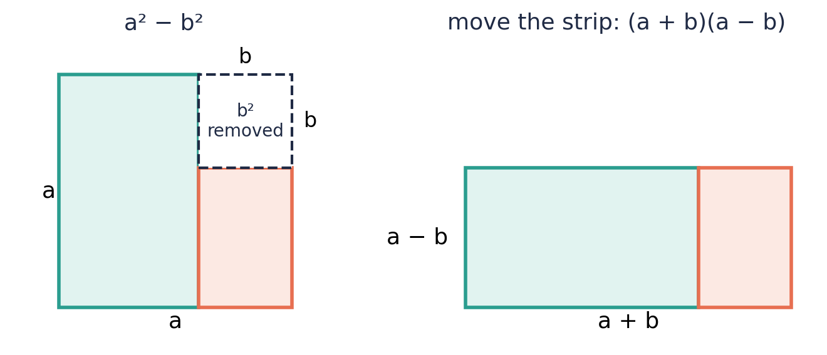

Example 3.2 · A coefficient in front of x²
Factorize 4x² − 9.
Solution
1. 4x² = (2x)² and 9 = 3².
2. So 4x² − 9 = (2x − 3)(2x + 3).
Answer: (2x − 3)(2x + 3)

Example 3.3 · Two letters
Factorize 25a² − 49b².
Solution
1. 25a² = (5a)² and 49b² = (7b)².
2. So 25a² − 49b² = (5a − 7b)(5a + 7b).
Answer: (5a − 7b)(5a + 7b)

Example 3.4 · Common factor first
Factorize completely 3y² − 75.
Solution
1. 75 is not a perfect square, but 3 is a common factor: 3(y² − 25).
2. y² − 25 = (y − 5)(y + 5).
3. So 3y² − 75 = 3(y − 5)(y + 5).
Answer: 3(y − 5)(y + 5)

Example 3.5 · Mental arithmetic
Work out 53² − 47² without a calculator.
Solution
1. Use a² − b² = (a − b)(a + b) with a = 53 and b = 47.
2. (53 − 47)(53 + 47) = 6 × 100 = 600.
Answer: 600
💭 Think: Why is this much quicker than working out 53² and 47² separately?

⚠ Common mistakes
- Writing (x − 3)² for x² − 9. (x − 3)² = x² − 6x + 9.
- Trying to factorize a sum of squares: x² + 25 ≠ (x + 5)(x + 5).
- Forgetting to square-root the coefficient: 9x² − 4 = (3x − 2)(3x + 2), not (9x − 2)(9x + 2).

④ Practice
Write your answers in your exercise book. Start at Level 1. If you get most of a level right, move on to the next one. The answers are at the back of the pack.

Level 1 · Foundation
1. Factorize.
(a) x² − 9
(b) y² − 25
(c) a² − 1
(d) 100 − m²
2. Which of these are a difference of two squares (using whole numbers)? Explain.
(a) x² − 36
(b) x² + 36
(c) x² − 7
(d) 49 − y²

Level 2 · Developing
3. Factorize.
(a) 4x² − 1
(b) 9y² − 16
(c) 25a² − b²
(d) 16p² − 81q²
4. Factorize completely.
(a) 2x² − 18
(b) 5a² − 20
(c) x³ − x
(d) 12 − 3y²
5. Work out without a calculator.
(a) 51² − 49²
(b) 1003² − 997²
(c) 8.5² − 1.5²
6. A square lawn has sides of x m. A square flower bed with sides of 3 m is dug out of one corner. Write the remaining grass area as a difference of two squares, factorize it, and find the area when x = 13.

Level 3 · Think Deeper
7. Spot the error. Rhea wrote x² + 25 = (x + 5)(x + 5). Expand her answer to show that she is wrong.
8. Spot the error. Dion wrote 9x² − 4 = (9x − 2)(9x + 2). Expand his answer and correct it.
9. Explain. Why does (a − b)(a + b) have no middle term when you expand it?
10. Challenge. Factorize x⁴ − 16 completely.
11. Investigate. Find all pairs of whole numbers whose squares differ by 40. (Hint: a² − b² = (a − b)(a + b) = 40.)

Before you move on, say or write in one or two sentences: "I can explain how to recognise a difference of two squares."
How confident do I feel? ☐ Not yet ☐ Getting there ☐ Got it!

Lesson 4: Perfect Square Trinomials
Building on: Lesson 3 and Unit 2, Lesson 4, where you found that (a + b)² ≠ a² + b².
Goal: By the end of this lesson I can recognise and factorize perfect squares such as x² + 8x + 16 and 9x² − 24x + 16.

① Key Ideas
- (a + b)² = a² + 2ab + b² and (a − b)² = a² − 2ab + b².
- The tile diagram shows (x + 3)² = x² + 6x + 9. There is one x² square, two strips of 3x, and a 3 × 3 square of ones.
- How to spot one: (1) the first and last terms are perfect squares, (2) the last term is positive, and (3) the middle term = 2 × (√first) × (√last).
- x² + 8x + 16: √x² = x, √16 = 4, and 2 × x × 4 = 8x ✓. So x² + 8x + 16 = (x + 4)².
- If the middle term is negative, the bracket has a minus: x² − 10x + 25 = (x − 5)².
- In Unit 8 (Completing the Square), you will learn to turn any quadratic into a perfect square plus or minus a number.

② Watch
Watch these videos after you have read the key ideas. Pause the video and try each example before it is solved. Online, click the link. On paper, type the short address into YouTube.
Video | What it covers | Link
Factoring Perfect Square Trinomials  Mario's Math Tutoring | Recognising and factorizing perfect squares | Watch on YouTube  youtu.be/xwVDcVNLxdY

③ Worked Examples
Cover the solution and try the example first. Then uncover one step at a time and compare it with your own working.
Example 4.1 · Seeing a perfect square
Expand (x + 3)² using the tile diagram.
Solution
1. (x + 3)² = (x + 3)(x + 3).
2. The diagram shows 1 x² tile, 6 x tiles (3 across the top and 3 down the side), and 9 unit tiles.
3. So (x + 3)² = x² + 6x + 9.
Answer: x² + 6x + 9
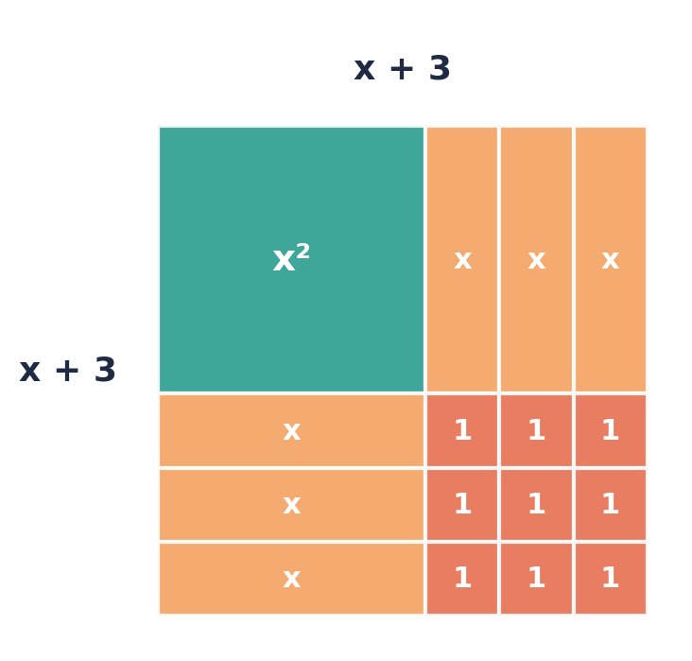
💭 Think: Why does the middle term always come out as 2 × x × 3?

Example 4.2 · Factorizing a perfect square
Factorize x² + 8x + 16.
Solution
1. First term: x² = (x)². Last term: 16 = 4².
2. Check the middle term: 2 × x × 4 = 8x ✓.
3. So x² + 8x + 16 = (x + 4)².
Answer: (x + 4)²

Example 4.3 · A negative middle term
Factorize x² − 10x + 25.
Solution
1. x² = (x)² and 25 = 5².
2. 2 × x × 5 = 10x, and the middle term is −10x, so use a minus sign.
3. x² − 10x + 25 = (x − 5)².
Answer: (x − 5)²

Example 4.4 · A coefficient in front of x²
Factorize (a) 4x² + 20x + 25 (b) 9x² − 24x + 16.
Solution
1. (a) 4x² = (2x)² and 25 = 5². 2 × 2x × 5 = 20x ✓. So (2x + 5)².
2. (b) 9x² = (3x)² and 16 = 4². 2 × 3x × 4 = 24x, and it is negative. So (3x − 4)².
Answer: (a) (2x + 5)² (b) (3x − 4)²

Example 4.5 · Is it a perfect square?
(a) Is x² + 6x + 4 a perfect square? (b) What number c makes x² + 12x + c a perfect square?
Solution
1. (a) If it were, it would be (x + 3)², because 2 × 3 = 6. But (x + 3)² = x² + 6x + 9, not + 4. So it is not a perfect square.
2. (b) Half of 12 is 6, and 6² = 36. So c = 36, and x² + 12x + 36 = (x + 6)².
Answer: (a) No (b) c = 36
💭 Think: "Halve the middle number and square it" is the key idea in Unit 8.

Example 4.6 · Common factor first
Factorize completely 2x² + 12x + 18.
Solution
1. Take out 2: 2(x² + 6x + 9).
2. x² + 6x + 9 = (x + 3)².
3. So 2x² + 12x + 18 = 2(x + 3)².
Answer: 2(x + 3)²

⚠ Common mistakes
- Writing (x + 4)(x − 4) for x² + 8x + 16. That is a difference of squares, which has no middle term.
- Using the wrong sign in the bracket when the middle term is negative.
- Calling x² + 6x − 9 a perfect square. The last term must be positive.

④ Practice
Write your answers in your exercise book. Start at Level 1. If you get most of a level right, move on to the next one. The answers are at the back of the pack.

Level 1 · Foundation
1. Expand.
(a) (x + 2)²
(b) (y − 5)²
(c) (2a + 1)²
2. Factorize.
(a) x² + 6x + 9
(b) x² − 4x + 4
(c) y² + 14y + 49
(d) m² − 18m + 81

Level 2 · Developing
3. Factorize completely.
(a) 9x² + 12x + 4
(b) 16y² − 8y + 1
(c) 25a² + 30ab + 9b²
(d) 3x² − 30x + 75
4. Which of these are perfect squares? Factorize the ones that are.
(a) x² + 10x + 25
(b) x² + 10x + 20
(c) x² − 6x − 9
(d) 4x² − 4x + 1
5. Fill in the missing numbers.
(a) x² + 16x + ☐ = (x + ☐)²
(b) x² − ☐x + 49 = (x − 7)²
(c) 9x² + ☐x + 1 = (3x + 1)²
6. Use factorizing to work out 97² + 2 × 97 × 3 + 3² without a calculator.

Level 3 · Think Deeper
7. Spot the error. Jordan wrote x² − 8x + 16 = (x + 4)². Expand his answer and correct it.
8. Explain. Why must the last term of a perfect square trinomial be positive?
9. Always, sometimes or never? Explain each answer.
(a) (a + b)² = a² + b²
(b) x² + 2x + 1 is a perfect square
10. Challenge. Find both values of k that make x² + kx + 36 a perfect square.
11. Create. Write a perfect square trinomial in which the coefficient of x² is 4. Factorize it.

Before you move on, say or write in one or two sentences: "I can explain how to tell whether a trinomial is a perfect square."
How confident do I feel? ☐ Not yet ☐ Getting there ☐ Got it!

Lesson 5: Factorizing Quadratics x² + bx + c
Building on: Lesson 2 (grouping) and Lesson 4 (perfect squares).
Goal: By the end of this lesson I can factorize any quadratic x² + bx + c that has whole-number factors.

① Key Ideas
- Expanding shows the pattern: (x + p)(x + q) = x² + (p + q)x + pq.
- So to factorize x² + bx + c, find two numbers that multiply to c and add to b. This is called factorizing by inspection.
- Signs: if c is positive, both numbers have the same sign as b. If c is negative, the numbers have opposite signs, and the larger one takes the sign of b.
- List the factor pairs of c in an organised way so that you don't miss any.
- The tile diagram shows x² + 5x + 6 as a rectangle (x + 2) by (x + 3).
- Another method: split bx into two terms using the numbers you found, then group (Lesson 2). x² + 5x + 6 = x² + 2x + 3x + 6 = (x + 2)(x + 3).
- Always check your answer by expanding.

② Watch
Watch these videos after you have read the key ideas. Pause the video and try each example before it is solved. Online, click the link. On paper, type the short address into YouTube.
Video | What it covers | Link
Factorising quadratics 1  Corbettmaths | Factorizing x² + bx + c | Watch on YouTube  youtu.be/X-djBcWVizM

③ Worked Examples
Cover the solution and try the example first. Then uncover one step at a time and compare it with your own working.
Example 5.1 · Two positive numbers
Factorize x² + 5x + 6.
Solution
1. We need two numbers that multiply to 6 and add to 5.
2. Factor pairs of 6: 1 × 6 (sum 7) and 2 × 3 (sum 5 ✓).
3. So x² + 5x + 6 = (x + 2)(x + 3).
Answer: (x + 2)(x + 3)
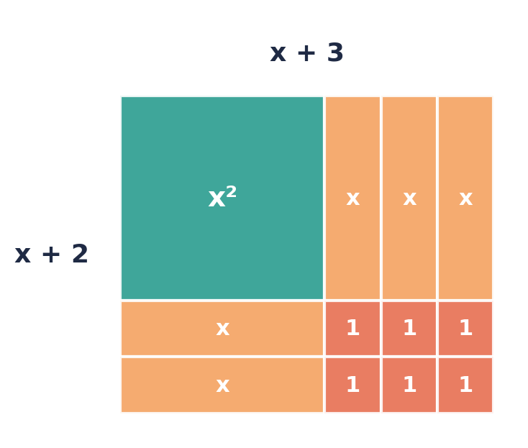

Example 5.2 · Listing factor pairs
Factorize x² + 13x + 36.
Solution
1. Factor pairs of 36: 1 × 36 (sum 37), 2 × 18 (sum 20), 3 × 12 (sum 15), 4 × 9 (sum 13 ✓), 6 × 6 (sum 12).
2. So x² + 13x + 36 = (x + 4)(x + 9).
Answer: (x + 4)(x + 9)

Example 5.3 · Both numbers negative
Factorize x² − 7x + 12.
Solution
1. c = +12 is positive, so both numbers have the same sign. b = −7 is negative, so both are negative.
2. −3 × −4 = 12 and −3 + (−4) = −7 ✓.
3. So x² − 7x + 12 = (x − 3)(x − 4).
Answer: (x − 3)(x − 4)

Example 5.4 · c is negative
Factorize (a) x² + 2x − 15 (b) x² − x − 20.
Solution
1. (a) The numbers multiply to −15, so they have opposite signs. They add to +2, so the larger one is positive: 5 and −3.
2. x² + 2x − 15 = (x + 5)(x − 3).
3. (b) The numbers multiply to −20 and add to −1, so the larger one is negative: −5 and 4.
4. x² − x − 20 = (x − 5)(x + 4).
Answer: (a) (x + 5)(x − 3) (b) (x − 5)(x + 4)

Example 5.5 · Splitting the middle term
Factorize x² + 5x + 6 by splitting the middle term and grouping.
Solution
1. Use the numbers 2 and 3 to split 5x: x² + 2x + 3x + 6.
2. Group: x(x + 2) + 3(x + 2).
3. Take out the common bracket: (x + 2)(x + 3). This is the same answer as Example 5.1.
Answer: (x + 2)(x + 3)
💭 Think: Splitting and grouping seems slower here. In Lesson 6 it becomes the most reliable method.

⚠ Common mistakes
- Finding numbers that add to c and multiply to b (the wrong way round).
- Getting the signs wrong when c is negative. Always expand to check.
- Forgetting to take out a common factor first, e.g. in 2x² + 10x + 12.

④ Practice
Write your answers in your exercise book. Start at Level 1. If you get most of a level right, move on to the next one. The answers are at the back of the pack.

Level 1 · Foundation
1. Factorize.
(a) x² + 7x + 10
(b) x² + 8x + 15
(c) x² + 9x + 20
(d) x² + 6x + 8
2. Factorize.
(a) x² − 5x + 6
(b) x² − 9x + 14
(c) x² − 8x + 12

Level 2 · Developing
3. Factorize.
(a) x² + 3x − 10
(b) x² − 2x − 24
(c) x² + x − 42
(d) x² − 4x − 21
(e) y² − 13y + 36
4. Factorize completely.
(a) 2x² + 10x + 12
(b) 3x² − 3x − 36
(c) x³ + 5x² + 6x
5. A rectangle has area (x² + 11x + 28) cm². Its width is (x + 4) cm.
(a) Find an expression for its length.
(b) Find the length, width and area when x = 3.
6. Factorize x² + 12x + 36. What kind of quadratic is it?

Level 3 · Think Deeper
7. Spot the error. Akeem wrote x² + x − 12 = (x − 4)(x + 3). Expand his answer and correct it.
8. Explain. When c is negative, why must the two numbers have opposite signs?
9. Always, sometimes or never? "x² + bx + c can always be factorized as (x + p)(x + q) using whole numbers p and q."
10. Challenge. Find all the whole-number values of b for which x² + bx + 12 can be factorized.
11. Create. Write a quadratic x² + bx + c that has (x − 5) as one of its factors, with c negative. Show that it factorizes.

Before you move on, say or write in one or two sentences: "I can explain how the signs of b and c help me choose the two numbers."
How confident do I feel? ☐ Not yet ☐ Getting there ☐ Got it!

Lesson 6: Factorizing ax² + bx + c and Choosing a Method
Building on: Lessons 1–5, especially grouping (Lesson 2) and splitting the middle term (Lesson 5).
Goal: By the end of this lesson I can factorize quadratics where the coefficient of x² is not 1, and choose the right method for any expression.

① Key Ideas
- Method 1: inspection (trial). Try pairs of brackets whose first terms multiply to ax² and whose last terms multiply to c. Expand to check the middle term. For example, 3x² + 22x + 24 = (3x + 4)(x + 6).
- Method 2: the AC method (splitting the middle term). This is reliable and needs no guessing:
- (1) Multiply a × c. (2) Find two numbers that multiply to ac and add to b. (3) Use them to split the middle term. (4) Group and factorize, as in Lesson 2.
- For 3x² + 22x + 24: ac = 72, and 4 × 18 = 72 with 4 + 18 = 22. So 3x² + 4x + 18x + 24 = x(3x + 4) + 6(3x + 4) = (3x + 4)(x + 6).
- A box (grid) method is a neat way to organise the four terms. Put ax² and c in opposite corners and the two split terms in the others.
- Choosing a method. (1) Always take out a common factor first. (2) Two terms: difference of two squares? (3) Three terms: perfect square? If not, use inspection or the AC method. (4) Four terms: grouping. (5) Check by expanding, and check that no bracket can be factorized further.
- Some quadratics, such as 3x² + 4x + 5, cannot be factorized with whole numbers. Completing the square (Unit 8) can handle these.

② Watch
Watch these videos after you have read the key ideas. Pause the video and try each example before it is solved. Online, click the link. On paper, type the short address into YouTube.
Video | What it covers | Link
Factorising quadratics 2  Corbettmaths | Factorizing ax² + bx + c | Watch on YouTube  youtu.be/8lejlzdWV58
How to factor trinomials ax^2+bx+c  bprp math basics | The AC method step by step | Watch on YouTube  youtu.be/EAqjmUoKr98

③ Worked Examples
Cover the solution and try the example first. Then uncover one step at a time and compare it with your own working.
Example 6.1 · The AC method
Factorize 2x² + 7x + 3.
Solution
1. a × c = 2 × 3 = 6. We need two numbers that multiply to 6 and add to 7: 1 and 6.
2. Split the middle term: 2x² + x + 6x + 3.
3. Group: x(2x + 1) + 3(2x + 1).
4. Take out the common bracket: (2x + 1)(x + 3).
5. Check: 2x² + 6x + x + 3 = 2x² + 7x + 3 ✓
Answer: (2x + 1)(x + 3)

Example 6.2 · The box method
Factorize 3x² + 22x + 24.
Solution
1. ac = 3 × 24 = 72. Pairs: 4 × 18 = 72 and 4 + 18 = 22 ✓.
2. Put 3x² and 24 in opposite corners of a 2 × 2 box, and 4x and 18x in the other two corners.
3. Take the HCF of each row and column: the rows give x and 6, and the columns give 3x and 4.
4. So 3x² + 22x + 24 = (3x + 4)(x + 6).
Answer: (3x + 4)(x + 6)
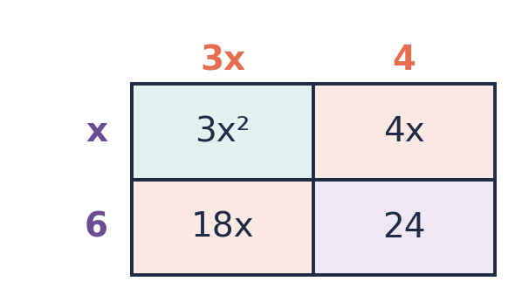

Example 6.3 · A negative constant
Factorize 6x² − x − 2.
Solution
1. ac = 6 × (−2) = −12. We need two numbers that multiply to −12 and add to −1: −4 and 3.
2. Split: 6x² − 4x + 3x − 2.
3. Group: 2x(3x − 2) + 1(3x − 2).
4. Answer: (3x − 2)(2x + 1).
Answer: (3x − 2)(2x + 1)

Example 6.4 · Inspection
Factorize 5x² + 11x + 2 by inspection.
Solution
1. The first terms must be 5x and x. The last terms must be 1 and 2 (in some order).
2. Try (5x + 1)(x + 2): the middle term is 10x + x = 11x ✓.
3. (Trying (5x + 2)(x + 1) gives 5x + 2x = 7x ✗.)
Answer: (5x + 1)(x + 2)

Example 6.5 · Choosing a method
Factorize completely: (a) 3x² − 12 (b) 2x² − 8x + 8 (c) 4x² + 8x − 12 (d) ax + bx − 2a − 2b
Solution
1. (a) Common factor 3: 3(x² − 4). Difference of squares: 3(x − 2)(x + 2).
2. (b) Common factor 2: 2(x² − 4x + 4). Perfect square: 2(x − 2)².
3. (c) Common factor 4: 4(x² + 2x − 3). Inspection (3 and −1): 4(x + 3)(x − 1).
4. (d) Four terms, so group: x(a + b) − 2(a + b) = (a + b)(x − 2).
Answer: (a) 3(x − 2)(x + 2) (b) 2(x − 2)² (c) 4(x + 3)(x − 1) (d) (a + b)(x − 2)
💭 Think: In every part, why did we look for a common factor before anything else?

⚠ Common mistakes
- Finding numbers that multiply to c instead of a × c.
- Stopping before the answer is complete, e.g. (2x + 4)(x + 3) still has a common factor of 2.
- Not checking by expanding. One expansion catches most sign errors.

④ Practice
Write your answers in your exercise book. Start at Level 1. If you get most of a level right, move on to the next one. The answers are at the back of the pack.

Level 1 · Foundation
1. Factorize.
(a) 2x² + 5x + 3
(b) 3x² + 7x + 2
(c) 2x² + 11x + 5
(d) 5x² + 7x + 2
2. Factorize 2x² + 9x + 4 by splitting the middle term. Show each step.

Level 2 · Developing
3. Factorize.
(a) 3x² − 10x + 8
(b) 2x² + x − 6
(c) 6x² + 7x + 2
(d) 4x² − 4x − 3
(e) 10x² − 11x − 6
4. Factorize completely. Choose the best method each time.
(a) 5x² − 45
(b) x² − 14x + 49
(c) 2x² + 2x − 24
(d) 6xy + 9x + 4y + 6
(e) 8x² − 18
(f) 12x² + 8x
5. The area of a rectangle is (2x² + 7x + 6) m². Find expressions for the lengths of its sides.

Level 3 · Think Deeper
6. Spot the error. Nia wrote 2x² + 7x + 6 = (2x + 6)(x + 1). Expand her answer, then give the correct factorization.
7. Spot the error. Shawn factorized 2x² + 10x + 12 as (2x + 4)(x + 3). Expanding gives the right expression. Why is his answer not complete?
8. Investigate. Which of these can be factorized using whole numbers? Explain how you know.
(a) x² + 5x + 6
(b) x² + 5x + 7
(c) 3x² + 4x + 5
(d) 2x² + 5x + 2
9. Explain. In the AC method for 3x² + 22x + 24, why do we look for numbers that multiply to a × c = 72, and not just to c = 24?
10. Create. Write a quadratic ax² + bx + c with a = 3 that can be factorized. Show the factorization using the AC method.

Before you move on, say or write in one or two sentences: "I can list the steps I use to decide how to factorize an expression."
How confident do I feel? ☐ Not yet ☐ Getting there ☐ Got it!

CSEC-Style Exam Practice
These questions are like the ones on CSEC Paper 2, and they use all six lessons. Try them under test conditions: no notes, and about 30 minutes. Show all your working.
1. Factorize completely:
(a) 6x² − 9x [1 mark]
(b) x² − 49 [1 mark]
(c) x² + 2x − 35 [2 marks]
(d) 2ax − 6a + bx − 3b [2 marks]
2.
(a) Factorize completely 3x² − 12. [2 marks]
(b) Hence, or otherwise, find the value of 3 × 102² − 12 without using a calculator. [2 marks]
3.
(a) Expand (2x − 3)². [2 marks]
(b) Factorize 2x² + 5x − 3. [2 marks]
(c) Factorize 6x² + 11x + 4. [2 marks]
4. A rectangular garden has an area of (x² + 8x + 15) m².
(a) Factorize x² + 8x + 15. [2 marks]
(b) The width of the garden is (x + 3) m. Write an expression for its length. [1 mark]
(c) The perimeter of the garden is 40 m. Find the value of x and the area of the garden. [3 marks]

Self-Check Quiz: Am I Ready?
Answer all 12 questions without looking back at the lessons. Then check your answers and write your score in the box. The lesson number after each question tells you where to go back if you get it wrong.
1. Factorize 8x + 12. (Lesson 1)
A 4(2x + 12) B 4(2x + 3) C 8(x + 4) D 2(4x + 6)
2. Factorize completely 6x² + 9x. (Lesson 1)
A 6x(x + 9) B x(6x + 9) C 3(2x² + 3x) D 3x(2x + 3)
3. Factorize ax + ay + bx + by. (Lesson 2)
A (a + b)(x + y) B (ax + by)² C (a + x)(b + y) D ab(x + y)
4. Factorize x² − 64. (Lesson 3)
A (x − 32)(x + 32) B It cannot be factorized C (x − 8)(x + 8) D (x − 8)²
5. Factorize 9y² − 25. (Lesson 3)
A (9y − 5)(y + 5) B (9y − 25)(y + 1) C (3y − 5)(3y + 5) D (3y − 5)²
6. Which of these cannot be factorized? (Lesson 3)
A x² + 16 B x² − 8x + 16 C x² + 8x + 16 D x² − 16
7. Factorize x² − 12x + 36. (Lesson 4)
A (x − 12)(x − 3) B (x + 6)² C (x − 6)(x + 6) D (x − 6)²
8. Factorize x² + 7x + 12. (Lesson 5)
A (x − 3)(x − 4) B (x + 3)(x + 4) C (x + 2)(x + 6) D (x + 12)(x + 1)
9. Factorize x² − 2x − 15. (Lesson 5)
A (x − 5)(x + 3) B (x − 15)(x + 1) C (x + 5)(x − 3) D (x − 5)(x − 3)
10. Factorize 2x² + 7x + 3. (Lesson 6)
A (x + 1)(x + 3) B (2x + 3)(x + 1) C (2x + 1)(x + 3) D (2x + 3)(x + 3)
11. In the AC method for 3x² + 10x + 8, the two numbers must multiply to… (Lesson 6)
A 10 B 24 C 11 D 8
12. What is the first step when you factorize 5x² − 20 completely? (Lesson 6)
A Group the terms B Use the AC method C Use difference of two squares straight away D Take out the common factor 5

My score | What it means
11–12 | Ready! You are ready for the next topic: Simultaneous Equations.
8–10 | Nearly there. Look at the lesson number next to each question you missed. Redo the Level 2 practice for those lessons.
0–7 | Go back over the lessons for the questions you missed. Redo the Level 1 and Level 2 practice, watch the videos again, then retake this quiz.
My score: ______ / 12

Answers
Use these to check your work. If your answer is different, look for your mistake before you ask for help. Your teacher has the full worked solutions.

Warm-Up
1. (a) 6 (b) 12
2. 1 × 24, 2 × 12, 3 × 8, 4 × 6
3. 6x − 15
4. x² + 7x
5. 3 and 4
6. 5 and −2

Lesson 1: Taking Out a Common Factor
Level 1 · Foundation
1. (a) 5(x + 2) (b) 4(3y − 2) (c) 7(a + 3b) (d) 3(3 − 2p)
2. (a) x(x + 5) (b) y(y − 7) (c) a(b + c) (d) m(3m + 1)
3. (a) 3 (b) 2y
Level 2 · Developing
4. (a) 4x(x + 2) (b) 5p(2p − 3) (c) 3ab(2a − 3b) (d) 6x²(2x + 3) (e) 3(x² + 2)
5. (a) 2(x + 2y − 3z) (b) πr(r + 2h) (c) 5ab²(ab + 2)
6. (a) (y + 3)(x + 4) (b) (b − 1)(2a − 3)
7. (a) A = 2πr(r + h) (b) A = 440
Level 3 · Think Deeper
8. Correct but not complete. The HCF is 3x: 3x(2x + 3).
9. 5 ÷ 5 = 1, so 5x + 5 = 5(x + 1).
10. Expand it. 4x(x − 3) = 4x² − 12x, so it is correct.
11. (a) 1700 (b) 3600
12. e.g. 8x² + 12x = 4x(2x + 3), 4x² − 20x = 4x(x − 5), 12xy + 4x = 4x(3y + 1)

Lesson 2: Factorizing by Grouping
Level 1 · Foundation
1. (a) (x + y)(p + q) (b) (x + 2)(a + b) (c) (m + n)(3 + k)
2. (a) (x + 4)(x + 3) (b) (y + 2)(y + 5)
Level 2 · Developing
3. (a) (y − 4)(x + 2) (b) (b − 3)(a − 5) (c) (3x − 2)(2x + 3) (d) (q + 3)(2p − 1)
4. (a) (c + d)(a + b) (b) (x + 3)(x − 4)
5. 2000
Level 3 · Think Deeper
6. −bx + by = −b(x − y), not −b(x + y). Answer: (x − y)(a − b).
7. Both give (x + 2)(x + 5). They are the same expression, so they have the same factors.
8. Sometimes. e.g. ab + a + b + 2 cannot be factorized this way.
9. (x + 2)(x² + 3)

Lesson 3: The Difference of Two Squares
Level 1 · Foundation
1. (a) (x − 3)(x + 3) (b) (y − 5)(y + 5) (c) (a − 1)(a + 1) (d) (10 − m)(10 + m)
2. (a) yes (b) no, it is a sum (c) no, 7 is not a square number (d) yes
Level 2 · Developing
3. (a) (2x − 1)(2x + 1) (b) (3y − 4)(3y + 4) (c) (5a − b)(5a + b) (d) (4p − 9q)(4p + 9q)
4. (a) 2(x − 3)(x + 3) (b) 5(a − 2)(a + 2) (c) x(x − 1)(x + 1) (d) 3(2 − y)(2 + y)
5. (a) 200 (b) 12 000 (c) 70
6. x² − 9 = (x − 3)(x + 3); 160 m²
Level 3 · Think Deeper
7. (x + 5)(x + 5) = x² + 10x + 25, not x² + 25. A sum of two squares cannot be factorized.
8. (9x − 2)(9x + 2) = 81x² − 4. Correct: (3x − 2)(3x + 2).
9. The two middle terms are +ab and −ab, which cancel.
10. (x − 2)(x + 2)(x² + 4)
11. 11 and 9, and 7 and 3

Lesson 4: Perfect Square Trinomials
Level 1 · Foundation
1. (a) x² + 4x + 4 (b) y² − 10y + 25 (c) 4a² + 4a + 1
2. (a) (x + 3)² (b) (x − 2)² (c) (y + 7)² (d) (m − 9)²
Level 2 · Developing
3. (a) (3x + 2)² (b) (4y − 1)² (c) (5a + 3b)² (d) 3(x − 5)²
4. (a) yes, (x + 5)² (b) no (c) no (d) yes, (2x − 1)²
5. (a) 64 and 8 (b) 14 (c) 6
6. 10 000
Level 3 · Think Deeper
7. (x + 4)² = x² + 8x + 16. Correct: (x − 4)².
8. It is b², and any number squared is positive (or zero).
9. (a) Sometimes (only if a or b is 0) (b) Always, = (x + 1)²
10. k = 12 or k = −12
11. e.g. 4x² + 12x + 9 = (2x + 3)²

Lesson 5: Factorizing Quadratics x² + bx + c
Level 1 · Foundation
1. (a) (x + 2)(x + 5) (b) (x + 3)(x + 5) (c) (x + 4)(x + 5) (d) (x + 2)(x + 4)
2. (a) (x − 2)(x − 3) (b) (x − 2)(x − 7) (c) (x − 2)(x − 6)
Level 2 · Developing
3. (a) (x + 5)(x − 2) (b) (x − 6)(x + 4) (c) (x + 7)(x − 6) (d) (x − 7)(x + 3) (e) (y − 4)(y − 9)
4. (a) 2(x + 2)(x + 3) (b) 3(x − 4)(x + 3) (c) x(x + 2)(x + 3)
5. (a) (x + 7) cm (b) 10 cm by 7 cm, area 70 cm²
6. (x + 6)², a perfect square
Level 3 · Think Deeper
7. (x − 4)(x + 3) = x² − x − 12. Correct: (x + 4)(x − 3).
8. Their product is c. A product is negative only when one number is positive and the other is negative.
9. Sometimes. e.g. x² + x + 1 cannot be factorized this way.
10. b = ±7, ±8, ±13
11. e.g. (x − 5)(x + 2) = x² − 3x − 10

Lesson 6: Factorizing ax² + bx + c and Choosing a Method
Level 1 · Foundation
1. (a) (2x + 3)(x + 1) (b) (3x + 1)(x + 2) (c) (2x + 1)(x + 5) (d) (5x + 2)(x + 1)
2. (2x + 1)(x + 4)
Level 2 · Developing
3. (a) (3x − 4)(x − 2) (b) (2x − 3)(x + 2) (c) (2x + 1)(3x + 2) (d) (2x − 3)(2x + 1) (e) (5x + 2)(2x − 3)
4. (a) 5(x − 3)(x + 3) (b) (x − 7)² (c) 2(x + 4)(x − 3) (d) (2y + 3)(3x + 2) (e) 2(2x − 3)(2x + 3) (f) 4x(3x + 2)
5. (2x + 3) m and (x + 2) m
Level 3 · Think Deeper
6. (2x + 6)(x + 1) = 2x² + 8x + 6. Correct: (2x + 3)(x + 2).
7. (2x + 4) still has a common factor of 2. Complete answer: 2(x + 2)(x + 3).
8. (a) yes, (x + 2)(x + 3) (b) no (c) no (d) yes, (2x + 1)(x + 2)
9. After splitting to 3x² + px + qx + 24, the pairs only share a bracket when 3 × 24 = p × q.
10. e.g. 3x² + 11x + 10 = (3x + 5)(x + 2)

CSEC-Style Exam Practice
1. (a) 3x(2x − 3) (b) (x − 7)(x + 7) (c) (x + 7)(x − 5) (d) (x − 3)(2a + b)
2. (a) 3(x − 2)(x + 2) (b) 31 200
3. (a) 4x² − 12x + 9 (b) (2x − 1)(x + 3) (c) (2x + 1)(3x + 4)
4. (a) (x + 3)(x + 5) (b) (x + 5) m (c) x = 6, area 99 m²

Self-Check Quiz
Q | Answer | Why
1 | B | The HCF of 8 and 12 is 4. (2(4x + 6) is correct but not complete.)
2 | D | The HCF is 3x.
3 | A | a(x + y) + b(x + y) = (x + y)(a + b).
4 | C | Difference of two squares: 64 = 8².
5 | C | 9y² = (3y)² and 25 = 5².
6 | A | A sum of two squares cannot be factorized with real numbers.
7 | D | 36 = 6² and 2 × 6 = 12, with a negative middle term.
8 | B | 3 × 4 = 12 and 3 + 4 = 7.
9 | A | −5 × 3 = −15 and −5 + 3 = −2.
10 | C | ac = 6: 1 and 6. 2x² + x + 6x + 3 = (2x + 1)(x + 3).
11 | B | a × c = 3 × 8 = 24. (The numbers are 4 and 6.)
12 | D | Always take out a common factor first: 5(x² − 4) = 5(x − 2)(x + 2).

