Clare Hall Secondary School · Mathematics Department

FORM 3 MATHEMATICS · UNIT 6
Simultaneous Equations
Self-Paced Learning Pack
Name: ______________________________________ Class: ___________
Time in class: 2 weeks School year: 2026–2027 Next topic: Direct and Inverse Variation

What's inside
Section | What you will do
Before You Start | Warm up with the number facts you need
Lesson 1 | What Simultaneous Equations Mean
Lesson 2 | Elimination by Adding or Subtracting
Lesson 3 | Elimination by Multiplying First
Lesson 4 | The Substitution Method
Lesson 5 | Cramer's Rule (Using Determinants)
Lesson 6 | Solving Problems with Simultaneous Equations
Exam Practice | CSEC-style questions that use all six lessons
Self-Check Quiz | 14 questions that show whether you are ready to move on
Answers | Check your work (at the back of the pack)

How to Use This Pack
- This pack lets you learn at your own pace. You can work ahead of the class or go back over anything you missed.
- Work through the lessons in order. Each lesson builds on the one before it.
- For each lesson: Read the key ideas → Watch the videos → Study the worked examples → Practise.
- Before you read the solution to a worked example, cover it and try the example yourself first. Then check each step.
- Practice has three levels. Level 1 (Foundation) checks the basics. Level 2 (Developing) makes you apply them. Level 3 (Think Deeper) asks you to explain, find mistakes and create your own examples.
- Check your answers at the back of the pack. If you get an answer wrong, find your mistake before you move on. A mistake you understand teaches you more than a correct guess.
- When you finish all the lessons, try the CSEC-Style Exam Practice, then the Self-Check Quiz. Your quiz score tells you whether you are ready for the next topic.

The learning route for every lesson
① Read the key ideas → ② Watch the videos → ③ Try the worked examples, then check each step → ④ Practise Level 1 → 2 → 3 → ⑤ Check your answers → ⑥ Tick your checklist

My Progress Checklist
Tick one box for each statement before you start and again after you finish. Be honest. This checklist is for you.
I can… | Not yet | Getting there | Got it!
Explain what the solution of a pair of simultaneous equations means, and check it (Lesson 1) | ☐ | ☐ | ☐
Find the solution from a graph as the point where two lines intersect (Lesson 1) | ☐ | ☐ | ☐
Solve simultaneous equations by elimination, adding or subtracting (Lesson 2) | ☐ | ☐ | ☐
Solve simultaneous equations by elimination, multiplying first (Lesson 3) | ☐ | ☐ | ☐
Solve simultaneous equations by substitution, and choose the better method (Lesson 4) | ☐ | ☐ | ☐
Solve simultaneous equations using Cramer's rule (determinants), and recognise when D = 0 (Lesson 5) | ☐ | ☐ | ☐
Form and solve simultaneous equations from word problems (Lesson 6) | ☐ | ☐ | ☐

Key Words
Symbol | Meaning | Example
simultaneous | true at the same time | x + y = 5 and x − y = 1 are both true when x = 3, y = 2
unknowns | the letters we need to find | x and y
(1), (2) | labels for the two equations so that we can refer to them | (1) + (2) means add the two equations
eliminate | remove one unknown by adding or subtracting the equations | (x + y) + (x − y) = 2x
substitute | replace a letter with an equal expression | put y = 2x into x + y = 9
intersection | the point where two lines cross | (3, 2)
determinant | for a grid with a, b on top and c, d below, the number ad − bc | for 2, 1 over 3, −2: (2)(−2) − (1)(3) = −7
Cramer's rule | x = Dx ÷ D and y = Dy ÷ D, where D, Dx and Dy are determinants | if D = −7, Dx = −21, then x = 3

Before You Start: Warm-Up
This unit uses skills from Units 2 and 3: solving equations, substituting and rearranging. Check you still have them.
1. Solve 5x − 3 = 17.
2. Solve 2(x + 4) = 18.
3. Find the value of 3x − 2y when x = 4 and y = −1.
4. Make y the subject of 2x + y = 9.
5. Simplify (3x + 2y) + (x − 2y).
6. Simplify (5x + 3y) − (2x + 3y).

Lesson 1: What Simultaneous Equations Mean
Building on: Unit 2: substitution and solving equations. Unit 1: the intersection of two sets.
Goal: By the end of this lesson I can explain what the solution of a pair of simultaneous equations is, check a solution, and find one from a graph.

① Key Ideas
- An equation with two unknowns, such as x + y = 5, has many solutions: (1, 4), (2, 3), (3, 2), (0.5, 4.5) and so on.
- Simultaneous equations are two equations that must be true at the same time. We look for the pair of values (x, y) that works in both.
- Think of Unit 1: the solution is the intersection of the two solution sets.
- To check a solution, substitute it into both equations.
- On a graph, each equation is a straight line. The solution is the point where the two lines intersect.
- Graphs can be inaccurate when the answer is not a whole number. That is why we also learn algebraic methods (Lessons 2–4).

② Watch
Watch these videos after you have read the key ideas. Pause the video and try each example before it is solved. Online, click the link. On paper, type the short address into YouTube.
Video | What it covers | Link
Solving Simultaneous Equations Graphically  Corbettmaths | The solution is where the lines cross | Watch on YouTube  youtu.be/20R39KaGwmc

③ Worked Examples
Cover the solution and try the example first. Then uncover one step at a time and compare it with your own working.
Example 1.1 · Finding a common solution
Find whole-number solutions of x + y = 5 and of x − y = 1. Which pair works for both?
Solution
1. x + y = 5: (0, 5), (1, 4), (2, 3), (3, 2), (4, 1), (5, 0).
2. x − y = 1: (1, 0), (2, 1), (3, 2), (4, 3), (5, 4).
3. The only pair in both lists is (3, 2).
Answer: x = 3, y = 2
💭 Think: The lists are like two sets, and the answer is their intersection. Why can there be only one pair in both lists here?

Example 1.2 · Checking a solution
Is x = 4, y = −1 the solution of 2x + y = 7 and x − 3y = 7?
Solution
1. First equation: 2(4) + (−1) = 8 − 1 = 7 ✓.
2. Second equation: 4 − 3(−1) = 4 + 3 = 7 ✓.
3. It works in both equations, so it is the solution.
Answer: Yes

Example 1.3 · Reading a graph
The graph shows the lines x + y = 5 and x − y = 1. Use it to solve the equations.
Solution
1. The lines cross at the point (3, 2).
2. So x = 3 and y = 2.
3. Check: 3 + 2 = 5 ✓ and 3 − 2 = 1 ✓.
Answer: x = 3, y = 2
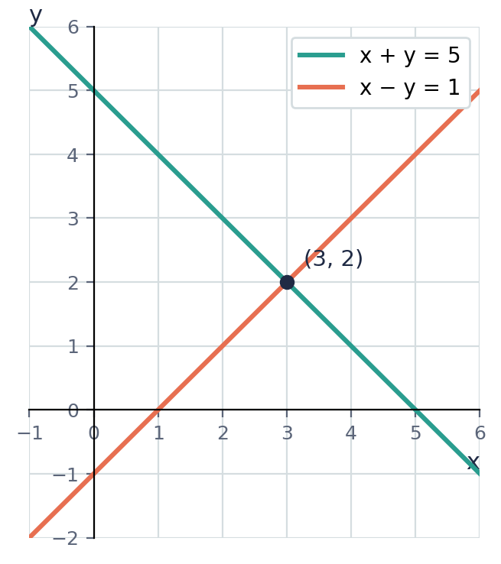

Example 1.4 · From words to a pair of equations
Two numbers add up to 20 and differ by 6. Write two equations and find the numbers.
Solution
1. Let the numbers be x and y, with x the larger one.
2. x + y = 20 and x − y = 6.
3. Try pairs that add to 20: 13 + 7 = 20 and 13 − 7 = 6 ✓.
Answer: x + y = 20, x − y = 6; the numbers are 13 and 7
💭 Think: Guessing worked here. In Lesson 2 you will find a method that always works, even when the answers are not whole numbers.

⚠ Common mistakes
- Checking a solution in only one equation.
- Writing the coordinates the wrong way round. (3, 2) means x = 3 and y = 2.
- Reading a graph carelessly. Always check your answer by substituting.

④ Practice
Write your answers in your exercise book. Start at Level 1. If you get most of a level right, move on to the next one. The answers are at the back of the pack.

Level 1 · Foundation
1. Which of these pairs are solutions of x + y = 8?
(a) (3, 5)
(b) (6, 2)
(c) (4, 5)
(d) (−1, 9)
2. y = 2x + 1 and x + y = 7.
(a) Is (2, 5) the solution?
(b) Is (1, 3) the solution?
3. Use the graph to solve y = 2x − 1 and y = 5 − x.
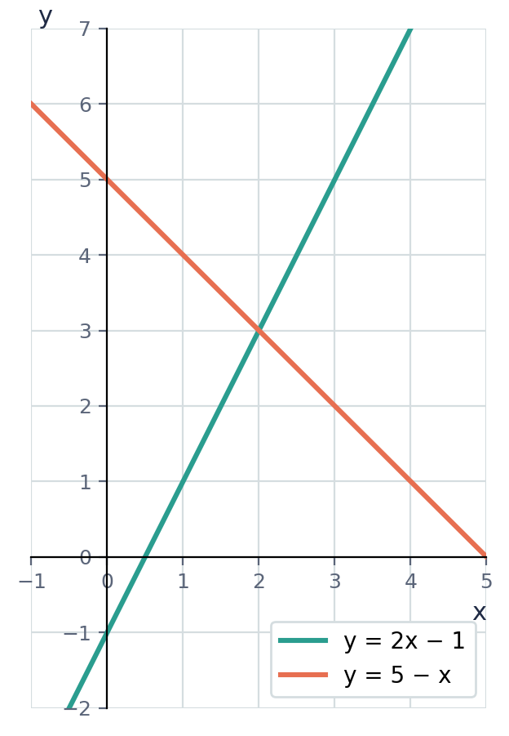

Level 2 · Developing
4. Make a table of whole-number solutions for x + y = 10 and for x − y = 4. Use your tables to solve the equations.
5. Is x = 3, y = −2 the solution of 2x − y = 8 and x + 4y = −5? Show your working.
6. Two numbers have a sum of 15 and a difference of 3. Write a pair of equations and find the numbers.
7. On a grid with x from 0 to 6, draw the lines y = x + 1 and y = 7 − x. Use your graph to solve the equations.

Level 3 · Think Deeper
8. Explain. Why does x + y = 5 on its own have infinitely many solutions, but only one when it is paired with x − y = 1?
9. Always, sometimes or never? "Two different straight lines meet at exactly one point." Use the graph of y = 2x + 1 and y = 2x − 3 in your answer.
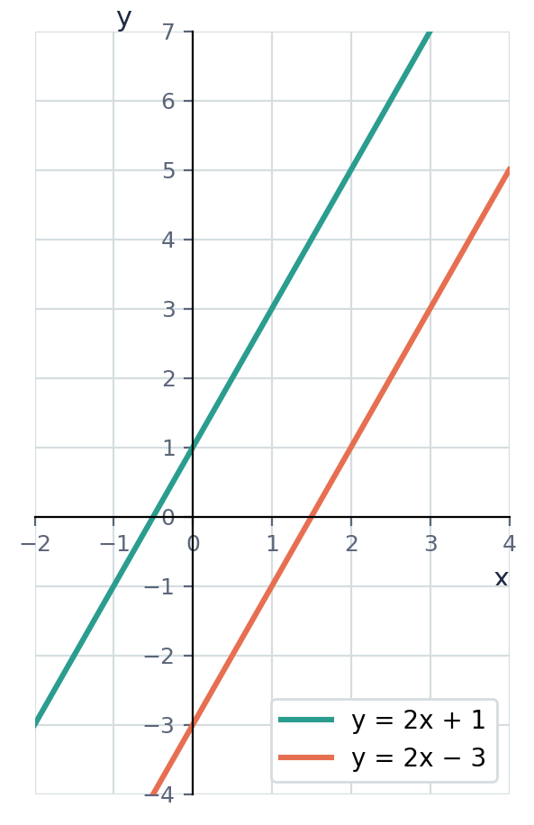
10. Create. Write a pair of simultaneous equations whose solution is x = 4, y = −1. Check your answer.
11. Connect to sets. A = {(x, y) : x + y = 6, where x and y are whole numbers} and B = {(x, y) : x − y = 2, where x and y are whole numbers}. List A, then find A ∩ B.

Before you move on, say or write in one or two sentences: "I can explain why the solution is the point where the two lines cross."
How confident do I feel? ☐ Not yet ☐ Getting there ☐ Got it!

Lesson 2: Elimination by Adding or Subtracting
Building on: Lesson 1, and collecting like terms (Unit 2).
Goal: By the end of this lesson I can solve simultaneous equations by adding or subtracting them to eliminate one unknown.

① Key Ideas
- Label the equations (1) and (2).
- If one unknown has the same coefficient in both equations, you can eliminate it. Then there is only one unknown left, and you can solve for it as in Unit 2.
- Same signs → subtract (for example, +2y and +2y). Different signs → add (for example, +y and −y). Remember it as "SSS: same signs subtract".
- Substitute the value you found into one of the original equations to find the other unknown.
- Check in the other equation. Then write the answer clearly: x = …, y = ….

② Watch
Watch these videos after you have read the key ideas. Pause the video and try each example before it is solved. Online, click the link. On paper, type the short address into YouTube.
Video | What it covers | Link
Simultaneous Equations elimination  Corbettmaths | Adding and subtracting to eliminate | Watch on YouTube  youtu.be/phlus4x0UqM

③ Worked Examples
Cover the solution and try the example first. Then uncover one step at a time and compare it with your own working.
Example 2.1 · Adding to eliminate
Solve x + y = 10 (1) and x − y = 4 (2).
Solution
1. The y terms are +y and −y (different signs), so add: (1) + (2): 2x = 14.
2. x = 7.
3. Substitute into (1): 7 + y = 10, so y = 3.
4. Check in (2): 7 − 3 = 4 ✓
Answer: x = 7, y = 3

Example 2.2 · Subtracting to eliminate
Solve 3x + 2y = 16 (1) and x + 2y = 8 (2).
Solution
1. Both equations have +2y (same signs), so subtract: (1) − (2): 2x = 8.
2. x = 4.
3. Substitute into (2): 4 + 2y = 8, so 2y = 4 and y = 2.
4. Check in (1): 12 + 4 = 16 ✓
Answer: x = 4, y = 2

Example 2.3 · Adding with larger coefficients
Solve 5x − 3y = 11 (1) and 2x + 3y = 17 (2).
Solution
1. −3y and +3y have different signs, so add: 7x = 28, so x = 4.
2. Substitute into (2): 8 + 3y = 17, so 3y = 9 and y = 3.
3. Check in (1): 20 − 9 = 11 ✓
Answer: x = 4, y = 3

Example 2.4 · Eliminating the first unknown
Solve 4a + b = 14 (1) and 4a − 3b = 6 (2).
Solution
1. Both equations have +4a, so subtract: (1) − (2).
2. b − (−3b) = 4b and 14 − 6 = 8, so 4b = 8 and b = 2.
3. Substitute into (1): 4a + 2 = 14, so a = 3.
4. Check in (2): 12 − 6 = 6 ✓
Answer: a = 3, b = 2
💭 Think: When you subtract, b − (−3b) = 4b. Why is it 4b and not −2b?

Example 2.5 · Negative answers
Solve 2x − y = 7 (1) and 3x − y = 10 (2).
Solution
1. Both have −y (same sign), so subtract: (2) − (1): x = 3.
2. Substitute into (1): 6 − y = 7, so y = −1.
3. Check in (2): 9 − (−1) = 10 ✓
Answer: x = 3, y = −1

⚠ Common mistakes
- Adding when you should subtract (or the other way round). Look at the signs.
- Sign errors when subtracting negatives, e.g. 3y − (−y) = 4y.
- Finding only one unknown. You need both.

④ Practice
Write your answers in your exercise book. Start at Level 1. If you get most of a level right, move on to the next one. The answers are at the back of the pack.

Level 1 · Foundation
1. Solve by adding the equations.
(a) x + y = 9 and x − y = 3
(b) 2x + y = 11 and x − y = 1
(c) a + 3b = 13 and a − 3b = 1
2. Solve by subtracting the equations.
(a) 3x + y = 14 and x + y = 6
(b) 5x + 2y = 19 and 3x + 2y = 13

Level 2 · Developing
3. Solve. Decide whether to add or subtract.
(a) 4x + 3y = 17 and 4x − y = 5
(b) 2p − 5q = 5 and 3p + 5q = 20
(c) 3x − 2y = 4 and x − 2y = −4
(d) 6m + n = 1 and 2m + n = −3
4. Solve x + y = 2 and x − y = 8.
5. Solve 2x + 3y = 8 and 5x − 3y = −1.
6. Rearrange the first equation, then solve y = 11 − 2x and 3x − y = 4.

Level 3 · Think Deeper
7. Spot the error. To solve 3x + y = 11 and x + y = 5, Kurt added the equations and got 4x + 2y = 16. Why didn't this help? Solve the equations correctly.
8. Spot the error. To solve 2x + 3y = 13 and 2x − y = 1, Maya subtracted and wrote 2y = 12, so y = 6. Find her mistake and solve correctly.
9. Explain. Why is it a good idea to check your answer in the equation you did NOT use to find the second unknown?
10. Create. Write a pair of simultaneous equations that you can solve by ADDING, and whose solution is x = −2, y = 5.

Before you move on, say or write in one or two sentences: "I can explain how the signs tell me whether to add or subtract."
How confident do I feel? ☐ Not yet ☐ Getting there ☐ Got it!

Lesson 3: Elimination by Multiplying First
Building on: Lesson 2: eliminating by adding or subtracting.
Goal: By the end of this lesson I can multiply one or both equations so that one unknown can be eliminated.

① Key Ideas
- If no unknown has matching coefficients, multiply one or both equations to make them match.
- Multiply every term in the equation, including the number on the right-hand side.
- Choose the unknown that is easier to match. Use the lowest common multiple of its two coefficients.
- Then add or subtract as in Lesson 2 (same signs subtract, different signs add).
- If everything cancels and you get something like 0 = 0, the two equations describe the same line, so there are infinitely many solutions. If you get something impossible, like 0 = 2, the lines are parallel and there is no solution.

② Watch
Watch these videos after you have read the key ideas. Pause the video and try each example before it is solved. Online, click the link. On paper, type the short address into YouTube.
Video | What it covers | Link
Simultaneous Equations elimination  Corbettmaths | Multiplying before eliminating (second half of the video) | Watch on YouTube  youtu.be/phlus4x0UqM

③ Worked Examples
Cover the solution and try the example first. Then uncover one step at a time and compare it with your own working.
Example 3.1 · Multiplying one equation
Solve x + 2y = 7 (1) and 3x + y = 11 (2).
Solution
1. Match the y terms: multiply (2) by 2 to get 6x + 2y = 22 (3).
2. (3) − (1): 5x = 15, so x = 3.
3. Substitute into (1): 3 + 2y = 7, so y = 2.
4. Check in (2): 9 + 2 = 11 ✓
Answer: x = 3, y = 2

Example 3.2 · Multiplying both equations
Solve 3x + 2y = 12 (1) and 2x + 3y = 13 (2).
Solution
1. To match the y terms, the LCM of 2 and 3 is 6.
2. (1) × 3: 9x + 6y = 36 (3). (2) × 2: 4x + 6y = 26 (4).
3. (3) − (4): 5x = 10, so x = 2.
4. Substitute into (1): 6 + 2y = 12, so y = 3.
5. Check in (2): 4 + 9 = 13 ✓
Answer: x = 2, y = 3

Example 3.3 · Different signs
Solve 4x − 3y = 1 (1) and 5x + 2y = 30 (2).
Solution
1. Match the y terms (LCM of 3 and 2 is 6): (1) × 2: 8x − 6y = 2. (2) × 3: 15x + 6y = 90.
2. The signs are different, so add: 23x = 92, so x = 4.
3. Substitute into (1): 16 − 3y = 1, so 3y = 15 and y = 5.
4. Check in (2): 20 + 10 = 30 ✓
Answer: x = 4, y = 5

Example 3.4 · Choosing which unknown to eliminate
Solve 5x + 3y = 21 (1) and 2x − y = 4 (2).
Solution
1. Eliminating y is easier: multiply (2) by 3 to get 6x − 3y = 12.
2. Add this to (1): 11x = 33, so x = 3.
3. Substitute into (2): 6 − y = 4, so y = 2.
4. Check in (1): 15 + 6 = 21 ✓
Answer: x = 3, y = 2
💭 Think: Could you eliminate x instead? What would you multiply by? Which way is quicker?

⚠ Common mistakes
- Multiplying only the left-hand side: (x + 2y = 7) × 3 is 3x + 6y = 21, not 3x + 6y = 7.
- Choosing multipliers that don't make the coefficients match.
- Forgetting to check the sign before deciding whether to add or subtract.

④ Practice
Write your answers in your exercise book. Start at Level 1. If you get most of a level right, move on to the next one. The answers are at the back of the pack.

Level 1 · Foundation
1. Solve. Multiply one equation first.
(a) x + 3y = 10 and 2x + y = 5
(b) 2x + y = 7 and 3x + 2y = 11
(c) 4x + y = 14 and 3x − 2y = 5

Level 2 · Developing
2. Solve.
(a) 3x + 4y = 18 and 2x + 3y = 13
(b) 5x − 2y = 4 and 3x + 5y = 21
(c) 2a + 3b = 1 and 3a + 4b = 2
(d) 4p + 3q = 17 and 6p + 5q = 25
3. Solve 7x + 2y = 11 and 3x − 5y = −7.
4. Solve 0.5x + y = 4 and x − 2y = 0.

Level 3 · Think Deeper
5. Spot the error. Tia multiplied x + 2y = 7 by 3 and wrote 3x + 6y = 7. What did she forget?
6. Explain. For 2x + 5y = 1 and 3x − 2y = 11, describe two different ways to eliminate an unknown. Then solve.
7. Investigate. Try to solve each pair. What happens? Explain what it means.
(a) 2x + 3y = 6 and 4x + 6y = 12
(b) 2x + 3y = 6 and 4x + 6y = 10
8. Create. Write a pair of simultaneous equations where BOTH equations must be multiplied, with solution x = 1, y = −2. Show that your pair works.

Before you move on, say or write in one or two sentences: "I can explain why I must multiply every term in an equation."
How confident do I feel? ☐ Not yet ☐ Getting there ☐ Got it!

Lesson 4: The Substitution Method
Building on: Lessons 2–3. Unit 4: changing the subject. Unit 2: expanding brackets.
Goal: By the end of this lesson I can solve simultaneous equations by substitution, and choose the better method.

① Key Ideas
- If one equation already gives one unknown in terms of the other (for example, y = 2x + 1), substitute that expression into the other equation.
- This leaves one equation with one unknown. Solve it, then substitute back to find the other unknown.
- Put the substituted expression in brackets: 2x − (x + 3), not 2x − x + 3.
- If neither equation is in that form, you can first make one letter the subject (Unit 4). This is easiest when a letter has coefficient 1.
- Choosing a method. Use substitution when a letter is already the subject, or when it has coefficient 1. Use elimination when both equations are in the form ax + by = c.
- Substitution also works when one equation is not linear. For example, y = x² and y = x + 2 give x² = x + 2, which you can solve by factorizing (Unit 5).

② Watch
Watch these videos after you have read the key ideas. Pause the video and try each example before it is solved. Online, click the link. On paper, type the short address into YouTube.
Video | What it covers | Link
Solving Simultaneous Equations by Substitution  Corbettmaths | The substitution method | Watch on YouTube  youtu.be/FrECUQpaa80

③ Worked Examples
Cover the solution and try the example first. Then uncover one step at a time and compare it with your own working.
Example 4.1 · Substituting an expression
Solve y = 2x + 1 (1) and 3x + y = 16 (2).
Solution
1. Replace y in (2) with 2x + 1: 3x + (2x + 1) = 16.
2. 5x + 1 = 16, so x = 3.
3. Substitute into (1): y = 2(3) + 1 = 7.
4. Check in (2): 9 + 7 = 16 ✓
Answer: x = 3, y = 7

Example 4.2 · Substituting for x
Solve x = 3y − 2 (1) and 2x + 5y = 18 (2).
Solution
1. Substitute into (2): 2(3y − 2) + 5y = 18.
2. 6y − 4 + 5y = 18, so 11y = 22 and y = 2.
3. x = 3(2) − 2 = 4.
4. Check in (2): 8 + 10 = 18 ✓
Answer: x = 4, y = 2

Example 4.3 · Rearrange first
Solve x + 2y = 9 (1) and 3x − y = 6 (2).
Solution
1. In (1), x has coefficient 1, so make x the subject: x = 9 − 2y.
2. Substitute into (2): 3(9 − 2y) − y = 6.
3. 27 − 6y − y = 6, so 7y = 21 and y = 3.
4. x = 9 − 6 = 3.
Answer: x = 3, y = 3

Example 4.4 · Both equations give y
Solve y = x + 3 and y = 2x − 1.
Solution
1. Both expressions are equal to y, so they are equal to each other: x + 3 = 2x − 1.
2. 4 = x, so x = 4.
3. y = 4 + 3 = 7.
Answer: x = 4, y = 7
💭 Think: On a graph, this is where the lines y = x + 3 and y = 2x − 1 cross. What are the coordinates of that point?

Example 4.5 · Same problem, two methods
Solve 2x + y = 8 and x − y = 1 by elimination AND by substitution.
Solution
1. Elimination: add the equations: 3x = 9, so x = 3 and y = 2.
2. Substitution: from the second equation, x = y + 1. Then 2(y + 1) + y = 8, so 3y = 6, y = 2 and x = 3.
3. Both methods give the same answer.
Answer: x = 3, y = 2

⚠ Common mistakes
- Leaving out the brackets: 2x − x + 3 instead of 2x − (x + 3).
- Substituting back into the same expression, which only gives you back what you already had.
- Stopping after finding one unknown.

④ Practice
Write your answers in your exercise book. Start at Level 1. If you get most of a level right, move on to the next one. The answers are at the back of the pack.

Level 1 · Foundation
1. Solve by substitution.
(a) y = x + 2 and x + y = 10
(b) y = 3x and 2x + y = 15
(c) x = y − 1 and 3x + 2y = 17
2. Solve y = 2x and y = x + 5.

Level 2 · Developing
3. Solve by substitution.
(a) y = 2x − 3 and 4x − y = 9
(b) x = 2y + 1 and 3x − 4y = 7
(c) y = 5 − x and 2x + 3y = 12
(d) a = 4 − 2b and 3a + b = 2
4. Make x the subject of the first equation, then solve x + 3y = 11 and 2x − y = 1.
5. Find the point where the lines y = 3x − 2 and y = −x + 6 intersect.
6. Choose the better method for each pair, and solve.
(a) 3x + 2y = 7 and 5x − 2y = 9
(b) y = 4x − 1 and 2x + y = 11

Level 3 · Think Deeper
7. Spot the error. To solve y = x + 3 and 2x − y = 1, Jalen wrote 2x − x + 3 = 1, so x = −2. Find his mistake and solve correctly.
8. Explain. When is substitution quicker than elimination? Give an example.
9. Challenge (links to Unit 5). Solve y = x² and y = x + 2.
10. Create. Write a pair of equations for which substitution is the natural method, with solution x = −1, y = 4. Check your pair.

Before you move on, say or write in one or two sentences: "I can explain why the substituted expression needs brackets."
How confident do I feel? ☐ Not yet ☐ Getting there ☐ Got it!

Lesson 5: Cramer's Rule (Using Determinants)
Building on: Lessons 2–4, and substituting into formulae (Unit 2).
Goal: By the end of this lesson I can solve a pair of simultaneous equations using Cramer's rule, and use the determinant D to tell when there is no single solution.

① Key Ideas
- Cramer's rule is a formula for solving two simultaneous equations. It uses numbers called determinants. It is a shortcut for what elimination does every time.
- Step 1: write both equations in standard form, with the x term, the y term, then = a number: ax + by = e and cx + dy = f. Rearrange first if you need to.
- Determinant of a 2 × 2 grid: for the grid with a, b on the top row and c, d on the bottom row, the determinant is ad − bc. Multiply the diagonal from top-left to bottom-right, then subtract the product of the other diagonal.
- Three determinants: D = ad − bc (the coefficients). Dx = ed − bf (replace the x-column a, c with e, f). Dy = af − ec (replace the y-column b, d with e, f).
- The solution: x = Dx ÷ D and y = Dy ÷ D, as long as D is not 0.
- If D = 0 there is no single solution. The lines are either parallel (no solution) or the same line (infinitely many solutions). Look at Dx and Dy: if both are 0, it is the same line; otherwise the lines are parallel.
- Watch the order of subtraction and keep the signs of negative numbers. Always check your answer in both original equations.
- Cramer's rule is fast when the numbers are small and the equations are in standard form. Elimination or substitution can be quicker when a letter already has coefficient 1 or is the subject.

② Watch
Watch these videos after you have read the key ideas. Pause the video and try each example before it is solved. Online, click the link. On paper, type the short address into YouTube.
Video | What it covers | Link
Cramer's Rule (2x2) | Linear Simultaneous Equations | OD Grade 10 | Math | Khan Academy  Khan Academy India - English | Solving a pair of equations with determinants | Watch on YouTube  youtu.be/wnJ4jZt37Ak

③ Worked Examples
Cover the solution and try the example first. Then uncover one step at a time and compare it with your own working.
Example 5.1 · Setting up D, Dx and Dy
For 2x + y = 7 and 3x − 2y = 7, find D, Dx and Dy, then solve.
Solution
1. Match with ax + by = e and cx + dy = f: a = 2, b = 1, e = 7 and c = 3, d = −2, f = 7.
2. D = ad − bc = (2)(−2) − (1)(3) = −4 − 3 = −7.
3. Dx = ed − bf = (7)(−2) − (1)(7) = −14 − 7 = −21.
4. Dy = af − ec = (2)(7) − (7)(3) = 14 − 21 = −7.
5. x = Dx ÷ D = −21 ÷ −7 = 3. y = Dy ÷ D = −7 ÷ −7 = 1.
6. Check: 2(3) + 1 = 7 ✓ and 3(3) − 2(1) = 7 ✓
Answer: x = 3, y = 1
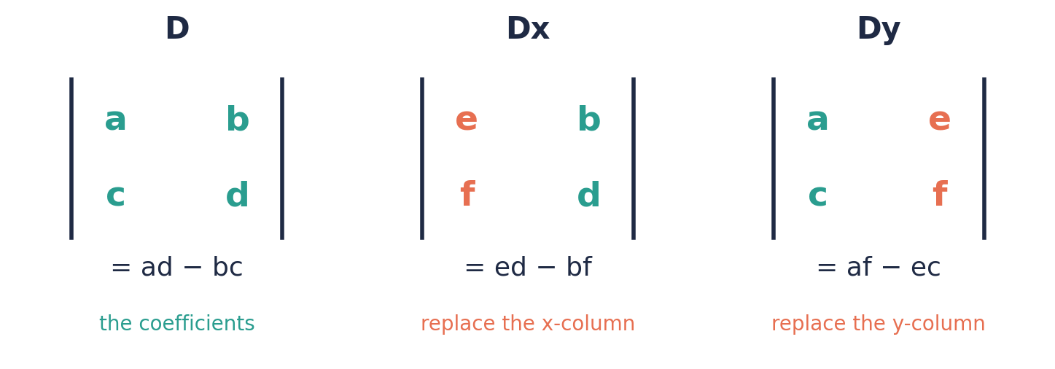

Example 5.2 · A straightforward case
Solve x + 2y = 8 and 3x − y = 3 using Cramer's rule.
Solution
1. a = 1, b = 2, e = 8 and c = 3, d = −1, f = 3.
2. D = (1)(−1) − (2)(3) = −1 − 6 = −7.
3. Dx = (8)(−1) − (2)(3) = −8 − 6 = −14.
4. Dy = (1)(3) − (8)(3) = 3 − 24 = −21.
5. x = −14 ÷ −7 = 2 and y = −21 ÷ −7 = 3.
6. Check: 2 + 6 = 8 ✓ and 6 − 3 = 3 ✓
Answer: x = 2, y = 3

Example 5.3 · A negative answer
Solve 2x + 3y = −1 and x − y = 2.
Solution
1. a = 2, b = 3, e = −1 and c = 1, d = −1, f = 2.
2. D = (2)(−1) − (3)(1) = −2 − 3 = −5.
3. Dx = (−1)(−1) − (3)(2) = 1 − 6 = −5.
4. Dy = (2)(2) − (−1)(1) = 4 + 1 = 5.
5. x = −5 ÷ −5 = 1 and y = 5 ÷ −5 = −1.
6. Check: 2(1) + 3(−1) = −1 ✓ and 1 − (−1) = 2 ✓
Answer: x = 1, y = −1
💭 Think: In Dy, the product (−1)(1) was subtracted. What would happen to the answer if you forgot the negative sign?

Example 5.4 · Rearranging first
Solve y = 2x − 1 and 3x + 2y = 12.
Solution
1. Put the first equation in standard form: 2x − y = 1.
2. a = 2, b = −1, e = 1 and c = 3, d = 2, f = 12.
3. D = (2)(2) − (−1)(3) = 4 + 3 = 7.
4. Dx = (1)(2) − (−1)(12) = 2 + 12 = 14.
5. Dy = (2)(12) − (1)(3) = 24 − 3 = 21.
6. x = 14 ÷ 7 = 2 and y = 21 ÷ 7 = 3.
7. Check in the original: y = 2(2) − 1 = 3 ✓ and 3(2) + 2(3) = 12 ✓
Answer: x = 2, y = 3

Example 5.5 · Answers that are not whole numbers
Solve 2x + y = 4 and x + 3y = 3.
Solution
1. a = 2, b = 1, e = 4 and c = 1, d = 3, f = 3.
2. D = (2)(3) − (1)(1) = 5.
3. Dx = (4)(3) − (1)(3) = 9.
4. Dy = (2)(3) − (4)(1) = 2.
5. x = 9/5 = 1.8 and y = 2/5 = 0.4.
6. Check: 2(1.8) + 0.4 = 4 ✓ and 1.8 + 3(0.4) = 3 ✓
Answer: x = 9/5 (1.8), y = 2/5 (0.4)
💭 Think: Elimination would also work here. Which method do you think is quicker when the answers are fractions?

Example 5.6 · When D = 0
Use Cramer's rule on (a) x + 2y = 4 and 2x + 4y = 3, and (b) x + 2y = 4 and 2x + 4y = 8.
Solution
1. (a) D = (1)(4) − (2)(2) = 0. So there is no single solution. Dx = (4)(4) − (2)(3) = 10, which is not 0, so the lines are parallel and there is no solution.
2. (b) D = (1)(4) − (2)(2) = 0. Dx = (4)(4) − (2)(8) = 0 and Dy = (1)(8) − (4)(2) = 0. All three are 0, so the lines are the same line.
3. Check: the second equation in (b) is the first one doubled, so any point on one line is on the other: infinitely many solutions.
Answer: (a) no solution (parallel lines) (b) infinitely many solutions (same line)
💭 Think: How does this connect to the graphs from Lesson 1? Sketch both pairs.

Example 5.7 · Checking against elimination
Solve x + 2y = 8 and 3x − y = 3 by elimination, and compare with Cramer's rule.
Solution
1. Multiply the second equation by 2: 6x − 2y = 6.
2. Add to the first equation: 7x = 14, so x = 2.
3. Substitute: 2 + 2y = 8, so y = 3.
4. This matches the Cramer's rule answer (2, 3).
Answer: x = 2, y = 3 (same answer)

Example 5.8 · A word problem
At a fair, 2 adult tickets and 3 child tickets cost $55. 3 adult tickets and 1 child ticket cost $65. Find the cost of each ticket using Cramer's rule.
Solution
1. Let a be the adult price and c the child price: 2a + 3c = 55 and 3a + c = 65.
2. D = (2)(1) − (3)(3) = −7.
3. Da = (55)(1) − (3)(65) = 55 − 195 = −140.
4. Dc = (2)(65) − (55)(3) = 130 − 165 = −35.
5. a = −140 ÷ −7 = 20 and c = −35 ÷ −7 = 5.
6. An adult ticket costs $20 and a child ticket costs $5.
Answer: Adult $20, child $5

⚠ Common mistakes
- Subtracting in the wrong order. D is ad − bc, not bc − ad. Reversing it changes the sign of the answer.
- Replacing the wrong column. For Dx, the x-column (a, c) is replaced by e, f. For Dy, the y-column (b, d) is replaced.
- Not writing the equations in standard form first, so that a, b, c, d, e, f are misread.
- Losing a negative sign when a coefficient is negative, such as b = −1.

④ Practice
Write your answers in your exercise book. Start at Level 1. If you get most of a level right, move on to the next one. The answers are at the back of the pack.

Level 1 · Foundation
1. Find D = ad − bc for each pair of equations.
(a) 2x + 3y = 5 and 4x + y = 7
(b) x + y = 6 and x − y = 2
(c) 3x − 2y = 1 and x + 4y = 9
(d) 5x + y = 3 and 10x + 2y = 8
2. Evaluate ad − bc in each case.
(a) a = 2, b = 5, c = 1, d = 3
(b) a = 4, b = −1, c = 3, d = 2
(c) a = −2, b = 3, c = 5, d = −4
(d) a = 6, b = 3, c = 2, d = 1
3. For x + 2y = 5 and 3x + y = 5, write down D, Dx and Dy. Then solve the equations.

Level 2 · Developing
4. Solve each pair using Cramer's rule.
(a) x + y = 7 and x − y = 3
(b) 2x + y = 8 and x + 3y = 9
(c) 3x − y = 5 and 2x + 3y = 18
5. Solve each pair using Cramer's rule.
(a) x − 3y = −7 and 2x + y = 7
(b) x + 2y = −3 and 3x − y = 5
6. Rearrange into standard form, then solve using Cramer's rule.
(a) y = x + 1 and 2x + y = 10
(b) 3x = 2y + 5 and x + y = 5
7. Solve 3x + y = 5 and x + 2y = 4. Give your answers as fractions and as decimals.
8. 2 pens and 3 pencils cost $7. 3 pens and 1 pencil cost $7. Use Cramer's rule to find the cost of a pen and of a pencil.

Level 3 · Think Deeper
9. Spot the error. For x + 2y = 7 and 3x + y = 11, Rosa wrote Dy = (7)(3) − (1)(11) = 10. What did she do wrong? Find the correct Dy and solve for y.
10. Explain. What does D = 0 tell you? Test with (a) x + 2y = 3 and 2x + 4y = 6, and (b) x + 2y = 3 and 2x + 4y = 7.
11. Always, sometimes or never? ‘If D = 0, the simultaneous equations have no solution.’
12. Create. Write a pair of equations with D = 0 whose lines are parallel, and a pair with D = 5.
13. Challenge. By eliminating y from ax + by = e and cx + dy = f, show that x = (ed − bf) ÷ (ad − bc).
14. Investigate. Use Cramer's rule to solve x + y = 5 and x − y = k, giving x and y in terms of k. For which values of k are x and y both whole numbers?

Before you move on, say or write in one or two sentences: "I can explain what D = 0 tells me about a pair of equations."
How confident do I feel? ☐ Not yet ☐ Getting there ☐ Got it!

Lesson 6: Solving Problems with Simultaneous Equations
Building on: Lessons 2–5, and forming equations (Unit 2, Lesson 5).
Goal: By the end of this lesson I can form two equations from a word problem, solve them, and answer in context.

① Key Ideas
- Step 1: choose letters for the two unknowns and say what they stand for, with units. For example, "Let p be the cost of a patty in dollars."
- Step 2: write two equations, one from each fact in the question.
- Step 3: solve using elimination or substitution.
- Step 4: answer the question in words, with units.
- Step 5: check your answer against the story, not just the equations. A negative number of people or a fraction of a ticket means something is wrong.
- "More than" can be tricky. "An adult ticket costs $5 more than a child ticket" means a = c + 5. Test your equation with numbers.

② Watch
Watch these videos after you have read the key ideas. Pause the video and try each example before it is solved. Online, click the link. On paper, type the short address into YouTube.
Video | What it covers | Link
How to solve any simultaneous equations word problem  Magic Monk | Forming equations from a story | Watch on YouTube  youtu.be/9tqlzouVQfs
Simultaneous Equations: Word Problems  Oninab Academy | Worked word problems | Watch on YouTube  youtu.be/jmyYG_PssqY

③ Worked Examples
Cover the solution and try the example first. Then uncover one step at a time and compare it with your own working.
Example 6.1 · Sum and difference
Two numbers have a sum of 42 and a difference of 8. Find them.
Solution
1. Let the numbers be x and y, with x > y.
2. x + y = 42 and x − y = 8.
3. Add: 2x = 50, so x = 25 and y = 17.
Answer: 25 and 17

Example 6.2 · Canteen prices
At the school canteen, 3 patties and 2 juices cost $24. 1 patty and 2 juices cost $12. Find the cost of a patty and of a juice.
Solution
1. Let a patty cost $p and a juice cost $j.
2. 3p + 2j = 24 (1) and p + 2j = 12 (2).
3. (1) − (2): 2p = 12, so p = 6.
4. 6 + 2j = 12, so j = 3.
5. Check: 3(6) + 2(3) = 24 ✓
Answer: A patty costs $6 and a juice costs $3.

Example 6.3 · Concert tickets
200 tickets were sold for a concert in St John's. Adult tickets cost $25 and child tickets cost $10. The total taken was $3800. How many of each were sold?
Solution
1. Let a = number of adult tickets and c = number of child tickets.
2. a + c = 200 and 25a + 10c = 3800.
3. Substitute c = 200 − a: 25a + 10(200 − a) = 3800.
4. 25a + 2000 − 10a = 3800, so 15a = 1800 and a = 120.
5. c = 80. Check: 25(120) + 10(80) = 3000 + 800 = 3800 ✓
Answer: 120 adult tickets and 80 child tickets

Example 6.4 · Ages
A father is 3 times as old as his son. In 10 years' time, he will be twice as old as his son. Find their ages now.
Solution
1. Let the son be s years old and the father f years old.
2. Now: f = 3s. In 10 years: f + 10 = 2(s + 10).
3. Substitute: 3s + 10 = 2s + 20, so s = 10.
4. f = 30. Check: in 10 years they will be 20 and 40, and 40 = 2 × 20 ✓
Answer: The son is 10 and the father is 30.
💭 Think: Why is "in 10 years" written as f + 10 and s + 10, and not just f + 10?

⚠ Common mistakes
- Not saying what the letters stand for, which leads to mixed-up equations.
- Writing "$5 more than" the wrong way round.
- Giving x = 120, y = 80 without saying what the numbers mean.

④ Practice
Write your answers in your exercise book. Start at Level 1. If you get most of a level right, move on to the next one. The answers are at the back of the pack.

Level 1 · Foundation
1. Two numbers have a sum of 30 and a difference of 4. Find the numbers.
2. 2 mangoes and 1 pineapple cost $11. 1 mango and 1 pineapple cost $8. Find the cost of each fruit.
3. 4 pens and 3 pencils cost $18. 4 pens and 1 pencil cost $14. Find the cost of a pen and of a pencil.

Level 2 · Developing
4. At a cinema, adult tickets cost $20 and child tickets cost $12. A group of 50 people paid $760 altogether. How many adults and how many children were there?
5. The line y = mx + c passes through the points (1, 5) and (3, 11). Find m and c.
6. A jar holds 25 coins, all 25-cent and 10-cent pieces. The coins are worth $4.00 in total. How many of each coin are there?
7. The sum of Kyle's age and his sister's age is 26. Kyle is 4 years older than his sister. Find their ages.
8. A fisherman in Barbuda sells snapper for $x per lb and grouper for $y per lb. 3 lb of snapper and 2 lb of grouper cost $66. 2 lb of snapper and 5 lb of grouper cost $88. Find the price per pound of each fish.

Level 3 · Think Deeper
9. Spot the error. "An adult ticket costs $5 more than a child ticket." Dana wrote c = a + 5. Test her equation with numbers, then correct it.
10. Explain. A student solved a problem about the number of children on a bus and got c = −3. What does this tell you, and what should the student do?
11. Create. Write a word problem whose answer is x = 7 and y = 4. Solve it to show that it works.
12. Challenge. The digits of a two-digit number add up to 11. When the digits are reversed, the number increases by 27. Find the number.

Before you move on, say or write in one or two sentences: "I can list the steps for solving a word problem with simultaneous equations."
How confident do I feel? ☐ Not yet ☐ Getting there ☐ Got it!

CSEC-Style Exam Practice
These questions are like the ones on CSEC Paper 2, and they use all six lessons. Try them under test conditions: no notes, and about 30 minutes. Show all your working.
1. Solve each pair of simultaneous equations.
(a) 3x + 2y = 13 and x − 2y = −1 [3 marks]
(b) y = 3x − 5 and 2x + y = 15 [3 marks]
2. At a fair, 2 adult tickets and 3 child tickets cost $55. 3 adult tickets and 1 child ticket cost $65.
(a) Using a for the cost of an adult ticket and c for the cost of a child ticket, write two equations. [2 marks]
(b) Solve your equations to find the cost of each type of ticket. [3 marks]
3. The straight line y = mx + c passes through the points (2, 7) and (5, 13).
(a) Write two equations in m and c. [2 marks]
(b) Solve them to find m and c. [2 marks]
(c) Does the point (−1, 1) lie on the line? Show how you decide. [1 mark]
4. The graph shows the lines y = x + 1 and x + 2y = 8.
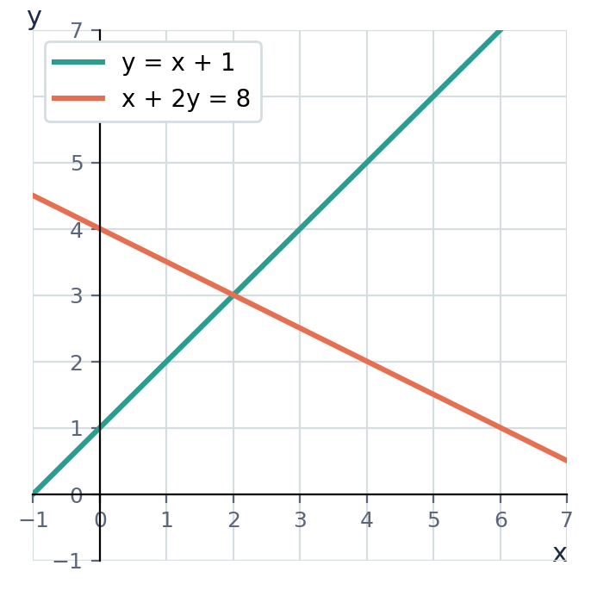
(a) Use the graph to write down the solution of the simultaneous equations. [1 mark]
(b) Solve the equations algebraically to confirm your answer. [3 marks]
5. (a) Use Cramer's rule to solve 2x + y = 7 and 3x − 2y = 7. Show D, Dx and Dy. [5 marks] (b) The equations 2x + 3y = 6 and 4x + 6y = k are given. Find the value of k for which there are infinitely many solutions, and explain why there is no solution for any other value of k. [3 marks]

Self-Check Quiz: Am I Ready?
Answer all 14 questions without looking back at the lessons. Then check your answers and write your score in the box. The lesson number after each question tells you where to go back if you get it wrong.
1. Which pair is the solution of x + y = 7 and x − y = 3? (Lesson 1)
A (3, 4) B (5, 2) C (4, 3) D (2, 5)
2. On a graph, the solution of two simultaneous equations is where the lines… (Lesson 1)
A are parallel B cross the y-axis C cross the x-axis D intersect
3. For x + y = 12 and x − y = 2, the best first step is to… (Lesson 2)
A add the equations B substitute y = 12 C subtract the equations D multiply the first by 2
4. Solve 3x + y = 11 and x + y = 5. What is x? (Lesson 2)
A 2 B 8 C 3 D 4
5. 2x + 3y = 13 and 2x − y = 1. Subtracting the second equation from the first gives… (Lesson 2)
A 2y = 12 B 4x = 14 C 4y = 12 D 4y = 14
6. To eliminate y from x + 2y = 7 and 3x + y = 11, you should… (Lesson 3)
A multiply the second equation by 2 B multiply the first equation by 2 C multiply the second equation by 3 D multiply the first equation by 3
7. What is the solution of 3x + 2y = 12 and 2x + 3y = 13? (Lesson 3)
A (3, 2) B (4, 0) C (1, 4.5) D (2, 3)
8. Solve y = 2x and x + y = 12. What is x? (Lesson 4)
A 8 B 4 C 6 D 3
9. Substituting y = x + 3 into 2x − y = 1 gives… (Lesson 4)
A 2x − (x + 3) = 1 B 2(x + 3) = 1 C 2x − x + 3 = 1 D 2x − y + 3 = 1
10. Where do the lines y = 3x − 2 and y = x + 4 meet? (Lesson 4)
A (1, 5) B (2, 4) C (3, 7) D (4, 8)
11. For 2x + 3y = 8 and x + 4y = 7, the value of D = ad − bc is… (Lesson 5)
A −5 B 5 C 13 D 11
12. For x + y = 7 and x − y = 3, D = −2 and Dx = −10. Using Cramer's rule, x =… (Lesson 5)
A −10 B 20 C −5 D 5
13. 3 patties and 2 juices cost $24. 1 patty and 2 juices cost $12. How much does a patty cost? (Lesson 6)
A $4 B $6 C $3 D $8
14. "An adult ticket costs $5 more than a child ticket" is written as… (Lesson 6)
A c = a + 5 B 5a = c C a + c = 5 D a = c + 5

My score | What it means
13–14 | Ready! You are ready for the next topic: Direct and Inverse Variation.
10–12 | Nearly there. Look at the lesson number next to each question you missed. Redo the Level 2 practice for those lessons.
0–9 | Go back over the lessons for the questions you missed. Redo the Level 1 and Level 2 practice, watch the videos again, then retake this quiz.
My score: ______ / 14

Answers
Use these to check your work. If your answer is different, look for your mistake before you ask for help. Your teacher has the full worked solutions.

Warm-Up
1. x = 4
2. x = 5
3. 14
4. y = 9 − 2x
5. 4x
6. 3x

Lesson 1: What Simultaneous Equations Mean
Level 1 · Foundation
1. (a), (b) and (d)
2. (a) Yes (b) No
3. x = 2, y = 3
Level 2 · Developing
4. x = 7, y = 3
5. Yes
6. x + y = 15, x − y = 3; 9 and 6
7. x = 3, y = 4
Level 3 · Think Deeper
8. One equation is a whole line of points. Two different lines that are not parallel cross at only one point.
9. Sometimes. Parallel lines, such as y = 2x + 1 and y = 2x − 3, never meet, so those equations have no solution.
10. e.g. x + y = 3 and x − y = 5
11. A = {(0, 6), (1, 5), (2, 4), (3, 3), (4, 2), (5, 1), (6, 0)}; A ∩ B = {(4, 2)}

Lesson 2: Elimination by Adding or Subtracting
Level 1 · Foundation
1. (a) x = 6, y = 3 (b) x = 4, y = 3 (c) a = 7, b = 2
2. (a) x = 4, y = 2 (b) x = 3, y = 2
Level 2 · Developing
3. (a) x = 2, y = 3 (b) p = 5, q = 1 (c) x = 4, y = 4 (d) m = 1, n = −5
4. x = 5, y = −3
5. x = 1, y = 2
6. x = 3, y = 5
Level 3 · Think Deeper
7. Adding did not eliminate anything, because the y terms have the same sign. Subtract instead: x = 3, y = 2.
8. 3y − (−y) = 4y, not 2y. So 4y = 12, y = 3, x = 2.
9. That equation was not used in your last step, so it gives an independent check that catches arithmetic mistakes.
10. e.g. x + y = 3 and x − y = −7

Lesson 3: Elimination by Multiplying First
Level 1 · Foundation
1. (a) x = 1, y = 3 (b) x = 3, y = 1 (c) x = 3, y = 2
Level 2 · Developing
2. (a) x = 2, y = 3 (b) x = 2, y = 3 (c) a = 2, b = −1 (d) p = 5, q = −1
3. x = 1, y = 2
4. x = 4, y = 2
Level 3 · Think Deeper
5. She forgot to multiply the right-hand side: 3x + 6y = 21.
6. Eliminate x (× 3 and × 2) or eliminate y (× 2 and × 5). x = 3, y = −1.
7. (a) You get 0 = 0: infinitely many solutions (the same line). (b) You get 0 = 2: no solution (parallel lines).
8. e.g. 2x + 3y = −4 and 3x + 5y = −7

Lesson 4: The Substitution Method
Level 1 · Foundation
1. (a) x = 4, y = 6 (b) x = 3, y = 9 (c) x = 3, y = 4
2. x = 5, y = 10
Level 2 · Developing
3. (a) x = 3, y = 3 (b) x = 5, y = 2 (c) x = 3, y = 2 (d) a = 0, b = 2
4. x = 2, y = 3
5. (2, 4)
6. (a) elimination (add): x = 2, y = ½ (b) substitution: x = 2, y = 7
Level 3 · Think Deeper
7. He needed brackets: 2x − (x + 3) = 1, so x = 4 and y = 7.
8. When one equation already has a letter as the subject (e.g. y = 3x − 1), or a letter has coefficient 1.
9. x = 2, y = 4 or x = −1, y = 1
10. e.g. y = −4x and x + y = 3

Lesson 5: Cramer's Rule (Using Determinants)
Level 1 · Foundation
1. (a) −10 (b) −2 (c) 14 (d) 0
2. (a) 1 (b) 11 (c) −7 (d) 0
3. D = −5, Dx = −5, Dy = −10; x = 1, y = 2
Level 2 · Developing
4. (a) x = 5, y = 2 (b) x = 3, y = 2 (c) x = 3, y = 4
5. (a) x = 2, y = 3 (b) x = 1, y = −2
6. (a) x = 3, y = 4 (b) x = 3, y = 2
7. x = 6/5 = 1.2, y = 7/5 = 1.4
8. Pen $2, pencil $1
Level 3 · Think Deeper
9. She subtracted in the wrong order. Dy = af − ec = (1)(11) − (7)(3) = −10. With D = −5, y = −10 ÷ −5 = 2.
10. D = 0 means there is no single solution. In (a), D = 0, Dx = 0 and Dy = 0: the same line, so infinitely many solutions. In (b), D = 0 but Dx = (3)(4) − (2)(7) = −2 ≠ 0: parallel lines, so no solution.
11. Sometimes. If D = 0 and the lines are parallel, there is no solution. If D = 0 and the lines are the same, there are infinitely many solutions.
12. e.g. x + y = 1 and x + y = 2 (D = 0); 2x + y = 3 and x + 3y = 4 (D = 5)
13. Multiply the first equation by d and the second by b, then subtract. This gives (ad − bc)x = ed − bf, so x = (ed − bf) ÷ (ad − bc) = Dx ÷ D.
14. D = −2, Dx = −5 − k, Dy = k − 5, so x = (5 + k) ÷ 2 and y = (5 − k) ÷ 2. Both are whole numbers when k is an odd integer.

Lesson 6: Solving Problems with Simultaneous Equations
Level 1 · Foundation
1. 17 and 13
2. Mango $3, pineapple $5
3. Pen $3, pencil $2
Level 2 · Developing
4. 20 adults and 30 children
5. m = 3, c = 2
6. 10 twenty-five-cent coins and 15 ten-cent coins
7. Kyle 15, sister 11
8. Snapper $14/lb, grouper $12/lb
Level 3 · Think Deeper
9. It should be a = c + 5. Test: if a child ticket is $10, an adult ticket is $15, but Dana's equation gives c = 15 + 5 = 20.
10. The number of children cannot be negative, so there is a mistake in the equations or the working. Check the set-up and the arithmetic.
11. e.g. "3 drinks and 2 snacks cost $29, and 1 drink and 1 snack cost $11."
12. 47

CSEC-Style Exam Practice
1. (a) x = 3, y = 2 (b) x = 4, y = 7
2. (a) 2a + 3c = 55, 3a + c = 65 (b) Adult $20, child $5
3. (a) 2m + c = 7, 5m + c = 13 (b) m = 2, c = 3 (c) Yes
4. (a) x = 2, y = 3 (b) confirmed
5. (a) D = −7, Dx = −21, Dy = −7; x = 3, y = 1 (b) k = 12

Self-Check Quiz
Q | Answer | Why
1 | B | 5 + 2 = 7 and 5 − 2 = 3. It must work in both equations.
2 | D | The intersection point lies on both lines, so it satisfies both equations.
3 | A | +y and −y have different signs, so adding eliminates y.
4 | C | Subtract: 2x = 6, so x = 3.
5 | C | 3y − (−y) = 4y and 13 − 1 = 12.
6 | A | This gives 2y in both equations.
7 | D | Check: 6 + 6 = 12 ✓ and 4 + 9 = 13 ✓.
8 | B | x + 2x = 12, so 3x = 12 and x = 4.
9 | A | The whole expression replaces y, so it needs brackets.
10 | C | 3x − 2 = x + 4, so x = 3 and y = 7.
11 | B | D = (2)(4) − (3)(1) = 8 − 3 = 5.
12 | D | x = Dx ÷ D = −10 ÷ −2 = 5.
13 | B | Subtract: 2p = 12, so p = 6.
14 | D | The adult price is the child price plus 5.

