Clare Hall Secondary School · Mathematics Department

FORM 3 MATHEMATICS · UNIT 7
Direct and Inverse Variation
Self-Paced Learning Pack
Name: ______________________________________ Class: ___________
Time in class: 1 week School year: 2026–2027 Next topic: Completing the Square

What's inside
Section | What you will do
Before You Start | Warm up with the number facts you need
Lesson 1 | Direct Variation
Lesson 2 | Direct Variation with Powers
Lesson 3 | Inverse Variation
Lesson 4 | Solving Problems with Variation
Exam Practice | CSEC-style questions that use all four lessons
Self-Check Quiz | 10 questions that show whether you are ready to move on
Answers | Check your work (at the back of the pack)

How to Use This Pack
- This pack lets you learn at your own pace. You can work ahead of the class or go back over anything you missed.
- Work through the lessons in order. Each lesson builds on the one before it.
- For each lesson: Read the key ideas → Watch the videos → Study the worked examples → Practise.
- Before you read the solution to a worked example, cover it and try the example yourself first. Then check each step.
- Practice has three levels. Level 1 (Foundation) checks the basics. Level 2 (Developing) makes you apply them. Level 3 (Think Deeper) asks you to explain, find mistakes and create your own examples.
- Check your answers at the back of the pack. If you get an answer wrong, find your mistake before you move on. A mistake you understand teaches you more than a correct guess.
- When you finish all the lessons, try the CSEC-Style Exam Practice, then the Self-Check Quiz. Your quiz score tells you whether you are ready for the next topic.

The learning route for every lesson
① Read the key ideas → ② Watch the videos → ③ Try the worked examples, then check each step → ④ Practise Level 1 → 2 → 3 → ⑤ Check your answers → ⑥ Tick your checklist

My Progress Checklist
Tick one box for each statement before you start and again after you finish. Be honest. This checklist is for you.
I can… | Not yet | Getting there | Got it!
Represent direct variation symbolically as y = kx and find the constant of variation, k (Lesson 1) | ☐ | ☐ | ☐
Represent direct variation with a power, such as y = kx² or y = kx³ (Lesson 2) | ☐ | ☐ | ☐
Represent inverse variation symbolically as y = k/x (Lesson 3) | ☐ | ☐ | ☐
Translate a word problem into a variation equation and solve it (Lesson 4) | ☐ | ☐ | ☐
Solve problems involving direct and inverse variation by finding the constant of variation first (Lessons 1–4) | ☐ | ☐ | ☐

Key Words
Symbol | Meaning | Example
varies as | changes in a fixed pattern with | y varies as x means y = kx
∝ | "is proportional to" — a shorthand for "varies as" | y ∝ x means y = kx
k | the constant of variation (a fixed number) | if y = kx and y = 12 when x = 4, then k = 3
direct variation | as one quantity increases, the other increases in the same ratio | y = kx, y = kx², y = kx³
inverse variation | as one quantity increases, the other decreases so their product stays constant | y = k/x
origin | the point (0, 0) | every direct variation graph is a straight line through the origin

Before You Start: Warm-Up
This unit uses skills from earlier units: substitution, rearranging a formula, and solving equations. Check you still have them.
1. If y = 5x, find y when x = 6.
2. If 20 = k × 4, find k.
3. Make k the subject of y = kx.
4. Make k the subject of y = k/x.
5. Evaluate 3 × 2² and 3 × 4².
6. Solve 45 = k × 9 for k.

Lesson 1: Direct Variation
Building on: Unit 2: substitution and rearranging. Unit 4: making a letter the subject.
Goal: By the end of this lesson I can write direct variation as y = kx, find k from a pair of values, and use it to find other values.

① Key Ideas
- y varies directly as x (or y is directly proportional to x, written y ∝ x) means y = kx for some fixed number k, called the constant of variation.
- As x gets bigger, y gets bigger in the same ratio — doubling x doubles y, trebling x trebles y.
- To find k, substitute one known pair of values (x, y) into y = kx and solve for k. Once you know k, you can find any other value.
- On a graph, direct variation is always a straight line through the origin (0, 0). If a graph does not pass through the origin, it is not direct variation, even if it is a straight line.
- In a table, direct variation shows up as y ÷ x being the same number (equal to k) for every pair in the table.
- Direct variation is a special kind of equation you already know from Unit 2 — it is just y = mx with c = 0.

② Watch
Watch these videos after you have read the key ideas. Pause the video and try each example before it is solved. Online, click the link. On paper, type the short address into YouTube.
Video | What it covers | Link
Direct Proportion  Corbettmaths | Setting up and using y = kx | Watch on YouTube  youtu.be/kcOwC7uqJNE

③ Worked Examples
Cover the solution and try the example first. Then uncover one step at a time and compare it with your own working.
Example 1.1 · Finding k from a table
The table shows values of y that vary directly as x. Find k, then write the equation.
x: 2, 4, 6, 8
y: 5, 10, 15, 20
Solution
1. Check that y ÷ x is the same each time: 5 ÷ 2 = 2.5, 10 ÷ 4 = 2.5, 15 ÷ 6 = 2.5, 20 ÷ 8 = 2.5.
2. So k = 2.5.
3. The equation is y = 2.5x.
Answer: y = 2.5x
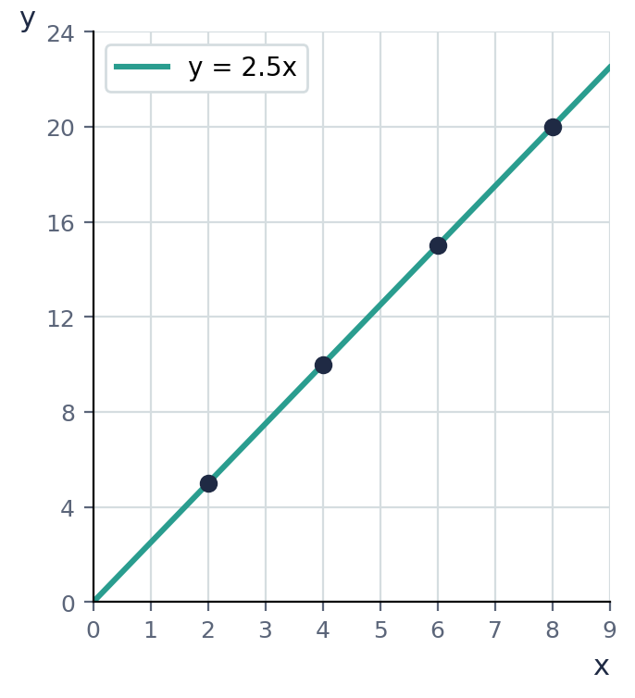

Example 1.2 · Finding k from one pair of values
y varies directly as x. When x = 5, y = 30. Find the equation connecting y and x, and use it to find y when x = 9.
Solution
1. y = kx, so 30 = k × 5.
2. k = 6.
3. The equation is y = 6x.
4. When x = 9: y = 6 × 9 = 54.
Answer: y = 6x; y = 54 when x = 9

Example 1.3 · Finding x when y is known
y varies directly as x. When x = 3, y = 21. Find x when y = 49.
Solution
1. 30 = k × 5 is not this question — use the given pair: 21 = k × 3, so k = 7.
2. y = 7x.
3. 49 = 7x, so x = 7.
Answer: x = 7
💭 Think: Notice this question asks you to find x, not y. The method is the same — just solve the equation for the letter you need.

Example 1.4 · Recognizing direct variation from a graph
The graph shows the cost C of fuel in dollars for d litres. Which line shows direct variation, and why?
Solution
1. The teal line C = 2.5d passes through the origin: when d = 0, C = 0 (no fuel, no cost). This is direct variation.
2. The coral line C = 15 + 2.5d does NOT pass through the origin — it starts at (0, 15). This is a fixed charge plus a rate, not direct variation, even though it is also a straight line.
Answer: The teal line (C = 2.5d) is direct variation, because it passes through the origin.
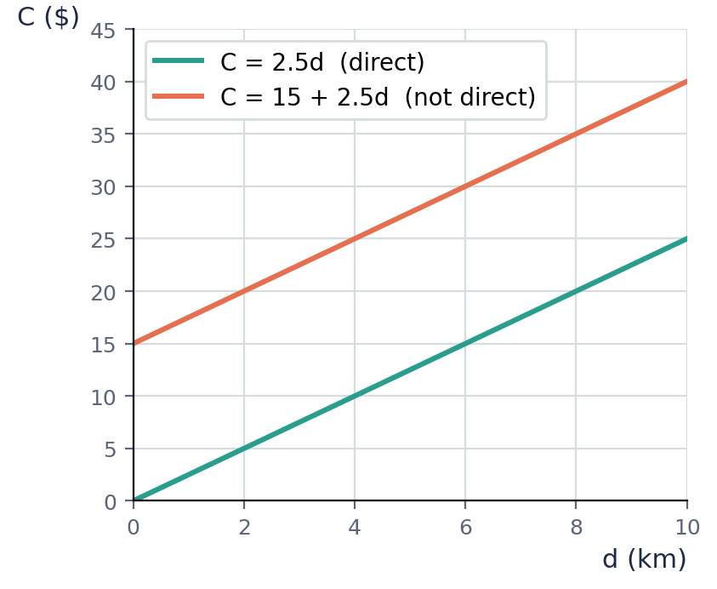
💭 Think: What might the $15 represent in the coral line? (Hint: think of a delivery fee.)

⚠ Common mistakes
- Thinking any straight line is direct variation. It must pass through the origin.
- Forgetting to find k first, and guessing the equation instead.
- Mixing up which value is x and which is y when substituting.

④ Practice
Write your answers in your exercise book. Start at Level 1. If you get most of a level right, move on to the next one. The answers are at the back of the pack.

Level 1 · Foundation
1. y varies directly as x. Find k and write the equation.
(a) x = 2, y = 8
(b) x = 5, y = 15
(c) x = 4, y = 10
2. y = 3x. Find y when x = 7.
3. y = 8x. Find x when y = 40.

Level 2 · Developing
4. y varies directly as x. When x = 6, y = 27. Find the equation, then find y when x = 10.
5. p varies directly as q. When q = 12, p = 3. Find q when p = 5.
6. The table shows the cost, C, of buying n identical exercise books.
n: 3, 5, 8
C ($): 12, 20, 32
Show that C varies directly as n, and find the cost of 15 books.
7. A recipe uses flour and sugar in direct variation: 200 g of flour needs 50 g of sugar. Find how much sugar is needed for 700 g of flour.

Level 3 · Think Deeper
8. Spot the error. Given y = 12 when x = 3, Kayla wrote the equation as y = 3x, using x as the constant. Find her mistake and the correct equation.
9. Always, sometimes or never? "A straight-line graph shows direct variation." Use the graph of C = 2.5d and C = 15 + 2.5d in your answer.
10. Explain. Why must a direct variation graph pass through the origin? Use the equation y = kx in your answer.
11. Create. Write a real-life pair of quantities that vary directly, and a pair that do NOT vary directly even though one increases when the other does. Explain the difference.

Before you move on, say or write in one or two sentences: "I can explain why a direct variation graph always passes through the origin."
How confident do I feel? ☐ Not yet ☐ Getting there ☐ Got it!

Lesson 2: Direct Variation with Powers
Building on: Lesson 1. Unit 2: substitution with indices.
Goal: By the end of this lesson I can write and use direct variation with a power, such as y = kx² or y = kx³.

① Key Ideas
- Direct variation is not always y = kx. Sometimes y varies as a power of x, such as y ∝ x² ("y varies as the square of x") or y ∝ x³ ("y varies as the cube of x").
- y ∝ x² means y = kx². As x doubles, y is multiplied by 2² = 4, not by 2.
- y ∝ x³ means y = kx³. As x doubles, y is multiplied by 2³ = 8.
- The method for finding k is the same as Lesson 1: substitute a known pair of values and solve for k — just remember to substitute x before squaring or cubing it, not after.
- The graph of y = kx² (with k > 0) is a curve through the origin that gets steeper — not a straight line. It still starts at (0, 0), like all direct variation.
- Watch the wording carefully: "y varies as the square of x" is y = kx², but "y varies as x, squared" would mean (y)² = kx — always translate from the words to the equation with care.

② Watch
Watch these videos after you have read the key ideas. Pause the video and try each example before it is solved. Online, click the link. On paper, type the short address into YouTube.
Video | What it covers | Link
Direct Variation - Basic Introduction  The Organic Chemistry Tutor | Direct variation with squares and cubes | Watch on YouTube  youtu.be/vh8Bs1iSrag

③ Worked Examples
Cover the solution and try the example first. Then uncover one step at a time and compare it with your own working.
Example 2.1 · Finding k for y ∝ x²
y varies directly as the square of x. When x = 2, y = 20. Find the equation, then find y when x = 4.
Solution
1. y = kx², so 20 = k × 2² = k × 4.
2. k = 5.
3. The equation is y = 5x².
4. When x = 4: y = 5 × 4² = 5 × 16 = 80.
Answer: y = 5x²; y = 80 when x = 4
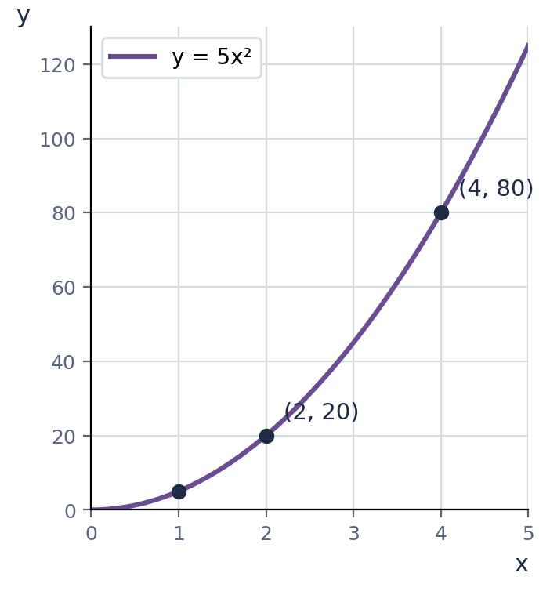

Example 2.2 · Finding x from y ∝ x²
y = 5x² (from the previous example). Find x when y = 45.
Solution
1. 45 = 5x².
2. x² = 9.
3. x = 3 (taking the positive root, since x represents a length here).
Answer: x = 3
💭 Think: Mathematically x² = 9 also gives x = −3. Why do we usually take only the positive answer in a real-world problem?

Example 2.3 · y varies as the cube of x
The volume, V, of a cube varies directly as the cube of its side length, s. When s = 2 cm, V = 8 cm³. Find the equation, then find V when s = 5 cm.
Solution
1. V = ks³, so 8 = k × 2³ = k × 8.
2. k = 1.
3. V = s³.
4. When s = 5: V = 5³ = 125 cm³.
Answer: V = s³; V = 125 cm³
💭 Think: Does this equation look familiar? It is the formula for the volume of a cube that you may already know.

Example 2.4 · Comparing effects on y
y varies directly as x². If x is doubled, what happens to y? If x is trebled, what happens to y?
Solution
1. y = kx². Replace x with 2x: k(2x)² = k × 4x² = 4(kx²) = 4y.
2. So doubling x makes y 4 times as big.
3. Replace x with 3x: k(3x)² = 9kx² = 9y.
4. So trebling x makes y 9 times as big.
Answer: Doubling x makes y 4 times as big; trebling x makes y 9 times as big.
💭 Think: This is why braking distance (which varies as speed squared) increases so quickly as a car speeds up.

⚠ Common mistakes
- Squaring or cubing k instead of x. In y = kx², only x is squared.
- Forgetting to square x before finding k: writing 20 = k × 2 instead of 20 = k × 2².
- Assuming doubling x always doubles y — this is only true for y = kx, not y = kx² or y = kx³.

④ Practice
Write your answers in your exercise book. Start at Level 1. If you get most of a level right, move on to the next one. The answers are at the back of the pack.

Level 1 · Foundation
1. y varies directly as x². Find k and write the equation.
(a) x = 2, y = 12
(b) x = 3, y = 45
(c) x = 1, y = 7
2. y = 4x². Find y when x = 3.
3. y = 2x³. Find y when x = 3.

Level 2 · Developing
4. y varies directly as the square of x. When x = 5, y = 50. Find the equation, then find y when x = 6.
5. y varies directly as the cube of x. When x = 2, y = 40. Find x when y = 135.
6. The distance, d, a stone falls varies directly as the square of the time, t, it has been falling. If it falls 20 m in 2 seconds, how far does it fall in 3 seconds?
7. The energy, E, stored in a stretched spring varies directly as the square of its extension, x. When x = 4 cm, E = 32 J. Find E when x = 6 cm.

Level 3 · Think Deeper
8. Spot the error. For y ∝ x², given x = 3, y = 27, Marlon wrote 27 = k × 3, so k = 9. Find his mistake and the correct equation.
9. Explain. If y varies directly as x², explain what happens to y when x is halved.
10. Investigate. A ball's braking distance, d, varies directly as the square of its speed, v. A car travelling at 40 km/h takes 10 m to stop. Estimate the stopping distance at 80 km/h, then explain why doubling your speed is more dangerous than it might seem.
11. Create. Write your own direct-variation problem using y ∝ x³, give one pair of values, and solve it for y at a different x-value.

Before you move on, say or write in one or two sentences: "I can explain why doubling x makes y four times as big when y varies as x²."
How confident do I feel? ☐ Not yet ☐ Getting there ☐ Got it!

Lesson 3: Inverse Variation
Building on: Lessons 1–2. Unit 4: rearranging a formula with a fraction.
Goal: By the end of this lesson I can write inverse variation as y = k/x, find k, and use it to find other values.

① Key Ideas
- y varies inversely as x (or y is inversely proportional to x) means y = k/x for some constant k. As x gets bigger, y gets smaller.
- An equivalent way to write it is xy = k — the product of x and y stays the same for every pair of values.
- To find k, substitute one known pair of values into y = k/x (or xy = k) and solve.
- On a graph, inverse variation (with k > 0) is a curve that gets closer and closer to both axes but never touches them. It is not a straight line, and it never passes through the origin.
- In a table, inverse variation shows up as x × y being the same number (equal to k) for every pair.
- A classic example: if a job takes 12 worker-days, then more workers finish it in fewer days — the number of workers and the number of days vary inversely, with k = 12.

② Watch
Watch these videos after you have read the key ideas. Pause the video and try each example before it is solved. Online, click the link. On paper, type the short address into YouTube.
Video | What it covers | Link
Inverse Proportion  Corbettmaths | Setting up and using y = k/x | Watch on YouTube  youtu.be/uZ6l-loSdRs

③ Worked Examples
Cover the solution and try the example first. Then uncover one step at a time and compare it with your own working.
Example 3.1 · Finding k from a table
The table shows values of y that vary inversely as x. Find k, then write the equation.
x: 1, 2, 3, 4
y: 12, 6, 4, 3
Solution
1. Check that x × y is the same each time: 1 × 12 = 12, 2 × 6 = 12, 3 × 4 = 12, 4 × 3 = 12.
2. So k = 12.
3. The equation is y = 12/x.
Answer: y = 12/x
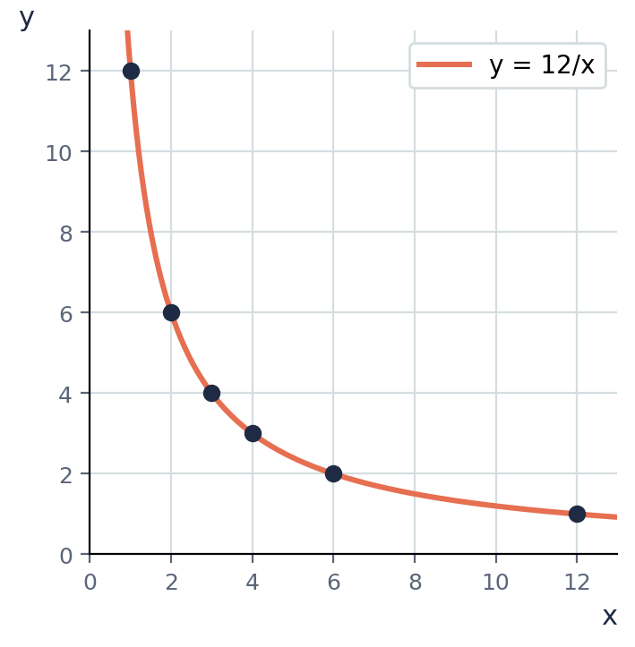

Example 3.2 · Finding k from one pair of values
y varies inversely as x. When x = 5, y = 8. Find the equation, then find y when x = 4.
Solution
1. y = k/x, so 8 = k/5.
2. k = 40.
3. y = 40/x.
4. When x = 4: y = 40/4 = 10.
Answer: y = 40/x; y = 10 when x = 4

Example 3.3 · Finding x when y is known
y = 40/x (from the previous example). Find x when y = 8, and again when y = 20.
Solution
1. When y = 8: 8 = 40/x, so 8x = 40 and x = 5 (this matches the pair we started with — a good check).
2. When y = 20: 20 = 40/x, so 20x = 40 and x = 2.
Answer: x = 5 (checks the original pair); x = 2 when y = 20
💭 Think: As y got bigger (from 8 to 20), x got smaller (from 5 to 2). Is that what you expect for inverse variation?

Example 3.4 · Workers and days (a classic inverse variation)
It takes 6 workers 8 days to build a wall. The number of days, d, varies inversely as the number of workers, w. How many days would it take 4 workers, working at the same rate?
Solution
1. d = k/w. Using w = 6, d = 8: 8 = k/6, so k = 48.
2. d = 48/w.
3. When w = 4: d = 48/4 = 12 days.
Answer: 12 days
💭 Think: Fewer workers means the job takes longer — does 12 days (up from 8) make sense?

⚠ Common mistakes
- Using y = kx (direct) by mistake instead of y = k/x (inverse) — check whether y increases or decreases as x increases.
- Forgetting to multiply both sides by x when solving for k or for x.
- Assuming an inverse variation graph is a straight line — it is a curve.

④ Practice
Write your answers in your exercise book. Start at Level 1. If you get most of a level right, move on to the next one. The answers are at the back of the pack.

Level 1 · Foundation
1. y varies inversely as x. Find k and write the equation.
(a) x = 2, y = 6
(b) x = 5, y = 4
(c) x = 3, y = 9
2. y = 24/x. Find y when x = 8.
3. y = 30/x. Find x when y = 5.

Level 2 · Developing
4. y varies inversely as x. When x = 4, y = 15. Find the equation, then find y when x = 10.
5. p varies inversely as q. When q = 9, p = 8. Find q when p = 6.
6. The table shows the speed, v (km/h), and the time, t (hours), for a 120 km journey.
v: 20, 30, 40, 60
t: 6, 4, 3, 2
Show that t varies inversely as v, and find the time taken at a speed of 80 km/h.
7. It takes 3 taps 40 minutes to fill a tank. The time, t, taken varies inversely as the number of taps, n. How long would it take 5 taps, working at the same rate?

Level 3 · Think Deeper
8. Spot the error. Given that y varies inversely as x, and x = 4, y = 10, Priya wrote y = kx and got 10 = 4k, so k = 2.5. Find her mistake and the correct equation.
9. Always, sometimes or never? "As x increases, y decreases." Consider both y = kx and y = k/x (with k > 0) in your answer.
10. Explain. Two quantities x and y satisfy xy = 20 for every pair of values. Explain why this means y varies inversely as x, and find y when x = 2.5.
11. Create. Write your own inverse-variation word problem (like the workers-and-days or taps-and-time examples), give one pair of values, and solve it for a different value.

Before you move on, say or write in one or two sentences: "I can explain the difference between the graphs of direct and inverse variation."
How confident do I feel? ☐ Not yet ☐ Getting there ☐ Got it!

Lesson 4: Solving Problems with Variation
Building on: Lessons 1–3, and forming equations from words (Unit 2, Lesson 5).
Goal: By the end of this lesson I can decide whether a situation is direct or inverse variation, form the equation, find k, and solve the problem in context.

① Key Ideas
- Step 1: Decide the type. Ask: as one quantity increases, does the other increase (direct) or decrease (inverse)? Or does the problem say "varies as the square/cube" (direct with a power)?
- Step 2: Write the general equation — y = kx, y = kxⁿ, or y = k/x — using letters that match the quantities in the problem.
- Step 3: Substitute the first pair of values given, and solve for k.
- Step 4: Rewrite the equation with k replaced by its value.
- Step 5: Substitute the new value given, and solve for the unknown.
- Step 6: Answer in words, with the correct units, and check the answer makes sense: for direct variation both quantities should move the same way; for inverse variation they should move opposite ways.

② Watch
Watch these videos after you have read the key ideas. Pause the video and try each example before it is solved. Online, click the link. On paper, type the short address into YouTube.
Video | What it covers | Link
Direct and Inverse Variation Intro & Word Problems  Eat Pi | Deciding direct or inverse, then solving word problems | Watch on YouTube  youtu.be/O_hhmULmKxQ

③ Worked Examples
Cover the solution and try the example first. Then uncover one step at a time and compare it with your own working.
Example 4.1 · Deciding the type first
For each situation, say whether it is direct or inverse variation. (a) The cost of tickets and the number bought. (b) The time for a journey and the speed travelled, for a fixed distance.
Solution
1. (a) More tickets costs more money — both increase together, so this is direct variation.
2. (b) A faster speed means less time — one increases while the other decreases, so this is inverse variation.
Answer: (a) direct (b) inverse

Example 4.2 · A full direct-variation problem
The weight, W, of a wire varies directly as its length, L. A 3 m length weighs 450 g. Find the weight of a 7 m length.
Solution
1. Increasing L increases W, so this is direct variation: W = kL.
2. 450 = k × 3, so k = 150.
3. W = 150L.
4. When L = 7: W = 1050 g.
Answer: 1050 g

Example 4.3 · A full inverse-variation problem
The number of days, d, needed to dig a trench varies inversely as the number of workers, w. It takes 5 workers 12 days. How many days would 3 workers take?
Solution
1. Fewer workers means more days, so this is inverse variation: d = k/w.
2. 12 = k/5, so k = 60.
3. d = 60/w.
4. When w = 3: d = 20 days.
Answer: 20 days
💭 Think: Does it make sense that fewer workers (3, down from 5) need more days (20, up from 12)?

Example 4.4 · Variation with a square, in context
The distance, d, a ball rolls down a ramp varies directly as the square of the time, t, since release. It rolls 2 m in 1 second. How far has it rolled after 3 seconds?
Solution
1. "Varies as the square of the time" means d = kt².
2. 2 = k × 1², so k = 2.
3. d = 2t².
4. When t = 3: d = 2 × 9 = 18 m.
Answer: 18 m

Example 4.5 · Combining variation with algebra from earlier units
y varies inversely as x. When x = 6, y = 5. Find x when y = 2x (that is, when y equals twice x).
Solution
1. Find k: 5 = k/6, so k = 30. So y = 30/x.
2. Set y = 2x: 2x = 30/x.
3. Multiply both sides by x: 2x² = 30, so x² = 15 and x = √15 (taking the positive root).
Answer: x = √15 ≈ 3.87
💭 Think: This question links variation to solving an equation, like the skills from Units 2 and 3. Which parts of your working came from variation, and which from equation-solving?

⚠ Common mistakes
- Not deciding direct or inverse first, and guessing the wrong equation.
- Forgetting units in the final answer.
- Not checking that the answer moves in a sensible direction for the type of variation.

④ Practice
Write your answers in your exercise book. Start at Level 1. If you get most of a level right, move on to the next one. The answers are at the back of the pack.

Level 1 · Foundation
1. Say whether each is direct or inverse variation.
(a) The number of pizzas bought and the total cost.
(b) The speed of a car and the time for a fixed journey.
(c) The number of pages read and the time spent reading, at a steady pace.
2. The cost, C, of apples varies directly as the mass, m, bought. 2 kg costs $6. Find the cost of 5 kg.
3. The time, t, for a job varies inversely as the number of workers, n. 4 workers take 9 hours. How long would 6 workers take?

Level 2 · Developing
4. The extension, e, of a spring varies directly as the force, F, applied. A force of 6 N causes an extension of 15 mm. Find the extension caused by a force of 10 N.
5. The pressure, P, of a fixed amount of gas varies inversely as its volume, V. When V = 8 m³, P = 150 kPa. Find P when V = 5 m³.
6. The area, A, of a circle varies directly as the square of its radius, r. A circle of radius 3 cm has area 28.26 cm². Find the area of a circle of radius 5 cm (same constant of proportionality).
7. It takes 8 taps 45 minutes to fill a pool. The time varies inversely as the number of taps. How many taps are needed to fill it in 20 minutes?
8. y varies directly as x². When x = 3, y = 27. Find x when y = 75.

Level 3 · Think Deeper
9. Spot the error. A question says "the time for a journey varies with the speed, for a fixed distance." Deshawn wrote t = ks (direct variation). Explain why this is wrong, and give the correct type and equation shape.
10. Explain. A student says, "If y varies inversely as x, then when x = 0, y = 0." Explain why this is false.
11. Investigate. For a fixed distance of 120 km, complete a table of speed (km/h) and time (hours) for speeds 20, 30, 40, 60. What kind of variation is this, and what is the constant?
12. Challenge. y varies directly as x, and z varies inversely as y. When x = 4, y = 12. When y = 12, z = 3. Find z when x = 8.

Before you move on, say or write in one or two sentences: "I can explain how I decide whether a problem is direct or inverse variation before I write an equation."
How confident do I feel? ☐ Not yet ☐ Getting there ☐ Got it!

CSEC-Style Exam Practice
These questions are like the ones on CSEC Paper 2, and they use all four lessons. Try them under test conditions: no notes, and about 30 minutes. Show all your working.
1. y varies directly as x. When x = 6, y = 27.
(a) Find the constant of variation, k, and write the equation connecting y and x. [2 marks]
(b) Find y when x = 10. [1 mark]
2. y varies inversely as x. When x = 4, y = 9.
(a) Find the constant of variation, k, and write the equation connecting y and x. [2 marks]
(b) Find x when y = 6. [2 marks]
3. The graph shows two relationships between x and y.
(a) Which line shows direct variation? Give a reason. [1 mark]
(b) Write the equation of the line that shows direct variation, and state the value of k. [2 marks]
4. The kinetic energy, E, of a moving object varies directly as the square of its speed, v. When v = 10 m/s, E = 500 J.
(a) Find the equation connecting E and v. [2 marks]
(b) Find E when v = 20 m/s. [2 marks]
(c) Find v when E = 1125 J. [2 marks]
5. It takes 5 taps 36 minutes to fill a water tank, working at the same rate.
(a) State whether the number of taps and the time taken vary directly or inversely, giving a reason. [1 mark]
(b) Find the constant of variation and the equation connecting time, t, and the number of taps, n. [2 marks]
(c) Find the time taken by 9 taps. [2 marks]

Self-Check Quiz: Am I Ready?
Answer all 10 questions without looking back at the lessons. Then check your answers and write your score in the box. The lesson number after each question tells you where to go back if you get it wrong.
1. y varies directly as x. Which equation is correct? (Lesson 1)
A x = k + y B y = kx C y = k/x D y = k + x
2. y = kx. When x = 4, y = 20. What is k? (Lesson 1)
A 16 B 24 C 80 D 5
3. Which graph shape shows direct variation? (Lesson 1)
A a straight line through the origin B a horizontal line C a straight line not through the origin D a curve approaching the axes
4. y varies directly as x². When x = 2, y = 12. What is y when x = 4? (Lesson 2)
A 16 B 24 C 48 D 96
5. If y varies directly as x², doubling x makes y… (Lesson 2)
A 2 times as big B the same C 4 times as big D 8 times as big
6. y varies inversely as x. Which equation is correct? (Lesson 3)
A y = k/x B y = k − x C y = kx² D y = kx
7. y = k/x. When x = 5, y = 8. What is k? (Lesson 3)
A 1.6 B 3 C 13 D 40
8. As x increases, y varies inversely as x. What happens to y? (Lesson 3)
A y stays the same B y decreases C y increases D y becomes negative
9. It takes 4 workers 10 days to finish a job. Using inverse variation, how long would 5 workers take? (Lesson 4)
A 8 days B 12.5 days C 20 days D 9 days
10. A quantity y varies directly as x, and both increase together. Which real-life pair matches this? (Lesson 4)
A speed and time for a fixed journey B temperature and pressure at a fixed volume of gas, inversely C mass of rice bought and its cost D number of workers and days to finish a job

My score | What it means
9–10 | Ready! You are ready for the next topic: Completing the Square.
6–8 | Nearly there. Look at the lesson number next to each question you missed. Redo the Level 2 practice for those lessons.
0–5 | Go back over the lessons for the questions you missed. Redo the Level 1 and Level 2 practice, watch the videos again, then retake this quiz.
My score: ______ / 10

Answers
Use these to check your work. If your answer is different, look for your mistake before you ask for help. Your teacher has the full worked solutions.

Warm-Up
1. y = 30
2. k = 5
3. k = y/x
4. k = xy
5. 12 and 48
6. k = 5

Lesson 1: Direct Variation
Level 1 · Foundation
1. (a) k = 4, y = 4x (b) k = 3, y = 3x (c) k = 2.5, y = 2.5x
2. y = 21
3. x = 5
Level 2 · Developing
4. y = 4.5x; y = 45
5. q = 20
6. k = 4; $60
7. 175 g
Level 3 · Think Deeper
8. She substituted the wrong way round. 12 = k × 3, so k = 4 and y = 4x.
9. Sometimes. Only a straight line through the origin, like C = 2.5d, shows direct variation. C = 15 + 2.5d is a straight line but does not pass through the origin.
10. When x = 0, y = k × 0 = 0 for any value of k, so the point (0, 0) always satisfies y = kx.
11. e.g. Direct: the mass of rice bought and its cost (no fixed charge). Not direct: a taxi fare made of a fixed pickup fee plus a rate per km.

Lesson 2: Direct Variation with Powers
Level 1 · Foundation
1. (a) k = 3, y = 3x² (b) k = 5, y = 5x² (c) k = 7, y = 7x²
2. y = 36
3. y = 54
Level 2 · Developing
4. y = 2x²; y = 72
5. x = 3
6. 45 m
7. 72 J
Level 3 · Think Deeper
8. He forgot to square x. 27 = k × 9, so k = 3 and y = 3x².
9. y becomes a quarter of its original value.
10. 40 m — four times as far, not twice.
11. e.g. "y varies as the cube of x. When x = 2, y = 24. Find y when x = 3." → k = 3, y = 3x³, y = 81.

Lesson 3: Inverse Variation
Level 1 · Foundation
1. (a) k = 12, y = 12/x (b) k = 20, y = 20/x (c) k = 27, y = 27/x
2. y = 3
3. x = 6
Level 2 · Developing
4. y = 60/x; y = 6
5. q = 12
6. k = 120; 1.5 hours
7. 24 minutes
Level 3 · Think Deeper
8. She used the direct variation formula by mistake. Inverse variation is y = k/x, so 10 = k/4 and k = 40, giving y = 40/x.
9. Sometimes. It is true for inverse variation (y = k/x) but false for direct variation (y = kx), where y increases as x increases.
10. xy = 20 means y = 20/x, which is the definition of inverse variation with k = 20. When x = 2.5, y = 8.
11. e.g. "4 painters take 15 hours to paint a hall. How long would 6 painters take?" → k = 60, t = 60/n, t = 10 hours.

Lesson 4: Solving Problems with Variation
Level 1 · Foundation
1. (a) direct (b) inverse (c) direct
2. $15
3. 6 hours
Level 2 · Developing
4. 25 mm
5. 240 kPa
6. 78.5 cm²
7. 18 taps
8. x = 5
Level 3 · Think Deeper
9. Faster speed gives less time, so it is inverse variation: t = k/s, not t = ks.
10. y = k/x is undefined when x = 0 (division by zero), so x = 0 is never allowed in inverse variation — the statement confuses it with direct variation.
11. Inverse variation, k = 120 (the distance). Times: 6, 4, 3, 2 hours.
12. z = 1.5

CSEC-Style Exam Practice
1. (a) k = 4.5, y = 4.5x (b) y = 45
2. (a) k = 36, y = 36/x (b) x = 6
3. (a) The teal line, because it passes through the origin. (b) C = 2.5d, k = 2.5
4. (a) E = 5v² (b) E = 2000 J (c) v = 15 m/s
5. (a) Inversely — more taps means less time. (b) k = 180, t = 180/n (c) t = 20 minutes

Self-Check Quiz
Q | Answer | Why
1 | B | Direct variation means y = kx for a constant k.
2 | D | 20 = k × 4, so k = 5.
3 | A | y = kx always passes through (0, 0).
4 | C | k = 3, so y = 3x². When x = 4: y = 3 × 16 = 48.
5 | C | k(2x)² = 4kx² = 4y.
6 | A | Inverse variation means y = k/x.
7 | D | 8 = k/5, so k = 40.
8 | B | In y = k/x, a bigger x gives a smaller y (for k > 0).
9 | A | k = 4 × 10 = 40. Time = 40/5 = 8 days.
10 | C | More rice costs more money — a direct relationship with no fixed part.

