Clare Hall Secondary School · Mathematics Department

FORM 3 MATHEMATICS · UNIT 8
Completing the Square
Self-Paced Learning Pack
Name: ______________________________________ Class: ___________
Time in class: 1 week School year: 2026–2027 Next topic: Form 4 Mathematics

What's inside
Section | What you will do
Before You Start | Warm up with the number facts you need
Lesson 1 | What Completing the Square Means
Lesson 2 | Completing the Square for x² + bx + c
Lesson 3 | Completing the Square for ax² + bx + c
Lesson 4 | Using a(x + h)² + k to Find the Turning Point
Lesson 5 | Solving Quadratic Equations by Completing the Square
Exam Practice | CSEC-style questions that use all five lessons
Self-Check Quiz | 12 questions that show whether you are ready to move on
Answers | Check your work (at the back of the pack)

How to Use This Pack
- This pack lets you learn at your own pace. You can work ahead of the class or go back over anything you missed.
- Work through the lessons in order. Each lesson builds on the one before it.
- For each lesson: Read the key ideas → Watch the videos → Study the worked examples → Practise.
- Before you read the solution to a worked example, cover it and try the example yourself first. Then check each step.
- Practice has three levels. Level 1 (Foundation) checks the basics. Level 2 (Developing) makes you apply them. Level 3 (Think Deeper) asks you to explain, find mistakes and create your own examples.
- Check your answers at the back of the pack. If you get an answer wrong, find your mistake before you move on. A mistake you understand teaches you more than a correct guess.
- When you finish all the lessons, try the CSEC-Style Exam Practice, then the Self-Check Quiz. Your quiz score tells you whether you are ready for the next topic.

The learning route for every lesson
① Read the key ideas → ② Watch the videos → ③ Try the worked examples, then check each step → ④ Practise Level 1 → 2 → 3 → ⑤ Check your answers → ⑥ Tick your checklist

My Progress Checklist
Tick one box for each statement before you start and again after you finish. Be honest. This checklist is for you.
I can… | Not yet | Getting there | Got it!
Understand the relationship between x² + bx + c and the completed-square form using an area (geometric) model (Lesson 1) | ☐ | ☐ | ☐
Rewrite a quadratic x² + bx + c in completed-square form, (x + h)² + k (Lesson 2) | ☐ | ☐ | ☐
Rewrite any quadratic ax² + bx + c in the general completed-square form a(x + h)² + k (Lesson 3) | ☐ | ☐ | ☐
Use a(x + h)² + k to find the turning point (minimum or maximum value) and axis of symmetry of a quadratic (Lesson 4) | ☐ | ☐ | ☐
Solve quadratic equations by completing the square (Lesson 5) | ☐ | ☐ | ☐

Key Words
Symbol | Meaning | Example
quadratic expression | an expression whose highest power of x is x² | ax² + bx + c, with a ≠ 0
completed-square form | the general form a(x + h)² + k | 2x² + 12x + 5 = 2(x + 3)² − 13
a, h, k | a is the coefficient of x² (it stays the same); h = b ÷ 2a; k = c − ah² | in 2(x + 3)² − 13: a = 2, h = 3, k = −13
monic | a quadratic where the coefficient of x² is 1, so a = 1 | x² + 6x + 5 is monic; 2x² + 6x + 5 is not
turning point / vertex | the single minimum or maximum point on a parabola | a(x + h)² + k has turning point (−h, k)
axis of symmetry | the vertical line through the turning point that the curve is a mirror image about | for 2(x + 3)² − 13, the axis of symmetry is x = −3
perfect square | an expression of the form (x + h)² | (x + 3)² = x² + 6x + 9

Before You Start: Warm-Up
This unit uses skills from earlier units: expanding brackets, factorizing, and solving equations with square roots. Check you still have them.
1. Expand (x + 5)².
2. Expand (x − 4)².
3. Expand 2(x + 3)².
4. Factorize x² + 8x + 16.
5. Factorize 2x² + 12x.
6. Find half of 10, then square your answer.
7. Solve x² = 49.

Lesson 1: What Completing the Square Means
Building on: Unit 2: expanding brackets. Unit 5: perfect square trinomials, (x + h)² = x² + 2hx + h².
Goal: By the end of this lesson I can explain, using an area diagram, why x² + bx needs the term (b/2)² added to become a perfect square.

① Key Ideas
- In Unit 5 you learned to factorize a perfect square trinomial like x² + 6x + 9 into (x + 3)². Completing the square asks the opposite question: given x² + 6x (which is NOT a perfect square), what must be added to make it one?
- Picture it as area. x² + bx is a square of side x, plus two matching rectangles of width b/2 — together they form an L-shape (a gnomon) with a small square-shaped corner missing.
- The missing corner has side b/2, so its area is (b/2)². Adding this completes the big square, of side (x + b/2).
- This gives the key identity: x² + bx = (x + b/2)² − (b/2)². We add (b/2)² to complete the square, and subtract the same amount so the value of the expression does not change.
- Completed-square form is the general form a(x + h)² + k. In Lessons 1 and 2 the coefficient a is 1, so it looks like (x + h)² + k; Lesson 3 handles a ≠ 1. It looks different from x² + bx + c, but for the same values of x it gives exactly the same output — the two forms are equivalent.
- Once b is a fraction (for example, b = 5, so b/2 = 2.5), the method is exactly the same — just work with the fraction or decimal carefully.

② Watch
Watch these videos after you have read the key ideas. Pause the video and try each example before it is solved. Online, click the link. On paper, type the short address into YouTube.
Video | What it covers | Link
Completing the Square  Corbettmaths | What completing the square means and how to do it | Watch on YouTube  youtu.be/VS6apvTv2Rc

③ Worked Examples
Cover the solution and try the example first. Then uncover one step at a time and compare it with your own working.
Example 1.1 · Reading the area diagram
The diagram shows x² + 6x as an L-shape with a missing corner. What is the side length of the missing corner, and its area? What perfect square does adding it complete?
Solution
1. The two rectangles each have width 3 (half of 6), so the missing corner is a 3 by 3 square.
2. Its area is 3² = 9.
3. Adding it completes the square (x + 3)², which has area x² + 6x + 9.
Answer: Side 3, area 9; completes (x + 3)²
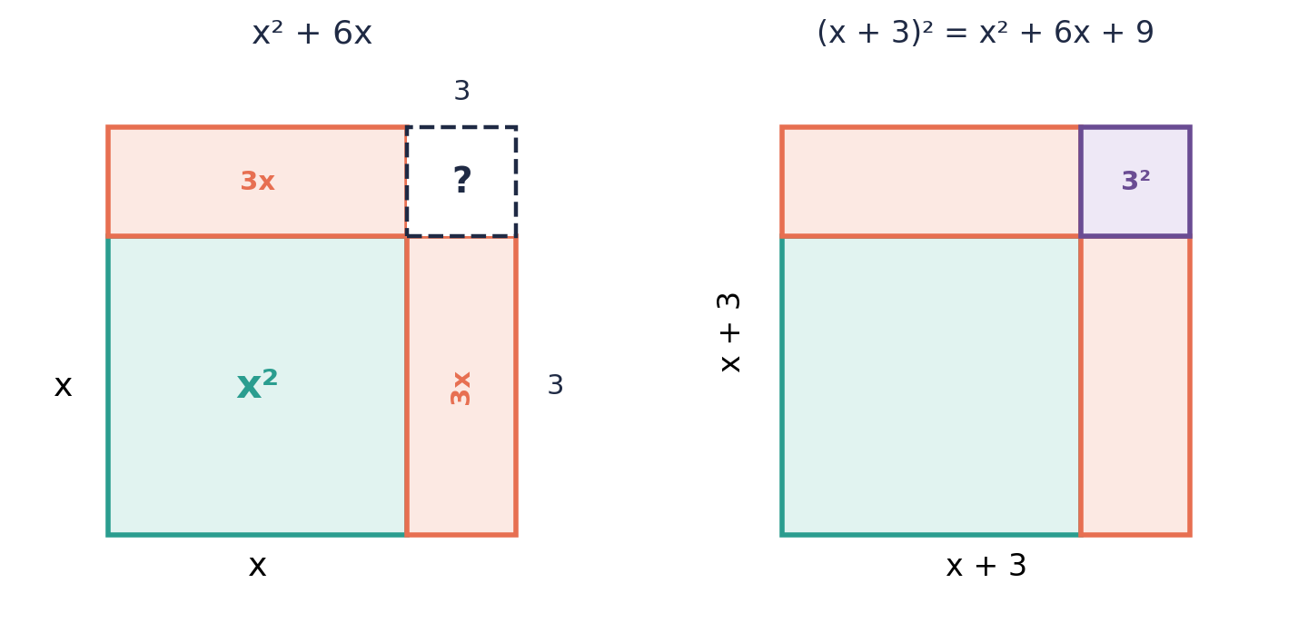

Example 1.2 · Checking the identity by expanding
Show that x² + 6x + 9 = (x + 3)² by expanding the right-hand side.
Solution
1. (x + 3)² = (x + 3)(x + 3).
2. = x² + 3x + 3x + 9 = x² + 6x + 9.
3. This matches the left-hand side.
Answer: Confirmed: (x + 3)² = x² + 6x + 9

Example 1.3 · Finding what completes the square
What must be added to x² + 10x to make it a perfect square trinomial? Write the trinomial and its factorized form.
Solution
1. Half of 10 is 5.
2. Square it: 5² = 25.
3. x² + 10x + 25 is a perfect square: (x + 5)².
Answer: Add 25; x² + 10x + 25 = (x + 5)²
💭 Think: Compare this to Unit 5, where you factorized perfect square trinomials that were already given to you. Here, you are building one from scratch.

Example 1.4 · A missing corner with a fraction
What must be added to x² + 5x to make it a perfect square? Write the completed square.
Solution
1. Half of 5 is 2.5.
2. Square it: 2.5² = 6.25.
3. x² + 5x + 6.25 = (x + 2.5)².
Answer: Add 6.25; (x + 2.5)²
💭 Think: The picture still works even though the missing corner is not a whole number. Can you sketch what side length 2.5 would look like compared to side length 3 in the earlier example?

⚠ Common mistakes
- Adding b instead of (b/2)² — for x² + 6x, adding 9 is correct, not 6 or 3.
- Forgetting to halve b before squaring — (b/2)² is not the same as b²/2 for most values.
- Thinking the missing corner's side is b, when it is actually b/2 (there are two rectangles sharing the b between them).

④ Practice
Write your answers in your exercise book. Start at Level 1. If you get most of a level right, move on to the next one. The answers are at the back of the pack.

Level 1 · Foundation
1. Find half of each number, then square your answer.
(a) 8
(b) 12
(c) 20
(d) 7
2. What must be added to each expression to complete the square?
(a) x² + 4x
(b) x² + 14x
(c) x² + 2x
3. Write x² + 4x + 4 as a perfect square.

Level 2 · Developing
4. The diagram shows x² + 8x as an L-shape with a missing corner.
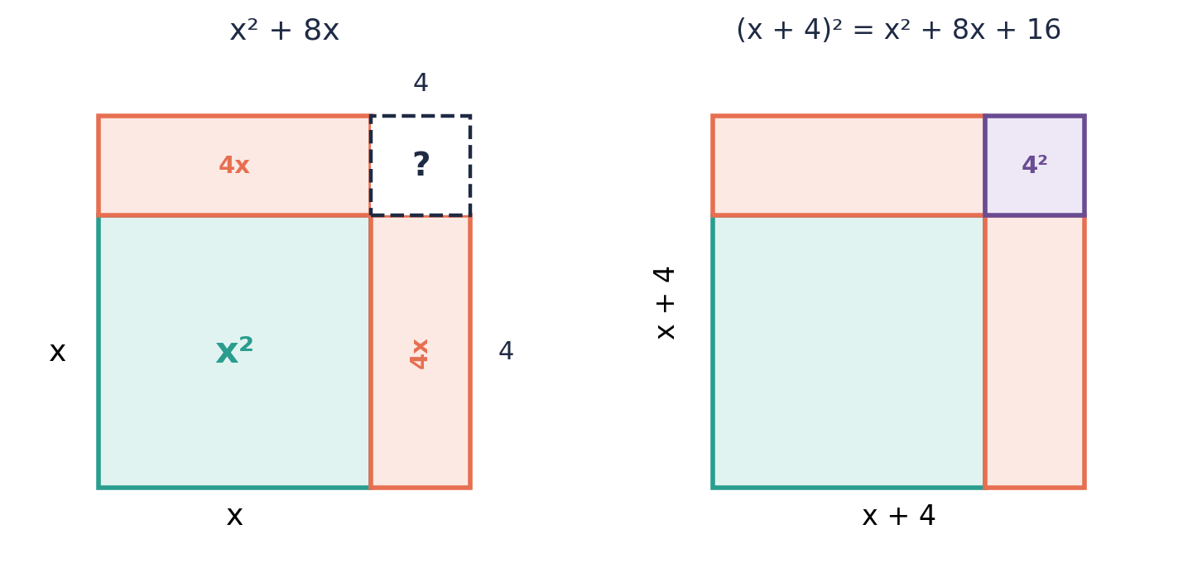
(a) State the side length of the missing corner.
(b) State its area.
(c) Write the completed square.
5. What must be added to each expression to complete the square? Then write the completed square.
(a) x² + 16x
(b) x² + 9x
(c) x² + 3x
6. Show, by expanding, that x² + 12x + 36 = (x + 6)².
7. Draw and label an area diagram (like the worked examples) for x² + 20x. What is the area of the missing corner?

Level 3 · Think Deeper
8. Spot the error. To complete the square for x² + 10x, Anaya added 10² = 100. Find her mistake and the correct value.
9. Explain. Using the area diagram, explain why the amount needed to complete the square is (b/2)² and not b² or b/2.
10. Always, sometimes or never? "x² + bx + c is already a perfect square trinomial." Use x² + 6x + 9 and x² + 6x + 11 in your answer.
11. Create. Write an expression of the form x² + bx that is NOT yet a perfect square. State what must be added to complete the square, and write the result in completed-square form.

Before you move on, say or write in one or two sentences: "I can explain, using the area diagram, why we add (b/2)² and not b² to complete the square."
How confident do I feel? ☐ Not yet ☐ Getting there ☐ Got it!

Lesson 2: Completing the Square for x² + bx + c
Building on: Lesson 1, and collecting like terms (Unit 2).
Goal: By the end of this lesson I can rewrite any monic quadratic x² + bx + c in completed-square form (x + h)² + k.

① Key Ideas
- The rule: x² + bx + c = (x + b/2)² − (b/2)² + c. The h in (x + h)² is always half of b.
- Method: (1) Halve b to get h. (2) Write (x + h)². (3) Subtract h² (to "cancel out" the extra amount you introduced). (4) Combine the subtracted h² with c to get the final k.
- So the completed-square form is (x + h)² + k, where h = b/2 and k = c − h². This is the general form a(x + h)² + k with a = 1; Lesson 3 covers a ≠ 1.
- Check your answer by expanding (x + h)² + k and confirming you get back x² + bx + c.
- This works whether b is positive or negative. If b is negative, h is negative too — for example, x² − 8x has h = −4, giving (x − 4)².

② Watch
Watch these videos after you have read the key ideas. Pause the video and try each example before it is solved. Online, click the link. On paper, type the short address into YouTube.
Video | What it covers | Link

③ Worked Examples
Cover the solution and try the example first. Then uncover one step at a time and compare it with your own working.
Example 2.1 · Positive b, simple case
Write x² + 6x + 11 in completed-square form.
Solution
1. b = 6, so h = 6 ÷ 2 = 3.
2. Write (x + 3)², which expands to x² + 6x + 9 — that is 9 = 3² too many.
3. Subtract 9 and add the original 11: (x + 3)² − 9 + 11 = (x + 3)² + 2.
Answer: (x + 3)² + 2

Example 2.2 · Negative b
Write x² − 8x + 5 in completed-square form.
Solution
1. b = −8, so h = −8 ÷ 2 = −4.
2. Write (x − 4)², which expands to x² − 8x + 16.
3. Subtract 16 and add the original 5: (x − 4)² − 16 + 5 = (x − 4)² − 11.
Answer: (x − 4)² − 11

Example 2.3 · Checking by expanding
Check the previous example by expanding (x − 4)² − 11.
Solution
1. (x − 4)² = x² − 8x + 16.
2. (x − 4)² − 11 = x² − 8x + 16 − 11 = x² − 8x + 5.
3. This matches the original expression.
Answer: Confirmed

Example 2.4 · Odd b (a fraction appears)
Write x² + 5x + 1 in completed-square form.
Solution
1. b = 5, so h = 5 ÷ 2 = 2.5.
2. (x + 2.5)² expands to x² + 5x + 6.25.
3. Subtract 6.25 and add 1: (x + 2.5)² − 6.25 + 1 = (x + 2.5)² − 5.25.
Answer: (x + 2.5)² − 5.25
💭 Think: Fractions and decimals are common in completing the square. Would it be easier for you to work with 2½ and 5¼, or with 2.5 and 5.25?

Example 2.5 · When c is already the right amount
Write x² + 12x + 36 in completed-square form.
Solution
1. b = 12, so h = 6.
2. (x + 6)² expands to x² + 12x + 36 exactly.
3. There is nothing left over: k = 36 − 36 = 0.
4. So x² + 12x + 36 = (x + 6)² + 0 = (x + 6)².
Answer: (x + 6)²
💭 Think: This is a perfect square trinomial, like the ones you factorized in Unit 5. Completing the square and factorizing a perfect square trinomial give the same result here.

⚠ Common mistakes
- Forgetting to add the original constant c back in after subtracting h².
- Sign errors with negative b, such as writing (x + 4)² instead of (x − 4)² for x² − 8x + 5.
- Leaving the answer as (x + h)² − h² + c instead of simplifying to (x + h)² + k.

④ Practice
Write your answers in your exercise book. Start at Level 1. If you get most of a level right, move on to the next one. The answers are at the back of the pack.

Level 1 · Foundation
1. Write each expression in completed-square form.
(a) x² + 2x + 5
(b) x² + 4x + 1
(c) x² + 10x + 3
2. Write x² − 4x + 7 in completed-square form.
3. Check that (x + 4)² − 9 expands to x² + 8x + 7.

Level 2 · Developing
4. Write each expression in completed-square form.
(a) x² + 6x − 1
(b) x² − 10x + 30
(c) x² + 8x + 20
(d) x² − 2x − 5
5. Write x² + 7x + 2 in completed-square form.
6. Write x² − 3x in completed-square form (there is no constant term to add on).
7. A student completed the square for x² + 6x + 4 and got (x + 3)² − 5. Verify this is correct by expanding.

Level 3 · Think Deeper
8. Spot the error. For x² − 8x + 5, Cody wrote h = 8 and got (x + 8)² − 59. Find both of his mistakes and give the correct answer.
9. Explain. Why must k always equal c − h², and not simply equal c?
10. Challenge. Show that x² + bx + c = (x + b/2)² + c − b²/4 by expanding the right-hand side. What does this tell you about h and k?
11. Create. Write your own quadratic x² + bx + c with a negative value of b, and rewrite it in completed-square form. Check your answer by expanding.

Before you move on, say or write in one or two sentences: "I can explain how to find h and k when completing the square for x² + bx + c."
How confident do I feel? ☐ Not yet ☐ Getting there ☐ Got it!

Lesson 3: Completing the Square for ax² + bx + c
Building on: Lessons 1–2, and taking out a common factor (Unit 5).
Goal: By the end of this lesson I can rewrite any quadratic ax² + bx + c in the general completed-square form a(x + h)² + k, including when a is not 1 or is negative.

① Key Ideas
- The general completed-square form is a(x + h)² + k. The number a is the same a as in ax² + bx + c. In Lessons 1–2, a was 1, so you never saw it.
- Method: (1) Take a out of the x² and x terms only, leaving c outside: a(x² + (b/a)x) + c. (2) Complete the square inside the bracket, as in Lesson 2. (3) Multiply the number you subtracted by a before combining it with c.
- Shortcut: h = b ÷ 2a and k = c − ah². Check with a = 1: h = b ÷ 2 and k = c − h², which is Lesson 2.
- The number you subtract is ah², not h². This is the most common mistake, because the subtracted square sits inside brackets that are multiplied by a.
- If a is negative, the method is the same and a stays negative: −x² + 6x + 1 = −(x − 3)² + 10. This matters in Lesson 4, where a negative a gives a maximum instead of a minimum.
- Always check by expanding a(x + h)² + k. You must get back ax² + bx + c.

② Watch
Watch these videos after you have read the key ideas. Pause the video and try each example before it is solved. Online, click the link. On paper, type the short address into YouTube.
Video | What it covers | Link
Completing the square method | Coefficient of x² is not one  JJ ONLINE MATHS CLASS | Completing the square when a is not 1 | Watch on YouTube  youtu.be/1BTKFeQz87c

③ Worked Examples
Cover the solution and try the example first. Then uncover one step at a time and compare it with your own working.
Example 3.1 · Taking out the common factor first
Write 2x² + 12x + 5 in the form a(x + h)² + k.
Solution
1. Take 2 out of the first two terms only: 2(x² + 6x) + 5.
2. Complete the square inside the bracket: x² + 6x = (x + 3)² − 9.
3. Multiply through by 2: 2[(x + 3)² − 9] + 5 = 2(x + 3)² − 18 + 5.
4. Combine: 2(x + 3)² − 13.
Answer: 2(x + 3)² − 13

Example 3.2 · Negative b
Write 3x² − 12x + 7 in the form a(x + h)² + k.
Solution
1. Take 3 out of the first two terms: 3(x² − 4x) + 7.
2. x² − 4x = (x − 2)² − 4.
3. 3[(x − 2)² − 4] + 7 = 3(x − 2)² − 12 + 7.
4. Combine: 3(x − 2)² − 5.
Answer: 3(x − 2)² − 5

Example 3.3 · Using the shortcut h = b ÷ 2a and k = c − ah²
Write 5x² + 20x + 9 in the form a(x + h)² + k using the shortcut.
Solution
1. a = 5, b = 20, c = 9.
2. h = 20 ÷ (2 × 5) = 2.
3. k = 9 − 5 × 2² = 9 − 20 = −11.
4. So 5(x + 2)² − 11.
5. Check: 5(x² + 4x + 4) − 11 = 5x² + 20x + 20 − 11 = 5x² + 20x + 9 ✓
Answer: 5(x + 2)² − 11

Example 3.4 · A fractional h
Write 2x² + 6x + 1 in the form a(x + h)² + k.
Solution
1. a = 2, b = 6, c = 1.
2. h = 6 ÷ 4 = 1.5.
3. k = 1 − 2 × 1.5² = 1 − 4.5 = −3.5.
4. So 2(x + 1.5)² − 3.5.
5. Check: 2(x² + 3x + 2.25) − 3.5 = 2x² + 6x + 4.5 − 3.5 = 2x² + 6x + 1 ✓
Answer: 2(x + 1.5)² − 3.5
💭 Think: Fractions and decimals are common here. Would you rather work with 1½ and 3½, or with 1.5 and 3.5?

Example 3.5 · A negative value of a
Write −x² + 6x + 1 in the form a(x + h)² + k.
Solution
1. Take −1 out of the first two terms: −(x² − 6x) + 1.
2. x² − 6x = (x − 3)² − 9.
3. −[(x − 3)² − 9] + 1 = −(x − 3)² + 9 + 1.
4. Combine: −(x − 3)² + 10.
Answer: −(x − 3)² + 10
💭 Think: The 9 changed from −9 to +9. Why? What happens to every term inside the brackets when you multiply by −1?

⚠ Common mistakes
- Subtracting h² instead of ah². For 2x² + 12x + 5, the number subtracted is 2 × 9 = 18, not 9.
- Taking a out of all three terms, including c, and then forgetting to put it back.
- Losing the negative sign when a is negative, or not changing the sign of the subtracted number.

④ Practice
Write your answers in your exercise book. Start at Level 1. If you get most of a level right, move on to the next one. The answers are at the back of the pack.

Level 1 · Foundation
1. Take out the coefficient of x² from the first two terms only.
(a) 2x² + 8x + 3
(b) 3x² + 18x + 5
(c) 5x² − 10x + 1
2. Write each expression in the form a(x + h)² + k.
(a) 2x² + 8x + 3
(b) 3x² + 6x + 5
(c) 4x² + 8x − 1
3. Check that 2(x + 1)² + 3 expands to 2x² + 4x + 5.

Level 2 · Developing
4. Write each expression in the form a(x + h)² + k.
(a) 2x² − 12x + 7
(b) 3x² + 12x + 20
(c) 5x² − 20x + 3
(d) 2x² + 10x + 1
5. Write 4x² + 8x + 9 in the form a(x + h)² + k.
6. Write 3x² − 6x − 2 in the form a(x + h)² + k.
7. Write −x² + 4x + 3 in the form a(x + h)² + k.

Level 3 · Think Deeper
8. Spot the error. To complete the square for 2x² + 12x + 5, Reggie wrote 2(x + 3)² − 9 + 5 = 2(x + 3)² − 4. What did he forget? Give the correct answer.
9. Explain. Why is the number subtracted equal to ah² and not just h²?
10. Challenge. Expand a(x + h)² + k. By comparing it with 3x² + 18x + 5, find a, h and k.
11. Create. Write your own quadratic with a ≠ 1 and a negative b. Rewrite it in the form a(x + h)² + k, and check by expanding.

Before you move on, say or write in one or two sentences: "I can explain why the number I subtract is ah² and not h²."
How confident do I feel? ☐ Not yet ☐ Getting there ☐ Got it!

Lesson 4: Using a(x + h)² + k to Find the Turning Point
Building on: Lesson 3, and plotting coordinates (earlier units).
Goal: By the end of this lesson I can use completed-square form to state the turning point, the minimum or maximum value, and the axis of symmetry of a quadratic, without drawing the graph.

① Key Ideas
- The graph of y = ax² + bx + c is a parabola. It opens upward (a ∪ shape) when a is positive, and downward (a ∩ shape) when a is negative.
- In y = a(x + h)² + k, the squared part (x + h)² can never be negative. Its smallest possible value is 0, when x = −h.
- If a > 0: a(x + h)² is never negative, so y is smallest when the bracket is 0. The minimum value of y is k, at x = −h.
- If a < 0: a(x + h)² is never positive, so y is largest when the bracket is 0. The maximum value of y is k, at x = −h.
- Either way, the turning point is (−h, k). Watch the sign: for 2(x + 3)² − 13 the turning point is (−3, −13), not (3, −13).
- The axis of symmetry is the vertical line through the turning point: x = −h. The curve is a mirror image of itself on either side of this line.

② Watch
Watch these videos after you have read the key ideas. Pause the video and try each example before it is solved. Online, click the link. On paper, type the short address into YouTube.
Video | What it covers | Link
Minimum Values using Completing the Square  Corbettmaths | Reading the minimum value and turning point from completed-square form | Watch on YouTube  youtu.be/QNu7geF0RaE

③ Worked Examples
Cover the solution and try the example first. Then uncover one step at a time and compare it with your own working.
Example 4.1 · Finding the minimum value and turning point
y = x² − 6x + 11. Write this in completed-square form, then state the minimum value of y, the turning point, and the axis of symmetry.
Solution
1. Complete the square: h = −3, h² = 9, k = 11 − 9 = 2. So y = (x − 3)² + 2.
2. Here a = 1, which is positive, so there is a minimum. The minimum value of y is 2, at x = 3.
3. The turning point is (3, 2).
4. The axis of symmetry is x = 3.
Answer: Minimum value 2 at x = 3; turning point (3, 2); axis of symmetry x = 3
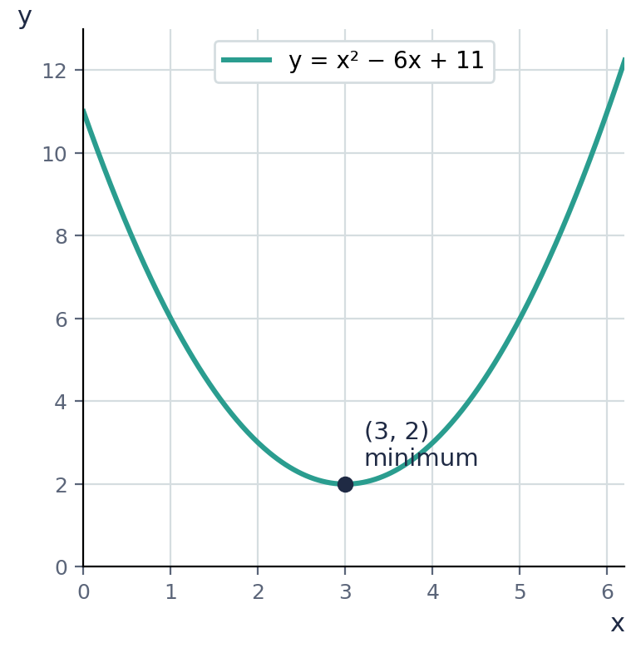

Example 4.2 · Reading the graph to confirm
The graph shows y = x² − 6x + 11. Confirm that the graph matches the answer from the previous example.
Solution
1. The lowest point on the curve is at (3, 2), matching our turning point.
2. The curve is symmetric about the vertical line x = 3.
3. For every x-value, the point directly opposite across x = 3 gives the same y-value. For example, y(2) = 3 and y(4) = 3.
Answer: Confirmed

Example 4.3 · A different sign of h
y = x² + 4x + 9. Find the minimum value, the turning point, and the axis of symmetry.
Solution
1. Complete the square: h = 2, h² = 4, k = 9 − 4 = 5. So y = (x + 2)² + 5.
2. The minimum value is 5, when x = −2 (the opposite sign of the +2 in the bracket).
3. The turning point is (−2, 5). The axis of symmetry is x = −2.
Answer: Minimum value 5 at x = −2; turning point (−2, 5)

Example 4.4 · When a is not 1
y = 2x² − 8x + 11. Find the turning point and say whether it is a minimum or a maximum.
Solution
1. Complete the square: h = −8 ÷ 4 = −2, k = 11 − 2 × 4 = 3. So y = 2(x − 2)² + 3.
2. a = 2 is positive, so the turning point is a minimum.
3. The turning point is (2, 3), so the minimum value is 3, at x = 2.
Answer: Minimum at (2, 3)

Example 4.5 · When a is negative: a maximum
y = −x² + 6x + 1. Find the turning point and say whether it is a minimum or a maximum.
Solution
1. From Lesson 3: y = −(x − 3)² + 10.
2. a = −1 is negative, so the curve opens downward and the turning point is a maximum.
3. The maximum value of y is 10, at x = 3. The turning point is (3, 10).
Answer: Maximum value 10 at x = 3; turning point (3, 10)
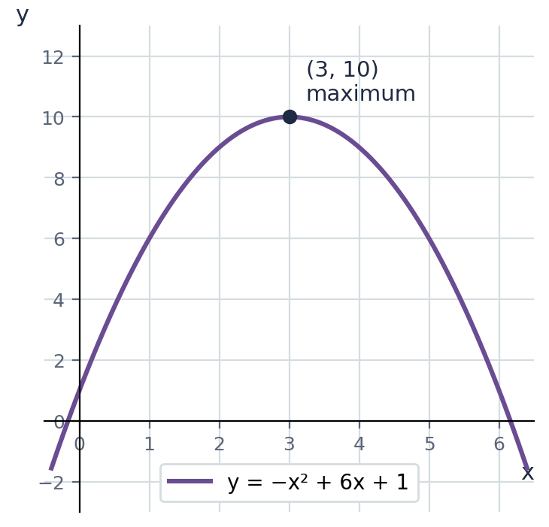
💭 Think: Why is −(x − 3)² never positive? What does that tell you about how large y can get?

Example 4.6 · Using the turning point in context
The height, in metres, of a cable above a valley floor is modelled by h(x) = x² − 10x + 34, where x is the horizontal distance in metres. Find the lowest point of the cable.
Solution
1. Complete the square: half of −10 is −5, (−5)² = 25. k = 34 − 25 = 9.
2. h(x) = (x − 5)² + 9.
3. The minimum value of h is 9, when x = 5.
4. The lowest point of the cable is 9 m above the valley floor, at x = 5 m.
Answer: 9 m above the valley floor, at x = 5 m
💭 Think: Why is knowing the minimum value useful here, compared with just knowing the equation?

⚠ Common mistakes
- Writing the turning point as (h, k) instead of (−h, k). The x-coordinate changes sign.
- Calling every turning point a minimum. When a is negative it is a maximum.
- Confusing the axis of symmetry (a whole line, x = a number) with a single point.

④ Practice
Write your answers in your exercise book. Start at Level 1. If you get most of a level right, move on to the next one. The answers are at the back of the pack.

Level 1 · Foundation
1. Each expression is already in completed-square form. State the minimum value of y and the value of x where it occurs.
(a) y = (x + 2)² + 6
(b) y = (x − 5)² + 1
(c) y = (x + 1)² − 3
2. State the turning point and axis of symmetry for y = (x − 4)² + 7.
3. Say whether each has a minimum or a maximum. State its value and where it occurs.
(a) y = 3(x − 2)² + 1
(b) y = −2(x + 1)² + 7
(c) y = −(x − 4)² − 3

Level 2 · Developing
4. Complete the square for each, then state the minimum value and the turning point.
(a) y = x² + 8x + 20
(b) y = x² − 4x − 1
(c) y = x² + 2x + 8
5. Find the minimum value of y = x² − 12x + 40 and state the axis of symmetry.
6. The profit, in dollars, of a small business is modelled by P(x) = x² − 20x + 75, where x is the number of items sold beyond a certain point. Find the minimum value of P and the value of x where it occurs. What does this tell the business?
7. A rectangle has perimeter 40 m. If one side is x m, the area is A = x(20 − x) = −x² + 20x. Write A in the form a(x + h)² + k to find the maximum possible area.
8. Write y = 3x² + 12x + 7 in completed-square form, then state its turning point and whether it is a minimum or a maximum.

Level 3 · Think Deeper
9. Spot the error. For y = (x + 5)² − 2, Rashida said the turning point is (5, −2). Find her mistake and the correct turning point.
10. Explain. Why does y = a(x + h)² + k have a maximum value, rather than a minimum, when a is negative?
11. Always, sometimes or never? "A quadratic y = x² + bx + c has a negative minimum value." Use y = x² + 6x + 9 and y = x² + 6x + 2 in your answer.
12. Investigate. For y = x² + bx (with c = 0), show that the minimum value is always −(b/2)², and is never positive. Test it with b = 6 and b = 10.

Before you move on, say or write in one or two sentences: "I can explain how the sign of a tells me whether the turning point is a minimum or a maximum."
How confident do I feel? ☐ Not yet ☐ Getting there ☐ Got it!

Lesson 5: Solving Quadratic Equations by Completing the Square
Building on: Lessons 2–4. Unit 5: solving quadratics by factorizing.
Goal: By the end of this lesson I can solve a quadratic equation by completing the square, including when a is not 1 and when the answers are not whole numbers.

① Key Ideas
- In Unit 5, you solved quadratic equations that factorize neatly. Completing the square gives a method that works for every quadratic equation, even ones that do not factorize with whole numbers.
- Method: (1) Complete the square to write the equation as a(x + h)² + k = 0. (2) Rearrange to (x + h)² = −k ÷ a. (3) Take the square root of both sides, remembering both the positive and negative root: x + h = ±√(−k ÷ a). (4) Solve for x.
- ± means "plus or minus". A quadratic equation usually has two solutions, one from each sign.
- If −k ÷ a is negative, there is no real solution, because you cannot take the square root of a negative number. This happens when a and k have the same sign.
- Always check your solutions by substituting them back into the original equation.
- This connects to Lesson 4: the equation ax² + bx + c = 0 asks "where does the graph cross the x-axis?" The turning point tells you whether it crosses at all.

② Watch
Watch these videos after you have read the key ideas. Pause the video and try each example before it is solved. Online, click the link. On paper, type the short address into YouTube.
Video | What it covers | Link
Solving Quadratic Equations By Completing The Square  The Organic Chemistry Tutor | Solving equations using the ± square root method | Watch on YouTube  youtu.be/2MKigAgPZMQ

③ Worked Examples
Cover the solution and try the example first. Then uncover one step at a time and compare it with your own working.
Example 5.1 · A simple case
Solve x² − 2x − 3 = 0 by completing the square.
Solution
1. Complete the square: h = −1, h² = 1, k = −3 − 1 = −4. So (x − 1)² − 4 = 0.
2. Rearrange: (x − 1)² = 4.
3. Square root both sides: x − 1 = ±2.
4. So x = 1 + 2 = 3, or x = 1 − 2 = −1.
Answer: x = 3 or x = −1
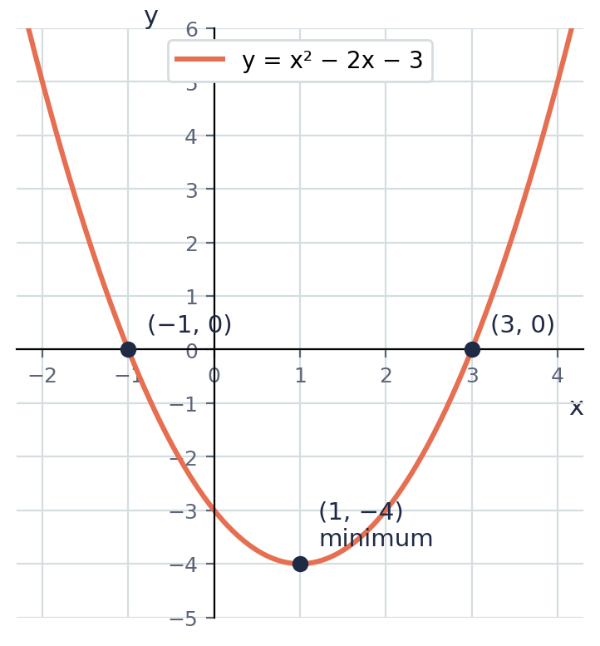

Example 5.2 · Checking against the graph
The graph shows y = x² − 2x − 3. Use it to confirm the solutions to x² − 2x − 3 = 0 from the previous example.
Solution
1. The solutions of x² − 2x − 3 = 0 are the x-values where the curve crosses the x-axis (where y = 0).
2. The graph crosses the x-axis at x = −1 and x = 3, matching the algebraic answer.
3. The turning point (1, −4) is below the x-axis, which is why the curve crosses twice.
Answer: Confirmed

Example 5.3 · Checking against factorizing (Unit 5)
Solve x² − 2x − 3 = 0 by factorizing, and compare with the completing-the-square answer.
Solution
1. x² − 2x − 3 = (x − 3)(x + 1).
2. (x − 3)(x + 1) = 0 gives x = 3 or x = −1.
3. This matches the answer from completing the square exactly.
Answer: x = 3 or x = −1 (same answer, different method)
💭 Think: Completing the square and factorizing gave the same answer here because this equation happens to factorize neatly. When would you need completing the square instead of factorizing?

Example 5.4 · An equation that does not factorize neatly
Solve x² + 4x − 2 = 0 by completing the square, giving your answers to 2 decimal places.
Solution
1. Complete the square: h = 2, h² = 4, k = −2 − 4 = −6. So (x + 2)² − 6 = 0.
2. (x + 2)² = 6.
3. x + 2 = ±√6 ≈ ±2.449.
4. x ≈ −2 + 2.449 = 0.45, or x ≈ −2 − 2.449 = −4.45.
Answer: x ≈ 0.45 or x ≈ −4.45
💭 Think: Try to factorize x² + 4x − 2 using whole numbers. Why does it not work? This is exactly when completing the square is essential.

Example 5.5 · No real solution
Solve x² + 4x + 9 = 0 by completing the square. What happens?
Solution
1. Complete the square: h = 2, h² = 4, k = 9 − 4 = 5. So (x + 2)² + 5 = 0.
2. (x + 2)² = −5.
3. There is no real number whose square is negative, so there is no real solution.
Answer: No real solution
💭 Think: Look back at Lesson 4: the minimum value of x² + 4x + 9 is 5, which is positive. What does that tell you about whether the graph ever crosses the x-axis?

Example 5.6 · When a is not 1
Solve 2x² − 8x − 10 = 0 by completing the square.
Solution
1. Complete the square: h = −8 ÷ 4 = −2, k = −10 − 2 × 4 = −18. So 2(x − 2)² − 18 = 0.
2. Add 18, then divide by 2: (x − 2)² = 9.
3. Square root both sides: x − 2 = ±3.
4. So x = 5 or x = −1.
5. Check: 2(25) − 40 − 10 = 0 ✓ and 2(1) + 8 − 10 = 0 ✓
Answer: x = 5 or x = −1

Example 5.7 · When a is not 1 and the answers are not whole numbers
Solve 3x² + 12x + 5 = 0 by completing the square, giving your answers to 2 decimal places.
Solution
1. Complete the square: h = 12 ÷ 6 = 2, k = 5 − 3 × 4 = −7. So 3(x + 2)² − 7 = 0.
2. Add 7, then divide by 3: (x + 2)² = 7/3.
3. x + 2 = ±√(7/3) ≈ ±1.528.
4. x ≈ −2 + 1.528 = −0.47, or x ≈ −2 − 1.528 = −3.53.
Answer: x ≈ −0.47 or x ≈ −3.53
💭 Think: Check one answer by substituting it into 3x² + 12x + 5. Do you get a number very close to 0? Why might it not be exactly 0?

⚠ Common mistakes
- Forgetting the ± sign, and giving only one solution instead of two.
- Forgetting to divide by a after moving k across: from 3(x + 2)² = 7, the next step is (x + 2)² = 7/3, not 7.
- Trying to take the square root of a negative number without recognising there is no real solution.

④ Practice
Write your answers in your exercise book. Start at Level 1. If you get most of a level right, move on to the next one. The answers are at the back of the pack.

Level 1 · Foundation
1. Solve by taking square roots.
(a) (x − 2)² = 9
(b) (x + 1)² = 16
(c) (x − 5)² = 1
2. Solve x² + 2x + 1 = 0 by completing the square.
3. Solve x² − 6x + 5 = 0 by completing the square, then check by factorizing.

Level 2 · Developing
4. Solve each equation by completing the square.
(a) x² + 6x + 5 = 0
(b) x² − 4x − 12 = 0
(c) x² + 8x + 7 = 0
5. Solve x² − 2x − 5 = 0 by completing the square, giving your answers to 2 decimal places.
6. Solve x² + 4x − 1 = 0 by completing the square, giving exact answers involving a square root.
7. Show that x² + 2x + 5 = 0 has no real solution, using completing the square.
8. Solve each equation by completing the square.
(a) 2x² + 8x − 10 = 0
(b) 3x² − 6x − 9 = 0

Level 3 · Think Deeper
9. Spot the error. Solving (x + 3)² = 25, Tariq wrote x + 3 = 5, so x = 2, and stopped. What did he miss? Give the full solution.
10. Explain. In a(x + h)² + k = 0, how can you tell from a and k, before doing any more work, whether the equation has a real solution?
11. Connect to Lesson 4. For y = x² + 4x + 9, you found in Lesson 4 that the minimum value is 5, which is positive. Without completing the square again, explain what this tells you about the solutions of x² + 4x + 9 = 0.
12. Create. Write a quadratic equation x² + bx + c = 0 that has no real solution, and one that has two real solutions. Justify each using the minimum value from Lesson 4.
13. Challenge. Solve 2x² + 4x − 3 = 0 by completing the square. Give your answers exactly, and then to 2 decimal places.

Before you move on, say or write in one or two sentences: "I can explain why a quadratic equation sometimes has no real solution, using the idea of a minimum value."
How confident do I feel? ☐ Not yet ☐ Getting there ☐ Got it!

CSEC-Style Exam Practice
These questions are like the ones on CSEC Paper 2, and they use all five lessons. Try them under test conditions: no notes, and about 30 minutes. Show all your working.
1. Write each expression in completed-square form.
(a) x² + 10x + 3, in the form (x + h)² + k [2 marks]
(b) 2x² + 12x + 5, in the form a(x + h)² + k [3 marks]
2. y = x² − 8x + 19.
(a) Write y in completed-square form. [2 marks]
(b) State the minimum value of y and the value of x at which it occurs. [2 marks]
(c) State the equation of the axis of symmetry. [1 mark]
3. Solve x² + 6x − 7 = 0 by completing the square. Show all your working. [4 marks]
4. Solve 2x² − 4x − 3 = 0 by completing the square, giving your answers to 2 decimal places. [5 marks]
5. A ball is thrown upward. Its height, h metres, after t seconds is h = −t² + 6t + 1. The graph is shown.
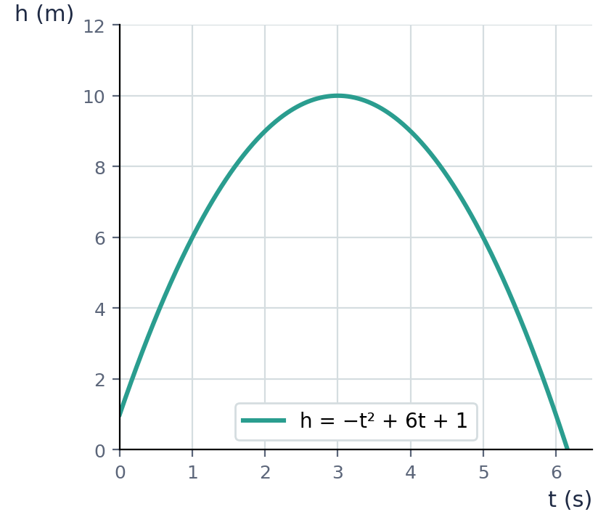
(a) Write h in the form a(t + p)² + q. [3 marks]
(b) Hence state the maximum height reached by the ball and the time at which it occurs. [2 marks]

Self-Check Quiz: Am I Ready?
Answer all 12 questions without looking back at the lessons. Then check your answers and write your score in the box. The lesson number after each question tells you where to go back if you get it wrong.
1. What must be added to x² + 8x to complete the square? (Lesson 1)
A 64 B 16 C 4 D 8
2. x² + 6x + 9 in factorized form is… (Lesson 1)
A (x + 3)(x − 3) B (x + 6)(x + 3) C (x + 9)² D (x + 3)²
3. The completed-square form of x² + 4x + 9 is… (Lesson 2)
A (x + 2)² + 5 B (x + 4)² + 9 C (x + 2)² + 9 D (x + 2)² − 5
4. For x² − 6x + 1, the value of h in (x + h)² is… (Lesson 2)
A −6 B 3 C −3 D 6
5. The completed-square form of 2x² + 12x + 5 is… (Lesson 3)
A 2(x + 3)² − 4 B 2(x + 6)² − 31 C 2(x + 3)² − 13 D (x + 3)² − 13
6. For 3x² − 12x + 7, the value of h in a(x + h)² + k is… (Lesson 3)
A −2 B −4 C −6 D 2
7. y = (x + 4)² − 3. The minimum value of y is… (Lesson 4)
A 4 B −4 C 3 D −3
8. The turning point of y = 2(x − 5)² + 1 is… (Lesson 4)
A (5, −1) B (5, 1) C (2, 1) D (−5, 1)
9. y = −(x − 1)² + 6 has… (Lesson 4)
A a maximum value of 6 B a maximum value of 1 C a minimum value of −6 D a minimum value of 6
10. To solve (x − 2)² = 25, the next correct step is… (Lesson 5)
A x = 25 + 2 B x − 2 = 5 C x − 2 = ±5 D x² = 27
11. Solving x² + 2x − 8 = 0 by completing the square gives (x + 1)² = 9, so x =… (Lesson 5)
A 3 or −1 B 2 or −4 C 9 or −9 D 8 or −8
12. For (x + 2)² + 7 = 0, we get (x + 2)² = −7. What does this mean? (Lesson 5)
A x = −2 B x = 7 C x = ±7 D there is no real solution

My score | What it means
11–12 | Ready! You are ready for the next topic: Form 4 Mathematics.
8–10 | Nearly there. Look at the lesson number next to each question you missed. Redo the Level 2 practice for those lessons.
0–7 | Go back over the lessons for the questions you missed. Redo the Level 1 and Level 2 practice, watch the videos again, then retake this quiz.
My score: ______ / 12

Answers
Use these to check your work. If your answer is different, look for your mistake before you ask for help. Your teacher has the full worked solutions.

Warm-Up
1. x² + 10x + 25
2. x² − 8x + 16
3. 2x² + 12x + 18
4. (x + 4)²
5. 2x(x + 6)
6. 5, then 25
7. x = 7 or x = −7

Lesson 1: What Completing the Square Means
Level 1 · Foundation
1. (a) 4, 16 (b) 6, 36 (c) 10, 100 (d) 3.5, 12.25
2. (a) 4 (b) 49 (c) 1
3. (x + 2)²
Level 2 · Developing
4. Side 4, area 16; completes (x + 4)²
5. (a) 64, (x + 8)² (b) 20.25, (x + 4.5)² (c) 2.25, (x + 1.5)²
6. Confirmed
7. 100
Level 3 · Think Deeper
8. She squared b instead of half of b. The correct value is (10/2)² = 25.
9. The gnomon is made of two rectangles, each of width b/2 (since together they use up the full b). The missing corner square has this same side length, b/2, so its area is (b/2)², not b² or b/2.
10. Sometimes. x² + 6x + 9 is a perfect square, (x + 3)², because 9 = (6/2)². x² + 6x + 11 is not, because 11 ≠ 9.
11. e.g. x² + 18x needs + 81 added, giving (x + 9)².

Lesson 2: Completing the Square for x² + bx + c
Level 1 · Foundation
1. (a) (x + 1)² + 4 (b) (x + 2)² − 3 (c) (x + 5)² − 22
2. (x − 2)² + 3
3. Confirmed
Level 2 · Developing
4. (a) (x + 3)² − 10 (b) (x − 5)² + 5 (c) (x + 4)² + 4 (d) (x − 1)² − 6
5. (x + 3.5)² − 10.25
6. (x − 1.5)² − 2.25
7. Confirmed
Level 3 · Think Deeper
8. He used h = 8 instead of h = −4 (half of −8, not 8), so the bracket sign is wrong. Correct: (x − 4)² − 11.
9. Writing (x + h)² already introduces an extra h² compared with x² + bx alone, so h² must be subtracted before adding the original constant c, giving k = c − h².
10. (x + b/2)² = x² + bx + b²/4, so (x + b/2)² + c − b²/4 = x² + bx + c. So h = b/2 and k = c − b²/4.
11. e.g. x² − 6x + 2 → (x − 3)² − 7

Lesson 3: Completing the Square for ax² + bx + c
Level 1 · Foundation
1. (a) 2(x² + 4x) + 3 (b) 3(x² + 6x) + 5 (c) 5(x² − 2x) + 1
2. (a) 2(x + 2)² − 5 (b) 3(x + 1)² + 2 (c) 4(x + 1)² − 5
3. Confirmed
Level 2 · Developing
4. (a) 2(x − 3)² − 11 (b) 3(x + 2)² + 8 (c) 5(x − 2)² − 17 (d) 2(x + 2.5)² − 11.5
5. 4(x + 1)² + 5
6. 3(x − 1)² − 5
7. −(x − 2)² + 7
Level 3 · Think Deeper
8. He subtracted 9 instead of 2 × 9 = 18. The correct answer is 2(x + 3)² − 13.
9. Expanding a(x + h)² gives ax² + 2ahx + ah², so the extra amount is ah². That must be subtracted so that the expression still equals ax² + bx + c.
10. a(x + h)² + k = ax² + 2ahx + (ah² + k). So a = 3, 2ah = 18 gives h = 3, and ah² + k = 5 gives k = −22. Answer: 3(x + 3)² − 22.
11. e.g. 2x² − 8x + 11 → 2(x − 2)² + 3

Lesson 4: Using a(x + h)² + k to Find the Turning Point
Level 1 · Foundation
1. (a) min 6 at x = −2 (b) min 1 at x = 5 (c) min −3 at x = −1
2. Turning point (4, 7); axis of symmetry x = 4
3. (a) minimum 1 at x = 2 (b) maximum 7 at x = −1 (c) maximum −3 at x = 4
Level 2 · Developing
4. (a) (x + 4)² + 4; min 4 at (−4, 4) (b) (x − 2)² − 5; min −5 at (2, −5) (c) (x + 1)² + 7; min 7 at (−1, 7)
5. Minimum value 4; axis of symmetry x = 6
6. Minimum P = −25 at x = 10; a negative minimum means the model predicts a loss of $25 at that number of items.
7. A = −(x − 10)² + 100. Maximum area 100 m², when x = 10 m
8. y = 3(x + 2)² − 5; minimum at (−2, −5)
Level 3 · Think Deeper
9. She used the same sign as in the bracket. The bracket is zero when x = −5, so the turning point is (−5, −2).
10. (x + h)² is never negative, so when a is negative, a(x + h)² is never positive. The most it can be is 0, so y ≤ k, and the largest value of y is k, at x = −h.
11. Sometimes. y = x² + 6x + 9 = (x + 3)² has minimum value 0, which is not negative. y = x² + 6x + 2 = (x + 3)² − 7 has minimum value −7, which is negative.
12. Minimum value is always −(b/2)², which is 0 or negative for every b. For b = 6: −9. For b = 10: −25.

Lesson 5: Solving Quadratic Equations by Completing the Square
Level 1 · Foundation
1. (a) x = 5 or x = −1 (b) x = 3 or x = −5 (c) x = 6 or x = 4
2. x = −1 (a repeated solution)
3. x = 5 or x = 1
Level 2 · Developing
4. (a) x = −1 or x = −5 (b) x = 6 or x = −2 (c) x = −1 or x = −7
5. x ≈ 3.45 or x ≈ −1.45
6. x = −2 + √5 or x = −2 − √5
7. No real solution
8. (a) x = 1 or x = −5 (b) x = 3 or x = −1
Level 3 · Think Deeper
9. He forgot the negative square root. x + 3 = ±5, so x = 2 or x = −8.
10. Rearranging gives (x + h)² = −k ÷ a. A square cannot be negative, so a real solution exists only when −k ÷ a ≥ 0, that is, when a and k have opposite signs (or k = 0).
11. Since the minimum value of y is 5 (always positive), y = x² + 4x + 9 is never equal to 0, so the equation x² + 4x + 9 = 0 has no real solution.
12. e.g. No real solution: x² + 2x + 10 = 0 (minimum value 9, positive). Two real solutions: x² + 2x − 10 = 0 (minimum value −11, negative).
13. x = −1 ± √(5/2); x ≈ 0.58 or x ≈ −2.58

CSEC-Style Exam Practice
1. (a) (x + 5)² − 22 (b) 2(x + 3)² − 13
2. (a) (x − 4)² + 3 (b) minimum 3 at x = 4 (c) x = 4
3. x = 1 or x = −7
4. x ≈ 2.58 or x ≈ −0.58
5. (a) h = −(t − 3)² + 10 (b) Maximum height 10 m at t = 3 s

Self-Check Quiz
Q | Answer | Why
1 | B | Half of 8 is 4, and 4² = 16.
2 | D | Half of 6 is 3, and 3² = 9 matches the constant term.
3 | A | h = 2, h² = 4, k = 9 − 4 = 5.
4 | C | h = half of b = half of −6 = −3.
5 | C | 2(x + 3)² = 2x² + 12x + 18, so subtract 13 to get back to +5.
6 | A | h = b ÷ 2a = −12 ÷ 6 = −2.
7 | D | The bracket is smallest (zero) when x = −4, leaving y = −3.
8 | B | The bracket is zero when x = 5, giving the point (5, 1).
9 | A | a is negative, so the turning point is a maximum. The maximum value is k = 6.
10 | C | Taking the square root of both sides gives two possible values, +5 and −5.
11 | B | x + 1 = ±3, so x = 2 or x = −4.
12 | D | No real number squares to a negative number.

