Clare Hall Secondary School · Mathematics Department

FORM 3 MATHEMATICS · UNIT 9
Algebraic Fractions
Self-Paced Learning Pack
Name: ______________________________________ Class: ___________
Time in class: 2 weeks School year: 2026–2027 Next topic: Revision for the Form 3 examinations

What's inside
Section | What you will do
Before You Start | Warm up with the number facts you need
Lesson 1 | Simplifying Algebraic Fractions
Lesson 2 | Adding, Subtracting, Multiplying and Dividing Algebraic Fractions
Lesson 3 | Fractional Equations with Numbers in the Denominator
Lesson 4 | Fractional Inequalities with Numbers in the Denominator
Lesson 5 | Fractional Equations with x in the Denominator
Lesson 6 | Fractional Equations with Squares and Factorised Denominators
Lesson 7 | Fractional Inequalities with x in the Denominator
Exam Practice | CSEC-style questions that use all seven lessons
Self-Check Quiz | 15 questions that show whether you are ready to move on
Answers | Check your work (at the back of the pack)

How to Use This Pack
- This pack lets you learn at your own pace. You can work ahead of the class or go back over anything you missed.
- Work through the lessons in order. Each lesson builds on the one before it.
- For each lesson: Read the key ideas → Watch the videos → Study the worked examples → Practise.
- Before you read the solution to a worked example, cover it and try the example yourself first. Then check each step.
- Practice has three levels. Level 1 (Foundation) checks the basics. Level 2 (Developing) makes you apply them. Level 3 (Think Deeper) asks you to explain, find mistakes and create your own examples.
- Check your answers at the back of the pack. If you get an answer wrong, find your mistake before you move on. A mistake you understand teaches you more than a correct guess.
- When you finish all the lessons, try the CSEC-Style Exam Practice, then the Self-Check Quiz. Your quiz score tells you whether you are ready for the next topic.

The learning route for every lesson
① Read the key ideas → ② Watch the videos → ③ Try the worked examples, then check each step → ④ Practise Level 1 → 2 → 3 → ⑤ Check your answers → ⑥ Tick your checklist

My Progress Checklist
Tick one box for each statement before you start and again after you finish. Be honest. This checklist is for you.
I can… | Not yet | Getting there | Got it!
Simplify algebraic fractions by factorising and cancelling common factors (Lesson 1) | ☐ | ☐ | ☐
Add, subtract, multiply and divide algebraic fractions (Lesson 2) | ☐ | ☐ | ☐
Solve fractional equations with numbers in the denominators, including fractions on both sides (Lesson 3) | ☐ | ☐ | ☐
Solve fractional inequalities with numbers in the denominators, and show the answers on a number line (Lesson 4) | ☐ | ☐ | ☐
Solve equations with x in the denominator, and reject answers that make a denominator zero (Lesson 5) | ☐ | ☐ | ☐
Solve equations with squares and factorised quadratics in the denominators (Lesson 6) | ☐ | ☐ | ☐
Solve inequalities with x in the denominator using critical values and a sign table (Lesson 7) | ☐ | ☐ | ☐

Key Words
Symbol | Meaning | Example
algebraic fraction | a fraction with algebra in the numerator, the denominator, or both | (x + 1)/(x − 2)
numerator / denominator | the top / the bottom of a fraction | in (x + 1)/(x − 2), the denominator is x − 2
factor | an expression that divides exactly into another | x + 3 is a factor of x² − 9
cancel | divide the top and bottom by the same common FACTOR | (x + 3)(x − 3)/(x + 3) = x − 3
LCD | lowest common denominator: the smallest expression that every denominator divides into | for 1/x and 1/(x + 1) the LCD is x(x + 1)
restriction | a value of x that makes a denominator zero, so it is not allowed | for 5/(x − 3), x ≠ 3
extraneous solution | an answer from the working that makes a denominator zero, so it must be rejected | x = 2 for x/(x − 2) = 2/(x − 2)
critical value | a value where the numerator or the denominator is zero. The sign of the fraction can change there | for (x + 1)/(x − 2): −1 and 2

Before You Start: Warm-Up
This unit uses factorising (Unit 5), solving equations (Unit 2) and inequalities (Unit 3). Check you still have these skills.
1. Factorise x² − 9.
2. Factorise x² + 5x + 6.
3. Simplify 12/18.
4. Find 1/2 + 1/3 as a single fraction.
5. Find the lowest common multiple (LCM) of 4 and 6.
6. Solve 3x − 4 = 5.
7. Solve 5 − 2x > 1.
8. Expand 3(x − 2) − 2(x + 1).

Lesson 1: Simplifying Algebraic Fractions
Building on: Unit 5: Factorization (common factors, difference of two squares, trinomials). Simplifying numerical fractions.
Goal: By the end of this lesson I can simplify an algebraic fraction by factorising the top and the bottom and cancelling common factors, and I know which cancellations are NOT allowed.

① Key Ideas
- An algebraic fraction has algebra in the top (numerator), the bottom (denominator), or both. We write (x + 1)/(x − 2) for ‘x + 1 divided by x − 2’. Put brackets round the top and bottom when they have more than one term.
- It works exactly like a numerical fraction: 12/18 = (2 × 6)/(3 × 6) = 2/3. We divide the top and bottom by the same common factor. This is called cancelling.
- Step 1: Factorise the numerator and the denominator completely. Use a common factor, the difference of two squares, or a trinomial from Unit 5. Step 2: Cancel every factor that appears on both the top and the bottom. Step 3: write what is left.
- You can only cancel factors (things multiplied together). You can never cancel terms (things added or subtracted). So (x + 4)/4 does NOT simplify to x + 1, because x + 4 cannot be written as a product with 4 as a factor.
- Opposite factors: (x − 3) and (3 − x) are opposites, because 3 − x = −(x − 3). So (x − 3)/(3 − x) = −1.
- A denominator can never be zero. The simplified fraction is equal to the original only for values of x that keep the original denominator from being zero. For (x² − 9)/(x − 3), we need x ≠ 3.
- Check by substitution. Pick a number for x (not one that makes a denominator zero). The original fraction and your simplified answer must give the same value.

② Watch
Watch these videos after you have read the key ideas. Pause the video and try each example before it is solved. Online, click the link. On paper, type the short address into YouTube.
Video | What it covers | Link
Simplifying Algebraic Fractions - GCSE Further Maths - Corbettmaths  Corbettmaths | Factorising and cancelling to simplify algebraic fractions | Watch on YouTube  youtu.be/yGi4P03RcJY

③ Worked Examples
Cover the solution and try the example first. Then uncover one step at a time and compare it with your own working.
Example 1.1 · Cancelling numbers and letters
Simplify (a) 12x/(18x²) (b) (6x + 12)/9
Solution
1. (a) 12x/(18x²): divide top and bottom by 6 to get 2x/(3x²). Then divide by x to get 2/(3x).
2. (b) Factorise the top: 6x + 12 = 6(x + 2). The fraction is 6(x + 2)/9.
3. Divide the top and bottom by 3: 2(x + 2)/3.
Answer: (a) 2/(3x) (b) 2(x + 2)/3
💭 Think: Why can you not cancel the 2 in 2(x + 2)/3 with the 3?

Example 1.2 · Taking out a common factor
Simplify (x² + 5x)/x².
Solution
1. Factorise the top: x² + 5x = x(x + 5).
2. The fraction is x(x + 5)/x². Write x² as x × x.
3. Cancel one x from the top and the bottom.
Answer: (x + 5)/x
💭 Think: Check with x = 2. Does (4 + 10)/4 equal (2 + 5)/2?

Example 1.3 · Difference of two squares
Simplify (x² − 9)/(x + 3).
Solution
1. Factorise the top: x² − 9 = (x − 3)(x + 3).
2. The fraction is (x − 3)(x + 3)/(x + 3).
3. Cancel the factor (x + 3).
Answer: x − 3 (for x ≠ −3)

Example 1.4 · Trinomials on top and bottom
Simplify (x² + 5x + 6)/(x² − 4).
Solution
1. Top: x² + 5x + 6 = (x + 2)(x + 3).
2. Bottom: x² − 4 = (x − 2)(x + 2).
3. The fraction is (x + 2)(x + 3)/((x − 2)(x + 2)). Cancel (x + 2).
Answer: (x + 3)/(x − 2)

Example 1.5 · A common factor first
Simplify (2x² − 8)/(x² + x − 6).
Solution
1. Top: take out 2 first: 2x² − 8 = 2(x² − 4) = 2(x − 2)(x + 2).
2. Bottom: x² + x − 6 = (x + 3)(x − 2).
3. Cancel (x − 2).
Answer: 2(x + 2)/(x + 3)

Example 1.6 · Opposite factors
Simplify (a) (x − 5)/(5 − x) (b) (2x − 6)/(3 − x)
Solution
1. (a) 5 − x = −(x − 5). So (x − 5)/(5 − x) = (x − 5)/(−(x − 5)) = −1.
2. (b) Top: 2x − 6 = 2(x − 3). Bottom: 3 − x = −(x − 3). So the fraction is 2(x − 3)/(−(x − 3)) = −2.
Answer: (a) −1 (b) −2

Example 1.7 · What you cannot do
A student says (x + 4)/4 = x + 1. Show that this is wrong.
Solution
1. Test with x = 4. Left side: (4 + 4)/4 = 2.
2. Right side: 4 + 1 = 5.
3. 2 ≠ 5, so the statement is false. The 4 in the top is added to x, so it is a term, not a factor. The correct simplification is not possible, but x/4 + 1 is a correct way to split the fraction.
Answer: False: the 4 on top is a term, not a factor

⚠ Common mistakes
- Cancelling terms instead of factors: (x + 4)/4 = x + 1 is wrong. Cancel only things that are multiplied.
- Cancelling before factorising, so that a common factor stays hidden in the top or bottom.
- Forgetting the opposite-factor rule: (x − 3)/(3 − x) = −1, not 1.
- Cancelling x² with x as ‘x² ÷ x = 1’. It is x² ÷ x = x.

④ Practice
Write your answers in your exercise book. Start at Level 1. If you get most of a level right, move on to the next one. The answers are at the back of the pack.

Level 1 · Foundation
1. Simplify.
(a) 8a/12
(b) 15x²/(5x)
(c) 4xy/(6y)
(d) 10a²b/(15ab²)
2. Factorise the top, then simplify.
(a) (3x + 6)/3
(b) (4x − 8)/(x − 2)
(c) (5x + 10)/10
(d) (x² + 3x)/x
3. True or false?
(a) (x + 2)/2 = x + 1
(b) 3x/3 = x
(c) x²/x = x
(d) (x + 3)/(x + 4) = 3/4
4. Factorise the top and the bottom, then simplify.
(a) (2x + 4)/(x + 2)
(b) (x² − x)/(x − 1)
(c) (6x − 12)/(4x − 8)
(d) (x² + 2x)/x²

Level 2 · Developing
5. Use the difference of two squares to simplify.
(a) (x² − 9)/(x − 3)
(b) (x² − 16)/(x + 4)
(c) (x² − 25)/(2x + 10)
(d) (4x² − 1)/(2x + 1)
6. Factorise trinomials to simplify.
(a) (x² + 5x + 6)/(x + 2)
(b) (x² − 5x + 6)/(x − 3)
(c) (x² + 7x + 10)/(x² − 25)
(d) (x² − x − 12)/(x² − 9)
7. Use opposite factors to simplify.
(a) (x − 4)/(4 − x)
(b) (2x − 6)/(3 − x)
(c) (x² − 1)/(1 − x)
8. A student simplifies (2x + 6)/2 and writes x + 6. Find the error and write the correct answer.
9. A rectangle has area x² + 5x + 6 and width x + 2. Find its length as an expression in x.

Level 3 · Think Deeper
10. Spot the error. Sam simplifies (x² − 9)/(x² − 3) by cancelling x² to get (−9)/(−3) = 3. What is wrong? Test Sam’s answer with x = 4.
11. Explain. (x² − 9)/(x − 3) simplifies to x + 3. Why are they not equal when x = 3?
12. Always, sometimes or never? (x + 2)/(x + 3) = 2/3. Find any value of x that makes it true.
13. Create. Write a fraction with a quadratic on the top and a quadratic on the bottom that simplifies to (x + 1)/(x − 2).
14. Investigate. Simplify (x² − 4)/(x − 2), (x² − 9)/(x − 3) and (x² − 25)/(x − 5). What pattern do you see? Write the pattern for (x² − a²)/(x − a). Challenge: simplify (x³ − 1)/(x − 1), given that x³ − 1 = (x − 1)(x² + x + 1).

Before you move on, say or write in one or two sentences: "I can explain why I can cancel a factor but not a term."
How confident do I feel? ☐ Not yet ☐ Getting there ☐ Got it!

Lesson 2: Adding, Subtracting, Multiplying and Dividing Algebraic Fractions
Building on: Lesson 1, and the rules for adding and multiplying numerical fractions.
Goal: By the end of this lesson I can write a sum or difference of algebraic fractions as one fraction, and multiply and divide algebraic fractions, simplifying the answer.

① Key Ideas
- Adding and subtracting: first write every fraction over a common denominator, then add or subtract the numerators and keep the denominator. Use the lowest common denominator (LCD): the smallest expression that every denominator divides into.
- With numbers in the denominator, find the LCM: x/2 + x/3 = 3x/6 + 2x/6 = 5x/6.
- With letters in the denominator, the LCD includes every different factor: the LCD of 1/x and 1/(x + 1) is x(x + 1). For 3/x and 5/(2x) it is 2x.
- When you subtract, put brackets round the whole top of the fraction being subtracted. The minus sign changes every term inside: (x + 1)/2 − (x − 1)/3 = (3(x + 1) − 2(x − 1))/6.
- Multiplying: multiply the tops and multiply the bottoms. It is easier to factorise and cancel first, before you multiply out.
- Dividing: keep the first fraction, change ÷ to ×, and flip the second fraction. a/b ÷ c/d = a/b × d/c.
- Always simplify your final answer (Lesson 1), and leave it as a single fraction with the denominator factorised.

② Watch
Watch these videos after you have read the key ideas. Pause the video and try each example before it is solved. Online, click the link. On paper, type the short address into YouTube.
Video | What it covers | Link
Adding Algebraic Fractions  corbettmaths | Using a common denominator to add algebraic fractions | Watch on YouTube  youtu.be/w3JewxYjiNs
Adding and Subtracting Algebraic Fractions - Part 1 - GCSE Further Maths - Corbettmaths  Corbettmaths | Adding and subtracting algebraic fractions step by step | Watch on YouTube  youtu.be/qjZeN1iUct0

③ Worked Examples
Cover the solution and try the example first. Then uncover one step at a time and compare it with your own working.
Example 2.1 · Numbers in the denominators
Write x/2 + x/3 as a single fraction.
Solution
1. The LCM of 2 and 3 is 6.
2. x/2 = 3x/6 and x/3 = 2x/6.
3. Add the tops: 3x + 2x = 5x.
Answer: 5x/6

Example 2.2 · Subtracting with brackets
Write (x + 1)/2 − (x − 1)/3 as a single fraction.
Solution
1. The LCD is 6. Multiply the first top by 3 and the second top by 2.
2. (3(x + 1) − 2(x − 1))/6.
3. Expand carefully: 3x + 3 − 2x + 2 = x + 5.
Answer: (x + 5)/6
💭 Think: Check with x = 1: the left side is 1 − 0 = 1. Does (1 + 5)/6 = 1?

Example 2.3 · A letter in the denominator
Write 3/x + 5/(2x) as a single fraction.
Solution
1. The LCD is 2x.
2. 3/x = 6/(2x).
3. Add: 6/(2x) + 5/(2x) = 11/(2x).
Answer: 11/(2x)

Example 2.4 · Two different brackets
Write 2/(x + 1) + 3/(x − 2) as a single fraction.
Solution
1. The LCD is (x + 1)(x − 2).
2. 2/(x + 1) = 2(x − 2)/((x + 1)(x − 2)) and 3/(x − 2) = 3(x + 1)/((x + 1)(x − 2)).
3. Add the tops: 2(x − 2) + 3(x + 1) = 2x − 4 + 3x + 3 = 5x − 1.
Answer: (5x − 1)/((x + 1)(x − 2))

Example 2.5 · Subtracting, with a difference of two squares
Write 1/(x − 1) − 1/(x + 1) as a single fraction.
Solution
1. The LCD is (x − 1)(x + 1).
2. The top is (x + 1) − (x − 1) = x + 1 − x + 1 = 2.
3. (x − 1)(x + 1) = x² − 1.
Answer: 2/(x² − 1)

Example 2.6 · Multiplying
Simplify (2x/(x − 3)) × ((x² − 9)/(4x)).
Solution
1. Factorise: x² − 9 = (x − 3)(x + 3).
2. The product is 2x(x − 3)(x + 3)/((x − 3) × 4x).
3. Cancel 2x/4x to 1/2 and cancel (x − 3).
Answer: (x + 3)/2

Example 2.7 · Dividing
Simplify (x/(x + 1)) ÷ (x²/(x² − 1)).
Solution
1. Change ÷ to × and flip: x/(x + 1) × (x² − 1)/x².
2. Factorise: x² − 1 = (x − 1)(x + 1).
3. Cancel x and (x + 1): (x − 1)/x.
Answer: (x − 1)/x

⚠ Common mistakes
- Adding the numerators and the denominators: 1/x + 1/y is NOT 2/(x + y).
- Forgetting brackets when subtracting, so only the first term of the top changes sign.
- Adding fractions with different denominators without a common denominator first.
- Flipping the wrong fraction when dividing. Only the second fraction is flipped.

④ Practice
Write your answers in your exercise book. Start at Level 1. If you get most of a level right, move on to the next one. The answers are at the back of the pack.

Level 1 · Foundation
1. Write as a single fraction.
(a) x/5 + 2x/5
(b) x/2 + x/4
(c) x/3 − x/6
(d) 2x/3 + x/2
2. Write as a single fraction in its simplest form.
(a) (x + 1)/2 + (x + 3)/2
(b) (2x − 1)/3 − (x − 4)/3
(c) (x + 2)/4 + (x − 2)/2
(d) (x − 1)/3 − (x + 2)/6
3. Write as a single fraction.
(a) 4/x + 3/x
(b) 2/x + 1/(2x)
(c) 5/(3x) − 1/(6x)
(d) 1/a + 1/b
4. Simplify.
(a) (2/x) × (x²/6)
(b) (3x/4) × (8/(9x))
(c) (5/x) ÷ (10/x²)
(d) (x/3) ÷ (2x/9)

Level 2 · Developing
5. Write as a single fraction.
(a) 1/(x + 1) + 1/(x + 2)
(b) 2/(x − 1) + 3/(x + 1)
(c) 3/(x + 2) − 1/(x − 1)
(d) 4/(x − 3) − 4/(x + 3)
6. Write as a single fraction in its simplest form.
(a) x/(x + 2) + 2/(x + 2)
(b) 1/x + 1/(x + 1)
(c) 2/x − 3/(x + 2)
7. Multiply or divide, then simplify.
(a) ((x + 2)/(x − 1)) × ((x − 1)/(x + 3))
(b) ((x² − 4)/x) × (x/(x + 2))
(c) ((x² − 1)/(x² + 2x)) × (x/(x + 1))
(d) ((x + 1)/(x − 2)) ÷ ((x + 1)/(x + 2))
8. A car travels 60 km at x km/h and then 40 km at (x + 10) km/h. Write the total time, in hours, as a single fraction.
9. Write (x + 1)/2 − (2x − 1)/3 + 1 as a single fraction.

Level 3 · Think Deeper
10. Spot the error. Kim writes 1/x + 1/y = 2/(x + y). Test with x = 1 and y = 1, then write the correct answer.
11. Spot the error. Lee writes (x + 1)/2 − (x − 1)/3 = (3x + 3 − 2x − 1)/6 = (x + 2)/6. Find the mistake and give the correct answer.
12. Explain and use. (a) Show that 1/x − 1/(x + 1) = 1/(x(x + 1)). (b) Use this to find 1/(1 × 2) + 1/(2 × 3) + 1/(3 × 4) without a calculator.
13. Create. Write two different pairs of fractions, with different denominators, that add up to 5x/6.
14. Investigate. Show that 1/(x − 1) + 1/(1 − x) = 0. What does this tell you about 1/(x − 1) and 1/(1 − x)? Then find 1/(x − 2) + 3/(2 − x) as a single fraction.

Before you move on, say or write in one or two sentences: "I can explain why 1/x + 1/y is not 2/(x + y)."
How confident do I feel? ☐ Not yet ☐ Getting there ☐ Got it!

Lesson 3: Fractional Equations with Numbers in the Denominator
Building on: Lesson 2, and solving equations from Unit 2 (brackets, unknowns on both sides).
Goal: By the end of this lesson I can solve an equation that has a fraction on each side, and an equation with several fractions on one or both sides, by clearing the denominators.

① Key Ideas
- Solve a fractional equation by getting rid of the fractions first. Multiply every term on both sides by the LCM of all the denominators.
- One fraction on each side: you can cross-multiply: if a/b = c/d, then a × d = b × c. (This is the same as multiplying both sides by b × d.)
- Several fractions: find the LCM of all the denominators (for 2, 3 and 4 it is 12). Multiply every term by it. Each fraction then becomes a whole expression.
- Use brackets when you clear a fraction with more than one term on top: (x + 1)/2 × 6 = 3(x + 1). Expand the brackets carefully before you collect terms.
- Remember to multiply the terms that have no fraction too: in (x + 1)/2 + (x − 1)/3 = 5, the 5 becomes 5 × 6 = 30.
- After clearing, solve the equation as in Unit 2. Then check by substituting your answer into the original equation.
- In a word problem, define x, write the equation, solve it, and answer in words.

② Watch
Watch these videos after you have read the key ideas. Pause the video and try each example before it is solved. Online, click the link. On paper, type the short address into YouTube.
Video | What it covers | Link
Equations Cross Multiplying - Corbettmaths  Corbettmaths | Cross-multiplying when there is one fraction on each side | Watch on YouTube  youtu.be/YcnDMu1o08I
Equations involving algebraic fractions - Corbettmaths  Corbettmaths | Clearing fractions in equations | Watch on YouTube  youtu.be/kaIqgpKV4Cc

③ Worked Examples
Cover the solution and try the example first. Then uncover one step at a time and compare it with your own working.
Example 3.1 · One fraction
Solve (x + 3)/2 = 5.
Solution
1. Multiply both sides by 2: x + 3 = 10.
2. Subtract 3: x = 7.
3. Check: (7 + 3)/2 = 5 ✓
Answer: x = 7

Example 3.2 · One fraction on each side
Solve (2x − 1)/3 = (x + 4)/2.
Solution
1. Cross-multiply: 2(2x − 1) = 3(x + 4).
2. Expand: 4x − 2 = 3x + 12.
3. Subtract 3x and add 2: x = 14.
4. Check: 27/3 = 9 and 18/2 = 9 ✓
Answer: x = 14

Example 3.3 · Two fractions on one side
Solve (x + 2)/2 + (x − 3)/3 = 5.
Solution
1. The LCM of 2 and 3 is 6. Multiply every term by 6.
2. 3(x + 2) + 2(x − 3) = 30.
3. Expand: 3x + 6 + 2x − 6 = 30, so 5x = 30.
4. x = 6. Check: 8/2 + 3/3 = 4 + 1 = 5 ✓
Answer: x = 6

Example 3.4 · Fractions on both sides
Solve (x + 1)/2 − (x − 1)/3 = (x − 2)/4.
Solution
1. The LCM of 2, 3 and 4 is 12. Multiply every term by 12.
2. 6(x + 1) − 4(x − 1) = 3(x − 2).
3. Expand: 6x + 6 − 4x + 4 = 3x − 6, so 2x + 10 = 3x − 6.
4. 16 = x. Check: 17/2 − 15/3 = 3.5 and 14/4 = 3.5 ✓
Answer: x = 16

Example 3.5 · More fractions on both sides
Solve (x + 1)/2 − (x − 1)/3 = (x − 2)/4 − x/6.
Solution
1. The LCM of 2, 3, 4 and 6 is 12.
2. 6(x + 1) − 4(x − 1) = 3(x − 2) − 2x.
3. Left: 2x + 10. Right: 3x − 6 − 2x = x − 6.
4. 2x + 10 = x − 6, so x = −16.
Answer: x = −16
💭 Think: Check x = −16 in the original equation. What is each side equal to?

Example 3.6 · A word problem
Half of (a number plus 3) is equal to a third of (the number plus 7). Find the number.
Solution
1. Let the number be x. Then (x + 3)/2 = (x + 7)/3.
2. Cross-multiply: 3(x + 3) = 2(x + 7), so 3x + 9 = 2x + 14.
3. x = 5. Check: 8/2 = 4 and 12/3 = 4 ✓
Answer: The number is 5

⚠ Common mistakes
- Multiplying only the fractions by the LCM and forgetting the terms with no fraction.
- Not using brackets: 6 × (x + 1)/2 must become 3(x + 1), not 3x + 1.
- Cross-multiplying when there is more than one fraction on a side. Clear with the LCM instead.
- Sign errors when a minus sits in front of a fraction: −(x − 1)/3 × 12 = −4(x − 1).

④ Practice
Write your answers in your exercise book. Start at Level 1. If you get most of a level right, move on to the next one. The answers are at the back of the pack.

Level 1 · Foundation
1. Solve.
(a) x/5 = 3
(b) (x + 1)/4 = 2
(c) 3x/2 = 9
(d) (2x − 3)/5 = 3
2. Cross-multiply to solve.
(a) x/4 = 6/3
(b) (x + 2)/3 = (x − 1)/2
(c) (2x + 1)/5 = (x + 4)/3
(d) (3x − 2)/4 = (x + 6)/2
3. Multiply by the LCM to solve.
(a) x/2 + x/3 = 10
(b) x/4 − x/6 = 1
(c) (x + 1)/2 + (x + 2)/3 = 2
(d) (2x − 1)/3 − (x − 1)/4 = 2
4. Half of a number plus 3 is equal to a third of the number plus 5. Find the number.

Level 2 · Developing
5. Solve. Each equation has fractions on both sides.
(a) x/2 + x/3 = x/4 + 7
(b) x/3 − (x − 2)/4 = (x + 1)/6 + 1/2
(c) (x − 1)/2 + (x + 2)/3 = (x + 1)/6 + x/2
(d) (x + 2)/3 − (x − 1)/2 = (x − 4)/6 + 1
6. Cross-multiply to solve. Be careful with the negative signs.
(a) (4 − x)/2 = (x + 1)/3
(b) (4 − x)/3 = (x + 1)/2
(c) (5 − x)/4 = (x + 2)/3
(d) (2x + 1)/3 = (x − 4)/2
7. Solve.
(a) 2(x − 1)/3 = 4
(b) (x + 1)/2 = 3x − 2
(c) x/4 + 1 = (x − 2)/3
(d) 3 − x/2 = x/4
8. One half of n plus one third of (n + 1) is 7, where n is a whole number. Find n and the next whole number.
9. A rectangle has length (x + 3)/2 cm and width (x − 1)/3 cm. Its perimeter is 14 cm. Find x, and the length and the width.

Level 3 · Think Deeper
10. Spot the error. Ben solves (x + 1)/2 + (x − 1)/3 = 5 and writes 3(x + 1) + 2(x − 1) = 5. What did Ben forget? Solve it correctly.
11. Explain. Why do we multiply by the LCM rather than by the product of the denominators? Use 1/4 + 1/6 = 5/12 to help you.
12. Always, sometimes or never? The equation x/a = x/b, where a and b are different non-zero numbers, has exactly one solution. Test it with a = 2 and b = 3.
13. Create. Write two different equations with fractions on both sides whose solution is x = 6.
14. Investigate. Solve (x + a)/2 = (x − a)/3 for x in terms of a. Check your answer using a = 2. Then say what happens when a = 0.

Before you move on, say or write in one or two sentences: "I can explain why I multiply every term by the LCM, including the terms with no fraction."
How confident do I feel? ☐ Not yet ☐ Getting there ☐ Got it!

Lesson 4: Fractional Inequalities with Numbers in the Denominator
Building on: Lesson 3 (clearing fractions) and Unit 3: Inequalities (reversing the sign, number lines).
Goal: By the end of this lesson I can solve an inequality with fractions on one or both sides, show the answer on a number line, and list integer solutions.

① Key Ideas
- Solve a fractional inequality in the same way as a fractional equation: multiply every term by the LCM of the denominators to clear the fractions.
- When the denominators are positive numbers, multiplying by the LCM does not change the inequality sign. For example, x/2 + 1 > 3 becomes x + 2 > 6.
- Reverse the sign only when you multiply or divide by a negative number. This happens when x ends up with a negative coefficient, such as −x > 3, which gives x < −3.
- Use brackets when you clear a fraction with more than one term on top, and be careful with a minus sign in front of a fraction.
- A compound inequality can be solved by working on all three parts at once: −1 < (x + 1)/2 ≤ 3 becomes −2 < x + 1 ≤ 6, then −3 < x ≤ 5.
- Show the answer on a number line: an open circle for < or >, a closed circle for ≤ or ≥. List the integer solutions carefully: they depend on whether the ends are included.
- Check with a number from your answer (it must make the original true) and a number outside it (it must make it false).

② Watch
Watch these videos after you have read the key ideas. Pause the video and try each example before it is solved. Online, click the link. On paper, type the short address into YouTube.
Video | What it covers | Link
Solving inequalities  Corbettmaths | Solving linear inequalities, including reversing the sign | Watch on YouTube  youtu.be/-YcE_D78fGE

③ Worked Examples
Cover the solution and try the example first. Then uncover one step at a time and compare it with your own working.
Example 4.1 · One fraction
Solve x/3 + 1 ≥ 4.
Solution
1. Subtract 1: x/3 ≥ 3.
2. Multiply by 3 (a positive number, so the sign stays): x ≥ 9.
Answer: x ≥ 9

Example 4.2 · Two fractions, then a number line
Solve (x + 1)/2 − (x − 1)/3 ≥ 1 and show the answer on a number line.
Solution
1. Multiply every term by 6: 3(x + 1) − 2(x − 1) ≥ 6.
2. Expand: 3x + 3 − 2x + 2 ≥ 6, so x + 5 ≥ 6.
3. x ≥ 1. Closed circle at 1, arrow to the right.
4. Check x = 3: 4/2 − 2/3 = 1.33 ≥ 1 ✓
Answer: x ≥ 1
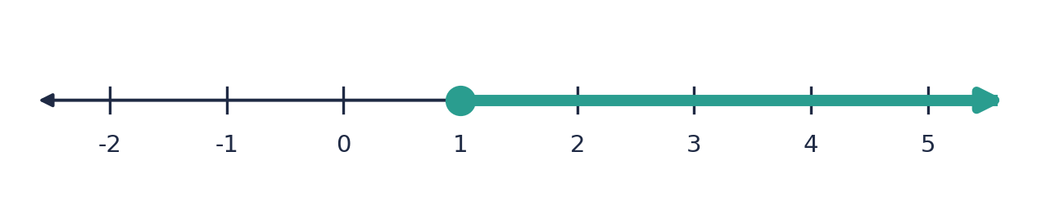

Example 4.3 · Fractions on both sides
Solve (5 − x)/2 > (x + 1)/4 and show the answer on a number line.
Solution
1. The LCM of 2 and 4 is 4. Multiply both sides by 4: 2(5 − x) > x + 1.
2. Expand: 10 − 2x > x + 1.
3. Add 2x to both sides (so we never divide by a negative): 10 > 3x + 1, so 9 > 3x.
4. Divide by 3: 3 > x, which is x < 3. Open circle at 3, arrow to the left.
Answer: x < 3
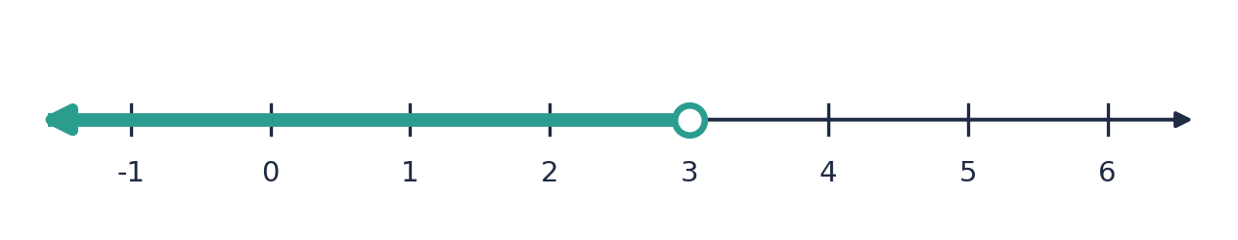

Example 4.4 · Reversing the sign
Solve (2 − x)/3 ≤ 1 and show the answer on a number line.
Solution
1. Multiply by 3: 2 − x ≤ 3.
2. Subtract 2: −x ≤ 1.
3. Multiply by −1 and reverse the sign: x ≥ −1.
Answer: x ≥ −1
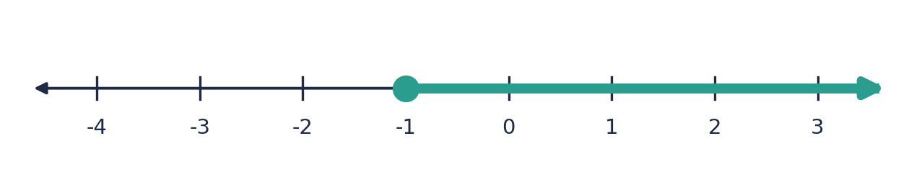
💭 Think: Solve it again by adding x to both sides first, so that you never multiply by a negative.

Example 4.5 · Several fractions on both sides
Solve x/2 + x/3 > x/4 + 7 and show the answer on a number line.
Solution
1. Multiply every term by 12: 6x + 4x > 3x + 84.
2. 10x > 3x + 84, so 7x > 84.
3. x > 12. Open circle at 12, arrow to the right.
Answer: x > 12
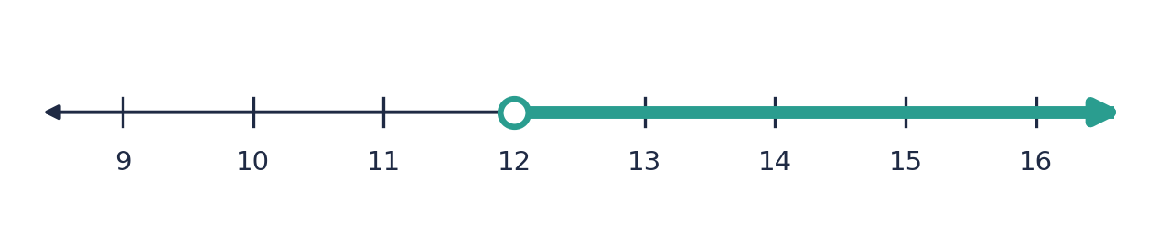

Example 4.6 · A compound inequality
Solve −1 < (x + 1)/2 ≤ 3. List the integers that satisfy it, and show the answer on a number line.
Solution
1. Multiply all three parts by 2: −2 < x + 1 ≤ 6.
2. Subtract 1 from all three parts: −3 < x ≤ 5.
3. Integers: −3 is excluded and 5 is included, so −2, −1, 0, 1, 2, 3, 4, 5.
Answer: −3 < x ≤ 5; integers −2, −1, 0, 1, 2, 3, 4, 5
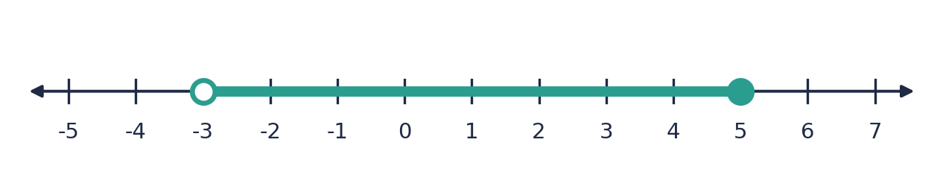

Example 4.7 · A word problem
Half of a number plus 3 is at least a third of the number plus 5. What values can the number take?
Solution
1. Let the number be x: x/2 + 3 ≥ x/3 + 5.
2. Multiply by 6: 3x + 18 ≥ 2x + 30.
3. Subtract 2x and 18: x ≥ 12.
Answer: x ≥ 12 (the number is 12 or more)

⚠ Common mistakes
- Reversing the sign when multiplying by a positive denominator such as 3. Only a negative multiplier reverses the sign.
- Not reversing the sign when dividing both sides by −1 or by a negative number.
- Forgetting to multiply the terms with no fraction by the LCM.
- Counting the end value as an integer solution when the circle should be open.

④ Practice
Write your answers in your exercise book. Start at Level 1. If you get most of a level right, move on to the next one. The answers are at the back of the pack.

Level 1 · Foundation
1. Solve.
(a) x/2 > 3
(b) x/4 ≤ 2
(c) (x + 1)/3 ≥ 2
(d) (2x − 1)/5 < 3
2. Solve. Watch for a negative multiplier.
(a) −x/2 > 3
(b) (3 − x)/2 ≥ 4
(c) (1 − 2x)/3 < 5
(d) −x/3 ≤ −2
3. Solve each inequality and describe the number line (circle type and arrow direction).
(a) x/2 + 1 ≤ 4
(b) (x − 1)/3 > 2
4. Find the greatest or least integer.
(a) The greatest integer that satisfies (x + 3)/2 < 4
(b) The least integer that satisfies (x − 1)/3 ≥ 2

Level 2 · Developing
5. Solve.
(a) (x + 2)/2 + (x − 3)/3 ≥ 5
(b) (x + 1)/2 − (x − 1)/3 < 2
(c) (2x − 1)/3 − (x − 1)/4 ≤ 2
(d) x/2 − (x − 1)/3 > 1
6. Solve. Each inequality has fractions on both sides.
(a) x/2 + x/3 ≤ x/4 + 7
(b) (x + 1)/2 > (x − 1)/3 + 1
(c) (5 − x)/3 ≥ (x + 1)/6
(d) (x − 2)/4 − (x + 1)/3 < 1/2
7. Solve each compound inequality and list the integer solutions.
(a) 1 ≤ (x + 1)/2 < 4
(b) −2 < (2x − 1)/3 ≤ 3
8. (a) The mean of x and 10 is at least 7. Find the values of x. (b) Maria’s test scores are 62 and 71. What must her third score be for her mean to be at least 70?
9. Solve (x + 1)/2 > 2 and (x − 1)/3 ≤ 3 together. Write the combined solution, and list the integers that satisfy both.

Level 3 · Think Deeper
10. Spot the error. Jo solves −x/3 > 2 and writes x > −6. What is wrong? Test with x = 0.
11. Explain. Why does multiplying by 12 not change the inequality sign in x/4 + x/6 > 5, but multiplying by −12 would?
12. Always, sometimes or never? If a/3 < b/3, then a < b. And: if −a/3 < −b/3, then a < b. Test each with a = 1 and b = 5.
13. Create. Write two different fractional inequalities, each with fractions, whose solution is x ≥ 4.
14. Investigate. Solve (x + k)/2 > 3 in terms of k. For which value of k is the solution x > 0? For which values of k are all positive numbers solutions?

Before you move on, say or write in one or two sentences: "I can explain when the sign reverses and when it does not."
How confident do I feel? ☐ Not yet ☐ Getting there ☐ Got it!

Lesson 5: Fractional Equations with x in the Denominator
Building on: Lessons 2 and 3, and solving linear equations.
Goal: By the end of this lesson I can solve an equation with x in the denominator, state the values x cannot take, and reject any answer that makes a denominator zero.

① Key Ideas
- A denominator can never be zero. Before you solve, find the restrictions: the values of x that make a denominator zero. For 5/(x − 3), x ≠ 3. For 1/(2x − 6), x ≠ 3. For 1/x, x ≠ 0.
- Multiply every term on both sides by the LCD, which now contains x. For 1/x + 1/(2x) the LCD is 2x. For 2/x and 3/(x + 1) it is x(x + 1).
- One fraction on each side: cross-multiply. 2/x = 3/(x + 1) becomes 2(x + 1) = 3x.
- After clearing the fractions, you usually have a linear equation. Solve it as in Unit 2.
- Always check your answer against the restrictions. If your answer is a value that makes a denominator zero, it is an extraneous solution and must be rejected. Sometimes this leaves no solution at all.
- Why? Multiplying both sides by an expression that is zero for some value of x can create a false ‘solution’. The check removes it.
- Substitute your final answer into the original equation to be sure both sides are equal.

② Watch
Watch these videos after you have read the key ideas. Pause the video and try each example before it is solved. Online, click the link. On paper, type the short address into YouTube.
Video | What it covers | Link
Equations: Advanced Algebraic Fractions  corbettmaths | Solving equations with algebraic fractions | Watch on YouTube  youtu.be/Aat-_BYvjLg
Solving Rational Equations (Includes Extraneous Solutions) • [6.4] Pre-Calculus 11  the AllAroundMathGuy | Rejecting answers that make a denominator zero | Watch on YouTube  youtu.be/7cDtgEv90kA

③ Worked Examples
Cover the solution and try the example first. Then uncover one step at a time and compare it with your own working.
Example 5.1 · One fraction
Solve 6/x = 3. State any restriction.
Solution
1. Restriction: x ≠ 0.
2. Multiply both sides by x: 6 = 3x.
3. x = 2. This is allowed. Check: 6/2 = 3 ✓
Answer: x = 2

Example 5.2 · One fraction on each side
Solve 2/x = 3/(x + 1).
Solution
1. Restrictions: x ≠ 0 and x ≠ −1.
2. Cross-multiply: 2(x + 1) = 3x.
3. 2x + 2 = 3x, so x = 2. Allowed. Check: 2/2 = 1 and 3/3 = 1 ✓
Answer: x = 2

Example 5.3 · Brackets in the denominators
Solve 5/(x − 1) = 2/(x + 2).
Solution
1. Restrictions: x ≠ 1 and x ≠ −2.
2. Cross-multiply: 5(x + 2) = 2(x − 1).
3. 5x + 10 = 2x − 2, so 3x = −12, so x = −4. Allowed. Check: 5/(−5) = −1 and 2/(−2) = −1 ✓
Answer: x = −4

Example 5.4 · Several fractions
Solve 1/x + 2/(3x) = 5.
Solution
1. Restriction: x ≠ 0. The LCD is 3x.
2. Multiply every term by 3x: 3 + 2 = 15x.
3. 5 = 15x, so x = 1/3. Allowed. Check: 3 + 2 = 5 ✓
Answer: x = 1/3

Example 5.5 · Fractions on both sides
Solve 3/(x − 2) = 1 + 1/(x − 2).
Solution
1. Restriction: x ≠ 2. The LCD is x − 2.
2. Multiply every term by (x − 2): 3 = (x − 2) + 1.
3. 3 = x − 1, so x = 4. Allowed. Check: 3/2 = 1 + 1/2 ✓
Answer: x = 4
💭 Think: Why did the 1 become (x − 2)?

Example 5.6 · An answer that must be rejected
Solve x/(x − 2) = 2/(x − 2).
Solution
1. Restriction: x ≠ 2.
2. Multiply by (x − 2): x = 2.
3. But x = 2 makes the denominator zero. It is an extraneous solution, so reject it.
Answer: No solution

Example 5.7 · A speed problem
A cyclist rides 24 km at x km/h. Then she rides 36 km at (x + 4) km/h. Both parts take the same time. Find x.
Solution
1. Time = distance ÷ speed, so 24/x = 36/(x + 4).
2. Cross-multiply: 24(x + 4) = 36x, so 24x + 96 = 36x.
3. 96 = 12x, so x = 8. Check: 24/8 = 3 h and 36/12 = 3 h ✓
Answer: x = 8 km/h

⚠ Common mistakes
- Not stating the restrictions, then accepting an answer that makes a denominator zero.
- Multiplying only some terms by the LCD (for example, not the whole-number terms).
- Cross-multiplying when there is more than one fraction on a side.
- Cancelling an x that appears in only part of the top: (x + 2)/x is not x/x + 2.

④ Practice
Write your answers in your exercise book. Start at Level 1. If you get most of a level right, move on to the next one. The answers are at the back of the pack.

Level 1 · Foundation
1. Solve.
(a) 12/x = 4
(b) 6/x = 1/2
(c) 3/(x + 1) = 1
(d) 10/(2x − 1) = 2
2. Cross-multiply to solve.
(a) 3/x = 6/(x + 2)
(b) 4/(x − 1) = 2/x
(c) 5/(x + 3) = 1/(x − 1)
(d) 2/(x + 1) = 3/(2x − 1)
3. State the values of x that are not allowed.
(a) 5/x
(b) 3/(x − 4)
(c) 2/(x + 7)
(d) 1/(2x − 6)
4. Solve. Each equation has more than one fraction.
(a) 1/x + 1/(2x) = 3/4
(b) 3/x − 1/(2x) = 5/4
(c) 5/(x + 1) − 2/(x + 1) = 6/(x − 2)
(d) 3/(x − 1) + 2/(x − 1) = 5/2

Level 2 · Developing
5. Solve.
(a) 3/(x + 2) = 4/(x − 1)
(b) 4/(2x − 1) = 3/(x + 2)
(c) (x + 4)/(x − 1) = 2 + 3/(x − 1)
(d) 3/(x − 2) = 1 + 1/(x − 2)
6. Solve each equation. For each one, say whether any answer must be rejected.
(a) x/(x − 2) = 2/(x − 2)
(b) (x + 1)/(x − 3) = 4/(x − 3)
(c) (x + 5)/(x + 2) = 3/(x + 2)
(d) x/(x − 4) = 2
7. A cyclist rides 24 km at x km/h and then 36 km at (x + 4) km/h. Both parts take the same time. Find x. Then find the total time.
8. Solve 12/x = 3/(x − 3).
9. Solve (2x + 1)/(x − 1) = (2x + 3)/(x + 2). What do you notice when you expand?

Level 3 · Think Deeper
10. Spot the error. Pat solves x/(x − 5) = 5/(x − 5) and writes ‘x = 5’. What should Pat have done?
11. Explain. In an equation like x + 3 = 7 we do not need to check for extra answers, but in a fractional equation we do. Why?
12. Always, sometimes or never? An equation with x in the denominators has a solution. Give an example for each case you find.
13. Create. Write an equation of the form (x + a)/(x − b) = c/(x − b) that has no solution.
14. Investigate. Solve 2/(x − 1) + 1/(x + 2) = k/(x − 1) for k = 0, 1, 2 and 3. What happens for k = 2 and k = 3?

Before you move on, say or write in one or two sentences: "I can explain why I must check my answer against the restrictions."
How confident do I feel? ☐ Not yet ☐ Getting there ☐ Got it!

Lesson 6: Fractional Equations with Squares and Factorised Denominators
Building on: Lesson 5, and Unit 5: Factorization (difference of two squares, trinomials, solving quadratics by factorising).
Goal: By the end of this lesson I can solve fractional equations whose denominators contain x², or brackets that come from factorising, including equations that become quadratic.

① Key Ideas
- Factorise every denominator first. x² − 9 = (x − 3)(x + 3). x² + 4x + 3 = (x + 1)(x + 3). x² − x = x(x − 1). Then you can see the restrictions and the LCD.
- The LCD uses each different factor once, with the highest power it appears with. For 1/x² and 1/x the LCD is x². For 1/(x − 1) and 1/(x² − 1) it is (x − 1)(x + 1).
- Restrictions: list every value that makes a factor of a denominator zero. For x² − 9, x ≠ 3 and x ≠ −3. For x², x ≠ 0.
- Multiply every term by the LCD. When there is an x² in the denominator, you often get an x² term in the equation. If so, move everything to one side and factorise to solve (Unit 5).
- A quadratic gives up to two answers. Check each one against the restrictions. Reject any that make a denominator zero.
- If x² appears as the only thing in the denominator, such as 3/x² = 12, then x² = 1/4 and x = ±1/2. Remember both the positive and negative roots.
- Some equations are true for every allowed x (an identity), and some have no solution. Be ready to see both.

② Watch
Watch these videos after you have read the key ideas. Pause the video and try each example before it is solved. Online, click the link. On paper, type the short address into YouTube.
Video | What it covers | Link
Equations: Advanced Algebraic Fractions  corbettmaths | Solving equations with algebraic fractions | Watch on YouTube  youtu.be/Aat-_BYvjLg
Equations involving algebraic fractions - Corbettmaths  Corbettmaths | Clearing fractions in equations | Watch on YouTube  youtu.be/kaIqgpKV4Cc

③ Worked Examples
Cover the solution and try the example first. Then uncover one step at a time and compare it with your own working.
Example 6.1 · A square on its own
Solve 3/x² = 12.
Solution
1. Restriction: x ≠ 0.
2. Multiply by x²: 3 = 12x².
3. x² = 3/12 = 1/4, so x = 1/2 or x = −1/2.
4. Check: 3/(1/4) = 12 ✓ for both.
Answer: x = 1/2 or x = −1/2

Example 6.2 · x² and x together
Solve 1/x² = 4/x.
Solution
1. Restriction: x ≠ 0. The LCD is x².
2. Multiply every term by x²: 1 = 4x.
3. x = 1/4. Allowed. Check: 1/(1/16) = 16 and 4/(1/4) = 16 ✓
Answer: x = 1/4

Example 6.3 · An equation that becomes a quadratic
Solve 3/x² + 2/x = 1.
Solution
1. Restriction: x ≠ 0. The LCD is x².
2. Multiply every term by x²: 3 + 2x = x².
3. Rearrange: x² − 2x − 3 = 0, so (x − 3)(x + 1) = 0.
4. x = 3 or x = −1. Both are allowed. Check x = 3: 1/3 + 2/3 = 1 ✓. Check x = −1: 3 − 2 = 1 ✓
Answer: x = 3 or x = −1

Example 6.4 · Factorising a difference of two squares
Solve 1/(x − 1) + 1/(x + 1) = 4/(x² − 1).
Solution
1. x² − 1 = (x − 1)(x + 1). Restrictions: x ≠ 1 and x ≠ −1. The LCD is (x − 1)(x + 1).
2. Multiply every term: (x + 1) + (x − 1) = 4.
3. 2x = 4, so x = 2. Allowed. Check: 1 + 1/3 = 4/3 and 4/3 ✓
Answer: x = 2

Example 6.5 · An answer to reject
Solve x/(x + 2) − 3/(x − 2) = 8/(x² − 4).
Solution
1. x² − 4 = (x − 2)(x + 2). Restrictions: x ≠ 2 and x ≠ −2.
2. Multiply every term by (x − 2)(x + 2): x(x − 2) − 3(x + 2) = 8.
3. x² − 2x − 3x − 6 = 8, so x² − 5x − 14 = 0, so (x − 7)(x + 2) = 0.
4. x = 7 or x = −2. But x = −2 is not allowed, so reject it. Check x = 7: 7/9 − 3/5 = 8/45 and 8/45 ✓
Answer: x = 7 (x = −2 rejected)

Example 6.6 · Factorising a denominator first
Solve 2/(x² − 1) + 1/(x − 1) = 3/(x + 1).
Solution
1. x² − 1 = (x − 1)(x + 1). Restrictions: x ≠ ±1.
2. Multiply every term by (x − 1)(x + 1): 2 + (x + 1) = 3(x − 1).
3. x + 3 = 3x − 3, so 6 = 2x, so x = 3. Allowed. Check: 2/8 + 1/2 = 3/4 and 3/4 ✓
Answer: x = 3

Example 6.7 · The x² terms cancel
Solve (2x + 1)/(x − 1) = (2x + 3)/(x + 2).
Solution
1. Restrictions: x ≠ 1 and x ≠ −2. Cross-multiply: (2x + 1)(x + 2) = (2x + 3)(x − 1).
2. Expand: 2x² + 5x + 2 = 2x² + x − 3.
3. The 2x² cancels: 4x = −5, so x = −5/4.
Answer: x = −5/4
💭 Think: Why is there no quadratic to solve, even though x² appeared?

⚠ Common mistakes
- Giving only x = +1/2 for x² = 1/4. There are two square roots.
- Not factorising the denominators first, so the LCD becomes far too large.
- Forgetting to check both answers of a quadratic against the restrictions.
- Multiplying by x² but only multiplying some of the terms.

④ Practice
Write your answers in your exercise book. Start at Level 1. If you get most of a level right, move on to the next one. The answers are at the back of the pack.

Level 1 · Foundation
1. Solve.
(a) 4/x² = 1
(b) 5/x² = 20
(c) 2/x² = 8/x
(d) 9/x² = 1
2. Solve. Each equation becomes a quadratic.
(a) 3/x² + 2/x = 1
(b) 6/x² − 1/x = 1
(c) 2/x² − 1/x = 3
(d) 1/x² − 5/x = −6
3. Factorise each denominator and state the values of x that are not allowed.
(a) x² − 9
(b) x² + 5x + 6
(c) x² − x
(d) 2x² − 8
4. Solve.
(a) 1/(x − 1) + 1/(x + 1) = 4/(x² − 1)
(b) 5/(x² − 9) = 1/(x − 3) + 1/(x + 3)
(c) 2/(x² − 1) + 1/(x − 1) = 3/(x + 1)
(d) x/(x² − 4) + 1/(x + 2) = 1/(x − 2)

Level 2 · Developing
5. Solve. Check each answer against the restrictions.
(a) x/(x + 2) − 3/(x − 2) = 8/(x² − 4)
(b) 2/(x + 3) + 1/(x − 1) = 7/((x + 3)(x − 1))
(c) 1/(x + 1) + 1/(x + 3) = 3/(x² + 4x + 3)
(d) x/(x − 1) + 2/(x + 1) = (x² + 3)/(x² − 1)
6. Solve each equation, and decide whether it has one solution, no solution, or is true for every allowed x.
(a) 1/(x − 2) − 1/(x + 2) = 4/(x² − 4)
(b) 3/(x² + x) = 1/x − 1/(x + 1)
(c) 1/(x² − 3x + 2) + 1/(x − 1) = 1/(x − 2)
7. Solve (x + 1)/x − (x − 2)/(x + 1) = 3/2.
8. A number x and its reciprocal 1/x add to 5/2. Find the number.
9. A train travels 120 km at x km/h and then 120 km at (x + 20) km/h. The total time is 5 hours. Find x.

Level 3 · Think Deeper
10. Spot the error. Ana solves 3/x² + 2/x = 1 by multiplying by x² and writing 3 + 2 = x², so x = ±√5. What went wrong?
11. Explain. In the example x/(x + 2) − 3/(x − 2) = 8/(x² − 4), why is x = −2 rejected even though it is a solution of x² − 5x − 14 = 0?
12. Always, sometimes or never? When a fractional equation is changed into a quadratic, both roots of the quadratic are solutions of the original.
13. Create. Write a fractional equation with x² in a denominator whose solutions are x = 1 and x = 2.
14. Investigate. Solve 1/(x − 1) + 1/(x + 1) = k/(x² − 1) in terms of k. For which values of k is there no solution? Test with k = 4 and k = 2.

Before you move on, say or write in one or two sentences: "I can explain why I factorise the denominators before I find the LCD."
How confident do I feel? ☐ Not yet ☐ Getting there ☐ Got it!

Lesson 7: Fractional Inequalities with x in the Denominator
Building on: Lessons 4 and 5, and Unit 3: Inequalities (number lines, compound and ‘or’ inequalities).
Goal: By the end of this lesson I can solve an inequality with x in the denominator by finding critical values and using a sign table, and I can show the answer on a number line.

① Key Ideas
- Do not multiply both sides by an expression with x in it, unless you know it is positive. If it is negative, the sign must reverse, and you do not know which case you are in. For example, 1/x < 1 does NOT mean x > 1.
- Method: (1) Move everything to one side so the other side is 0. (2) Write it as one fraction. (3) Find the critical values: where the top is zero, and where the bottom is zero. (4) Make a sign table to find the sign of the fraction in each interval. (5) Choose the intervals that match the inequality.
- A fraction is positive if the top and bottom have the same sign, and negative if they have different signs. It is zero only when the top is zero.
- Critical values from the bottom are never part of the answer (the fraction is undefined there), so they always get an open circle. Critical values from the top are included only if the sign is ≤ or ≥.
- Squares are safe: x² and (x − 2)² are positive for every allowed x, so you may multiply by them without reversing the sign. For 4/x² > 1, multiply by x² (x ≠ 0) to get 4 > x².
- The answer can be two separate pieces on the number line. Write it with ‘or’, for example x < 0 or x > 1.
- Always test a number in each piece of your answer, and one number outside, in the original inequality.

② Watch
Watch these videos after you have read the key ideas. Pause the video and try each example before it is solved. Online, click the link. On paper, type the short address into YouTube.
Video | What it covers | Link
How to Solve a Rational Inequality with SIGN CHART  Prof. Redden | Using critical values and a sign chart | Watch on YouTube  youtu.be/wXkheTuo6Qk

③ Worked Examples
Cover the solution and try the example first. Then uncover one step at a time and compare it with your own working.
Example 7.1 · Moving to one side
Solve 6/x > 2.
Solution
1. Subtract 2: 6/x − 2 > 0. As one fraction: (6 − 2x)/x > 0.
2. Critical values: the top is zero at x = 3, the bottom is zero at x = 0 (open circle).
3. Sign table (see the figure): the fraction is positive only between 0 and 3.
4. Check x = 1: 6 > 2 ✓. Check x = −1: −6 > 2 is false ✓. Check x = 4: 1.5 > 2 is false ✓
Answer: 0 < x < 3
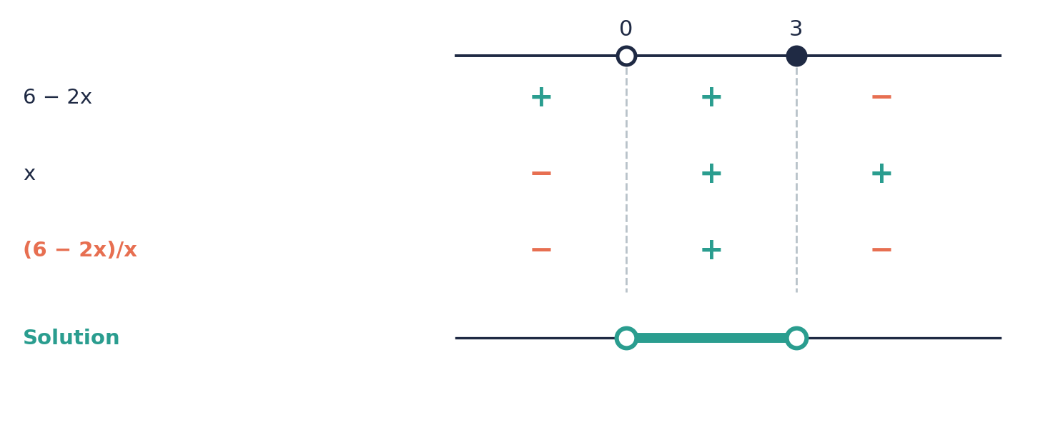

Example 7.2 · A fraction compared with zero
Solve (x + 1)/(x − 2) ≥ 0.
Solution
1. Critical values: x = −1 (top is zero) and x = 2 (bottom is zero).
2. The fraction is positive when the top and bottom have the same sign: for x < −1 and for x > 2.
3. It is zero at x = −1, which is allowed because of ≥. x = 2 is never allowed.
4. So x ≤ −1 (closed circle) or x > 2 (open circle).
Answer: x ≤ −1 or x > 2
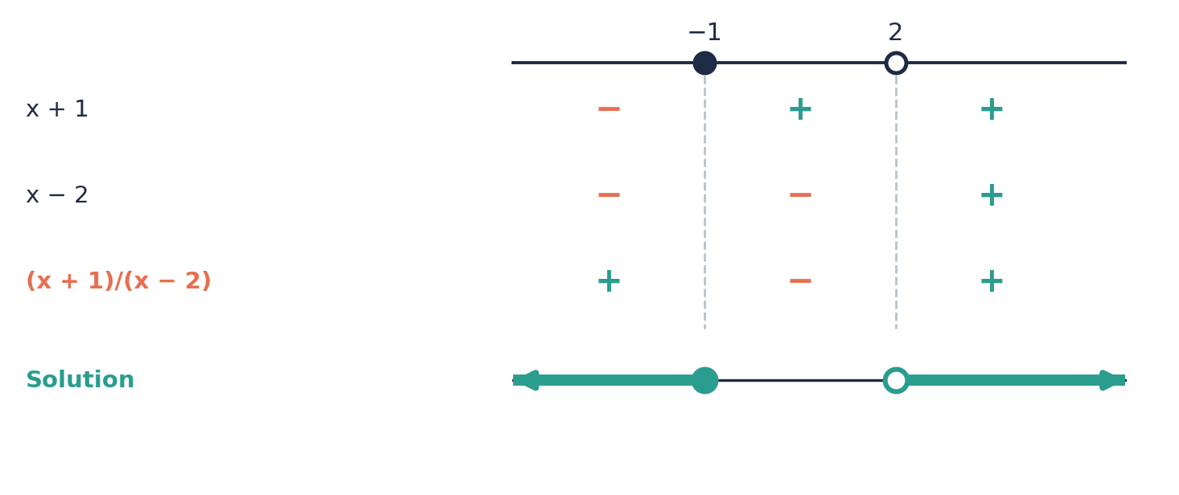

Example 7.3 · A constant over a bracket
Solve 3/(x − 1) < 2.
Solution
1. 3/(x − 1) − 2 < 0. As one fraction: (3 − 2(x − 1))/(x − 1) = (5 − 2x)/(x − 1) < 0.
2. Critical values: x = 5/2 and x = 1 (open).
3. From the sign table, the fraction is negative for x < 1 and for x > 5/2.
4. Check x = 0: −3 < 2 ✓. Check x = 2: 3 < 2 is false ✓. Check x = 3: 1.5 < 2 ✓
Answer: x < 1 or x > 5/2
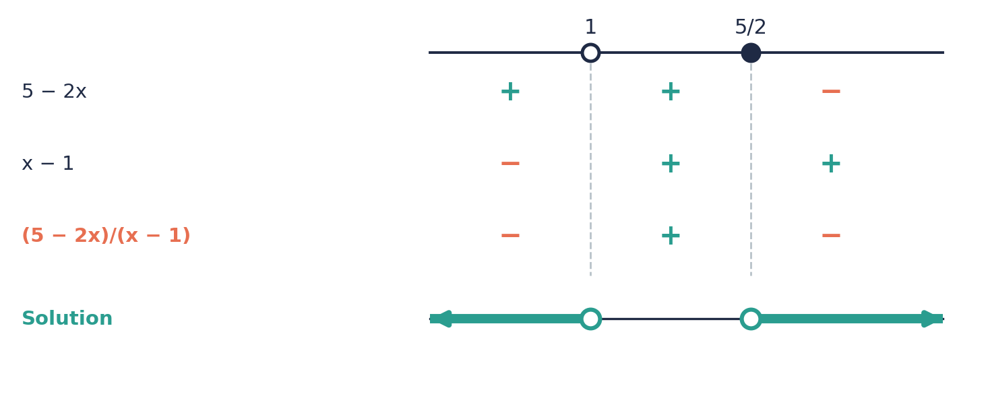

Example 7.4 · A square in the denominator
Solve 4/x² > 1.
Solution
1. x² is positive for every x except 0, so we can multiply by x² without reversing the sign.
2. 4 > x², so x² < 4, so −2 < x < 2.
3. Remove x = 0, because 4/0 is undefined.
Answer: −2 < x < 2, x ≠ 0
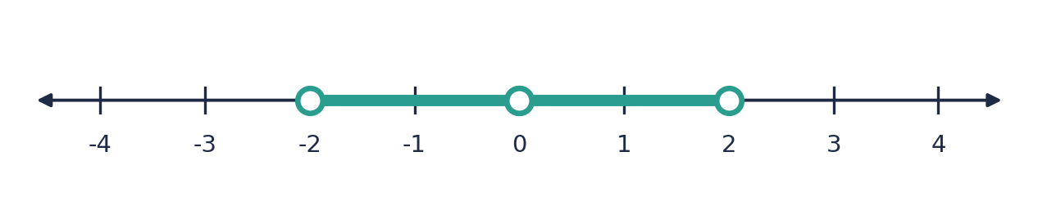
💭 Think: Check x = 1 and x = 3. Which satisfies 4/x² > 1?

Example 7.5 · Two fractions
Solve 2/(x + 1) ≥ 1/(x − 1).
Solution
1. Move to one side: 2/(x + 1) − 1/(x − 1) ≥ 0.
2. One fraction: (2(x − 1) − (x + 1))/((x + 1)(x − 1)) = (x − 3)/((x + 1)(x − 1)) ≥ 0.
3. Critical values: x = −1 and x = 1 (open, from the bottom) and x = 3 (closed, from the top).
4. The sign table gives positive for −1 < x < 1 and for x > 3, and zero at x = 3.
Answer: −1 < x < 1 or x ≥ 3
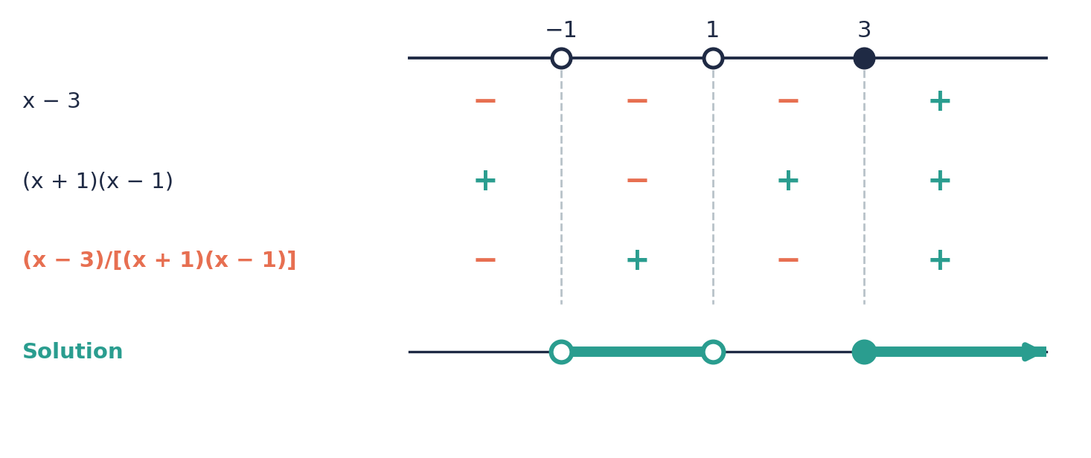

Example 7.6 · A common trap
Solve 1/x < 1.
Solution
1. Do not multiply by x. Write 1/x − 1 < 0, which is (1 − x)/x < 0.
2. Critical values: x = 1 (top) and x = 0 (bottom, open).
3. The sign table shows negative for x < 0 and for x > 1.
4. Check x = −1: −1 < 1 ✓. Check x = 1/2: 2 < 1 is false ✓. Check x = 2: 1/2 < 1 ✓
Answer: x < 0 or x > 1
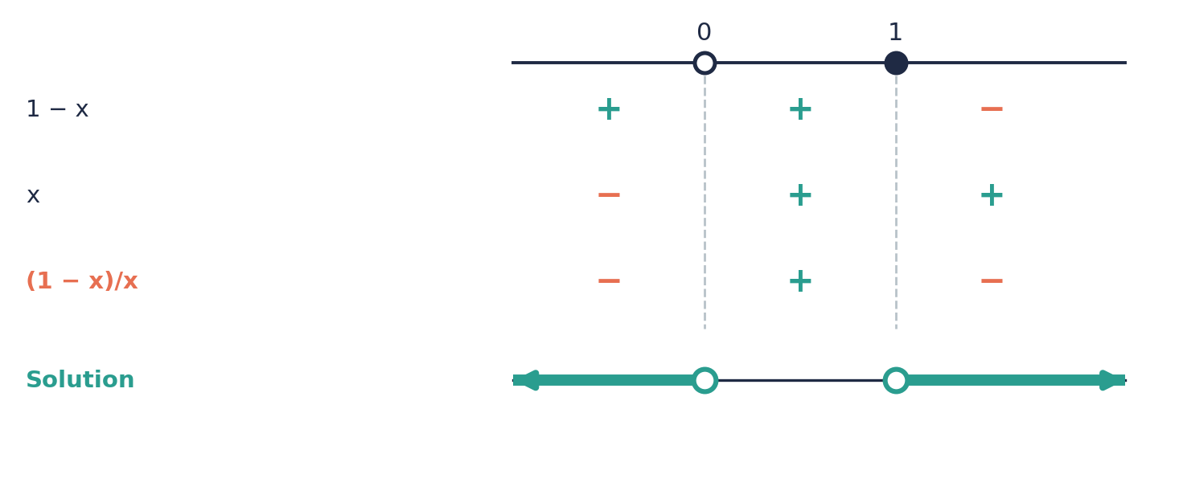

⚠ Common mistakes
- Multiplying both sides by x (or by (x − 2)) and not reversing the sign when it is negative.
- Including a critical value from the denominator in the answer. It is always excluded.
- Writing ‘x > 0 and x < 0’ or one long interval when the answer is two separate pieces.
- Forgetting to move everything to one side so that the other side is exactly 0.

④ Practice
Write your answers in your exercise book. Start at Level 1. If you get most of a level right, move on to the next one. The answers are at the back of the pack.

Level 1 · Foundation
1. Say whether (x − 3)/(x + 1) is positive or negative for each value of x.
(a) x = −2
(b) x = 0
(c) x = 2
(d) x = 5
2. Write the critical values: the value that makes the top zero, then the value that makes the bottom zero.
(a) (x − 2)/(x + 3)
(b) (2x − 6)/x
(c) x/(x − 1)
(d) (x + 1)/(2x − 4)
3. Solve each inequality using a sign table.
(a) (x − 1)/(x + 2) > 0
(b) x/(x − 3) ≤ 0
(c) (x + 4)/(x − 1) ≥ 0
(d) (2 − x)/(x + 1) < 0
4. Solve.
(a) 1/x > 1/2
(b) 6/x < 3

Level 2 · Developing
5. Solve and show each answer on a number line.
(a) 4/x > 1
(b) 3/(x − 2) ≥ 1
(c) 2/(x + 1) < 1
(d) x/(x + 2) ≤ 1
6. Solve. Remember that squares are never negative.
(a) 9/x² > 1
(b) 2/x² ≤ 8
(c) 1/(x − 1)² > 0
(d) −3/x² < 0
7. Solve.
(a) 2/(x + 1) ≥ 1/(x − 1)
(b) 1/(x − 1) < 2/(x + 2)
8. Solve 1/x + 1/(x + 1) > 0.
9. List the whole numbers x for which 12/x > 3. Then list the whole numbers for which 12/x ≥ 3.

Level 3 · Think Deeper
10. Spot the error. Raj solves 1/x < 1 by multiplying both sides by x to get 1 < x, so x > 1. Test x = −1. What went wrong?
11. Explain. Why can you multiply both sides of 4/x² > 1 by x², but you cannot multiply 4/x > 1 by x?
12. Always, sometimes or never? If a > b, then 1/a < 1/b. Test with a = 3, b = 2, and with a = 2, b = −3.
13. Create. Write a fractional inequality whose solution is x < −2 or x > 3.
14. Investigate. Solve 1/x < k for k = 1, k = 2 and k = −1. What is the pattern for any k > 0?

Before you move on, say or write in one or two sentences: "I can explain why I must not multiply by x when I do not know its sign."
How confident do I feel? ☐ Not yet ☐ Getting there ☐ Got it!

CSEC-Style Exam Practice
These questions are like the ones on CSEC Paper 2, and they use all seven lessons. Try them under test conditions: no notes, and about 30 minutes. Show all your working.
1. (a) Simplify (x² + 3x)/(x² − 9). [3 marks] (b) Express 3/(x − 1) − 2/(x + 1) as a single fraction in its simplest form. [3 marks]
2. (a) Solve (2x − 1)/3 − (x − 1)/2 = 1. [3 marks] (b) Solve (x + 1)/2 + (x − 2)/3 = x/4 + 1. [4 marks]
3. (a) Solve (x + 2)/3 − (x − 1)/2 ≥ 1. [3 marks] (b) Show your answer to (a) on a number line. [1 mark] (c) List the integers that satisfy both the inequality in (a) and x > −2. [2 marks]
4. (a) Solve 3/(x + 1) = 2/(x − 2). [3 marks] (b) Solve 2/x + 3/(x + 1) = 2. [5 marks] (c) Solve x/(x − 3) − 2 = 3/(x − 3). Explain your answer. [3 marks]
5. (a) Solve 6/x² − 1/x = 1. [4 marks] (b) Solve the inequality 4/x > 1 and show the answer on a number line. [4 marks]

Self-Check Quiz: Am I Ready?
Answer all 15 questions without looking back at the lessons. Then check your answers and write your score in the box. The lesson number after each question tells you where to go back if you get it wrong.
1. (x² − 9)/(x + 3) simplifies to… (Lesson 1)
A x − 9 B x − 3 C x + 3 D x² − 3
2. Which cancellation is allowed? (Lesson 1)
A (x + 4)/4 = x + 1 B (x² + 3)/(x² + 5) = 3/5 C (x + 2)/(x + 5) = 2/5 D 6x/(3x) = 2
3. 1/x + 1/y is equal to… (Lesson 2)
A (x + y)/(xy) B 1/(xy) C 2/(x + y) D 2/(xy)
4. (x + 1)/2 − (x − 1)/3 simplifies to… (Lesson 2)
A (x + 1)/6 B (x + 5)/5 C (x + 5)/6 D (x + 2)/6
5. Solve (x + 3)/2 = 5. (Lesson 3)
A x = 2 B x = 13 C x = 7 D x = 8
6. Solve x/2 + x/3 = 10. (Lesson 3)
A x = 12 B x = 24 C x = 60 D x = 6
7. Solve (2 − x)/3 ≤ 1. (Lesson 4)
A x ≥ 1 B x ≤ −1 C x ≤ 1 D x ≥ −1
8. Solve x/2 + x/3 > x/4 + 7. (Lesson 4)
A x > 84 B x > 12 C x > 7 D x < 12
9. Which value of x is not allowed in 5/(x − 3)? (Lesson 5)
A x = 3 B x = −3 C x = 5 D x = 0
10. Solve 2/x = 3/(x + 1). (Lesson 5)
A x = 1 B x = −2 C x = 2 D x = 3
11. The equation x/(x − 2) = 2/(x − 2) has… (Lesson 5)
A the solution x = 0 B no solution C the solution x = −2 D the solution x = 2
12. Solve 3/x² = 12. (Lesson 6)
A x = 1/2 only B x = 4 or x = −4 C x = 2 or x = −2 D x = 1/2 or x = −1/2
13. Solve 3/x² + 2/x = 1. (Lesson 6)
A x = −3 or x = 1 B x = 3 or x = −1 C x = 3 only D x = ±√5
14. To solve 1/x < 1, you should… (Lesson 7)
A take the reciprocal of both sides and keep the sign B cross-multiply to get 1 < x C multiply both sides by x D move everything to one side and use a sign table
15. The solution of 6/x > 2 is… (Lesson 7)
A 0 < x < 3 B x < 0 or x > 3 C x < 3 D x > 3

My score | What it means
14–15 | Ready! You are ready for the next topic: Revision for the Form 3 examinations.
11–13 | Nearly there. Look at the lesson number next to each question you missed. Redo the Level 2 practice for those lessons.
0–10 | Go back over the lessons for the questions you missed. Redo the Level 1 and Level 2 practice, watch the videos again, then retake this quiz.
My score: ______ / 15

Answers
Use these to check your work. If your answer is different, look for your mistake before you ask for help. Your teacher has the full worked solutions.

Warm-Up
1. (x − 3)(x + 3)
2. (x + 2)(x + 3)
3. 2/3
4. 5/6
5. 12
6. x = 3
7. x < 2
8. x − 8

Lesson 1: Simplifying Algebraic Fractions
Level 1 · Foundation
1. (a) 2a/3 (b) 3x (c) 2x/3 (d) 2a/(3b)
2. (a) x + 2 (b) 4 (c) (x + 2)/2 (d) x + 3
3. (a) False (b) True (c) True (d) False
4. (a) 2 (b) x (c) 3/2 (d) (x + 2)/x
Level 2 · Developing
5. (a) x + 3 (b) x − 4 (c) (x − 5)/2 (d) 2x − 1
6. (a) x + 3 (b) x − 2 (c) (x + 2)/(x − 5) (d) (x − 4)/(x − 3)
7. (a) −1 (b) −2 (c) −(x + 1)
8. The 2 was cancelled only with the first term. The correct answer is x + 3.
9. x + 3
Level 3 · Think Deeper
10. x² is a term, not a factor, so it cannot be cancelled. With x = 4 the fraction is 7/13, not 3. The fraction cannot be simplified.
11. When x = 3 the original has denominator 0, so it is undefined. The simplified expression x + 3 would be 6. They are equal for every x except 3.
12. Sometimes. It is true only when x = 0.
13. e.g. (x² + 3x + 2)/(x² − 4)
14. x + 2, x + 3, x + 5. The pattern is (x² − a²)/(x − a) = x + a. The challenge gives x² + x + 1.

Lesson 2: Adding, Subtracting, Multiplying and Dividing Algebraic Fractions
Level 1 · Foundation
1. (a) 3x/5 (b) 3x/4 (c) x/6 (d) 7x/6
2. (a) x + 2 (b) (x + 3)/3 (c) (3x − 2)/4 (d) (x − 4)/6
3. (a) 7/x (b) 5/(2x) (c) 3/(2x) (d) (a + b)/(ab)
4. (a) x/3 (b) 2/3 (c) x/2 (d) 3/2
Level 2 · Developing
5. (a) (2x + 3)/((x + 1)(x + 2)) (b) (5x + 1)/((x − 1)(x + 1)) (c) (2x − 5)/((x + 2)(x − 1)) (d) 24/(x² − 9)
6. (a) 1 (b) (2x + 1)/(x(x + 1)) (c) (4 − x)/(x(x + 2))
7. (a) (x + 2)/(x + 3) (b) x − 2 (c) (x − 1)/(x + 2) (d) (x + 2)/(x − 2)
8. (100x + 600)/(x(x + 10)) = 100(x + 6)/(x(x + 10))
9. (11 − x)/6
Level 3 · Think Deeper
10. With x = y = 1, the left side is 2 but Kim’s answer gives 2/2 = 1. The correct answer is (x + y)/(xy).
11. Lee did not put a bracket round the second top, so the − did not change the sign of the 1. The correct answer is (x + 5)/6.
12. (a) ((x + 1) − x)/(x(x + 1)) = 1/(x(x + 1)). (b) (1 − 1/2) + (1/2 − 1/3) + (1/3 − 1/4) = 1 − 1/4 = 3/4.
13. e.g. x/2 + x/3 and 2x/3 + x/6
14. Since 1 − x = −(x − 1), 1/(1 − x) = −1/(x − 1), so the sum is 0. The two fractions are opposites. 1/(x − 2) + 3/(2 − x) = −2/(x − 2).

Lesson 3: Fractional Equations with Numbers in the Denominator
Level 1 · Foundation
1. (a) x = 15 (b) x = 7 (c) x = 6 (d) x = 9
2. (a) x = 8 (b) x = 7 (c) x = 17 (d) x = 14
3. (a) x = 12 (b) x = 12 (c) x = 1 (d) x = 5
4. 12
Level 2 · Developing
5. (a) x = 12 (b) x = −2 (c) x = 0 (d) x = 5/2
6. (a) x = 2 (b) x = 1 (c) x = 1 (d) x = −14
7. (a) x = 7 (b) x = 1 (c) x = 20 (d) x = 4
8. n = 8, so the numbers are 8 and 9
9. x = 7, length 5 cm, width 2 cm
Level 3 · Think Deeper
10. Ben did not multiply the 5 by 6. The correct equation is 3(x + 1) + 2(x − 1) = 30, which gives x = 29/5.
11. Using the LCM (12) gives smaller numbers than the product (24). Both clear the fractions and give the same answer, but the LCM is less work and less likely to cause errors.
12. Always (when a ≠ b). The only solution is x = 0.
13. e.g. (x + 2)/4 = x/3 and x/2 − 1 = x/3
14. x = −5a. With a = 2, x = −10. When a = 0 the equation is x/2 = x/3 and x = 0, which agrees with x = −5a.

Lesson 4: Fractional Inequalities with Numbers in the Denominator
Level 1 · Foundation
1. (a) x > 6 (b) x ≤ 8 (c) x ≥ 5 (d) x < 8
2. (a) x < −6 (b) x ≤ −5 (c) x > −7 (d) x ≥ 6
3. (a) x ≤ 6: closed circle at 6, arrow left (b) x > 7: open circle at 7, arrow right
4. (a) 4 (b) 7
Level 2 · Developing
5. (a) x ≥ 6 (b) x < 7 (c) x ≤ 5 (d) x > 4
6. (a) x ≤ 12 (b) x > 1 (c) x ≤ 3 (d) x > −16
7. (a) 1 ≤ x < 7; integers 1, 2, 3, 4, 5, 6 (b) −5/2 < x ≤ 5; integers −2, −1, 0, 1, 2, 3, 4, 5
8. (a) x ≥ 4 (b) at least 77
9. 3 < x ≤ 10; integers 4, 5, 6, 7, 8, 9, 10
Level 3 · Think Deeper
10. Jo did not reverse the sign when multiplying by −3. The correct answer is x < −6. With x = 0, the left side is 0, and 0 > 2 is false, so x = 0 is correctly outside the solution set.
11. Multiplying by a positive number keeps the order of two numbers (2 < 5 and 12 × 2 < 12 × 5). Multiplying by a negative number reverses the order (−12 × 2 > −12 × 5).
12. The first is always true. The second is never true: it gives a > b.
13. e.g. x/2 ≥ 2 and (x + 2)/3 ≥ 2
14. x > 6 − k. The solution is x > 0 when k = 6. All positive numbers are solutions when 6 − k ≤ 0, that is k ≥ 6.

Lesson 5: Fractional Equations with x in the Denominator
Level 1 · Foundation
1. (a) x = 3 (b) x = 12 (c) x = 2 (d) x = 3
2. (a) x = 2 (b) x = −1 (c) x = 2 (d) x = 5
3. (a) x ≠ 0 (b) x ≠ 4 (c) x ≠ −7 (d) x ≠ 3
4. (a) x = 2 (b) x = 2 (c) x = −4 (d) x = 3
Level 2 · Developing
5. (a) x = −11 (b) x = 11/2 (c) x = 3 (d) x = 4
6. (a) x = 2 rejected, no solution (b) x = 3 rejected, no solution (c) x = −2 rejected, no solution (d) x = 8, valid
7. x = 8 km/h; total time 6 hours
8. x = 4
9. x = −5/4. The x² terms are the same on both sides and cancel.
Level 3 · Think Deeper
10. Pat should have checked the answer. x = 5 makes the denominator 0, so it must be rejected and there is no solution.
11. In a fractional equation we multiply by an expression that contains x. If that expression equals zero for some x, the new equation can have a solution that the original does not.
12. Sometimes. 6/x = 3 has the solution x = 2, but x/(x − 2) = 2/(x − 2) has no solution.
13. Choose c = a + b. For example (x + 1)/(x − 3) = 4/(x − 3).
14. k = 0: x = −1. k = 1: x = −1/2. k = 2: no solution. k = 3: no solution.

Lesson 6: Fractional Equations with Squares and Factorised Denominators
Level 1 · Foundation
1. (a) x = 2 or −2 (b) x = 1/2 or −1/2 (c) x = 1/4 (d) x = 3 or −3
2. (a) x = 3 or −1 (b) x = 2 or −3 (c) x = −1 or 2/3 (d) x = 1/2 or 1/3
3. (a) (x − 3)(x + 3); x ≠ ±3 (b) (x + 2)(x + 3); x ≠ −2, −3 (c) x(x − 1); x ≠ 0, 1 (d) 2(x − 2)(x + 2); x ≠ ±2
4. (a) x = 2 (b) x = 5/2 (c) x = 3 (d) x = 4
Level 2 · Developing
5. (a) x = 7 (x = −2 rejected) (b) x = 2 (c) x = −1/2 (d) x = 5/3
6. (a) true for every x except ±2 (b) no solution (c) true for every x except 1 and 2
7. x = 2 or x = −1/3
8. x = 2 or x = 1/2
9. x = 40 km/h (x = −12 is rejected)
Level 3 · Think Deeper
10. Ana multiplied 2/x by x² and got 2, but 2/x × x² = 2x. The correct equation is 3 + 2x = x², giving x = 3 or x = −1.
11. x = −2 makes the denominators x + 2 and x² − 4 equal to zero, so the original equation is not defined at x = −2.
12. Sometimes. In 3/x² + 2/x = 1 both roots work. In x/(x + 2) − 3/(x − 2) = 8/(x² − 4) one root is rejected.
13. e.g. 2/x² − 3/x + 1 = 0
14. x = k/2. There is no solution when k = 2 or k = −2, because then x = ±1 is not allowed. For k = 4 the solution is x = 2.

Lesson 7: Fractional Inequalities with x in the Denominator
Level 1 · Foundation
1. (a) positive (b) negative (c) negative (d) positive
2. (a) 2; −3 (b) 3; 0 (c) 0; 1 (d) −1; 2
3. (a) x < −2 or x > 1 (b) 0 ≤ x < 3 (c) x ≤ −4 or x > 1 (d) x < −1 or x > 2
4. (a) 0 < x < 2 (b) x < 0 or x > 2
Level 2 · Developing
5. (a) 0 < x < 4 (b) 2 < x ≤ 5 (c) x < −1 or x > 1 (d) x > −2
6. (a) −3 < x < 3, x ≠ 0 (b) x ≤ −1/2 or x ≥ 1/2 (c) every x except 1 (d) every x except 0
7. (a) −1 < x < 1 or x ≥ 3 (b) −2 < x < 1 or x > 4
8. −1 < x < −1/2 or x > 0
9. 12/x > 3: 1, 2, 3. 12/x ≥ 3: 1, 2, 3, 4.
Level 3 · Think Deeper
10. Raj multiplied by x without knowing its sign. At x = −1 the original gives −1 < 1, which is true, but Raj’s answer says x = −1 is not a solution. The correct solution is x < 0 or x > 1.
11. x² is always positive (for x ≠ 0), so the sign stays the same. x can be positive or negative, and a negative multiplier reverses the sign.
12. Sometimes. It is true when a and b have the same sign (1/3 < 1/2), and false when they have different signs (1/2 > −1/3).
13. e.g. (x + 2)/(x − 3) > 0
14. k = 1: x < 0 or x > 1. k = 2: x < 0 or x > 1/2. k = −1: −1 < x < 0. For k > 0 the solution is x < 0 or x > 1/k.

CSEC-Style Exam Practice
1. (a) x/(x − 3) (b) (x + 5)/(x² − 1)
2. (a) x = 5 (b) x = 2
3. (a) x ≤ 1 (b) closed circle at 1, arrow pointing left (c) −1, 0, 1
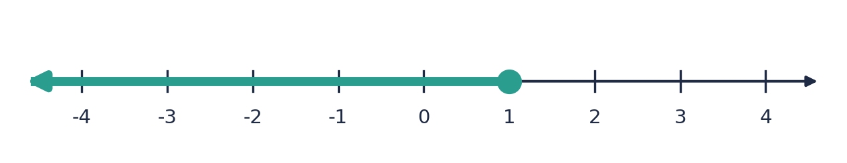
4. (a) x = 8 (b) x = 2 or x = −1/2 (c) no solution, because x = 3 makes the denominator 0
5. (a) x = 2 or x = −3 (b) 0 < x < 4; open circles at 0 and 4, with the line between them
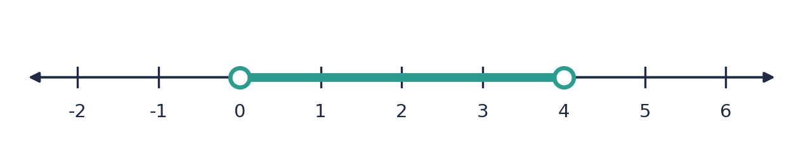

Self-Check Quiz
Q | Answer | Why
1 | B | x² − 9 = (x − 3)(x + 3). Cancel the factor (x + 3).
2 | D | In 6x/(3x) the 3x is a factor of the top. The others cancel terms, which is never allowed.
3 | A | The LCD is xy: y/(xy) + x/(xy) = (x + y)/(xy).
4 | C | (3(x + 1) − 2(x − 1))/6 = (3x + 3 − 2x + 2)/6 = (x + 5)/6.
5 | C | Multiply by 2: x + 3 = 10, so x = 7.
6 | A | Multiply by 6: 3x + 2x = 60, so 5x = 60.
7 | D | 2 − x ≤ 3, so −x ≤ 1. Multiplying by −1 reverses the sign: x ≥ −1.
8 | B | Multiply by 12: 6x + 4x > 3x + 84, so 7x > 84.
9 | A | x = 3 makes the denominator zero.
10 | C | Cross-multiply: 2(x + 1) = 3x, so 2 = x.
11 | B | Multiplying by (x − 2) gives x = 2, but x = 2 makes the denominator zero, so it is rejected.
12 | D | 3 = 12x², so x² = 1/4. There are two square roots.
13 | B | Multiply by x²: 3 + 2x = x², so x² − 2x − 3 = 0, so (x − 3)(x + 1) = 0.
14 | D | You do not know whether x is positive or negative, so multiplying by x is unsafe. Use critical values and a sign table.
15 | A | (6 − 2x)/x > 0. The critical values are 0 and 3, and the fraction is positive between them.

