<https://p.w3layouts.com/demos_new/template_demo/03-09-2018/arable_demo_Free/1791219992/web/index.html>

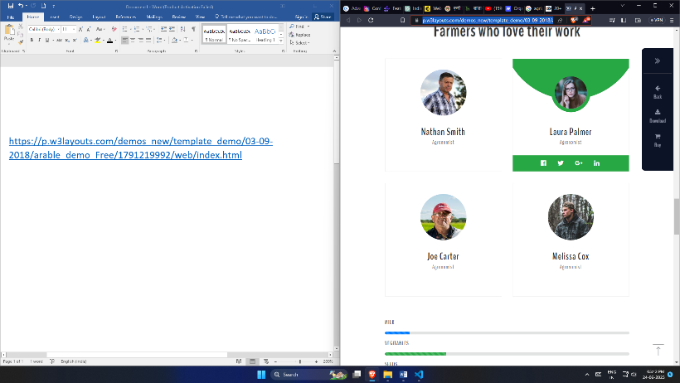responsive profile info