KPR Institute of Engineering and Technology
(Autonomous), Coimbatore – 641 407 | Department of CSE
U21CS501 – Web Technology
Assignment II – Student Admission & Records System
Student name | Amudan
Roll number | <enter your roll number>
Year / Sem / Section | III / V / A
Issue date / Submission date | 07.10.2026 / 20.10.2026
GitHub repository | https://github.com/Amudan06/webtech-assignment-2

Contents of this report
- Project overview and architecture
- Database schema script
- Q1 – HTML form, CSS and JavaScript validation (code explanation + screenshots)
- Q2 – PHP and MySQL CRUD with file upload (code explanation + screenshots)
- Q3 – Servlet, JDBC and JSP portal (code explanation + screenshots)
- Testing summary and conclusion

1. Project overview
The three questions are built as one connected system instead of three separate programs. A student fills in the registration form (Q1); the form posts to a PHP page (Q2) that validates the data again on the server, saves the student in MySQL and stores the uploaded files on disk with their metadata in a second table; finally a Java Servlet portal (Q3) reads the same database and the same upload folder and shows the profiles to logged-in users.
Part | Technology | Main files
Q1 Registration form | HTML5, CSS3, JavaScript | index.html, css/style.css, js/validation.js
Q2 Admin panel | PHP 8, PDO, MySQL | index.php, add.php, view.php, edit.php, delete.php, includes/helpers.php
Q3 Student portal | Servlet, JDBC, JSP, Tomcat 10 | servlet/*.java, dao/*.java, filter/AuthFilter.java, *.jsp, WEB-INF/web.xml
Database | MySQL | database/schema.sql

Design decisions. Validation is done twice on purpose: JavaScript gives instant feedback, but the PHP code repeats every check because a browser check can be bypassed. All SQL uses prepared statements, all output is escaped, and files are accepted only after their real content type is checked, so renaming a program to .jpg does not get it through.

2. Database schema script
The file database/schema.sql creates the database student_portal. The three tables are linked so that deleting a student automatically removes their file records (ON DELETE CASCADE). The stored_name column is UNIQUE, which is one more safeguard against two uploads sharing a name.
CREATE TABLE students (
id INT UNSIGNED AUTO_INCREMENT PRIMARY KEY,
name VARCHAR(100) NOT NULL,
roll_number VARCHAR(20) NOT NULL UNIQUE,
email VARCHAR(120) NOT NULL UNIQUE,
course VARCHAR(80) NOT NULL,
password_hash VARCHAR(255) NULL, -- bcrypt hash from PHP password_hash()
created_at TIMESTAMP NOT NULL DEFAULT CURRENT_TIMESTAMP,
updated_at TIMESTAMP NOT NULL DEFAULT CURRENT_TIMESTAMP ON UPDATE CURRENT_TIMESTAMP
) ENGINE=InnoDB;

CREATE TABLE student_files (
id INT UNSIGNED AUTO_INCREMENT PRIMARY KEY,
student_id INT UNSIGNED NOT NULL,
category ENUM('profile_image','id_proof','certificate') NOT NULL,
original_name VARCHAR(255) NOT NULL, -- name on the user computer
stored_name VARCHAR(255) NOT NULL UNIQUE, -- unique name on the server (no overwrite)
file_path VARCHAR(255) NOT NULL, -- relative path, e.g. uploads/abc.png
file_type VARCHAR(100) NOT NULL, -- real MIME type detected on the server
file_size INT UNSIGNED NOT NULL, -- size in bytes
uploaded_at TIMESTAMP NOT NULL DEFAULT CURRENT_TIMESTAMP,
CONSTRAINT fk_files_student FOREIGN KEY (student_id)
REFERENCES students(id) ON DELETE CASCADE,
INDEX idx_files_student (student_id)
) ENGINE=InnoDB;

After the sample data and uploads were added, the tables looked like this:
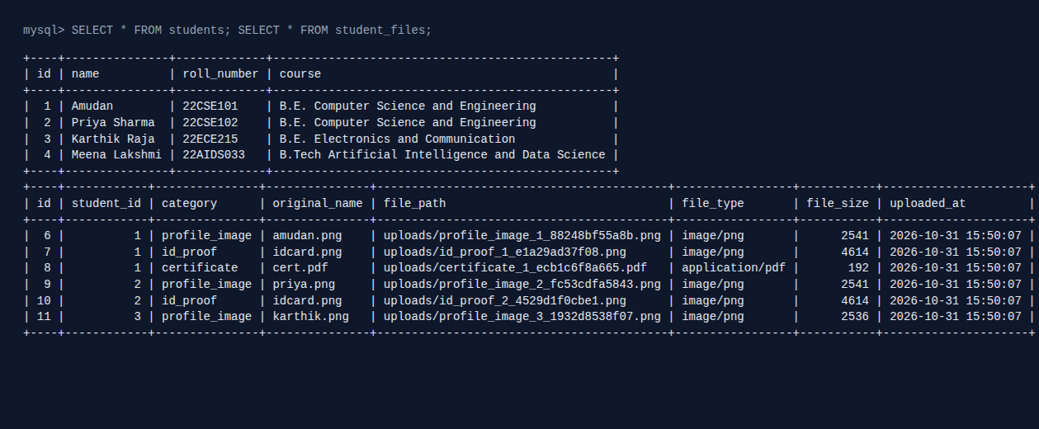
Figure 1: students and student_files tables in MySQL

3. Q1 – Registration form (HTML, CSS, JavaScript)

3.1 HTML form
The form collects name, roll number, e-mail, course (drop-down), password with confirmation, a profile photo and an ID proof. Two attributes matter most: enctype="multipart/form-data" (without it the browser would not send the files) and novalidate (it switches off the browser pop-ups so my own error messages appear, styled to match the page).
<form id="regForm" action="../q2-php-crud/add.php" method="POST"
enctype="multipart/form-data" novalidate>

<div class="form-grid">

<!-- Full name -->
<div class="field">
<label for="name">Full Name <span class="req">*</span></label>
<input type="text" id="name" name="name" placeholder="e.g. Amudan" autocomplete="name">
<span class="error-msg"></span>
</div>

<!-- Roll number -->
<div class="field">
<label for="roll_number">Roll Number <span class="req">*</span></label>
<input type="text" id="roll_number" name="roll_number" placeholder="e.g. 22CSE101" maxlength="15">
<span class="error-msg"></span>
</div>

3.2 CSS
All colours, radius and shadows are CSS variables declared once in :root, so the theme can be changed in one place. Fields sit in a two-column CSS Grid; a media query at 680 px switches it to a single column for phones. The classes .invalid and .valid, toggled by JavaScript, give red and green borders and the error text style.
.form-grid {
display: grid;
grid-template-columns: 1fr 1fr; /* two columns on desktop */
gap: 1.1rem 1.4rem;
}
.field { display: flex; flex-direction: column; }
.field.full { grid-column: 1 / -1; }

label { font-weight: 600; font-size: .92rem; margin-bottom: .3rem; }
label .req { color: var(--danger); }

input[type="text"], input[type="email"], input[type="password"],
input[type="search"], select, input[type="file"] {
padding: .65rem .8rem;
border: 1.5px solid var(--border);
border-radius: 8px;
font-size: 1rem;
background: #fff;
color: var(--text);
transition: border-color .15s, box-shadow .15s;
width: 100%;
}
input:focus, select:focus {
outline: none;
border-color: var(--primary);
box-shadow: 0 0 0 3px rgba(79, 70, 229, .18);
}
/* validation states toggled by validation.js */
.field.invalid input, .field.invalid select { border-color: var(--danger); background: #fef2f2; }
.field.valid input, .field.valid select { border-color: var(--success); }

.error-msg { color: var(--danger); font-size: .82rem; min-height: 1.1rem; margin-top: .25rem; }
.hint { color: var(--muted); font-size: .8rem; margin-top: .25rem; }

@media (max-width: 680px) {
.form-grid { grid-template-columns: 1fr; } /* stack fields on small screens */
.card { padding: 1.2rem; }
.topbar { flex-direction: column; align-items: flex-start; }
.topbar a { margin: 0 1rem 0 0; }
.details th { width: 120px; }
}

3.3 JavaScript validation
Every field has a small rule function that returns an error message or an empty string. Names accept letters only, roll numbers must be 6–15 letters/digits, and the e-mail must match a practical something@domain.tld pattern.
name: function (el) {
var v = el.value.trim();
if (!v) return 'Full name is required.';
// letters, spaces, dots and apostrophes only, at least 3 characters
if (!/^[A-Za-z][A-Za-z .']{2,}$/.test(v)) return 'Enter a valid name (letters only, min 3 characters).';
return '';
},

roll_number: function (el) {
var v = el.value.trim();
if (!v) return 'Roll number is required.';
// letters + digits only, 6 to 15 characters (e.g. 22CSE101)
if (!/^[A-Za-z0-9]{6,15}$/.test(v)) return 'Roll number must be 6-15 letters/digits, no spaces.';
return '';
},

email: function (el) {
var v = el.value.trim();
if (!v) return 'Email address is required.';
// simple but practical e-mail pattern: something@something.tld
if (!/^[^\s@]+@[^\s@]+\.[A-Za-z]{2,}$/.test(v)) return 'Enter a valid email (e.g. name@example.com).';
return '';
},

Password strength is scored from 0 to 5 (length, lower case, upper case, digit, symbol). The same score drives the coloured meter under the field, and a password must reach 5 to be accepted. File checks read the extension and size before anything is uploaded.
function passwordScore(v) {
var score = 0;
if (v.length >= 8) score++;
if (/[a-z]/.test(v)) score++;
if (/[A-Z]/.test(v)) score++;
if (/[0-9]/.test(v)) score++;
if (/[^A-Za-z0-9]/.test(v)) score++;
return score;
}

function checkFile(el, allowedExt, maxMB, label) {
if (!el.files || el.files.length === 0) return label + ' is required.';
var file = el.files[0];
var ext = file.name.split('.').pop().toLowerCase();
if (allowedExt.indexOf(ext) === -1) return label + ' must be: ' + allowedExt.join(', ').toUpperCase() + '.';
if (file.size > maxMB * 1024 * 1024) return label + ' must be smaller than ' + maxMB + ' MB.';
return '';
}

// Show / clear the message under a field and colour the border

On submit, every field is validated; if any fails, preventDefault() stops the request and the first wrong field gets focus.
// Block submission if any field fails
form.addEventListener('submit', function (event) {
var firstBad = null;
fields.forEach(function (el) {
if (!validateField(el) && !firstBad) firstBad = el;
});
if (firstBad) {
event.preventDefault(); // stop the POST request
firstBad.focus(); // take the user to the first mistake
}
});

3.4 Output screenshots
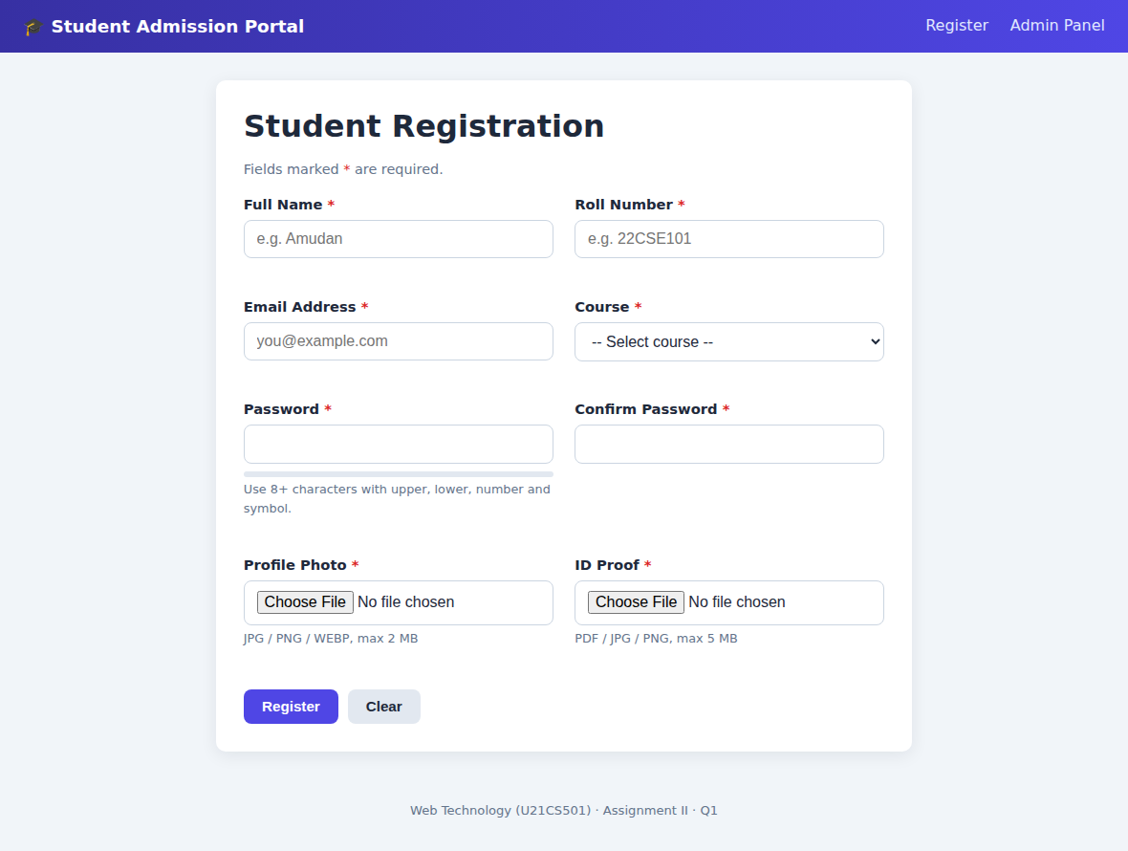
Figure 2: Empty registration form (responsive two-column layout)
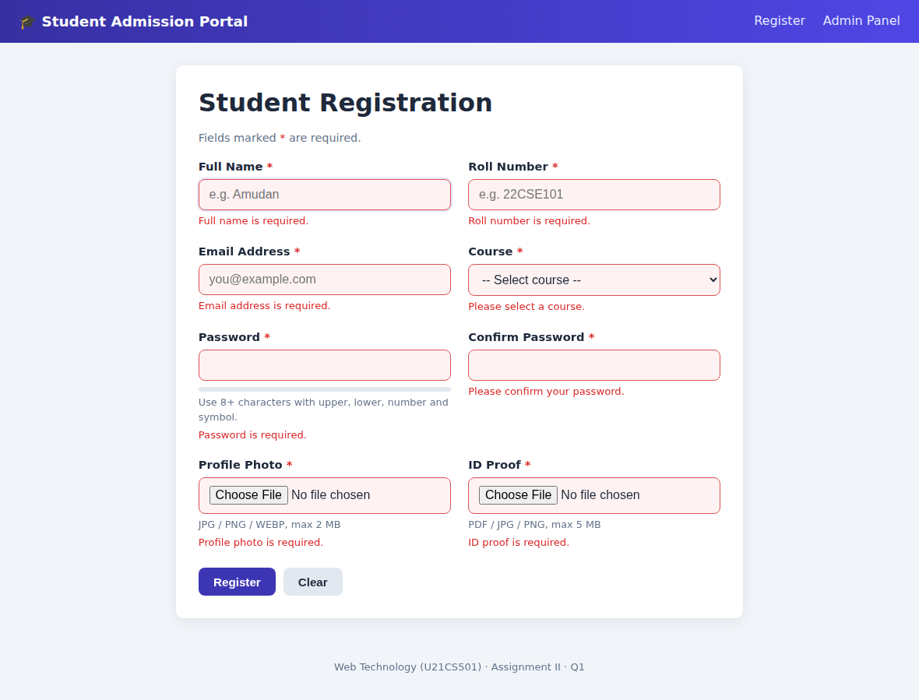
Figure 3: Pressing Register with empty fields shows required-field errors
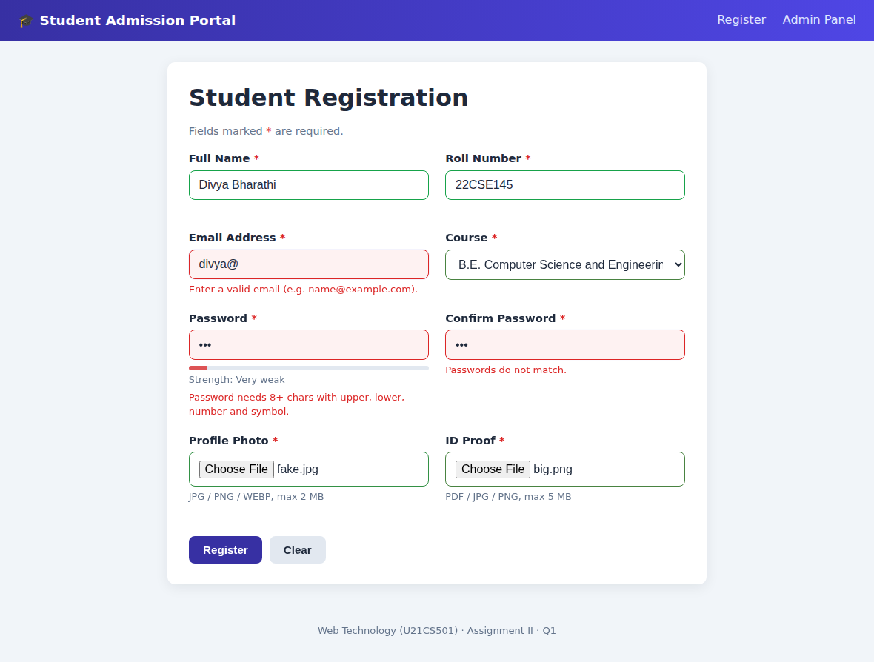
Figure 4: Invalid e-mail, weak password and mismatching confirmation
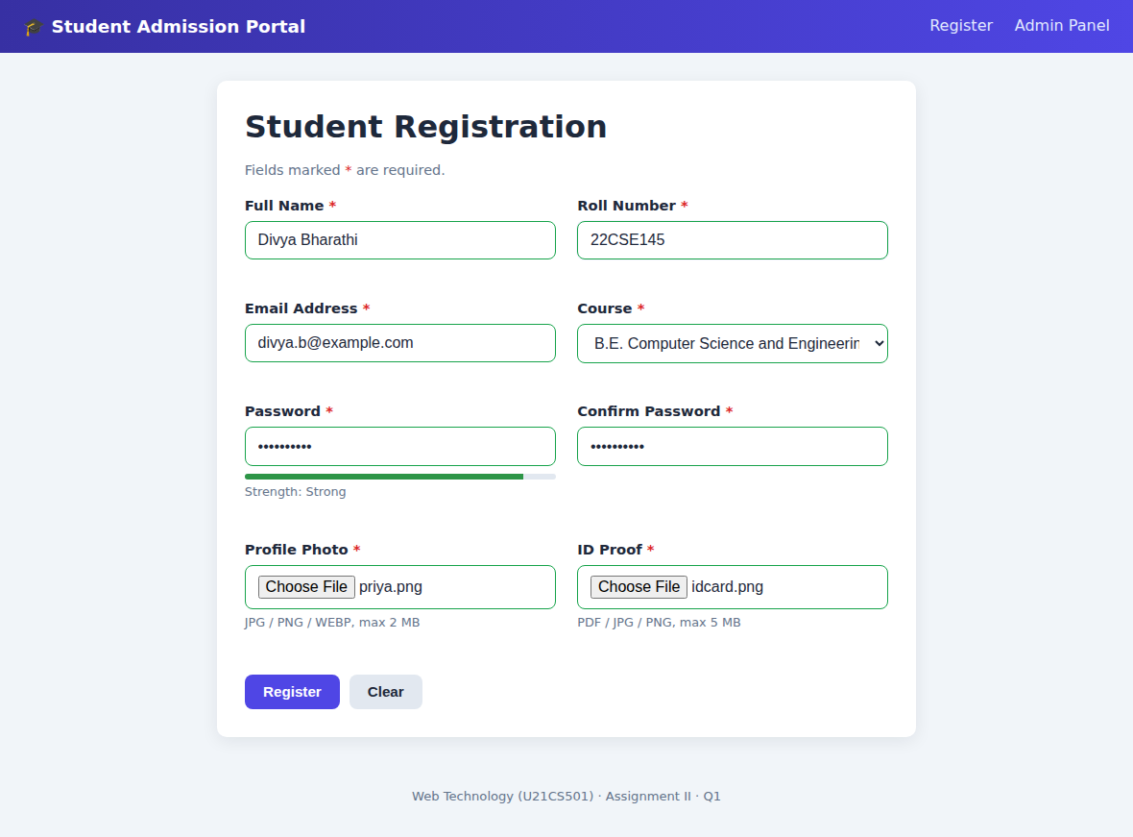
Figure 5: Valid data with a strong password (green borders, full meter)

4. Q2 – PHP and MySQL (CRUD + file upload)

4.1 Page map
Page | CRUD role | What it does
index.php | Read (list) | Lists students with their photo; search by name, roll number or course
add.php | Create | Validates text + files, inserts student and files inside one transaction
view.php | Read (one) | Shows details and every uploaded file with type, size and upload date
edit.php | Update | Updates details; replaces photo/ID proof; adds certificates
delete.php | Delete | POST only; removes files from disk, then the student row
delete_file.php | Delete (file) | Removes one uploaded file and its metadata row

4.2 Database connection
db.php opens one PDO connection with exceptions switched on and real prepared statements. Because user input travels separately from the SQL text, SQL injection is not possible. A connection failure shows a generic message; the technical reason goes only to the error log.
function db(): PDO
{
static $pdo = null; // created once, reused afterwards
if ($pdo === null) {
$dsn = "mysql:host=" . DB_HOST . ";dbname=" . DB_NAME . ";charset=utf8mb4";
try {
$pdo = new PDO($dsn, DB_USER, DB_PASS, [
PDO::ATTR_ERRMODE => PDO::ERRMODE_EXCEPTION, // throw on SQL errors
PDO::ATTR_DEFAULT_FETCH_MODE => PDO::FETCH_ASSOC,
PDO::ATTR_EMULATE_PREPARES => false,
]);
} catch (PDOException $e) {
// never print the raw error to visitors - it can leak credentials
error_log($e->getMessage());
http_response_code(500);
exit("Database connection failed. Check includes/config.php and that MySQL is running.");
}
}
return $pdo;
}

4.3 Validating an upload
check_upload() decides whether a file may be accepted. It handles PHP’s own error codes, enforces the size limit for the category, and – most importantly – asks finfo for the real MIME type from the file contents. The allowed types come from FILE_RULES in config.php, so changing the policy needs no change here.
function check_upload(array $file, string $category): array
{
$rule = FILE_RULES[$category];
$label = $rule["label"];

if ($file["error"] === UPLOAD_ERR_NO_FILE) {
return ["skip" => true];
}
// PHP itself rejects files bigger than upload_max_filesize
if ($file["error"] === UPLOAD_ERR_INI_SIZE || $file["error"] === UPLOAD_ERR_FORM_SIZE) {
return ["error" => "$label is too large (limit {$rule['max_mb']} MB)."];
}
if ($file["error"] !== UPLOAD_ERR_OK || !is_uploaded_file($file["tmp_name"])) {
return ["error" => "$label could not be uploaded. Please try again."];
}
// our own size limit
if ($file["size"] > $rule["max_mb"] * 1024 * 1024) {
return ["error" => "$label must be smaller than {$rule['max_mb']} MB."];
}
// detect the real type from the file content, not from the file name
$finfo = new finfo(FILEINFO_MIME_TYPE);
$mime = $finfo->file($file["tmp_name"]);
if (!isset($rule["mimes"][$mime])) {
$allowed = strtoupper(implode(", ", array_values($rule["mimes"])));
return ["error" => "$label must be one of: $allowed."];
}
return ["mime" => $mime, "ext" => $rule["mimes"][$mime]];
}

4.4 Saving the file and its metadata
save_upload() creates a random unique file name, loops while a file with that name exists (so nothing is ever overwritten), moves the file out of PHP’s temp folder and stores path, MIME type, size and the upload timestamp in student_files, linked by student_id.
function save_upload(int $studentId, array $item): string
{
if (!is_dir(UPLOAD_DIR)) mkdir(UPLOAD_DIR, 0755, true);

// Build a unique name. random_bytes makes a clash practically impossible,
// and the file_exists loop guarantees an existing file is NEVER overwritten.
do {
$stored = sprintf("%s_%d_%s.%s", $item["category"], $studentId, bin2hex(random_bytes(6)), $item["ext"]);
$target = UPLOAD_DIR . $stored;
} while (file_exists($target));

if (!move_uploaded_file($item["file"]["tmp_name"], $target)) {
throw new RuntimeException("Could not save " . $item["file"]["name"]);
}

$stmt = db()->prepare(
"INSERT INTO student_files
(student_id, category, original_name, stored_name, file_path, file_type, file_size)
VALUES (?, ?, ?, ?, ?, ?, ?)"
);
$stmt->execute([
$studentId,
$item["category"],
mb_substr(basename($item["file"]["name"]), 0, 255), // basename strips any ../ tricks
$stored,
UPLOAD_URL . $stored,
$item["mime"],
(int) $item["file"]["size"],
]);
return $stored;
}

4.5 Create with a transaction
add.php first validates everything and saves nothing if any check fails. Then the student row and all file rows are written inside a transaction. If a step fails, the transaction is rolled back and any file already moved is deleted, so the database and the disk never disagree.
$errors = validate_student($_POST, true);
[$fileErrors, $uploads] = validate_all_uploads(true);
$errors = array_merge($errors, $fileErrors);

if (!$errors) {
$pdo = db();
$saved = []; // remember saved files so we can undo on failure
try {
$pdo->beginTransaction(); // student row + file rows succeed or fail together

$stmt = $pdo->prepare(
"INSERT INTO students (name, roll_number, email, course, password_hash) VALUES (?, ?, ?, ?, ?)"
);
$stmt->execute([
trim($_POST["name"]),
strtoupper(trim($_POST["roll_number"])),
trim($_POST["email"]),
$_POST["course"],
password_hash($_POST["password"], PASSWORD_DEFAULT), // never store plain passwords
]);
$studentId = (int) $pdo->lastInsertId();

foreach ($uploads as $item) {
$saved[] = save_upload($studentId, $item);
}
$pdo->commit();

flash("success", "Student " . trim($_POST["name"]) . " was added successfully.");
redirect("view.php?id=" . $studentId);
} catch (Throwable $ex) {
if ($pdo->inTransaction()) $pdo->rollBack();
foreach ($saved as $name) @unlink(UPLOAD_DIR . $name); // remove orphan files
error_log($ex->getMessage());
$errors[] = "Something went wrong while saving. Please try again.";
}
}

4.6 Output screenshots
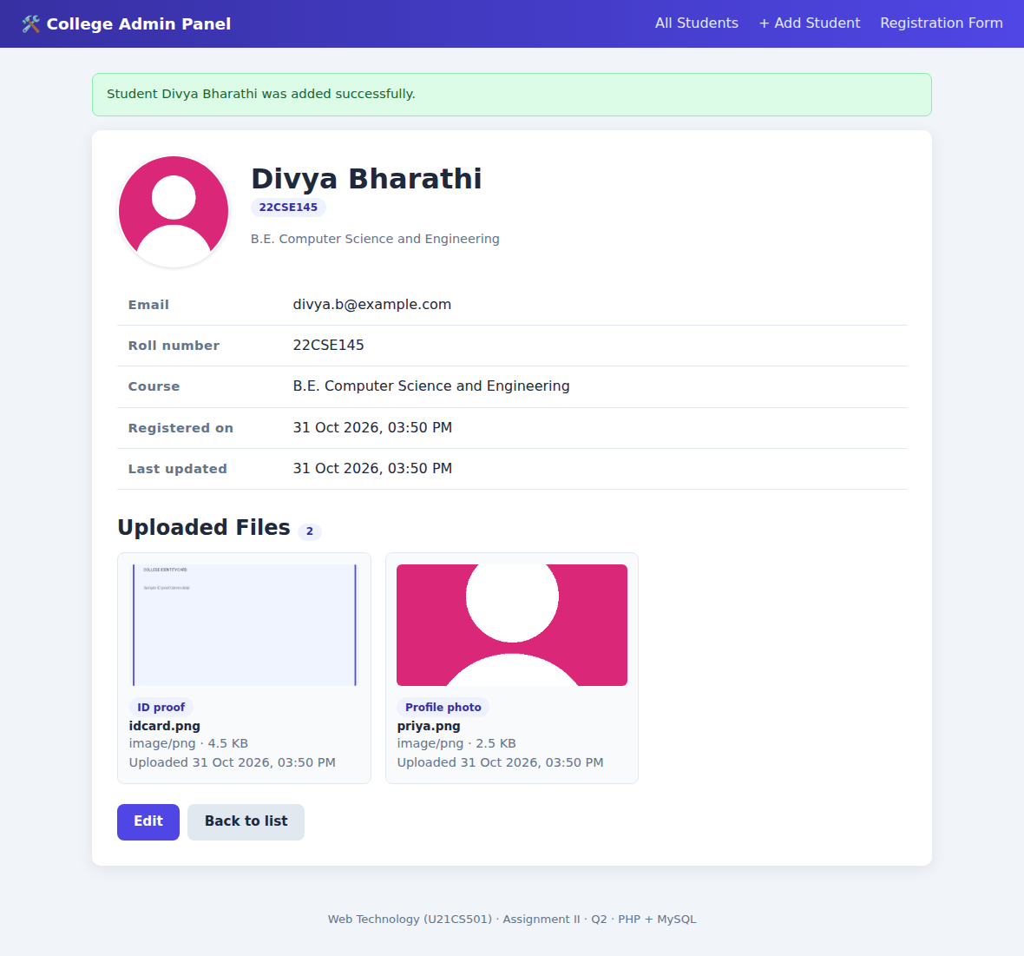
Figure 6: Student registered from the Q1 form – saved and shown with files
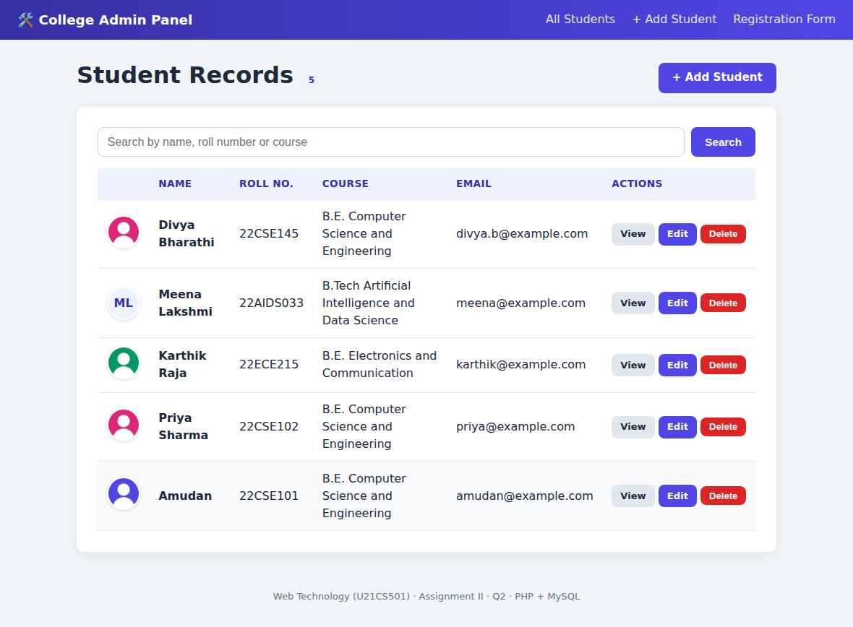
Figure 7: Student list with photo avatars, search and View / Edit / Delete
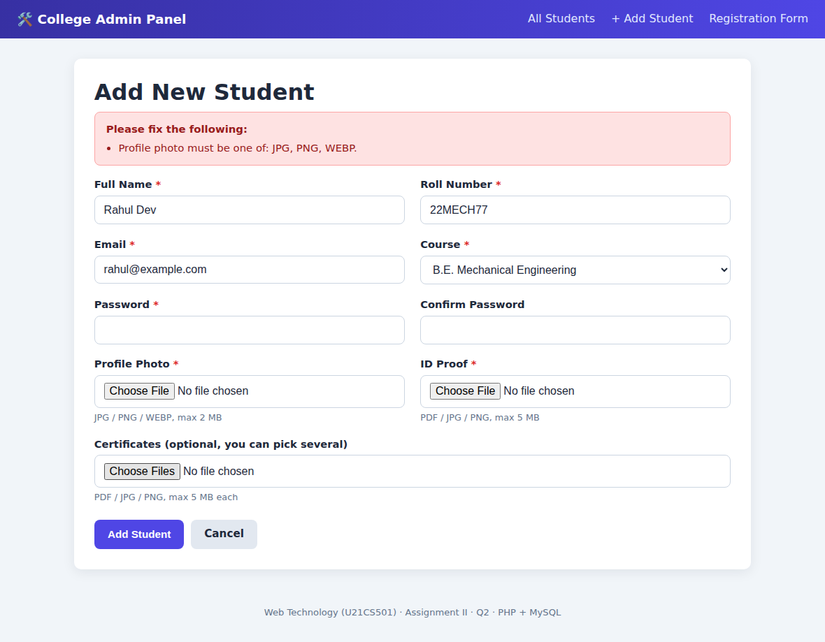
Figure 8: A fake .jpg (program content) rejected by the server
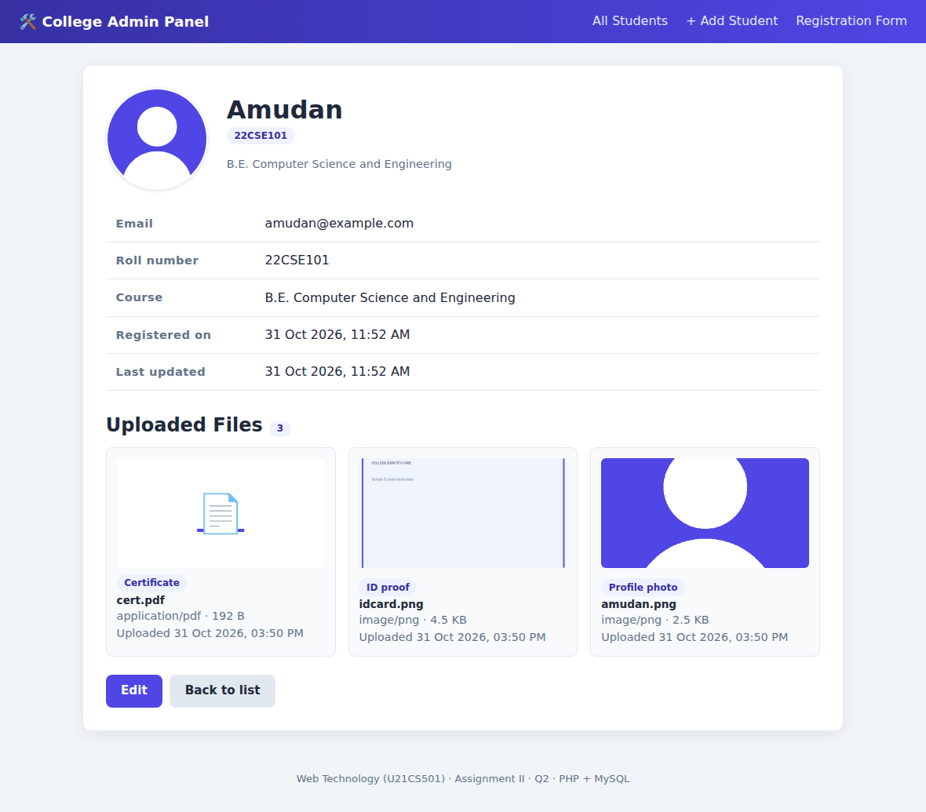
Figure 9: View page – files displayed with MIME type, size and upload date
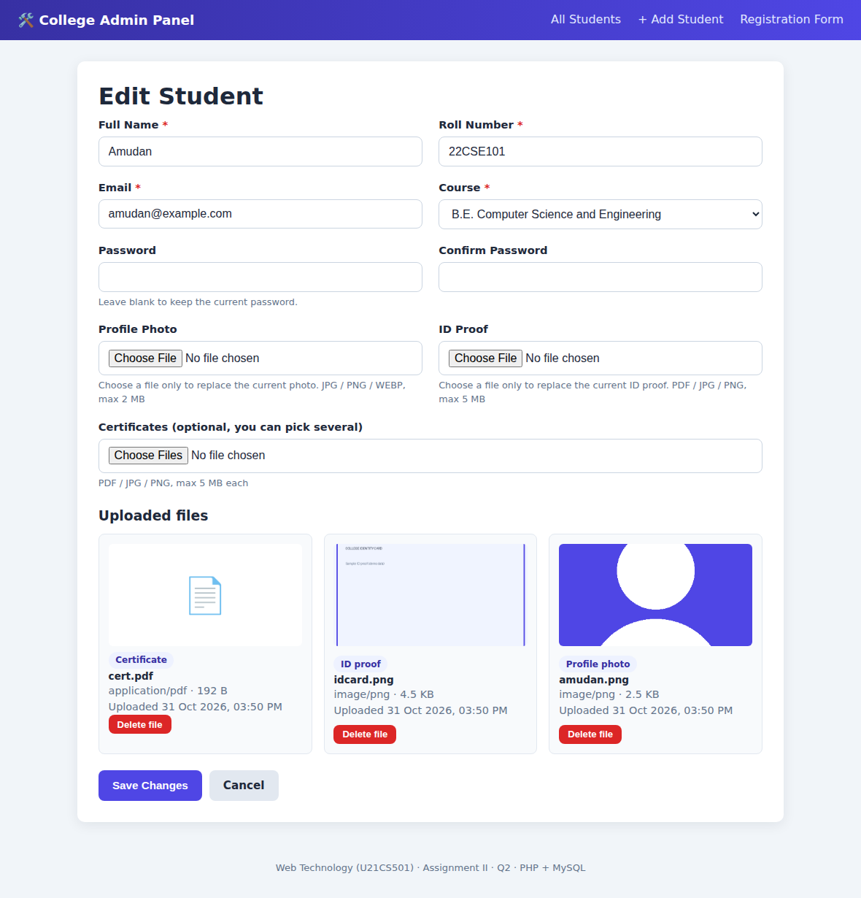
Figure 10: Edit page – replace photo / ID proof, add certificates, delete a file
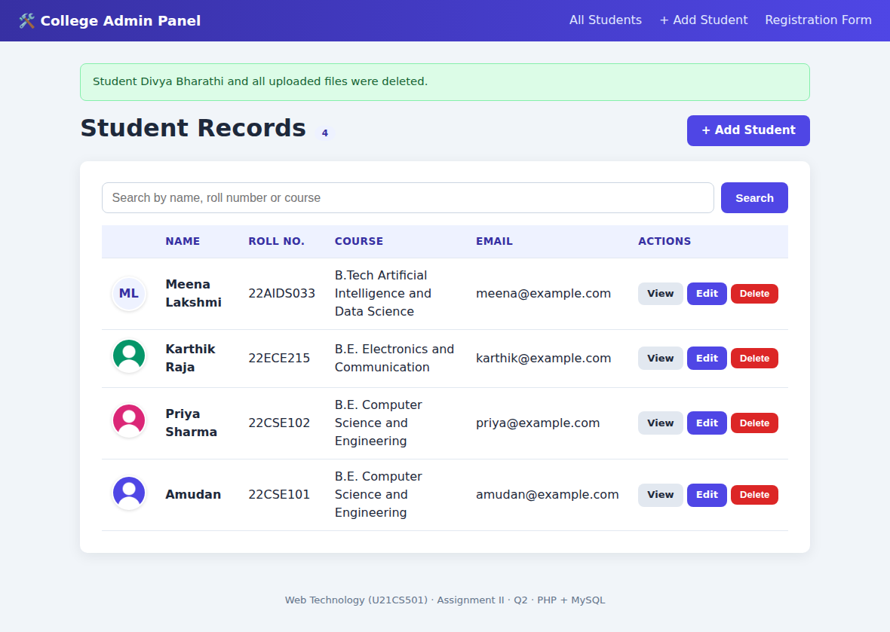
Figure 11: After deleting a student – record and files are removed

5. Q3 – Servlet, JDBC and JSP portal

5.1 Architecture (MVC)
Servlets act as controllers, DAO classes talk to MySQL through JDBC, model classes (Student, StudentFile) carry the data, and JSP pages only draw HTML. A filter in front of the private URLs makes sure only logged-in users get in.

5.2 web.xml – the deployment descriptor
web.xml registers the servlets and the URLs they answer (/login, /students, /profile, /file, /logout), connects AuthFilter to the private URLs, and configures the session (30-minute timeout, HttpOnly cookie). The database settings are context-params so no password is written inside Java code.
<!-- ============ Security filter: only logged-in users pass ============ -->
<filter>
<filter-name>AuthFilter</filter-name>
<filter-class>com.portal.filter.AuthFilter</filter-class>
</filter>
<filter-mapping>
<filter-name>AuthFilter</filter-name>
<url-pattern>/students</url-pattern>
<url-pattern>/profile</url-pattern>
<url-pattern>/file</url-pattern>
</filter-mapping>

<!-- ===================== Session settings ===================== -->
<session-config>
<session-timeout>30</session-timeout> <!-- minutes of inactivity -->
<cookie-config>
<http-only>true</http-only> <!-- JavaScript cannot read the session cookie -->
</cookie-config>
</session-config>

5.3 Session handling – LoginServlet and AuthFilter
After a correct login the old session is destroyed and a new one is created (this prevents session fixation) and the username is stored in it. The password is compared against the SHA-256 hash in the users table using a prepared statement.
protected void doPost(HttpServletRequest req, HttpServletResponse resp)
throws ServletException, IOException {

String username = req.getParameter("username");
String password = req.getParameter("password");

// basic empty-field check before touching the database
if (username == null || username.trim().isEmpty() || password == null || password.isEmpty()) {
fail(req, resp, "Please enter both username and password.");
return;
}

try {
String fullName = userDAO.authenticate(username.trim(), password);
if (fullName == null) {
fail(req, resp, "Invalid username or password.");
return;
}

// Login OK. Destroy any old session first (prevents session fixation),
// then create a fresh one and remember who logged in.
HttpSession old = req.getSession(false);
if (old != null) old.invalidate();

HttpSession session = req.getSession(true);
session.setAttribute("user", username.trim());
session.setAttribute("fullName", fullName);
session.setMaxInactiveInterval(30 * 60); // log out after 30 idle minutes

resp.sendRedirect(req.getContextPath() + "/students");

} catch (SQLException e) {
log("Login query failed", e);
fail(req, resp, "Server error. Please try again later.");
}
}

AuthFilter runs before every request to /students, /profile and /file. It looks for the "user" attribute in the session; if there is none, the visitor is redirected to the login page.
public class AuthFilter implements Filter {

@Override
public void doFilter(ServletRequest req, ServletResponse res, FilterChain chain)
throws IOException, ServletException {

HttpServletRequest request = (HttpServletRequest) req;
HttpServletResponse response = (HttpServletResponse) res;

// false = do NOT create a new session just for checking
HttpSession session = request.getSession(false);
boolean loggedIn = session != null && session.getAttribute("user") != null;

if (loggedIn) {
// stop browsers from caching private pages (back button after logout)
response.setHeader("Cache-Control", "no-store, must-revalidate");
chain.doFilter(req, res); // allowed: carry on to the servlet
} else {
response.sendRedirect(request.getContextPath() + "/login?error=Please+log+in+first");
}
}
}

5.4 JDBC – fetching students and file paths
StudentDAO opens connections with try-with-resources, so they close automatically. It loads the students in one query and all file rows in a second query, then attaches every file to its owner in Java using a map – two queries instead of one query per student.
try (PreparedStatement fp = con.prepareStatement(
"SELECT * FROM student_files ORDER BY category, uploaded_at DESC");
ResultSet rs = fp.executeQuery()) {
while (rs.next()) {
StudentFile f = mapFile(rs);
Student owner = byId.get(f.getStudentId());
if (owner != null) owner.getFiles().add(f);
}
}
}
return new ArrayList<>(byId.values());
}

5.5 Streaming images and documents – FileServlet
The browser never sees the real folder. In the JSP, an image tag points to /file?id=12; FileServlet looks up file 12 in MySQL, builds a safe path inside the upload folder (blocking “../” tricks), sets the content type and length, and copies the bytes to the response. Adding download=1 changes the header to a download.
StudentFile meta = studentDAO.findFile(fileId);
if (meta == null) {
resp.sendError(HttpServletResponse.SC_NOT_FOUND, "No such file.");
return;
}

// 2) build the path safely: getFileName() drops any "../" parts, and we
// double-check the result still lives inside the upload folder
Path folder = Paths.get(DBUtil.getUploadDir()).toAbsolutePath().normalize();
Path file = folder.resolve(Paths.get(meta.getStoredName()).getFileName()).normalize();
if (!file.startsWith(folder) || !Files.isRegularFile(file)) {
resp.sendError(HttpServletResponse.SC_NOT_FOUND, "File is missing on the server.");
return;
}

// 3) response headers: type, size, and inline (show) vs attachment (download)
resp.setContentType(meta.getFileType());
resp.setContentLengthLong(Files.size(file));
resp.setHeader("Cache-Control", "private, max-age=3600"); // uploads never change
resp.setHeader("X-Content-Type-Options", "nosniff");
boolean download = "1".equals(req.getParameter("download"));
String safeName = meta.getOriginalName().replaceAll("[^A-Za-z0-9._-]", "_");
resp.setHeader("Content-Disposition",
(download ? "attachment" : "inline") + "; filename=\"" + safeName + "\"");

// 4) copy the file bytes to the browser
try (OutputStream out = resp.getOutputStream()) {
Files.copy(file, out);
}

5.6 Dynamic page with loops and conditions – students.jsp
The JSP receives the list from StudentListServlet. An if/else handles the “no students” case, an outer for loop draws one card per student, an inner for loop lists that student’s files, and a conditional shows either the streamed photo or the initials.
<% if (students.isEmpty()) { %>
<div class="card"><p class="muted" style="text-align:center">No students found.</p></div>
<% } else { %>
<div class="student-grid">
<%-- LOOP 1: one card per student --%>
<% for (Student s : students) {
StudentFile photo = s.getProfileImage();
%>
<div class="student-card">
<%-- CONDITIONAL: real photo (streamed by FileServlet) or initials --%>
<% if (photo != null) { %>
<img class="avatar big" src="<%= ctx %>/file?id=<%= photo.getId() %>" alt="Photo of <%= Html.escape(s.getName()) %>">
<% } else { %>
<span class="avatar big"><%= Html.escape(s.getInitials()) %></span>
<% } %>

<h3><%= Html.escape(s.getName()) %></h3>
<span class="badge"><%= Html.escape(s.getRollNumber()) %></span>
<p class="muted"><%= Html.escape(s.getCourse()) %></p>

<ul class="file-links">
<%-- LOOP 2: every file of this student --%>
<% for (StudentFile f : s.getFiles()) { %>
<li>
<%= f.isImage() ? "🖼️" : "📄" %>
<a href="<%= ctx %>/file?id=<%= f.getId() %>" target="_blank"><%= Html.escape(f.getCategoryLabel()) %></a>
<span class="muted">(<%= Html.size(f.getFileSize()) %>)</span>
</li>
<% } %>
<% if (s.getFiles().isEmpty()) { %>
<li class="muted">No files uploaded</li>
<% } %>
</ul>

5.7 Output screenshots
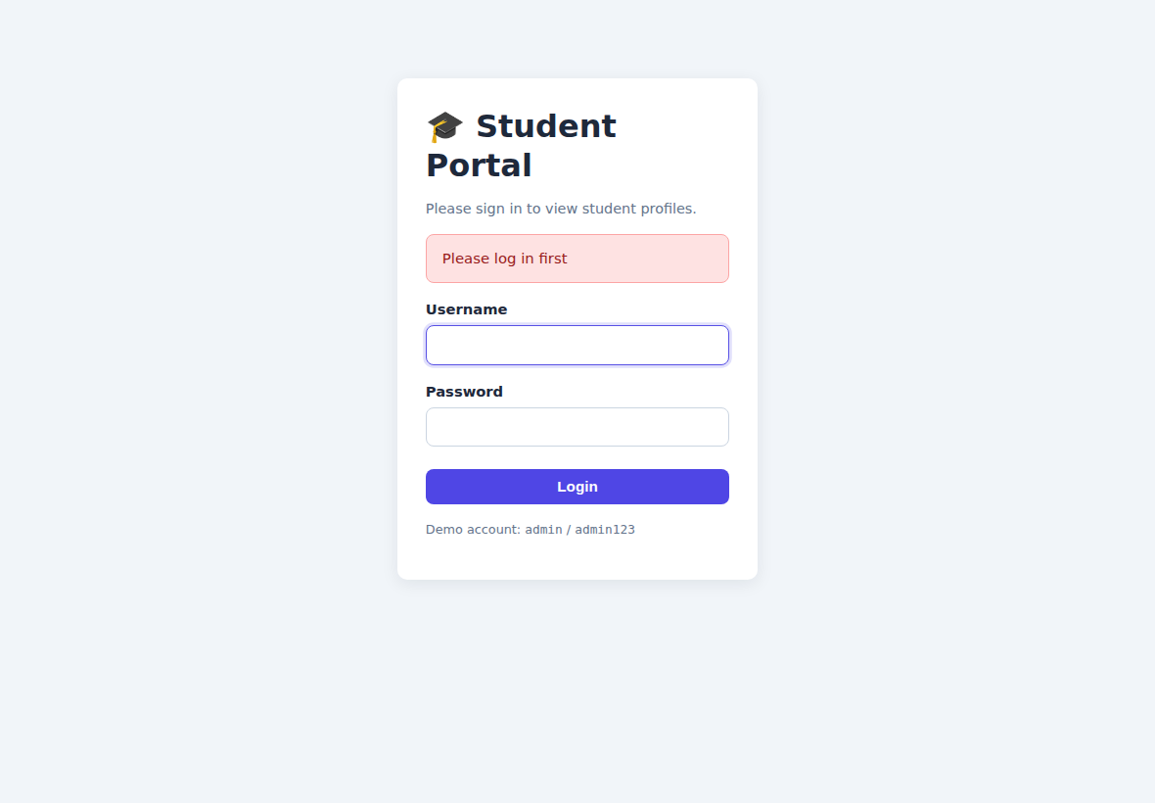
Figure 12: Opening /students without logging in redirects to the login page
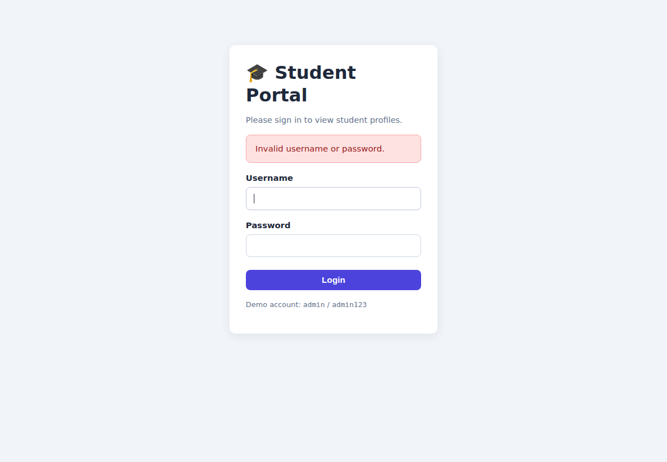
Figure 13: Wrong password is rejected
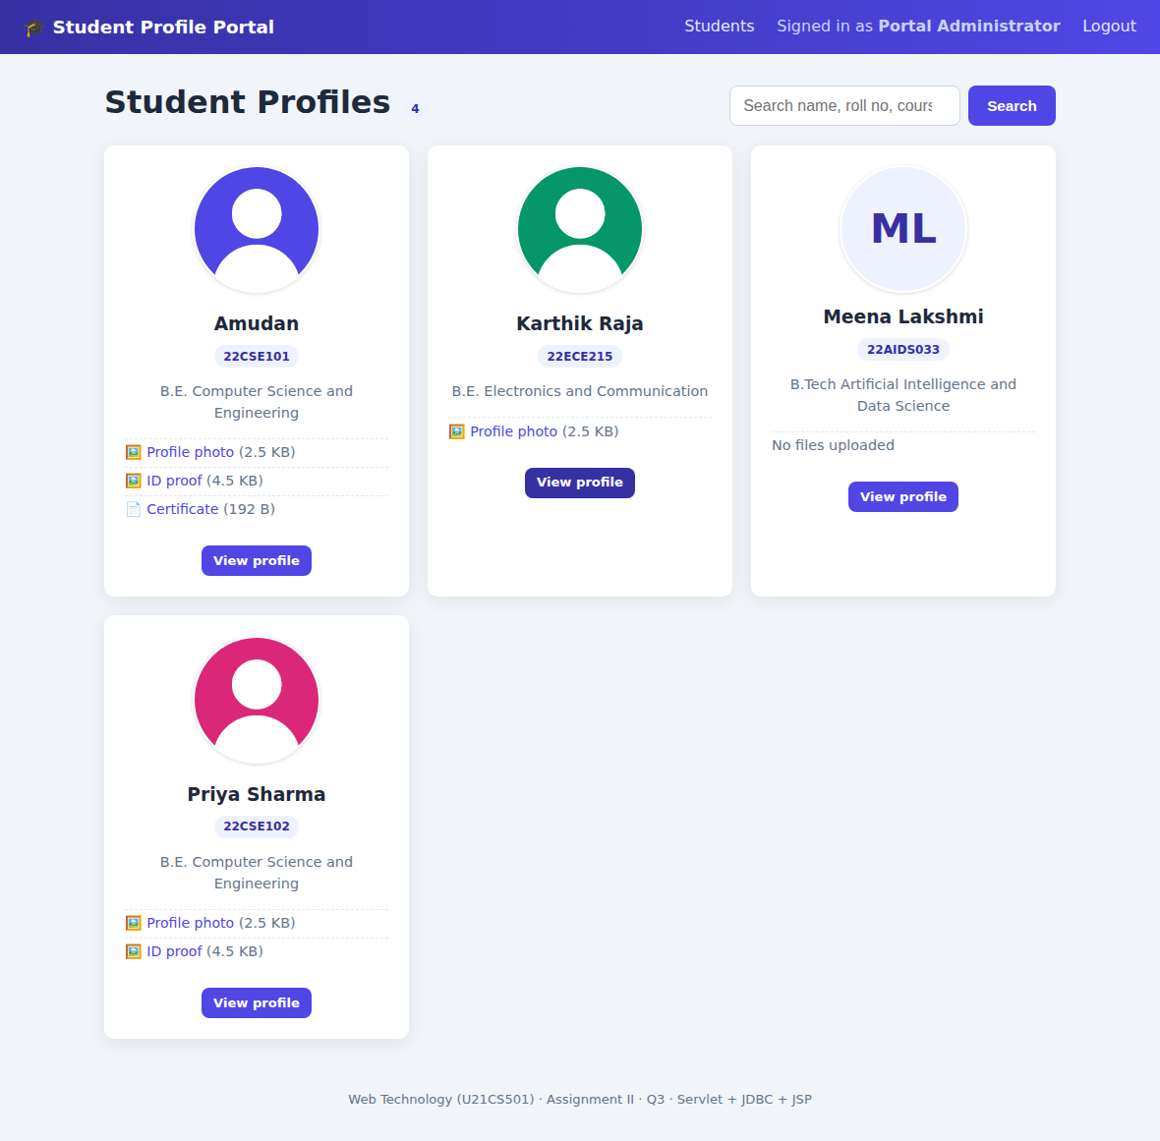
Figure 14: Logged-in student list – photos streamed by the servlet
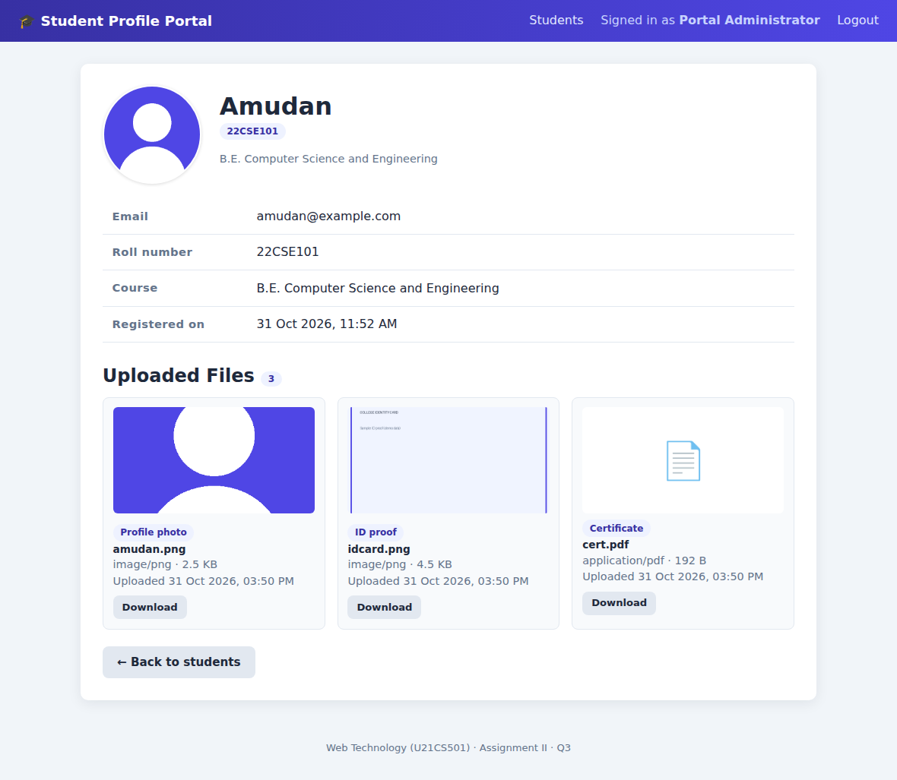
Figure 15: Profile page with image and document files

6. Testing summary
Test | Result
Register with valid data and files | Saved; 2 file rows with MIME type, size and timestamp
Upload a program renamed to .jpg | Rejected (content check, not name check)
Upload a 3 MB photo (limit 2 MB) | Rejected with a clear message
Weak password / missing files / duplicate roll no. or e-mail | Rejected with the matching message
Edit: new photo, extra certificates | Old photo removed from disk, certificates added
Delete a student | Files removed from disk; file rows removed by cascade
GET request to delete.php | HTTP 405 – only POST is allowed
Portal URLs without login | Redirected to the login page
SQL-injection text in the login box | Treated as a normal wrong password
Image and PDF streamed by FileServlet | Downloaded bytes identical to the originals

7. Conclusion
This assignment brought the whole web stack together: a responsive, validated HTML/CSS/JavaScript form, a PHP and MySQL back end with safe file uploads and full CRUD, and a Servlet/JDBC portal that serves the same data and files only to logged-in users. Building both PHP and Java versions on one database showed me that sessions, prepared statements, validation and output escaping are the same ideas in different languages. The key lessons were never to rely on client-side checks alone, and to keep database changes and file operations consistent so a failed upload never leaves half-saved data.

