**Joints**

1. Patients with Their Lifestyle and Medical History

SELECT

p.PatientId,

p.PatientName,

l.Smoking,

l.AlcoholDrinking,

m.GenHealth AS MedicalGenHealth,

m.Treatment

FROM

Patient p

JOIN

LifeStyle_Factor l ON p.PatientId = l.PatientId

JOIN

MedicalHistory m ON p.PatientId = m.PatientId;

Result



1. Patients with Their Age and Years Information

SELECT

p.PatientId,

p.PatientName,

p.Age,

y.Years

FROM

Patient p

JOIN

Years y ON p.PatientId = y.YearId;

Result



1. Medical History and Heart Metrics for Each Patient

SELECT

p.PatientId,

p.PatientName,

m.GenHealth AS MedicalGenHealth,

m.Treatment,

h.HeartDisease,

h.BMI

FROM

Patient p

JOIN

MedicalHistory m ON p.PatientId = m.PatientId

JOIN

Heart_Metric h ON p.PatientId = h.PatientId;

Result

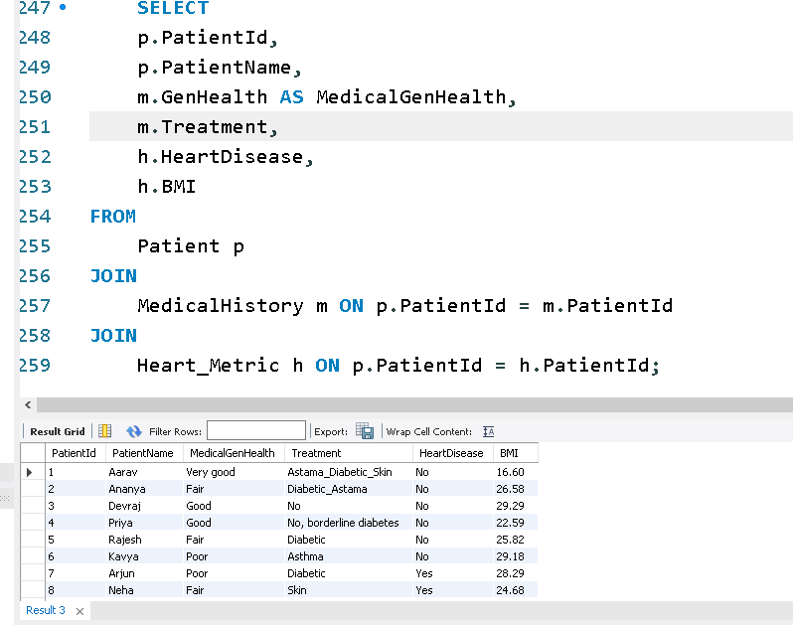

1. Patients with Certain Lifestyle Factors

SELECT

p.PatientId,

p.PatientName,

l.Smoking,

l.AlcoholDrinking,

l.PhysicalHealth

FROM

Patient p

JOIN

LifeStyle_Factor l ON p.PatientId = l.PatientId;

Result

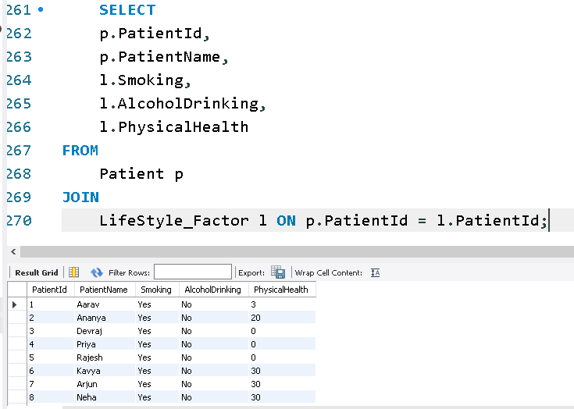

1. Patients with Their Heart Metrics

SELECT

p.PatientId,

p.PatientName,

h.HeartDisease,

h.BMI,

h.Smoking,

h.AlcoholDrinking,

h.Stroke,

h.PhysicalHealth,

h.MentalHealth

FROM

Patient p

JOIN

Heart_Metric h ON p.PatientId = h.PatientId;

Result

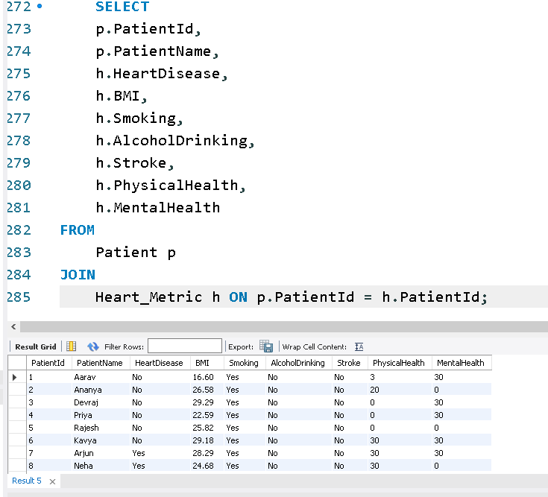

1. Patients with Both High BMI and Smoking Habit

SELECT

p.PatientId,

p.PatientName,

h.BMI,

l.Smoking

FROM

Patient p

JOIN

Heart_Metric h ON p.PatientId = h.PatientId

JOIN

LifeStyle_Factor l ON p.PatientId = l.PatientId

WHERE

h.BMI > 30 -- Assuming BMI > 30 indicates high BMI

AND l.Smoking = 'Yes';

Result

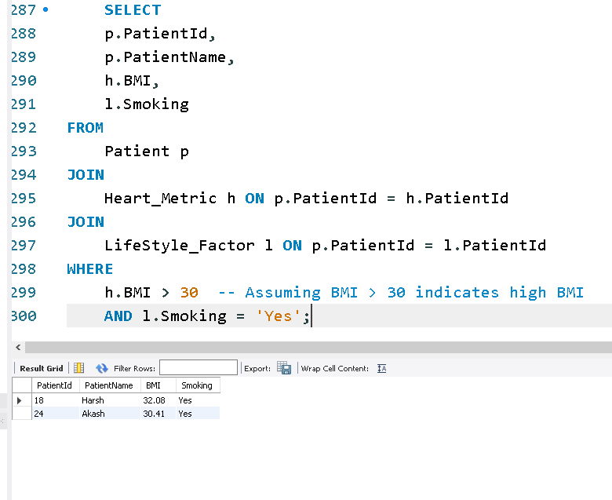

Sub Query