By Name – Nirbhay
Roll_No – AE-12
Course – B.S.c.(hons) Computer Science
Semester – IVth
Assignment – DBMS 4th
Submission Date – 29-03-2024(Monday)
SubmissionTiming –
Submitted to:
Prof. Sharanjit Kaur

Do the following database administration commands:

- create user:
- create role:

- grant privileges to a role:

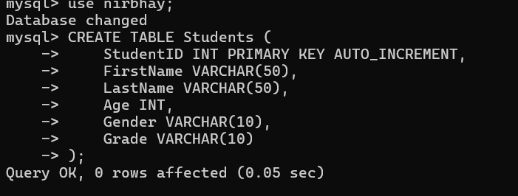
- revoke privileges from a role:

- create index.

Execute any five queries given in Q 1 of practical list on society database through a high-level language using ODBC connection:

import mysql.connector

# Establish a connection to the MySQL database
connection = mysql.connector.connect(
host="localhost",
user="root",
password="atulakulamul990",
database="data"
)

# Create a cursor to execute SQL queries
cursor = connection.cursor()

# Query 1: Retrieve all student names
cursor.execute("SELECT Studentname FROM student")
students = cursor.fetchall()
print("Query 1: All student names:")
for student in students:
print(student[0])

# Query 2: Retrieve all society names
cursor.execute("SELECT socNAME FROM society")
societies = cursor.fetchall()
print("\nQuery 2: All society names:")
for society in societies:
print(society[0])

# Query 3: Retrieve the count of students in each society
cursor.execute("SELECT s.socNAME, COUNT(e.roll_no) FROM society s LEFT JOIN enrollment e ON s.SocID = e.sid GROUP BY s.socNAME")
society_counts = cursor.fetchall()
print("\nQuery 3: Count of students in each society:")
for society_count in society_counts:
print(f"{society_count[0]}: {society_count[1]} students")

# Query 4: Update enrollment fees paid for a specific student
cursor.execute("UPDATE enrollment SET fees_paid= 'yes' WHERE roll_no = '11'")
print("Query 4: Excuted successfully.")

# Query 5: Delete a student record
# Query 5: Insert a new student record
cursor.execute("INSERT INTO student (Roll_no, StudentName, Course, DOB) VALUES ('15', 'John Doe', 'Maths', '2000-05-20')")
print("Query 5: Excuted successfully.")

# Commit the changes to the database
connection.commit()

# Close the cursor and connection
cursor.close()
connection.close()

Output:

