**OUTPUT**

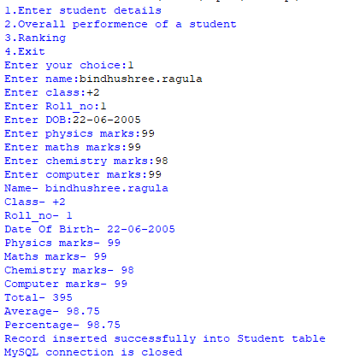

Fig.1 - Inserting record into database

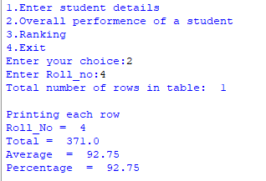

Fig.2-Displaying details of given roll number

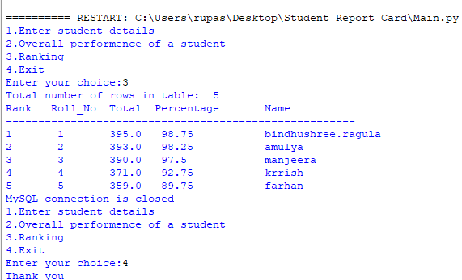

Fig.3 - Display ranks of all the students