**RESULTS AND DISCUSSIONS**

The project is compiled and executed using WAMP server. We have put in few snapshots here to show the working of our project.

**SNAPSHOTS**

Figure shows the home page of our project.

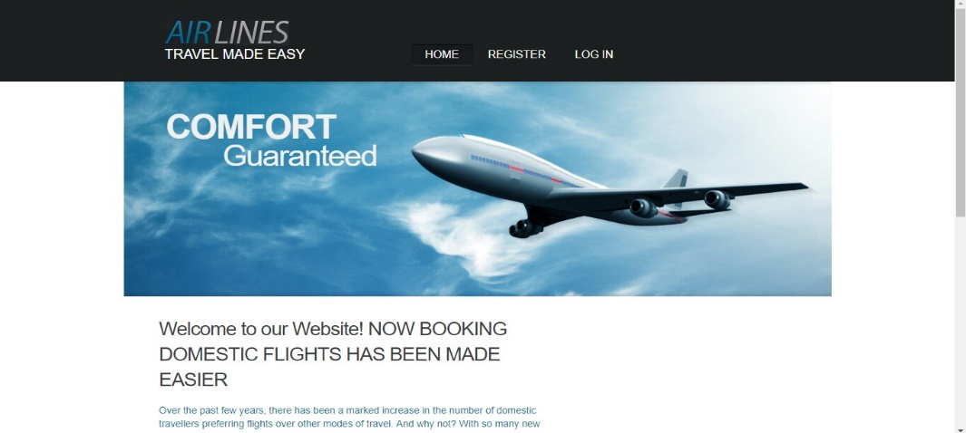

Figure shows login page of the application



Figure represents the error displayed when an invalid credentials of user are entered.



Figure represents the registration page for new users

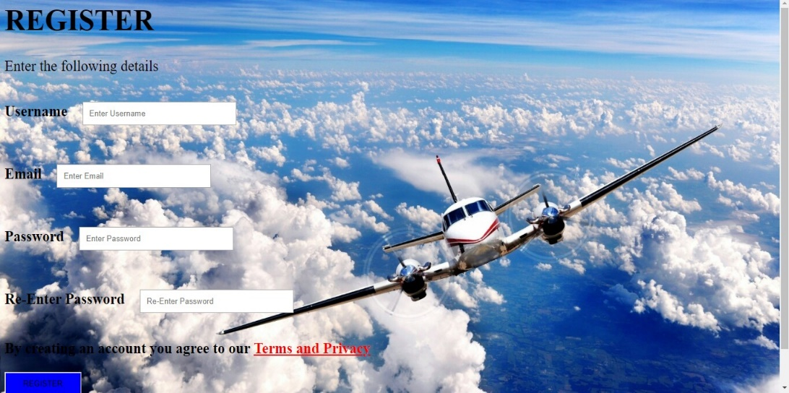

Figure represents the page which tells the user not to register using an email that was already registered



Figure represents the selection page where we select from city and to city.



Figure represents the screen which displays all information about flight that is related to the given from and to city



Figure represents the selection page of flight number and number of flight tickets to be booked

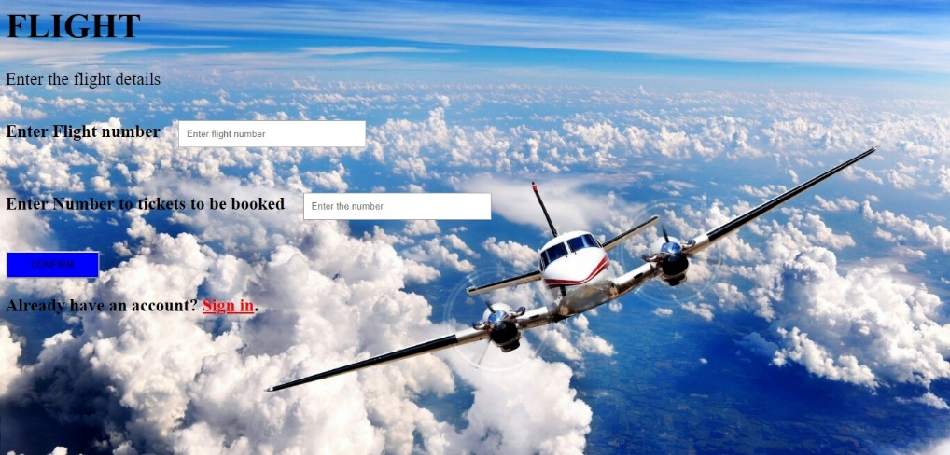

Figure represents a page which tells user not to book more than five tickets

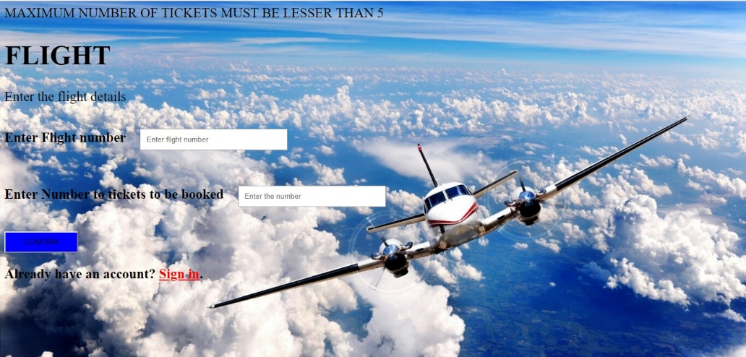

Figure represents the selection page of passenger details

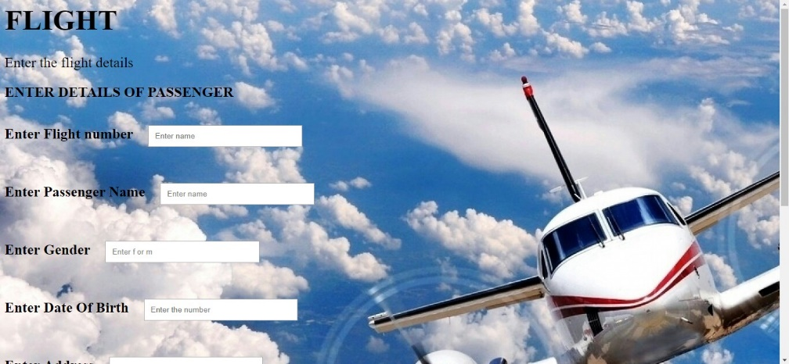

Figure represents the page which tells user about invalid card credentials.



Figure represents the selection page where user can make changes of previously set values.



Figure represent the selection for updating the passenger details

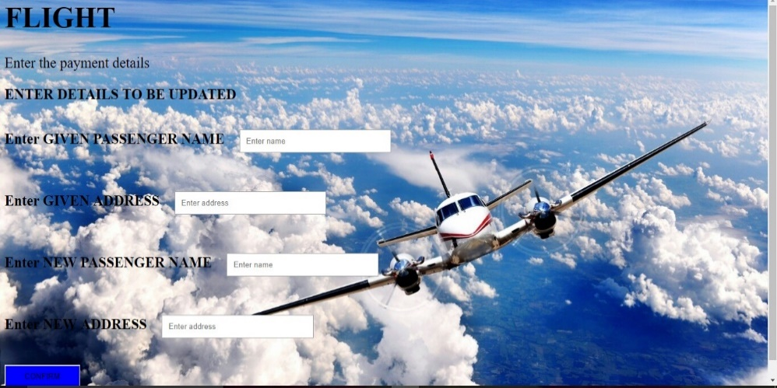

Figure represent the selection for deleteing flight tickets.

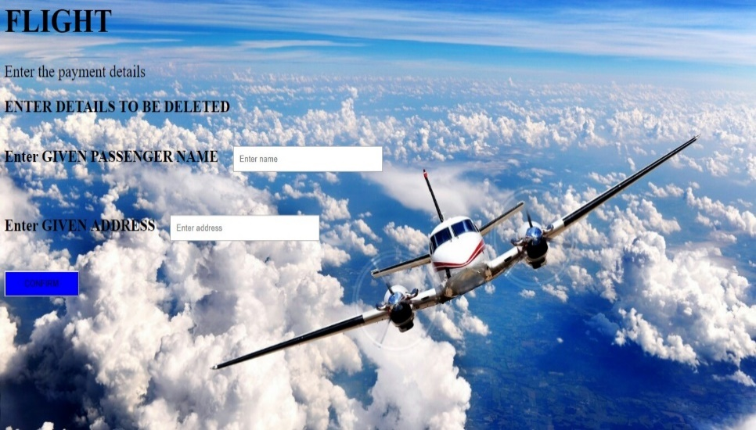

Figure represents the last page of the application.

