**Activity 1**

Create a text file named txtFile.txt and create a CSV file named csvFile.csv in the local filesystem

Add the following text to txtFile.txt, following data to csvFile.csv and display here

Create a directory named textData in the HDFS

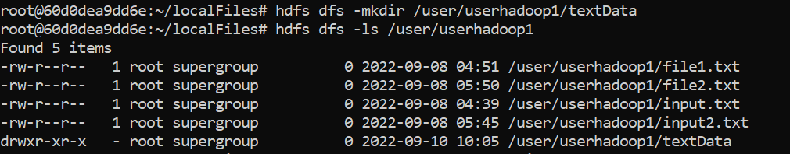

Copy the TXT file, txtFile.txt, into the textData folder in the HDFS.



Copy the CSV file, csvFile.csv, into the textData folder in the HDFS.

Finally use the stat command to get the file statistics

